Supplementary information for
Drought increases soil nitrous oxide emissions and nitrogen availability under plant cover in arable soils
Pauliina Turunen^{a,b}, Xuhui Luo^{b,c}, Ezekiel K. Boreª, Anne Viinikainen^{a,b}, Asko Simojoki^{a,b}, Markku Koskinen^{a,b}, Per Lennart Ambus^{d}, Kristiina Karhu^{b,c}, & Mari Pihlatie^{a,b}
ªEnvironmental Soil Science, Department of Agricultural Sciences, University of Helsinki, Viikinkaari 9, P.O. Box 56, FI-00014 Helsinki, Finland
^{b}Institute for Atmospheric and Earth System Research (INAR)/Faculty of Agriculture and Forestry, University of Helsinki, Viikinkaari 9, P.O. Box 56, FI-00014 Helsinki, Finland
^{c}Department of Forest Sciences, University of Helsinki, P.O. Box 27, 00014, Helsinki, Finland
^{d}Department of Geosciences and Natural Resource Management, Center for Landscape Research in Sustainable Agricultural Futures (Land-CRAFT), University of Copenhagen, Copenhagen, 1350 Denmark

Corresponding author:
Pauliina Turunen
ORCID: 0000-0001-8778-1628
E-mail address: Pauliina.t.turunen@helsinki.fi
Present address: Viikinkaari 9, 00790 Helsinki
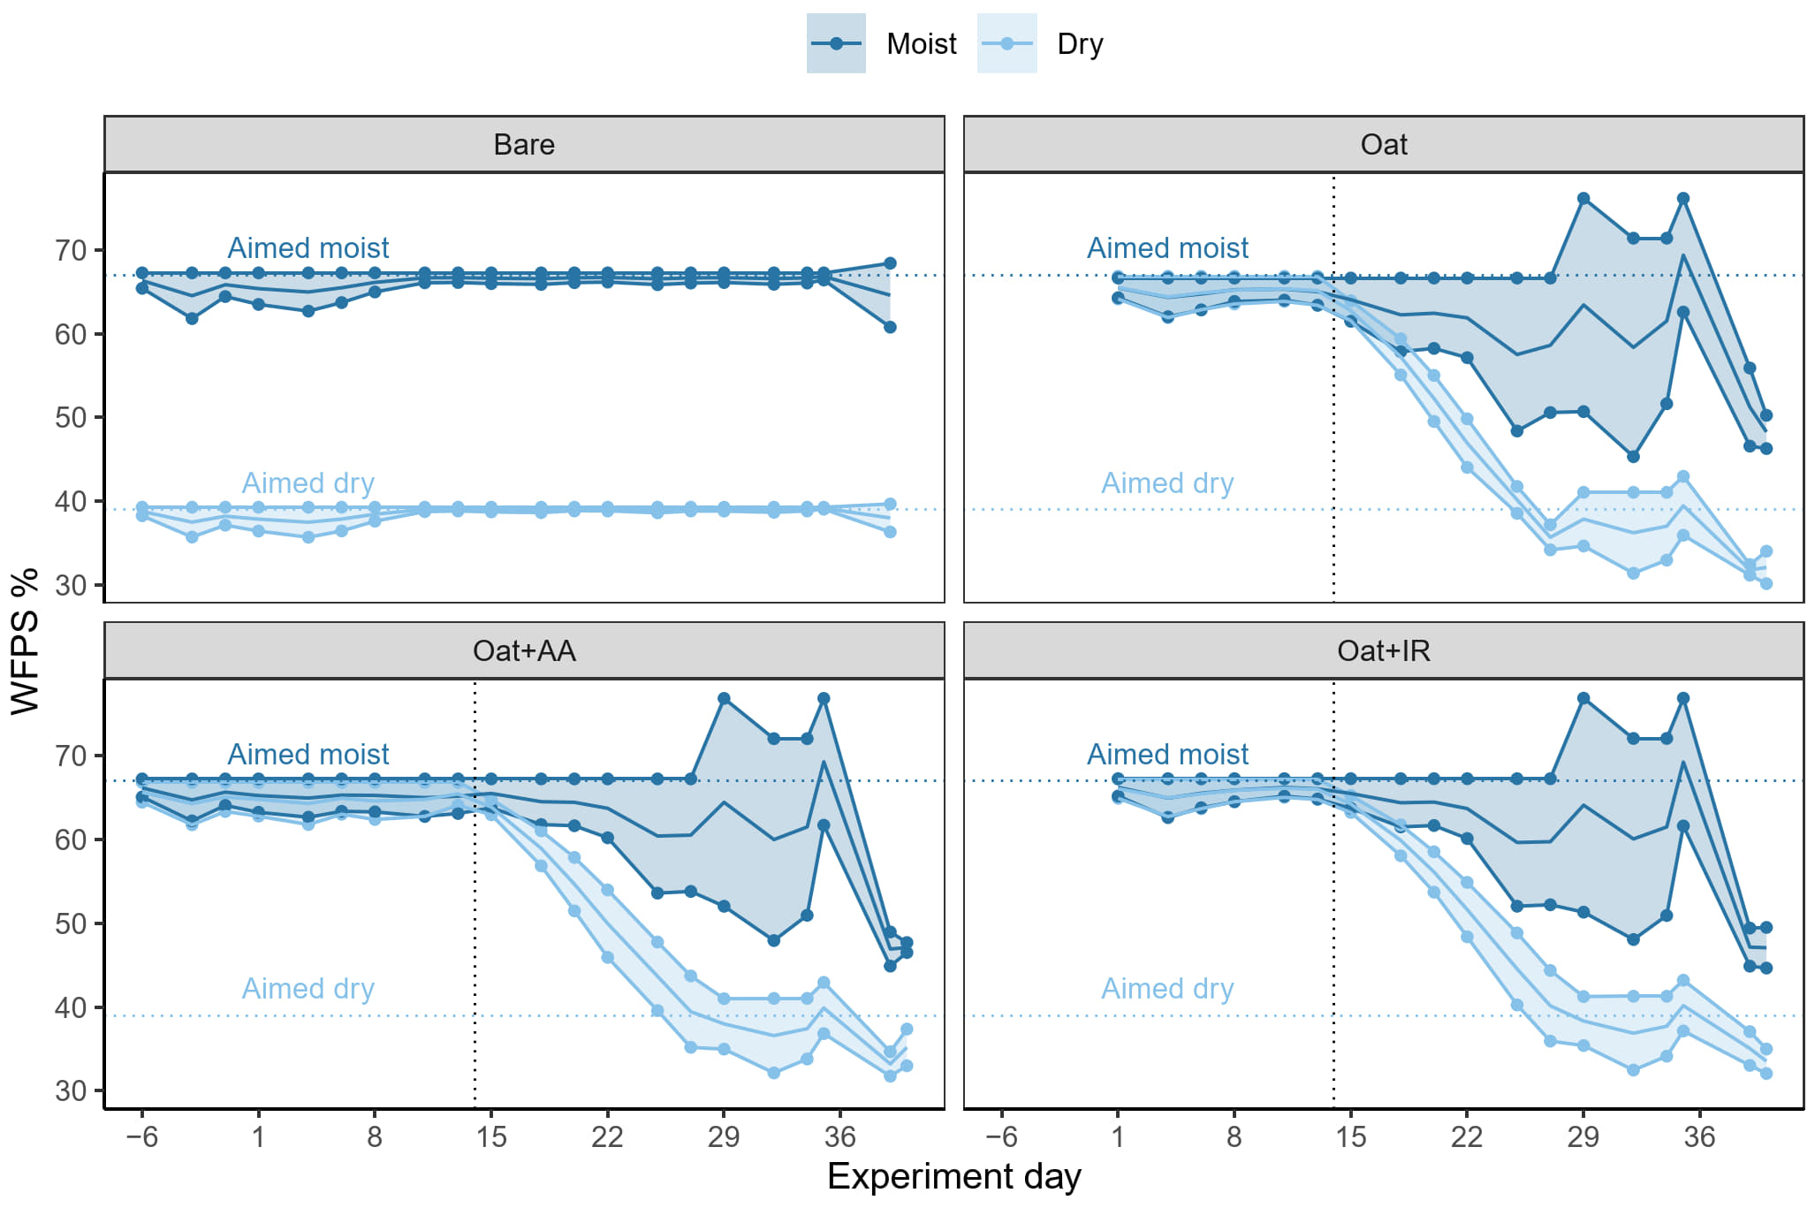
Fig. S1 Range of WFPS in the pots during the experiment. Dots on the min and max lines show the days when pots were watered. The solid lines inside the ranges show the average WFPS. Vertical dotted lines show the day when drought treatments started, and horizontal dotted lines show the initial WFPS of the pots which we aimed to maintain. The mean soil water contents decreased below the permanent wilting point (PWP) in the drought treatments, but as water was regularly added to the soil from above, the topsoil stayed above PWP, which prevented wilting of the plants
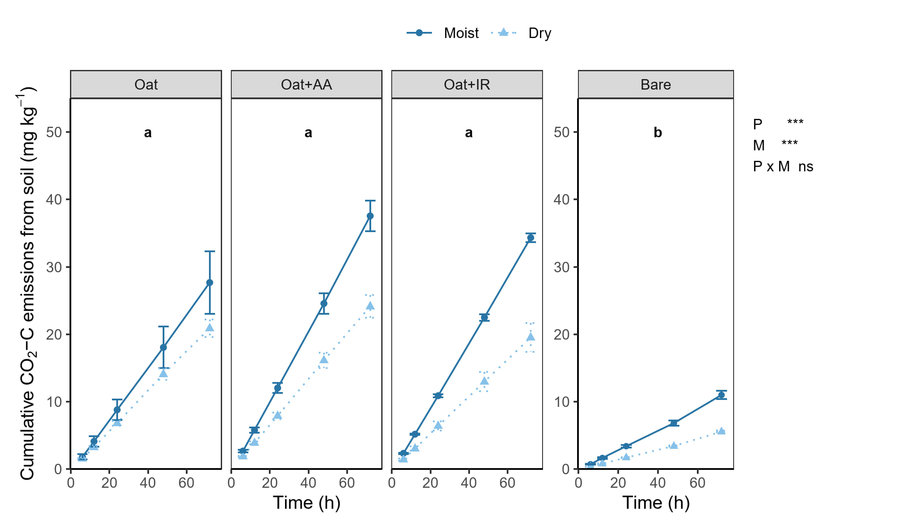Fig. S2 Mean cumulative CO₂ emissions (± SE) during a 72-h period in soil under oats (Oat, n=6), soil under oat-alfalfa mixture (Oat+AA, n=6), soil under oat-Italian ryegrass mixture (Oat+IR, n=6) and in bare soil (Bare, n=3). Solid dark blue lines indicate moist (70% WFPS) and dotted light blue lines indicate dry (40% WFPS) conditions. Two-way ANOVA shows significant main effects of plant cover (P) and soil moisture (M) treatments, whereas their interaction (P × M) showed no significant differences (*p < 0.05; **p < 0.01; ***p < 0.001; ns = not significant). Lower case letters denote significant differences between plant cover treatments based on the estimated marginal means (Tukey adjustment p < 0.001)
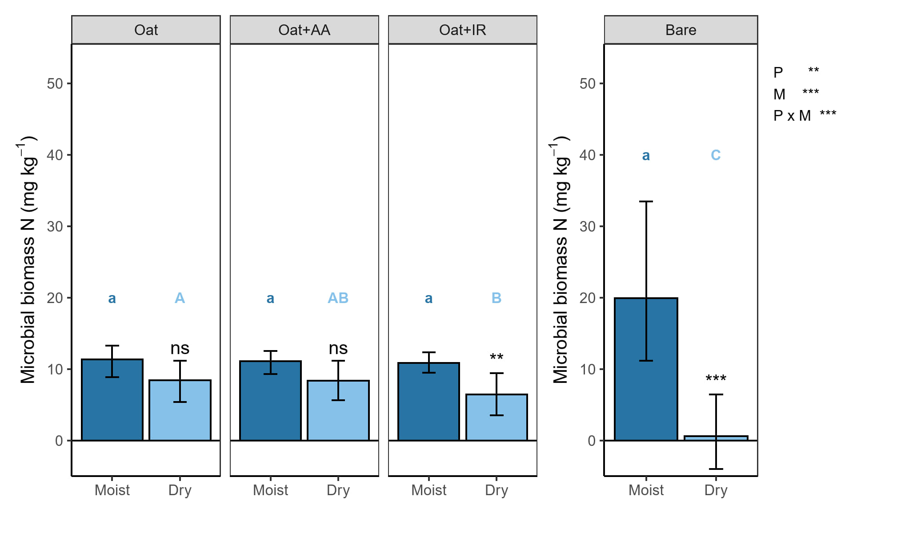
Fig. S3 Profile-average soil MBN content (mg kg⁻¹) for each plant cover and soil moisture treatment. Uncertainty was estimated using non-parametric bootstrapping (2000 iterations), resampling pots with replacement within each plant cover × soil moisture combination. Missing depth measurements due to analyzer failure were handled as missing values and were not imputed. Error bars represent the 95% confidence interval, obtained from bootstrapping. Two-way ANOVA reveal significant effects of plant cover treatment (P), soil moisture (M), and their interaction (P × M) and the asterisks within panels indicate significant effects of drought within each plant cover treatment (*p < 0.05; **p < 0.01; ***p < 0.001; ns = not significant). Lowercase and uppercase letters indicate significant differences among plant cover treatments within moist and dry conditions, respectively (p < 0.05). Note the difference in y-axis scale between the vegetated and bare soil
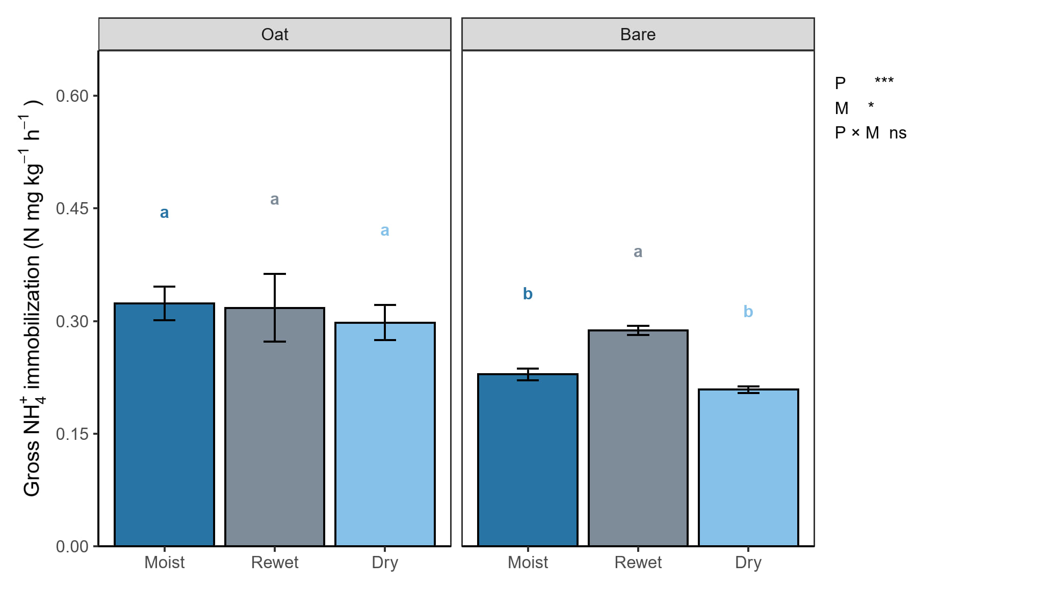Fig. S4 Mean (± SE) gross NH₄⁺ immobilization rates (mg N kg⁻¹ h⁻¹) in soil previously cultivated with oats (n=5) and in bare soil (n=5). Plant cover (P) increased immobilization whereas moisture (M) had only a significant effect in bare soil treatment. Plant cover × moisture interaction (P × M) was not significant. Lowercase letters indicate significant differences among treatments (p < 0.05)
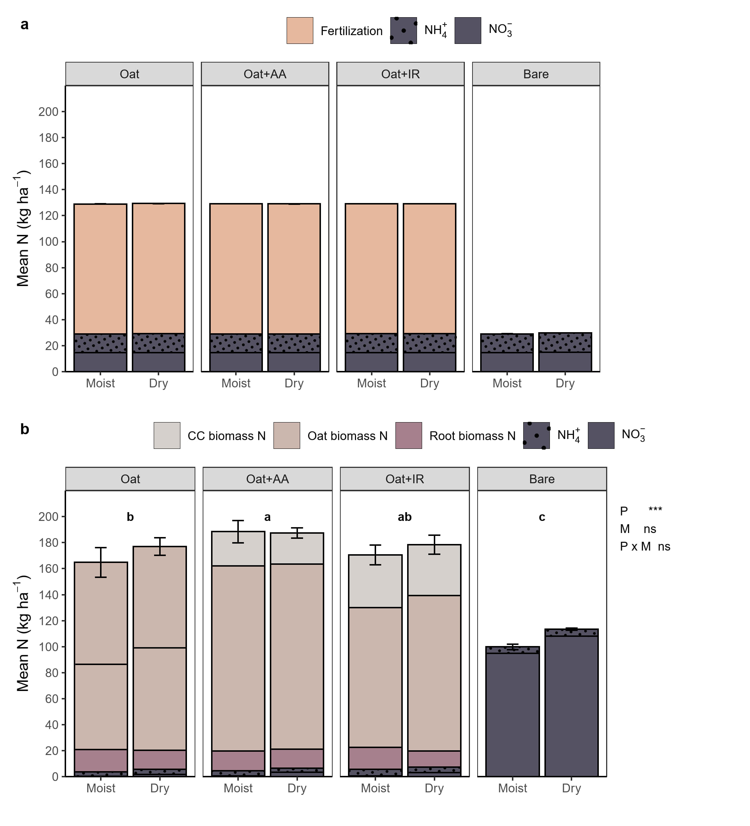
Fig. S5 Nitrogen fractions and their sums at the start of the experiment (a) and at the end of the experiment (b). At the start of the experiment N in the pots consisted of NH₄⁺ and NO₃⁻ in soil and in vegetated pots also fertilization. At the end of the experiment N was distributed into plants and roots in vegetated pots as well as soil NH₄⁺ and NO₃⁻ in all plant cover treatments. Plant cover (P) had a significant effect, oat-alfalfa mixture having higher total N compared to oat alone. Plant cover × soil moisture interaction (P × M) or soil moisture (M) did not influence the total N in the pots. Different letters denote significant differences among plant treatments based on estimated marginal means (Tukey adjustment, p < 0.001)

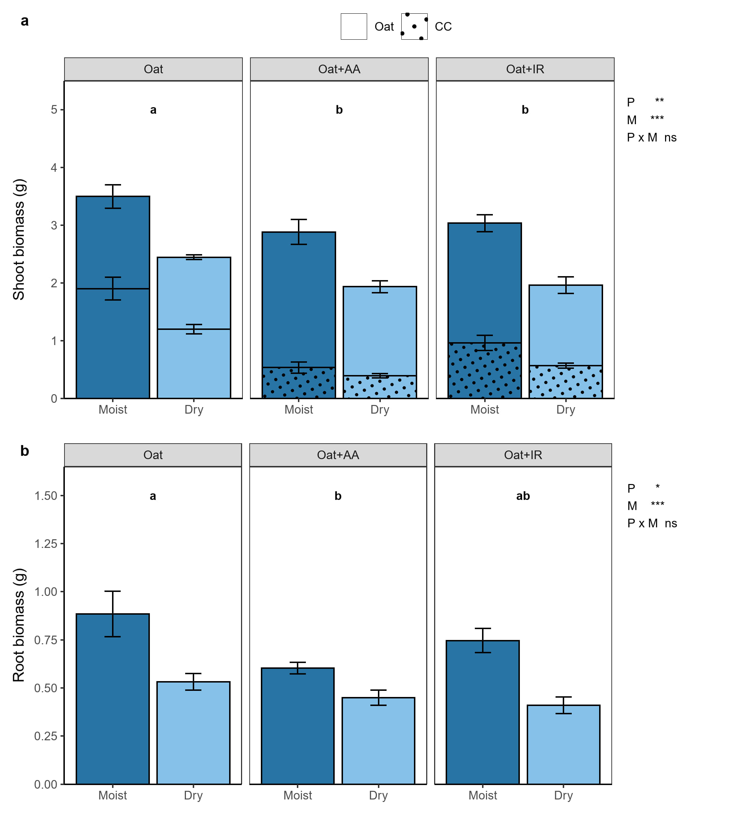
Fig. S6 Shoot (a) and root (b) biomasses. The stacked bars in A show the biomass of separate plants in the pot. The effect of soil moisture and plant cover was tested only for the total biomass in the pot. Two-way ANOVA showed significant main effects of plant cover (P) and soil moisture (M) on both shoot and root biomass. Plant cover × soil moisture interaction (P × M) had no significant effect on either (*p < 0.05; **p < 0.01; ***p < 0.001; ns = not significant). Different letters denote significant differences among plant treatments based on estimated marginal means (Tukey adjustment, p < 0.05)
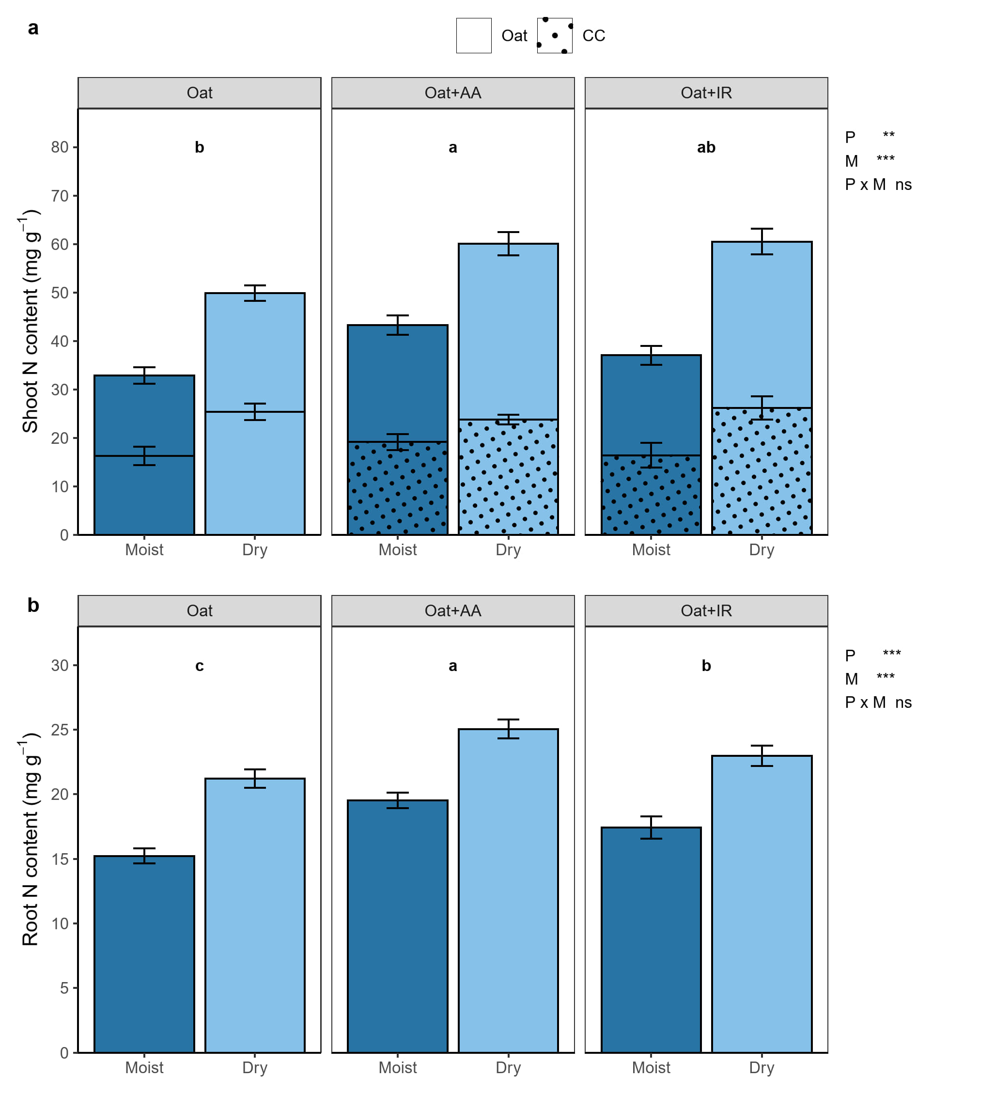
Fig. S7 Shoot (a) and root (b) N contents (mg g ⁻¹ dry biomass). Stacked bars in A show the contents of the two separate plants. Two-way ANOVA showed significant main effects of plant cover (P) on both shoot and root N content. Under dry conditions N content in both plants and shoots were significantly higher than under moist conditions (M). Plant cover × soil moisture interaction (P × M) had no significant effect on either (*p < 0.05; **p < 0.01; ***p < 0.001; ns = not significant). Different letters denote significant differences among plant treatments based on estimated marginal means (Tukey adjustment, p < 0.05)

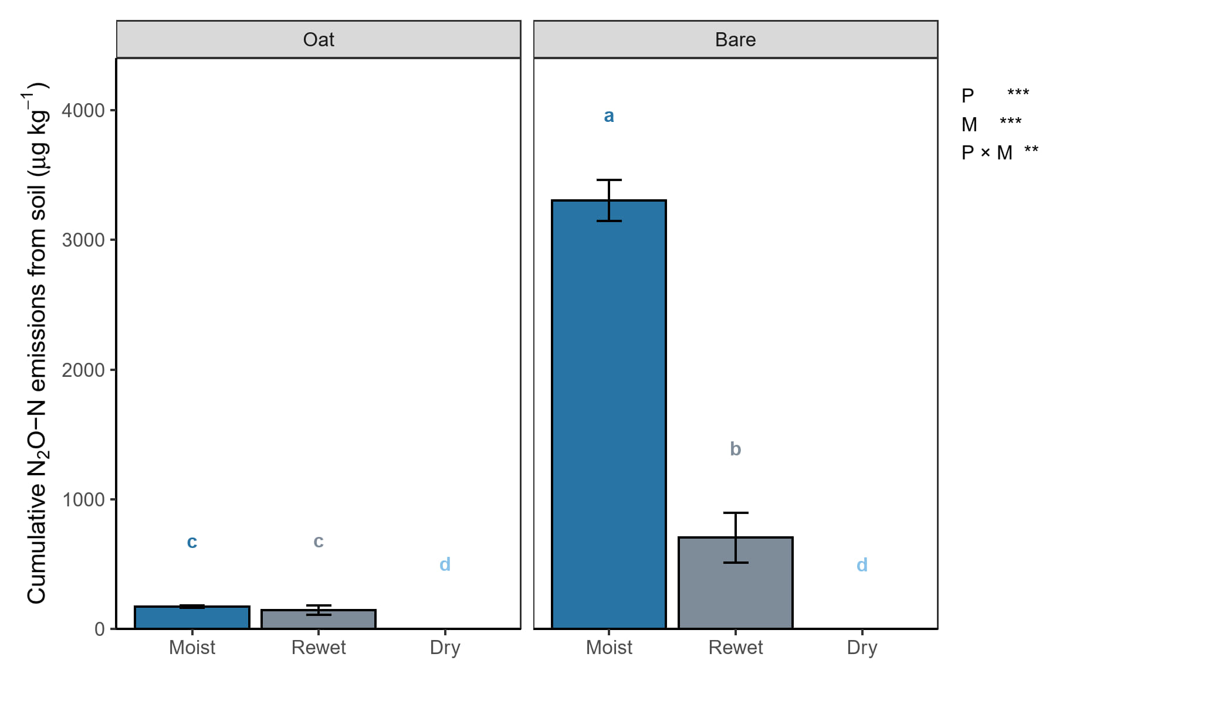
Fig. S8 Mean (± SE) cumulative soil N₂O emissions during the 48-h incubation experiment in soil previously cultivated with oats (n=5) and in bare soil (n=5). Two-way ANOVA reveal significant effects of plant cover treatment (P), soil moisture (M), and their interaction (P × M). Lowercase letters denote significant differences among treatments (p < 0.05)

