Nonlinear and Lagged Associations of Compound Cold Wave–PM_{2.5} Pollution Exposure with Cardiovascular Emergency Ambulance Calls: A Time-Series Study in Shijiazhuang, China
Siyuan Chen^{1,2}, Mengna Li^{1,3}, Yishan Ding^{1,2}, Ning Xu^{1,3}, Mingyang Guan^{1,4,5*}, Fengge Chen^{1,4,5}, Junwang Tong²
1. Department of Public Health Monitoring and Evaluation, Shijiazhuang Center for Disease Control and Prevention, Shijiazhuang,Hebei, China
2. School of Public Health, North China University of Science and Technology, Tangshan, Hebei, China
3. School of Public Health, Hebei Medical University, Shijiazhuang, Hebei, China
4. Research Base for Environment and Health in Shijiazhuang, Chinese Center for Disease Control and Prevention, Shijiazhuang, Hebei, China.
5. Hebei Key Laboratory of Intractable Pathogens, Shijiazhuang, China
Corresponding author: Mingyang Guan, Department of Public Health Monitoring and Evaluation, Shijiazhuang Center for Disease Control and Prevention, Shijiazhuang,Hebei, China; Research Base for Environment and Health in Shijiazhuang, Chinese Center for Disease Control and Prevention, Shijiazhuang, Hebei, China; Hebei Key Laboratory of Intractable Pathogens, Shijiazhuang, China. Email: gmyguan@126.com
Funding Program:
The Hebei Natural Science Foundation (Project No. H2026106020)
2024 Shijiazhuang Municipal Science and Technology Plan (Project No. 2414605403)

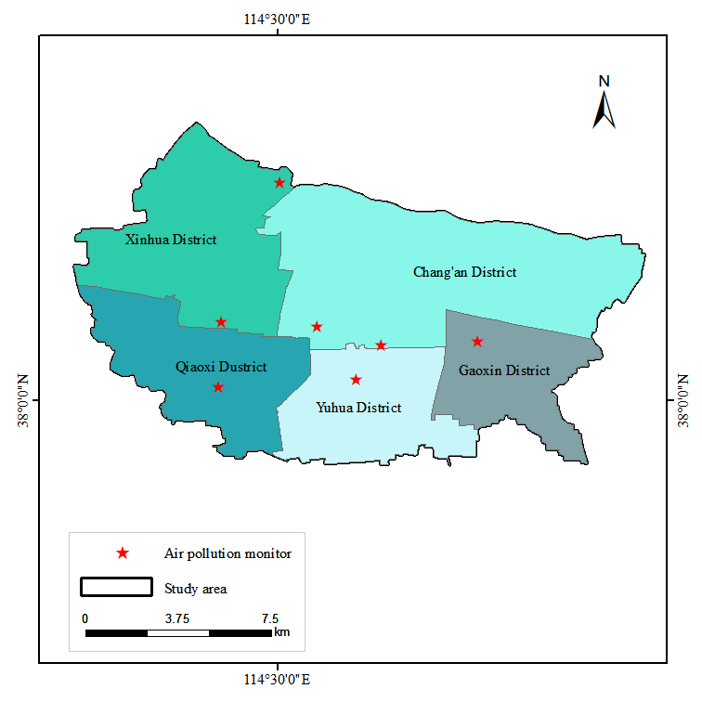
Figure S1 Spatial distribution of air quality monitoring stations in Shijiazhuang

Table S1 Akaike Information Criterion (AIC) values for different definitions of cold wave–PM_{2.5} compound exposure events.
Combined events | Circulatory system diseases
P1T1 | 23260.4
P1T2 | 23260.2
P1T3 | 23259.7
P2T1 | 23260.4
P2T2 | 23260.3
P2T3 | 23259.6
P3T1 | 23254.7
P3T2 | 23257.3
P3T3 | 23254.7
P4T1 | 23237.6
P4T2 | 23257.3
P4T3 | 23249.3

Table S2 Sensitivity analyses for the joint effects of cold wave–PM_{2.5} compound exposure under different lag structures, covariate adjustments, and model specifications.
Analysis type | Specification | CRR (P4T1) | CRR (P4T3)
Main model | Lag 0–21 | 1.008 (0.950-1.069) | 1.013 (0.954-1.076)
Lag | 0–28 | 1.018 (0.954-1.087) | 1.040 (0.978-1.107)
Adjustment | + O3 | 1.008 (0.950-1.069) | 1.014 (0.955-1.077)
Model df | Time df=8 | 1.004 (0.944-1.068) | 1.013 (0.953-1.077)
 | RH df=4 | 1.006 (0.948-1.067) | 1.012 (0.953-1.075)
 | RH df=5 | 1.006 (0.949-1.067) | 1.012 (0.953-1.075)

