Additional file 1. Supplementary tables and figures
eTable 1. Sensitivity analyses for transition from CVD-free to CVD per one-component metabolic increase
Analysis | Adjusted OR (95% CI) | P value | Participants | Events
Inverse-probability-of-observation weighting | 1.14 (1.06-1.21) | <0.001 | 3,553 | 905
Blood-sample weighting | 1.14 (1.04-1.24) | 0.005 | 3,520 | 897
Excluded baseline diabetes | 1.14 (1.06-1.23) | <0.001 | 3,343 | 824
2018-2020 interval only | 1.19 (1.03-1.37) | 0.016 | 2,695 | 203
All models used the same covariates as the primary model. CI, confidence interval; CVD, cardiovascular disease; OR, odds ratio.

eTable 2. Observed state transitions by follow-up interval
Interval | Transition | Records, n | Within-origin state, %
2015-2018 | CVD-free to CVD-free | 2,956 | 77.4
2015-2018 | CVD-free to CVD | 724 | 19.0
2015-2018 | CVD-free to death | 139 | 3.6
2015-2018 | CVD to CVD | 670 | 94.0
2015-2018 | CVD to death | 43 | 6.0
2018-2020 | CVD-free to CVD-free | 2,580 | 89.7
2018-2020 | CVD-free to CVD | 215 | 7.5
2018-2020 | CVD-free to death | 81 | 2.8
2018-2020 | CVD to CVD | 1,264 | 95.5
2018-2020 | CVD to death | 60 | 4.5
Percentages are calculated within each interval and origin state. CVD, cardiovascular disease.

eTable 3. Sensitivity analyses for the continuous metabolic-change exposure across all transitions
Transition | Analysis | Adjusted OR (95% CI) | P value | Participants | Events
CVD-free to CVD | Primary | 1.14 (1.06-1.21) | <0.001 | 3,553 | 905
CVD-free to CVD | Blood-sample weighted | 1.14 (1.04-1.24) | 0.005 | 3,520 | 897
CVD-free to CVD | Observation weighted | 1.14 (1.06-1.21) | <0.001 | 3,553 | 905
CVD-free to CVD | Excluded baseline diabetes | 1.14 (1.06-1.23) | <0.001 | 3,343 | 824
CVD-free to CVD | 2018-2020 only | 1.19 (1.03-1.37) | 0.016 | 2,695 | 203
CVD-free to death | Primary | 1.08 (0.93-1.25) | 0.293 | 2,984 | 212
CVD-free to death | Blood-sample weighted | 1.10 (0.94-1.30) | 0.237 | 2,956 | 210
CVD-free to death | Observation weighted | 1.09 (0.94-1.26) | 0.273 | 2,984 | 212
CVD-free to death | Excluded baseline diabetes | 1.06 (0.90-1.24) | 0.476 | 2,825 | 195
CVD-free to death | 2018-2020 only | 1.19 (0.94-1.51) | 0.152 | 2,571 | 79
CVD to death | Primary | 0.91 (0.74-1.12) | 0.374 | 1,374 | 101
CVD to death | Blood-sample weighted | 0.82 (0.64-1.03) | 0.091 | 1,364 | 100
CVD to death | Observation weighted | 0.91 (0.73-1.12) | 0.378 | 1,374 | 101
CVD to death | Excluded baseline diabetes | 0.88 (0.70-1.10) | 0.255 | 1,238 | 88
CVD to death | 2018-2020 only | 0.85 (0.65-1.12) | 0.259 | 1,292 | 59
Odds ratios are per one-component increase in metabolic burden. All models used the covariates specified for the primary analysis. CI, confidence interval; CVD, cardiovascular disease; OR, odds ratio.
eFigure 1. Distribution of metabolic-change categories from 2011 to 2015.
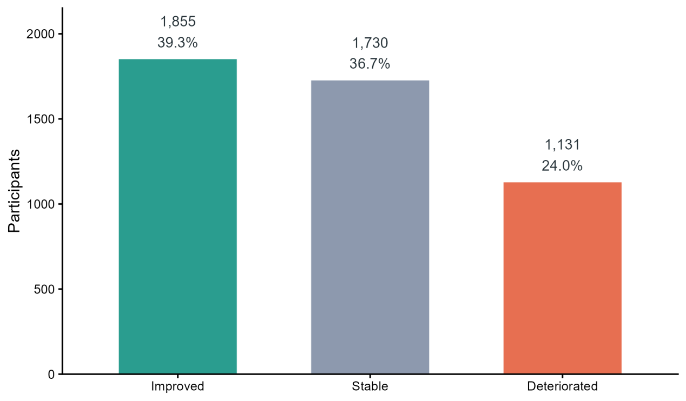
eFigure 2. Sensitivity analyses for the transition from CVD-free to CVD.
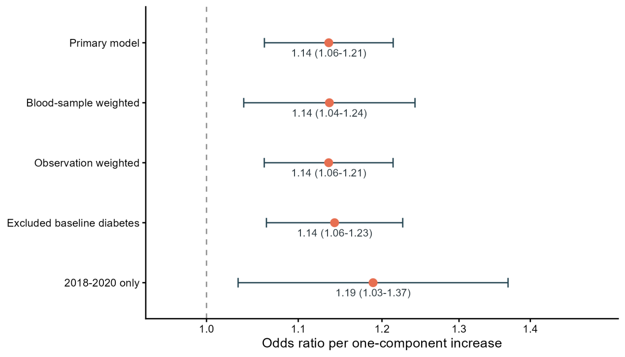
eFigure 3. Mean metabolic component counts in 2011 and 2015 according to change category.
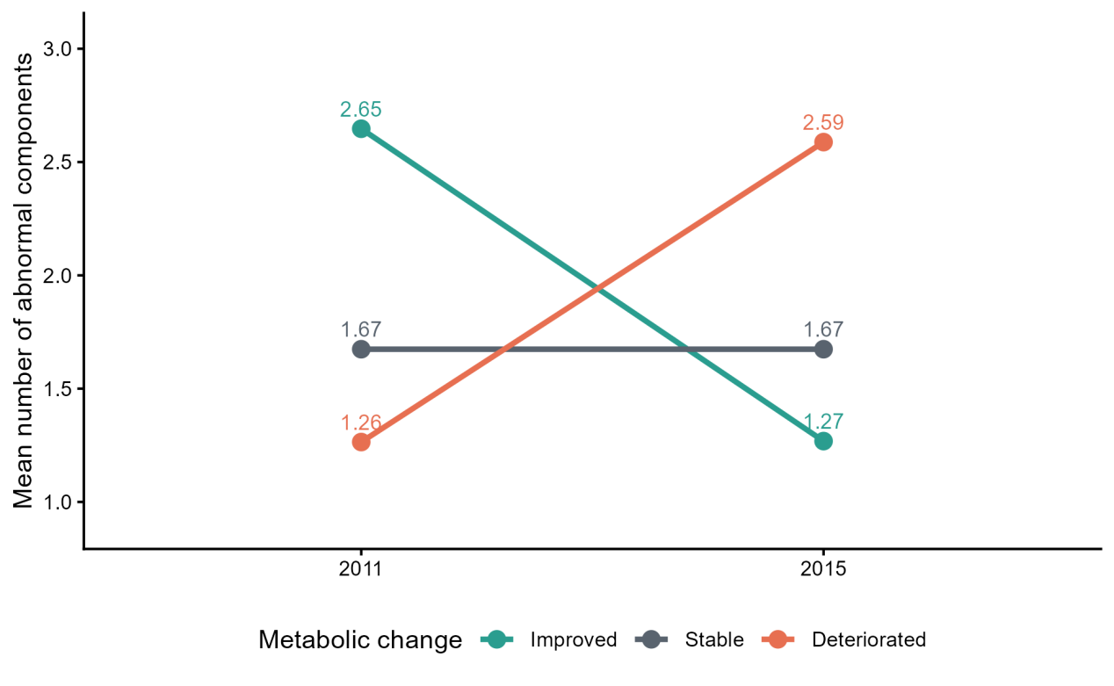
eFigure 4. Categorical metabolic change and subsequent state transitions.
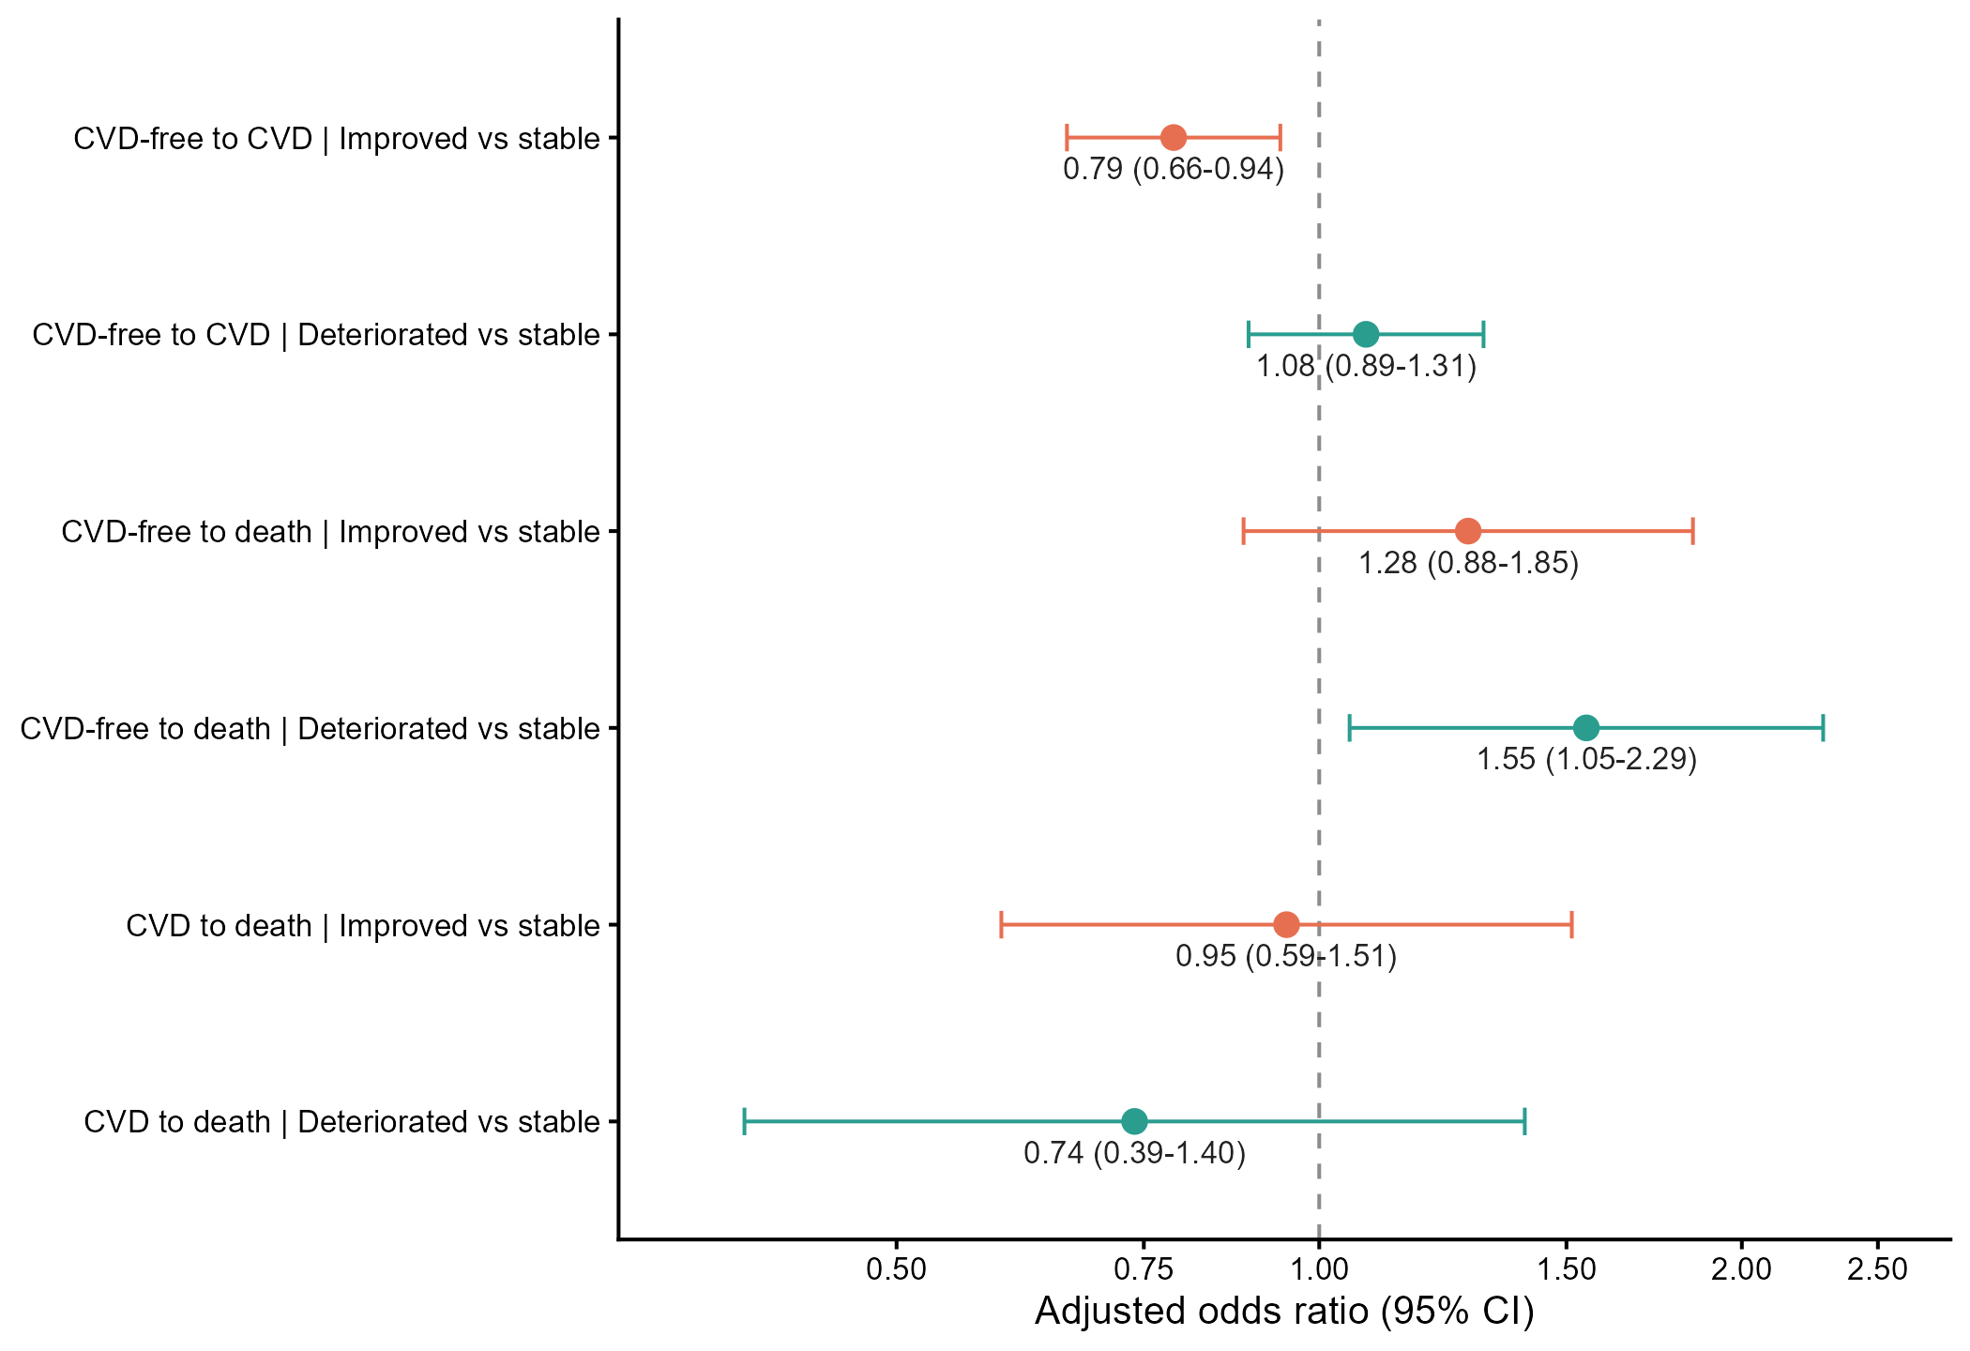

eTable 4. Sensitivity analysis using Asian-specific waist circumference thresholds
Transition | Exposure | Adjusted OR (95% CI) | P value | FDR P | Participants | Events
CVD-free to CVD | Per one-component increase | 1.14 (1.06-1.21) | <.001 | .002 | 3,553 | 905
CVD-free to CVD | Improved vs stable | 0.84 (0.70-1.00) | .052 | .118 | 3,553 | 905
CVD-free to CVD | Deteriorated vs stable | 1.14 (0.94-1.38) | .170 | .306 | 3,553 | 905
CVD-free to death | Per one-component increase | 1.03 (0.89-1.20) | .670 | .767 | 2,984 | 212
CVD-free to death | Improved vs stable | 1.54 (1.06-2.23) | .022 | .066 | 2,984 | 212
CVD-free to death | Deteriorated vs stable | 1.79 (1.21-2.66) | .004 | .016 | 2,984 | 212
CVD to death | Per one-component increase | 0.93 (0.75-1.14) | .475 | .712 | 1,374 | 101
CVD to death | Improved vs stable | 1.11 (0.68-1.79) | .682 | .767 | 1,374 | 101
CVD to death | Deteriorated vs stable | 1.00 (0.55-1.83) | .998 | .998 | 1,374 | 101
Asian-specific central obesity was defined as waist circumference >=90 cm in men and >=80 cm in women. Models adjusted for the revised 2011 metabolic component count, age, sex, education, marital status, rural hukou, current smoking, sleep duration, and follow-up period, with participant-clustered robust standard errors. The categorical mortality estimates were not supported by the continuous exposure and should be interpreted as exploratory. CI, confidence interval; CVD, cardiovascular disease; FDR, false discovery rate; OR, odds ratio.

