Supplementary

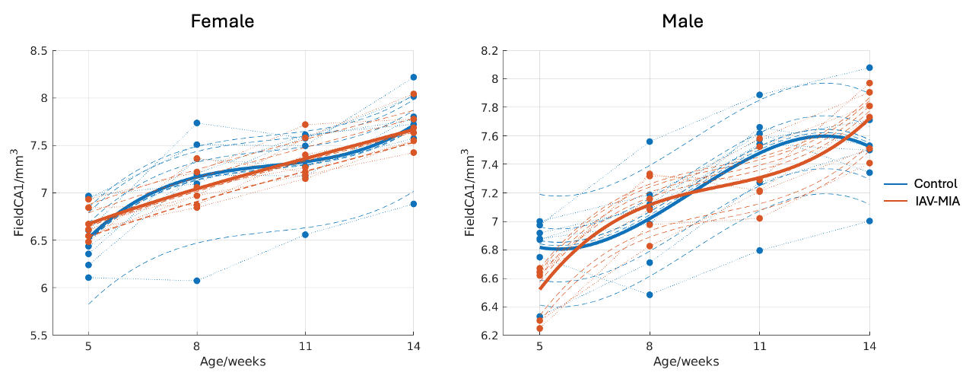
Trajectories of CA1 from atlas-based analysis
Figure 1: Maternal IAV exposure alters sex-specific developmental trajectories of hippocampal CA1 volume. Longitudinal volumetric trajectories of the CA1 region in male and female offspring in IAV and PBS groups. Plots depict volumetric changes in the CA1 region from 5 to 14 weeks of age. Blue lines represent the PBS group, and red lines represent the IAV group. Dashed lines indicate individual mouse trajectories, and solid lines represent the group mean trajectories. Following mixed-effects modelling and FDR correction, Field CA1 was the only atlas region showing significant treatment-related sex- and age-dependent developmental effects. The treatment × sex × age term was significant in CA1 (raw p = 0.000269; FDR-adjusted p = 0.0242; adjusted R² = 0.90).

Trajectories of other brain regions from atlas-based analysis

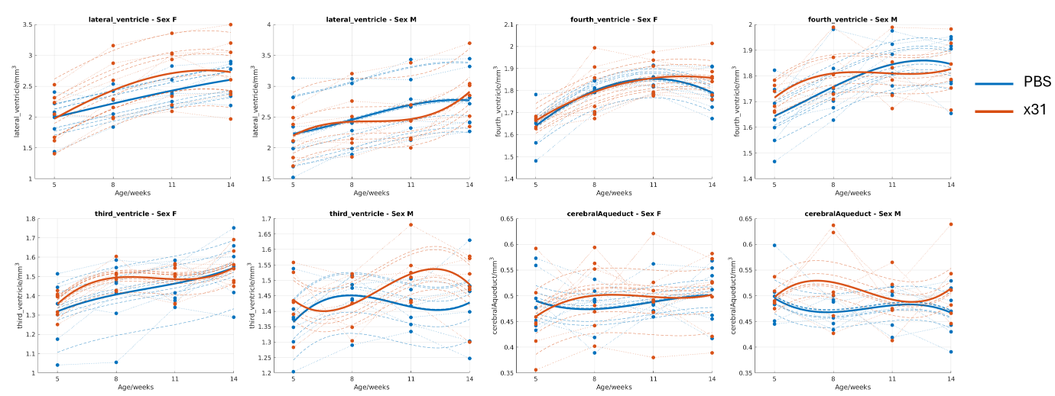
Ventricles

Figure 2: Longitudinal volumetric trajectories of brain ventricles in the atlas-based analysis. The plots illustrate the volumetric changes in various brain ventricles (lateral ventricle, fourth ventricle, third ventricle, and cerebral aqueduct) across different ages (5, 8, 11, and 14 weeks) in male and female mice. The offsprings were subjected to two conditions: PBS (blue) and MIA (orange). Each subplot represents a specific ventricle and sex combination, showing the mean volume (bold lines) and individual trajectories (dashed lines). The data indicate sex-specific and treatment-specific effects (p<0.05 before multiple-comparison correction) on brain ventricle development.

In Figure 2, both males and females have an increase in volume with age in the lateral ventricle, but the age trajectory of the MIA-treated group (x31) shows a unique pattern from the control. The fourth ventricle, too, showed an age-related volumetric change, but the MIA treatment resulted in altered growth patterns, particularly evident in male mice. The third ventricle and cerebral aqueduct are both regions where there are large volumetric trajectory differences between the PBS and the x31 group, and these were larger in the males than the females. As shown in the above trajectories, there are trends suggesting a dynamic and sex-specific MIA effect across the brain during the development, which we have furtherly investigated using longitudinal TBM with cluster-based corrections as in the later result section in the main text.

Cerebral cortex
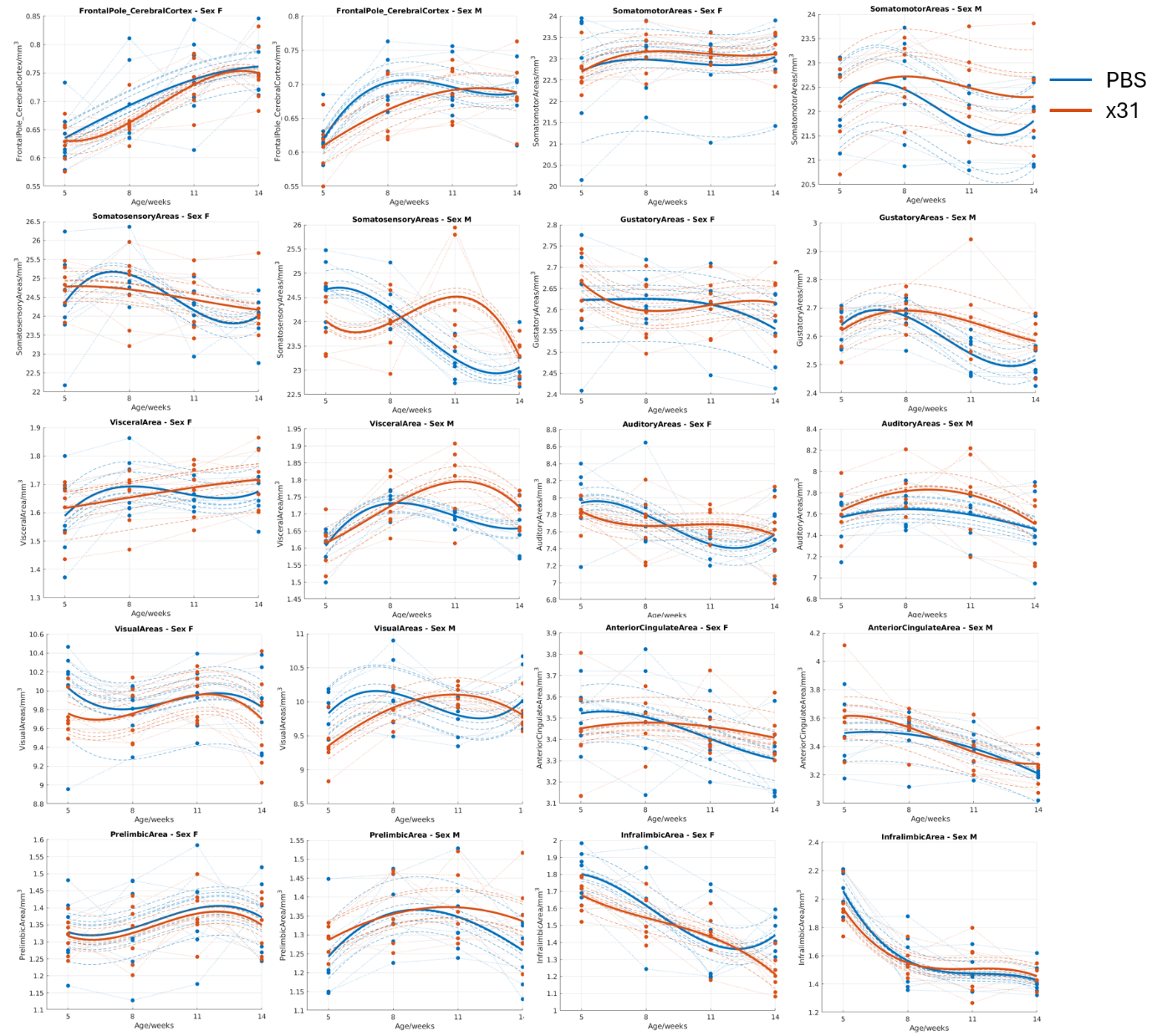
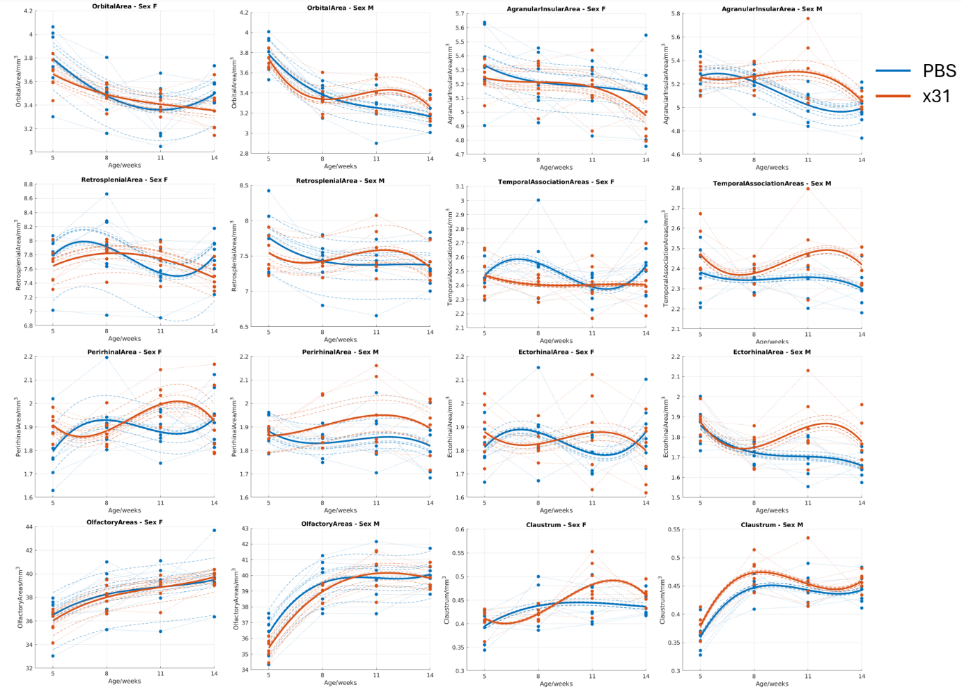
Figure 3: Longitudinal volumetric trajectories of cerebral cortex in the atlas-based analysis.

Hippocampal formation
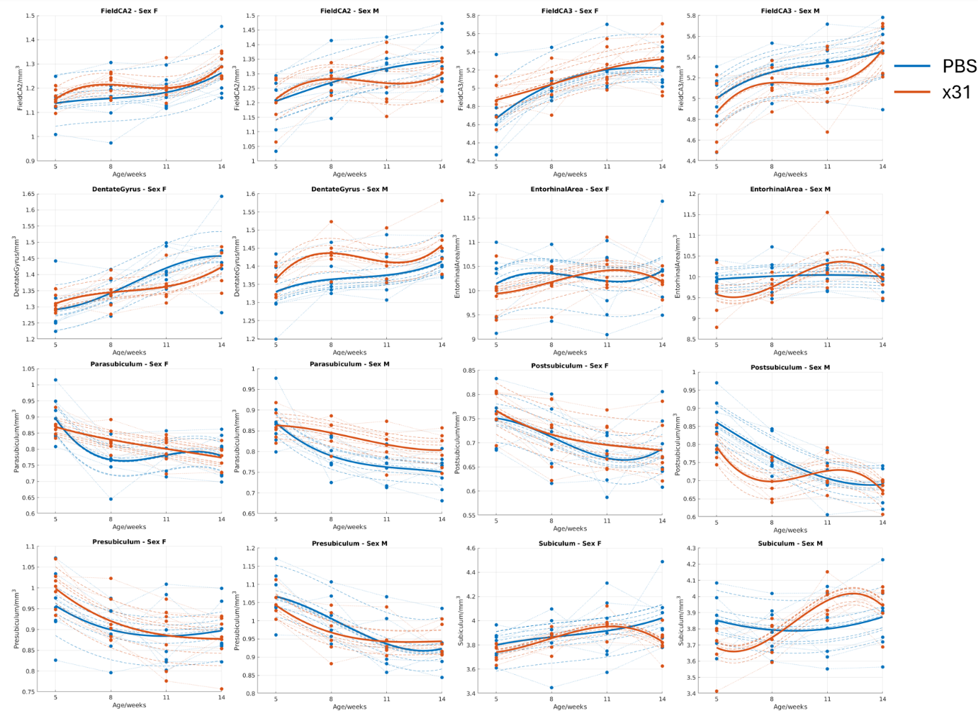
Figure 4: Longitudinal volumetric trajectories of hippocampal formation in the atlas-based analysis.

Cortical subplate and cerebral nuclei
Figure 5: Longitudinal volumetric trajectories of cortical subplate and cerebral nuclei in the atlas-based analysis.

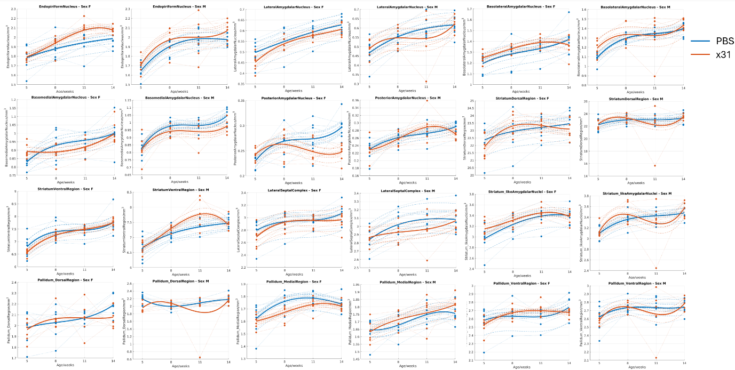
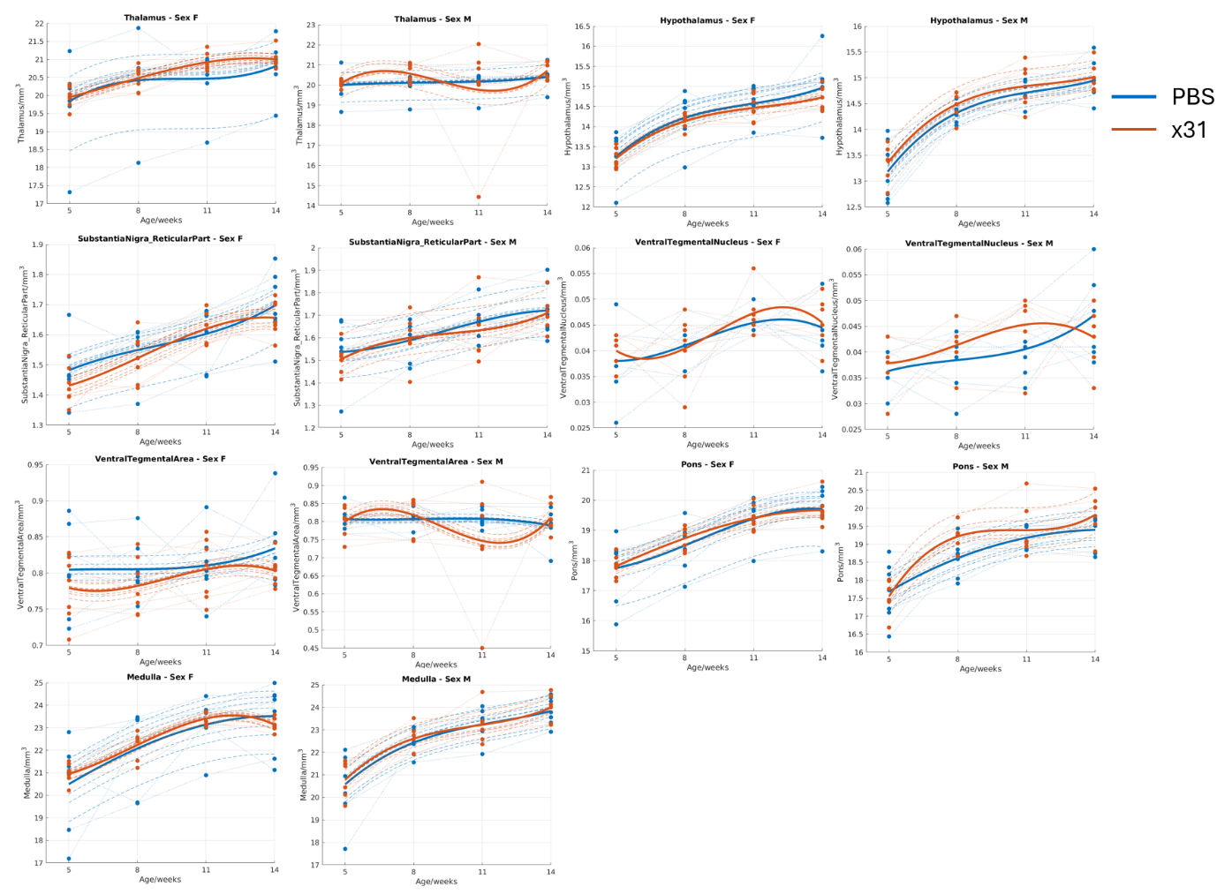
Brain stem
Figure 6: Longitudinal volumetric trajectories of brain stem in the atlas-based analysis.

Cerebellum

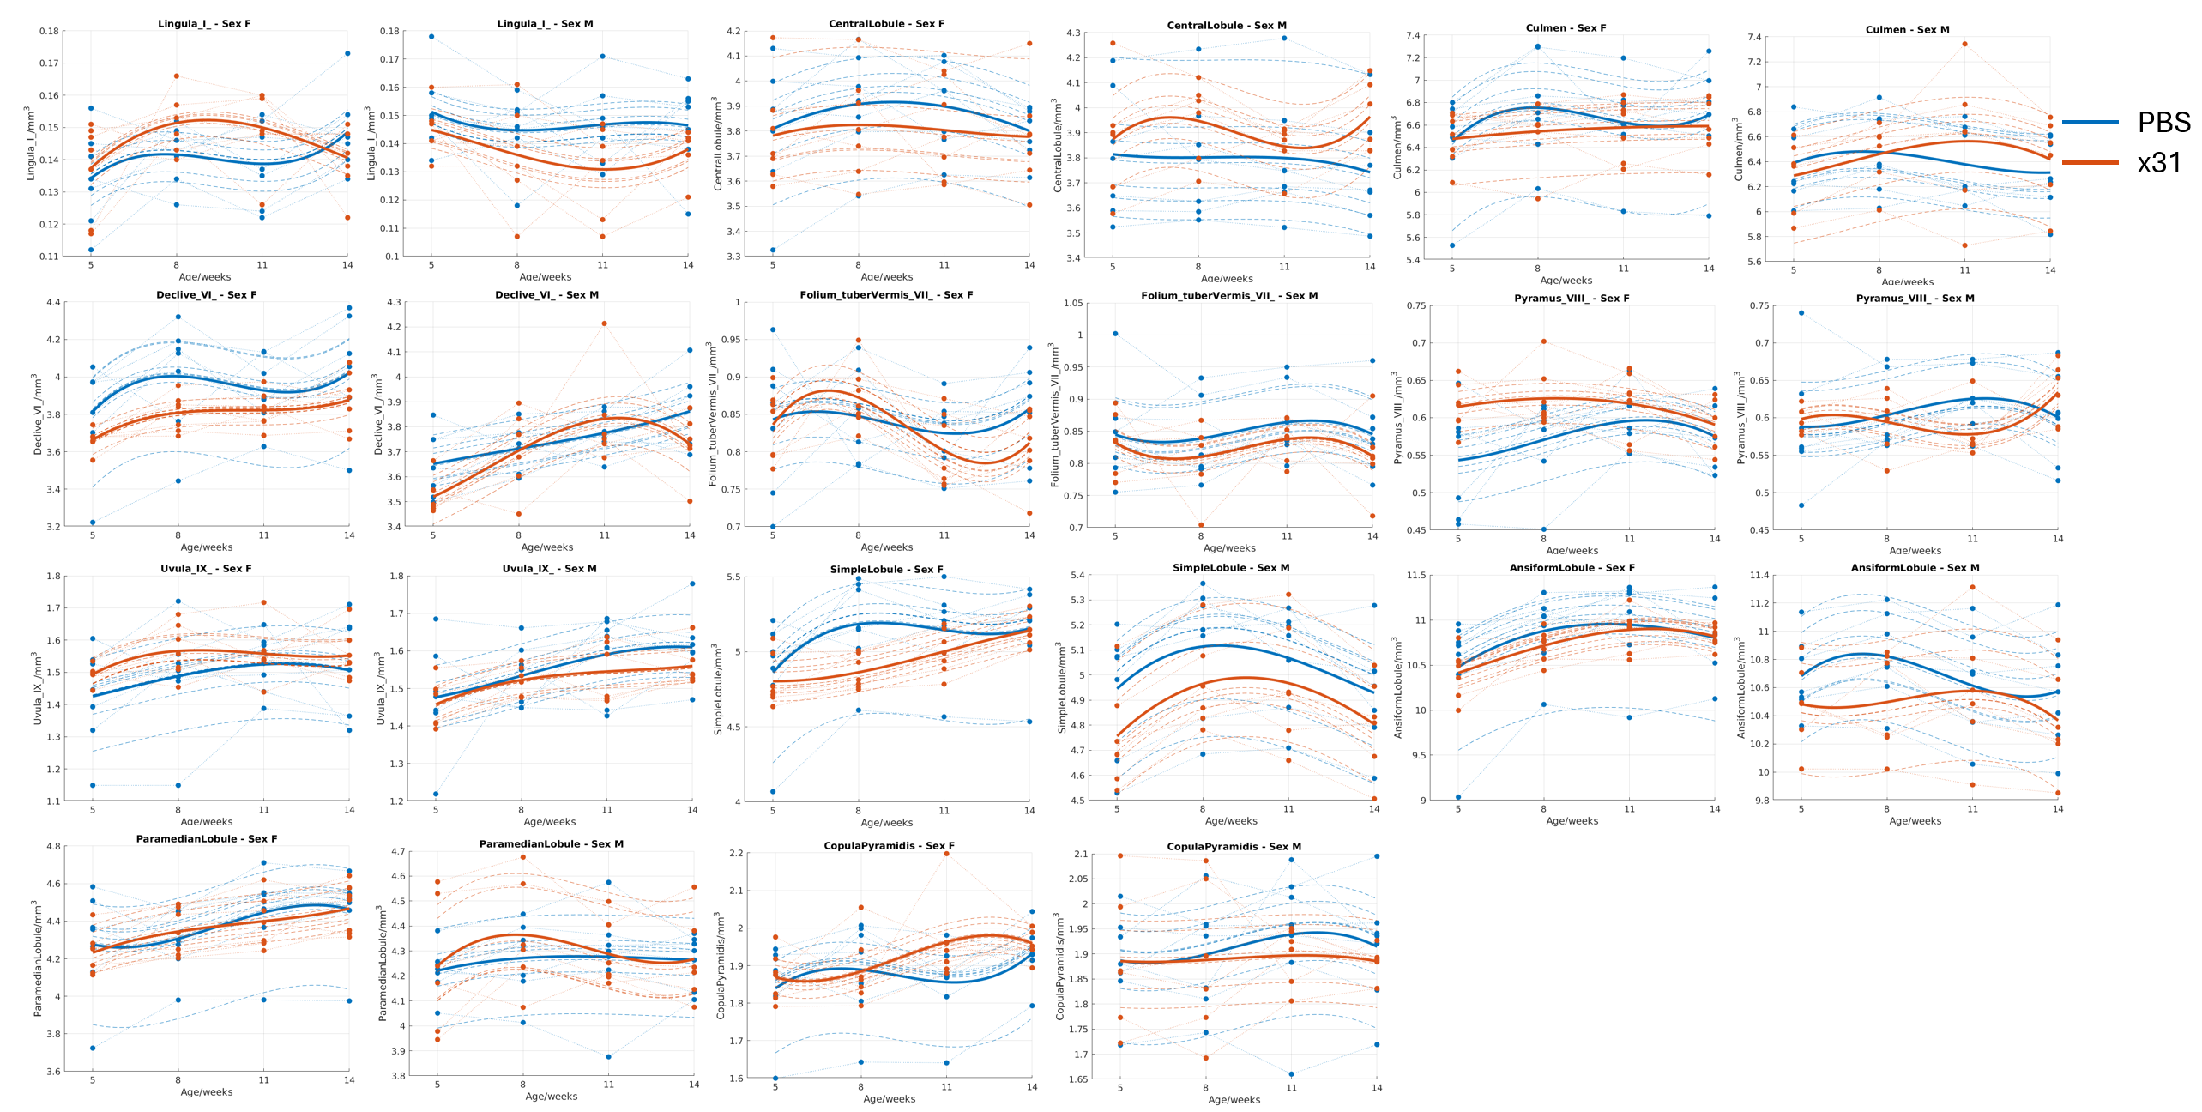
Figure 7: Longitudinal volumetric trajectories of cerebellum in the atlas-based analysis.

TBM

Main MIA effects

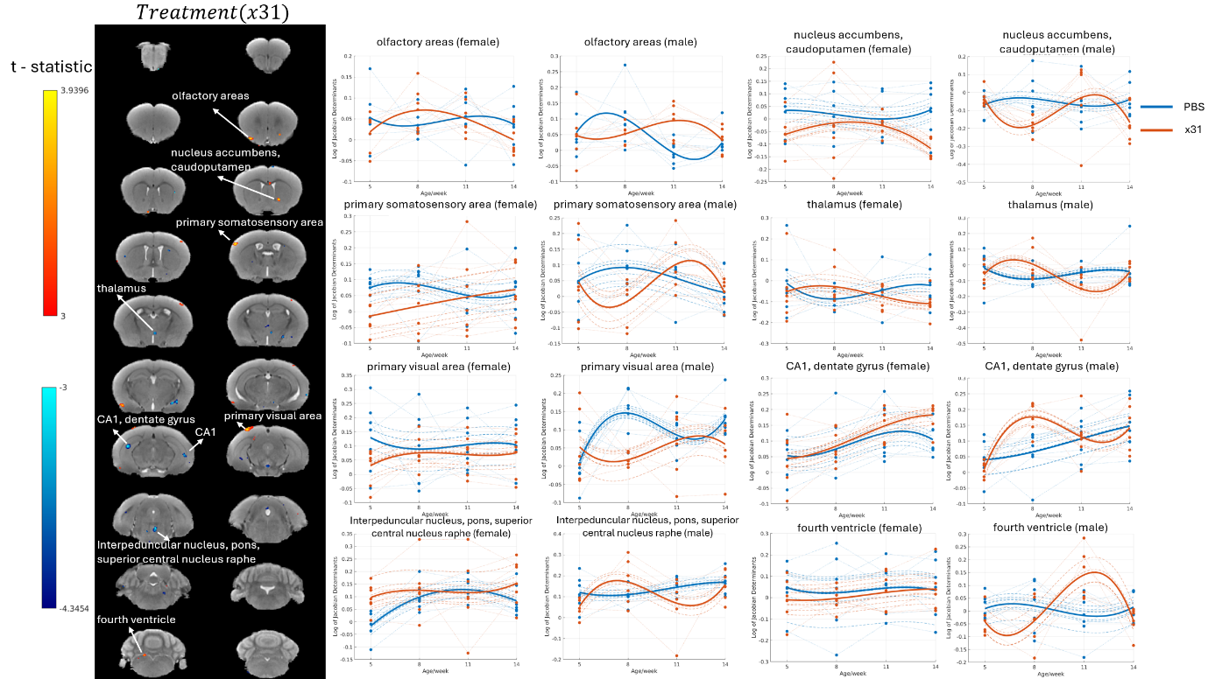
Figure 8: Longitudinal Analysis of Brain Volume Changes Due to Main MIA effects. The left panel displays the t-statistic map illustrating the main effects of x31 (MIA) on longitudinal data, with significant areas indicated by arrows. The color bar represents the t-statistic range, with warmer colors (yellow to red) indicating higher t-values and cooler colors (blue) indicating lower t-values. The right panel presents the volumetric trajectories for significant brain regions, separated by sex. Blue lines depict the PBS group, and red lines show the x31 group. Connected dotted lines link data points from the same animal across timepoints, while dashed lines represent model-predicted curves for each animal. Thick solid lines indicate the average of these predictions. Dots correspond to individual animal data points at each timepoint.
The longitudinal analysis of the brain volume changes using mixed effects model demonstrated significant effects of MIA in areas of the brain, as demonstrated in Figure 8; In this study we compared differences between X31 treatment vs the PBS control group and produced the statistical parametric maps shown on the left with arrows indicating regions of significant differences. The colour bar shows t-statistic values with warmer colours representing higher t-statistic values. The clusters including olfactory areas, the nucleus accumbens, the caudoputamen, the primary somatosensory area, the thalamus, the CA1, the dentate gyrus, the primary visual area, the interpeduncular nucleus, the pons, the superior central nucleus raphe, and the fourth ventricle were identified as significantly affected areas where X31 group was notably different from PBS group.

In the olfactory areas, the PBS and x31 trajectories diverge sharply, with x31 exhibiting significantly increased volume over time in both sexes. The primary somatosensory area displays prominent treatment effects with a unique pattern for the x31 group when compared with that of the PBS group – specifically, in the male brain.

Importantly, region-specific volumetric changes in the nucleus accumbens and caudoputamen spanned the rapport sessions, with the x31 group showing greater volumetric change over time compared with the PBS group and reaching significance in females. In addition, differential trajectories between the treatment groups were observed in the thalamus and CA1 regions, indicating region-specific responses to MIA.

Brain changes were seen in the primary visual area, dentate gyrus, interpeduncular nucleus, pons, superior central nucleus raphe, and the fourth ventricle. These areas showed different patterns of changes between the x31 group and the PBS group. These results suggest widespread and complicated regional-specific changes in brain structure following the x31 treatment.

Overall, the longitudinal change trajectories illustrated in Figure 7 provide a convincing temporal evolution of brain region alterations due to the administration of x31, revealing the dynamic and differential mechanism of this intervention across different brain regions and sexes.

MIA×Age² effects
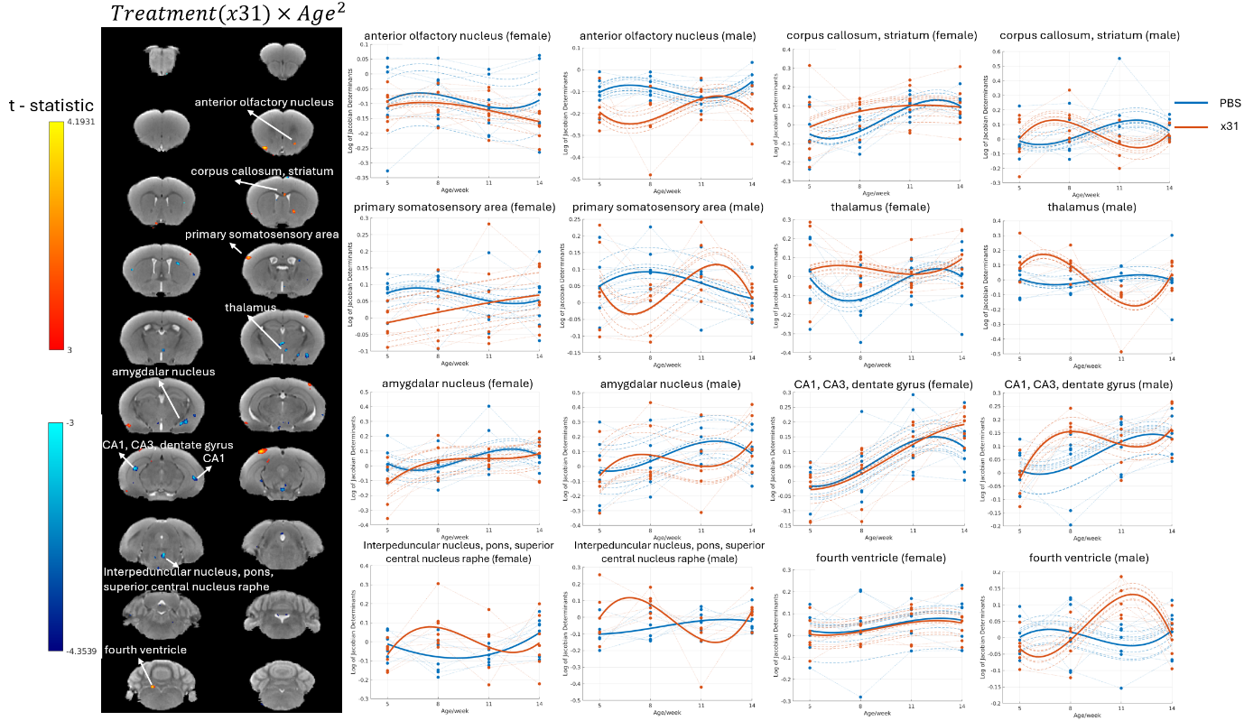
Figure 9: Longitudinal Analysis of Brain Volume Changes Due to Treatment×Age² effects. The left panel presents the t-statistic map for the x31*Age^2 interaction effects derived from the mixed effect model on longitudinal MRI data. Significant regions are indicated with arrows. The right panel displays the trajectories of significant clusters, with blue lines representing the PBS group and red lines representing the x31 group. Connected dotted lines show individual animal data, dashed lines represent model-predicted curves for each animal, and thick solid lines depict the average of the dashed lines. The dots correspond to data points for each animal at each timepoint.
As illustrated in Figure 9, describing the interaction effects of treatment (x31), age, sex on the different brain regions in mice. Figure 6 shows the significant regions identified by the t-statistic heatmap, which specifically included the anterior olfactory nucleus, corpus, callosum, striatum, primary somatosensory area, thalamus, amygdalar nucleus, CA1, CA3, dentate gyrus, interpeduncular nucleus, pons, superior central nucleus raphe and the fourth ventricle.

Figure 9, right side shows the trends of these informative clusters. For each region, blue lines depict the trajectories of the PBS group, and red lines display the x31 group. Individual animal’s data were joined with dotted lines, which expresses the intraindividual variability for both groups. Dashed lines indicate the model-predicted curves for each animal, and the thick solid lines represent the average trajectories in each group.

x31 group showed more pronounced curvature of trajectories over time in the anterior olfactory nucleus. When derived for the corpus callosum or striatum, the x31 group mice also exhibited a distinct shape of age-related trajectories when compared with the PBS group.

For sex differences, the primary somatosensory area was the region with the significant sex-specific interaction effects: the trajectories of development in x31-treated males and females were altered, but the pattern was sex-specifically differentiated; similarly for the thalamus, which also displayed significant sex-specific interactions because the trajectories of males and females were diverging from each other after x31.

In the amygdalar nucleus there was a significant interaction of age and treatment whereby across ages the volume of the region was greater in the x31 than among controls, suggesting a possible treatment effect on this region. In the hippocampus, there were significant interactions of age and treatment in the CA1, CA3 and dentate gyrus whereby the pattern of age-related changes differed between x31 and PBS.

Lastly, x31 treatment-related significant interactions were found in the interpeduncular nucleus, pons, superior central nucleus raphe, and in the fourth ventricle, among others, with spatial variations and unique time points of ageing among different regions. These results not only reflected a widespread changing pattern in each brain region, but also confirmed the direct effect of x31 treatment in modifying brain functions.

These data indicate that x31 treatment leads to significant age-dependent x31-induced changes consistent with multiple and varying brain-region trajectories in both male and female mice that identify the potential neurobiological influence of x31 treatment over the course of development.

MIA×Sex×Age³ effects
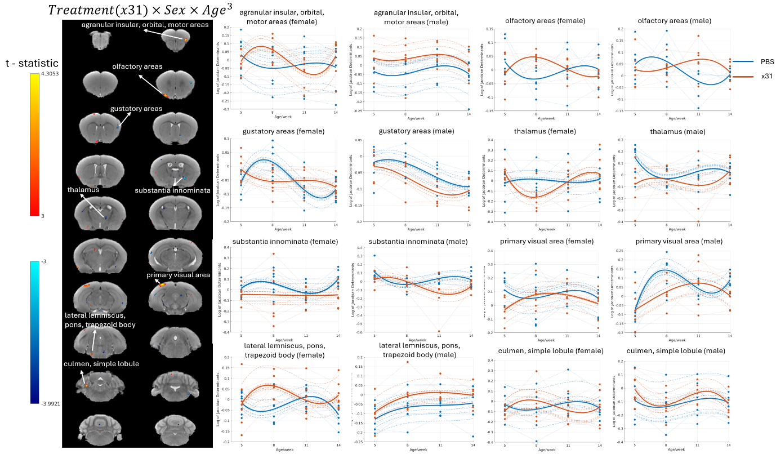
Figure 10: Longitudinal Analysis of Brain Volume Changes Due to Treatment×Sex×Age³ effects. The left panel shows the t-statistic maps for significant x31SexAge^3 interaction effects from a mixed-effects model, with significant regions indicated by arrows. The color scale represents the t-statistic values, with positive values in warm colors and negative values in cool colors. The right panels display longitudinal trajectories for significant clusters in different brain regions for male and female mice. Blue lines represent the PBS group, and red lines represent the x31 group. Dotted lines connect data from the same animal, dashed lines indicate model-predicted trajectories, and thick solid lines show the average predicted curves. Dots represent individual animal data points at each time point.

Figure 10 shows the significant Treatment (x31) x Sex x Age³ interaction effects. Note t-statistic maps depicting interaction effects showing clusters of significant interaction effects, namely in the insular (agranular and orbital), motor, and gustatory areas, olfactory areas, thalamus, substantia innominate, primary visual area, lateral lemniscus, pons, trapezoid body, cumen/simple lobule.

We observed a complex interaction pattern in the gustatory areas where, from PBS to x31 group, males and females showed opposing trends, while in the thalamus, we identified the significant age-related interaction, where the x31 treatment allowed males females to show a unique and opposite trajectory over time.

The substantia innominata showed significant age-related interaction effects in both males and females in the x31 group compared with the PBS group, with increasing divergence of trajectories with age. The primary visual area showed significant age-related interaction effects as well, with the males showing a stronger response to the x31 treatment compared with the females.

Regions where we did see interaction effects were the lateral lemniscus, pons, trapezoid body and culmen/simple lobule, where clear longitudinal differences between treatment groups and sexes were observed. These regions showed important age-related differences between x31 and PBS groups. These data reflect the complex interplay of treatment x sex x age reported in various subcortical brain regions.

Collectively, these results suggest that x31 infusion causes a large effect on brain development and aging, and sex and age have major modulatory influences. These results emphasize the importance of using sex and age when evaluating treatment and whether brain structure and function change as a result.

Correlations of hippocampus formation changes with the other brain regions
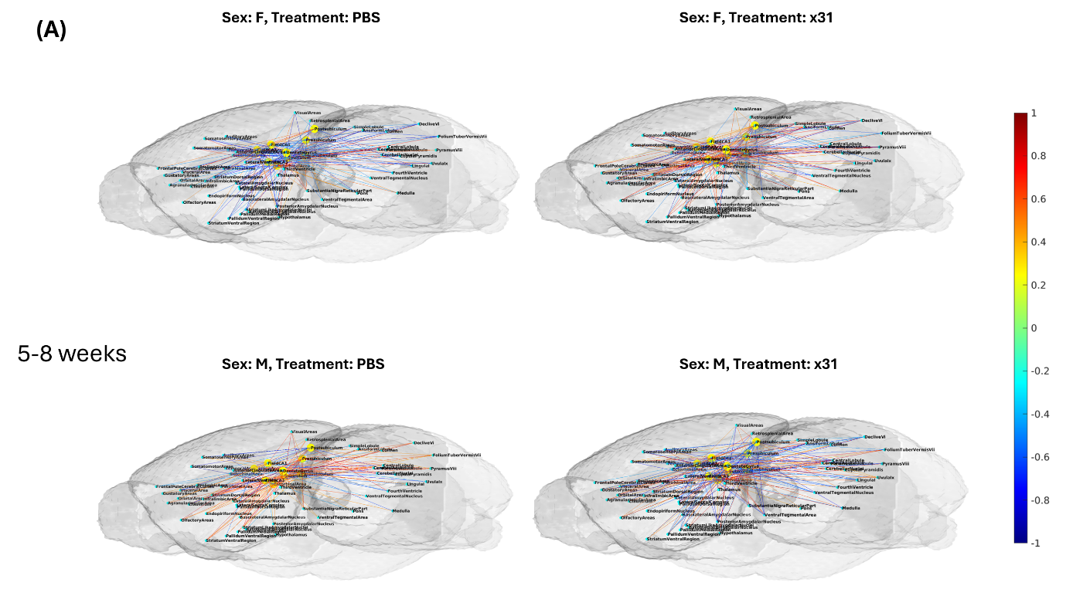
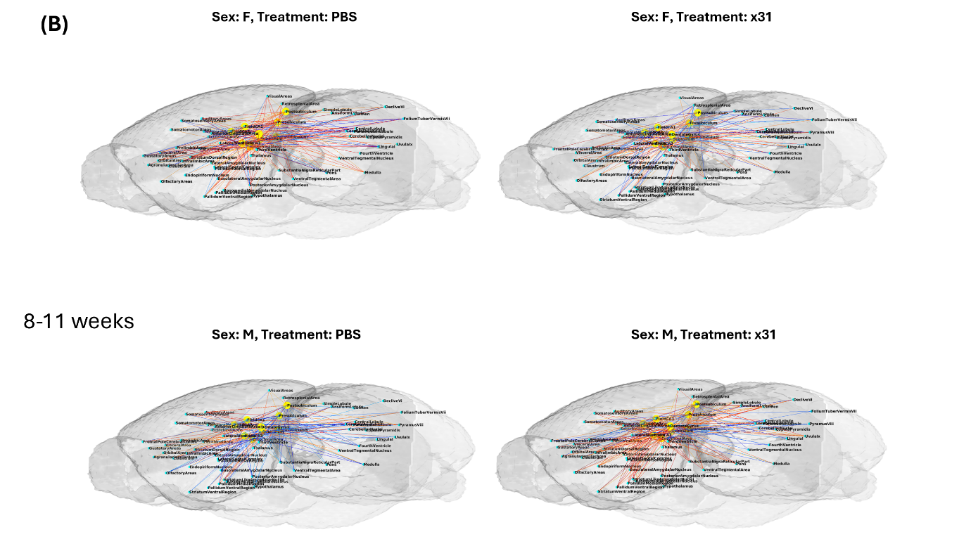

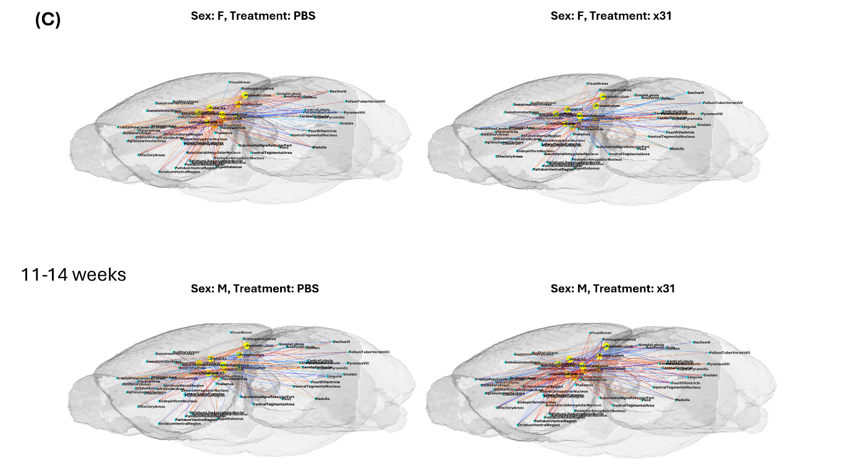
Figure 11: Heatmaps depicting Spearman correlation matrices in 3D for hippocampal formation inter-regional relative volumes changes across three age groups (5-8 weeks, 8-11 weeks, and 11-14 weeks) and within sex and treatment groups (Female/Male, PBS/x31). The color of the lines represents the Spearman correlation coefficient between the hippocampus and other brain regions. Yellow spheres are hippocampal subregions. Cyan spheres are the other brain regions. Permutation test was performed to examine the significance of the numbers of positive and negative correlated region pairs in PBS and x31 group (1000 times). For 8-11 weeks development, males showed a significant p-value of 0.0320 for more positive correlations. For 11-14 weeks development, males also displayed a significant p-value of 0.0330 for more positive correlations. These findings suggest a notable positive correlation pattern in male mice across these age groups.

In order to explore how IAV-MIA influenced inter-regional relative volume changes correlations of hippocampal sub-regions, Spearman correlation was investigated on the hippocampal formations’ relative volume changes for three consecutive age intervals: 5-8 weeks, 8-11 weeks and 11-14 weeks (Figure 11). The overall analysis showed that the effect of IAV-MIA did not get past the FDR threshold, implying that there are limitations in the resolution of the dataset. Nonetheless, enlisting the positive and negative hippocampal regions inter-regional analysis patterns revealed, there is some degree of MIA modulation on inter-regional correlation patterns.

In the 5-8 weeks group females exhibited a low extent of number of negative correlations with a p value of 0.0540 while male mice had almost no difference in p values for the number of positive and even negative correlations (p > 0.05). Starting from age 8 weeks, a significant more positive correlations was observed where male MIA offspring aged 8-11 weeks were treated with x31 (p = 0.0320) while females have no significant changes. Also x31 male aged 11-14 weeks detected significant more positive correlations (p = 0.0330), females are not significant. These findings suggest that the presence of MIA can change the intrahippocampal interregional volume correlations patterns that depend on sex starting from 8 weeks.

Graph theory and correlation networks

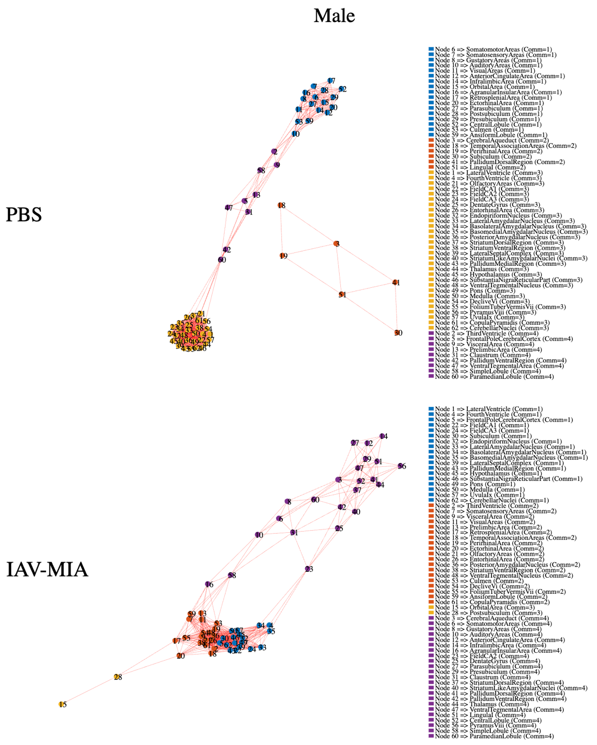
Figure 12: Graphical representation of longitudinal volumetric correlations between brain regions from 5 to 14 weeks of age for male. Edges between regions indicate correlation values exceeding the threshold of 0.625. Different colors signify distinct Louvain communities. The closeness in the IAV-MIA male group was 30% greater than in the Control group (P = 0.0321).

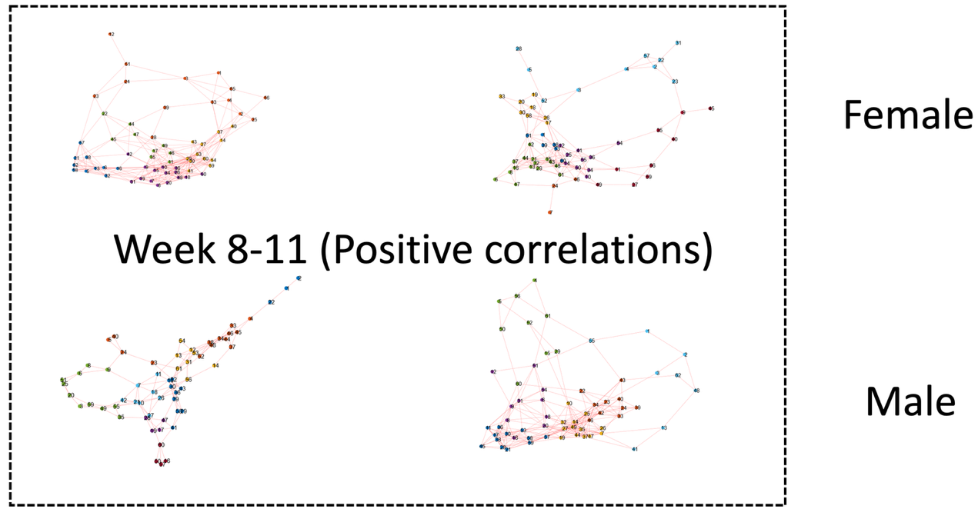
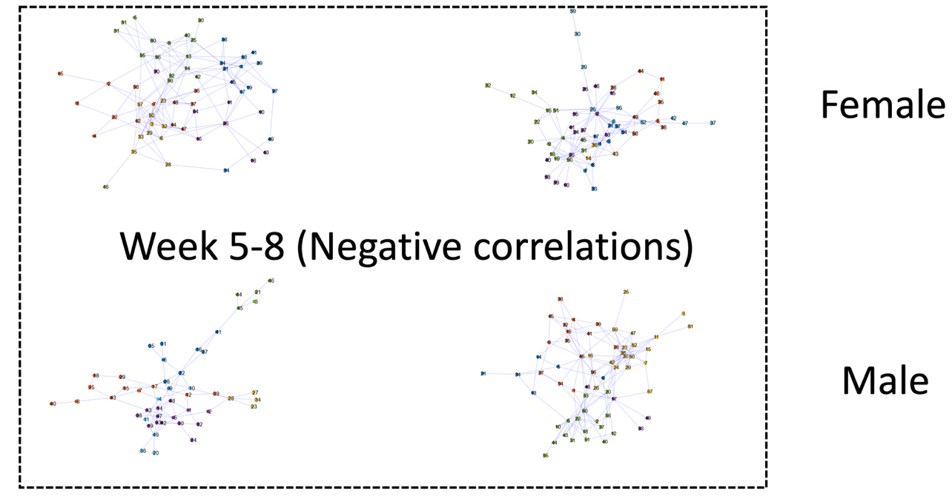
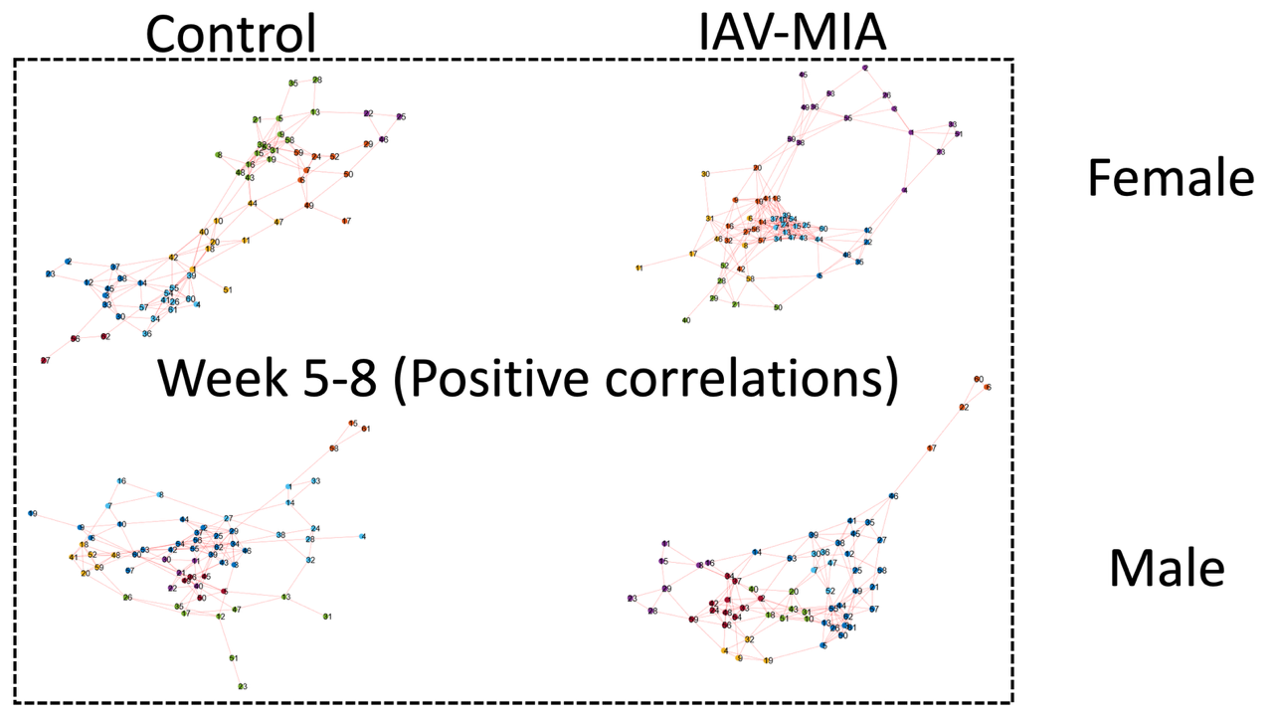
Period (weeks) | Female | Male
5-8 | - (Global Positive) Structure: MIA≠Control (P=0.008) | - (Global Positive) CharPathLength: MIA>Control (P=0.040)  - (Global Negative) Assortativity: MIA<Control (P=0.008)
8-11 | NSNM | - (Global Positive) Transitivity: MIA<Control (P=0.049)
11-14 | NSNM | NSNM
Figure 13: Short‐term correlation networks for female (top rows) and male (bottom rows) offspring, split by treatment (Control vs IAV-MIA). Edge colours correspond to Louvain communities as in Figure 11. IAV-MIA induces marked reshaping of network modules - females exhibit network changes early on, while males show pronounced changes in integration and segregation metrics over week 8.

Figure 14: Summary of significant global graph‐theoretical metrics comparing Control and IAV-MIA networks by sex and developmental period. ‘NSNM’: No significant difference in network metrics

