Supporting information
Pestalachlorides A3a, A3b and pestalotinone E: three new compounds derivative from endolichenic fungi Pestalotiopsis rhododendri

Qing Lv¹·Mengyuan Wang ¹·Mengna Luo¹·Ning He¹·Shanshan Chang¹·Yunying Xie¹

¹CAMS Key Laboratory of Synthetic Biology for Drug Innovation, Institute of Medicinal Biotechnology, Chinese Academy of Medical Sciences & Peking Union Medical College, Tiantan xili No.1, Beijing 100050, People’s Republic of China

Contents
Experimental section 3
Figure S1 (+)-HRESIMS data of pestalachloride A3a (1a) 4
Figure S2. ¹H NMR for pestalachloride A3a (1a) in DMSO-d₆ (600 MHz) 4
Figure S3. ¹³C NMR for pestalachloride A3a (1a) in DMSO-d₆ (150 MHz) 5
Figure S4. HSQC for pestalachloride A3a (1a) in DMSO-d₆ 5
Figure S5. HMBC for pestalachloride A3a (1a) in DMSO-d₆ 6
Figure S6 (-)-HRESIMS data of pestalotinone E (2) 6
Figure S7. ¹H NMR for pestalotinone E (2) in DMSO-d₆ (600 MHz) 7
Figure S8. ¹³C NMR for pestalotinone E (2) in DMSO-d₆ (150 MHz) 7
Figure S9. HSQC for pestalotinone E (2) in DMSO-d₆ 8
Figure S10. ¹H-¹H COSY for pestalotinone E (2) in DMSO-d₆ 8
Figure S11. HMBC for pestalotinone E (2) in DMSO-d₆ 9
Figure S12 (-)-HRESIMS data of SB87-H (3) 9

Experimental section
General experimental procedures
Optical rotations and UV spectra were obtained using a Rudolph Autopol® IV automatic polarimeter and a SHIMADZU UV-1800 spectrometer. NMR spectra were measured on a Varian VNS 600 MHz spectrometer in DMSO-d₆ with TMS as an internal reference (δ in ppm, J in Hz). HRESIMS and LC-MS data were acquired on Waters Xevo G2-XS QTof mass spectrometer managed by MassLynx v 4.1 software. Flash chromatography was performed on Combi Flash® Rf system fitted with ODS flash column (RediSep Rf C₁₈ flash column, 12 g). Semi-preparative HPLC experiments were conducted on an Agilent 1100 series HPLC system equipped with the diode array detector (DAD), using a Waters X-bridge C₁₈ semi-preparative column (10 mm × 250 mm, 5 µm).
Antibacterial Bioassay
Antibacterial activity was evaluated using the broth microdilution method in flat-bottomed sterile 96-well plates (Corning, USA). All assays were performed in triplicate. Compounds 1a、2 and 3 were tested against Staphylococcus aureus ATCC 29213, Staphylococcus aureus 77, Staphylococcus aureus 78, Enterococcus faecium ATCC 35667, Mycobacterium smegmatis, Mycobacterium marinum ATCC BAA-535, and Mycobacterium phlei.
Each well received 100 µL of bacterial suspension adjusted to 5 × 10⁵ CFU·mL⁻¹, followed by the addition of 1 µL of working solutions of compounds 1a、2 and 3, along with positive control agents, subjected to twofold serial dilutions ranging from 64 to 0.03125 µg·mL⁻¹. The plates were incubated at 37 °C for 16 hours, after which the minimum inhibitory concentration (MIC) values were determined as the lowest concentration that completely inhibited visible growth.
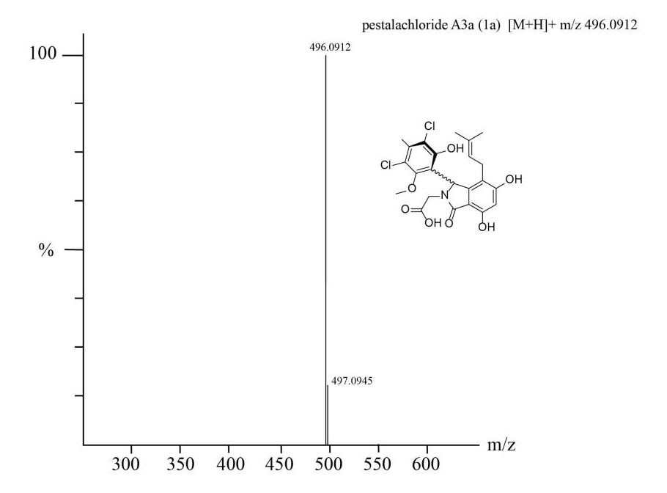

Figure S1 (+)-HRESIMS data of pestalachloride A3a (1a)
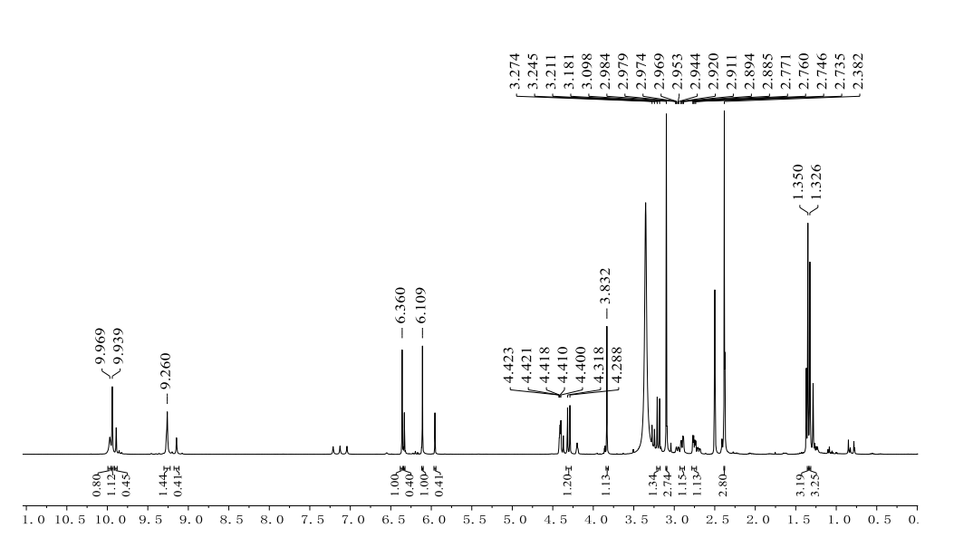

Figure S2. ¹H NMR for pestalachloride A3a (1a) in DMSO-d₆ (600 MHz)

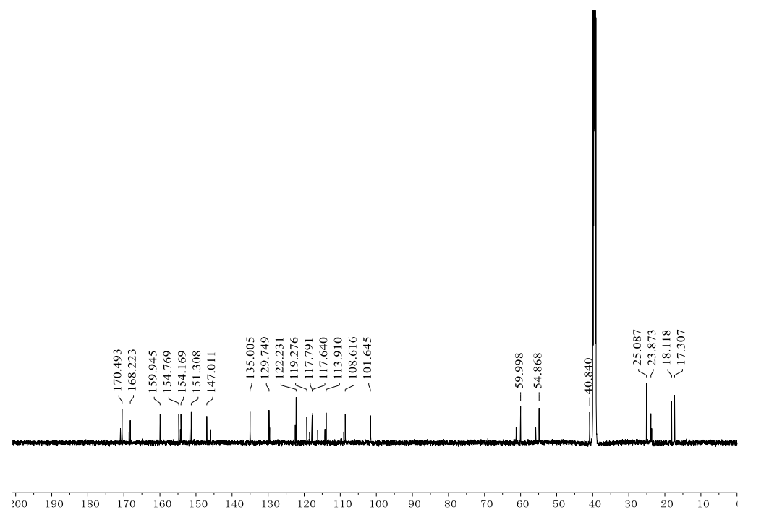

Figure S3. ¹³C NMR for pestalachloride A3a (1a) in DMSO-d₆ (150 MHz)
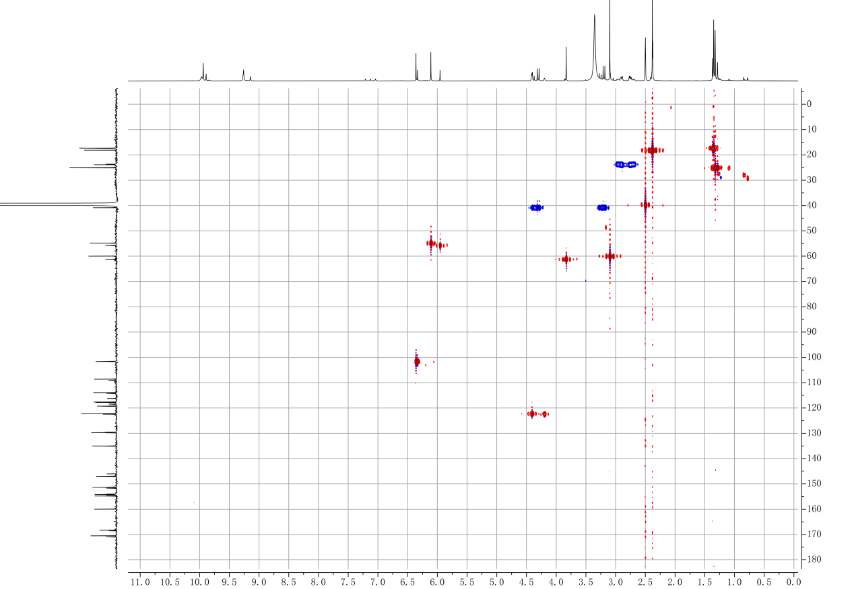

Figure S4. HSQC for pestalachloride A3a (1a) in DMSO-d₆
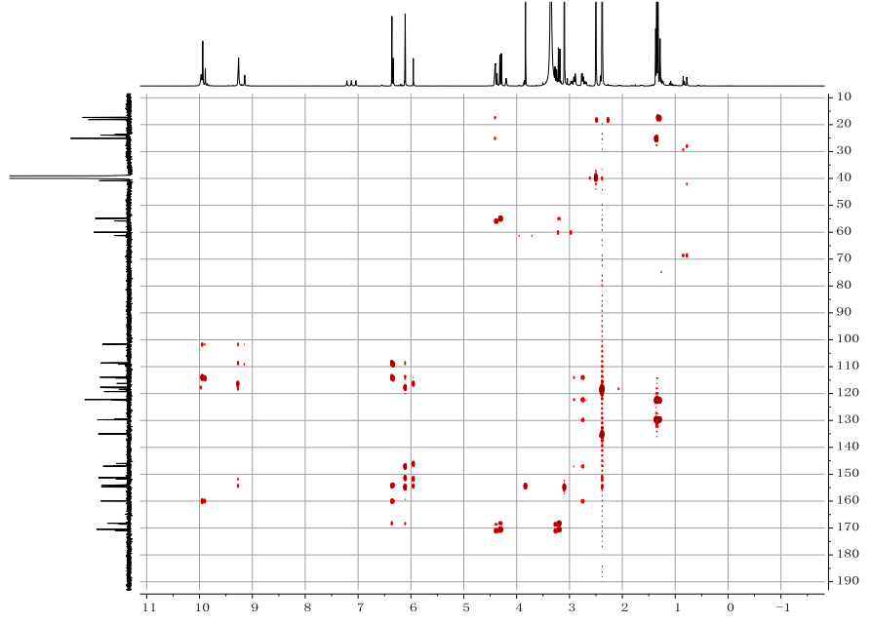

Figure S5. HMBC for pestalachloride A3a (1a) in DMSO-d₆

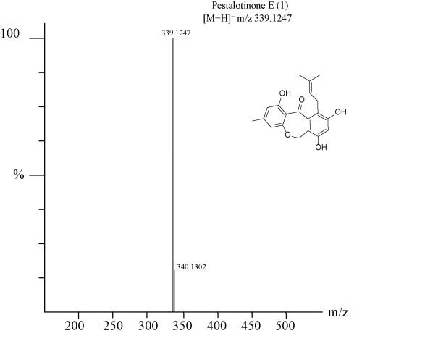

Figure S6 (-)-HRESIMS data of pestalotinone E (2)
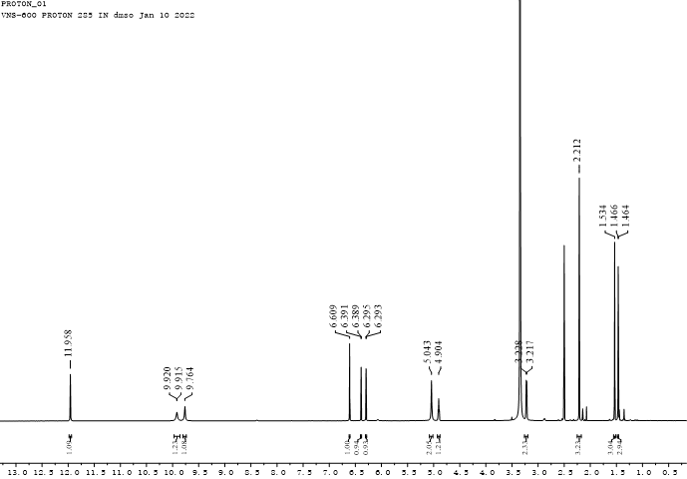

Figure S7. ¹H NMR for pestalotinone E (2) in DMSO-d₆ (600 MHz)

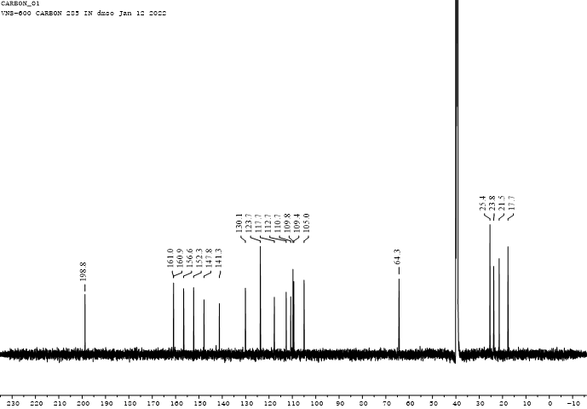

Figure S8. ¹³C NMR for pestalotinone E (2) in DMSO-d₆ (150 MHz)

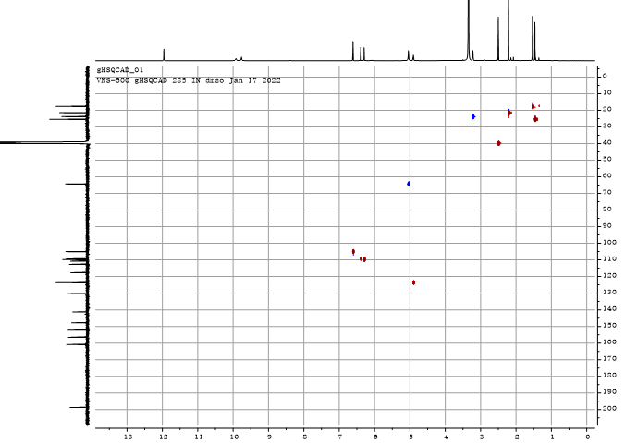

Figure S9. HSQC for pestalotinone E (2) in DMSO-d₆

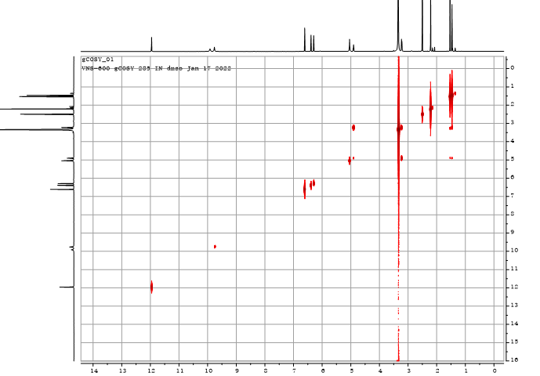

Figure S10. ¹H-¹H COSY for pestalotinone E (2) in DMSO-d₆

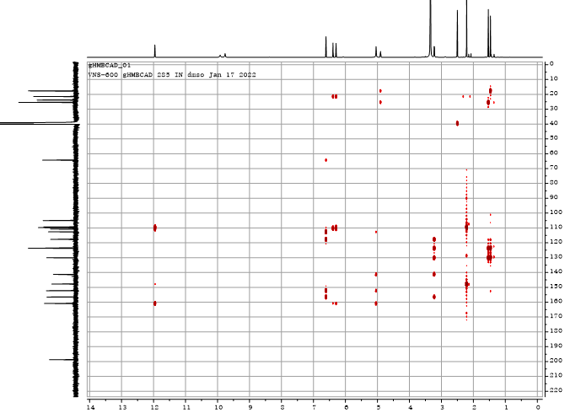

Figure S11. HMBC for pestalotinone E (2) in DMSO-d₆

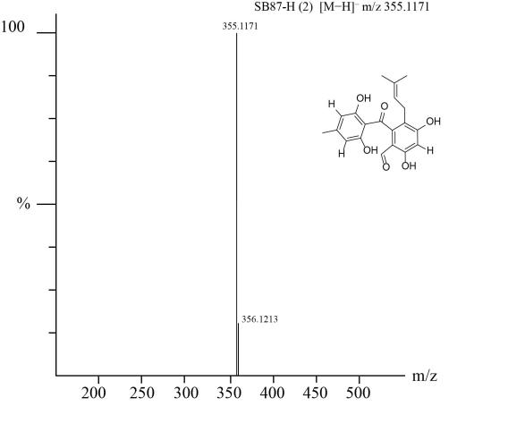

Figure S12 (-)-HRESIMS data of SB87-H (3)

