Supporting Information

Title A Conformal Bioelectronic Interface Enables Reproducible Electrical Stimulation for Skin Regeneration

Author(s), and Corresponding Author(s)*
Jiwan Jeon ^{a 1}, Youngchul Suh ^{b 1}, Yohan Kim ^{b}, Hyun Roh ^{b}, Sungmin Oh ª, Jihee Kim ^{c, d, e}, Sejung Park ^{f}, Wonjai Lee ^{b, g *}, Jin-Woo Park ^{a *}

ª Department of Materials Science and Engineering, Yonsei University, Seoul 03722, Republic of Korea.
^{b} Department of Plastic and Reconstructive Surgery, Yonsei University, Seoul 03722, Republic of Korea.
^{c} Department of Dermatology & Cutaneous Biology Research Institute, Yonsei University College of Medicine, Seoul 03722, Republic of Korea
^{d} Scar Laser and Plastic Surgery Center, Yonsei Cancer Hospital, Seoul 03722, Republic of Korea
^{e} Department of Dermatology, Yongin Severance Hospital, Yongin 16995, Republic of Korea
^{f} Asen Company, Seoul 03722, Republic of Korea
^{g} Department of Plastic Surgery Center and Scar Laser and Plastic Surgery Center, Yonsei Cancer Hospital, Seoul 03722, Republic of Korea

* Corresponding author

Wonjai Lee - pswjlee@yuhs.ac
Jin-Woo Park - jwpark09@yonsei.ac.kr

¹ These authors contributed equally to this work

Figures. S1 to S6
Tables. S1 to S4

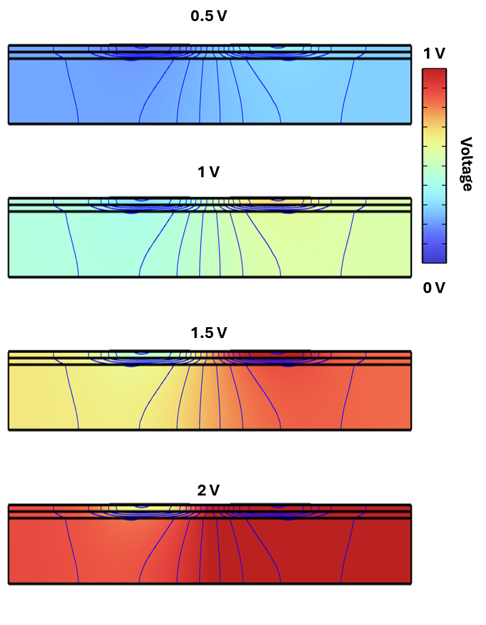

Figure. S1. Simulation of voltage distribution across skin layers under increasing applied voltage (0.5–2V). As the applied voltage increases from 0.5 to 2 V, the electrical potential penetrates more deeply and intensely through the stratum corneum into the underlying tissues. While higher voltages enhance energy delivery, the applied voltage was optimized to 1 V to remain within the electrochemical stability window and prevent unintended side reactions.

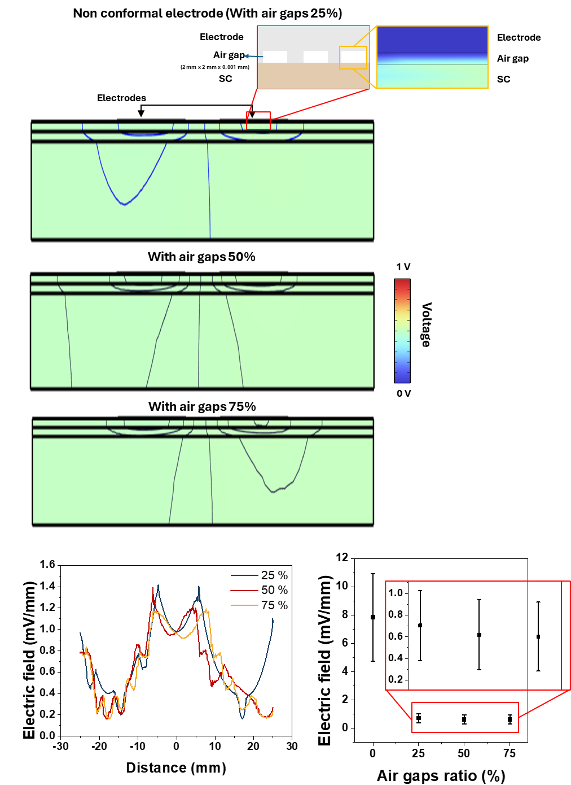

Figure. S2. The proportion of air gap coverage increases, the electric field exhibits increasingly irregular behavior. Air gaps were modeled as 2 mm × 2 mm × 0.001 mm (width × length × height) domains inserted between the electrode and the SC layer. The resulting voltage distribution and electric field chages were simulated. The cases in which air gaps covered 25 %, 50 %, and 75 % of the total electrode area were examined. The mean electric field values show a sharp decrease from the conformal contact case to 25 %, with continued reduction as the air gap fraction increases (VD electric field).

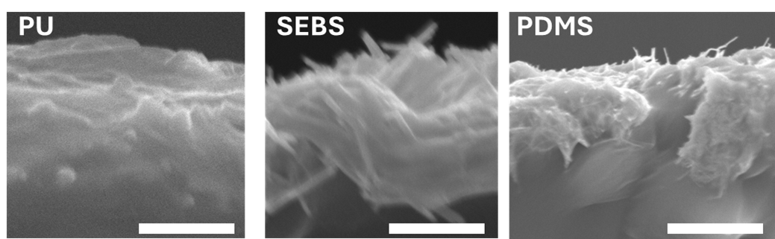

Figure. S3. Cross-sectional SEM images of AgNW embedded PU, SEBS, And PDMS electrodes. PU shows a relatively smooth surface with minimal protrusion, whereas SEBS and PDMS exhibit noticeable nanowire protrusion.. Scale bars 1 um.

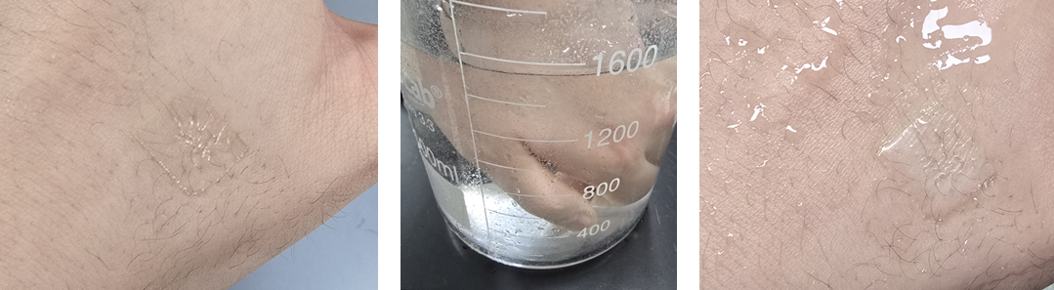Figure. S4. Robust adhesion under wet conditions on hair-bearing skin. Photographs taken (left) after application, (middle) during water immersion, and (right) after retrieval show preserved adhesion and conformal contact after 5 min immersion.

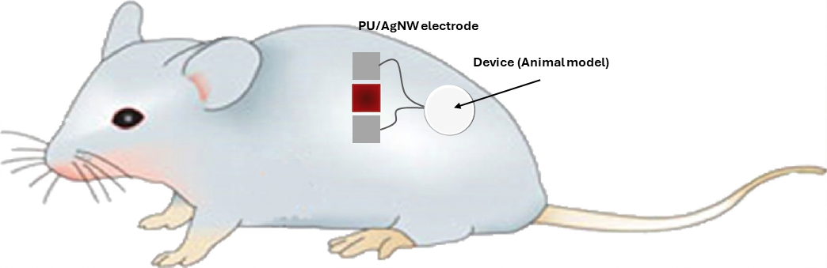Figure. S5. Schematic of the in vivo electrical stimulation. A full thickness excisional wound (1 cm x 1 cm) was created on the dorsal skin. and The PU/AgNW electrode was conformally applied to the wound and connected to the device for animal model.

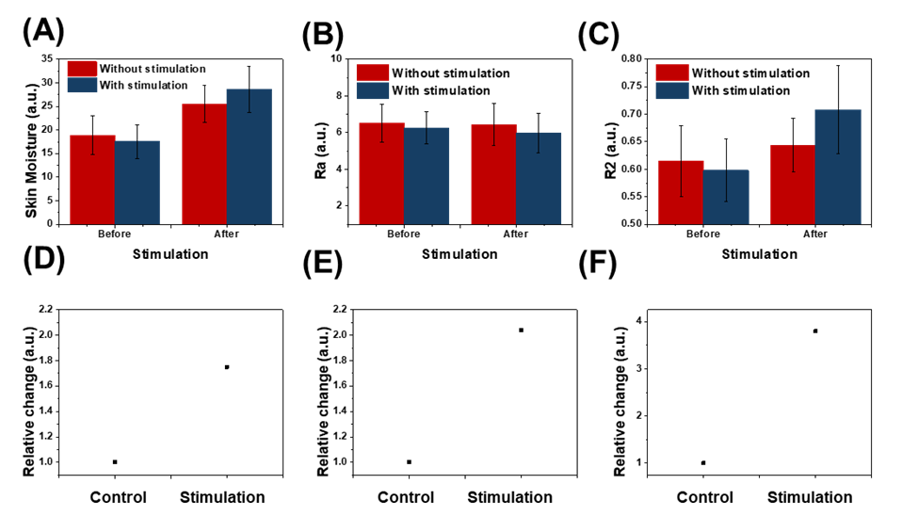Figure. S6. Short-term clinical evaluation of skin parameters (n = 20). (A–C) Group-averaged skin hydration (A), skin texture (Ra, B), and skin elasticity (R2, C) measured before and immediately after the session at the stimulated site and the contralateral non-stimulated control site. Bars represent mean ± SD. (D–F) Corresponding normalized responses for hydration (D), Ra (E), and R2 (F), expressed as the stimulated-to-control ratio at each time point (baseline normalized to 1).
Subject ID | Date of birth | Age | Skin type | Gender
25O27-E1-01 | 1973-11-20 | 51 | Dry | F
25O27-E1-02 | 1975-06-06 | 50 | Dry to normal | F
25O27-E1-03 | 1965-12-20 | 59 | Dry | F
25O27-E1-04 | 1977-12-22 | 47 | Dry to normal | F
25O27-E1-05 | 1969-08-09 | 56 | Dry to normal | F
25O27-E1-06 | 1978-09-20 | 47 | Dry | F
25O27-E1-07 | 1973-03-03 | 52 | Dry to normal | F
25O27-E1-08 | 1972-04-15 | 53 | Dry | F
25O27-E1-09 | 1983-09-30 | 42 | Normal | M
25O27-E1-10 | 1975-12-04 | 49 | Dry to normal | F
25O27-E1-11 | 1966-03-02 | 59 | Normal | M
25O27-E1-12 | 2001-08-17 | 24 | Dry | M
25O27-E1-13 | 1974-02-28 | 51 | Dry to normal | F
25O27-E1-14 | 1967-09-25 | 58 | Dry | F
25O27-E1-15 | 1974-05-24 | 51 | Dry | F
25O27-E1-16 | 1974-06-29 | 51 | Dry | M
25O27-E1-17 | 1977-12-29 | 47 | Dry | F
25O27-E1-18 | 1971-06-20 | 54 | Dry to normal | F
25O27-E1-19 | 1970-08-10 | 55 | Normal | F
25O27-E1-20 | 1972-09-07 | 53 | Normal | M
25O27-E1-21 | 1977-08-28 | 48 | Normal | F
25O27-E1-22 | 1969-02-17 | 56 | Dry | F
25O27-E1-23 | 1992-01-14 | 33 | Normal | M

Table S1. Subject Information. Detail information of all of subjects.

Table S2. Subject age. The average age of 23 subjects who completed the study was 49.3.
Age | Number | %
20-29 | 1 | 4.348
30-39 | 1 | 4.348
40-49 | 6 | 26.087
50-59 | 15 | 65.217

Table S3. Subject gender. Of these subjects, 6 were male and 17 were female.
Gender | Number | %
Male | 4 | 26.087
Female | 17 | 73.913

Table S4. Subject skin types. The skin types of 23 subjects were 10 of dry skin, 7 of dry to normal skin, and 6 of normal skin.
Skin types | Number | %
Dry skin | 10 | 43.478
Dry to normal skin | 7 | 30.435
Normal skin | 6 | 26.087
Normal to oily skin | 0 | 0
Oily skin | 0 | 0

