Etoricoxib Versus Diclofenac Sodium Intramuscular Injections in Acute Orthopaedic Pain Management: A Randomized, Open-Label Pilot Trial.
Pravin Selvi Saravanan1, Aishwaryaa Anand1, Lokesh R1, Lithesh.S. K1, N. Gowthaman2, Sarumathy. S1*
1. Department of Pharmacy Practice, SRM College of Pharmacy, SRM Institute of Science and Technology, Kattankulathur-603203, Chengalpattu (DT), Tamil Nadu.
2. Department of Orthopaedics, SRM Medical College Hospital and Research Centre, Faculty of Medicine and Health Sciences, SRM Institute of Science and Technology, Kattankulathur-603203, Chengalpattu (DT), Tamil Nadu

TABLE S1: Shapiro-Wilk Test for Normality of VAS and VNRS Scores at Each Time Point
Time Point | Group-A W  (n=35) | p- value | Group-B W  (n=35) | p- value
0 min | 0.939 | 0.0521 | 0.9262 | 0.0215*
30 min | 0.920 | 0.0143* | 0.9533 | 0.1436
60 min | 0.8941 | 0.0028* | 0.9151 | 0.0104*
12 hrs | 0.8763 | 0.0010* | 0.6782 | <0.0001*
24 hrs | 0.9361 | 0.0426* | 0.7310 | <0.0001*
* p < 0.05 indicates significant deviation from normality

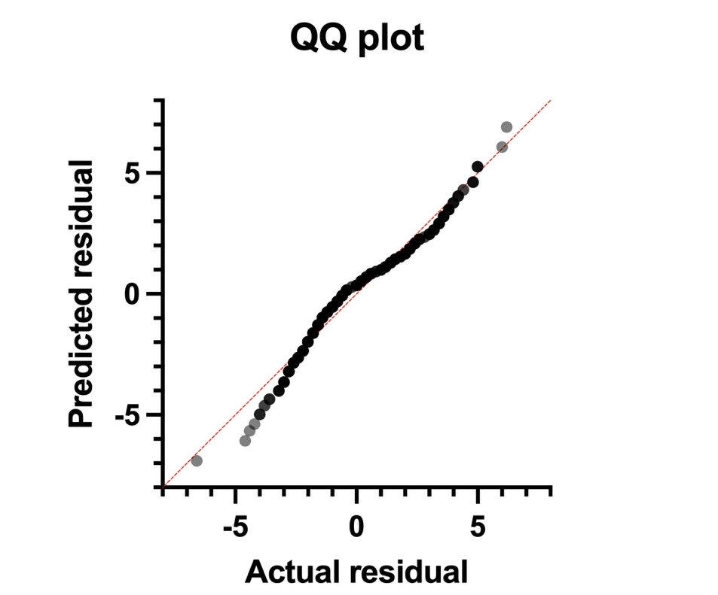.
Figure S1: Quantile–Quantile (Q–Q) Plot of Standardized Residuals for Pain Score Analysis. The Q–Q plot demonstrates the distribution of standardized residuals relative to the theoretical normal distribution. Most observations closely follow the reference line, indicating approximate normality of residuals, with only minor deviations observed at the distribution tails. No substantial skewness or extreme outliers were identified, supporting the use of parametric statistical analyses.

