Supplementary data
MSFP increased in both responders and non-responders during the PLR maneuver; however, the magnitude of increase was significantly greater in responders (Figure S1). We considered responders to be patients who increased aortic blood flow VTI recorded using pulsed-wave Doppler 1 minute after mobilization by more than 12%, as proposed by Maizel et al. [20].
20. Maizel J, Airapetian N, Lorne E, Tribouilloy C, Massy Z, Slama M. Diagnosis of central hypovolemia by using passive leg raising. Intensive Care Med. 2007 Jul;33(7):1133-1138. doi:10.1007/s00134-007-0642-y. Epub 2007 May 17. PMID:17508202.

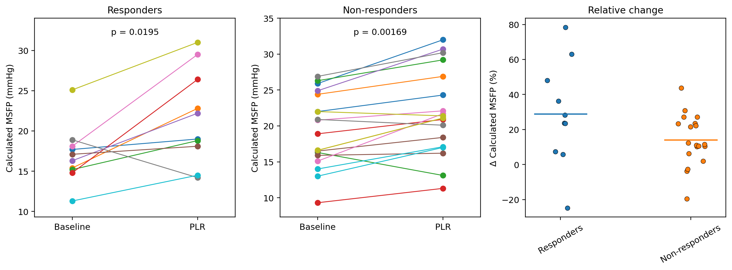
Figure S1. Effect of the passive leg raising maneuver (PLR) on calculated mean systemic filling pressure (MSFP) in responders and non-responders.

