Bioactive Metal-Phenolic Network and Prebiotic Hydrogel Synergize with Mesenchymal stem cell-derived extracellular vesicles for Microenvironment-Modulating Therapy of Inflammatory Bowel Disease

Supplementary Figures

Figure S1. Cytocompatibility of MV and MPN@MV in RAW264.7 macrophages assessed by CCK-8 assay across the tested MV protein concentrations. Data are shown as mean ± SD with n = 3.

Figure S2. Live/Dead staining of RAW264.7 macrophages after treatment with MV or MPN@MV. Data are shown as mean ± SD with n = 3.

Figure S3. Cellular uptake and quantification of PKH26-labeled MV and MPN@MV by RAW264.7 macrophages under basal and LPS-stimulated conditions. Data are shown as mean ± SD with n = 3.

Figure S4. qRT-PCR analysis of Arg-1 expression in LPS-stimulated RAW264.7 macrophages after treatment. Data are shown as mean ± SD with n = 3.

Figure S5. Representative DCFH-DA fluorescence quantification. Data are shown as mean ± SD with n = 3.

Figure S6. JC-1 staining analysis and quantification of mitochondrial membrane potential in RAW264.7 macrophages after LPS stimulation and treatment with MV or MPN@MV. Data are shown as mean ± SD with n = 3.

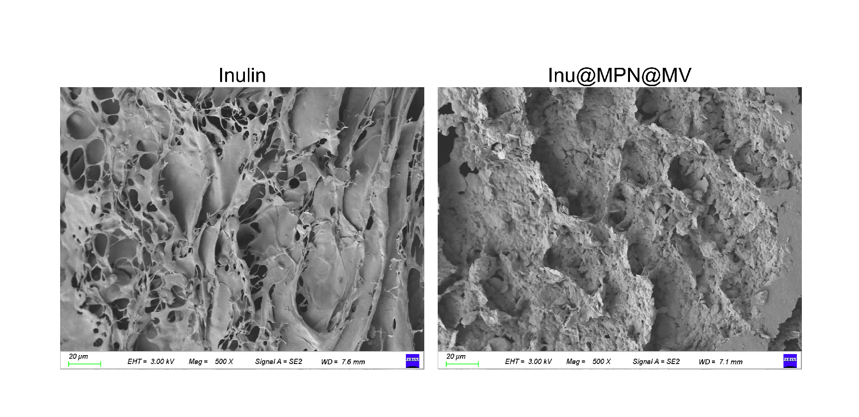
Figure S7. Scanning electron microscopy of the inulin hydrogel before and after MPN@MV encapsulation.

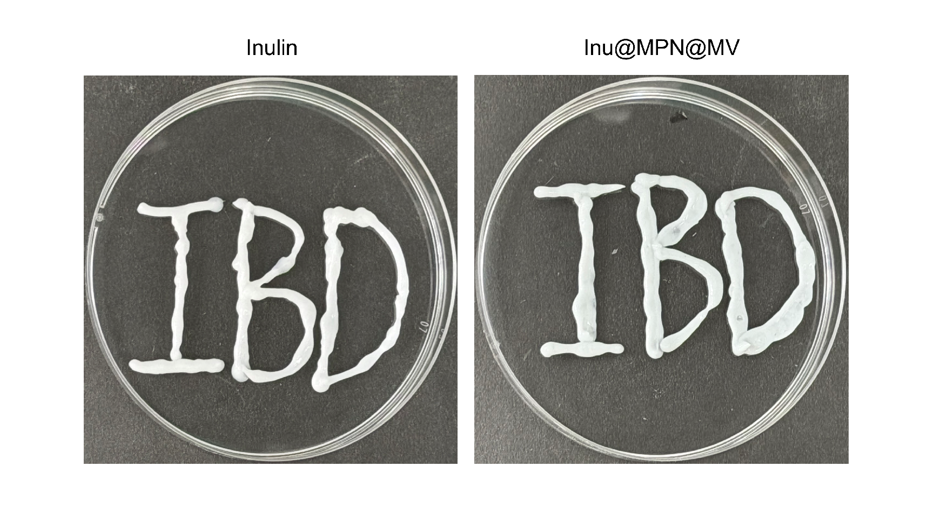
Figure S8. Macroscopic appearance of inulin hydrogel and Inu@MPN@MV hydrogel.

Figure S9. Injectability/gavage compatibility of Inu@MPN@MV hydrogel.

Figure S10. Ex vivo fluorescence imaging of major organs after oral administration. Representative ex vivo fluorescence images of the heart, liver, spleen, lung, and kidney collected at 24 h post-oral administration of Inu@MPN@MV in DSS-induced colitis mice. Data are shown as mean ± SD with n = 4.

Figure S11. Masson's trichrome staining of colon tissues after DSS challenge and treatment. Data are shown as mean ± SD with n = 4.

Figure S12. Colon-tissue Arg-1 expression after DSS challenge and oral treatment. Data are shown as mean ± SD with n = 3.

Figure S13. CAT activity in colonic tissues from Control, DSS and treatment groups. Data are shown as mean ± SD with n = 3.

Figure S14. Genus-level phylogenetic tree illustrating microbial taxonomic diversity after DSS challenge and Inu@MPN@MV treatment. Data are shown as mean ± SD with n = 3.

Figure S15. Hierarchical clustering heatmaps of gut microbiota composition at phylum and family levels among Control, DSS and Inu@MPN@MV groups.

Figure S16. Relative abundance of Verrucomicrobiota populations after treatment. Data are shown as mean ± SD with n = 3.

Figure S17. Alteration of allocholic acid or bile-acid-related metabolites after Inu@MPN@MV treatment. Data are shown as mean ± SD with n = 3.

Figure S18. Treatment-associated changes in L-phenylalanine. Data are shown as mean ± SD with n = 5.

Figure S19. Additional GSEA results showing regulation of AGE-RAGE signaling, fatty-acid metabolism and other metabolism-related pathways after treatment. Data are shown as mean ± SD with n = 5.

Figure S20. H&E staining of major organs, including heart, liver, spleen, lung and kidney, after repeated oral administration, showing no obvious tissue abnormality in the tested window. Data are shown as mean ± SD with n = 3.

Figure S21. Routine hematological analysis after repeated oral administration of the formulations, showing no obvious treatment-related abnormalities. Data are shown as mean ± SD with n = 3.

Figure S22. Serum biochemical analysis of hepatic and renal function markers after repeated oral administration, supporting preliminary systemic safety. Data are shown as mean ± SD with n = 3.

