Supplementary Information
Interpretable machine learning analysis of apelin-12 for major adverse cardiovascular events after primary PCI in ST-elevation myocardial infarction
Qingqing Wu¹, Rui Yan¹, Ping Li¹, Guangyao Zhai^{1*}
¹ Department of Cardiology, Beijing Luhe Hospital, Capital Medical University, Beijing, China
*Correspondence: Guangyao Zhai, Drzhaiguangyao@163.com
Supplementary Figure S1
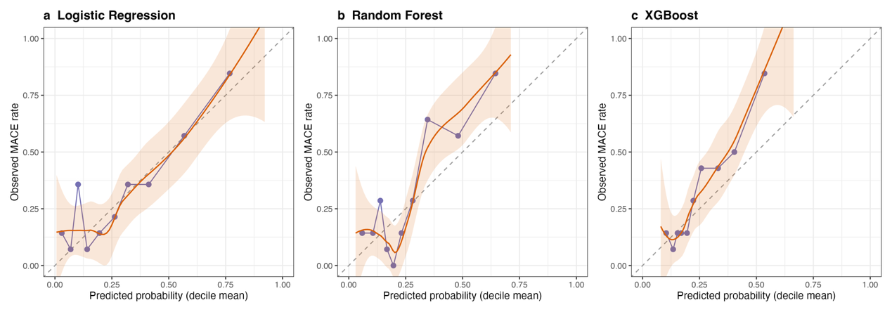
Supplementary Figure S1. Calibration plots on the held-out test set (n=139) for all three models: (a) logistic regression, (b) random forest, (c) XGBoost. Purple points are observed MACE rates within deciles of predicted risk (approximately 14 patients per decile); orange curves are LOESS smooths with 95% confidence bands; dashed lines indicate ideal calibration. Corresponding calibration slope and intercept for each model are reported as described in the main text Methods section.
Supplementary Figure S2
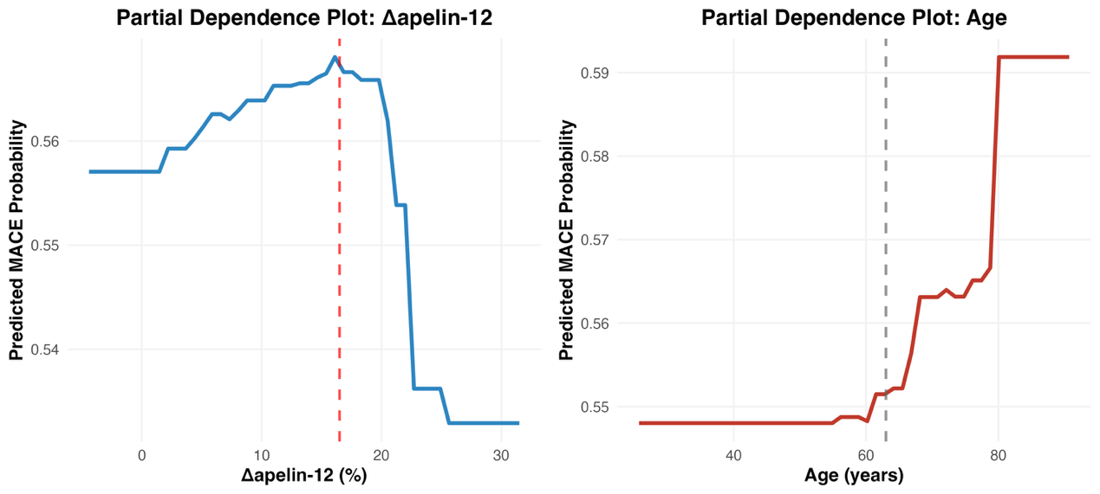
Supplementary Figure S2. Partial dependence plots for (a) Δapelin-12 and (b) age from the final XGBoost model (n=464). The y-axis shows the predicted MACE probability on the probability scale. Each point represents the average prediction across all patients at that predictor value, holding all other predictors at their observed values. The vertical dashed line in (a) marks the breakpoint identified by piecewise logistic regression (16.5%); in (b), the dashed line marks the median age (62 years) for reference. The shapes of the curves are qualitatively consistent with the SHAP dependence plots presented in Figure 3 of the main text, with PDP showing the average marginal effect and SHAP showing individual-level contributions.
Supplementary Table S1
Supplementary Table S1. Baseline characteristics by MACE status, all 35 candidate variables.
Variable | No MACE (n=346) | MACE (n=118) | Test | P
Apelin-12 change rate (%) | 14.70 [5.32, 22.20] | 13.80 [5.65, 17.48] | MWU | 0.091
Apelin-12 (ng/mL) | 0.79 [0.63, 1.03] | 0.69 [0.53, 0.87] | MWU | <0.001
Urea nitrogen (mmol/L) | 6.70 [5.23, 8.10] | 6.90 [5.23, 8.10] | MWU | 0.702
Glucose (mmol/L) | 7.17 [5.79, 9.65] | 7.05 [5.76, 9.75] | MWU | 0.913
Neutrophils (%) | 76.85 [67.03, 84.47] | 78.35 [65.25, 86.97] | MWU | 0.288
White blood cells (×10⁹/L) | 9.96 [6.96, 11.96] | 10.24 [7.94, 14.09] | MWU | 0.072
Systolic BP (mmHg) | 132.0 [107.3, 155.0] | 128.0 [114.0, 149.8] | MWU | 0.857
Heart rate (bpm) | 75.0 [64.0, 87.0] | 78.5 [67.3, 92.8] | MWU | 0.035
Age (years) | 62.0 [55.0, 70.0] | 68.0 [57.3, 76.8] | MWU | <0.001
Stent number | 1 [1, 2] | 1 [1, 2] | MWU | 0.385
Creatinine (µmol/L) | 72.0 [60.1, 83.0] | 80.0 [64.1, 88.8] | MWU | 0.011
Uric acid (µmol/L) | 340.0 [286.6, 390.0] | 329.7 [273.1, 387.4] | MWU | 0.405
Hemoglobin (g/L) | 145.0 [133.0, 159.0] | 140.5 [128.0, 151.5] | MWU | 0.003
Platelet (×10⁹/L) | 229.5 [183.0, 271.0] | 248.5 [184.3, 288.3] | MWU | 0.093
Albumin (g/L) | 38.0 [35.0, 41.0] | 38.0 [35.0, 40.2] | MWU | 0.991
Total cholesterol (mmol/L) | 5.53 [4.84, 6.25] | 5.83 [5.20, 6.70] | MWU | 0.005
Triglycerides (mmol/L) | 0.94 [0.56, 1.56] | 1.03 [0.55, 1.48] | MWU | 0.970
HDL cholesterol (mmol/L) | 1.18 ± 0.27 | 1.25 ± 0.28 | t-test | 0.030
LDL cholesterol (mmol/L) | 3.00 [2.50, 3.59] | 3.00 [2.44, 3.70] | MWU | 0.485
cTnI (ng/mL) | 12.60 [3.00, 28.72] | 21.45 [9.54, 31.10] | MWU | 0.015
D-dimer (mg/L) | 1.00 [0.23, 1.70] | 0.70 [0.20, 1.60] | MWU | 0.363
CK-MB (U/L) | 103.0 [39.3, 192.8] | 131.5 [52.5, 206.8] | MWU | 0.252
GENSINI score | 67.0 [37.3, 101.8] | 85.0 [49.8, 99.8] | MWU | 0.125
LVEDD (mm) | 49.0 [45.0, 55.0] | 53.0 [46.0, 57.0] | MWU | 0.003
Left atrial diameter (mm) | 38.0 [33.0, 41.0] | 39.0 [35.3, 42.0] | MWU | 0.009
Male sex, n (%) | 270 (78.0) | 85 (72.0) | χ² | 0.229
Hypertension, n (%) | 193 (55.8) | 72 (61.0) | χ² | 0.376
Diabetes mellitus, n (%) | 109 (31.5) | 41 (34.7) | χ² | 0.592
Pathological Q wave, n (%) | 153 (44.2) | 70 (59.3) | χ² | 0.006
Prior MI, n (%) | 36 (10.4) | 19 (16.1) | χ² | 0.137
Anterior-wall MI, n (%) | 159 (46.0) | 72 (61.0) | χ² | 0.007
Killip class >I, n (%) | 71 (20.5) | 41 (34.7) | χ² | 0.003
Culprit vessel LAD, n (%) | 169 (48.8) | 64 (54.2) | χ² | 0.365
Culprit vessel LCX, n (%) | 54 (15.6) | 18 (15.3) | χ² | 1.000
Culprit vessel RCA, n (%) | 123 (35.5) | 36 (30.5) | χ² | 0.377
Continuous variables are median [IQR] unless noted as mean ± SD; MWU = Mann-Whitney U test; χ² = Pearson chi-square test. D-dimer had the highest missingness among candidate variables (98/464, 21.1%) and was not retained in the final feature set; its descriptive comparison is shown for completeness and should be interpreted cautiously. BP, blood pressure; HDL/LDL, high/low-density lipoprotein; cTnI, cardiac troponin I; CK-MB, creatine kinase-MB; LVEDD, left ventricular end-diastolic diameter; MI, myocardial infarction; LAD, left anterior descending; LCX, left circumflex; RCA, right coronary artery.
Supplementary Table S2
Supplementary Table S2. Multivariable logistic regression: odds ratios for the 14-variable model (training set, n=325).
Variable | OR | 95% CI | P
Apelin-12 change rate | 0.974 | 0.942–1.007 | 0.126
Apelin-12 (admission) | 0.265 | 0.097–0.726 | 0.010
Age | 1.060 | 1.030–1.089 | <0.001
Pathological Q wave | 1.975 | 1.094–3.564 | 0.024
Prior myocardial infarction | 1.877 | 0.721–4.891 | 0.197
Anterior-wall myocardial infarction | 2.620 | 1.408–4.874 | 0.002
Killip class >I | 1.033 | 0.525–2.029 | 0.926
Admission glucose | 0.883 | 0.782–0.997 | 0.045
White blood cell count | 1.063 | 0.982–1.151 | 0.131
Platelet count | 1.005 | 1.000–1.010 | 0.055
Total cholesterol | 1.297 | 0.980–1.717 | 0.069
GENSINI score | 1.006 | 0.996–1.016 | 0.217
LVEDD | 1.025 | 0.978–1.075 | 0.301
Left atrial diameter | 1.055 | 0.997–1.115 | 0.061
OR, odds ratio; LVEDD, left ventricular end-diastolic diameter. Odds ratios are from the training-set logistic regression model and should be interpreted with caution given the limited events per variable and the exploratory role of this model in the present analysis. Associations with directions inconsistent with established clinical expectations may reflect residual confounding, correlation among predictors, or model instability and require external validation.
Supplementary Table S3
Supplementary Table S3. Statistical assessment of non-linearity and candidate breakpoints for apelin-12 and Δapelin-12 (full cohort, n=464).
Variable | RCS nonlinear P (unadjusted) | RCS nonlinear P (age-adjusted) | Hinge breakpoint (approx. range) | Hinge vs. linear LRT P
Apelin-12 (ng/mL) | 0.017 | 0.060 | 0.43 (0.43–0.46) | 0.0001
Δapelin-12 (%) | <0.0001 | <0.0001 | 16.5 (15.5–19.0) | <0.0001
RCS, restricted cubic spline (4 knots) logistic regression; nonlinear P is the Wald test for the spline's nonlinear component. Hinge breakpoint is the AIC-minimizing cut-point from a piecewise logistic regression MACE ~ x + max(0, x − c), searched over candidates with ≥30 patients on each side; approximate range is all candidates within 2 AIC units of the minimum. LRT P compares the two-piece model against a linear term for the same variable. See Methods, “Statistical assessment of non-linearity and candidate breakpoints.”
Supplementary Table S4
Supplementary Table S4. LASSO tuning sensitivity analysis: XGBoost test-set AUC using feature sets selected under three tuning rules.
Feature-selection rule | N features | Test AUC
Pre-specified 12–15-variable target (primary analysis) | 14 | 0.781
lambda.min | 7 | 0.765
lambda.1se | 7 | 0.765
lambda.min and lambda.1se both selected only the 7 predictors specified in advance and exempted from penalization (apelin-12, Δapelin-12, age, pathological Q wave, prior myocardial infarction, anterior-wall infarction, Killip class >I); none of the 28 penalized candidate variables survived shrinkage at either tuning value. All three models used identical hyperparameters and were evaluated on the same held-out test set. The numerically lower AUC of the 7-variable models should be interpreted cautiously because it was based on a single held-out test split and these models were evaluated as sensitivity analyses rather than specified as the primary model. See Methods, “LASSO tuning sensitivity analysis.”
Supplementary Table S5
Supplementary Table S5. Classification performance at each model's Youden-optimal threshold (threshold determined in the training set, applied fixed to the test set).
Model | Threshold | Sensitivity | Specificity | PPV | NPV
Logistic regression | 0.233 | 0.744 | 0.604 | 0.457 | 0.841
Random forest | 0.429 | 0.419 | 0.927 | 0.720 | 0.781
XGBoost | 0.248 | 0.628 | 0.760 | 0.540 | 0.820
PPV, positive predictive value; NPV, negative predictive value. See Table 2 of the main text for AUC, Brier score, and calibration slope/intercept for the same three models.

