Supplementary Material

1 Supplementary Figures and Tables

1.1 Supplementary Tables
Supplementary Table S 1. Associations Between ln-Transformed Urinary Heavy Metals and Liver Function Biomarkers Estimated Using Multivariable Linear Regression Models
Liver Function Biomarker | Urinary Heavy Metal | Model 1 |  | Model 2
Liver Function Biomarker | Urinary Heavy Metal | β（95%CI） | P | β（95%CI） | P
ALT | Li | 0.638(-1.050,2.325) | 0.459 | 1.678(-0.014,3.370) | 0.053
ALT | Al | 0.333(-1.18,1.847) | 0.666 | 1.047(-0.462,2.557) | 0.175
ALT | Ti | -0.345(-1.978,1.288) | 0.679 | 0.847(-0.831,2.525) | 0.323
ALT | Sr | -0.998(-2.498,0.501) | 0.193 | 0.018(-1.527,1.563) | 0.982
ALT | Hg | 0.253(-0.947,1.454) | 0.68 | 0.792(-0.414,1.997) | 0.199
ALT | Pb | 0.040(-1.055,1.136) | 0.943 | 0.484(-0.604,1.571) | 0.384
ALT | V | 0.001(-1.62,1.623) | 0.999 | 0.769(-0.881,2.420) | 0.362
ALT | Cr | 0.384(-1.573,2.34) | 0.701 | 0.975(-0.977,2.927) | 0.328
ALT | Co | 0.035(-1.52,1.59) | 0.965 | 0.683(-0.846,2.212) | 0.382
ALT | Ni | 0.247(-0.484,0.977) | 0.508 | 0.693(-0.040,1.426) | 0.065
ALT | Cu | 1.209(-0.376,2.794) | 0.136 | 1.654(0.075,3.233) | 0.041
ALT | Zn | 1.709(0.097,3.321) | 0.039 | 1.714(0.109,3.320) | 0.037
ALT | As | 1.218(0.254,2.181) | 0.014 | 0.910(-0.069,1.889) | 0.07
ALT | Se | 0.226(-1.65,2.102) | 0.813 | 1.200(-0.684,3.083) | 0.213
AST | Li | 1.186(0.181,2.192) | 0.021 | 1.25(0.174,2.327) | 0.024
AST | Al | 0.443(-0.466,1.351) | 0.34 | 0.458(-0.506,1.422) | 0.352
AST | Ti | 0.717(-0.261,1.695) | 0.152 | 0.813(-0.255,1.88) | 0.137
AST | Sr | 0.129(-0.774,1.033) | 0.779 | 0.172(-0.813,1.157) | 0.733
AST | Hg | 0.182(-0.539,0.903) | 0.621 | 0.199(-0.571,0.97) | 0.613
AST | Pb | 0.383(-0.274,1.04) | 0.254 | 0.331(-0.362,1.025) | 0.35
AST | V | 0.578(-0.395,1.55) | 0.245 | 0.58(-0.471,1.632) | 0.28
AST | Cr | 0.805(-0.367,1.978) | 0.179 | 0.785(-0.459,2.028) | 0.217
AST | Co | 0.224(-0.71,1.158) | 0.639 | 0.271(-0.705,1.247) | 0.587
AST | Ni | -0.072(-0.511,0.367) | 0.748 | -0.078(-0.549,0.392) | 0.744
AST | Cu | 0.721(-0.232,1.674) | 0.139 | 0.76(-0.251,1.77) | 0.142
AST | Zn | 0.519(-0.455,1.494) | 0.297 | 0.646(-0.383,1.675) | 0.219
AST | As | 0.619(0.038,1.199) | 0.038 | 0.635(0.012,1.259) | 0.047
AST | Se | 1.043(-0.078,2.164) | 0.069 | 1.08(-0.117,2.278) | 0.078
AST/ALT | Li | 0.017(-0.035,0.07) | 0.522 | -0.016(-0.068,0.035) | 0.541
AST/ALT | Al | 0.007(-0.04,0.054) | 0.779 | -0.017(-0.063,0.028) | 0.458
AST/ALT | Ti | 0.029(-0.022,0.079) | 0.266 | -0.009(-0.06,0.042) | 0.729
AST/ALT | Sr | 0.045(-0.002,0.091) | 0.059 | 0.012(-0.035,0.059) | 0.619
AST/ALT | Hg | -0.011(-0.049,0.026) | 0.557 | -0.03(-0.067,0.006) | 0.104
AST/ALT | Pb | 0.018(-0.016,0.052) | 0.313 | 0.001(-0.032,0.034) | 0.931
AST/ALT | V | 0.011(-0.039,0.062) | 0.661 | -0.016(-0.066,0.034) | 0.539
AST/ALT | Cr | 0.041(-0.020,0.102) | 0.186 | 0.013(-0.046,0.073) | 0.657
AST/ALT | Co | 0.030(-0.018,0.078) | 0.227 | -0.001(-0.048,0.045) | 0.952
AST/ALT | Ni | -0.023(-0.046,-0.001) | 0.043 | -0.038(-0.060,-0.016) | 0.001
AST/ALT | Cu | -0.014(-0.064,0.035) | 0.575 | -0.030(-0.078,0.018) | 0.216
AST/ALT | Zn | -0.053(-0.103,-0.003) | 0.038 | -0.049(-0.098,0.000) | 0.05
AST/ALT | As | -0.010(-0.040,0.020) | 0.507 | -0.002(-0.032,0.028) | 0.883
AST/ALT | Se | 0.018(-0.040,0.076) | 0.543 | -0.013(-0.070,0.044) | 0.652
Note: Model 1 was unadjusted. Model 2 was adjusted for age, sex, body mass index (BMI), estimated glomerular filtration rate (eGFR), educational attainment, smoking status, alcohol consumption, physical activity, hypertension, and diabetes. All urinary heavy metal concentrations were natural log-transformed prior to analysis. β, regression coefficient; CI, confidence interval.

Supplementary Table S 2. Overall Effects of Urinary Heavy Metal Mixtures on Liver Function Biomarkers Estimated by the QG-Comp Model
Liver Function Biomarker | ALT |  | AST |  | AST/ALT
Liver Function Biomarker | β (95%CI) | P | β (95%CI) | P | β (95%CI) | P
Overall Population | 1.128(-0.710，2.966) | 0.230 | 0.019(-1.143，1.181) | 0.974 | -0.050（-0.104，0.004） | 0.069
Industrial Region | 0.267(-1.444,1.979) | 0.760 | -0.309(-1.654,1.037) | 0.654 | -0.038(-0.096,0.020) | 0.202
Non-industrial Region | -1.083(-5.590,3.423) | 0.639 | 0.652(-1.648,2.952) | 0.580 | 0.101(-0.012,0.212) | 0.082

Supplementary Table S 3 . Region-Stratified Associations Between Urinary Heavy Metals and Liver Function Biomarkers
Liver Function Biomarker | Urinary Heavy Metal | Industrial Region(n=189) | Non-industrial Region( n=95) | P _{for Interaction}
Liver Function Biomarker | Urinary Heavy Metal | β（95%CI） | β（95%CI） | P _{for Interaction}
ALT | Li | 0.250(-1.355,1.856) | 3.143(-0.980,7.265) | 0.526
ALT | Al | 0.104(-1.382,1.589) | 2.594(-0.725,5.913) | 0.419
ALT | Ti | -0.532(-2.095,1.031) | 2.304(-1.985,6.594) | 0.344
ALT | Sr | -0.237(-1.672,1.198) | -0.016(-3.657,3.624) | 0.612
ALT | Hg | 0.361(-0.860,1.582) | 2.165(-0.238,4.569) | 0.596
ALT | Pb | -0.070(-1.021,0.881) | 2.280(-1.556,6.115) | 0.681
ALT | V | -0.572(-2.188,1.045) | 1.348(-2.909,5.605) | 0.991
ALT | Cr | -0.703(-2.695,1.288) | 0.872(-3.445,5.190) | 0.582
ALT | Co | 0.187(-1.364,1.739) | 0.852(-2.252,3.956) | 0.78
ALT | Ni | 0.754(-0.055,1.563) | 0.837(-0.632,2.305) | 0.86
ALT | Cu | -0.282(-1.915,1.352) | 2.810(-0.700,6.320) | 0.206
ALT | Zn | -0.717(-2.463,1.030) | 3.368(-0.018,6.755) | 0.077
ALT | As | -0.059(-1.666,1.548) | -0.171(-1.874,1.532) | 0.952
ALT | Se | 0.174(-1.740,2.089) | 0.903(-2.885,4.691) | 0.858
AST | Li | 0.569(-0.707,1.846) | 2.522(0.418,4.626) | 0.319
AST | Al | -0.526(-1.707,0.655) | 2.383(0.710,4.057) | 0.035
AST | Ti | -0.011(-1.257,1.236) | 2.518(0.339,4.697) | 0.117
AST | Sr | 0.110(-1.033,1.253) | 0.078(-1.816,1.971) | 0.854
AST | Hg | -0.031(-1.004,0.943) | 0.608(-0.659,1.875) | 0.694
AST | Pb | 0.127(-0.630,0.884) | 1.146(-0.850,3.143) | 0.632
AST | V | -0.391(-1.679,0.897) | 2.912(0.784,5.041) | 0.08
AST | Cr | -0.353(-1.941,1.234) | 2.161(-0.038,4.360) | 0.091
AST | Co | -0.118(-1.354,1.118) | 0.578(-1.035,2.191) | 0.433
AST | Ni | 0.084(-0.566,0.735) | -0.226(-0.994,0.542) | 0.311
AST | Cu | -0.425(-1.724,0.875) | 2.508(0.736,4.280) | 0.029
AST | Zn | -0.518(-1.910,0.873) | 1.891(0.136,3.646) | 0.115
AST | As | -0.430(-1.708,0.848) | 0.968(0.107,1.829) | 0.067
AST | Se | 0.317(-1.208,1.841) | 1.776(-0.160,3.711) | 0.301
AST/ALT | Li | 0.004(-0.053,0.062) | -0.005(-0.120,0.110) | 0.737
AST/ALT | Al | -0.031(-0.084,0.022) | 0.030(-0.062,0.123) | 0.135
AST/ALT | Ti | -0.005(-0.061,0.051) | 0.051(-0.067,0.169) | 0.231
AST/ALT | Sr | 0.013(-0.038,0.064) | 0.026(-0.074,0.126) | 0.523
AST/ALT | Hg | -0.014(-0.058,0.029) | -0.079(-0.144,-0.013) | 0.324
AST/ALT | Pb | 0.017(-0.017,0.051) | -0.030(-0.136,0.076) | 0.846
AST/ALT | V | -0.013(-0.070,0.045) | 0.070(-0.046,0.186) | 0.063
AST/ALT | Cr | 0.028(-0.043,0.099) | 0.077(-0.040,0.195) | 0.282
AST/ALT | Co | -0.012(-0.067,0.044) | 0.030(-0.055,0.116) | 0.23
AST/ALT | Ni | -0.036(-0.065,-0.007) | -0.044(-0.084,-0.005) | 0.686
AST/ALT | Cu | -0.010(-0.068,0.049) | 0.003(-0.095,0.101) | 0.517
AST/ALT | Zn | -0.013(-0.076,0.049) | -0.051(-0.146,0.043) | 0.668
AST/ALT | As | -0.010(-0.068,0.047) | 0.048(0.002,0.093) | 0.073
AST/ALT | Se | -0.021(-0.090,0.047) | 0.047(-0.057,0.151) | 0.148
Note: All heavy metal concentrations were natural log-transformed prior to analysis. Models were adjusted for age, sex, BMI, eGFR, educational level, smoking status, alcohol consumption, physical activity, hypertension, and diabetes. P for effect modification represents the P value for the interaction term between region and each urinary heavy metal included in the regression model.

1.2 Supplementary Figures
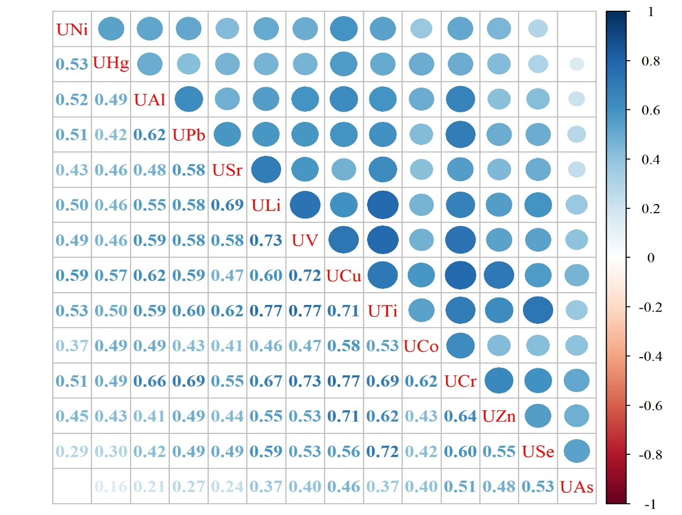
Supplementary Figure S 1. Spearman Rank Correlation Matrix of Urinary Heavy Metals

Supplementary Figure S 2. Dose–Response Relationships Between Urinary Heavy Metals and ALT Levels

Supplementary Figure S 3. Dose–Response Relationships Between Urinary Heavy Metals and AST Levels

Supplementary Figure S 4. Dose–Response Relationships Between Urinary Heavy Metals and the AST/ALT Ratio

