Figures

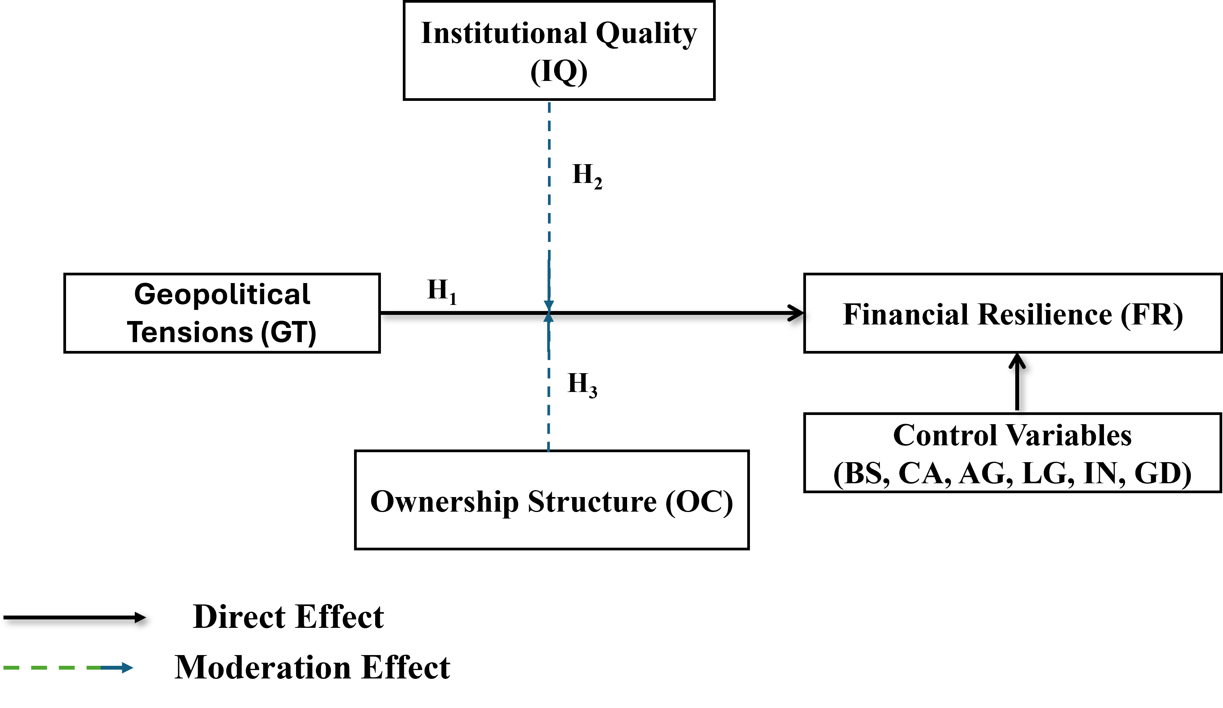
Figure 1. The research Model

