Supplementary Material (A). Difference in difference
To identify the causal impact of geopolitical disruptions on bank financial resilience, we employ a difference-in-differences (DID) approach. DID compares changes in financial resilience before and after the shock between banks exposed to the event and those not directly affected. This methodology allows us to isolate the effect of the Arab Spring from other time-varying factors by controlling for both bank-specific characteristics and common macroeconomic shocks. The basic DID specification expressed as follows:
$ZR_{i,t}=α_{1}Treat_{it}+α_{2}Time_{it}+α_{3}Teat_{it}*Time_{it}+∑αControls_{i,t}+YearFE+CountryFE+ε_{i,t}$ (4)
Where: $ZR_{it}$​&$SD_{it}$​ represent alternative measures of financial resilience for bank (i) in year (t), treatment variable ($Treat_{i}$) is a dummy variable equal to one for banks operating in countries significantly affected by the Arab Spring (e.g., Egypt and Tunisia) and zero for banks located in less-affected countries (e.g., Bahrain and Qatar). Time indicator ($Time_{t}$) equals one for observations during the Arab Spring period (2011–2013) and zero otherwise. The coefficient of interest is $α_{3}$, which captures the differential change in financial resilience between affected and unaffected banks following the geopolitical shock. The vector of control variables includes bank-specific factors (bank size, capital adequacy, asset growth, and loan growth) and macroeconomic variables (inflation and GDP growth). Year and country fixed effects are included to control for unobserved time-specific and country-specific factors, while $ε_{i,t}$represents the error term.
Table A1 presents the DID estimation examining the causal impact of the Arab Spring geopolitical shock on bank financial resilience. The treatment group consists of banks operating in countries directly affected by political unrest during 2011–2013, while banks in less-affected MENA countries represent the control group. The coefficient of the interaction term (Treat × Time) captures the differential effect of the shock on exposed banks. The results show that the Arab Spring significantly weakened financial resilience. For ZR, the interaction term is negative and significant (β = −0.078 and −0.090, p < 0.01), indicating that banks in affected countries experienced a decline in stability compared with non-affected banks. This finding suggests that geopolitical instability reduced banks’ solvency buffers through increased uncertainty, weaker economic activity, and higher credit risk, consistent with previous evidence that geopolitical shocks undermine banking stability. The results for SDR provide further support. The interaction coefficient is positive and significant (β = 0.045 and 0.067, p < 0.01), indicating that the Arab Spring increased earnings volatility among affected banks. Since higher SDR represents lower resilience, these findings confirm that geopolitical disruptions negatively affected banks’ operational stability. Economically, the DID estimates imply that exposure to the Arab Spring reduced ZR by approximately 0.08–0.09 points and increased earnings volatility by 0.045–0.067 points relative to unaffected banks. These effects highlight the substantial consequences of geopolitical shocks for banking stability. The DID analysis provides causal evidence that geopolitical instability reduces financial resilience and increases banking vulnerability, supporting H1 that geopolitical tensions adversely affect financial resilience. Figure (2) illustrates the DID results, showing that banks in Arab Spring–affected countries experienced a significant decline in financial resilience after 2011 compared with non-affected banks, confirming the negative causal impact of geopolitical shocks on financial resilience.
Table A1. Difference in difference
Var | [1] | [2] | [3] | [4]
Var | ZR | ZR | SD | SD
Time _{it} | -0.133*** | -0.128*** | 0.034*** | 0.027***
 | (-2.910) | (-4.153) | (3.081) | (5.121)
Treat _{it} | -0.098** | -0.067** | 0.021** | 0.016**
 | (-1.980) | (-2.210) | (2.311) | (2.119)
Treat _{it} *Time _{it} | -0.078*** | -0.090*** | 0.045*** | 0.067***
 | (-3.114) | (-2.890) | (4.220) | (2.970)
Controls |  | Included |  | Included
Country FE |  | Included |  | Included
Year FE |  | Included |  | Included
Constant | 1.883*** | 2.341*** | 0.566*** | 0.177***
 | (5.112) | (7.711) | (3.109) | (2.981)
Observations | 1904 | 1904 | 1904 | 1904
R-squared | 0.454 | 0.345 | 0.321 | 0.281
Note: Treatment group consists of banks located in countries that experienced significant unrest during the Arab Spring (e.g., Egypt, Tunisia), while banks in the remaining MENA countries (e.g., Bahrain, Qatar) form the control group (exposed vs. non-exposed banks).
Time equals 1 for observations from 2011 to 2013, capturing the Arab Spring period, and 0 otherwise.
Robust standard errors clustered at the bank level are shown in parentheses. *** indicates significance at the 1 % level; ** at the 5 % level; * at the 10 % level.

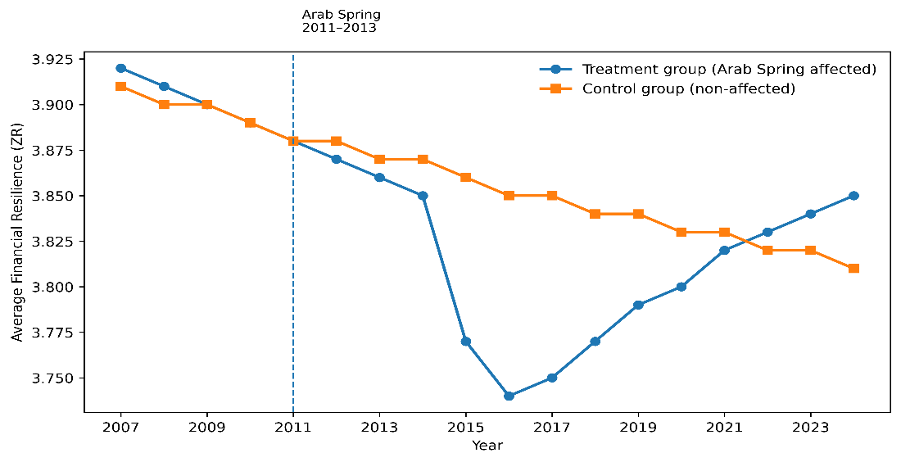
Figure A. Impact of the Arab Spring on Financial Resilience via DID
The treatment and control groups may differ systematically before the shock, which could introduce selection bias. Therefore, we complement the DID approach with propensity score matching (PSM) and entropy balancing (EB) methods. DID, PSM, and EB provide a more rigorous identification strategy by reducing observable differences between exposed and non-exposed banks and strengthening the causal interpretation of the relationship between geopolitical shocks and financial resilience. PSM creates a comparable control group by matching treated and untreated banks with similar observable characteristics. The propensity score is defined as the conditional probability of receiving treatment given observed covariates
$P(X_{i})=Pr(Treat_{i}-1\left|\left.X_{i}\right)\right.$ (5)
Where $P(X_{i})$ represents the propensity score, $Treat_{i}$is the treatment indicator, and $X_{i}$is a vector of observed bank and country characteristics used for matching.
In addition, we apply entropy balancing to improve covariate balance between treatment and control groups. Unlike traditional matching methods, entropy balancing directly assigns weights to control observations so that the weighted moments of covariates match those of the treated group. The optimization problem can be expressed as:
$\min_{w_{i}}\sum_{i∈c}{w_{i}ln(w_{i})}$ (6)
Subject to:
${\sum_{i∈c}{w_{i}X_{ik}=\overline{X}}}_{k}^{T}$ (7)
Where:$C$ represents the set of control observations, $w_{i}$denotes the entropy-balancing weight assigned to control unit $i$, $X_{ik}$ represents the value of covariate $k$for control unit $i$, and ${\overset{ˉ}{X}}_{k}^{T}$is the corresponding covariate moment of the treated group. The balancing constraints ensure that the weighted control group has identical distributions of key covariates, including means and potentially higher-order moments.
Table A2 reports the robustness analysis using propensity score matching (PSM) and entropy balancing (EB) approaches to address potential selection bias and ensure that the observed relationship between geopolitical tension growth (GG) and financial resilience is not driven by systematic differences between banks. The results remain consistent with the baseline findings, providing further support for the negative effect of geopolitical tensions on financial resilience. Using the PSM matched sample, GG has a negative and significant effect on ZR (β = −0.045, p < 0.05) and a positive significant effect on SDR (β = 0.025, p < 0.05). Since higher SDR represents greater earnings volatility, these results indicate that increases in geopolitical tensions reduce overall resilience and increase operational instability. Similarly, the EB matched sample produces consistent results, with GG negatively affecting ZR (β = −0.062, p < 0.05) and positively affecting SDR (β = 0.033, p < 0.05). These findings confirm that the negative impact of geopolitical tensions is not driven by observable differences across banks or countries. After balancing the treatment and control groups based on bank characteristics, geopolitical tension growth continues to weaken financial resilience, supporting the financial fragility perspective. The models include bank-level controls, country fixed effects, and year fixed effects, ensuring that the results account for time-invariant country characteristics and common macroeconomic shocks. The consistent significance and direction of GG across both matching techniques demonstrates the robustness of the main findings. Both the PSM and EB results provide additional evidence that geopolitical tensions have a significant adverse effect on banking resilience, confirming that the baseline relationship remains robust after controlling for potential sample selection bias.
Figure (B) demonstrates that PSM and entropy balancing substantially improve the overlap of propensity score distributions between treated and control banks, confirming effective sample balancing and supporting the robustness of the negative impact of geopolitical tension growth on financial resilience .
Table A2. PSM and EB Matched Sample Results
 | PSM matched sample |  | EB matched sample
 | [1] | [2] | [3] | [4]
 | ZR | SD | ZR | SD
GG | -0.045** | 0.025** | -0.062** | 0.033**
 | (-2.531) | (2.109) | (-1.973) | (2.045)
Controls | Included | Included | Included | Included
Country FE | Included | Included | Included | Included
Year FE | Included | Included | Included | Included
Constant | 1.612*** | 2.311*** | 2.671*** | 1.031***
 | (4.103) | (5.223) | (4.612) | (2.841)
N | 1904 | 1904 | 1904 | 1904
R-sq | 0.456 | 0.345 | 0.398 | 0.321
Note: This table presents the results for the PSM and EB sample. Each model incorporates bank-level control variables with year and country fixed effects.
Robust standard errors clustered at the bank level are shown in parentheses. *** indicates significance at the 1 % level; ** at the 5 % level; * at the 10 % level.
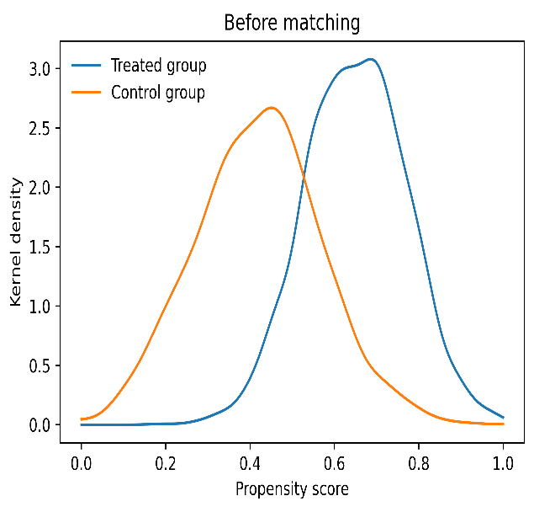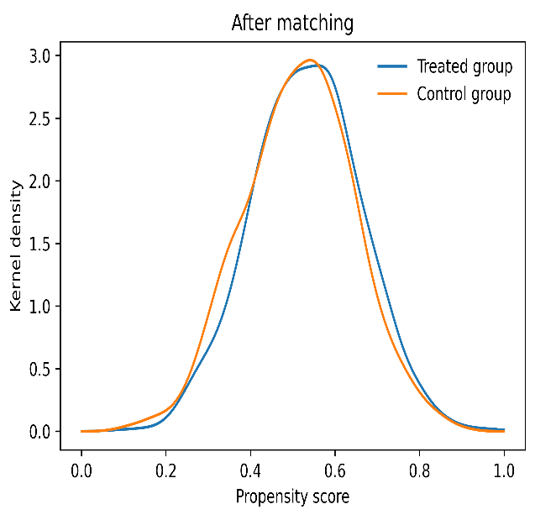
Figure B. Kernel Density Distribution.

Supplementary Material (B). Heterogeneity Effects

1. Heterogeneity by Country Income
Table B1 examines whether the effect of geopolitical tensions on financial resilience differs across country income groups. Our sample divided into lower-middle-income, upper-middle-income, and high-income economies to capture differences in institutional capacity, financial development, and shock-absorption ability. The results reveal significant heterogeneity across income groups, indicating that the impact of geopolitical tensions is not uniform across MENA economies. For lower-middle-income countries, geopolitical tensions have the strongest negative effect on financial resilience. The coefficients of GT (β = −0.528, p < 0.01) and GG (β = −0.119, p < 0.01) indicate that both persistent geopolitical pressures and their escalation significantly reduce ZR. However, the interaction terms GT*Lower (β = 0.231, p < 0.01) and GG*Lower (β = 0.048, p < 0.01) are positive, suggesting that although these economies are initially more vulnerable, prolonged exposure may encourage stronger adaptation mechanisms. This finding reflects the adaptive resilience perspective, where repeated shocks motivate banks to improve risk management and strengthen internal controls. For upper-middle-income countries, the negative impact of geopolitical tensions becomes stronger, with GT = −0.690 (p < 0.01) and GG = −0.424 (p < 0.01). However, the positive interaction effects (GT*Upper = 0.287, p < 0.01; GG*Upper = 0.044, p < 0.05) indicate that stronger financial systems and greater institutional capacity help mitigate the adverse effects of geopolitical uncertainty. High-income countries exhibit the highest initial sensitivity to geopolitical tensions, with GT = −0.928 (p < 0.01) and GG = −0.232 (p < 0.01). However, the moderating effects are also the strongest, with GT*High = 0.523 (p < 0.01) and GG*High = 0.050 (p < 0.01). This suggests that high-income economies experience larger immediate market reactions due to greater financial integration and international exposure, but they possess stronger institutional frameworks, diversified financial systems, and greater policy capacity to recover from shocks.
Countries with stronger financial systems and governance structures are better equipped to manage uncertainty and external shocks . At the same time, emerging and lower-income economies face greater vulnerability because of weaker institutions, limited fiscal capacity, and less-developed financial markets amplify geopolitical shocks. The results demonstrate significant income-based heterogeneity in the geopolitical tensions–financial resilience relationship. While geopolitical tensions negatively affect banks across all income groups, the ability to absorb and recover from these shocks differs substantially. Higher-income economies benefit from stronger institutional environments and financial systems, allowing them to better transform geopolitical challenges into resilience-building opportunities. These findings extend previous literature by highlighting that the consequences of geopolitical uncertainty depend not only on the intensity of shocks but also on countries’ economic development and adaptive capacity.
Table B1. Heterogeneity by Country Income
VAR | [1] | [2] | [3] | [4] | [5] | [6]
VAR | ZR | ZR | ZR | ZR | ZR | ZR
GT | -0.528*** |  | -0.690*** |  | -0.928***
 | (-5.467) |  | (-7.743) |  | (-7.717)
GG |  | -0.119*** |  | -0.424*** |  | -0.232***
 |  | (-2.969) |  | (-3.026) |  | (-3.096)
Low middle | -0.053** | -0.104***
 | (-2.044) | (-5.374)
Upper middle |  |  | 0.059*** | 0.049***
 |  |  | (3.154) | (2.718)
High income |  |  |  |  | 0.170***
 |  |  |  |  | (4.417) | 0.087***
GT*Lower | 0.231*** |  |  |  |  | (4.563)
 | (4.683)
GG* Lower |  | 0.048***
 |  | (2.678)
GT* Upper |  |  | 0.287***
 |  |  | (5.599)
GG* Upper |  |  |  | 0.044**
 |  |  |  | (2.552)
GT* High |  |  |  |  | 0.523***
 |  |  |  |  | (4.156)
GG* High |  |  |  |  |  | 0.050***
 |  |  |  |  |  | (2.692)
BS | 0.021* | 0.007* | 0.009* | 0.020* | 0.012* | 0.003*
 | (1.757) | (1.842) | (1.903) | (1.780) | (1.692) | (1.932)
CA | 0.006*** | 0.008*** | 0.010*** | 0.010*** | 0.007*** | 0.019***
 | (4.675) | (5.393) | (5.326) | (6.234) | (5.893) | (6.812)
AG | 0.135* | 0.094* | 0.114* | 0.121* | 0.120* | 0.113*
 | (1.958) | (1.722) | (1.949) | (1.721) | (1.790) | (1.671)
LG | 0.095* | 0.159* | 0.069* | 0.077* | 0.071* | 0.018*
 | (1.713) | (1.811) | (1.832) | (1.698) | (1.761) | (1.943)
IN | -0.006*** | -0.012*** | -0.005* | -0.006** | -0.005** | -0.004*
 | (-2.657) | (-5.485) | (-1.936) | (-2.337) | (-2.113) | (-1.697)
GD | 0.011** | 0.015*** | 0.009** | 0.006* | 0.011*** | 0.005*
 | (2.441) | (3.364) | (2.039) | (1.861) | (2.601) | (1.938)
Year FE | Included | Included | Included | Included | Included | Included
Country FE | Included | Included | Included | Included | Included | Included
Constant | 1.542*** | 1.665*** | 1.480*** | 1.508*** | 1.591*** | 1.538***
 | (6.371) | (3.145) | (5.640) | (4.687) | (4.996) | (3.907)
N | 936 | 936 | 270 | 270 | 810 | 810
R-squared | 0.564 | 0.439 | 0.467 | 0.360 | 0.569 | 0.554
Wald Chi2 | 437.8*** | 561.7*** | 550.6*** | 674.5*** | 767.1*** | 599.2***
N of Banks | 52 | 52 | 15 | 15 | 45 | 45

2. Heterogeneity by Oil Dependence
Table B2 investigates whether the effect of geopolitical tensions on financial resilience differs between high and low oil-dependent economies. Countries are classified according to whether their oil rents as a percentage of GDP are above or below the sample median. The results reveal significant heterogeneity, indicating that oil dependence shapes banks’ vulnerability and adjustment capacity during geopolitical shocks. For high oil-dependent economies, geopolitical tensions have a significant negative impact on distance-to-default (DD). Specifically, the coefficient of GT is negative (B= −0.331, p < 0.01), indicating that persistent geopolitical tensions reduce banks’ financial resilience by increasing uncertainty, weakening economic stability, and amplifying exposure to external shocks. This effect becomes stronger when geopolitical tensions increase rapidly, as shown by the larger negative coefficient of GT (B= −0.615, p < 0.01) in the alternative specification. These findings are consistent with previous studies showing that economies highly dependent on natural resources are more vulnerable to geopolitical uncertainty because oil revenues, fiscal conditions, and financial market expectations are closely linked to geopolitical developments. For low oil-dependent economies, geopolitical tensions also negatively affect financial resilience. The coefficients of GG are negative (B=−0.411 ;−0.192, p < 0.05), suggesting that sudden increases in geopolitical tensions weaken banks’ distance-to-default even in less oil-dependent countries. However, the relatively smaller effect compared with high oil-dependent economies indicates that diversified economies may have greater capacity to absorb geopolitical shocks due to lower dependence on oil revenues and more diversified economic structures.
The results highlight an important economic mechanism. Oil-dependent economies face greater exposure because geopolitical tensions can directly affect oil production, export revenues, fiscal stability, and investor confidence. These channels can increase liquidity pressures and credit risks in the banking sector. In contrast, lower oil-dependent economies are relatively less exposed to commodity-related shocks and may rely on broader economic activities, reducing the transmission of geopolitical risks to banks. The findings demonstrate that oil dependence is an important source of heterogeneity in the geopolitical tensions–financial resilience relationship. Although geopolitical tensions weaken banking resilience across all economies, the adverse effect is stronger in oil-dependent countries due to their greater exposure to energy-market volatility and geopolitical disruptions. These results are consistent with the resource dependence perspective and extend previous literature by showing that economic structure influences banks’ ability to absorb geopolitical shocks. Therefore, policymakers in oil-dependent economies should strengthen financial diversification, institutional capacity, and risk-management frameworks to reduce vulnerability to geopolitical uncertainty.
Table B2 Heterogeneity by Oil Dependence
 | Oil Dependence
 | High | High | Low | Low
 | DD | DD | DD | DD
GT | -0.331*** | -0.615***
 | (-2.419) | (-3.344)
GG |  |  | -0.411** | -0.192**
 |  |  | (-2.198) | (-1.987)
BS | 0.019*** | 0.026*** | 0.018** | 0.010***
 | (2.111) | (2.811) | (1.991) | (2.901)
CA | 0.021*** | 0.016*** | 0.015*** | 0.010***
 | (4.076) | (3.281) | (3.017) | (2.815)
AG | 0.044* | 0.055* | 0.032* | 0.107*
 | (1.941) | (1.711) | (1.675) | (1.881)
LG | 0.008** | 0.022* | 0.067* | 0.115*
 | (2.013) | (1.917) | (1.706) | (1.811)
IN | -0.009** | -0.012* | -0.008* | -0.013**
 | (-2.108) | (-1.713) | (-1.901) | (-2.011)
GD | 0.011** | 0.025** | 0.045** | 0.006*
 | (2.514) | (2.011) | (2.331) | (1.690)
Cons | 1.117*** | 1.055*** | 1.653*** | 1.333***
 | (2.611) | (5.081) | (2.816) | (4.411)
N | 1,003 | 816 | 969 | 850
Wald chi2 | 346.8*** | 511.3*** | 981.2*** | 561.7***
N of Banks | 60 | 60 | 52 | 52
Note: Z-statistics in parentheses; *** p<0.01, ** p<0.05, * p<0.1
DD= default to distance (financial resilience); GT = Geopolitical tensions index; GG= the growth of geopolitical tensions; BS = Bank size; CA = Capital adequacy ratio; AG= Assets growth, LG = Loan growth; GD= Gross domestic product, IN = Inflation rate; High oil dependence = 1 if a country's oil rents (% GDP) are above the median; 0 otherwise. High values indicate oil-dependent economies.

