Statistical Analysis of Avian Reproduction Studies
Supplementary Material
John W Green¹, Manousos Foudoulakis², Timothy Fredricks³ , Tiffany Carro⁴, Jonathan Maul⁵, Stephanie Plautz ⁶, Pablo Valverde^{7,} Adam Schapaugh³, Xiaoyi Sopko⁸, Zhenglei Gao⁹
¹John W Green Ecostatistical Consulting LLC, Newark, DE, USA
² Corteva™ Agriscience, 152 32 Halandri, Greece
³ Bayer U.S. Crop Science, Chesterfield, MO, USA
⁴ FMC Corporation, 2929 Walnut Street, Philadelphia, PA, USA
⁵ Syngenta Crop Protection LLC, Greensboro, NC
⁶ BASF Corporation, 26 Davis Dr, Research Triangle Park, NC, USA
⁷ Corteva™ Agriscience, Indianapolis, IN, USA
⁸ Corteva™ Agriscience, Wilmington, DE, USA
⁹Bayer AG, Monheim, Germany
Corresponding author
John W. Green
John@JohnWGreen-ecostats.com
Phone: 1(302) 545-4375
Fax: 1(302) 731-7262

Annex 1: Case Studies
The main manuscript provided brief summaries of five case studies illustrating key points in the recommended statistical protocol for avian reproduction studies. The purpose of this Annex is to provide more detail on those five studies and to present additional case studies that further illustrate the benefits and challenges of the recommended protocol. The case studies are derived from the numerous avian reproduction studies supplied by members of the ECPA-TVaht (Terrestrial Vertebrates ad hoc team (TVahT). The case studies provided here are taken from a larger set of case studies developed for the TVahT team.
Case Study A1.1 Eggs Cracked/Eggs Laid

Summary of results
Case study A1.1 illustrates how historical control data can help identify an extreme concurrent control results that can lead to misleading statistical significance. It also illustrates the importance of outlier identification. Table A1.1 shows the mean response (as a percent) in all treatment groups with all observations included. The mean response, quail cracked eggs per eggs laid, is notably higher in all treatment groups than in the control. It is also apparent that the treatment-response is not monotone.
An unusually low control mean response makes small increases in the percent of eggs cracked statistically significant without having any biological importance. Without historical control data (HSD), a regulatory authority required an additional study be run. With the HCD, there is no biologically important increase in eggs cracked below 100 ppm and it is questionable whether the increase at 100 ppm is meaningful.

Figure A1.1 shows the study data in relation to the historical control data from the same lab. The 95% confidence bounds on the HCD are given by (LB,UB)=(1,5), so the mean response at conc=100 ppm > UB. The Tukey outlier test (Tukey 1977) found 1 outlier in the 100-ppm treatment group. With that observation omitted, the mean response in that group was 3.27% which is well below UB. The control mean, 0.62, is 38% below the lower 95% CB of the HCD.
Table A1.1 Percent Eggs Cracked/Eggs Laid
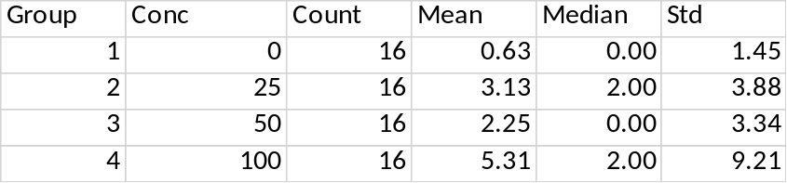
Four analyses were done of eggs cracked. The total number of eggs cracked were compared using a GLMM model with Poisson error distribution followed by a Dunnett-Hsu test to determine a NOEC. By this analysis, the mean responses in the low- and high-test concentrations, but not the intermediate test concentration, were significantly higher than the control mean response. This approach ignores possible effects on egg production. An alternative approach is to analyze the proportion of eggs laid that are cracked. This approach was done in three ways. First the proportions were transformed with an arc-sine square-root transform to normalize and stabilize the variance after which the data were analyzed as continuous. This is a standard approach to analyzing proportion data. See for example, Fleiss et al (2003). The Dunnett test using this approach gave the same result as the Poisson model for total eggs cracked. An alternative was to analyze the eggs cracked counts as conditionally binomial, given the eggs laid on a per-hen basis using a GLMM model followed by the Dunnett-Hsu test. This approach reached the same conclusions as the two methods discussed above. As discussed in Green et al (2018) a GLMM approach is preferred on the grounds of directly capturing the actual data rather than treating the data as approximately normally distributed following a transform. It must be acknowledged however, that the data exhibited overdispersion and all attempts to adjust the analysis, for example using a negative binomial distribution, to take overdispersion into did not removed its effects. As Figure A1.1 shows, the control mean response was unusually low, in fact below the historical control range. The mean responses in the low and intermediate treatment groups were within the historical control range and the only reason the high treatment mean response was above the historical control range was due to a single hen where 36% (8 of 22) of eggs laid were cracked. Only three hens in the study laid fewer eggs than were laid by this hen. The biological importance of this single observation or the resulting high proportion of cracked eggs is not clear. A NOEC of 50 is justified for this response and the biological importance of the statistical result at 100 is questionable.

To put these data in context, the data were compared to the historical control data for the period 2003-2009. Figure A1.1 shows this comparison for the percent cracked eggs per eggs laid where the large outlier in the high test concentration is obvious. Figure A1.2 shows the data with this single observation omitted. It is evident in both figures that the control mean response is below the historical control range.

Figure A1.1. Percent of eggs cracked/Eggs laid in the years 2003 to 2009 – Case Study A1.1
45 studies in historical control database
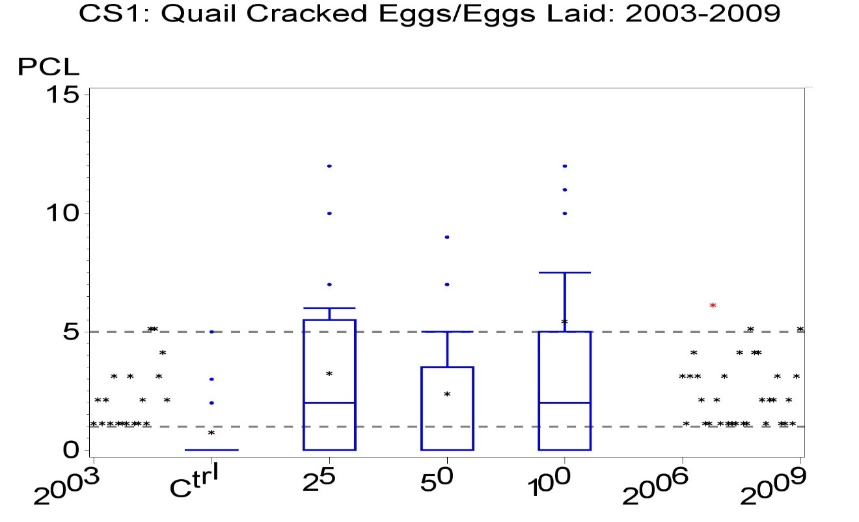

The response was percent eggs cracked per eggs laid (PCL). In the box plot of study data, the bottom and top are the 25th & 75th percentiles of the indicated treatment group, the horizontal line between the top & bottom is the median, the mean is the blue asterisk, whiskers extend from top or bottom to most extreme non-outliers, with outliers indicated as blue dots beyond the whiskers. Individual historical control data mean responses are indicated by black asterisks. HCD data from 2003-2005 are displayed to the left of the 2006 study data, while HCD data from 2006-2009 are displayed to the right.
Figure A1.2 Percent of eggs cracked/Eggs laid in the years 2003 to 2009 with one outlier omitted
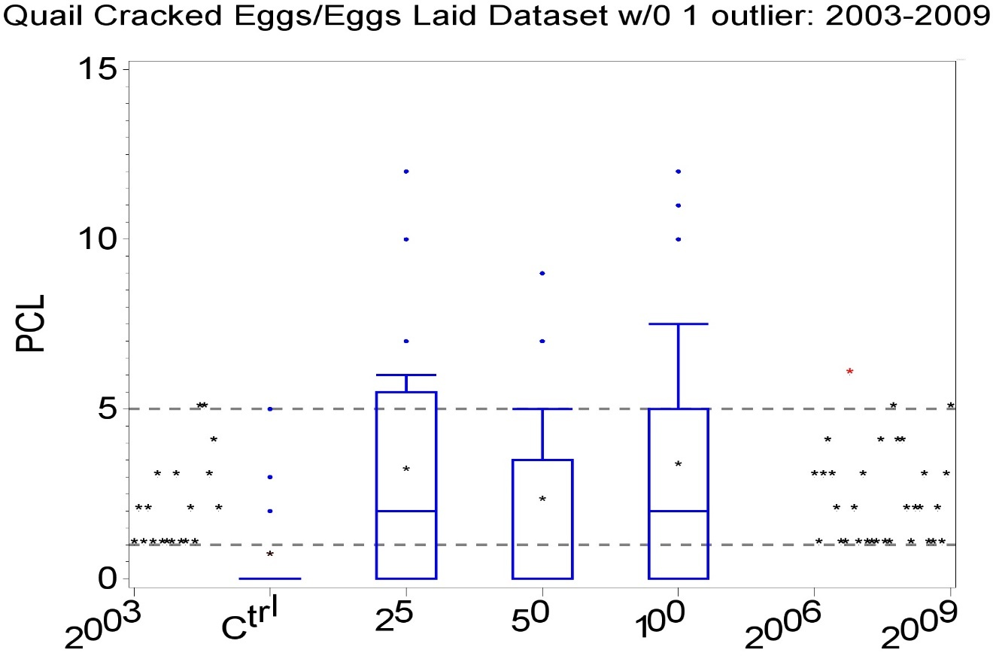

Statistically significance was assessed in several ways. A standard way to analyze such percentage data is a to apply Dunnett’s test to arc-sine square-root transformed proportions (Fleiss et al 2003). A scientifically preferable analysis would be to analyze the number of cracked eggs as binomially distributed conditioned on the number of eggs laid, followed by Dunnett’s test in a generalized linear mixed model (GLMM). There was evidence of overdispersion in the study data, but all attempts to capture it failed. The Jonckheere-Terpstra (JT) trend-based test would also be appropriate except for the non-monotonicity observed in both the complete and outlier omitted data. The increases found by either Dunnett test at 25 ppm and 100 ppm were a function of the low control, not real effects. The mean responses in the low and intermediate treatment groups were within the historical control range and the only reason the high treatment mean response was above the historical control range was due to a single hen where 36% (8 of 22) of eggs laid were cracked. Only three hens in the study laid fewer eggs than were laid by this hen. The biological importance of this single observation or the resulting high proportion of cracked eggs is not clear. It should be noted that a regulatory reviewer requested another avian reproduction study on the test substance based on the significant increase found in the low treatment group. The historical control database suggests strongly that this was not warranted and a new study supported this conclusion.
Case Study A1.2 Analysis of 14-day hatchling survivors/eggs set (H14DS_ES)
The points illustrated with this example are (i) the identification and effect of outliers on conclusion; (ii) the identification and effect of an improper transformation; (iii) the utility of a historical control database.

Table A1.2. Case Study A1.2. Quail Proportion 14-day hatchling survivors/eggs set (H14DS_ES)
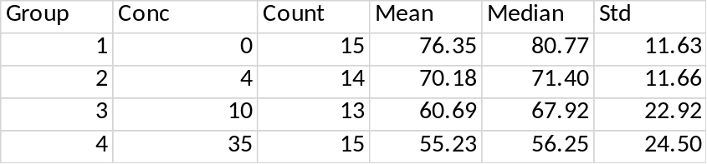
Count=number of replicates (breeding pairs); Mean, median, and standard deviation are simple unweighted summary statistics; Conc=ppm

There is a clear downward trend in these means and medians. Whether the 8% decrease from the control mean observed in the low dose group is biologically meaningful can be considered at a following level of investigation. The higher standard deviations in the 10 and 35 ppm test concentrations are also notable. The Tukey outlier test identified an outlier in each of those treatment groups. When those two outliers were omitted, the

Data were found not to be normally distributed according to the Shapiro-Wilk test applied to the residuals from a simple ANOVA. Since this is a proportion, the arc-sine square-root transform was investigated. The transformed data were still not normally distributed. An alternative Freeman-Tukey transform was tried. While it made no difference in conclusions in this case study, this approach is problematic for reasons indicated below. For reference, that transform is provided below.

The Freeman-Tukey transform is
$y_{i}^{`}=\text{arcsin}\left(\sqrt{\frac{n_{i}y_{i}}{n_{i}+1}}\right)+\text{arcsin}\left(\sqrt{\frac{n_{i}y_{i}+1}{n_{i}+1}}\right)$,
where n_{i} is the number of eggs set and y_{i} is the number of hatchlings surviving to 14 days. It should be noted that if there are zero proportions (y_{i}=0), the Freeman-Tukey transform need not be order preserving and this can distort the data. To understand this, consider the situation where y_{i}=0 and n_{i}=1 vs y_{j} small and n_{j} large in the same dataset. For this reason, the Freeman-Tukey transform is not recommended.

A non-parametric Dunn test for decreasing response was performed which found the NOEC to be the lowest test concentration, 4 ppm. A step-down Jonckheere-Terpstra test was also done and it found a significant effect at 4 ppm, so that the NOEC by that test was less than 4.

The Tukey outlier test was done on the same residuals as indicated above. It identified two outliers, shown in Table A1.3.

Table A1.3. Outliers in H14DS_ES
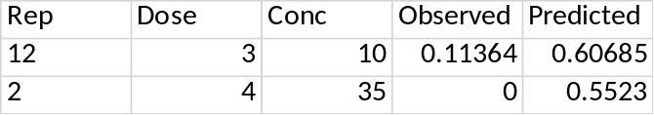
The 0 value for H14DS_ES at 35 ppm is notable. This hen laid 17 eggs of which 13 were set but none hatched. There was only one other hen in the study with no hatchlings. This was a hen at 10 ppm which laid only 1 egg which was not set and thus HS14DS_ES for that hen did not contribute to the analysis. When these two outliers are omitted, the remaining data were found to be normally distributed with homogeneous variances following an arc-sine square-root transform and Williams’ test found the NOEC to be 4 ppm. The Dunnett test found the NOEC to be 10 ppm. The data with outliers omitted is summarized in Table A1.4. The purpose of doing an analysis of the data with these two outliers omitted was to determine their impact on the analysis. There is no suggestion that these are unimportant observations. What is suggested is that they distort the evidence of general tendencies in the response.

Table A1.4. Summary statistics with 2 outliers omitted
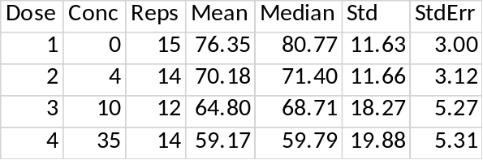
Treatment means were compared to a historical control database (HCD) from the testing laboratory using all data from the years 1993-1999, which is centered on the year of the study. Table 2.4 summarizes that database. The mean response of the concurrent control is slightly higher than the historical control mean, but it and the mean response in the lowest test concentrations are well within the middle 90% of the historical control database range and even the mean response in the two highest test concentrations are above the lower 5th percentile of the HCD, which is 57.6. These observations together with the fact that the statistical significance by the Jonckheere-Terpstra test at 4 ppm was the result of two outliers suggests that the observed decrease at that concentration was not biologically meaningful and even those in the higher concentrations are of questionable biological relevance. Figure A1.1 displays the historical control data and the concurrent study together. Figure A1.2 displays the historical control data and the concurrent study together with 2 outliers omitted.

Figure A1.3. Concurrent and historical control data for H14DS_ES
38 studies in historical control database
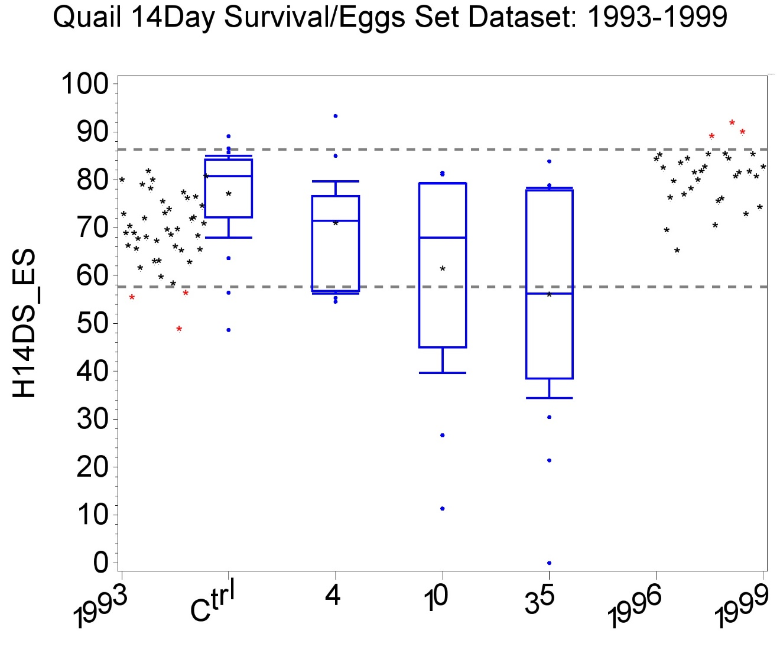

Boxes: top=Q3, bottom=Q1, interior line=median, *=mean, T=90th percentile, inverted T=10th percentile, dots=outliers. The horizontal reference lines are the 5th and 95% percentiles of the control mean responses from the HCD.

Figure A1.4. Concurrent and historical control data for H14DS_ES with 2 outliers omitted

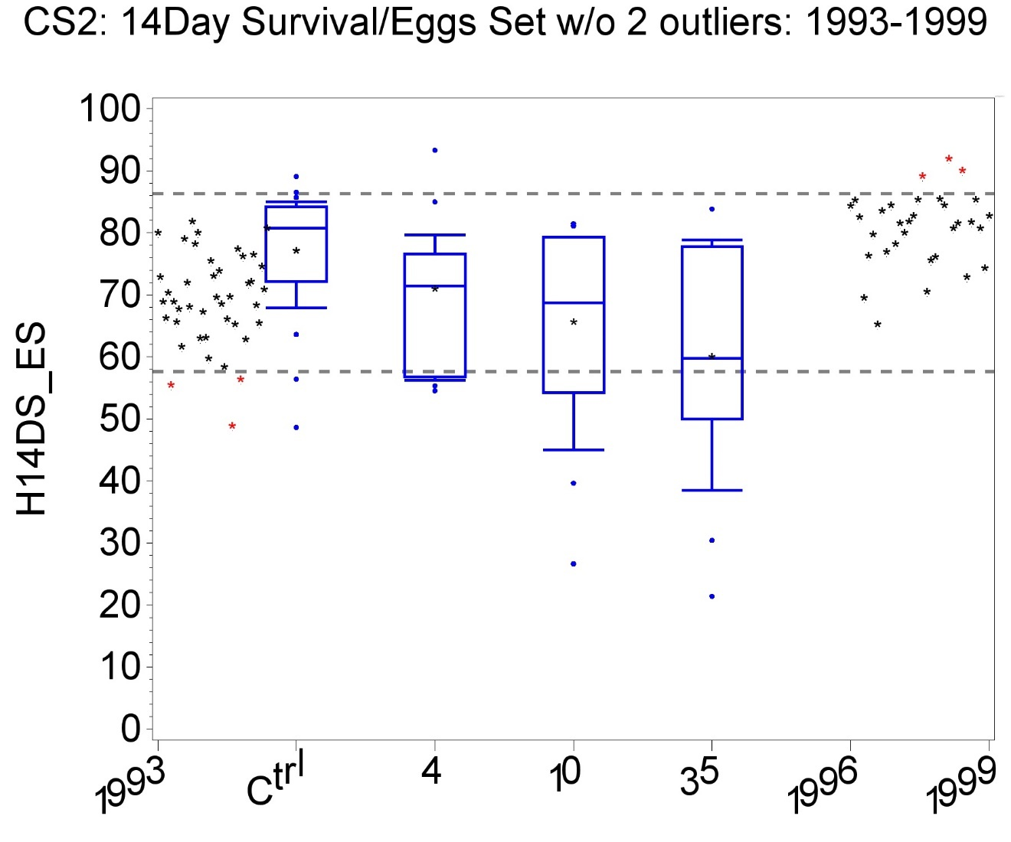

Case Study A1.3 Eggs hatched per eggs set (HATCH_ES)

Case study A1.3 illustrates that an incorrect statistical test or ad hoc visual interpretation can lead to a wrong conclusion. As with other examples, the use of historical control data and outlier detection help to clarify the analysis. Summary data are given in Table A1.5. A regulatory reviewer set the NOEC at 10 ppm on the grounds that a 10+% decrease was observed in the two higher treatment groups. By comparing the treatment means and medians, a skewness can be deduced in the two highest treatment groups. Moreover, the standard deviations in the two highest treatment groups were much higher than in the control and low treatment. The data were in fact found to be inconsistent with normality and variance homogeneity and a non-parametric analysis was indicated. There were only 6% and 1% decreases in the two treatment medians.
Table A1.5. Case Study A1.3. Eggs Hatched per Eggs Set (HATCH_ES)
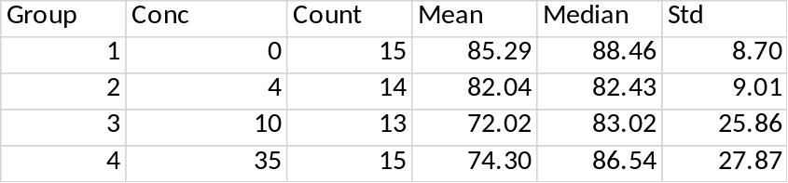
Count=number of replicates (breeding pairs); Mean, median, and standard deviation are simple unweighted summary statistics
Conc=ppm

The median responses show no more than 6% decrease from control in any treatment group. No statistical analysis found a significant effect at any test concentration. The data were found inconsistent with a normal distribution by the Shapiro-Wilk test. Consequently, the tests done were Dunn’s test and a step-down Jonckheere-Terpstra test, neither of which require normality or variance homogeneity. As a further check, both the Dunnett and Williams tests were done despite the data not meeting the requirements of those tests. These tests also did not find a significant effect in any test concentration. A regulatory review of these data concluded that there were significant effects in the high and intermediate doses because there was more than a 10% decrease in mean response there.

This raises the question of when statistical analysis should be overruled by ad hoc rules based on the observed effect sizes. This is especially relevant since the summary data in Table 3.1 indicate notable differences between mean and median values. Such a result demands a careful evaluation of the data.

A plot of the concurrent and historical control data (Figure A1.3.1) indicates several features of interest: (1) The variances in the intermediate and high dose groups appear much larger than in the control and low dose group. (2) The high variance in the intermediate dose group is due to two unusually low values and that in the high dose group is due to two or possibly three unusually low values. The four lowest of these five unusual values were identified as outliers by the Tukey outlier rule. (3) Even with these possible outliers included, the mean responses in all treatment groups fall within the historical control range for this response, as is evident from Figure A1.5.

Figure A1.5. Concurrent and historical control data for Hatchlings per eggs set
38 studies in historical control database
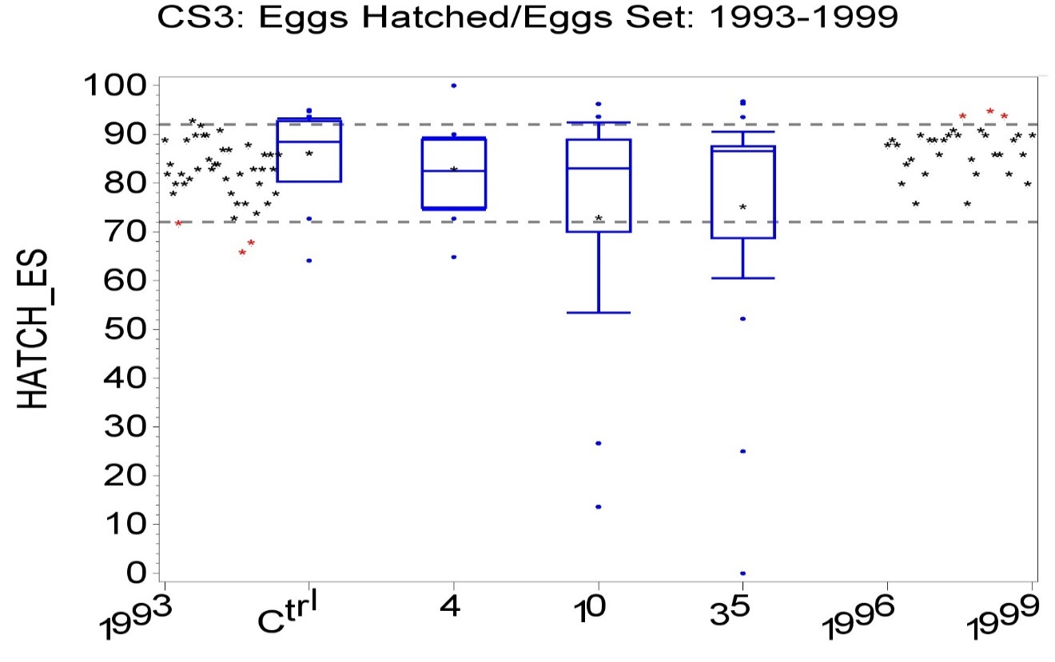
HCD data from 1993-1995 are displayed to the left of the concurrent study, while data from 1996-1999 are on the right. Two low outliers are evident at 10 and two more at 35 ppm. All treatment means and medians are within the HCD.
Finally, when the data are re-analyzed after the omission of the four outliers identified by the Tukey outlier rule, the resulting data were found to be normally distributed with homogeneous variances. The Dunnett, Williams, and Jonckheere-Terpstra tests still found no significant effect at any dose. Table 1.6 provides the summary statistics with these four outliers omitted. It will be noted that the mean and median values are now in general agreement. Figure A1.6 shows that the resulting treatment means are well within the historical control range, further supporting the conclusion of no biological effects present.

Table A1.6. Summary statistics for eggs hatched per eggs set with 4 outliers omitted
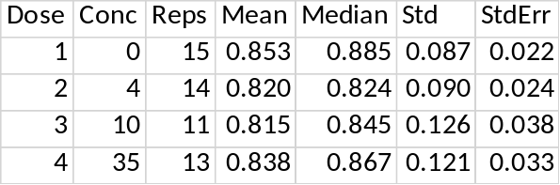

Figure A1.6. Concurrent and historical control data for Hatchlings per eggs set with 4 outliers omitted
38 studies in historical control database
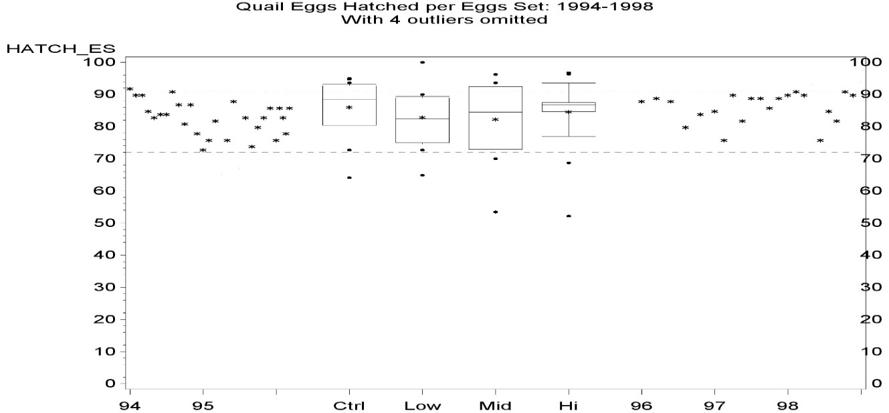

Case study A1.4. Quail Eggshell Thickness
This example illustrates the MAXSD method to determine the maximum safe dose in the sense that the effect of a treatment at that or any lower dose is significantly less than 10% (or whatever level of effect one wishes to investigate). This procedure can be helpful when there are too few test concentrations to fit a useful regression model. This example also shows the importance of knowledge of the minimum biologically important effect size when that is known. The value of historical control data is also illustrated. The data are summarized in Table A1.7.
Table A1.7. Case Study A4. Eggshell thickness
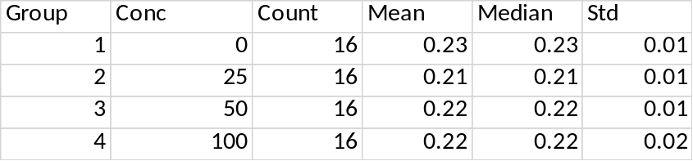
Count=number of replicates (breeding pairs)
Mean, median, and standard deviation are simple unweighted summary statistics.
Conc=ppm
Initial analysis found the data inconsistent with a normal distribution. Non-parametric hypothesis tests (Dunn and Jonckheere-Terpstra) find all treatment groups differed significantly from the control. Three outliers were found by the Tukey outlier test. When these were omitted, the resulting data were found to be consistent with a normal distribution with homogeneous variances and parametric analysis (Williams and Dunnett) on these data arrived at the same conclusion.
Comparison of the study data with historical control data within a ± 2- or ± 3-year span around the date of the study showed that the concurrent control and high and intermediate treatment group mean responses were all within the HCD range. These observations and the absence of a concentration-response trend make the statistical significance of the treatment effects questionable.
Regression was not feasible, given the small number of test concentrations and visually apparent (but not statistically significant) non-monotonicity of the concentration-response. However, the MAXSD method demonstrated that there was significantly less than 10% effect at the tested concentrations, supporting the conclusion that the statistical significance of the standard tests should not be considered definitive. Finally, there is a published opinion (EFSA 2009a) that a reduction in eggshell thickness of less than 18% is not biologically important, at least in terms of population level concern.
Conclusion: The decrease is statistically significant in every treatment group and this does not change when outliers identified by the Tukey outlier test are omitted. It should be noted, however, that the magnitude of the observed effect is only 6% in the two highest test doses and only 9% in the lowest dose. With only three treatment groups in addition to the control, it was not possible to fit a useful regression model. Even a simple exponential model with only two parameters fit to the data yielded an EC10 estimate not significantly different from zero, making the estimate of little value for risk assessment. However, the test SD1HC under the MAXSD methodology (Tamhane and Logan (2004); Tamhane and Logan (2002); Tamhane et al (2001) found the decrease in eggshell thickness to be significantly less than 10%, making the high dose (100 ppm) safe at the 10% effects level. In other words, EC10LB>100 ppm.
The concept of MAXSD is simple. One specifies an effect size X of interest, such as X=10%. Then the null hypothesis that the effect size equals or exceeds X% is tested against the alternative that it is less than X%. Assuming a monotone concentration-response, the smallest test concentration at which the null hypothesis can be rejected in favor of the specified alternative is the highest tested concentration at which the effect is less than X%. This test concentration is labeled the MAXSD or maximum safe dose. Normally distributed responses within test concentrations are assumed, but variance homogeneity is not required. This test can be used when there is only one test concentration or several. The test statistic is based on the multivariate T-statistic. The corresponding probabilities were computed using the R package mvtnorm. All other calculations were done using a SAS program written by the lead author of this manuscript. The original implementation of the MAXSD test was developed in FORTRAN (Schervish 1984 and Dunnett 1989). That program appears no longer to be available and FORTRAN is no longer widely used. The discussion of this test given below is taken from Green et al (2018). More detail is provided for this test here since it is less well known than the other tests recommended in the recommended statistical protocol.
The MAXSD test is a step-down test but based on Helmert contrasts of the treatment means that take the full dose-response shape into account. The implementation of MAXSD used in this case study is called SD1HP in Tamhane et al. (2001). It is useful when the concentration-response shape is less regular in appearance (leaving that term undefined) and it has reasonable power properties. The contrasts are defined by

$C_{ij}=\left({\overline{y}}_{i}+…+{\overline{y}}_{j}\right)-\left(j-i+1\right)λ{\overline{y}}_{0}$ (Eq. S1))

for j>i.

A t-statistics defined by

$t_{ij}=\frac{C_{ij}}{stderr(C_{ij})}=\frac{C_{ij}}{\frac{s}{n_{0}}\sqrt{{\left(j-i+1\right)}^{2}λ^{2}+\sum_{h=i}^{j}{ \frac{n_{0}}{ n_{h}}}}}$, (Eq. S2)

where s is the usual pooled within-treatment standard deviation. H_{0i} is rejected in favor of H_{1i} if

$t_{i,max}=\max_{i≤j≤k}\left\{t_{ij}\right\}>t_{m,ν,R_{m}}^{α}$, (Eq. S3))

where k is the number of test concentration compared to the control, m =k-i+1, and $t_{m,ν,R_{κ}}^{α}$ is the upper α equicoordinate critical constant of an m variate central t-distribution with ν degrees of freedom and correlation matrix

$R_{m}=\left\{ρ_{jj`}^{(m)}\right\}$, (Eq. S4)

where

$ρ_{jj`}^{(m)}=corr(C_{ij},C_{ij`})=\frac{\left(j-i+1\right)\left(j`-i+1\right)λ^{2}+\sum_{h=i}^{j}{ \frac{n_{0}}{n_{h}}}}{\sqrt{\left[{\left(j-i+1\right)}^{2}+\sum_{h=i}^{j}{ \frac{n_{0}}{n_{h}}}\right]\left[{\left(j`-i+1\right)}^{2}+\sum_{h=i}^{j`}{ \frac{n_{0}}{n_{h}}}\right]}}$, for i ≤ j < j` ≤ k. (Eq. S5))

Critical values for the right-most term in (Eq. S3) can be derived from Schervish (1984) or approximated by Dunnett (1989) or from R package mvtnorm. The procedure begins by testing H₀₁ vs. H₁₁ by computing

$t_{1,max}=\max_{1≤j≤k}\left\{t_{1j}\right\}$ and comparing it to $t_{m,ν,R_{m}}^{α}$.

If there is insufficient evidence to reject H₀₁ in favor of H₁₁, then testing stops and MAXSD is less than the lowest tested concentration. Otherwise, one tests H_{0i} vs. H_{1i}, i>1 until the first integer i is encountered at which there is insufficient evidence to reject H_{0i} in favor of H_{1i}, at which point testing stops and MAXSD=(i-1)^{th} concentration.
For numerical stability, the eggshell thickness values have been multiplied by 100 with corresponding changes in the variance. Variances are needed for the MAXSD method and additional digits are displayed that may be relevant to that test.
Table A1.8. Case Study A4 Additional summary information
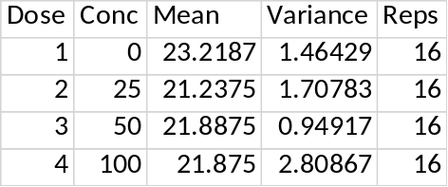

Table A1.9. T-test correlations for TMAX probabilities
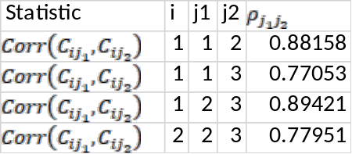
The superscript (m) has been suppressed on the rho label in the last column. The I and j values are for the treatment groups, with 1 for the lowest tested concentration, etc., I.e., dose-1 in Table A1.8.

Table A1.10. TMAX calculations
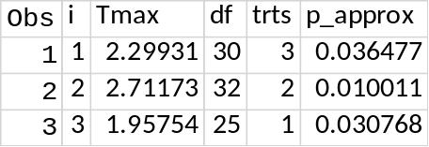

The initial p-value (where trts=3) is less than 0.05, which indicates that there is sufficient evidence to conclude significantly less than 10% effect in the highest test concentration.

Biological Importance
According to EFSA (2009b), a decrease of less than 18% in eggshell thickness is not biologically important in terms of a population effect. However, the lowest treatment mean response does fall below the historical control range, as indicated by Figure A1.7.

Figure A1.7 Eggshell thickness compared to historical control data
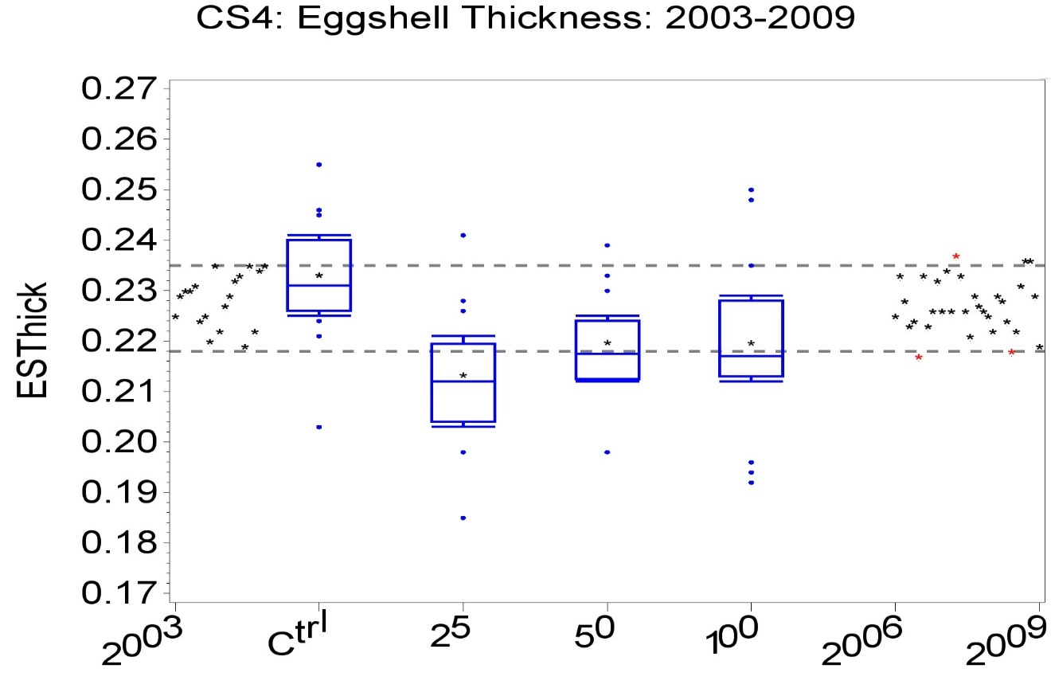

There were 45 studies in historical control database in the indicated period. HCD data from 1993-1995 are displayed to the left of the concurrent study, while data from 1996-1999 are on the right. One high outlier is evident in the control and two low outliers are evident at 100 ppm. The mean response at 25 ppm is below the HCD lower confidence bound. The control mean response is near the HCD upper bound and mean responses in the two highest treatments are near the HCD lower bound. The median responses in all treatment groups were below the HCD lower bound. There is no question about the statistical significance of the decreased thickness in the three treatment groups. Nor is there any question about whether the mean or median responses are below the HCD lower bound. The question is whether such small differences are biologically important. EFSA (2009a) guidance indicates not.

A plot showing a window of ± 2 years instead of the ± 3 years shown does not change the comparison of study data to historical control data in a material way.
Case Study A5. % 14-Day Survivors per Hatchling (P14DH)
The primary objective of this case study was to illustrate regression modelling, with emphasis on model averaging as promoted by EFSA (BMD approach). It is shown that some older approaches to regression modelling treating proportions as continuous responses can lead to problems that can be overcome to considerable advantage by using more scientifically sound models that treat the key response, in this case 14-day survivors, as binomial conditioned on the base variable, which in this case is hatchlings. Table A1.11 is a summary of the data.

Table A1.11 Summary data for P14DH
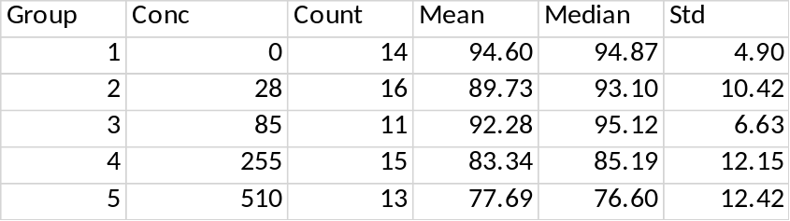
Count=number of replicates (breeding pairs); Mean, median, and standard deviation are simple unweighted summary statistics; Conc=ppm

The year the study was started was 1997. The response analyzed is the proportion of 14-day survivors per hatchling, though Figure 5.1 shows the corresponding percentages. The percent data are summarized in Table A1.12 and the corresponding proportion were found consistent with normality (Shapiro-Wilk p=0.06). The Dunnett and step-down Williams and Jonckheere-Terpstra tests applied to the corresponding proportions all determined the NOEC=85 ppm, where there was a 2% observed effect. No transform was applied to the proportions. While it is standard to use an arc-sine square-root transform to analyze proportion data, this would be problematic for regression since there is no practical way to determine the percent change in the transformed response that is equivalent to a 10% change (for example) in the actual proportions.

A preferable alternative GLMM analysis treats the number of 14-day survivors as a quantal response conditioned on the number of hatchlings. By this approach, the NOEC was also found to be 85 ppm. The GLMM approach more accurately captures the data since it takes the number of hatchlings directly into account, whereas the normal approximation methods within standard ANOVA uses either unweighted proportions or indirectly uses proportions weighted by the number of hatchlings. It is also interesting that the mean responses at two lowest test concentrations are near the middle of the HCD, while the mean response at 255 ppm was near the lower bound and the mean response at 510 ppm was below the HCD. No evidence of overdispersion was found.

Figure A1.8 puts these data in context with the historical control data base, where it will be evident that the mean in the highest tested concentration is noticeably below the HCD, the mean at 255 ppm is just within that range and the other treatment mean responses are near the middle of the range and the control mean response is towards the high end of the control range.

Figure A1.8 Case Study A1.5 (P14DH) in context with HCD for years 1995-1999
36 studies in historical control database
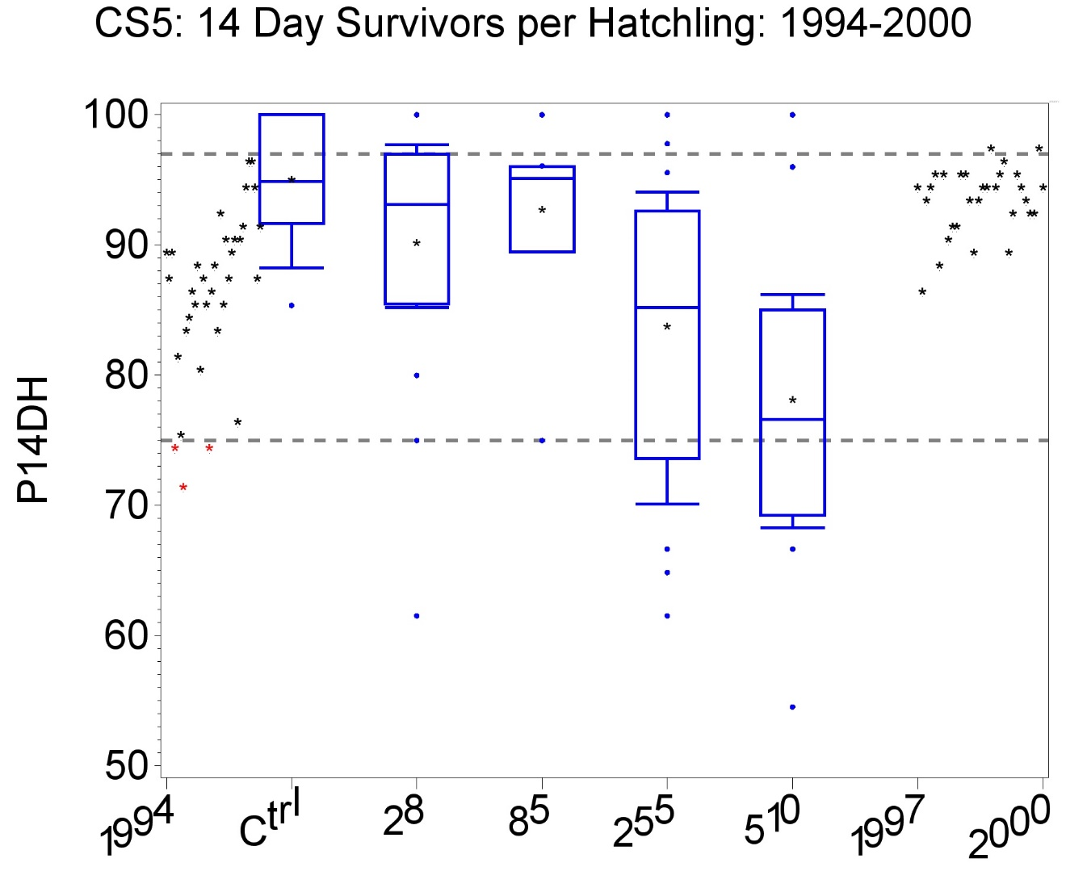
EFSA guidance (EFSA 2009a) suggests the use of benchmark dose methodology in risk assessment and a USEPA workshop (USEPA 2015) explored this. EFSA states that ”the BMD approach is a scientifically more advanced method to the NOAEL approach for deriving a Reference Point.” The document describes a few conditions under which a model is considered acceptable and then proposes a model averaging technique to be applied to all models deemed acceptable. EFSA guidance assumes a set of nested models, such as the models OE2, OE3, OE4. This would rule out some widely used models such as the Bruce-Versteeg and log-logistic, but these can be added by replacing the nesting feature by information criteria such as AICs or BIC. These models are described in Annex 3.

With only three positive test concentrations in most avian reproduction guideline studies, regression modeling is seldom rewarding. In this case study, there were four test concentrations, so regression is more feasible.

Model averaging, as discussed in EFSA (2009a), primarily meant to take the lowest of the lower confidence bounds for ECx of a set of adequate models. EFSA (2009a) provided only limited guidance on what determines model adequacy and even less on what models to use. While model averaging has been found useful for estimating the mean response at a given test concentration, recent research (e.g., Cade 2015) has given it significant criticism for estimating model parameters. In the modelling approach used in these case studies and recommended in the protocol, EC10 is a model parameter. However, Cade’s criticism does not seem to apply to this parameter and model average results for it appear useful. The BBMD, BMDS, PROAST, and drc software implement model averaging for both point and interval estimates of EC10 and EFSA (2017) and USEPA (2015) provide further justification.

Table A1.11 summarizes EC10 estimates from five models commonly used for ecotoxicity data fit to replicate proportions treated as continuous. The EC10 point estimates from these models are consistent, but the confidence bounds for EC10 are not. No acceptable fit could be obtained from a sixth model, OE5. Table A1.11 provides information for these models, showing that all parameters are significantly different from zero, with one exception for model OE4. Table A1.12 gives detailed information on one of the most plausible of these models based on formal goodness-of-fit criteria such as AICc, agreement of predicted means with observed means (especially for the control), width of the prediction interval at the estimated EC10, and the width of the confidence intervals for all model parameters.

Table A1.11. Summary of models fit to P14DH
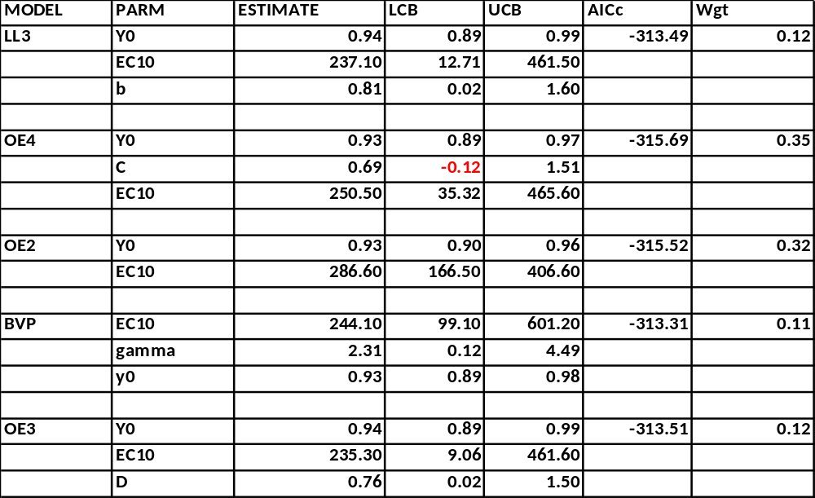
LL3=3-parameter log-logistic
OE4=exponential model with a floor
OE2=simple exponential model
BVP=Bruce-Versteeg probit-type model
OE3=exponential model with curvature
PARM=model parameter
AICc=Akiaki information criterion with small sample correction
Wgt=Akaiki weight
Estimate, LCB, UCB=point estimate, lower and upper 95% confidence bounds

The older model averaging from EFSA (2009a) would suggest using the point and interval estimates from OE3 since this model gives the lowest point and lower bound estimates of EC10. The summary of results from the BVP model given in Table A1.12 suggest that model describes the data well. There is nothing obvious in the fits of these two models that indicates superiority of one over the other. The great disparity in bounds and the lesser differences in EC10 point estimates suggests some problems with the models or data not captured in this set of models.

The revised procedure in (EFSA 2017) is to use actual model averaging based on the weights shown in Table A1.11 to obtain EC10_{avg}=258 and EC10LB_{avg}=76.7. It should be noted that the parameter C for model OE4 is indistinguishable from 0, as indicated by the interval estimate including 0. This model was included in the model average calculations, nonetheless.

Table A1.12 Results from the BVP model fit prp14DH
 |  | Mean |  | % Change
Conc | Reps | Observed | Predicted | Observed | Predicted
0 | 14 | 0.94605 | 0.93422 | 0 | 0
28 | 16 | 0.89728 | 0.92187 | -5 | -1
85 | 11 | 0.92276 | 0.89587 | -2 | -4
255 | 15 | 0.83344 | 0.83765 | -12 | -10
510 | 13 | 0.77689 | 0.7773 | -18 | -17

Figure A1.9 BVP model fit to prp14DH
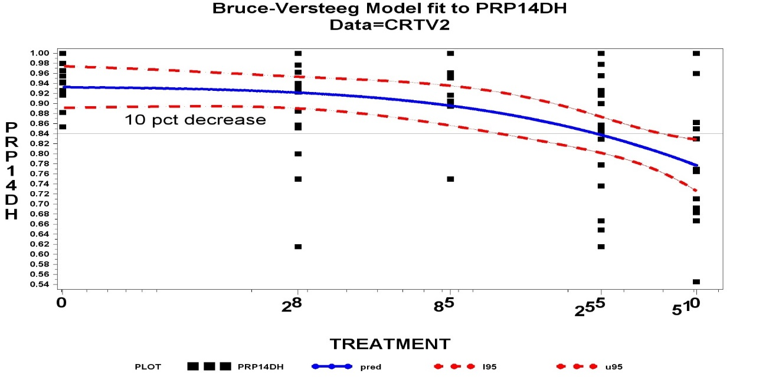

Alternative regression models
The same models can be fit using Generalized non-linear mixed models (GNLMM) with a binomial error structure conditioned on hatchlings as was done with GLMM analysis to obtain a NOEC. This approach is more consistent with the nature of the data and is recommended for endpoints that can be configured as quantal, i.e., response/risk. In this case study, the endpoint has the form HS14D/Hatch. Table A1.12 summarizes the results of five models fit to the data that assume a conditionally binomial error structure. It will be seen that the results of these models are more consistent with one another. The BVP model with binomial error structure is a probit model. The B at the end of each model name indicates that the binomial error structure was used. Of these five models, all but OE4B met the requirement that all model parameters be significantly different from zero. While OE4B is included in the table, it should not be used for risk assessment. For this case study, the model averaging idea suggested by EFSA (2009a) would select the ProbitB model, as it has both the lowest point estimate and lowest lower confidence bound. Table A1.13 summarizes the parameter estimates from all models given in Table A1.12.

Table A1.13 Summary of GNLMMs with conditionally binomial error structure fit to P14DH
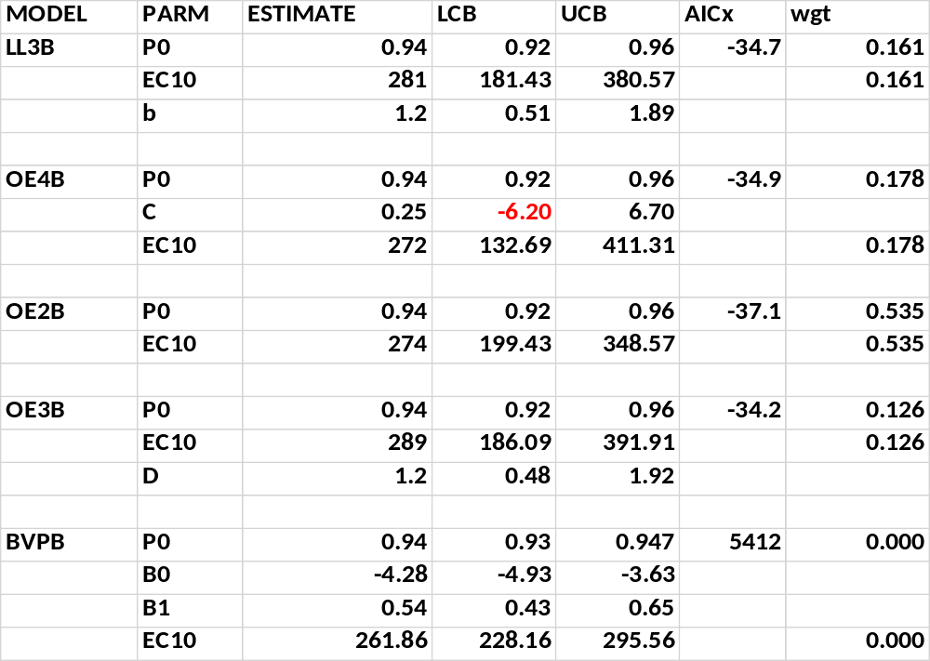

The suffix B indicates that a binomial error structure was used. Otherwise these are the models indicated in the appendix. The probit model described in Annex 3 is for an increasing concentration-response in mortality, while all the other models are formulated for a decrease in survival. To make model comparisons simpler, the background parameter for the probit model in Table A1.13 referred to as P0 is the estimated survival in the control. It is interesting that the BVP model parameters appear reasonable, but the estimated responses (not shown) at positive test concentrations are very poor and that is reflected in the zero weight and huge AICc value given to that model in the average calculation. Model averaging gave estimates EC10_{avg}=277 and EC10LB_{avg}=183ppm. A tighter lower bound reflects less uncertainty in this estimate compared to that of Approach 1.

Case Study A1.6. Hatchling survival at 14 days per maximum eggs set.

The purpose of this case study is to point out that this is a biologically meaningless and statistically objectionable measurement and to provide a better way to assess the effect of the test substance on hatchling survival.

There are several objections to statistically analyzing this response. First, from a purely conceptual perspective, this is no different from analyzing hatchling survival at 14 days since each survival number is divided by the same value, the maximum eggs set. Each ratio is transformed into a proportion and then, presumably, analyzed treating these proportions as a continuous response, probably using an arc-sine square-root transform, just as was done for the response hatchling survival at 14 days per eggs set. This technique is an approximation since the counts are not continuous and dividing them by the same value does not make them continuous. The count response, Hatchling survival at 14 days, is more properly analyzed using a generalized linear mixed model (GLMM) based on a Poisson distribution. Such an analysis treats these counts as counts with no approximation. It also allows for overdispersion in a simple manner, something more complicated using the continuous approximation.

The second serious objection is that the maximum eggs set is not a constant. It is a random variable, so that the ratios are all correlated by virtue of having the same random variable in the denominator. This correlation among observations being modeled violates one of the basic requirements of statistical tests and models, namely that the observations be independent. Moreover, the maximum eggs set is an extreme value response and so highly variable, thus possibly increasing the variance of the ratio. It is not possible to fully appreciate the effect on the variance by simply applying the standard variance formula to the ratios, since this is not the correct variance given that the observations are not independent. Computer simulations show that the NOEC (or ECx) value derived from the ratios can be significantly different from that derived from analysis of the simpler response, Hatchling survival at 14 days. Finally, the maximum eggs set is possibly dependent on a single unusual hen and it is not clear what biological utility there is in comparing all survival results to a single, possibly unusual, animal.

Similar objections apply to some other responses, such as Hatchlings per maximum eggs set. Green et al (2018) contains a detailed discussion of the errors that arise in a similar manner when analyzing adult survival data by first normalizing to the control survival rate.

Case Study A1.7 (Mallard) Viable eggs per eggs set (VE_ES)
This example illustrates (i) the importance of identifying and assessing outliers, (ii) the value and use of historical data in identifying an unusual control that affects statistical conclusions (iii) the questionable use of a trend test for non-monotone concentration-response data. The data are summarized in Table A1.14.

Table A1.14. Summary statistics for Case Study 7 viable eggs per eggs set
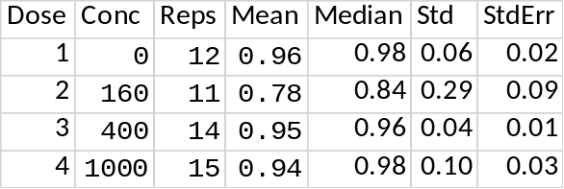
As Table A1.14 indicates, the mean response in most groups was high, though there was a notable decrease in the lowest test concentration. As Figure A1.10 indicates, this was due primarily to one extreme observation in the low test concentration where the response was zero. Table A1.15 and Figure A1.10 display the effect on the low dose mean when that one observation is omitted. Tukey’s outlier test on the raw data identified six other observations as outliers. Deleting so many observations from analysis runs the risk of no longer representing the data observed. Transformations of the response were investigated instead.

With all data present, there is a significant departure from normality and non-monotonicity in the dose-response. A non-parametric Dunn’s test found a significant decrease in the low dose group. The arc-sine square-root transform did not remove all data issues. However, the Tukey outlier test applied to the arc-sine square-root transformed data identified only two outliers, one in the high treatment group and the other, already discussed, in the low treatment group. Trend tests were not justified with either the full data or with the two outliers omitted due to the significant non-monotonicity. When both outliers are omitted, the data were normally distributed with homogeneous variances.

Figure A1.10 also shows that the mean responses in the control and highest two treatment groups are at the top of the range of the historical control database. The mean response in the low dose group is below that range, but as Figure A1.11 illustrates, that changes with the omission of the single zero observation. What the tables and figures do not indicate is that there was only one egg set by the hen in question. Indeed, there were only two hens in the dataset with only one egg set. The other was in the high dose group. All other hens had either no eggs set or more than 16. The importance of the one set egg in the low dose group not being viable should not be exaggerated.

If Williams’ test was used despite the non-monotonicity, it found no significant effect in any test group, meaning the NOEC=1000. However, Dunnett’s test still found a significant decrease in the low dose group. Given that the mean response in that group is within the historical control range and the concentration-response was not monotone, the significance is due at least in part to the high concurrent control mean response.

Figure A1.10. Comparison of study and historical control data for viable eggs per eggs set
37 studies in historical control database
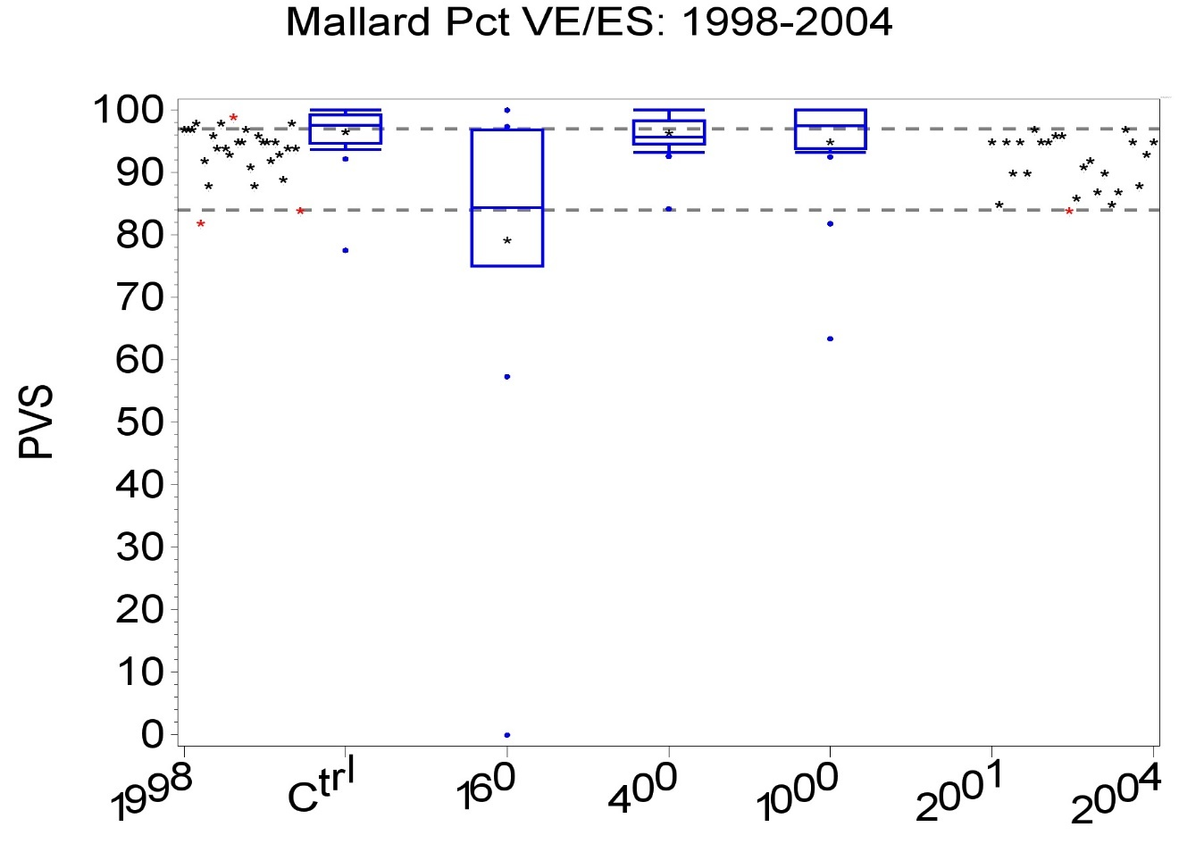

Table A1.15. Summary statistics for VE_ES with one outlier omitted
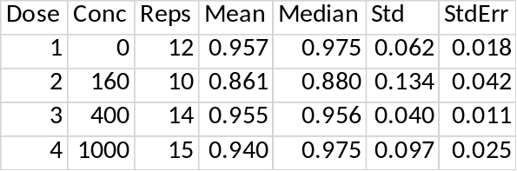

Figure A1.11. Comparison of study and historical control data for viable eggs per eggs set, with one extreme observation omitted
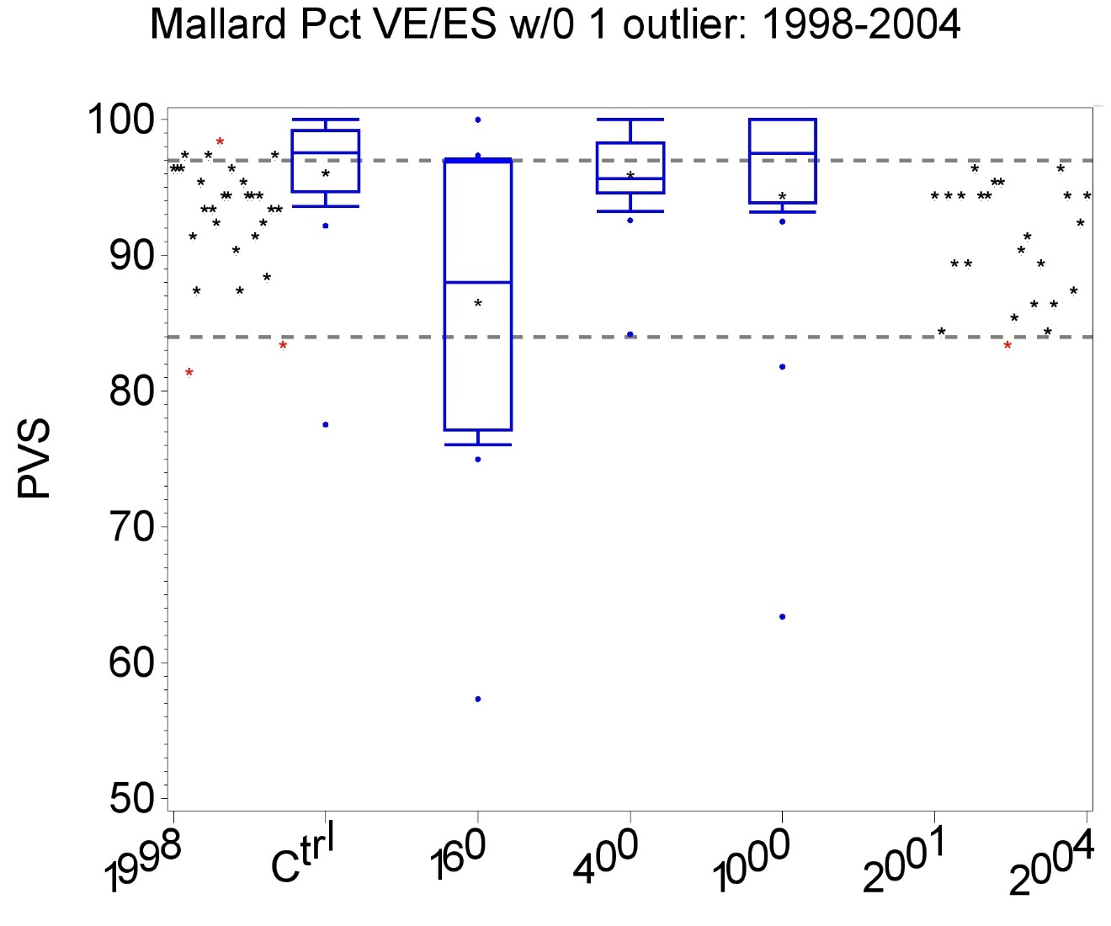

So, the significant effect in the low dose group is caused by a single unusual observation and a high concurrent control mean response. Without that unusual observation, all treatment mean responses lie within the range of the historical control mean responses. Given these observations and that there is no concentration-response trend. there is no statistical or biological justification for setting the NOEC below the highest tested concentration. Omitting the outlier identified in the high treatment group does not alter the conclusions.

Case Study 1.8 Hatchlings/Eggs Set (PHS)
This example illustrates (i) the value and use of historical data in identifying an unusual control that affects statistical conclusions and (ii) the use of a trend test for non-monotone concentration-response data is questionable. The data are summarized in Table A1.16.

Table A1.16 Proportion Hatchlings per Eggs Set
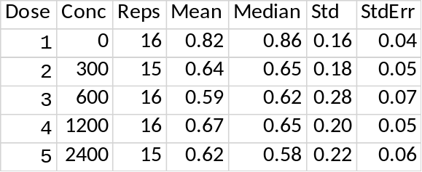

The variability of this response in the current study is well within the historical control range of within-study variance, with a CV=26, which is the 30th percentile of the distribution of CVs for this response from the historical control database. The treatment means do not exhibit a concentration-response trend. Rather they are rather flat, but all are notably lower than the control mean response.

Two analyses were done. First, the proportion data were analysed as continuous. The data were found consistent with a normal distribution with homogeneous variances. The Williams and Jonckheere-Terpstra stepdown trend tests both found all treatment group mean responses significantly lower than the control mean response. Dunnett’s test found all mean responses except at 1200 ppm significantly lower than the control mean response.

A second analysis used a GLMM model with binomial distribution conditioned on the number of eggs set followed by the Dunnett-Hsu test. This test again found all mean responses except at 1200 ppm significantly lower than the control mean response.

It is apparent from Figure A1.12 that even with 3 very small values in the low middle treatment and one in the high treatment, all treatment mean responses in this 2012 study lie within the historical control range. It is also evident that the control mean response is at extreme high end of the historical control range. This high control mean response is an important contributor to the statistical significance of the treatment means. The plot uses a historical window spanning ± 2 years from the study date. The relationship between the current and historical controls does not change substantially using spans of ± 3 years or ± 5 years. The statistical significance is due primarily to the unusually high control mean response and does not appear to indicate an effect of the test substance.

Given the lack of a concentration-response trend, no regression analysis of this response was useful and outlier analysis did not improve results. Similar results were found in this study for some other responses, notably survival of hatchlings to 14 days per eggs set.

Figure A1.12. %Hatchlings per eggs set: Current and historical controls 2010-2014
59 studies in historical control database
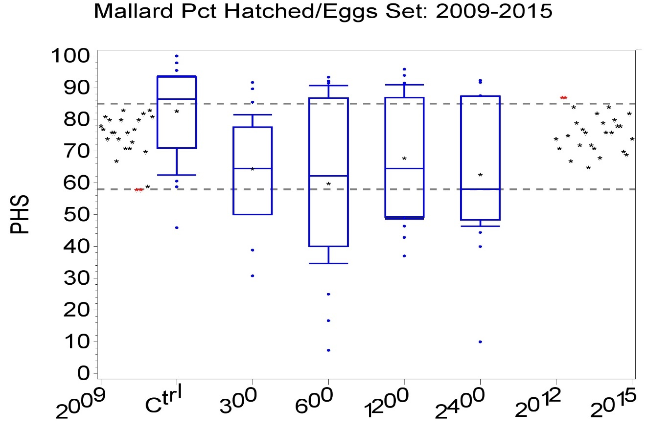

Case Study A1.9. Body Weight of surviving hatchlings at 14 days (S14DBW)
This case study illustrates that the ability to fit a regression model depends on more than the number of treatment groups. Also illustrated is that the percent effects found statistically significant by the NOEC approach are small. The information on the effect size provided by a regression model can prevent over reaction to a statistically significant test statistic when a suitable regression model can be fit. The data are summarized in Table A1.17.

Table A1.17. Body weight of hatchlings surviving at 14 days post hatch (S14DBW)
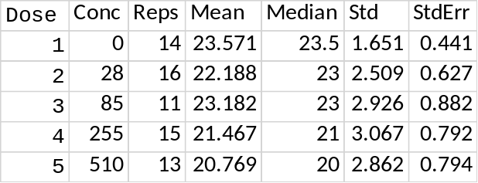
Conc=concentration (ppm); Std=standard deviation; StdErr=standard error; Mean, Median, Std, StdErr (g)

The data were found consistent with normality (Shapiro-Wilk test) and variance homogeneity (Levene test). One outlier was found (Tukey outlier test) at 85 ppm, but its omission did not alter conclusions. The NOEC was found to be 85 ppm by Williams’ test and 255 ppm by the Dunnett and Jonckheere-Terpstra test, as indicated below. Of these, Williams’ test would usually be considered definitive since it makes most use of the data characteristics (normality, variance homogeneity, and approximate concentration-response monotonicity). However, the regression results presented after the NOEC results are interesting in part because they predict small effects at the tests concentrations where the Williams’ test finds significant effects without regard to the magnitude of effect. Ecotoxicity theory would predict a monotone dose-response. Williams’ test forces monotonicity by amalgamating the two lowest treatment group means (Table A1.18). Similar smoothing is done by any monotone regression model. These two approaches are in conflict for these data, adding uncertainty to the results. The Dunnett and Jonckheere-Terpstra tests are perhaps the most reliable indicators of what can be discerned about toxicity from these data. Despite, or perhaps because of, the smoothing, the EC10 estimated to be 485 ppm is perhaps a more reliable indicator of toxicity than the NOEC where only a 2% effect was observed.

Table A1.18. Treatment means amalgamated for Williams’ test
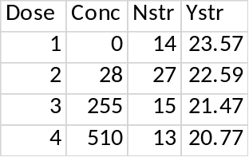

Results of the Pool-the-Adjacent-Violators-Algorithm (PAVA) used by Williams’ test
Conc=concentration; Nstr=number of reps in amalgamated treatment mean; Ystr=amalgamated treatment mean response.
The PAVA algorithm used by Williams’ test combined the means in treatment groups 2 and 3 to force monotonicity in the dose-response.

The only regression model found to fit the data acceptably well was the simple exponential model OE2, summarized in Table A1.19. Other models attempted were OE3, OE4, Bruce-Versteeg, Log-logistic, and Brain-Cousens hormetic. These models all have three or more parameters to estimate, which apparently were too many for this dataset having only four treatment groups and control. This should be contrasted with Case Study A1.5, which also had the same test concentrations but several models could be fit to those data. The response in that case study was conditionally binomial, while the response here is continuous and consistent with a normal distribution.

Table A1.19. Summary of model OE2 fit to data from case study A1.9
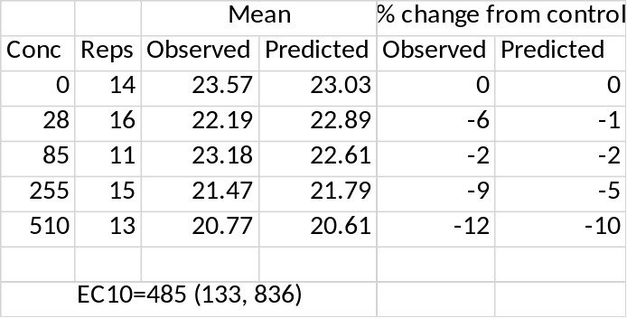
The observed and model-predicted mean response and % change from control mean response are shown, together with the point and interval estimate of EC10. Model averaging was not used since only one model was found that fit the data and met customary goodness-of-fit criteria given in Annex 3. Model OE2 cannot capture the non-monotonicity observed, but an acceptable hormetic model could not be fit.

Figure A1.13. Model OE2 fit to S14DBW
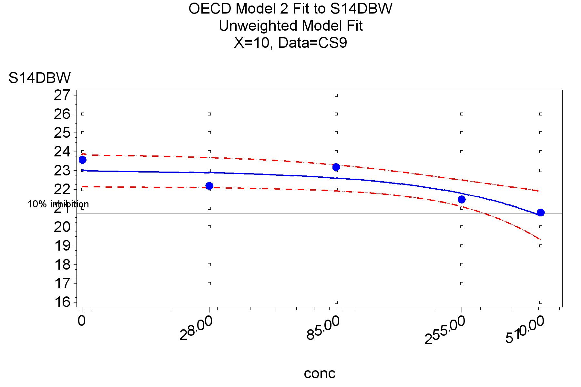
Dots indicate mean observed response at test concentrations.
Case Study A1.10. Variability of key endpoints
The purpose of this case study was to highlight the importance of variability of a key endpoint in the risk assessment process and how to address it. A regulatory review of one mallard study questioned the variability of the endpoints, # hatchlings per embryo live at three weeks (PH3W expressed as a percentage) and # hatchlings per eggs set (PHS, also expressed as a percent). The concern raised was whether the variability was too high to allow the detection of biologically meaningful effects. The CVs for these two endpoints in this study were 29 and 33%, respectively. In the HCD, these CVs were at the 90th and 83rd percentiles of the respective endpoints. While higher than the median values (15 and 23), these are still within the normal range of the HCD. An initial response to this regulatory concern was to compare the standard deviations of these responses with those in the HCD, which made the current study appear closer to the middle of the HCD. However, in terms of determining the size effect that can be found statistically significant, the CV is a better indicator. Indeed, CVs are less important than the minimum sized effects that can be detected statistically, MDD%. However, as demonstrated in the main manuscript, for this study MDD% and CV are similar. The historical data demonstrates that the variability in these endpoints is not unusually high. As indicated in the main manuscript, reducing the variability would require much greater replication or laboratory practices yet to be identified.

Case study A1.11 Quail Hatchling body weight 14 days after hatch
This case study presents data where all treatment groups differ significantly from the control but there is no concentration-response trend. Standard regression models were not satisfactory, but a hockey-stick model proved useful. The data are summarized in Table A1.20.

Table A1.20 Hatchling body weight 14 days after hatch (HBW14D)
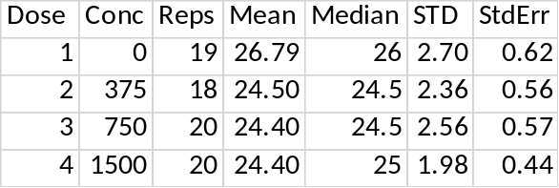
Conc=test concentration (ppm); Std=standard deviation; StdErr=standard error; Mean, Median, Std, StdErr (g)
The treatment mean responses are almost identical, with no indication of a monotone concentration-response. Given this, it is not surprising that no decreasing model could fit these data well and ECx estimates from such a model would therefore be suspect. Nonetheless, Figure A1.14 shows the fitted simple exponential model and Table A1.21 summarizes the results of that model.

Figure A1.14. Box plot of study data and historical controls: Full data
59 studies in historical control database
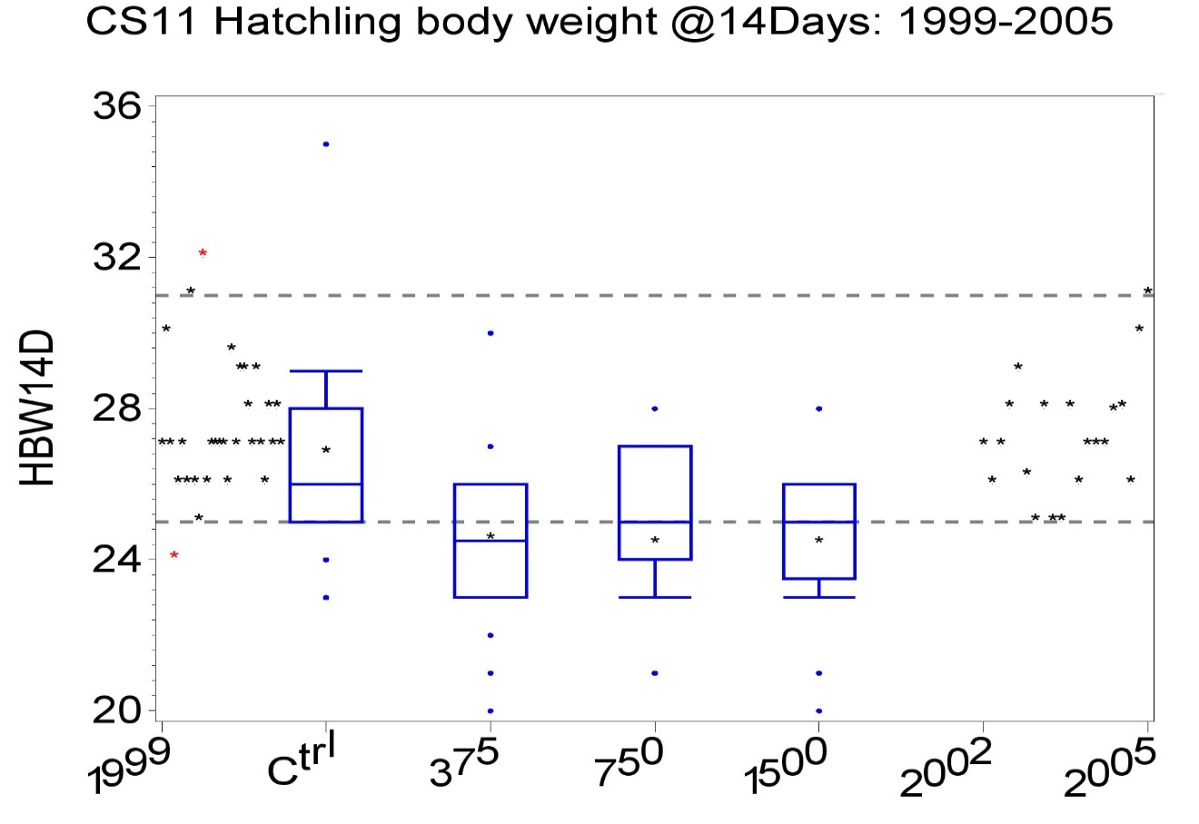
One large outlier in the control can be seen. Figure A1.15 shows the same data with that outlier omitted.
Figure A1.15. Box plot of study data and historical controls: 1 outlier omitted
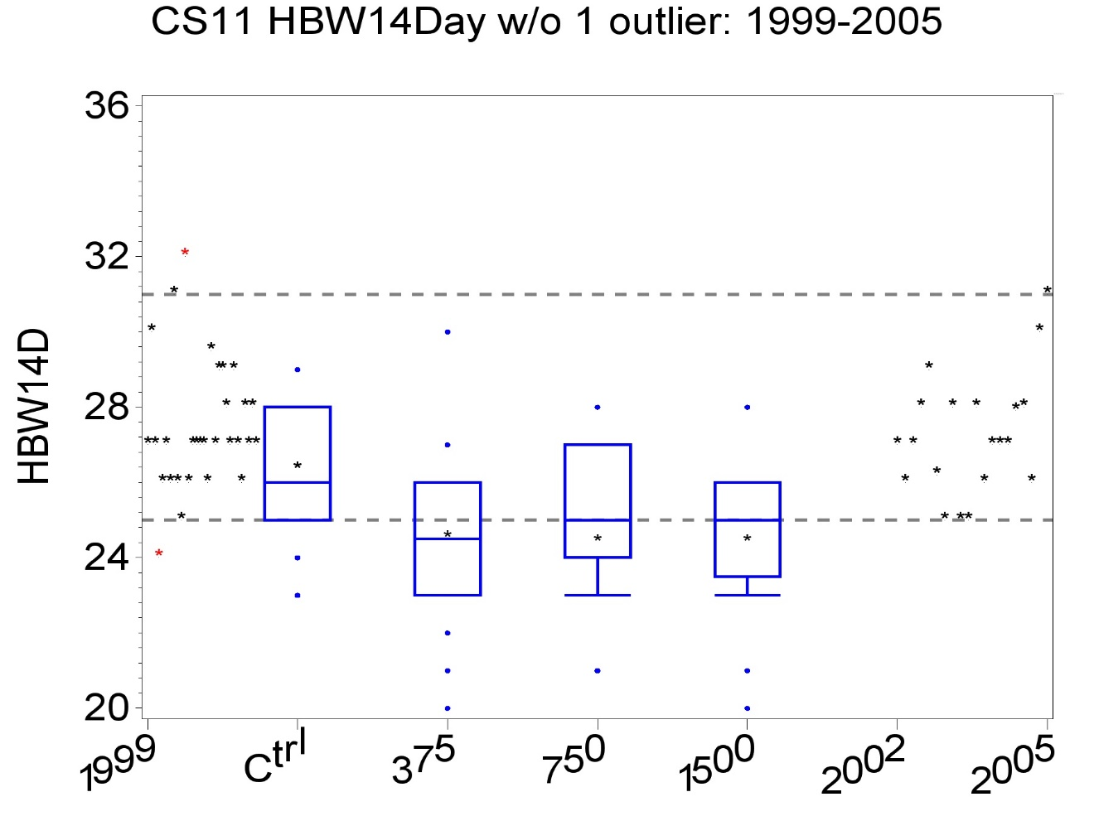
The asterisks indicate control or treatment mean responses. Boxplots indicate the study data, with the center horizontal line the median, the top and bottoms of the boxes are the third and first quartiles, respectively. Points above or below the boxes are unusual observations, not necessarily outliers.
Figures A1.14 and A1.15 show that the decreases in hatchling body weight at 14 days are statistically significant and outside the historical control range for that response. It is interesting that a 5-year time span shows all treatment group means within the HCD, as indicated by Figure A1.16.

Figure A1.16. Box plot of study data and historical controls: Full data w/ 5-year span
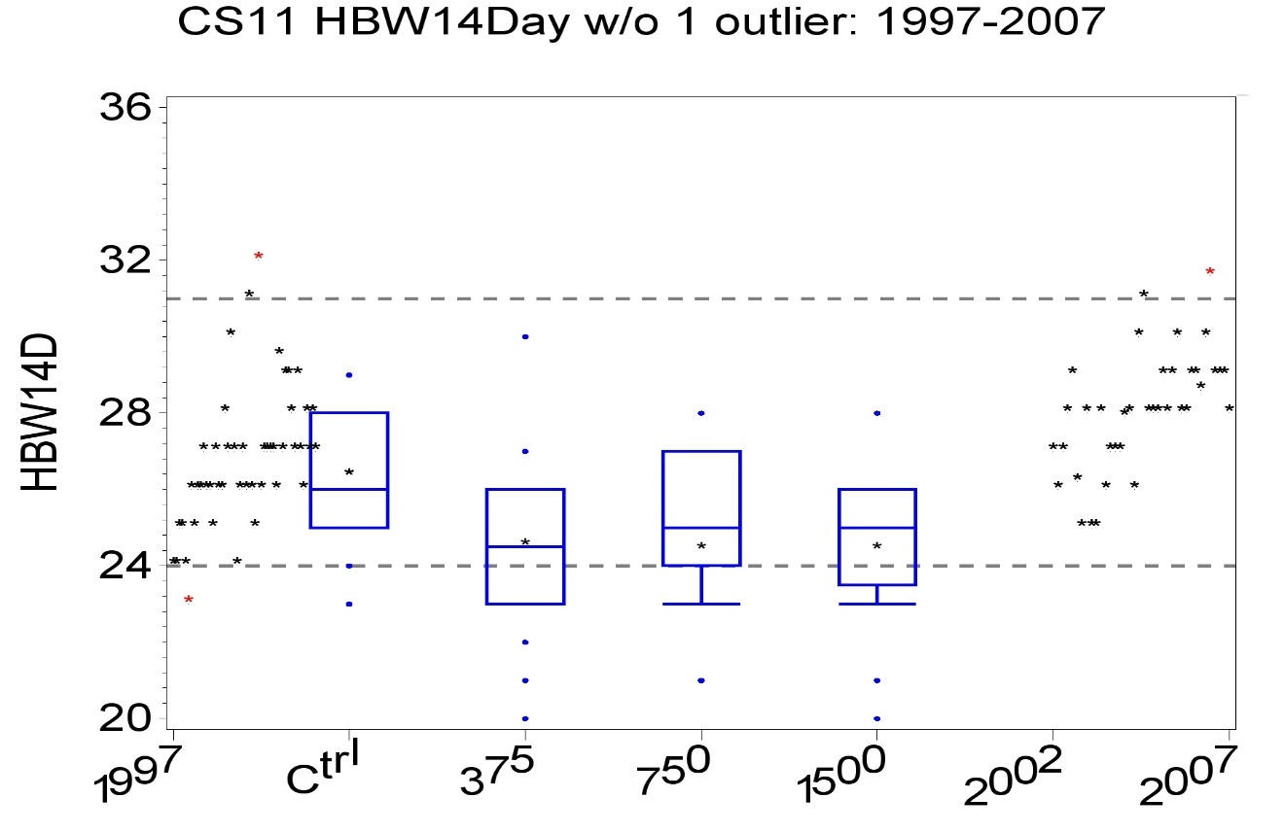
This suggests the decreases are not biologically unusual and thus likely unimportant. It is also apparent that there is no trend in the dose-response, as the treatment means are relatively flat.
The data were found not consistent with a normal distribution by the Shapiro-Wilk test. The Tukey outlier test found a single outlier, which was a large response in the control. With that outlier omitted, the data were found to be consistent with normality (Shapiro-Wilk test) and variance homogeneity (Levene test). The Dunn and Jonckheere-Terpstra nonparametric tests found all treatment group mean responses significantly less than the control mean response based on the full data. With the one outlier omitted, the Dunnett and Williams tests found the same result.

The observed decrease was under 9% in every treatment group and the decrease in median response was under 6%. To help assess the biological importance of these small decreases, a historical control database was used. Figures A1.14 and A1.15 display the study data in context with the HCD with all data and with the outlier mitted.

When the single outlier was omitted, the largest decrease in any treatment mean response was under 7%. The control and treatment mean responses were within the middle 90% of the historical control database using a ± 5-year window but not using a shorter window. Regression modeling estimated EC10 and EC5 to be 2491 and 1212 ppm, respectively, from the only standard model that could be fit to these data that met goodness-of-fit criteria given in Annex 3. An alternative hockey stick model that better captured the flat treatment mean responses estimated EC5 and EC7 as 269 and 395 ppm, respectively, but EC10 was inestimable. A regulatory reviewer cited the absence of a NOEC, even with only a 7-9% maximum effect observed, as reason to reject the study.

With only three treatment groups plus a control, regression modeling is challenging. Several models often used for ecotoxicity studies were attempted to fit these data, including a 3-parameter log-logistic, Bruce-Versteeg, exponential with a curvature term, simple exponential with a floor. The only one of these models that met standard acceptance criteria was a simple exponential. A summary of the fit of the simple exponential (OECD2) are given in Table A1.21 and Figure A1.17 displays the model and data. Modelling was done with the single outlier identified by the Tukey outlier rule omitted.

Table A1.21 Summary of model OE2 fit to data from Case Study A1.11
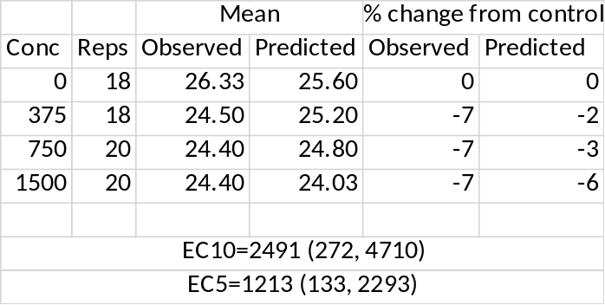
Caption. Table A1.21. Summary of model OE2 fit to data from case study11
The observed and model-predicted mean response and % change from control mean response are shown, together with the point and interval estimate of EC10 and EC5. Model averaging was not used since only one model was found that fit the data and met customary goodness-of-fit criteria given in Annex 3.
Figure A1.17. Simple exponential model fit to HBW14D data w/ one outlier omitted
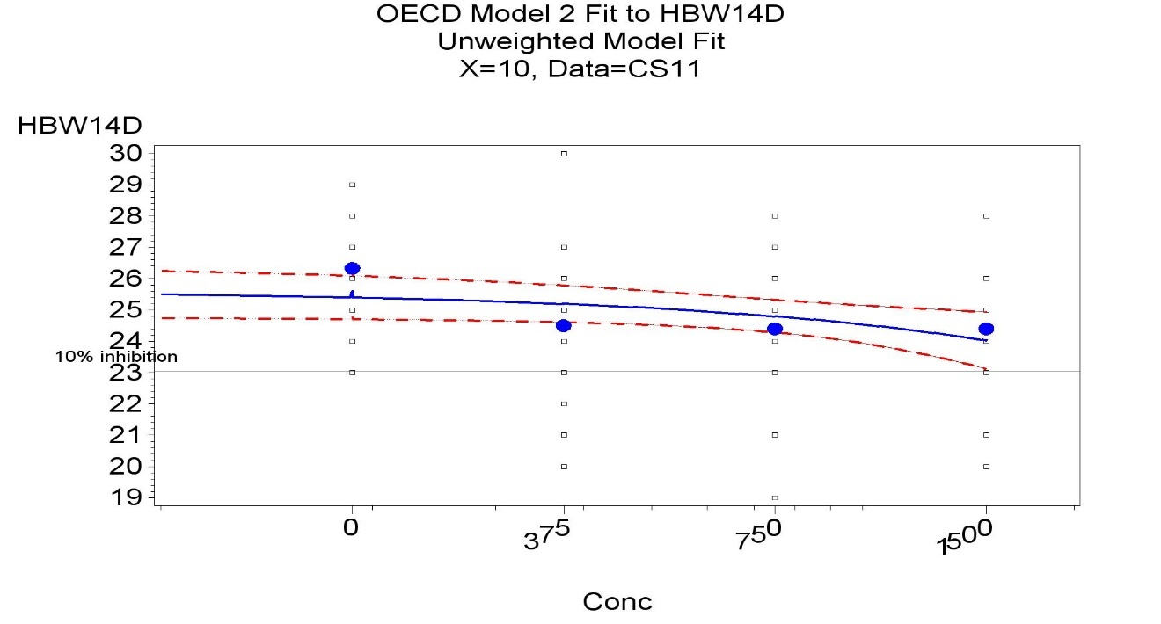
Dots indicate the observed mean response in each test concentration. The flat response in the positive test concentrations is visible.

The simple exponential model described above cannot capture the flat concentration-response that was observed. None of the other models attempted could capture this sort of concentration-response either. These models were unsatisfactory since they modelled a slight decrease in response from the low to high concentration. Consequently, a hockey-stick model was attempted. The hockey-stick model shows a steady linear decrease from the zero dose until some concentration determined by the model fit is reached, followed by a flat response thereafter. This is consistent with the flat response observed at every test dose. The effect observed and predicted by this model is never greater than 7%, so no estimate of EC10 is possible from this model. There appears to be no agreed percent effect that is biologically important to estimate. In lieu of that, an EC5 was estimated, but ECx for any value of x ≤ 7 can be estimated from this model. For example, EC7=395.5, which is the parameter B in the detailed printed below. It should be observed that the ECx estimates obtained from the hockey-stick are considerably smaller than those obtained from the exponential model given above and can be considered conservative. As before, modelling was done with the single outlier identified by the Tukey outlier rule omitted. The hockey-stick model used here is a minor modification of Model HS4PL described in Green et al (2018). The difference is not modelling an initial flat response but instead having the decrease start immediately. To be clear, the model is given by the following equation.

HS3PLFLR: $y=\left\{\begin{matrix}y_{0}+\frac{C-y_{0}}{b}\left(U\right) if 0<U≤b \\ C if b<U \end{matrix}\right.$.

The parameter C establishes a floor or baseline below which the response cannot fall, U is the dose or concentration, y0 is the control mean, and b is where the “stick” flattens.

Figure A1.18. Hockey-stick model fit to HBW14D
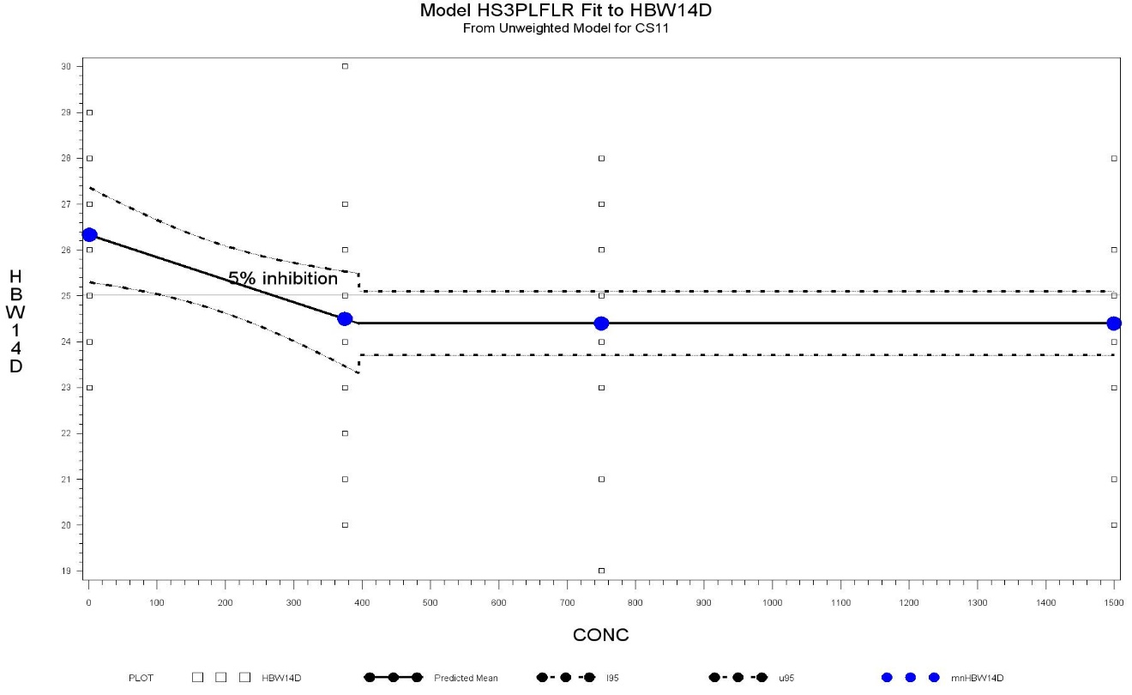

Dots indicate mean observed responses at test concentrations.
Table A1.22. Summary of results for hockey stick model
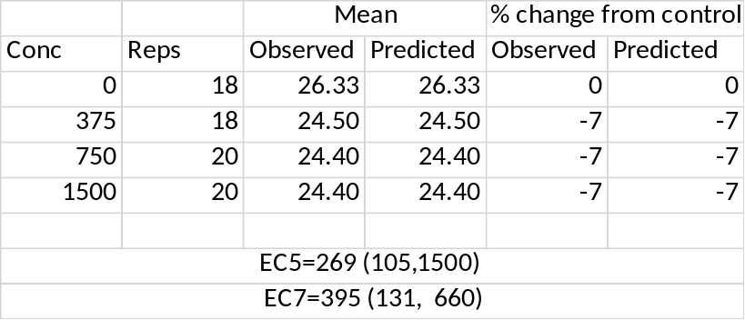

Note that the 95% confidence interval (24.2, 25.8) for the predicted response at EC5 does not contain the predicted control mean response, 26.3. This is one of the model acceptance criteria. Other criteria include an estimate of the control mean response close to the observed mean, good agreement of predicted mean response with observed mean at every test dose, and all model terms significantly different from zero.

It should also be noted that the AICc value for model OE2 (128.4) is lower than that for the hockey stick model (135.6), which would favor OE2. However, the models are not comparable by this criterion since the hockey-stick model has a segmented error structure.

References
Cade BS 2015. Model averaging and muddled multimodel inferences. Ecology 96: 2370-2382. https://doi.org/10.1890/14-1639.1

EFSA 2009a. Guidance of the Scientific Committee on a request from EFSA on the use of the benchmark dose approach in risk assessment. The EFSA Journal (2009) 1150: 1-72.

EFSA 2009b. Risk Assessment for Birds and Mammals. EFSA Journal 2009; 7(12):1438.
Fleiss JL, Levin B, Cho Paik M 2003. Statistical methods for rates and proportions. Third edition. Wiley. ISBN 0-471-52629-0.
Green JW, Springer TA, Holbech H 2018. Statistical Analysis of Ecotoxicity Studies. Wiley. ISBN: 978-1-119-48881-1

OECD 2019. Test No. 248: Xenopus Eleutheroembryonic Thyroid Assay (XETA), OECD Guidelines for the Testing of Chemicals, Section 2, OECD Publishing, Paris, https://doi.org/10.1787/a13f80ee-en.

Springer TA, du Hoffmann G 2018. Evaluation of Monotonicity of Concentration Response in Avian
Reproduction Studies – Summary of Findings. Project 857B-101. Eurofins Laboratory.

Tamhane AC and Logan BR 2004. Finding the maximum safe dose level for heteroscedastic data. J Biopharm Stat. 14: 843-56.
Tamhane AC and Logan BR 2002. Multiple Test Procedures for Identifying the Minimum Effective and Maximum Safe Doses of a Drug. Journal of the American Statistical Association 97: 293- 301.
Tamhane AC, Dunnett CW, Green JW, Weatherington JD 2001. Multiple Test Procedures for Identifying the Maximum Safe Dose. JASA 96: 835-843.
USEPA 2015. https://www.epa.gov/sites/production/files/2015-11/documents/support_material_for_model_averaging_workshop-11_06_2015-508.pdf

Annex 2: Statistical Decision Charts
These decision charts provide more detail about NOEC determination than was possible in Figure 7 of the main manuscript.

Figure A2.1. NOEC detailed decision tree for continuous response
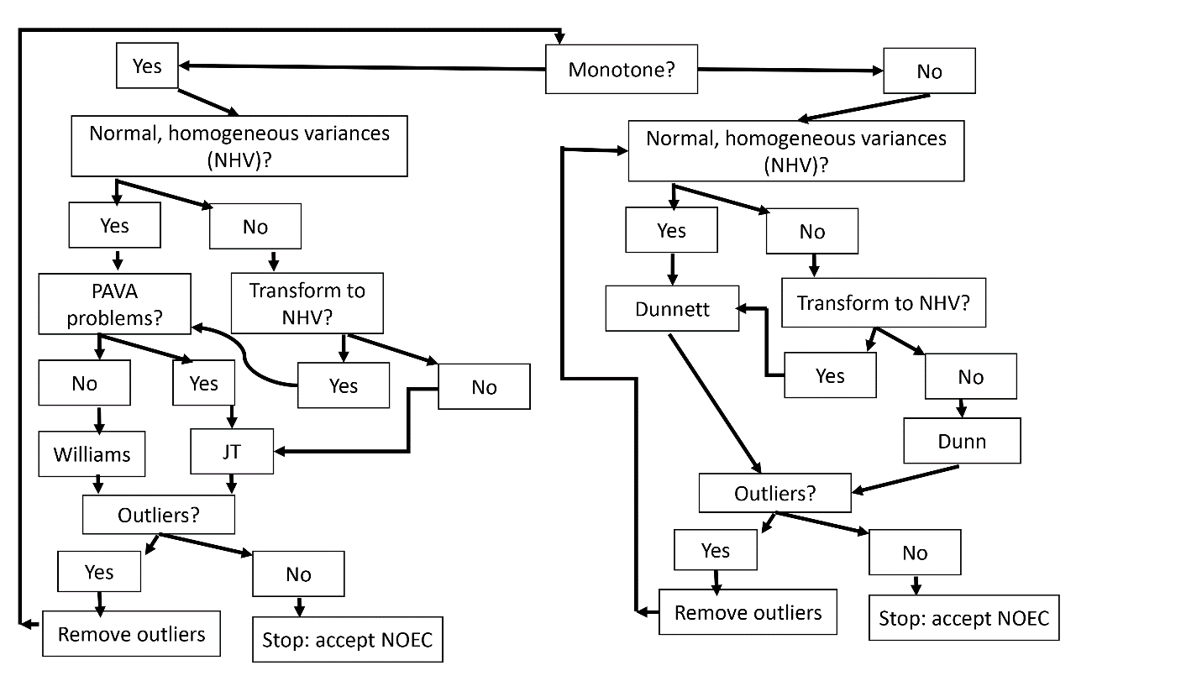 Monotonicity is assessed through formal methods using the “quadratic rule” (as indicated in Annex 3) or visually.
Normality is assessed by Shapiro-Wilk or Anderson-Darling at 0.05 level applied to the residuals from ANOVA. Variance homogeneity is assessed from Levene’s test at 0.05 level.
Outliers should not total more than 6, preferably 4 or fewer. When this total is reached, follow path from Outlier question marked No.
PAVA Problems: if 3 or more treatment groups mean responses are amalgamated (i.e., smoothed out) then Williams’ test is not recommended, but statistical judgment can override.
If the NOEC changes after outliers are removed or a normalizing, variance stabilizing transform is found, then scientific judgment is needed to resolve the difference.
Once NOEC is determined from decision tree, results should be evaluated in relation to an appropriate historical control database if available.

Abbreviations:
JT=Jonckheere-Terpstra (step-down trend test)
NHV=normally distributed with homogeneous variances
PAVA see PAVA problems above

Figure A2.2. NOEC detailed decision tree for count response (e.g., total eggs laid)
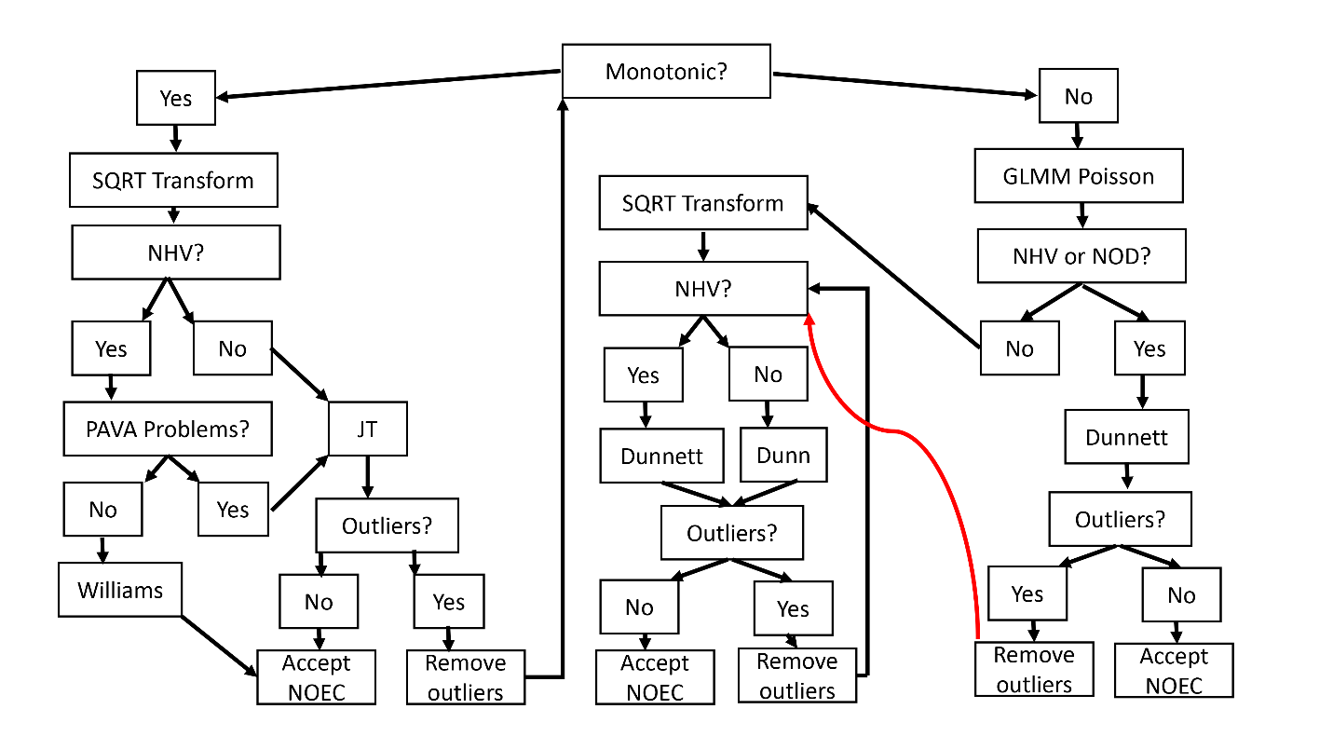
Monotonicity is assessed through formal methods using contrasts (as indicated in text) or visually.
Normality is assessed by Shapiro-Wilk or Anderson-Darling at 0.05 level applied to the studentized residuals from ANOVA. Variance homogeneity is assessed from comparing models with and without adjustment for overdispersion.

The wavy red line is meant to indicate that the indicated path does not interact with any decision line it crosses.

Outliers should not total more than 6, preferably 4 or fewer. When this total is reached, follow path from Outlier question marked No.
PAVA Problems: if 3 or more treatment groups mean responses are amalgamated (i.e., smoothed out) then Williams’ test is not recommended, but statistical judgment can override.
If the NOEC changes after outliers are removed or a square-root transform is used, then scientific judgment is needed to resolve the difference.
Once NOEC is determined from decision tree, results should be evaluated in relation to an appropriate historical control database if available.

Abbreviations:
JT=Jonckheere-Terpstra (step-down trend test)
SQRT=square-root
GLMM=generalized linear mixed model
NHV=normally distributed with homogeneous variances
NOD=No overdispersion

Figure A2.3. NOEC decision tree for conditionally binomial response (e.g., eggs cracked per eggs laid)
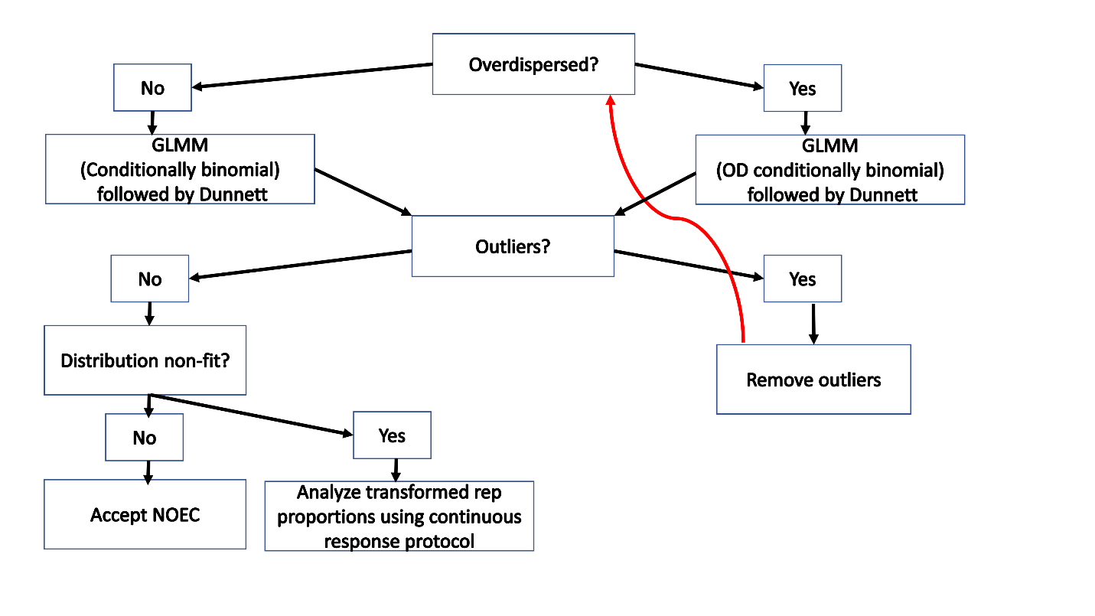
Overdispersion is tested by comparing likelihoods of model assuming overdispersion with model assuming no overdispersion or by distribution fit testing (see below) with and without adjusting for overdispersion.
The wavy red line is meant to indicate that the indicated path does not interact with any decision line it crosses.

GLMM (OD conditionally binomial) can be either conditionally negative binomial or have a group term allowing different binomial distributions within different treatment groups.
Distribution fit (or non-fit) is tested by applying Shapiro-Wilk or Anderson-Darling test to studentized residuals from model.
Outliers are assessed from studentized residuals. No more than 6 outliers total, preferably 4 or fewer, should be omitted. If total exceeds this level, follow protocol for no outliers.
Replicate proportions are analyzed after an arc-since square-root transform.
Abbreviations:
GLMM=generalized linear mixed model
NHV=normally distributed with homogeneous variances
OD=Overdispersion

Figure A2.4. NOEC decision tree for binomial response (e.g., adult survival)
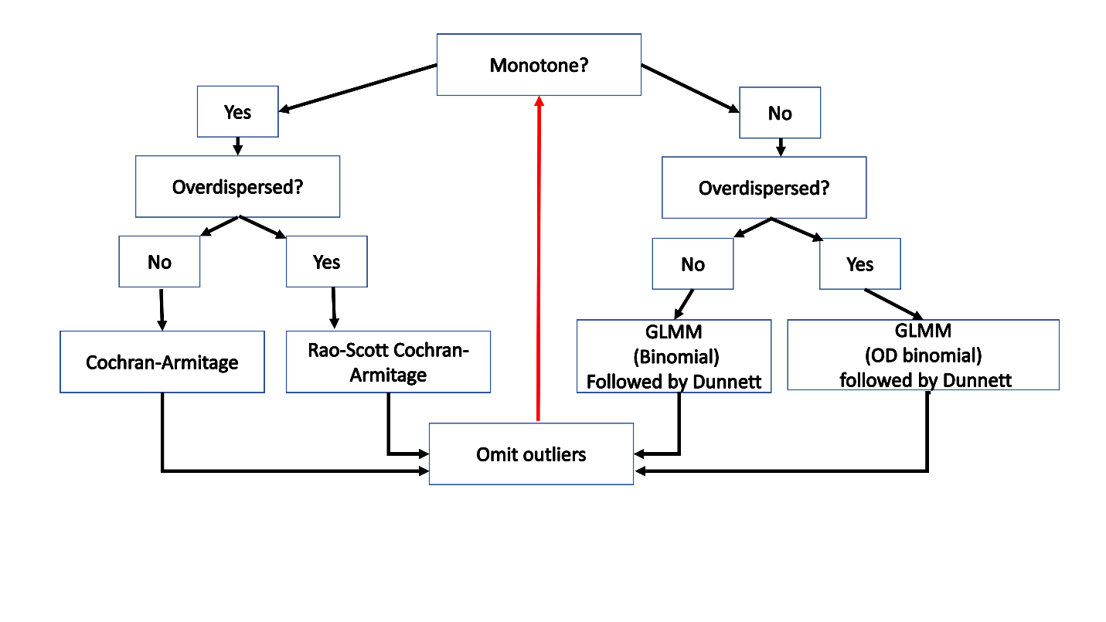Overdispersion is tested by comparing likelihoods of model assuming overdispersion with model assuming no overdispersion or by distribution fit testing (see below) with and without adjusting for overdispersion.
GLMM (OD binomial) can be either negative binomial or have a group term allowing different binomial distributions within different treatment groups.
Distribution fit (or non-fit) is tested by applying Shapiro-Wilk or Anderson-Darling test to studentized residuals from model.
Outliers are assessed from studentized residuals. No more than 6 outliers total, preferably 4 or fewer, should be omitted. If total exceeds this level, follow protocol for no outliers.
Abbreviations:
GLMM=generalized linear mixed model
OD=Overdispersion

Annex 3 Statistical Details
Test for monotonicity
A useful, but not definitive test for monotonicity for a continuous response is based on linear and quadratic contrasts. The first step is to obtain a normalized rank ordering of the response data, with ranks assigned to all response values ignoring groups. Next, linear and quadratic contrasts of the rank data are constructed. If the linear contrast is not significant but the quadratic contrast is significant, then the data are likely not consistent with the monotonicity assumption underlying trend tests for continuous responses. This assessment of monotonicity is what Springer and du Hoffmann (2018) call the “quadratic rule”. They also discuss an alternative “cap rule” for such assessment which will not be discussed here.
It is highly advisable to plot the data on its original (unranked) scale rather than blindly accepting the result of this test, as it is entirely possible for there to be a clear monotone trend that leads to a significant test for non-monotonicity by this test. Consider, for example, data that follows a dose-response curve such as y=x², x≥0.
For quantal data, the Cochran-Armitage test has a built-in test for monotonicity. It can be shown that a chi-square test for differences among treatment groups with k df (k= number of positive test concentrations) is the sum of two chi-squared statistics, one a test for linear trend with 1 df (the Cochran-Armitage test statistic) and the other a test for lack of monotonicity with k-1 df (literally, a test for lack of a linear trend). As documented in Tarone and Gart (1980) and discussed in Green et al (2018), the test for monotonicity and non-monotonicity are much more general than linearity.
Detailed descriptions of the hypothesis tests recommended in the protocol can be found in Green et al (2018). The MAXSD method can be considered as an intermediate analysis that combines aspects of regression modelling in a hypothesis testing framework. While that is also described in the cited references, it is likely to be unfamiliar to many in the field of ecotoxicity testing. For that reason, a somewhat detailed description of this method is given in the discussion of Case Study 4 in Annex 1.
Model selection criteria
The following criteria are recommended to select a model for use in risk assessment. Further discussion of these criteria with some illustrations is given in Green et al (2018). It is entirely possible that no model meets all of these criteria and some judgment is required to determine a single “best” model. If model averaging is used (see below), then each model to be used in the model average should meet most of these criteria.
  - Model predictions should be consistent with observations at tested concentrations, especially for control. Visually, the fitted curve should appear to fit the data across the entire range of test concentrations. Since an x% effect is estimated from the model predicted control mean, it is especially important that the model provide good agreement with the observed control mean response.
  - Confidence interval for ECx should not be “overly” wide. No hard rule can be given to define what overly wide means, but if the confidence interval for ECx spans the entire range of tested concentrations including 0, it is overly wide and the estimate has little value for risk assessment.
  - For every parameter, confidence interval should not include 0. This is to eliminate overly parameterized models and reduce model instability.
  - Prediction interval for response at ECx should not contain estimated control mean. Otherwise, an x% effect is indistinguishable from no effect. Figure A3.1 below illustrates this criterion.

Figure A3.1. Illustration of model selected goodness-of-fit criteria

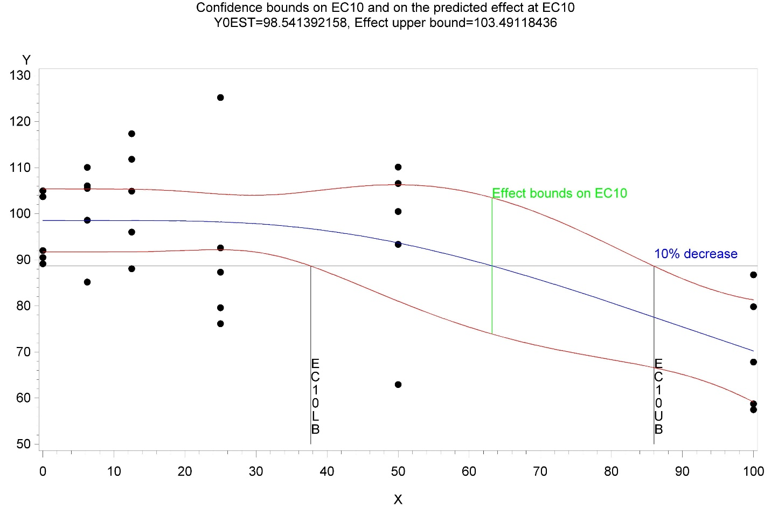

  - Models should be compared using AICc or BIC. If the AICc values for two models differ by more than 10, the one with the smaller AICc value is better (by this criterion). Where two models differ by less than 10, this criterion does not distinguish between them.
No significant lack-of-fit (e.g., F-test comparing regression & pure error residuals)
Model averaging
True model averaging begins with a set of models to try to fit to the data. For avian studies with 5 or more positive test concentrations a candidate set of models is Bruce-Versteeg (probit type), 3-parameter log-logistic, simple exponential (OE2), exponential with a curvature term (OE3), exponential with a flow or ceiling (OE4), exponential with a curvature term and a ceiling or floor (OE5), Brain-Cousens hormetic. See Green et al (2018) for additional discussion of these models and references. Mathematical descriptions of these models are given in Appendix 1. Hockey stick models are not included in the default set of models, as the situations to which they would apply are unusual and fitting such a model to more typical data can produce misleading results.

Each model is fit and the same information criterion (IC, e.g., AICc) is calculated for each model. The model with the smallest IC is identified and labeled model 0 and its IC value, IC₀. Label the IC values for the other models IC₁ , IC₂ , …, IC_{n} . Compute the differences Δ_{i} =IC_{i} – IC₀, which is always non-negative. Following Burnham and Anderson (1998), define the Akaiki weight for the ECx value from model as

$w_{i}=\frac{exp⁡(-\frac{1}{2}∆_{i})}{\sum_{i=0}^{n}{exp⁡(-\frac{1}{2}∆_{i})}}$. (A3.1)

The denominator of the weight formula is to make the sum of weights equal to 1. The exponentiation of the Δ_{i} is from the distribution of these differences which in turn is related to the log-likelihood function. The model average point estimate of ECx is given by
${EC}_{x}=\sum_{i=0}^{n}{w_{i}{EC}_{x}^{i}}$, (A3.2)
where ${EC}_{x}^{i}$ is the ECx estimate from model. The estimated variance of this average is given by
$var\left({EC}_{x}\right)={\left[\sum_{i=0}^{n}{\sqrt{var\left({EC}_{x}^{i}\right)+{\left({EC}_{x}^{i}-{EC}_{x}\right)}^{2}}}\right]}^{2}$. (A3.3)
A simplistic way to estimate the lower 5% confidence bound on ECx is to compute the weighted average of the individual model lower confidence bounds. Alternative methods are to obtain this bound or the variance are based on bootstrap sampling. See Burnham and Anderson (1998) or USEPA (2015) for further details.
The recommendation in EFSA (2009a) was to use the lowest value of the point and lower bound estimates. EFSA (2017) updated this to recommend estimation of both parameters using bootstrap samples from the family of models used. EFSA (2017) provides extensive references on model averaging, including modifications needed for quantal data.

Regression models
Bruce-Versteeg Model (BVP)
BVP: 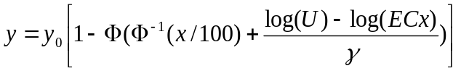 for U>0
= y₀ for U=0 (A3.4)
Log-Logistic LL3: $y=\frac{y_{0}}{1+{\left(\frac{U}{ECx}\right)}^{d}\frac{x}{100-x}}$. (A3.5)
OE2: $y=y_{0}e^{-\left(U/ECx\right)Log\left(\frac{1}{1-x/100}\right)}$. (A3.6)

OE3: $y=y_{0}e^{-{\left(U/ECx\right)}^{d}Log\left(\frac{1}{1-x/100}\right)}$. (A3.7)

OE4 $y=y_{0}\left[C-(1-C)e^{-\left(U/ECx\right)Log\left(\frac{C-1}{C-1+x/100}\right)}\right]$. (A3.8)

OE5: $y=y_{0}\left[C-(1-C)e^{-{\left(U/ECx\right)}^{d}Log\left(\frac{C-1}{C-1+x/100}\right)}\right]$. (A3.9)
Probit:
$y=$ for U>0, (A3.10)
$y=c$ for U=0.

In terms of the notation used in the case studies, the probit model can also be written as

y = c + (1-c)Φ(b₀+b₁Log(U)) for U>0
$y=c$ for U=0. (A3.11)

In all these models, U is the test concentration and Log refers to the natural logarithm. All functions are continuous and differentiable at U=0. Except for the probit model. These are formulated for a decreasing concentration-response. Minor modifications can accommodate increasing concentration-responses and a minor change can be made to the probit model to accommodate a decreasing concentration-response. Modeling a decreasing response for (Response/Risk) yields the same ECx estimates as modeling an increasing response for (Risk-Response/Risk). Further detail on these models is given in Green et al (2018) and references therein.
The above models can be fit assuming normal or binomial error structure. All except the probit can also be fit assuming a Poisson error structure and overdispersion can be included in all GNLMM error structures.
Hockey stick with immediate decline

HS3PLFLR: $y=\left\{\begin{matrix}y_{0}+\frac{C-y_{0}}{b}\left(U\right) if 0<U≤b \\ C if b<U \end{matrix}\right.$. (A3.12)

The parameter C establishes a floor or baseline below which the response cannot fall, U is the dose or concentration, y0 is the control mean, and b is where the “stick” flattens. Alternative hockey stick models with an initial flat response preceding an eventual decline are described in Green et al (2018).

Simulation Study
Three general concentration-response shapes were simulated corresponding to concentrations that exhibited an immediate decreased response (increase effect) starting at the control, or a moderately delayed (or shallower) response that does not start to decrease until the second or third lowest test concentration or a more delayed (or even shallower) response. These general tendencies are controlled by a parameter labeled here by ECPB with values 1, 5, and 10, respectively. The three shapes are illustrated in Figure A3.2
Figure A3.2. Concentration-response shapes simulated
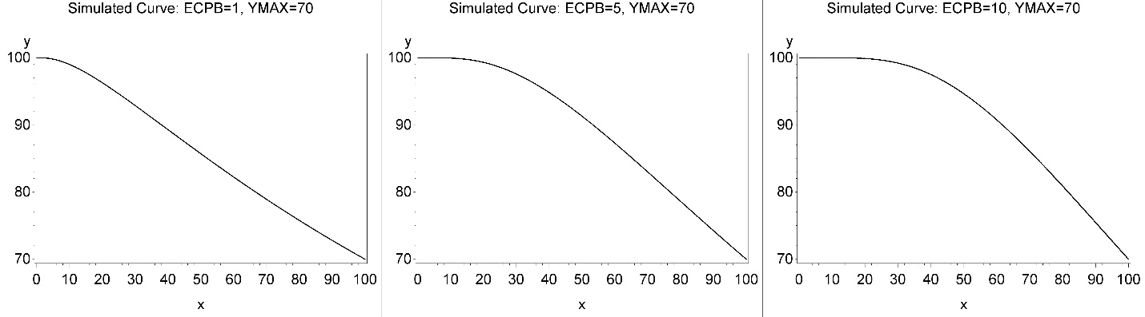
Each curve is displayed with a maximum decrease of 30% (YMAX=70) at the highest tested concentration. For simplicity, the concentration-response range was always 0 to 100 and the control mean response of the curve simulated was 100 so that a YMAX=70 means a 30% effect is simulated at concentration=100. These restrictions are for convenience and in no way alter the conclusions drawn. In addition, the spacing of simulated concentrations was geometric with a common ratio Dose_{i+1}/Dose_{i}=2. In all cases, 5 positive test concentration and a control were simulated and in every group, there were 12 replicates corresponding to cages in an actual experiment. The variability simulated was CV= 5, 10, 20, 30, and 40, which covers all but the most extreme values found in the historical control database. CVs for selected avian response are given in Table 1 of the manuscript. Data were simulated to follow a Bruce-Versteeg probit-type (BVP) concentration-response shape determined by the control mean, YMAX, and the shape parameter ECPB. YMAX=60-90 were simulated for all choices of CV and shape parameter ECPB. The SAS9.4 function RAND was used to generate random normal values centered on the BVP shape at each concentration having the CV value selected.
Summary tables 2 and 3 in the main text summarized results for the shape determined by ECPB=1. Tables A3.1-A3.4 summarized the results determined by shape parameter ECPB=5 and 10.

Table A3.1. Distribution of EC10 point estimates for shape ECPB=5
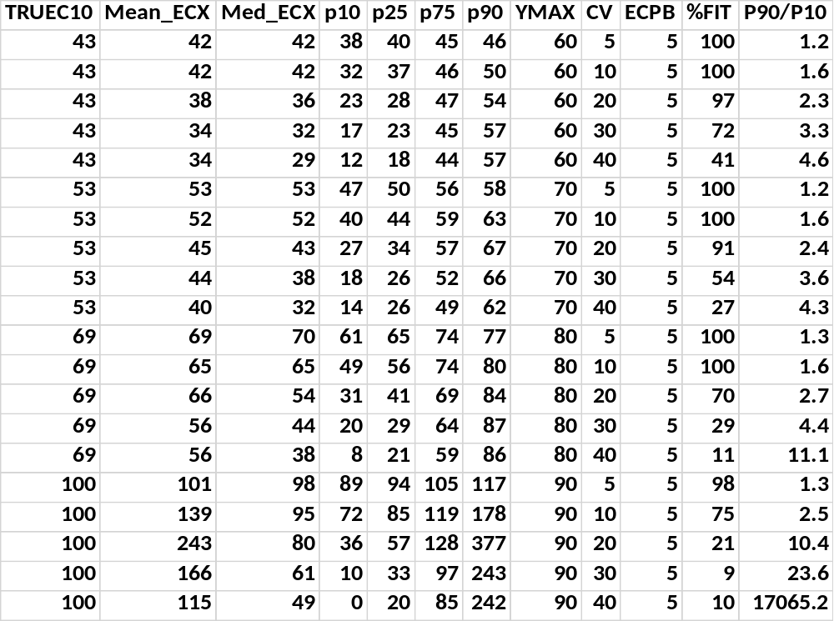
TRUEC10= value of EC10 for distribution simulated
Mean_ECX=mean EC10 estimate from simulated data
Med_EC10=median EC10 estimate from simulated data
pN=Nth percentile of EC10 estimates from simulated data, N=10, 25, 75, 90
YMAX=maximum % of control mean response at highest concentration in simulated data
CV=coefficient of variation simulated
%Fit=% of simulated datasets for which at least one model converged and had a positive lower confidence bound for EC10 estimate
P90/P10=ratio of the indicated percentiles of the distribution of EC10 estimates. Larger values indicate more spread in the point estimates.
ECPB=shape parameter controlling the shape of the simulated curve

Table A3.2. Distribution of EC10 lower bound (ECXLB) estimates for shape ECPB=5
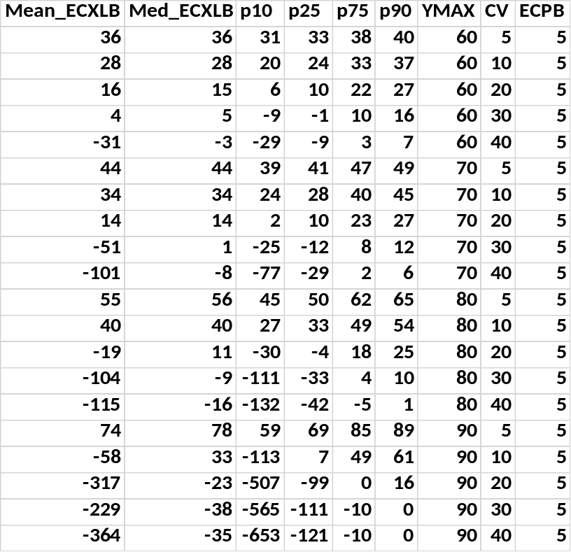
Mean_ECXLB=mean EC10LB estimate from simulated data
Med_EC10=median EC10LB estimate from simulated data
pN=Nth percentile of EC10LB estimates from simulated data, N=10, 25, 75, 90
YMAX=maximum % of control mean response at highest concentration in simulated data
CV=coefficient of variation simulated
ECPB=shape parameter controlling the shape of the simulated curve
A negative mean or median ECXLB or another percentile indicates EC10 estimates of little value for risk assessment. When ECXLB<0 then the EC10 estimate is statistically indistinguishable from zero. This occurred in 7 of the 15 simulated conditions and very skewed distributions of ECXLB are evident. The results for ECPB=10 given in Table A3.4 are somewhat worse.

Table A3.3. Distribution of EC10 point estimates for shape ECPB=10
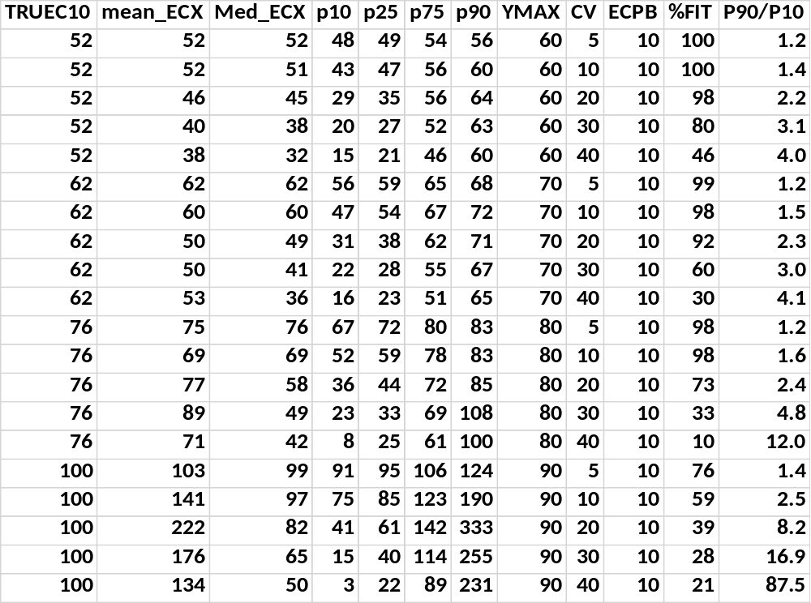
By comparing the mean and median responses, some skewness can be discerned in the distribution of EC10 estimates, especially when YMAX=90. The mean estimates are close to the true (simulated) values except when YMAX=90 and CV≥10. However, the median values deviate more from the true and this is more relevant for the purposes of evaluating the applicability of BMD estimates.

Table A3.4. Distribution of EC10 lower bound (ECXLB) estimates for shape ECPB=10
