Supplementary Material

Ellagitannin corilagin targets V-ATPase B2 to restore lysosomal Ca²⁺-AMPK metabolic axis and suppress microglia-driven neuroinflammation in aging mice

Chenxi Yue^{1,2}, Ruixiang Li^{1,3}, Zhang Sang¹, Jiexin Lei⁴, Fuchao Chen⁵, Benhong Zhou¹, Peng Chen^{1,2}

- Department of Pharmacy, Renmin Hospital of Wuhan University, Wuhan, Hubei, 430060, P. R. China
- Wuhan University School of Pharmaceutical Sciences, Wuhan, Hubei, 430071, P. R. China
- Hubei University of Chinese Medicine School of Pharmacy, Wuhan, Hubei, 430072, P. R. China
4. Department of Endocrinology, Renmin Hospital of Wuhan University, Wuhan, Hubei, 430060, P. R. China
5. Sinopharm Dongfeng General Hospital, Hubei University of Medicine, Shiyan, Hubei, 442001, P. R. China.

Correspondence: Chen Peng
Department of Pharmacy, Renmin Hospital of Wuhan University, Wuhan, Hubei, 430060, P. R. China. Tel 18271851543; Email 2282968908@qq.com;

CONTENT:
Experimental section
Supplementary Figure S1. CORG protective effects against D-gal-induced neuroinflammation in BV-2 cells.
Supplementary Figure S2. CORG protective effects against MCM-induced primary cortical neuron damage.
Supplementary Figure S3. Protective effect of CORG on D-gal-induced mitochondrial damage in BV-2 cells.
Supplementary Figure S4. CORG can cross BBB and improve general appearance in D-gal-induced aging mice.
Supplementary Figure S5. CORG protective effects against D-gal-induced hippocampal pathological damage.
Supplementary Figure S6. CORG prevents D-gal-induced impairment of LTP and abnormal expression of synapse-associated proteins.
Supplementary Figure S7. CORG attenuates D-gal-induced oxidative stress and SASP factors in the brains of D-gal-induced aging mice.
Supplementary Figure S8. CORG rescues microglia activation and morphological plasticity in vivo.
Supplementary Figure S9. Identifying potential mechanisms of action for CORG through network pharmacology screening.
Supplementary Figure S10. Effects of CORG on Dgal-induced behavioral abnormalities and microglial inflammatory activation in mice are abolished by V-ATPase B2 knockout.
Supplementary Figure S11. Sequences for V-ATPase B2, TRPML1, CaMKK2, and AMPK primers and detection of transfection efficiency for the these sequences.

Experimental Section:
Cell viability assay
The assessment of cell viability was conducted using the Cell Counting Kit-8 assay. In conclusion, the culture medium was eliminated, and 10 μL of CCK-8 solution was placed into each well. The cells were placed in 96-well plates and incubated at 37 °C for 30 min, after which cell viability was assessed by reading absorbance at 450 nm with a microplate reader.
Primary cortical neurons culture
Cortical neurons were isolated from 15-day gestation C57BL/6J mouse fetuses as outlined in earlier descriptions. The cells were cultured in Neurobasal® medium (Invitrogen, Life Technologies) with an addition of 2% B27, 50 U/mL penicillin (Thermo Scientific, USA), and 50 μg/mL streptomycin (Thermo Scientific, USA). The neuronal cultures were preserved at 37 °C in a humidified atmosphere containing 5% CO₂. After 1 week of culture, the medium was replaced with various microglia-conditioned media (MCMs) and maintained for 24 h.
The BV-2-cortical neurons co-culture was divided into five groups: Ctrl-MCM group; D-gal-MCM group; and D-gal combined with high (10 μM), medium (5 μM), and low (1 μM) doses of CORG-MCM groups. Following co-culture, samples were collected for cell viability assessment, immunostaining, and western blotting analysis. Figures S2A and S2B provide a detailed overview of the MCM intervention plan and the grouping information for the BV-2-cortical neuron co-culture system.
Determination of biochemical parameters
The levels of MDA and the activities of SOD, CAT, and GSH-Px were measured using commercial reagent kits according to the instructions provided by the manufacturer. Critical homogenization buffer specifications did not influence oxidative stress results. Enzyme-linked immunosorbent assay (ELISA) Kits were used to detect IL-1β, TNF-ɑ, IL-2, IL-6, ICAM-1, PAI-1, MMP-9, and MMP-3, following the manufacturer's instructions.
Hematoxylin–eosin staining
The fixed brain tissues were processed by dehydration, paraffin embedding, and sectioning into 6-micron-thick slices for histological purposes. The sections were treated with xylene to remove paraffin, rehydrated using a series of graded ethanol, and then stained with hematoxylin and eosin (H&E). Histomorphological results examined under a light microscope (Olympus, Japan) to observe histopathological changes in the hippocampal tissues and representative images were captured for analysis.
Nissl staining
The sections embedded in paraffin were treated with cresyl violet stain and placed in an oven at 56 °C for 1 h. Post-staining, the sections were thoroughly rinsed with distilled water. Dehydration was achieved using anhydrous ethanol, and xylene was employed for clarification. Ultimately, a microscope was used to visualize and observe neuronal cells and Nissl bodies in the hippocampus.
Electrophysiological recording
Brains were quickly extracted and immersed in ice-cold artificial cerebrospinal fluid (ACSF) with the following composition (in mM): 124 NaCl, 2.69 KCl, 1.25 KH₂PO₄, 2 MgSO₄, 26 NaHCO₃, 10 D-glucose, and 2 CaCl₂, kept at a pH of 7.3–7.4. Then brains were sectioned into 300-μm slices in ice-cold oxygenated ACSF (95% O₂/5% CO₂). After 1 h, the brain slices transferred into the recording chamber and continuously superfused with ACSF composed of (mM): 124 NaCl, 2.5 KCl, 1.2 NaH₂PO₄, 24 NaHCO₃, 5 HEPES, 12.5 glucose, 2 MgSO₄, and 2 CaCl₂. Field excitatory postsynaptic potentials (EPSPs) were measured in the CA1 stratum radiatum following established methodologies. To elicit long-term potentiation (LTP), recordings were made at 30°C while 10 trains were delivered at 200 Hz with 2-second intervals.
Mitochondrial reactive oxygen species (mtROS) assay
BV-2 cells incubating the with DMEM was supplemented with 200 nM MitoTracker Green and maintained at 37 °C for 30 min. After removal of the staining medium, the cultures were gently rinsed using PBS and subsequently exposed to a freshly prepared 5 μM MitoSOX Red staining solution, followed by an additional incubation at 37 °C for 30 min under light-protected conditions to enable the detection of mitochondrial reactive oxygen species (mtROS). Fluorescence signals were immediately captured using a laser scanning confocal microscope (Nikon AX R, Japan), and the corresponding fluorescence intensity, which represented intracellular mtROS levels, was quantitatively analyzed using ImageJ software.
Mitochondrial membrane potential (MMP) assay
MMP was assessed by JC-1 staining. After the designated interventions, BV2 cells assigned to a CCCP-treated control condition were briefly rinsed in PBS for 40 min at 37 °C. Upon completion of treatment, the JC-1 dye solution was given to all experimental groups, which were then maintained at 37 °C for at least 30 minutes, away from light exposure. The assessment of MMP was conducted using JC-1 staining, which reflected alterations in mitochondrial membrane potential, was quantitatively analyzed using ImageJ software.
Mitochondrial respiratory chain complex I (complex I, CI) activity assay
The activity of Complex I (CI) within the mitochondrial respiratory chain was assessed utilizing an enzymatic detection kit available on the market, adhering to the instructions provided by the manufacturer. Following sample preparation, the required reaction components were sequentially dispensed into a 96-well ultraviolet-compatible microplate according to the recommended assay protocol. The absorbance was continuously monitored at 340 nm, with measurements initially recorded at 10-s intervals and subsequently acquired at 1 min and 10 s. Complex I activity was then calculated on the basis of the protein concentration recommended by the manufacturer, thereby allowing quantitative comparison among different experimental groups.
Detection of ATP levels
Briefly, an aliquot of 100 μL of freshly prepared ATP assay detection reagent, consisting of the ATP reaction reagent and its corresponding dilution buffer mixed at a ratio of 1:4, was dispensed into each well of a 96-well microplate. Following equilibration under ambient conditions for approximately 3–5 min, an aliquot of 30 μL from each corresponding cell lysate was rapidly introduced into the designated reaction well before being immediately mixed thoroughly by gentle pipetting to ensure complete homogenization. The resulting chemiluminescence signal was subsequently recorded as luminescence intensity through the chemiluminescent detection mode available on the microplate reader.
Preparation of samples and high-performance liquid chromatography (HPLC) analysis for CORG
Quantification of CORG in hippocampal tissue was conducted via HPLC. This assay was designed to evaluate the blood-brain barrier (BBB) penetration capability of CORG. The stereotaxic method was employed to insert a probe into the hippocampus of animals at the specified coordinates: anterior-posterior: 2.2 mm, medial-lateral: 1.6 mm, and dorsal-ventral: 1.6 mm. Following sustained perfusion with ACSF, the interstitial fluid was collected and subsequently lyophilized. Subsequently, 0.1 mL of 0.5 M sulfuric acid was added per milliliter of the microdialysis sample to adjust the pH. For each milliliter of supernatant, vortexing was performed before extraction with 1 mL of ethyl acetate for 2 min. The sample was then centrifuged at speeds exceeding 10,000 RPM for 10 min and incubated at 4 °C for 30 min. Supernatant-derived ethyl acetate extracts were maintained at −20 °C pending subsequent HPLC analysis.
The chromatographic analysis was conducted using a Thermo ODS2 Hypersil C18 column with dimensions of 30 mm × 0.32 mm × 0.25 µm, manufactured by Agilent, USA.A mixture of water with 1% formic acid (v/v, eluent A) and acetonitrile (eluent B) in a 70:30 volume ratio (v/v) was used as the mobile phase, flowing at 200 μL/min without any splitting. A 0.20 μm Millipore filter (Molsheim, France) was used to filter all solvents, which were then degassed in an ultrasonic bath for 15 minutes before being used. Detection was carried out at 270 nm, with the autosampler temperature set to 4 °C and an injection volume of 5 μL.
Protein–protein interaction (PPI) network analysis
The functional interactions among ATP6V1B2, PRKAA1, and MCOLN1 were analyzed using the STRING database, with experimental and predictive evidence integrated to map their direct or indirect functional associations. Meanwhile, the canonical structure of CORG was submitted to Swiss Target Prediction to predict potential protein targets based on structural and chemical similarity with known bioactive compounds. After duplicate removal, the candidate targets were imported into STRING for protein interaction data retrieval. The interaction network was finally constructed and visualized via Cytoscape to screen core proteins underlying the pharmacological effects of CORG.

Supplementary Figure Legends:
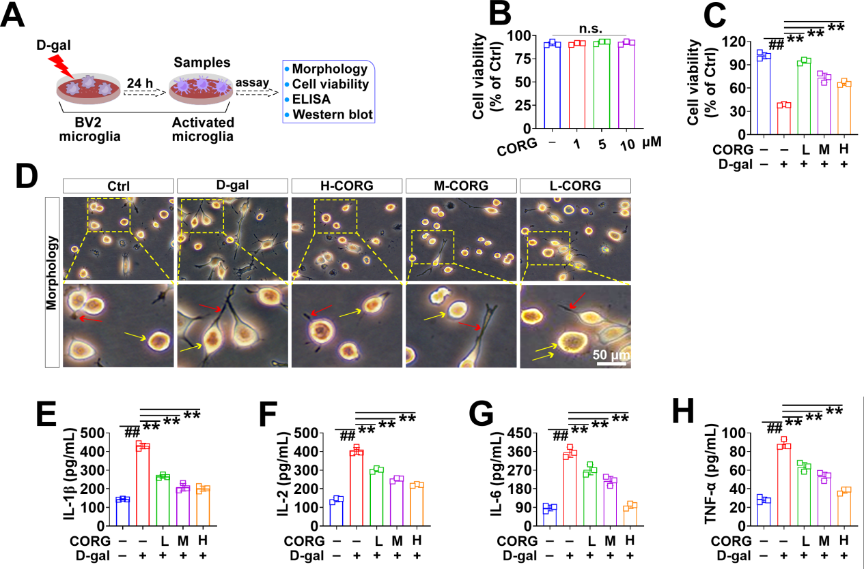
Figure S1. CORG protective effects against D-gal-induced neuroinflammation in BV-2 cells. (A) Schematic diagram of BV-2 cell culture. Relative viability of BV-2 cells primed with D-gal (B), followed by treatment with CORG (C). The morphology of BV-2 cells (D). Measured levels of IL-1β (E), IL-2 (F), IL-6 (G), and TNF-α (H) (n = 3 independent experiments). β-actin was used as an internal control. Data are presented as mean ± SEM from each group. #P < 0.05 and ##P < 0.01 vs the untreated Ctrl group; *P < 0.05 and **P < 0.01 vs the D-gal-treated group.

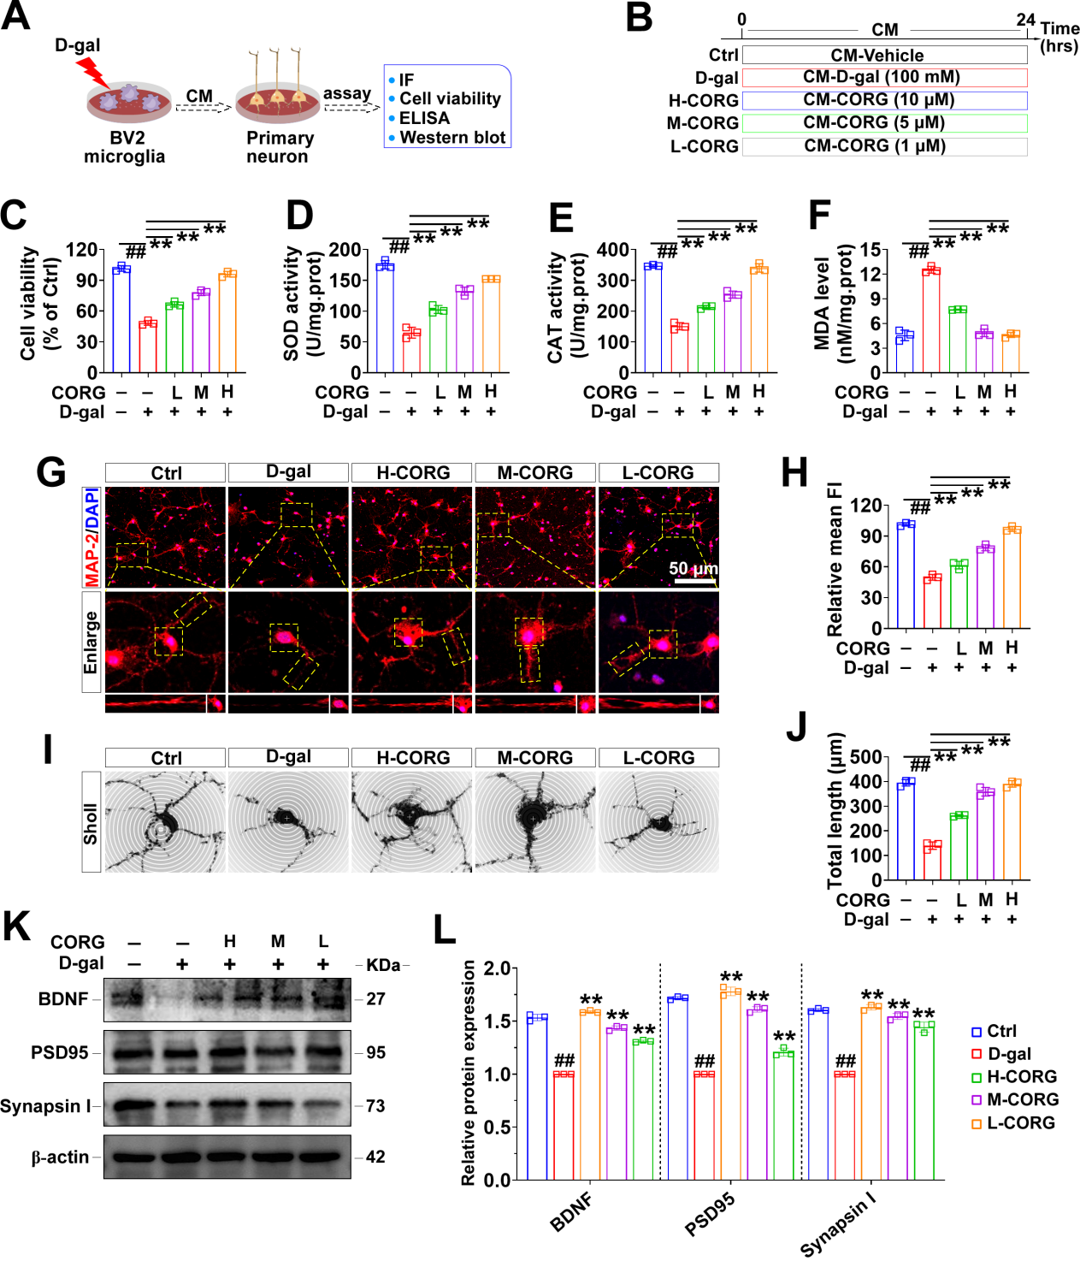
Figure S2. CORG protective effects against MCM-induced primary cortical neuron damage. (A–B) Schematic diagram of primary cortical neuron culture and experimental grouping. (C) Effects of CORG on cell viability. (D–E) SOD and CAT activity. (F) MDA content. (G–H) Immunofluorescence staining and quantification of MAP-2 levels in primary cortical neurons. (I, J) Representative images of Sholl analysis and quantification of total neurite length. (K, L) Western blots and densitometric analysis for BDNF, PSD95, and Synaspin I. β-actin was used as an internal control. Data are presented as mean ± SEM from each group (n = 3 independent experiments). #P < 0.05 and ##P < 0.01 vs the MCM-Ctrl group; *P < 0.05 and **P < 0.01 vs the MCM-D-gal-treated group.

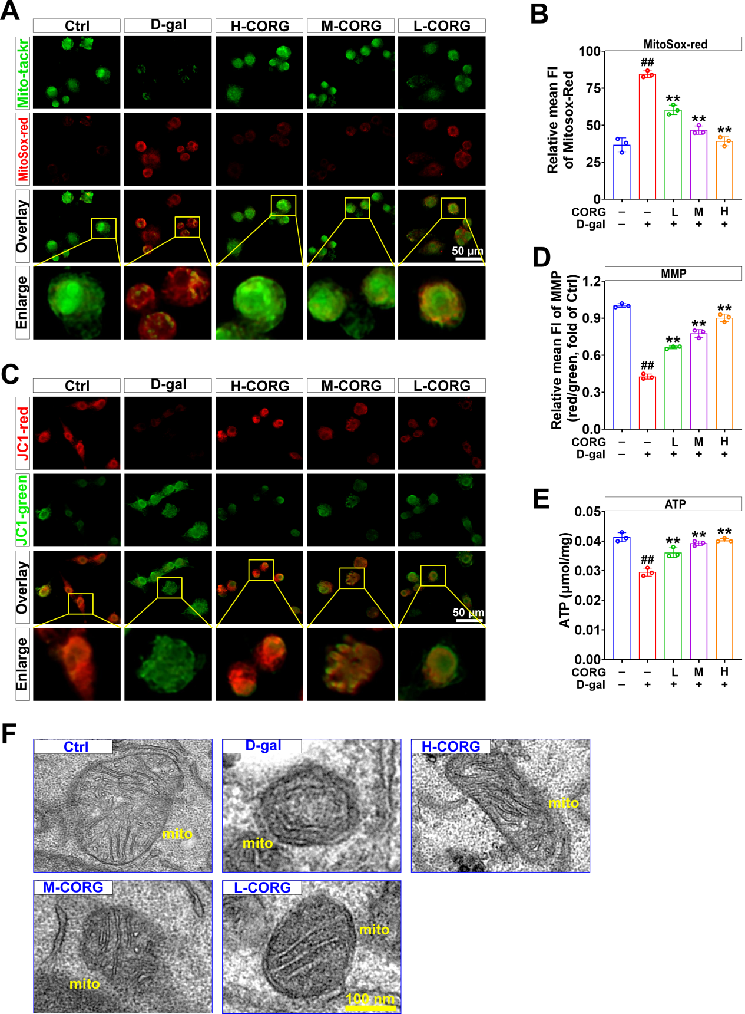
Figure S3. Protective effect of CORG on D-gal-induced mitochondrial damage in BV-2 cells. (A) Representative MitoTracker Green and MitoSOX-red fluorescence images of BV-2 cells. (B) Quantification of MitoSOX-red fluorescence intensity. (C) Representative JC-1 fluorescence images showing changes in MMP. Red fluorescence indicates JC-1 aggregates, whereas green fluorescence indicates JC-1 monomers. (D) Quantification of the JC-1 red/green fluorescence ratio. (E) Intracellular ATP level. (F) Representative TEM images showing mitochondrial ultrastructure. Data are presented as mean ± SEM from each group. #P < 0.05 and ##P < 0.01 vs the untreated Ctrl group; *P < 0.05 and **P < 0.01 vs the D-gal-treated group.

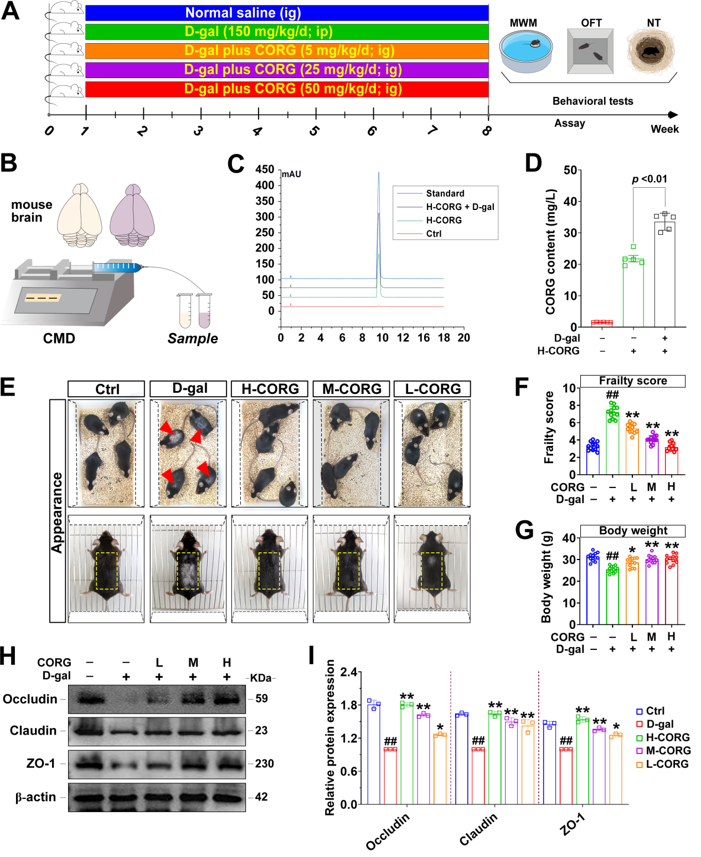
Figure S4. CORG can cross BBB and improve general appearance in D-gal-induced aging mice. (A) Schematic diagram of experimental design for D-gal injection and CORG administration. (B) Schematic diagram of CMD and sample collection. (C) The concentration of CORG in the Ctrl, CORG, and CORG + D-gal groups was measured using HPLC. CORG elutes at 8.75 min. (D) HPLC analysis indicated a significant increase in CORG concentration in the hippocampus of the CORG (50 mg/kg/d) + D-gal group compared with that in the CORG (50 mg/kg/d) group. Effects of CORG on general appearance (E), frailty score (F), body weight (G) in D-gal-induced aging mice (n = 12 independent experiments). (H, I) Western blots and densitometric analysis for Occludin, Claudin, and ZO-1 (n = 3 independent experiments). β-actin was used as an internal control. Data are presented as mean ± SEM from each group. #P < 0.05 and ##P < 0.01 vs the Ctrl group; *P < 0.05 and **P < 0.01 vs the D-gal-treated group.
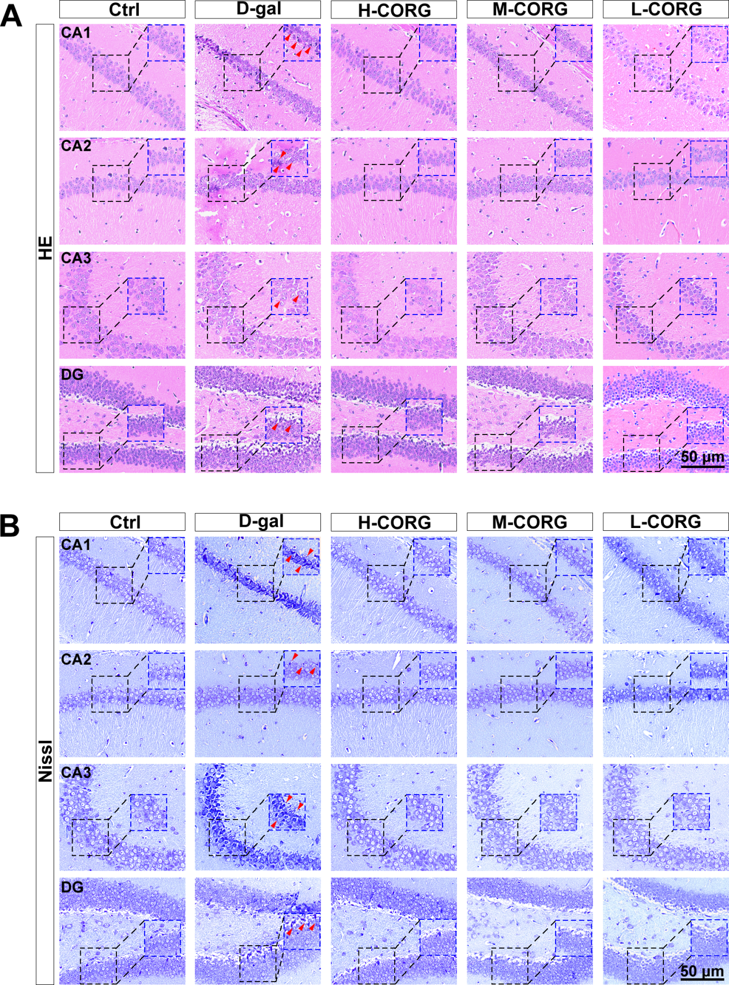
Figure S5. CORG protective effects against D-gal-induced hippocampal pathological damage. Representative H&E (A) and Nissl (B) staining of the hippocampal CA1, CA2, CA3, and DG regions. Red arrows indicate neuronal pathological alterations, including disordered cell arrangement, nuclear shrinkage, neuronal loss, and reduced Nissl bodies.

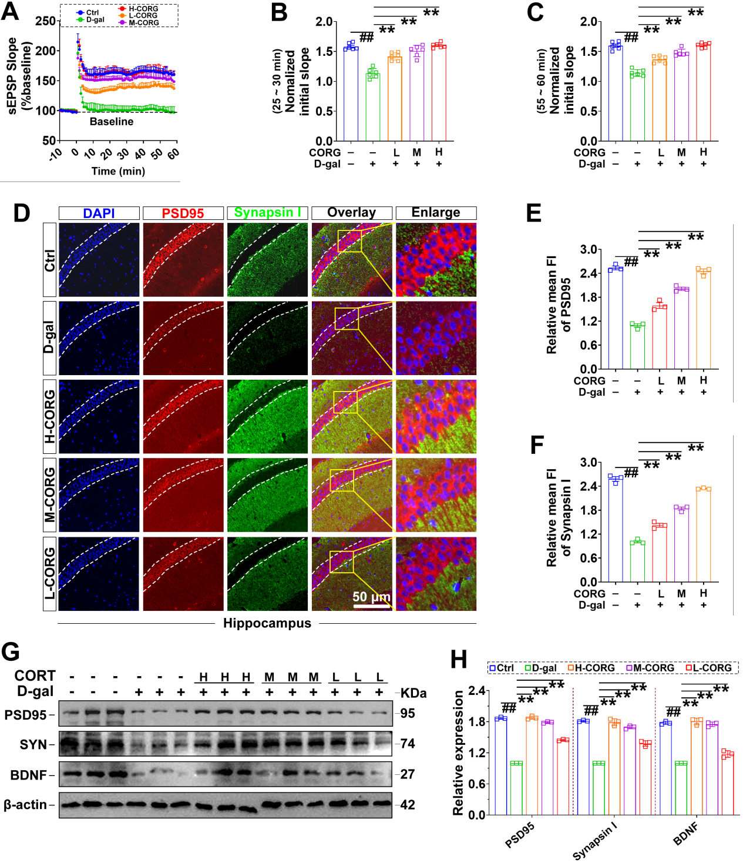
Figure S6. CORG prevents D-gal-induced impairment of LTP and abnormal expression of synapse-associated proteins. (A) Schematic of electrophysiological recordings. (B) fEPSP slope input-output patterns in acute slices of the hippocampus. (C) LTP measured in hippocampal acute slices. Quantification of fEPSP slope at 25–30 min (D) and 55–60 min (E) relative to baseline. (D) Representative immunofluorescence‌ images of PSD95 and Synapsin I in the hippocampus. (E, F) Quantification of PSD95 and Synapsin I fluorescence intensity (n = 5). (G, H) Western blots and densitometric analysis for of PSD95, Synapsin I, and BDNF (n = 3). β-actin was used as an internal control. Data are presented as mean ± SEM from each group. #P < 0.05 and ##P < 0.01 vs the untreated Ctrl group; *P < 0.05 and **P < 0.01 vs the D-gal-treated group.

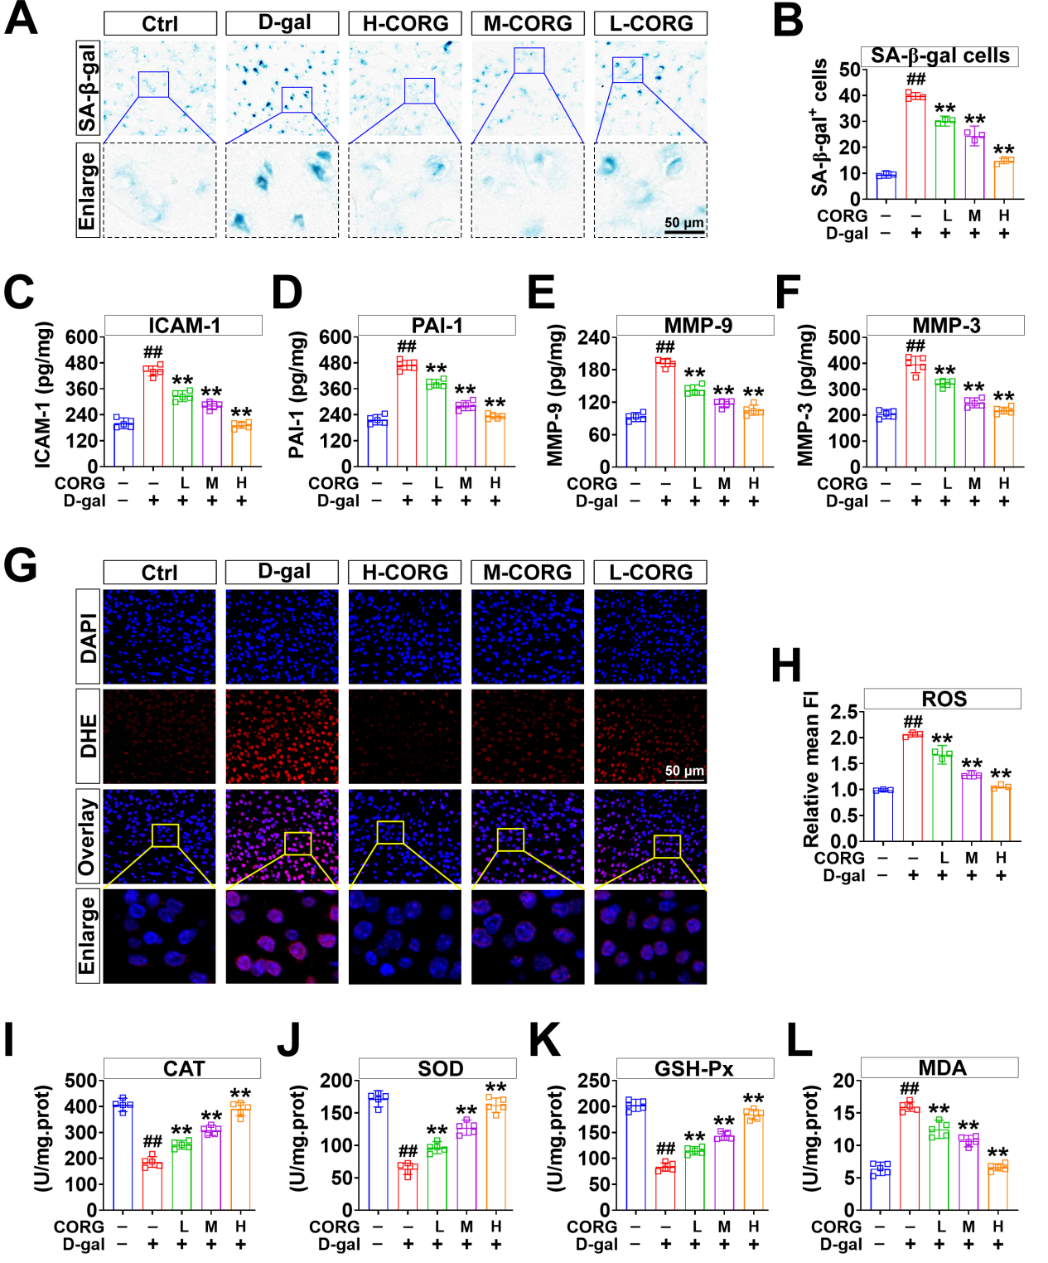
Figure S7. CORG attenuates D-gal-induced oxidative stress and SASP factors in the brains of D-gal-induced aging mice. (A) SA-β-gal staining in hippocampus. (B) Quantification of SA-β-gal⁺ cells. (C–F) Levels of ICAM-1, PAI-1, MMP-9, and MMP-3. (G) Representative DHE fluorescence images showing intracellular ROS production. Nuclei were stained with DAPI, and boxed areas are shown at higher magnification. (H) Quantification of DHE fluorescence intensity. (I–L) CAT activity, SOD activity, GSH-Px activity, and MDA level. Data are presented as mean ± SEM from each group. #P < 0.05 and ##P < 0.01 vs the untreated Ctrl group; *P < 0.05 and **P < 0.01 vs the D-gal-treated group.

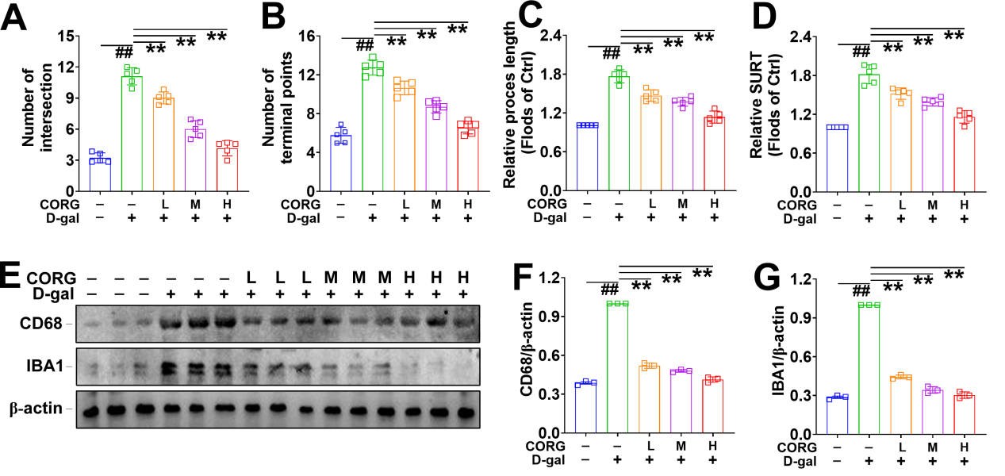
Figure S8. CORG rescues microglia activation and morphological plasticity in vivo. Statistical results for the number of intersections (A), the number of terminal points (B), relative process length of single microglia (C), and relative surveillance territory (D) in each group (n = 5 independent experiments). (E, F) Western blots and densitometric analysis for CD68 and IBA1 (n = 3 independent experiments). β-actin was used as an internal control. Data are presented as mean ± SEM from each group. #P < 0.05 and ##P < 0.01 vs the untreated Ctrl group; *P < 0.05 and **P < 0.01 vs the D-gal-treated group.
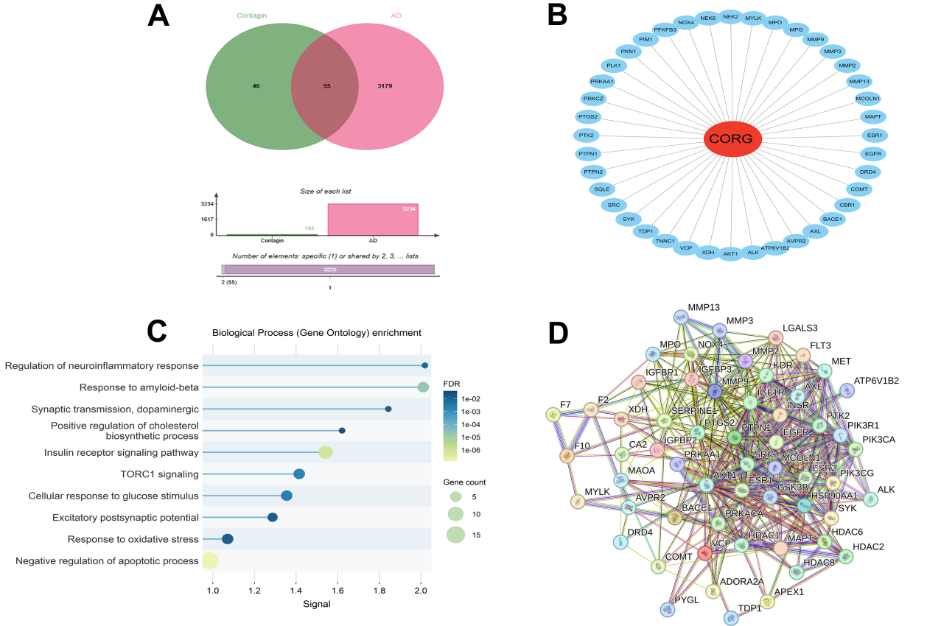
Figure S9. Identifying potential mechanisms of action for CORG through network pharmacology screening. (A) Venn diagram showing the overlapping targets between CORG-related targets and AD-associated targets. (B) CORG–target interaction network. (C) GO-BP enrichment analysis of the overlapping targets. Bubble size represents the gene count, and bubble color represents the FDR value. (D) PPI network of the candidate targets.
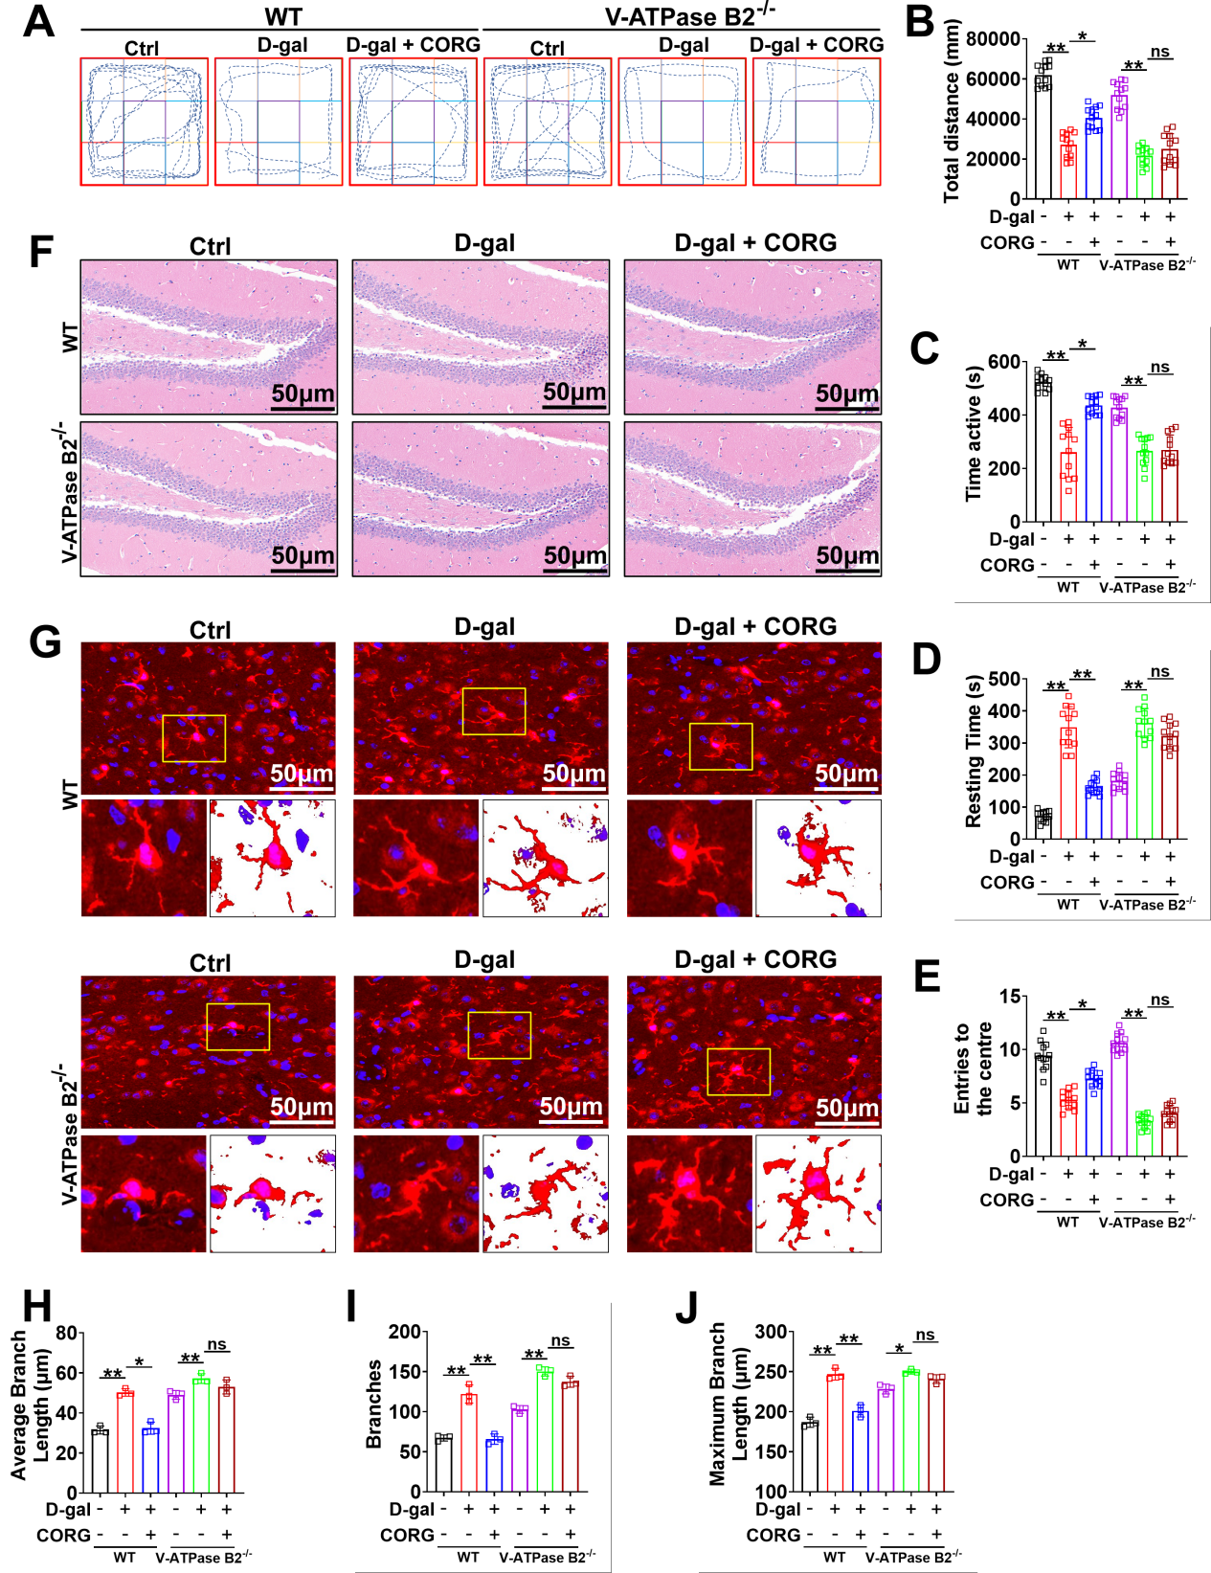
Figure S10. Effects of CORG on Dgal-induced behavioral abnormalities and microglial inflammatory activation in mice are abolished by V-ATPase B2 knockout. (A) Representative OFT movement trajectories of WT and V-ATPase B2⁻/⁻ mice. (B–E) Total distance, active time, resting time, and number of entries into the central area (n = 12). (F) Representative H&E staining of the hippocampus in WT and V-ATPase B2⁻/⁻ mice. (G) Representative IBA1 IF images and morphological reconstruction of hippocampal microglia. Nuclei were stained with DAPI, and boxed areas are shown at higher magnification. (H–J) Average branch length, branch number, and maximum branch length of microglia (n = 5). Scale bars, 50 μm. Data are presented as mean ± SD. *P < 0.05 and **P < 0.01 for the indicated comparisons; ns, not significant.
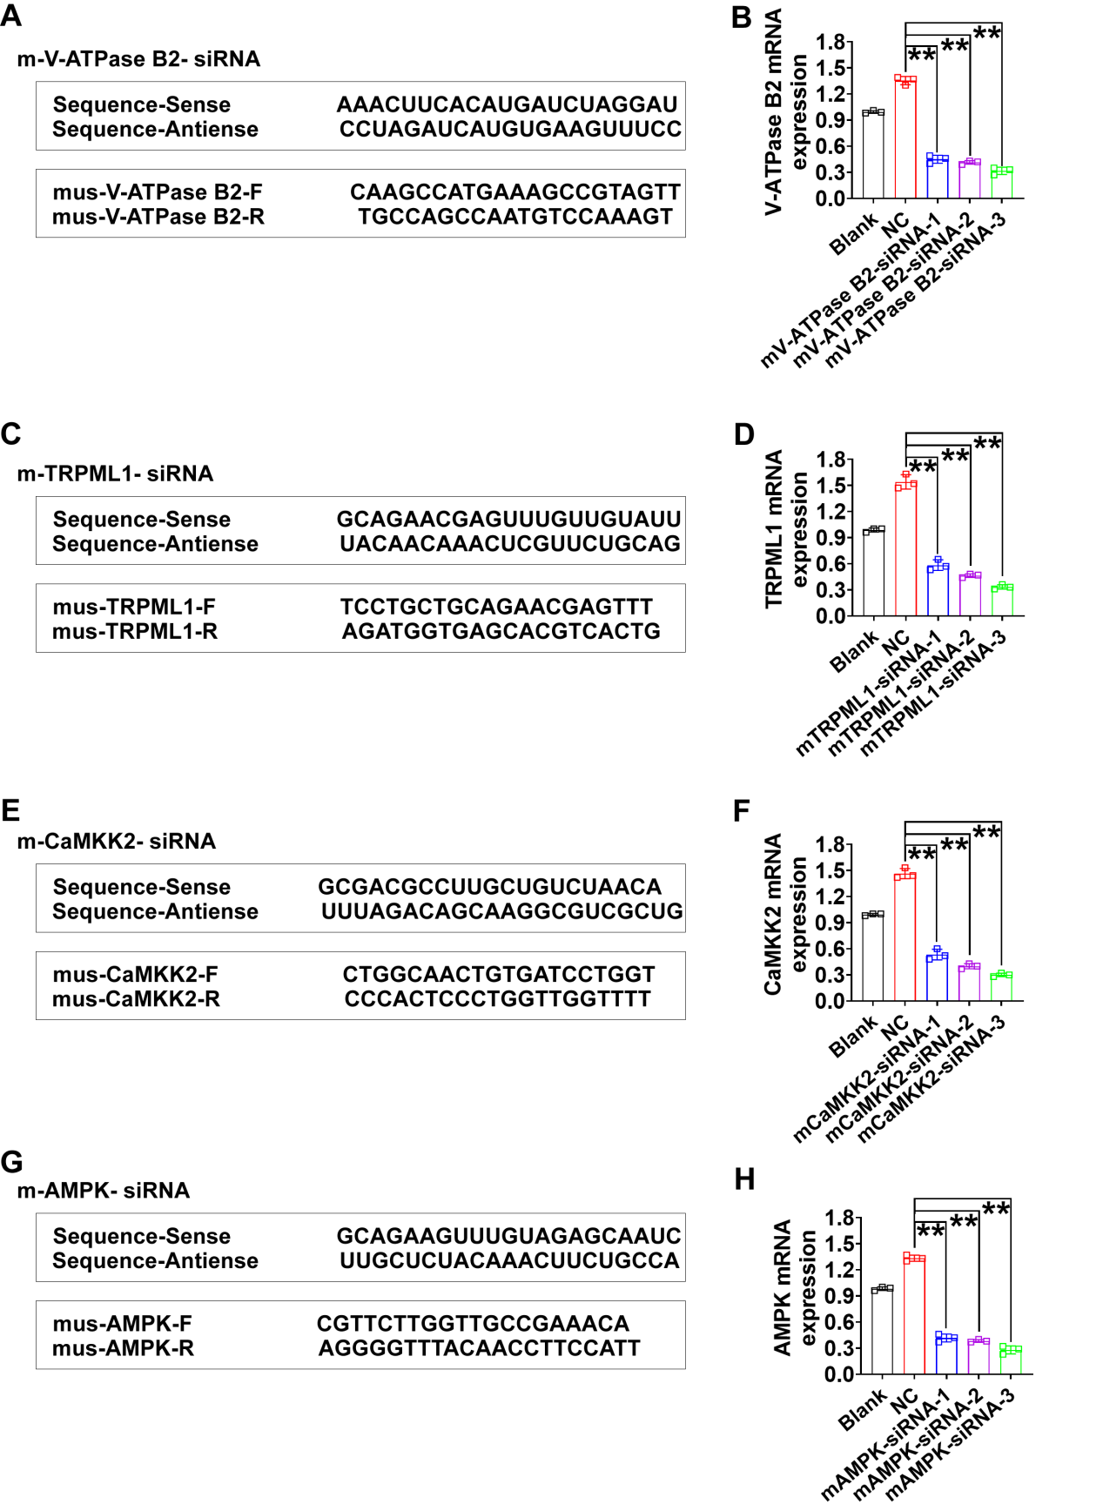
Figure S11. Sequences for V-ATPase B2, TRPML1, CaMKK2, and AMPK primers and detection of transfection efficiency for the these sequences. (A, C, E, G) siRNA and qPCR primer sequences for V-ATPase B2, TRPML1, CaMKK2, and AMPK. (B, D, F, H) Relative mRNA expression of V-ATPase B2, TRPML1, CaMKK2, and AMPK following transfection with three candidate siRNAs. Blank represents untransfected cells, and NC represents cells transfected with NC-siRNA. Data are presented as mean ± SEM from each group. #p < 0.05, ##p < 0.01 and *p < 0.05, **p < 0.01 for comparisons indicated by lines above the bars.

WB raw data:
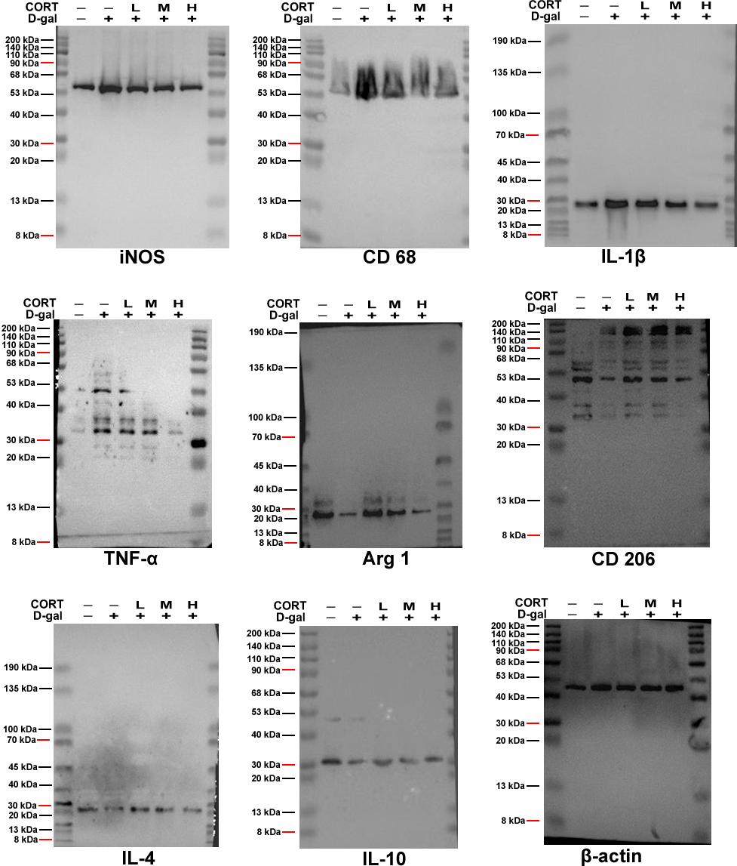
Figure 1

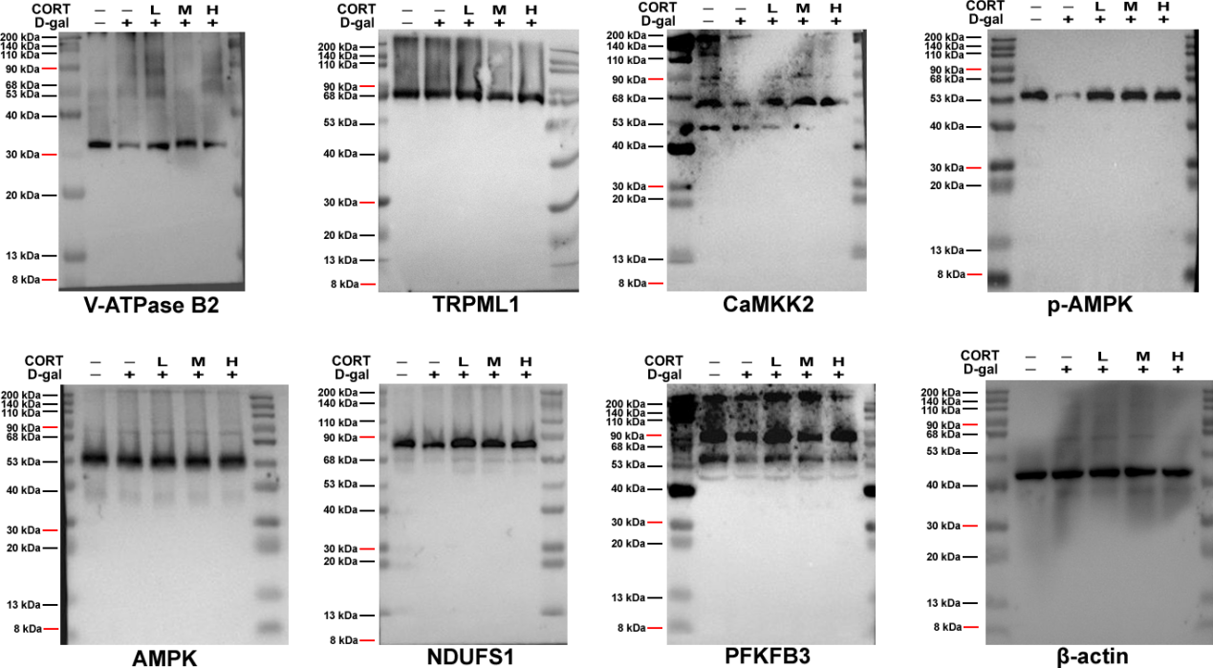
Figure 2

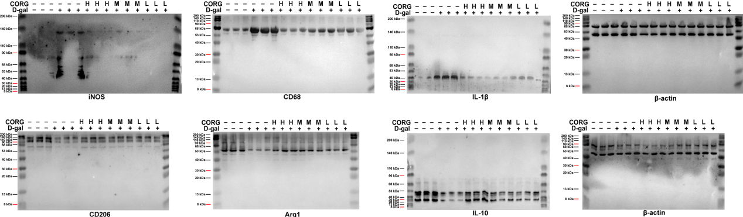
Figure 5

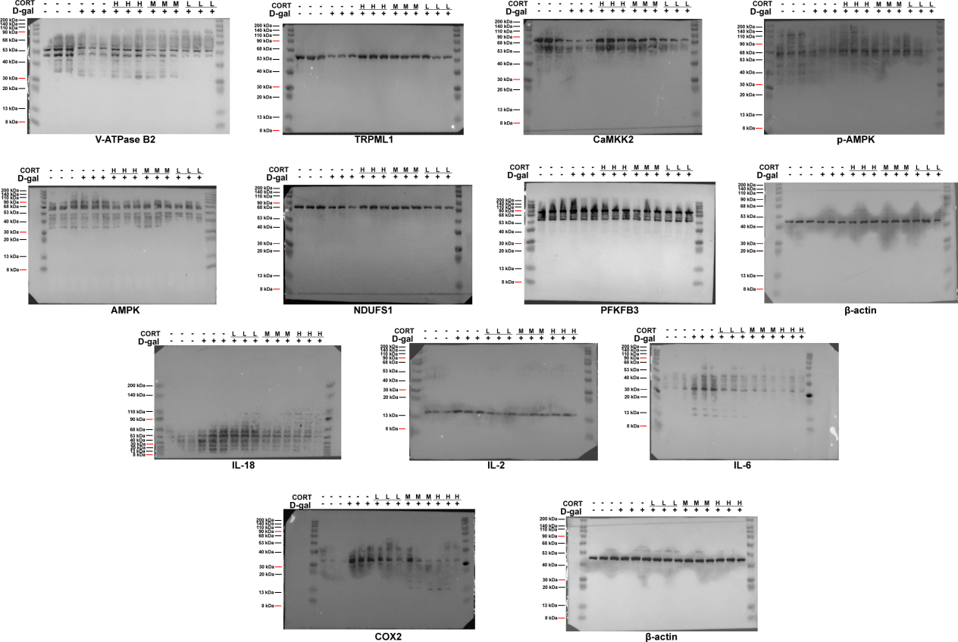
Figure 6

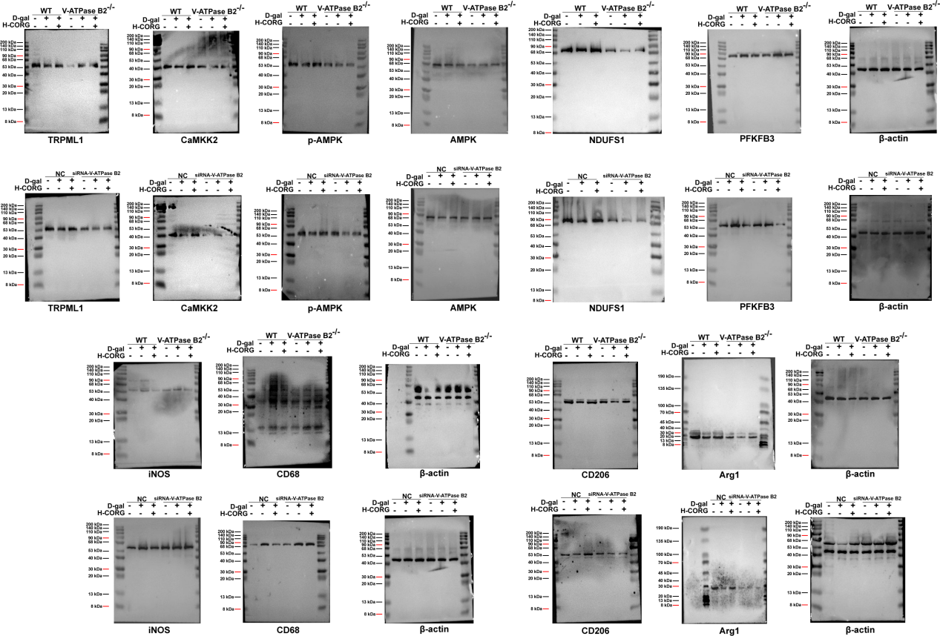
Figure 7

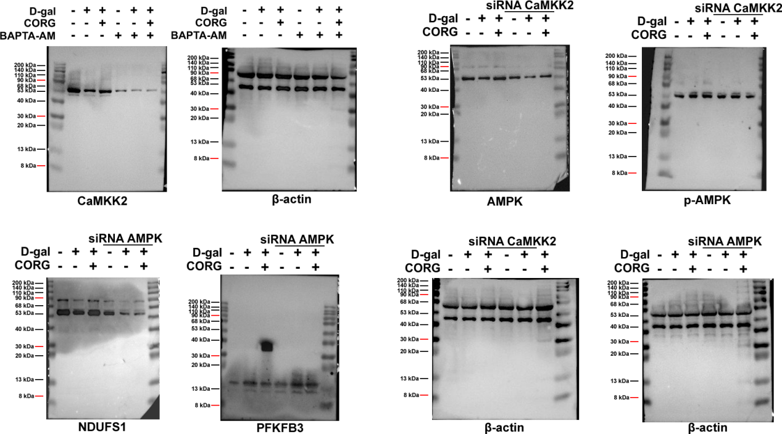
Figure 8

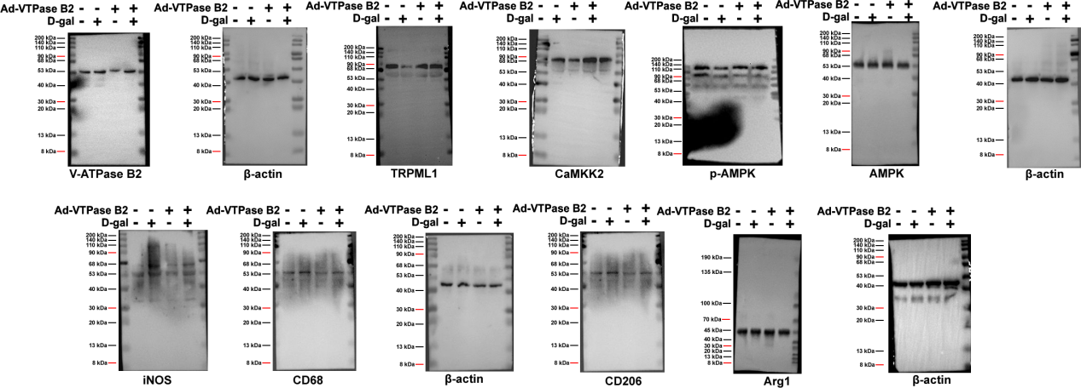
Figure 9
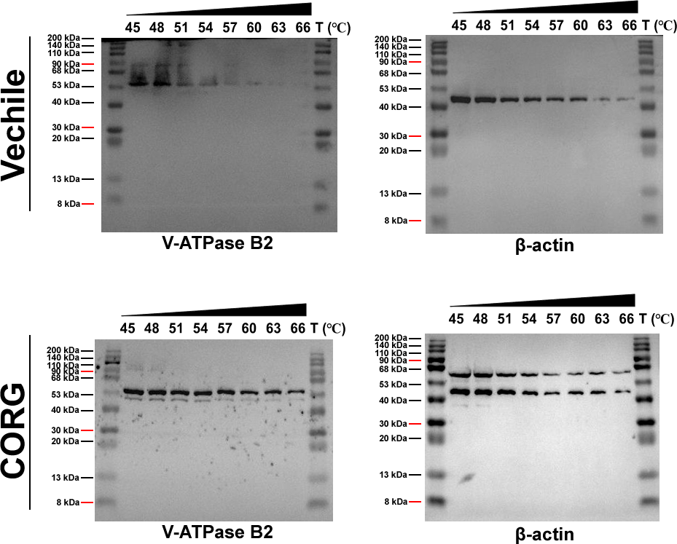
Figure 10

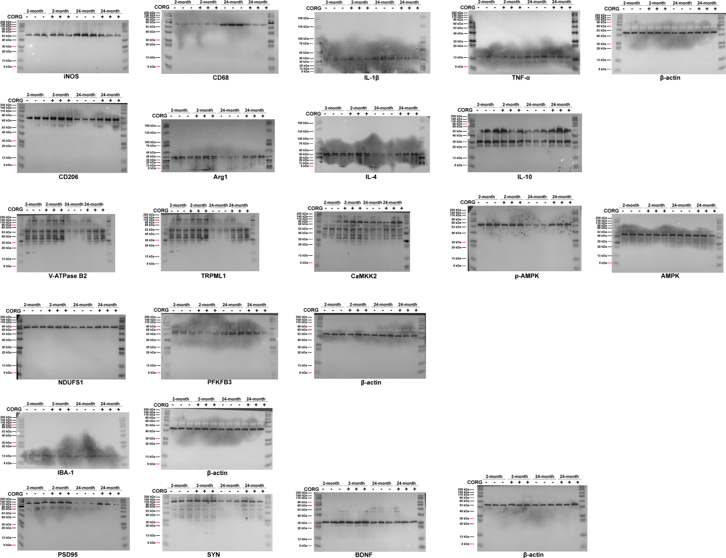
Figure 11

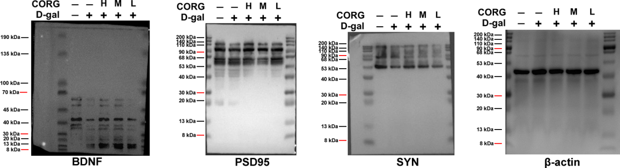
Figure S2

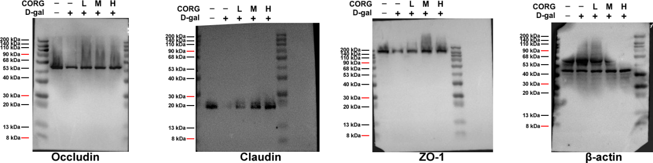
Figure S4

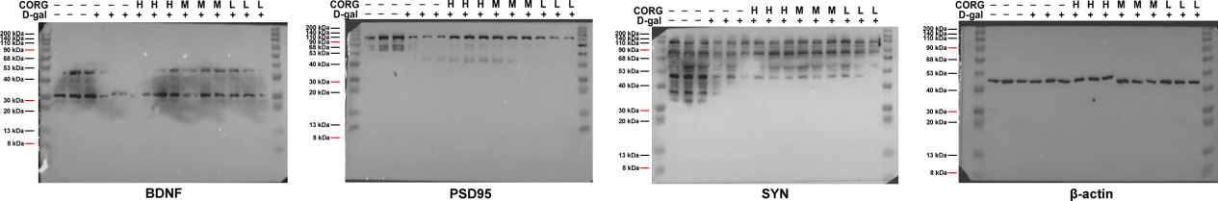
Figure S6

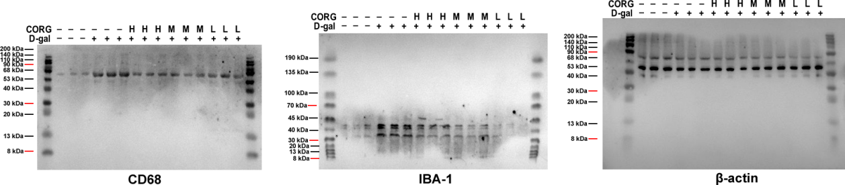
Figure S9

