Supplementary Material
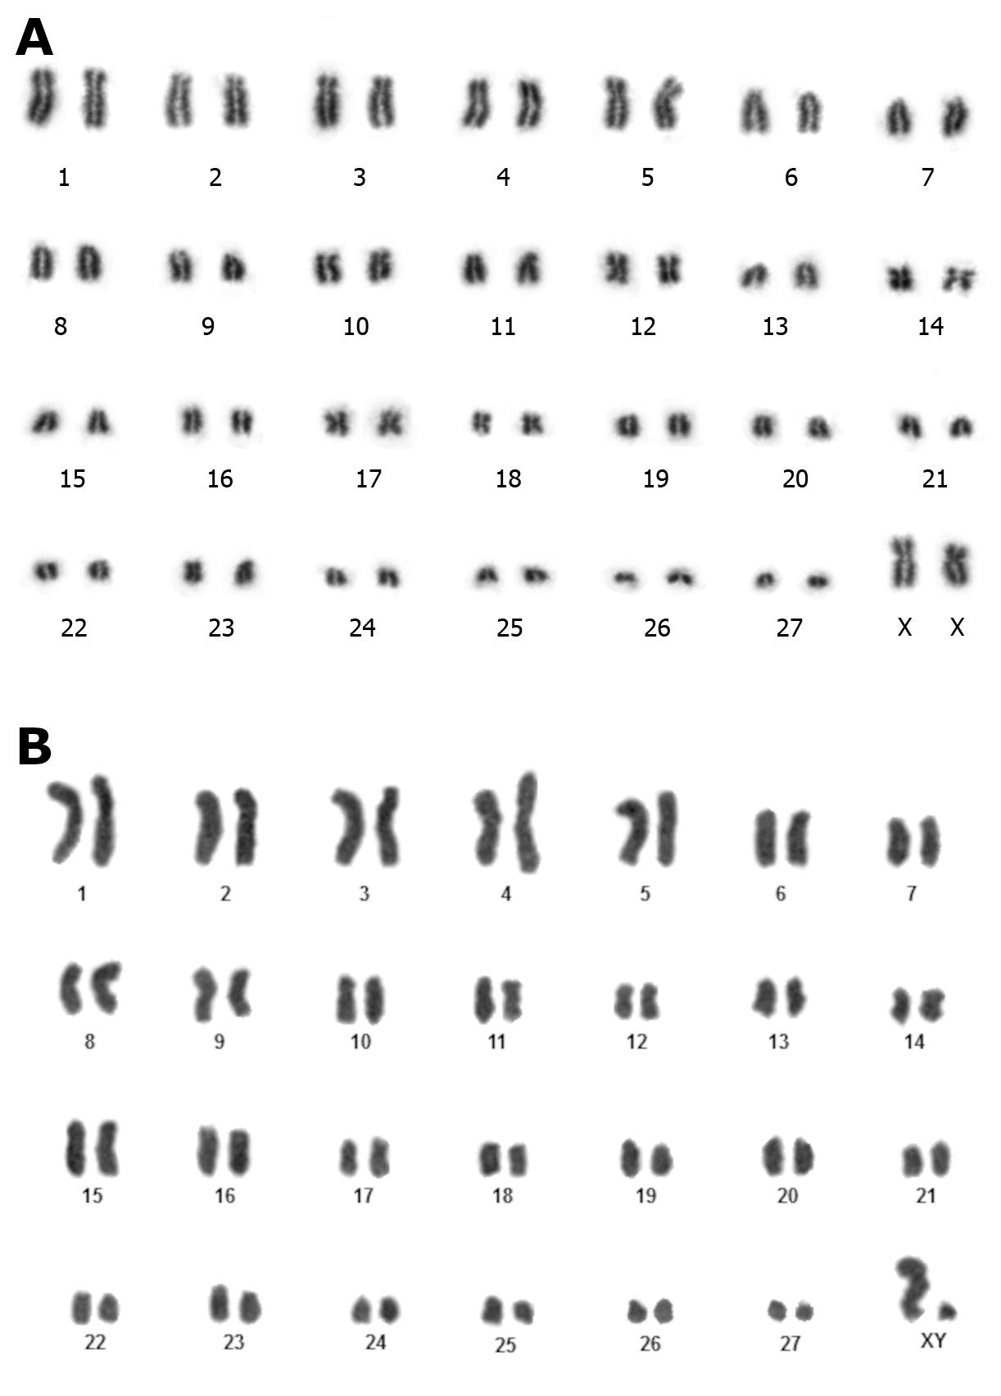
Suplementary Figure 1. Karyotypes of Trichechus inunguis individuals analyzed in this study. (a) female named “Neguinha"; (b) male named "Buriti".

Supplementary Table 1. Statistics on Trichechus genome assemblies before and after scaffolding and patching with RagTag software.
Features | T. inunguis - Female | T. inunguis - Male | T. manatus
Genome size | 2,865.41 | 2,729.39 | 3,103.80
Genome size – RagTag | 2,889.21 | 2,752.79 | 3,103.92
Contig N50 (Mb) | 59 | 62 | 37
Contig N50 (Mb) – RagTag | 59 | 62 | 37
Scaffold N50 (Mb) | 36 | 36 | 14
Scaffold N50 (Mb) – RagTag | 121 | 109 | 129
Number of contigs | 622,658 | 698,723 | 166,490
Number of contigs – RagTag | 622,658 | 698,723 | 166,490
Number of scaffolds | 243,856 | 241,005 | 6,323
Number of scaffolds – RagTag | 5,850 | 7,000 | 5,186
BUSCO | C: 60.2% [S: 59.6%, D: 0.6%]  F: 18.9%  M: 20.9%  n: 9226 | C: 59.8% [S: 59.2%, D: 0.6%]  F: 17.1%  M: 23.1%  n: 9226 | C: 97.7% [S: 97.1%, D: 0.6%]  F: 0.8%  M: 1.5%  n: 9226
BUSCO - RagTag | C: 98.8% [S: 98.3%, D: 0.5%]  F: 0.3%  M: 0.9%  n: 9226 | C: 96.7% [S: 96.2%, D: 0.5%]  F: 0.3  M: 2.9%  n: 9226 | C: 97.8% [S: 97.2%, D: 0.6%]  F: 0.7%  M: 1.5%  n: 9226

