Title:
USP7 Represents a Therapeutic Target for EGFR-Driven and EGFR-TKI–Resistance to EGFR mutations in Lung Cancer

Running title: USP7-EGFR-ABL1 axis in EGFR resistance

Ji Hye Shin^{1,§}, Mi-Jeong Kim^{2,§}, Ji Young Kim^{1,§}, Yeeun Kang¹, Chaeeun Lee¹, Ha-Jeong Lee³, Kyunghwa Baik¹, Duk-Hwan Kim⁴, Jae-Hyuck Shim², Tae Jin Kim^{1,5}, Eunyoung Chun^{6,*}, Ki-Young Lee^{1,3,5,7,*}

Supplementary Materials
- Material and Methods
- Supplementary Fig. S1 ~ Fig. S12 & Legends

Supplementary Materials and methods
Gene set enrichment analysis (GSEA)
Normalized microarray expression data obtained from paired lung tumor tissues (LTTs, n = 42) and matched lung normal tissues (mLNTs, n = 42) were used to determine the differential expression of USP7, EGFR, and ABL1 (c-Abl). Based on the relative expression levels of each gene, 42 NSCLC patients were stratified into gene upregulated and gene downregulated subgroups, as shown in Supplementary Fig. S1A, S6A, and S9A. Gene Set Enrichment Analysis (GSEA) was subsequently performed using the GSEA software (http://www.gsea-msigdb.org/gsea/index.jsp) to identify significantly enriched biological pathways and gene signatures. Enrichment results were evaluated using the normalized enrichment score (NES), nominal P-value, and false discovery rate (FDR) q value.
Xenograft mouse model
NOD/SCID/IL-2Rγ^{null} (NSG) mice (Jackson Laboratory, Bar Harbor, ME, USA) were maintained under specific pathogen-free conditions in accordance with the guidelines of the Institutional Animal Care and Use Committee (IACUC) of Sungkyunkwan University (approval No. SKKUIACUC2025-05-05-1, Suwon, Korea). Six- to eight-week-old mice were subcutaneously injected into the dorsal flank with 1 × 10⁶ control (Ctrl) A549 EGFR-wild type (EGFR^{WT}) or USP7-knockout (USP7-KO) A549 cells (n = 4 per group), suspended in 100 µL serum-free RPMI 1640 containing a 1:1 (v/v) mixture of ice-cold Matrigel (BD Biosciences, La Jolla, CA, USA). Body weight was monitored during the experimental period, and tumor images of xenografted mice were captured on post-inoculation day 63. Body weight data are presented as mean ± SEM.
Wound-healing migration assay
Ctrl A549 EGFR^{WT}, USP7-KO A549, Ctrl H460 EGFR^{WT}, and USP7-KO H460 cells were seeded into 12-well plates and cultured to full confluence. Cell monolayers were scratched with a sterile pipette tip to generate a linear wound and washed with culture medium to remove detached cells and debris. Images were acquired at the indicated time points, and cell migration was quantified by measuring the remaining wound area using ImageJ software (National Institutes of Health, Bethesda, MD, USA).
Immunoprecipitation (IP) assay
For semi-endogenous immunoprecipitation (IP) assay, H460 EGFR^{WT} lung cancer cells were transiently transfected with Flag-USP7 vector. After 24h incubation, cells were stimulated with vehicle (DMSO, 0.1% v/v) or EGF (5 ng/mL) for 30 min. After cell collection, lysates were immunoprecipitated with anti-IgG or anti-Flag antibodies. IP complexes were separated by sodium dodecyl sulfate-polyacrylamide gel electrophoresis (SDS-PAGE, 8~12 %) and immuno-probed with anti-Flag, anti-EGFR, or anti-c-Abl antibodies.
Western Blotting (WB) assay
A549 EGFR^{WT} and H460 EGFR^{WT} lung cancer cells were seeded into 6-well plates and cultured. Cells were stimulated with vehicle (DMSO, 0.1% v/v) or different concentrations of P5091 (USP7 inhibitor, 12.5 μM, 25 μM, and 50 μM) for 24 hr. After collecting cells, cell lysates were separated by SDS-PAGE (8~12%) and immune-probed with anti-c-Abl or anti-GAPDH (as loading control) antibodies.
Statistical analysis
All data are expressed as mean ± SD (standard deviation) or ± SEM (standard error of the mean). Statistical significance was determined by Student’s t-test using GraphPad Prism 8 (GraphPad Software, San Diego, CA, USA). P-values were marked as *P < 0.05, **P < 0.01, ***P < 0.001.

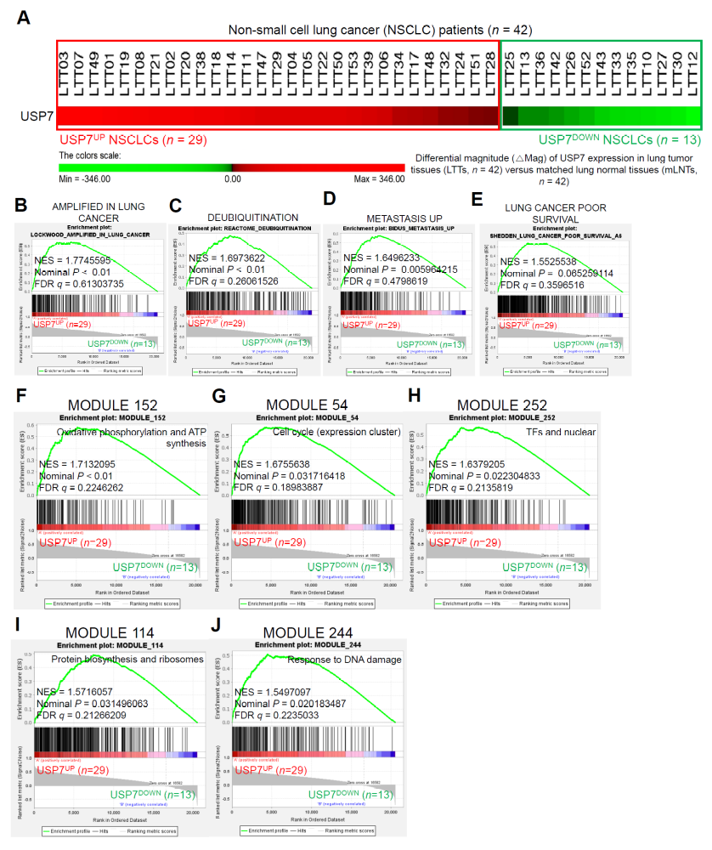
Supplementary Fig. S1. Oncogenic signatures and cancer-related modules are enriched in USP7-upregulated (USP7^{UP}) NSCLC patients. A Based on the differential expression magnitude (ΔMag) of USP7, the 42 NSCLC patient samples were stratified into two groups: USP7-upregulated (USP7^{UP}; n = 29) and USP7-downregulated (USP7^{DOWN}; n = 13) tumors (Supplementary Table S1). B-J Gene Set Enrichment Analysis (GSEA) comparing USP7^{UP} (n = 29) and USP7^{DOWN} (n = 13) NSCLC tumors revealed significant enrichment of gene sets associated with oncogenic signatures, including lung cancer amplification (B), deubiquitination (C), metastasis (D), and poor survival in lung cancer (E), as well as cancer-related modules, including Cancer Module 152 (F), Cancer Module 54 (G), Cancer Module 252 (H), Cancer Module 114 (I), and Cancer Module 244 (J). The normalized enrichment score (NES), nominal P value, and false discovery rate (FDR) q value are shown in each panel.
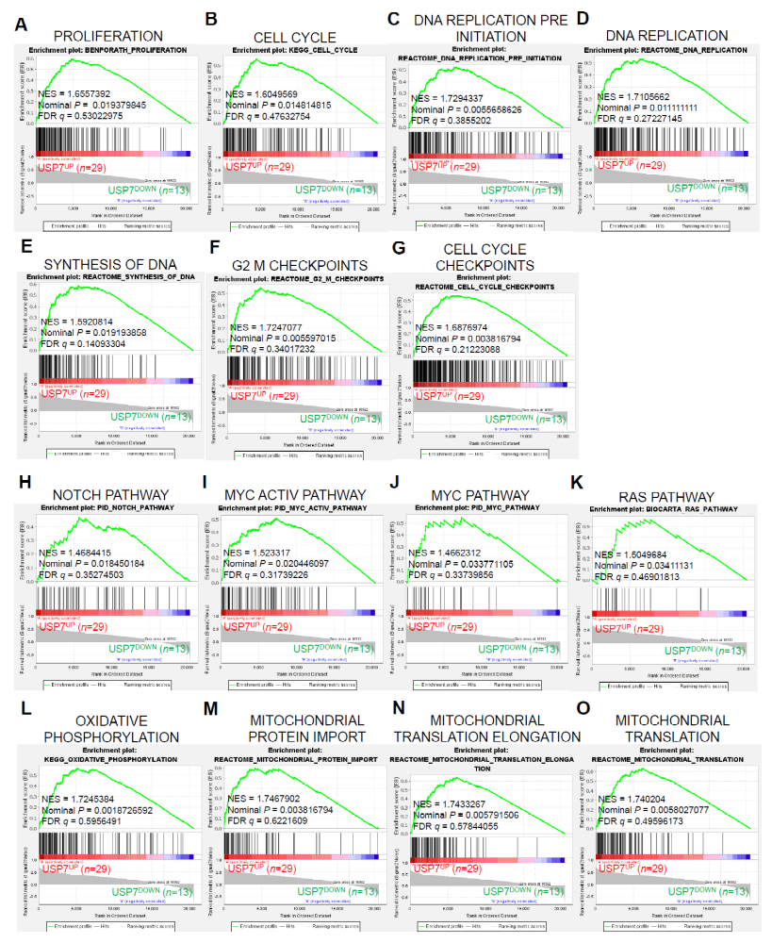
Supplementary Fig. S2. Gene sets associated with cell proliferation, cell cycle progression, oncogenic signaling, and mitochondrial oxidative phosphorylation are enriched in USP7-upregulated (USP7^{UP}) NSCLC patients. Based on the differential expression magnitude (ΔMag) of USP7, the 42 NSCLC patient samples were stratified into two groups: USP7-upregulated (USP7^{UP}; n = 29) and USP7-downregulated (USP7^{DOWN}; n = 13) tumors (Supplementary Fig. S1A). A-O Gene Set Enrichment Analysis (GSEA) comparing USP7^{UP} (n = 29) and USP7^{DOWN} (n = 13) NSCLC tumors revealed significant enrichment of gene sets associated with cell proliferation (A), cell cycle progression (B-G), oncogenic signaling pathways (H-K), and mitochondrial oxidative phosphorylation (L-O). The normalized enrichment score (NES), nominal P value, and false discovery rate (FDR) q value are indicated in each panel.

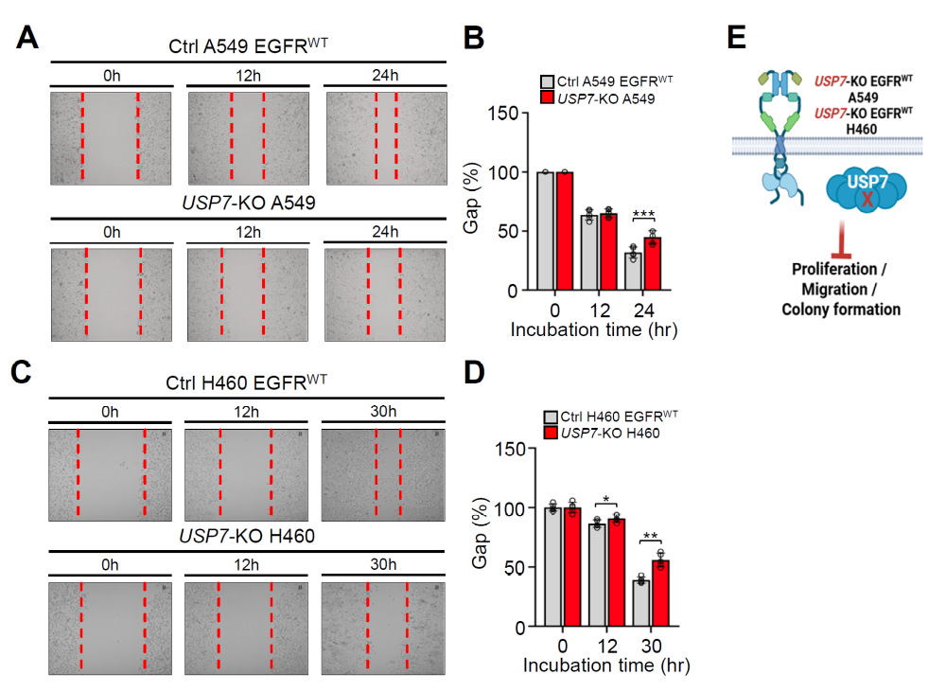
Supplementary Fig. S3. Genetic ablation of USP7 suppresses cell migration in EGFR wild-type (EGFR^{WT}) NSCLC cells. A–D Wound-healing assays were performed using Ctrl A549 (EGFR^{WT}) and USP7-KO A549 cells (A and B), as well as Ctrl H460 (EGFR^{WT}) and USP7-KO H460 cells (C and D), at the indicated time points. Data are presented as the mean ± SD (n = 5). Statistical significance was determined using a two-tailed unpaired Student's t-test (*P < 0.05, **P < 0.01, ***P < 0.001). E Schematic illustration summarizing that genetic ablation of USP7 markedly suppresses EGFR-driven oncogenic activities, including cell migration, in EGFR wild-type (EGFR^{WT}) A549 and H460 lung cancer cells.

Supplementary Fig. S4. USP7 deficiency suppresses tumor growth in a xenograft model without affecting body weight. A Body weight of NSG mice subcutaneously xenografted with control (Ctrl) A549 (EGFR^{WT}) or USP7-KO A549 cells (1 × 10⁶ cells per mouse; n = 4 per group) was monitored throughout the experimental period. Data are presented as the mean ± SEM. B Representative images of tumors from NSG mice bearing subcutaneous xenografts of Ctrl A549 EGFR^{WT} or USP7-KO A549 cells were captured on day 63 after tumor cell inoculation.

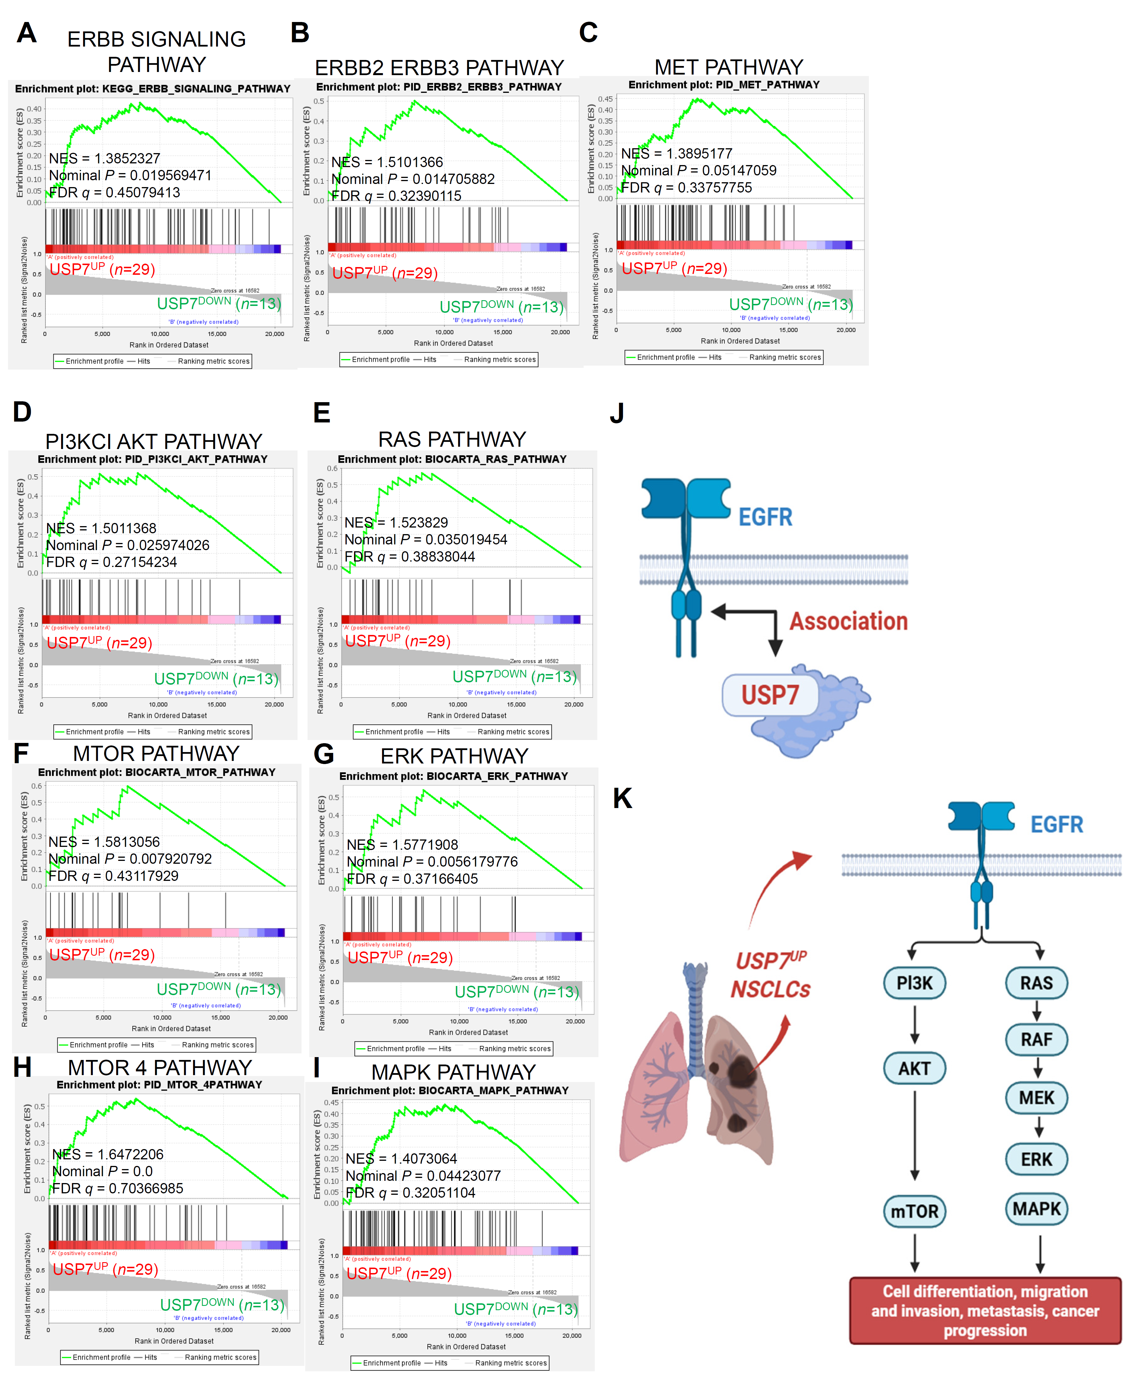
Supplementary Fig. S5. EGFR-related and downstream signaling pathways are enriched in USP7-upregulated (USP7^{UP}) NSCLC patients. Based on the differential expression magnitude (ΔMag) of USP7, the 42 NSCLC patient samples were stratified into two groups: USP7-upregulated tumors (USP7^{UP}; n = 29) and USP7-downregulated tumors (USP7^{DOWN}; n = 13) (Supplementary Fig. S1A). A-I Gene set enrichment analysis (GSEA) comparing USP7^{UP} NSCLCs (n = 29) with USP7^{DOWN} NSCLCs (n = 13) revealed significant enrichment of gene sets associated with EGFR-related signaling and its downstream pathways, including the ERBB signaling pathway (A), ERBB2–ERBB3 pathway (B), MET pathway (C), PI3KCI AKT pathway (D), RAS pathway (E), MTOR pathway (F), ERK pathway (G), MTOR 4 signaling (H), and MAPK pathway (I). Normalized enrichment scores (NES), nominal P values, and false discovery rate (FDR) q values are indicated in each panel. J and K Schematic models illustrating the molecular association between USP7 and EGFR (J), and the activation of EGFR downstream signaling pathways in USP7-upregulated NSCLCs (K).

Supplementary Fig. S6. Oncogenic gene signatures are enriched in EGFR^{UP}USP7^{UP} NSCLC patients. A Based on the differential expression magnitude (ΔMag) of EGFR and USP7, the 42 NSCLC patient samples were stratified into two groups: EGFR^{UP}USP7^{UP} tumors (n = 24) and EGFR^{DOWN}USP7^{DOWN} tumors (n = 7) (Supplementary Table S2). B-D Gene set enrichment analysis (GSEA) comparing EGFR^{UP}USP7^{UP} NSCLCs (n = 24) with EGFR^{DOWN}USP7^{DOWN} NSCLCs (n = 7) revealed significant enrichment of oncogenic gene signatures, including lung cancer amplification signatures (B), metastasis-associated gene signatures (C), and lung cancer poor-survival signatures (D). Normalized enrichment scores (NES), nominal P values, and false discovery rate (FDR) q values are indicated in each panel.

Supplementary Fig. S7. Gene sets associated with cancer modules, hypoxia, oxidative phosphorylation, proliferation, DNA replication, and cell cycle progression are enriched in EGFR^{UP}USP7^{UP} NSCLC patients. Based on the differential expression magnitude (ΔMag) of EGFR and USP7, the 42 NSCLC patient samples were stratified into two molecular subgroups: EGFR^{UP}USP7^{UP} tumors (n = 24), exhibiting concurrent upregulation of EGFR and USP7, and EGFR^{DOWN}USP7^{DOWN} tumors (n = 7), exhibiting concurrent downregulation of EGFR and USP7 (Supplementary Fig. S6A). A-E Gene set enrichment analysis (GSEA) comparing EGFR^{UP}USP7^{UP} NSCLCs (n = 24) with EGFR^{DOWN}USP7^{DOWN} NSCLCs (n = 7) revealed significant enrichment of gene sets associated with cancer modules (A), hypoxia and metagene signatures (B), oxidative phosphorylation (C), cell proliferation and DNA replication (D), and cell cycle progression (E). Normalized enrichment scores (NES), nominal P values, and false discovery rate (FDR) q values are indicated in each panel.

Supplementary Fig. S8. EGFR-related and downstream signaling pathways are enriched in EGFR^{UP}USP7^{UP} NSCLC patients. Based on the differential expression magnitude (ΔMag) of EGFR and USP7, the 42 NSCLC patient samples were stratified into two molecular subgroups: EGFR^{UP}USP7^{UP} tumors (n = 24), exhibiting high EGFR and USP7 expression, and EGFR^{DOWN}USP7^{DOWN} tumors (n = 7), exhibiting low EGFR and USP7 expression (Supplementary Fig. S6A). A-G Gene set enrichment analysis (GSEA) comparing EGFR^{UP}USP7^{UP} NSCLCs (n = 24) with EGFR^{DOWN}USP7^{DOWN} NSCLCs (n = 7) revealed significant enrichment of gene sets associated with EGFR-related signaling, including the ERBB signaling pathway (A) and ERBB2–ERBB3 pathway (B), as well as EGFR downstream signaling pathways, including the RAS pathway (C), ERK pathway (D), MAPK pathway (E), MTOR 4 signaling (F), and PI3KCI AKT pathway (G). Normalized enrichment scores (NES), nominal P values, and false discovery rate (FDR) q values are indicated in each panel.

Supplementary Fig. S9. Oncogenic gene signatures are enriched in EGFR^{UP}ABL1^{UP}USP7^{UP} NSCLC patients. A Based on the differential expression magnitude (ΔMag) of ABL1, EGFR, and USP7, the 42 NSCLC patient samples were stratified into two molecular subgroups: EGFR^{UP}ABL1^{UP}USP7^{UP} tumors (n = 16), exhibiting concurrent upregulation of ABL1, EGFR, and USP7, and EGFR^{DOWN}ABL1^{DOWN}USP7^{DOWN} tumors (n = 7), exhibiting concurrent downregulation of ABL1, EGFR, and USP7 (Supplementary Table S3). B-F Gene set enrichment analysis (GSEA) comparing EGFR^{UP}ABL1^{UP}USP7^{UP} NSCLCs (n = 16) with EGFR^{DOWN}ABL1^{DOWN}USP7^{DOWN} NSCLCs (n = 7) revealed significant enrichment of oncogenic gene signatures, including lung cancer amplification signatures (B), hypoxia-related signatures (C), metastasis-associated signatures (D), MYC oncogenic signatures (E), and lung cancer poor-survival signatures (F). Normalized enrichment scores (NES), nominal P values, and false discovery rate (FDR) q values are indicated in each panel.

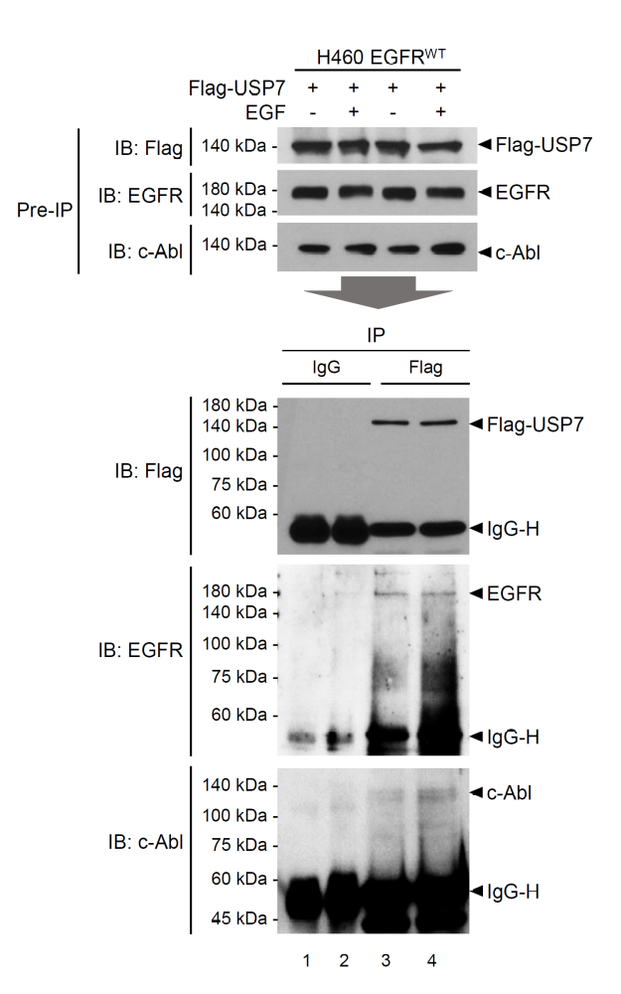
Supplementary Fig. S10. Flag-tagged USP7 interacts with endogenous EGFR and c-Abl. H460 EGFR^{WT} lung cancer cells were transiently transfected with Flag-tagged USP7 and treated with or without EGF, as indicated. Cell lysates were subjected to immunoprecipitation (IP) using control IgG or anti-Flag antibody, followed by immunoblotting (IB) with antibodies against Flag, EGFR, and c-Abl.
Supplementary Fig. S11. P5091 treatment reduces c-Abl protein levels in EGFR wild-type NSCLC cells. A-D A549 EGFR^{WT} (A and B) and H460 EGFR^{WT} (C and D) lung cancer cells were treated with increasing concentrations of the selective USP7 inhibitor P5091 (12.5, 25, and 50 μM), as indicated. c-Abl protein levels were subsequently analyzed by immunoblotting. Data are presented as the mean ± SD (n = 3). Statistical significance was determined using a two-tailed unpaired Student's t-test (*P < 0.05, ***P < 0.001).

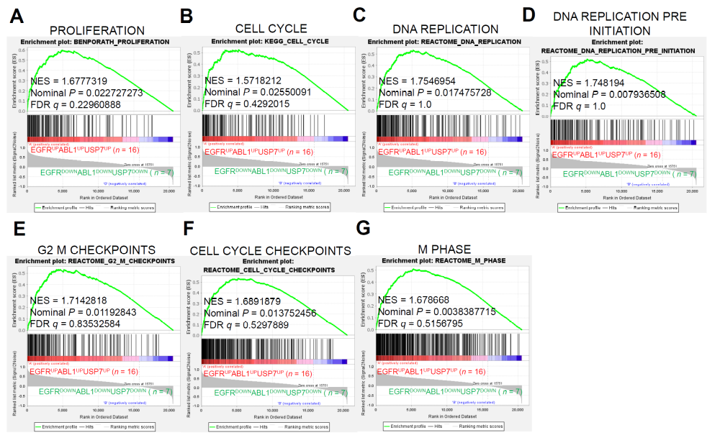
Supplementary Fig. S12. Gene sets associated with cell proliferation and cell cycle progression are enriched in EGFR^{UP}ABL1^{UP}USP7^{UP} NSCLC patients. Based on the differential expression magnitude (ΔMag) of EGFR, ABL1, and USP7, the 42 NSCLC patient samples were stratified into two molecular subgroups: EGFR^{UP}ABL1^{UP}USP7^{UP} tumors (n = 16), exhibiting concurrent upregulation of EGFR, ABL1, and USP7, and EGFR^{DOWN}ABL1^{DOWN}USP7^{DOWN} tumors (n = 7), exhibiting concurrent downregulation of EGFR, ABL1, and USP7 (Supplementary Fig. S9A). A-G Gene set enrichment analysis (GSEA) comparing ABL1^{UP}EGFR^{UP}USP7^{UP} NSCLCs (n = 16) with EGFR^{DOWN}ABL1^{DOWN}USP7^{DOWN} NSCLCs (n = 7) revealed significant enrichment of gene sets associated with cell proliferation (A) and cell cycle progression (B-G). Normalized enrichment scores (NES), nominal P values, and false discovery rate (FDR) q values are indicated in each panel.

