SUPPORTING INFORMATION

Evolved Gas Analysis and Mechanistic Modeling of Thermal Degradation Products from Polytetrafluoroethylene using Thermogravimetric Analysis-Mass Spectrometry (TGA-MS) and Density Functional Theory
Benjamin R. Johnson^{1,2}, Aaron D. Ajeti³, Justin R. Toole¹, Nijel J. Rogers¹, Dairen Jean¹, Taylor N. Miller¹, Jacob R. Nauman¹, Edward L. Zhang¹, Amelia J. Kitlinski¹, Charles M. Aronov¹, Kai D. Palam¹, Andon Z. Thomas¹, H. Daniel Bahaghighat¹, Samuel V. Cowart^{1,2}, Corey M. James¹, Pamela L. Sheehan⁴, Simuck F. Yuk^{1,2*}, Shubham Vyas^{3*}, and Enoch A. Nagelli^{1,2*}
¹Department of Chemical and Biological Science and Engineering, United States Military Academy, West Point, NY 10996, USA; ²Photonics Research Center, United States Military Academy, West Point, NY 10996, USA; ³Department of Chemistry, Colorado School of Mines, Golden, CO 80401, USA; ⁴U.S. Army Combat Capabilities Development Command, Picatinny Arsenal, NJ 07806, USA.

*Co-corresponding authors: simuck.yuk@westpoint.edu, svyas@mines.edu, enoch.nagelli@westpoint.edu

Supplemental information S1: Details of DFT calculations.
Density functional theory (DFT) calculations performed with Gaussian 16 using DFT method ωB97XD/6-311+G(d,p) Single point energies thermally corrected to 298 and 795 K with GoodVibes software. The reverse radical recombination rate constant applied to unimolecular BDEs is 10¹⁰ M⁻¹ * s⁻¹. This may be a source of error for predicted dissociation rate constants,¹ however the activation energies and the resulting trends should be the same. Bimolecular rate constants were calculated with transition state theory.
Table S1. DFT-calculated pathways of PTFE degradation.
Reaction (795 K only) | ΔG |  | ΔH | Ea |  |  |  |  |  |  |  | k (s⁻¹)
C₇F₁₆ → C₆F₁₃ + CF₃ | 44.3 |  | 85.0 | 84.2 |  |  |  |  |  |  |  | 1.02 × 10⁻⁴
C₇F₁₆ → C₅F₁₁ + C₂F₅ | 36.7 |  | 80.0 | 79.4 |  |  |  |  |  |  |  | 1.25 × 10⁻²
C₇F₁₆ → C₄F₉ + C₃F₇ | 33.9 |  | 79.1 | 78.6 |  |  |  |  |  |  |  | 7.43 × 10⁻²
C₇F₁₆ → C₇F₁₅ + F_{A} | 89.5 |  | 118.5 | 116.7 |  |  |  |  |  |  |  | 3.74 × 10⁻¹⁷
C₇F₁₆ → C₇F₁₅ + F_{B} | 79.0 |  | 109.4 | 107.1 |  |  |  |  |  |  |  | 2.91 × 10⁻¹⁴
C₇F₁₆ → C₇F₁₅ + F_{C} | 77.5 |  | 107.6 | 105.6 |  |  |  |  |  |  |  | 7.50 × 10⁻¹⁴
C₇F₁₆ → C₇F₁₅ + F_{D} | 77.5 |  | 107.4 | 105.5 |  |  |  |  |  |  |  | 7.49 × 10⁻¹⁴
Chain shortening |  | ΔG  298 |  795 K |  |  | ΔH | Ea (ΔG) |  | Rev Ea (ΔG) |  | Ea (ΔH) | Rev Ea (ΔH) |  | k (M⁻¹ s⁻¹) |  | rev k
A1) C₆F₁₃ → C₂F₄ + C₄F₉ |  | 19.7 | -4.93 |  |  | 33.8 | 32.3 | 34.6 | 32.4 |  | 14.9 | 37.3 |  | 36.5 | 36.1 | 2.63 | 3.83 |  | 2.59 × 10⁻¹³ | 2.12 × 10⁴ |  | 73.6 | 2.82 × 10⁻¹⁵
B1) C₆F₁₃ → C₅F₁₁ + CF₂  *Ea obtained by Ahrenius plot |  | 39.3 | 16.3 |  |  | 52.8 | 51.6 | 50.2 | 50.2 |  | N/A |  | N/A | N/A |  | 6.56 × 10⁻²¹ | 4.93 ×10³ |  | 1.00 × 10¹⁰ | 1.00 × 10¹⁰

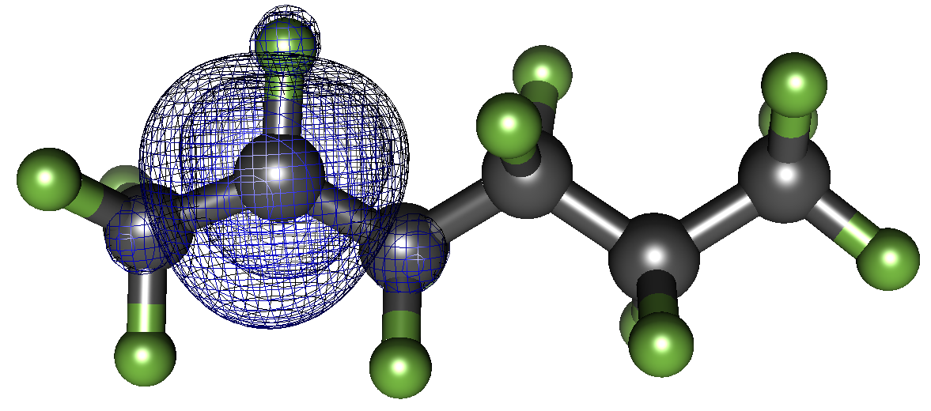
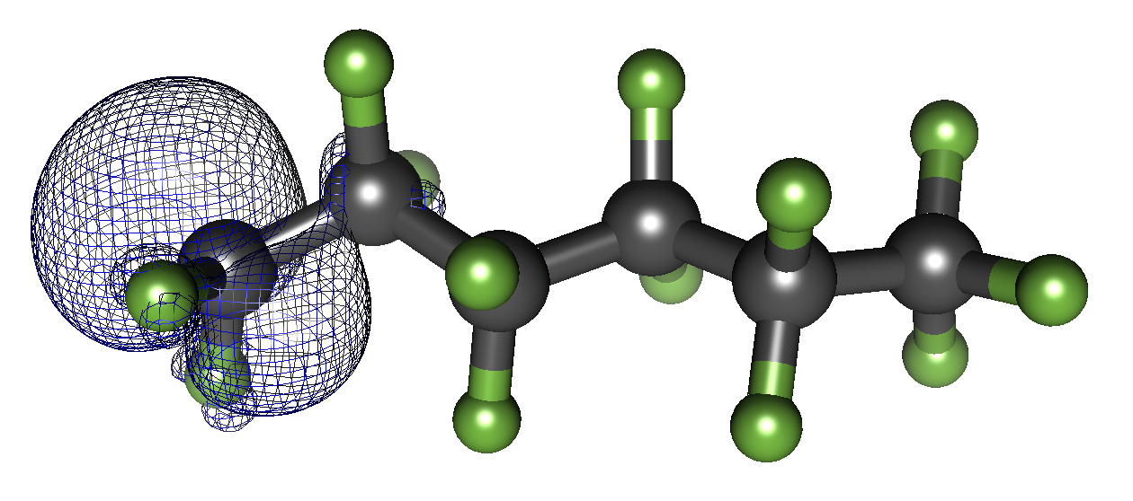
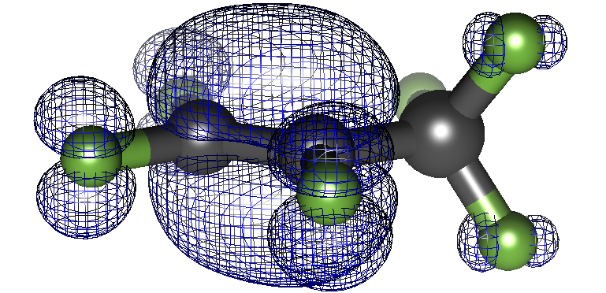
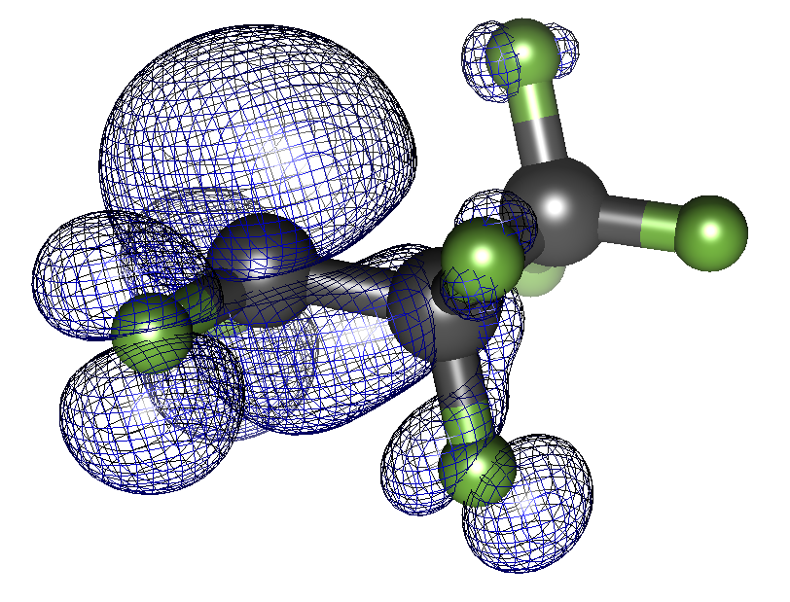
Chain Shortening involving a 1,2–F atom shift (not included in the original mechanism)

C₆F₁₃_C1 radical C₆F₁₃_C2 radical C₃F₆ + C₃F₇
Chain shortening | ΔG  298 |  795 K | ΔH | Ea (ΔG) | Rev Ea (ΔG) | Ea (ΔH) | Rev Ea (ΔH) | k (M⁻¹ s⁻¹) | rev k
1,2–F atom shift | -8.44 | -9.00 | -7.98 | -8.00 | 35.9 | 35.8 | 44.3 | 44.8 | 35.9 | 35.3 | 43.9 | 43.3 | 3.01 × 10⁻¹⁴ | 2.46 × 10³ | 1.92 × 10⁻²⁰ | 8.22
C₆F₁₃ → C₃F₆ + C₃F₇ | 12.9 | -12.6 | 27.5 | 25.9 | 30.5 | 29.3 | 17.6 | 42.0 | 31.6 | 31.2 | 4.07 | 5.31 | 2.73 × 10⁻¹⁰ | 1.45 × 10⁵ | 0.756 | 48.5

Oxidation Reaction 1 | ΔG  298 |  795 K | ΔH | Ea (ΔG) | Rev Ea (ΔG) | Ea (ΔH) | Rev Ea (ΔH) | k (M⁻¹ s⁻¹) | Rev k
C) C₆F₁₃ + O₂ → C₆F₁₃O₂ | -16.6 | 4.05 | -28.8 | -28.0 | 0 | 4.05 | 26.4 | 26.4 | 0 | 0 | 26.4 | 26.4 | 4.4 ×10⁹ | 4.4 ×10⁹ | 1.10 × 10⁶ | 9.16 × 10⁵
C1) C₆F₁₃O₂ → C₆F₁₃O + O | 46.5 | 30.1 | | 56.2 | 55.4 | 55.4 | 0 | 0 | | 56.2 | 0 | 0 | 3.19 ×10⁻²⁶ | 0.815 | Diffusion limited
C2a) C₆F₁₃O → C₅F₁₁ + COF₂ | -27.1 | -50.3 | -13.0 | -15.0 | 2.13 | 2.25 | 29.1 | 52.6 | 2.32 | 1.60 | 15.4 | 16.6 | | 4.58 ×10¹² | | 0.412

Oxidation Reaction 2 | ΔG  298 |  795 K | ΔH | Ea (ΔG) | Rev Ea (ΔG) | Ea (ΔH) | Rev Ea (ΔH) | k (M⁻¹ s⁻¹) | rev k
C) C₆F₁₃ + O₂ → C₆F₁₃O₂ | -16.6 | 4.05 | -28.8 -28.0 | 0 | 4.05 | 26.4 | 26.4 | 0 | 0 | 26.4 | 26.4 | 4.4 ×10⁹ | 4.4 ×10⁹ | 1.10 × 10⁶ | 9.16 × 10⁵
C1) C₆F₁₃O₂ → C₆F₁₃O + O | 46.5 | 30.1 | 55.8 | 56.2 | 55.4 | 55.4 | 0 | 0 | | 56.2 | 0 | 0 | 3.19 ×10⁻²⁶ | 0.815 | Diffusion limited
C2b) C₆F₁₃O + H₂O → C₆F₁₃OH + OH | 1.79 |  2.99 | 0.99 | 1.29 | 13.8 | 32.1 | 12.1 | 29.1 | 3.52 | 4.19 | 2.54 | 2.90 | 434 | 2.53 × 10⁴ | 8970 | 1.68 × 10⁵
C3) C₆F₁₃OH → C₆F₁₂=O + HF | -6.10 | -24.5 | 5.04 | 4.66 | 43.4 | 43.8 | 49.5 | 68.3 | 43.5 | 43.0 | 38.4 | 38.3 | 8.51 × 10⁻²⁰ | 15.5 | 2.87 × 10⁻²⁴ | 2.8 × 10⁻⁶
C4) C₆F₁₂=O + H₂O → C₅F₁₁COOH + HF | -9.10 | -7.60 | -10.1 | -9.74 | 42.3 | 62.2 | 51.4 | 69.8 | 30.3 | 30.6 | 40.4 | 40.4 | 5.99 × 10⁻¹⁹ | 1.28 × 10⁻⁴ | 1.27 × 10⁻²⁵ | 1.04 × 10⁻⁶
C5) C₅F₁₁COOH → CO₂ + HF + C₅F₁₀ | -44.4 | -55.1 | 11.7 | 4.97 | 64.9 | 63.9 | 109.3 | 118.9 | 65.5 | 65.2 | 53.8 | 60.2 | 1.69 × 10⁻³⁵ | 4.54 × 10⁻⁵ | 4.53 × 10⁻⁶⁸ | 3.33 × 10⁻²⁰

COF₂ hydrolysis | ΔG  298 |  795 K | ΔH  298 |  795 K | Ea (ΔG)  298 |  795 K | Rev Ea (ΔG)  298 |  795 K | Ea (ΔH)  298 |  795 K | Rev Ea (ΔH)  298 |  795 K | k (M⁻¹ s⁻¹)  298 |  795 K | rev k  298 |  795 K
COF₂ + H₂O → COFOH + HF | -8.06 | -7.58 | -8.50 | -7.98 | 46.1 | 64.6 | 54.1 | 72.2 | 35.0 | 35.3 | 43.5 | 43.3 | 1.01 × 10⁻²¹ | 2.89 × 10⁻⁵ | 1.24 × 10⁻²⁷ | 2.39 × 10⁻⁷
COFOH + H₂O → CO₂ + HF | -22.9 | -37.5 | -14.4 | -14.2 | 30.3 | 26.6 | 53.2 | 64.1 | 30.4 | 30.9 | 44.8 | 45.0 | 3.58 × 10⁻¹⁰ | 8.30 × 10⁵ | 5.57 × 10⁻²⁷ | 4.07 × 10⁻⁵

TFE/HFP/c–C₄F₈ | ΔG  298 |  795 K | ΔH  298 |  795 K | Ea (ΔG)  298 |  795 K | Rev Ea (ΔG)  298 |  795 K | Ea (ΔH)  298 |  795 K | Rev Ea (ΔH)  298 |  795 K | k (M⁻¹ s⁻¹)  298 |  795 K | rev k  298 |  795 K
D1) C₂F₄ + CF₂ → c-C₃F₆ | -27.7 | -6.83 | -40.2 | -39.1 | 19.3 | 39.4 | 47.0 | 46.2 | 7.79 | 8.74 | 48.0 | 47.9 | 4.15 × 10⁻² | 247.9 | 2.12 × 10⁻²² | 3.3
D2) c-C₃F₆ → CF₃CF=CF₂ | -27.6 | -27.7 | -27.2 | -27.2 | 55.4 | 54.6 | 83.0 | 82.2 | 56.2 | 55.9 | 83.4 | 83.1 | 1.48 × 10⁻²⁸ | 1.67 × 10⁻² | 8.11 × 10⁻⁴⁹ | 4.09 × 10⁻¹⁰
D3) C₂F₄ + C₂F₄ → c-C₄F₈ | -11.6 | -13.8 | -48.9 | -49.1 | 71.5 | 69.4 | 83.1 | 83.2 | 38.7 | 38.6 | 87.6 | 87.6 | 1.44 × 10⁻²³ | 1.33 × 10⁻⁶ | 1.62 × 10⁻⁵⁰ | 2.13⁻¹⁰

Tetrafluoroethylene (TFE) oxidation (1st possibility) | ΔG  298 |  795 K | ΔH | Ea (ΔG) | Rev Ea (ΔG) | Ea (ΔH) | Rev Ea (ΔH) | k (M⁻¹ s⁻¹) | rev k
E1) C₂F₄ + O₂ → C₂F₄O₂ triplet | 27.9 | 44.9 | 18.1 | 19.2 | 35.1 | 51.4 | 7.2 | 6.5 | 25.9 | 26.6 | 7.78 | 7.36 | | 0.121 | | 2.71 ×10¹¹
E2) C₂F₄O₂ triplet → C₂F₄O₂ ring | -55.9 |  -51.7 | -58.4 | -59.1 | Diffusion limited
E3) C₂F₄O₂ ring → 2 COF₂ | -98.0 | -120.2 | -84.7 | -86.3 | Diffusion limited (also can not find a transition state due to singlet to triplet to singlet crossover)
E4a1) COF₂ + HF → CF₃OH | 4.14 | 14.5 | -6.03 | -5.63 | 47.1 | 53.6 | 43.0 | 39.0 | 43.0 | 38.0 | 43.0 | 43.6 | 1.64 ×10⁻²² | 0.0313 | 1.78 ×10⁻¹⁹ | 310.6
E4a2) CF₃OH + OH → CF₃O + H₂O | -0.54 | -1.79 | 0.32 | - 0.123 | 13.0 | 24.1 | 13.5 | 25.9 | 3.41 | 5.77 | 3.41 | 5.89 | 1.89 ×10³ | 4.01 ×10⁶ | 7.54 ×10² | 1.29 ×10⁶

*E1 to E3 is suspected to be one smooth reaction as it is extremely thermodynamically driven.

Hexafluoropropylene (HFP) oxidation | ΔG  298 | 795 K | ΔH | Ea (ΔG) | Rev Ea (ΔG) | Ea (ΔH) | Rev Ea (ΔH) | k (M⁻¹ s⁻¹) | rev k
F1) C₃F₆ + O₂ → C₃F₆O₂ triplet | 33.6 | 51.8 | 23.0 | 24.3 | 39.9 | 58.4 | 6.32 | 6.64 | 29.4 | 30.1 | 6.37 | 5.80 | 3.37 ×10⁻¹⁷ | 1.47 ×10⁻³ | 1.44 ×10⁸ | 2.48 ×10¹¹
F2) C₃F₆O₂ + H₂O → C₃F₆OOH + OH * this reaction possibly goes through an O–O homolytic cleavage instead | 27.0 | 27.1 | 26.9 | 27.5 | 32.9 | 50.9 | 5.93 | 23.8 | 22.5 | 23.4 | -4.37 | -4.08 | 4.69 ×10⁻¹² | 0.165 | 2.78 ×10⁸ | 4.70 ×10⁶
F3) C₃F₆OOH → C₃F₆Oring + OH | -25.9 | -41.3 | -17.4 | -18.2 | 14.8 | 14.9 | 40.8 | 56.2 | 14.5 | 14.2 | 32.0 | 32.4 | 80.1 | 1.33 ×10⁹ | 7.60 ×10⁻¹⁸ | 6.00 ×10⁻³
F4) C₃F₆Oring→ CF₂ + C₂F₄=O | 15.4 | -7.48 | 29.1 | 28.1 | 37.5 | 36.4 | 22.1 | 43.9 | 38.5 | 38.3 | 9.39 | 10.2 | 1.97 ×10⁻¹⁵ | 1.58 ×10³ | 3.69 ×10⁻⁴ | 13.9
F5) C₂F₄=O + H₂O → CF₃COOH + HF | -9.00 | -7.64 | -9.89 | -9.50 | 42.1 | 61.7 | 51.1 | 69.3 | 30.3 | 30.6 | 40.2 | 40.1 | 8.74 ×10⁻¹⁹ | 1.84 ×10⁻⁴ | 2.20 ×10⁻²⁵ | 1.46⁻⁶

Possible alternative to F2, F3
alternate | ΔG  298 | 795 K | ΔH | Ea (ΔG) | Rev Ea (ΔG) | Ea (ΔH) | Rev Ea (ΔH) | k (M⁻¹ s⁻¹) | rev k
C₃F₆O₂ → O + C₃F₆Oring | -12.4 |  -25.6 | -5.1 | -5.1 | -5.47 | -5.47 | N/A | N/A | N/A | 5.32 × 10¹⁷ | 1.67 ×10¹⁵ | N/A
Calculated through the unimolecular reverse recombination rate constant, may not be accurate, but wanted report it.

References:
(1) Rossi, M.; Golden, D. M. Rate of Decomposition of Hexafluoroazomethane and the Absolute Rate of Recombination of Trifluoromethyl Radical at Higher Temperatures. Int J Chem Kinet 1979, 11 (7), 775–788. https://doi.org/10.1002/kin.550110709.

Supplemental information S2: Microkinetic model Python script
Table S2. Microkinetic model Python script of PTFE degradation in Figure 7 of main text.
"""
Created on Wed Sep 17 13:16:50 2025

@author: benjamin.johnson2
"""
# Import packages
import math
# Output file
outfile = open("MKM_jump_v2_20_deact.csv", "w")
outfile.write("CF2-CF2,CF2-*-CF2,CF3-*-CF2,CF2-O2-CF2,C2F4(g),C3F6(g),COF2,Time (s),Temp (C)\n")
# Initialize some variables
time = 0. # s
temperature_start = 450 + 273.15 # K
temperature = temperature_start
heating_rate = 20 # K/min
gas_constant = 1.98720e-3 # kcal/(mol K)
k_B = 1.38065e-23 # Boltzmann constant; J/K
h_P = 6.62607e-34 # Planck constant, J s
num_cycles = 0
init_time_step = 1e-10
big_time_step = 1e-3
small_time_step = init_time_step
clutch = 0
clutch_limit = 25
# Initialize concentration array:
# [0]: CF2-CF2- regular bond A
# [1]: CF2-*-CF2- activated bond B
# [2]: CFCF3-*-CF2- F-shifted bond C
# [3]: CF2-O2-CF2- Oxygenated bond D
# [4]: C2F4(g) (TFE product) E
# [5]: C3F6(g) (HFP product) F
# [6]: COF2(f) product G
# [-2]: Time (s)
# [-1]: Temperature (C)
num_species = 7
conc_array = [[]]
for i in range(num_species):
conc_array[0].append(0.)
conc_array[0][0] = 1.
changes_array = [[]]
change_rates = []
change_factors = []
for i in range(len(conc_array[0])):
changes_array[0].append(0.)
change_rates.append(0.)
change_factors.append(0.)
conc_array[0].append(time)
conc_array[0].append(temperature_start - 273.15)
record_interval = 1e6
record_interval2 = 1e6
force_interval = record_interval / 500
#for item in conc_array[0]:
# outfile.write(str(item) + ",")
#outfile.write(",")
# Create lists for activation energies and rates:
# [] denotes using carbons from carbon chain:
# Affects amounts consumed/produced but not kinetics
# [0]: CF2-CF2-CF2-CF2- --> CF2-CF2-*-CF2-CF2- (bond activation) A --> B
# [1]: CF2-CF2-*-CF2-CF2- --> CF2-CF2-CF2-CF2- (deactivation) B --> A
# [2]: CF2-CF2-*-CF2-CF2 --> C2F4(g) + CF2-CF2-CF2-CF2- (TFE release and deactivation) [2A + ] B --> E + A
# [3]: CF2-CF2-*-CF2-CF2 --> CF2-CFCF3-*-CF2-CF2- (F-shift from secondary to primary carbon) [A + ] B --> C
# [4]: CF2-CFCF3-*-CF2-CF2- --> CF2-CF2-*-CF2-CF2 (F-shift from primary to secondary carbon) C --> B [+ A]
# [5]: CF2-CFCF3-*-CF2-CF2- --> C3F6(g) + CF2-CF2-CF2-CF2- (HFP release and deactivation) [2A +] C --> F + A
# [6]: CF2-CF2-CF2-CF2- --> CF2-CF2-O2-CF2-CF2- (bond oxygenation) A --> D
# [7]: CF2-CF2-O2-CF2-CF2- --> CF2-CF2-*-CF2-CF2- (oxygen removal) D --> A
# [8]: CF2-CF2-O2-CF2-CF2- --> CF2-CF2-CF2- + COF2 + O* (oxygen splitting and COF2 removal) [A + ] D --> G + A
# (Reverse reaction very slow, subsequent COF2 removal very fast)
num_reactions = 9
act_energies = []
rates = []
for i in range(num_reactions):
act_energies.append(0.)
rates.append(0.)
prefactor1 = 2.41e17
prefactor2 = 4.00e21
jump_flag = False
jump_count = 0
stall_count = 0
stall_limit = 10000
max_change_rate = 1e6
#
# Begin main loop
#
while conc_array[-1][0] > 0.01 and num_cycles < (5e9 + 1):
last_change_rate = max_change_rate
if num_cycles % record_interval == 0:
for item in conc_array[-1]:
outfile.write(str(item) + ",")
outfile.write(",")
# prefactor = k_B * temperature / h_P # 1/s
#### Calculate activation energies:
delta_G_CCsplit = 79.1 - (0.056855 * temperature)
delta_G_Fshift = -8.4 + (-0.0012072 * (temperature - 298))
delta_G_oxy = -16.6 + (0.041650 * (temperature - 298))
delta_G_directoxy = delta_G_CCsplit + delta_G_oxy
K_eq_CCsplit = math.exp(-delta_G_CCsplit / (gas_constant * temperature))
K_eq_Fshift = math.exp(-delta_G_Fshift / (gas_constant * temperature))
K_eq_oxy = math.exp(-delta_G_oxy / (gas_constant * temperature))
act_energies[0] = 78.6 + (0.0 * (temperature - 298))
act_energies[1] = act_energies[0] - delta_G_CCsplit
act_energies[2] = 34.6 + (-0.0044266 * (temperature - 298))
act_energies[3] = 35.9 + (-0.00020121 * (temperature - 298))
act_energies[4] = 44.3 + (0.0010060 * (temperature - 298))
act_energies[5] = 30.5 + (-0.0024145 * (temperature - 298))
act_energies[6] = delta_G_CCsplit + 9.8 + (0.041650 * (temperature - 298))
act_energies[7] = 26.4 + (0.0 * (temperature - 298))
act_energies[8] = 55.4 + (0.0 * (temperature - 298))
#### Calculate rates
for i in range(len(act_energies)):
if i == 8:
rates[i] = prefactor2 * math.exp(-act_energies[i] / (gas_constant * temperature))
else:
rates[i] = prefactor1 * math.exp(-act_energies[i] / (gas_constant * temperature))
rates[0] *= conc_array[-1][0]
rates[1] *= conc_array[-1][1]
rates[2] *= conc_array[-1][1] * 2 # Either side of active bond can react to release TFE
rates[3] *= conc_array[-1][1]
rates[4] *= conc_array[-1][2]
rates[5] *= conc_array[-1][2]
rates[6] *= conc_array[-1][0]
rates[7] *= conc_array[-1][3]
rates[8] *= conc_array[-1][3]
#### Calculate change rates for each component
changes_array.append([])
changes_array[-1].append(-rates[0] + rates[1] - rates[2] - rates[3] + rates[4] - rates[5] - rates[6] + rates[7])
changes_array[-1].append(rates[0] - rates[1] - rates[2] - rates[3] + rates[4])
changes_array[-1].append(rates[3] - rates[4] - rates[5])
changes_array[-1].append(rates[6] - rates[7] - rates[8])
changes_array[-1].append(rates[2])
changes_array[-1].append(rates[5])
changes_array[-1].append(rates[8])
#### Calculate change factors (max time step that does not result in negative concentrations)
for i in range(len(changes_array[-1])):
if changes_array[-1][i] < 0:
change_factors[i] = -conc_array[-1][i] / changes_array[-1][i]
else:
change_factors[i] = big_time_step
#### Change concentrations
#### Use large time steps occasionally to speed of model and small time steps to re-establish equilibrium
if jump_flag == True:
time_step = min(big_time_step, min(change_factors))
else:
time_step = small_time_step
conc_array.append([])
for i in range(len(conc_array[-2]) - 2):
conc_array[-1].append(conc_array[-2][i] + changes_array[-1][i] * time_step)
time += time_step
jump_flag = False
#### Calculate rate of changes
for i in range(len(change_rates)):
if changes_array[0][i] == 0:
change_rates[i] = 1e6
else:
change_rates[i] = abs((changes_array[1][i] - changes_array[0][i]) / changes_array[0][i])
max_change_rate = max(change_rates[1:4])
#### Set jump flag if change rate is low enough
#### Also adjust small time step: increase when jump flag is set, decrease if rates are too high/equilibrium not re-establishing
if max_change_rate < 0.001 or num_cycles % force_interval == force_interval / 2:
jump_flag = True
small_time_step *= 1.05
clutch = 0
stall_count = 0
jump_count += 1
elif max_change_rate > 1.0 and max_change_rate > last_change_rate:
clutch += 1
else:
stall_count += 1
if clutch == clutch_limit:
small_time_step *= 0.95
clutch = 0
stall_count = 0
elif stall_count == stall_limit:
small_time_step *= 1.05
#### Update temperature
temperature = temperature_start + (time/60) * heating_rate
conc_array[-1].append(time)
conc_array[-1].append(temperature - 273.15)
#### Delete older values in these arrays to keep variable size manageable
del conc_array[0]
del changes_array[0]
#### Write results to output file
if num_cycles % record_interval == 0:
for item in act_energies:
outfile.write(str(item) + ",")
outfile.write(",")
for item in rates:
outfile.write(str(item) + ",")
outfile.write(",")
for item in changes_array[-1]:
outfile.write(str(item) + ",")
outfile.write(",")
for item in change_rates:
outfile.write(str(item) + ",")
outfile.write(",")
outfile.write(str(max_change_rate) + ",")
outfile.write(str(time_step) + ",")
outfile.write(str(jump_count) + ",")
outfile.write("\n")
if num_cycles % record_interval2 == 0:
print(num_cycles, conc_array[-1][0], temperature - 273.15, jump_count)
num_cycles += 1
#
# End main loop
#
outfile.close()

