Mild and Reversible Proprioception Perturbation Suggests Causal Biomechanics for Memory-Dependent Spatial Behavior in Mice

Liu et al.

Supplementary Material

Supplementary Figure 1. Design and implementation of closed-loop visual and auditory control for mouse navigation-like behavior in a VR system
Left, overview of the VR system. Right, the Bonsai workflow used for the auditory virtual environment.

Supplementary Figure 2. Lack of significant effects of luminopsin activation on behaviors in Open Field with temporal specificity over the full 30-min session of recording
Complementary to Figure 2, with the same analysis and visualization as Figure 5D. Ctl, blue, n = 11; PV-Cre;LMO3^{f/f}, red, n = 14. Shaded pink region, estimated CTZ effective time window based on IVIS bioluminescent measurement. Due to post-handling neuro-behavioral instability, statistical analysis was performed only over 5-30 mins. (A–E) Similar to Figure 2A-E, but over post-injection time. (F) Similar to Figure 2J, but over post-injection time. Aligned-rank-transform (ART) two-way repeated-measures ANOVA; subtitles showing Benjamini–Hochberg FDR-corrected q value for the genotype (G), (T) and genotype × time interaction (G × T) effect. No significance was found in genotype × time interaction a test for genotype-specific temporal changes, suggesting no temporally-specific LMO3 activation on Open-Field behaviors was observed. *q < 0.05. At the first 5-min time bin (0–5 min), group differences in per-class occupancy were tested by unpaired permutation of the mean difference (5,000 resamples) with Benjamini–Hochberg correction across the nine classes. Walking (Ctl 0.040 vs PV-Cre;LMO3 0.028): Δ = −0.012, p = 0.030, q = 0.134. Running (0.128 vs 0.087): Δ = −0.041, p = 0.020, q = 0.134. Both were nominally lower in PV-Cre;LMO3 at 0–5 min (uncorrected p < 0.05) but did not survive FDR correction (q = 0.13); no class reached FDR significance at this time bin.

Supplementary Figure 3. Visualization of temporally binned data and post-hoc analysis for the Grid Walking test
The Cumming estimation plot in this figure is similar in format to Figure 5. Ctl (LMO3^{f/f}) n = 12 mice, PV-Cre;LMO3^{f/f} n = 7 mice; Unpaired permutation test; no significant difference; n.s..
(A) Cumming estimation plots comparing all foot faults across each time bin.
(B) Cumming estimation plots comparing forelimb foot faults across each time bin.
(C) Cumming estimation plots comparing hindlimb foot faults across each time bin.

Supplementary Figure 4. Mice with distal muscle injections of CTZ at a relatively low dose (0.1 mg/kg body weight) showed no significant difference in anticipatory lick position or variance
The Cumming estimation plot in this figure is similar in format to Figure 5&8. This experiment used the treatment as the control, and all mice were of the PV-Cre;LMO3^{f/f} (PL) genotype. PV-Cre;LMO3^{f/f} (PL) n = 4 mice; Unpaired or paired permutation test; no significant difference; n.s.
Supplementary Figure 5. Mice with distal muscle injections of CTZ at a relatively medium dose (2.5 mg/kg body weight) showed no significant difference in anticipatory lick position or variance
The Cumming estimation plot in this figure is similar in format to Figure 5&8. Here were comparisons of two different types of pharmacology and genotype control. Ctl (LMO3^{f/f}) n = 4 mice, PV-Cre;LMO3^{f/f} (PL) n = 6 mice; Unpaired or paired permutation test; no significant difference; n.s.

Supplementary Figure 6. Mice with intraperitoneal injections of CTZ at a relatively high dose (20 mg/kg body weight) showed no difference in anticipatory lick position or variance (preliminary tests)
The Cumming estimation plot in this figure is similar in format to Figure 5&8. Ctl (LMO3^{f/f}) n = 2 mice, PV-Cre;LMO3^{f/f} (PL) n = 3 mice. Because the sample size was very small, statistical tests were not performed.

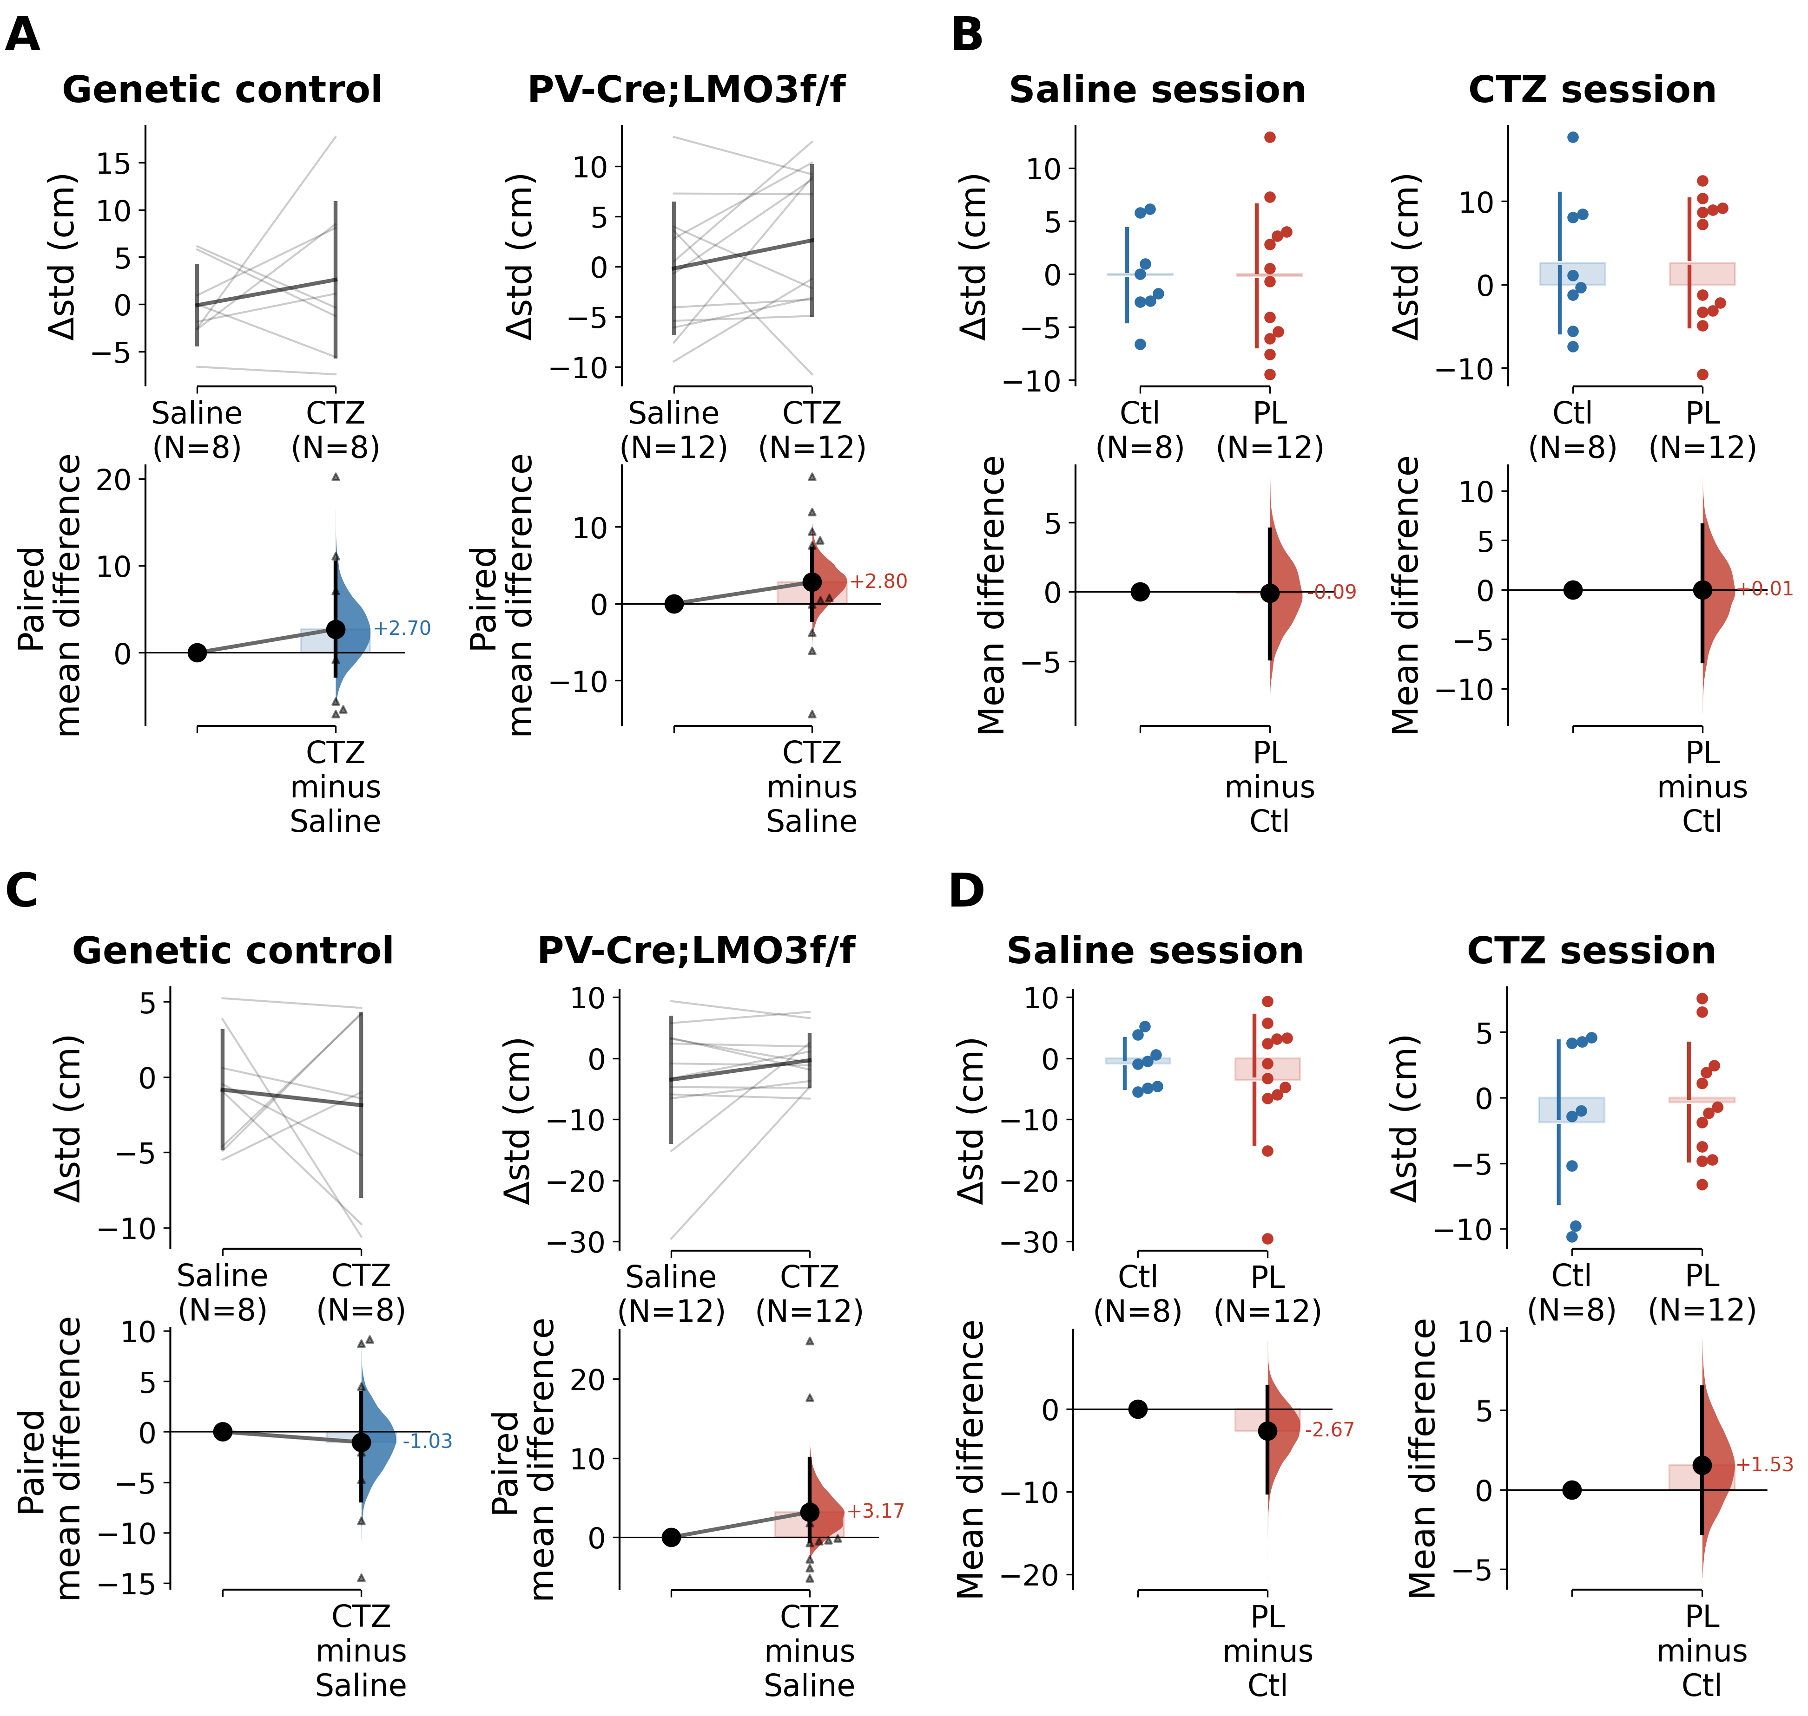
Supplementary Figure 7. Mice with proximal muscle injections of CTZ at a relatively high dose (7.2 mg/kg body weight) showed no significant difference in anticipatory lick variance
The Cumming estimation plot in this figure is similar in format to Figures 5, 8. (A, B) Δstd within-trial: (A) within-genotype, (B) cross-genotype. (C, D) Δstd across-trial: (C) within-genotype, (D) cross-genotype. Ctl (LMO3^{f/f}) n = 8 mice, PV-Cre;LMO3^{f/f} (PL) n = 12 mice. Within-genotype Saline-vs-CTZ comparisons used a paired permutation test; cross-genotype comparisons used an unpaired permutation test (5,000 resamples, DABEST). Blue, genetic control; red, PL.

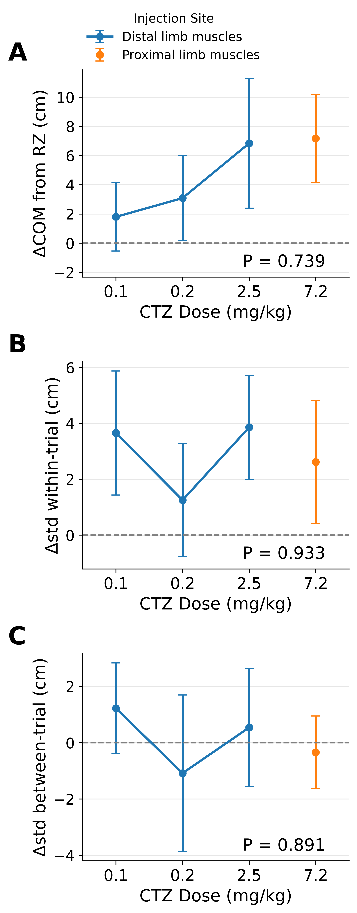
Supplementary Figure 8. Effects of CTZ dose and injection-site on licking behavior
All mice were of the PV-Cre;LMO3^{f/f} (PL) genotype with CTZ injection into either distal (blue line) or proximal (orange dot) limb muscles, and only CTZ sessions are shown. Each mouse contributes a single value per dose, computed over the same 20 preTx and 20 postTx trials used in Fig. 8. Distal muscle injection: 0.1 mg/kg body weight, n = 4 mice (Fig. S4); 0.2 mg/kg (no separate figure), n = 3 mice; 2.5 mg/kg, n = 6 mice (Fig. S5). Proximal muscle injection: 7.2 mg/kg, n = 12 mice (Fig. 8). (A) ΔCOM of lick from RZ. (B) Δstd within-trial. (C) Δstd cross-trials.
Across all three measures there was no significant difference across doses (one-way ANOVA: (A) F(3,21) = 0.42, P = 0.739; (B) F(3,21) = 0.14, P = 0.933;
(C) F(3,21) = 0.21, P = 0.891); n.s. All data are presented as mean ± SEM.

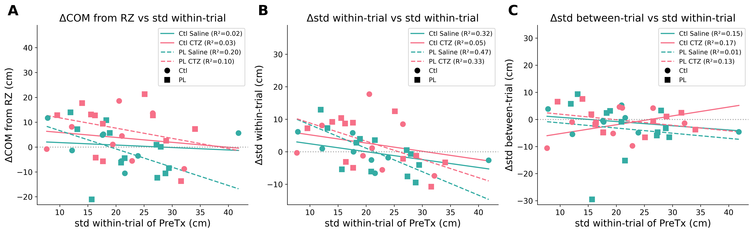
Supplementary Figure 9. The effects of treatment did not correlate with baseline within-trial variability of licking
the animals are the same cohort as those presented in Fig. 8. For each of the four genotype × treatment combinations, the treatment effect (y axis, post-Tx minus pre-Tx) was plotted against that animal's own pre-Tx within-trial standard deviation of lick position (x axis) and fitted by ordinary least squares; the R² of each fit is given in the legend.
(A) ΔCOM of lick from RZ. (B) Δstd within-trial. (C) Δstd cross-trials. The combination in which proprioceptive feedback is expected to be perturbed — PL mice given CTZ — behaved no differently from the other three combinations: its regression slope carried the same sign as the control combinations in every panel (all four slopes negative in (A) and in (B); negative in (C), as in Ctl saline and PL saline), its slope magnitude fell within the range spanned by them, and none of its correlations reached significance ((A) r = −0.31, P = 0.329; (B) r = −0.57, P = 0.051; (C) r = −0.36, P = 0.252; Pearson). Of the twelve fits, only one reached nominal significance — PL saline in (B) (r = −0.68, P = 0.014) — that is, in a vehicle condition rather than in the CTZactivated PL group. The direction and magnitude of the treatment effect were therefore not accounted for by how variable an animal's licking already was before treatment, and this was equally true of the CTZ-activated PL mice.

Supplementary Method Details
In the lightweight VR system designed in house, the mouse was head-restrained over a treadmill. Behavioral outputs, such as licking and locomotion, were detected / recorded by a capacitive sensor and a linear treadmill encoder (implemented with a Teensy microchip) using an Arduino microcontroller. The signals were then relayed to Bonsai, a visual reactive programming framework. Bonsai enables parallel processing of heterogeneous data streams and allows for custom logic scripting. Using C# scripts in Bonsai, we calculated the animal’s position in the virtual space and its task state in real time (see below for the integration of DeepLabCut-Live!). These computations dynamically updated the VR environment custom-implemented in a game engine (Unity, which has been made prior to this project) with Arduino to provide feedback, including sucrose solution as rewards, to the animal.
The VR environment was displayed on screens positioned in front of the mouse (in some of our designs, through audio speakers), while cameras were set up to capture the animal's behavior and facial movements in real time. In certain applications (which we did not apply to this project), behavioral videos were processed to estimate the animal’s pose using deep neural networks in DeepLabCut-Live! (DLC-Live!). Critically, DLC-Live! had very short reaction time delays as we empirically measured (around tens of ms), and talked to Unity using a fast (and lossy, yet negligible) communication protocol (OSC). These pose estimations also enabled motion segmentation for further analyses. This closed-loop VR system continuously recorded behavioral data, updated the virtual environment, and delivered sensory feedback through screens, speakers or another device whenever applicable. For our particular implementations employed for this paper, we adopted only the “path-integration” part (without closed-loop video and audio feedback, except for the starting auditory cue). Additionally, the VR suite has been designed to integrate neural activity recording techniques, such as Ca²⁺ imaging, and extracellular and patch-clamp electrophysiological recording⁶⁰. Hardware synchronization was achieved through Arduino triggers, ensuring alignment between behavioral, neural, and task-related data.
The task logic was represented in the visual-programming environment of Bonsai as a workflow, where individual-colored circles corresponded to distinct C# scripts. In this Bonsai workflow, behavioral data were first read from Arduino using the SerialReadLine function. The data were then processed in a custom GameRule script to evaluate the game logic, which determined subsequent actions, such as playing a corresponding auditory cue (Fig. S1).

