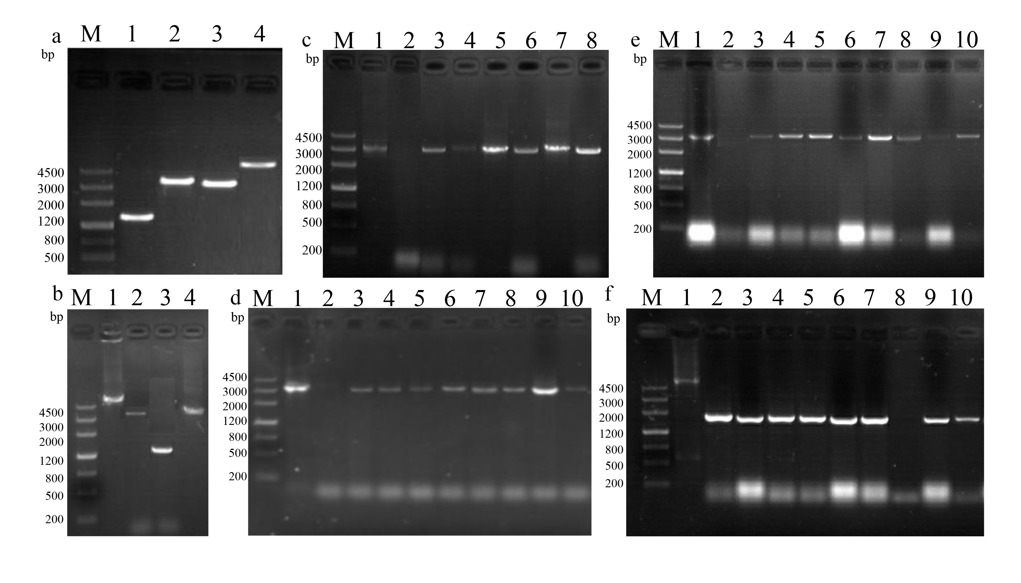
Figure S1. Verification of HGT1 gene overexpression plasmids and strains. (a) Verification of the plasmid p20, M: DNA marker Ⅲ, 1: hyg (1389 bp), 2: PglaA-HGT1 (3312 bp), 3: HGT1-hyg (3217 bp), 4: PglaA–HGT1-hyg (4710 bp); (b) Verification of the plasmid p21, M: DNA marker Ⅲ, 1: Paox1-HGT1-hyg (4612 bp), 2: HGT1-hyg (3217 bp), 3: hyg (1389 bp), 4: Paox1-HGT1 (3223 bp); (c) Verification of A. niger p20 transformants, M: DNA marker Ⅲ, 1: p20 plasmid control, 2: negative control, 3-10: p20 transformants genome verifying of PglaA-HGT1 (3312 bp); (d) Verification of A. niger p21 transformants M: DNA marker Ⅲ, 1: p21 plasmid control, 2: negative control, 3-10: p21 transformants genome verifying of Paox1-HGT1 (3223 bp); (e) HTG1-hyg verifation M: DNA marker Ⅲ 1: plasmid control, 2: negative control, 2-10: PCR product of HTG1-hyg (3217 bp) from transformants genome; (f) Verifying from ku70 upstream sequence to the downstream sequence of the transformants M: DNA marker Ⅲ 1: plasmid control (5710 bp), 2 negative control (1800 bp), 3-10: transformants genome ku70 amplification.

