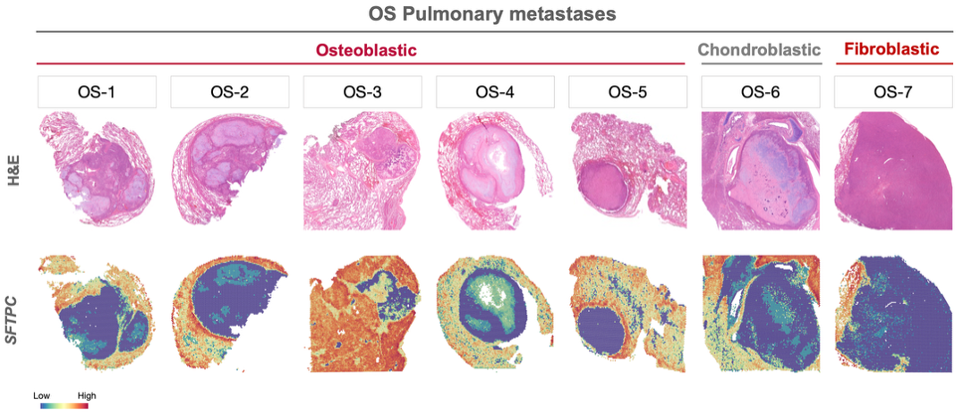
Supplementary Figure 1: Spatial feature plots of SFTPC expression in human osteosarcoma lung metastases samples.

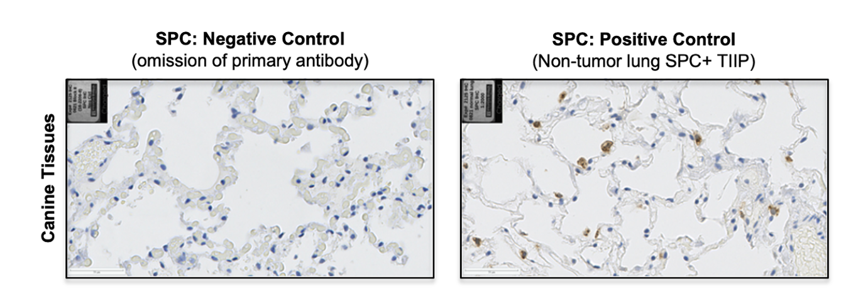
Supplementary Figure 2: Representative images of negative and positive controls for IHC staining of SPC in canine samples.

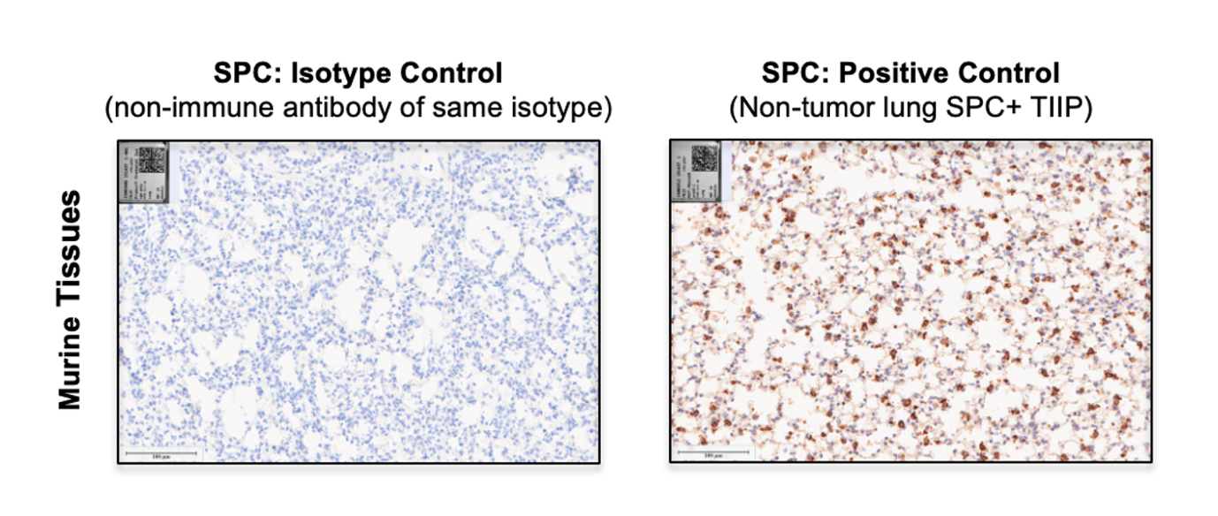
Supplementary Figure 3: Representative images of isotype and positive controls for IHC staining of SPC in murine samples.

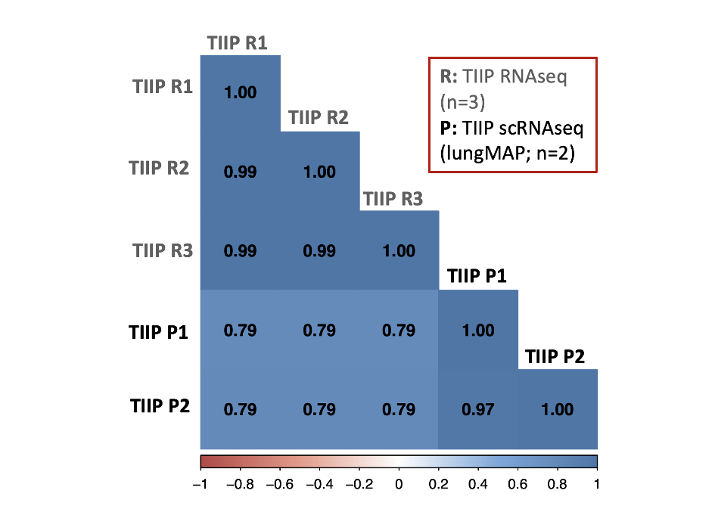
Supplementary Figure 4: Validation of TIIP identity by comparison of our in vitro TIIP RNAseq data (n=3) with publicly available single-cell RNAseq data of TIIPs in culture (n=2), shown as a Pearson correlation heatmap.

Supplementary Table 1: Demographics of human patient samples included in the present study.
Sample ID | Sex | Age (years) | Tissue Acquisition Site
OS-1 | Female | 18 | Right Lung
OS-2 | Female | 18 | Right Lung
OS-3 | Female | 11 | Left Lung
OS-4 | Male | 19 | Right Lung
OS-5 | Male | 8 | Left Lung
OS-6 | Male | 8 | Right Lung
OS-7 | Male | 15 | Left Lung

Supplementary Table 2: Demographics of canine patient samples included in the present study.
Patient ID | COTC Site | Breed | Sex | Age (years) | Primary Tumor Location
COTC022-0227 | CSU | Great Pyrenees | Male | 9.5 | Left distal radius
COTC021-0621 | OSU | Golden Retriever | Male | 5.7 | Left proximal humerus
COTC022-0627 | OSU | Mixed Breed | Male | 8.9 | Left distal tibia
COTC022-0628 | OSU | Rottweiler | Male | 8.5 | Left distal tibia
COTC021-0709 | IL | Golden Retriever | Female | 11 | Left distal ulna
COTC021-0809 | Guelph | Mixed Breed | Male | 8.6 | Left distal radius
COTC022-1006 | UCD | Rottweiler | Male | 8.3 | Right distal femur
COTC021-1015 | UCD | Mixed Breed | Female | 10 | Right distal radius
COTC021-1020 | UCD | Labrador Retriever | Male | 7.2 | Right distal radius
COTC022-1402 | UGA | Mixed Breed | Male | 8 | Right distal tibia
COTC021-1913 | TXAMU | Mixed Breed | Male | 5.3 | Right distal femur
COTC022-2006 | KSU | Old English Bulldog | Female | 9 | Left proximal ulna
COTC022-2202 | VT | Labrador Retriever | Male | 9.3 | Left distal tibia
COTC021-2205 | VT | Greyhound | Male | 9 | Left distal femur

