Longitudinal systemic and medullary immune profiling identifies candidate immune mediator signatures associated with mortality in pediatric B-cell acute lymphoblastic leukemia
Fábio Magalhães-Gama^{1,2,3}; Flavio Souza Silva^{1,4}; Mateus Souza Barros^{1,4}; Izabela Cabral Freitas^{1,5}; Júlia Santos Moraes^{1,4}; Juliana Costa Ferreira Neves^{1,6}; Claudio Lucas Santos Catão^{1,4}; Julia Goes Souza Ghedini¹; Nilberto Dias Araújo¹; Fabíola Silva Alves-Hanna¹; Dayane Andriotti Otta²; Ana Carolina Campi-Azevedo²; Ismael Artur Costa-Rocha²; Gabriel Rocha Fernandes^{,3,7}; Gemilson Soares Pontes^{1,8}; Maria do Perpétuo Socorro Sampaio Carvalho¹; Andréa Monteiro Tarragô^{1,4,5}; Adriana Malheiro^{1,4,5}; Olindo Assis Martins-Filho^{2,3,5}; Allyson Guimarães Costa^{1,4,5‡*} & Andréa Texeira-Carvalho^{2,3,5‡*}
¹Fundação Hospitalar de Hematologia e Hemoterapia do Amazonas (HEMOAM), Diretoria de Ensino e Pesquisa, Manaus, Brazil;
²Instituto René Rachou - Fundação Oswaldo Cruz (FIOCRUZ-Minas), Grupo Integrado de Pesquisas em Biomarcadores, Belo Horizonte, Brazil;
³Instituto René Rachou - Fundação Oswaldo Cruz (FIOCRUZ-Minas), Programa de Pós-graduação em Ciências da Saúde, Belo Horizonte, Brazil;
⁴Universidade Federal do Amazonas (UFAM), Programa de Pós-graduação em Imunologia Básica e Aplicada, Manaus, Brazil;
⁵Universidade do Estado do Amazonas, Programa de Pós-graduação em Ciências Aplicadas à Hematologia, (UEA), Manaus, Brazil;
⁶Universidade do Estado do Amazonas (UEA), Programa de Pós-graduação em Medicina Tropical, Manaus, Brazil;
⁷Instituto René Rachou - Fundação Oswaldo Cruz (FIOCRUZ-Minas), Grupo de Diagnóstico e Terapia de Doenças Infecciosas e Câncer, Belo Horizonte, Brazil;
⁸Instituto Nacional de Pesquisas da Amazônia (INPA), Laboratório de Virologia e Imunologia, Manaus, Brazil.
‡These authors share senior authorship
Corresponding Author:
Allyson Guimarães da Costa - allyson.gui.costa@gmail.com, UFAM, Av. Rodrigo Otávio Jordão Ramos, 1200, Coroado, Manaus, AM, CEP 69067-005, Brazil;
Andréa Texeira-Carvalho - atcteixeira@gmail.com, Instituto René Rachou – FIOCRUZ-Minas, Av. Augusto de Lima, 1715, sala 115, Belo Horizonte, MG, CEP: 30.190-009, Brazil
Supplementary table 1. Hematological parameters at diagnosis in pediatric B-ALL patients and controls.
Variables |  | CG (n = 25) |  | B-ALL  (n = 36) |  | Outcome during treatment |  |  |  | Reference Value
 |  |  |  |  |  | B-ALL RG (n = 25) |  | B-ALL DG (n = 11) |  | Reference Value
Leukocytes (×10⁹/L) |  | 7.2 (5.5 - 8.4) |  | 7.3 (2.7 - 26.8) |  | 5.8 (2.5 - 31.4) |  | 10.2 (5.1 - 26.8) |  | 5 - 13
Absolute lymphoblast count (×10⁹/L) |  | - |  | 1.0 (0 - 13.7) |  | 0.6 (0 - 15.2) |  | 3.8 (0 - 26.1) |  | 0
Relative lymphoblast count (%) |  | - |  | 29 (0 - 57) |  | 23 (0 - 59) |  | 41 (0 - 62) |  | 0
Lymphocytes (×10⁹/L) |  | 2.8 (2.3 - 3.5) |  | 6.3 (2.2 - 22.1)* |  | 5.4 (2.0 - 23.4) |  | 8.2 (2.6 - 22.2)* |  | 1 - 5
Neutrophils (×10⁹/L) |  | 3.0 (2.6 - 4.0) |  | 0.4 (0.1 - 1.3)* |  | 0.4 (0.1 - 1.2)* |  | 0.5 (0.2 - 1.3)* |  | 1.5 - 8
Monocytes (×10⁹/L) |  | 0.4 (0.3 - 0.5) |  | 0.05 (0.02 - 0.2)* |  | 0.06 (0.02 - 0.2)* |  | 0.04 (0.02 - 0.2)* |  | 0.2 - 1
Eosinophils (×10⁹/L) |  | 0.2 (0.09 - 0.5) |  | 0.02 (0.01 - 0.08)* |  | 0.02 (0.05 - 0.05)* |  | 0.05 (0.01 - 0.1)* |  | 0.1 - 1
Basophils (×10⁹/L) |  | 0.03 (0.01 - 0.05) |  | 0.09 (0.02 - 0.7)* |  | 0.05 (0.01 - 0.6) |  | 0.1 (0.06 - 0.8)* |  | 0.02 - 0.1
Erythrocytes (×10¹²/L) |  | 4.6 (4.3 - 4.9) |  | 3.0 (2.7 - 3.3)* |  | 3.0 (2.7 - 3.3)* |  | 3.0 (2.5 - 3.4)* |  | 4.5 - 5.9
Hemoglobin (g/dL) |  | 12.8 (12.3 - 13.8) |  | 8.3 (7.6 - 9.2)* |  | 8.7 (7.5 - 9.3)* |  | 7.8 (7.6 - 9.1)* |  | 12.5 - 18
Platelets (×10⁹/L) |  | 325 (259 - 357) |  | 34 (21 - 88)* |  | 35 (21 - 88)* |  | 27 (14 - 34)* |  | 200 - 400

Abbreviations: B-ALL, B-cell acute lymphoblastic leukemia; RG, remission group (patients who completed remission chemotherapy); DG, deceased group (patients who died during induction therapy); CG, control group.
Data presentation: Data are presented as median (interquartile range, IQR). All measurements correspond to values obtained at diagnosis (D0).
Statistical analysis: *p < 0.05 compared with the control group. Comparisons between RG and DG were performed and were not statistically significant.
Units: Leukocytes, lymphocytes, neutrophils, monocytes, eosinophils, basophils, and platelets are expressed as ×10⁹/L; erythrocytes as ×10¹²/L; hemoglobin as g/dL.
Reference ranges: Obtained from Fundação HEMOAM Hematology Laboratory, based on the ADVIA 2120 Hematology Analyzer (Siemens), and expressed in international (SI) units.

Supplementary table 2. Soluble immune mediators included in the multiplex panel and their classification.

Class |  | Soluble immune mediators
Chemokines |  | CCL2 (MCP-1)
Chemokines |  | CCL3 (MIP-1α)
Chemokines |  | CCL4 (MIP-1β)
Chemokines |  | CCL5 (RANTES)
Chemokines |  | CCL7 (MCP-3)
Chemokines |  | CCL11(Eotaxin)
Chemokines |  | CCL27 (CTACK)
Chemokines |  | CXCL1 (GRO-α)
Chemokines |  | CXCL8 (IL-8)
Chemokines |  | CXCL9 (MIG)
Chemokines |  | CXCL10 (IP-10)
Chemokines |  | CXCL12 (SDF-1α)
Pro-inflammatory cytokines |  | IFN-α2
Pro-inflammatory cytokines |  | IL-1α
Pro-inflammatory cytokines |  | IL-1β
Pro-inflammatory cytokines |  | IL-6
Pro-inflammatory cytokines |  | TNF-α
Pro-inflammatory cytokines |  | TNF-β
Pro-inflammatory cytokines |  | IL-12p40
Pro-inflammatory cytokines |  | IL-12p70
Pro-inflammatory cytokines |  | IFN-γ
Pro-inflammatory cytokines |  | IL-15
Pro-inflammatory cytokines |  | IL-17
Pro-inflammatory cytokines |  | IL-18
Regulatory cytokines |  | IL-1Ra
Regulatory cytokines |  | IL-4
Regulatory cytokines |  | IL-5
Regulatory cytokines |  | IL-9
Regulatory cytokines |  | IL-10
Regulatory cytokines |  | IL-13
Growth factors |  | bFGF
Growth factors |  | HGF
Growth factors |  | PDGF
Growth factors |  | VEGF
Growth factors |  | NGF-β
Growth factors |  | TRAIL
Growth factors |  | IL-3
Growth factors |  | SCF
Growth factors |  | SCGF-β/Clec11a
Growth factors |  | G-CSF
Growth factors |  | M-CSF
Growth factors |  | GM-CSF
Growth factors |  | IL-2Rα
Growth factors |  | IL-2
Growth factors |  | IL-7
Growth factors |  | IL-16
Growth factors |  | MIF
Growth factors |  | LIF

Supplementary table 3. Global baseline median cutoff values for soluble immune mediators (pg/mL).
Soluble immune mediators |  | Global medians expressed in pg/mL
Soluble immune mediators |  | B-ALL & CG |  | B-ALL RG & B-ALL DG
 |  |  |  | //
CCL2 (MCP-1) |  | 6,01 |  | 17,42
CCL3 (MIP-1α) |  | 1,81 |  | 3,84
CCL4 (MIP-1β) |  | 10,40 |  | 15,83
CCL5 (RANTES) |  | 112,17 |  | 319,24
CCL7 (MCP-3) |  | 0,48 |  | 0,51
CCL11(Eotaxin) |  | 14,51 |  | 24,18
CCL27 (CTACK) |  | 23,58 |  | 69,99
CXCL1 (GRO-α) |  | 137,36 |  | 178,68
CXCL8 (IL-8) |  | 2,98 |  | 8,46
CXCL9 (MIG) |  | 97,09 |  | 357,52
CXCL10 (IP-10) |  | 32,31 |  | 160,10
CXCL12 (SDF-1α) |  | 31,12 |  | 83,86
IFN-α2 |  | 5,31 |  | 5,71
IL-1α |  | 10,28 |  | 14,35
IL-1β |  | 0,72 |  | 1,06
IL-6 |  | 0,93 |  | 3,91
TNF-α |  | 9,35 |  | 15,41
TNF-β |  | 26,03 |  | 32,71
IL-12p40 |  | 41,53 |  | 48,07
IL-12p70 |  | 1,14 |  | 1,05
IFN-γ |  | 5,86 |  | 10,95
IL-15 |  | 100,20 |  | 115,86
IL-17 |  | 2,49 |  | 3,14
IL-18 |  | 17,82 |  | 86,69
IL-1Ra |  | 47,33 |  | 47,84
IL-4 |  | 0,67 |  | 0,86
IL-5 |  | 32,43 |  | 50,95
IL-9 |  | 18,49 |  | 21,25
IL-10 |  | 3,26 |  | 6,18
IL-13 |  | 1,44 |  | 1,20
bFGF |  | 4,12 |  | 5,03
HGF |  | 53,83 |  | 96,49
PDGF |  | 32,01 |  | 29,55
VEGF |  | 40,56 |  | 37,70
NGF-β |  | 0,29 |  | 0,46
TRAIL |  | 14,19 |  | 17,45
IL-3 |  | 0,19 |  | 0,22
SCF |  | 11,78 |  | 18,18
SCGF-β/Clec11a |  | 2789,14 |  | 6317,90
G-CSF |  | 71,48 |  | 155,20
M-CSF |  | 9,58 |  | 20,96
GM-CSF |  | 1,37 |  | 1,48
IL-2Rα |  | 54,73 |  | 165,33
IL-2 |  | 1,55 |  | 2,17
IL-7 |  | 2,08 |  | 2,08
IL-16 |  | 7,30 |  | 38,91
MIF |  | 8,38 |  | 37,10
LIF |  | 21,63 |  | 31,38

B-ALL, B-cell Acute Lymphoblastic Leukemia; B-ALL RG, patients who completed remission chemotherapy; B-ALL DG, patients who died during induction therapy; CG, control group.

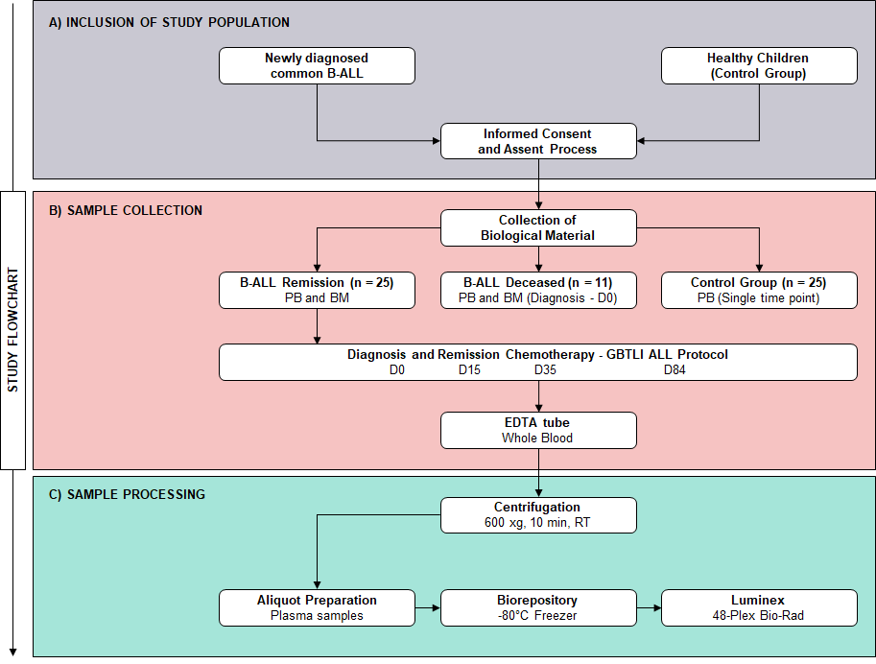
Supplementary Figure 1. Study Flowchart detailing Population inclusion, Sample collection, and processing from pediatric patients with B-cell acute lymphoblastic leukemia and healthy controls. B-ALL, B-cell Acute Lymphoblastic Leukemia; D0, diagnosis baseline; D15, day 15 of induction therapy; D35, end of the induction therapy; D84, day 84 of consolidation therapy; RT, room temperature.
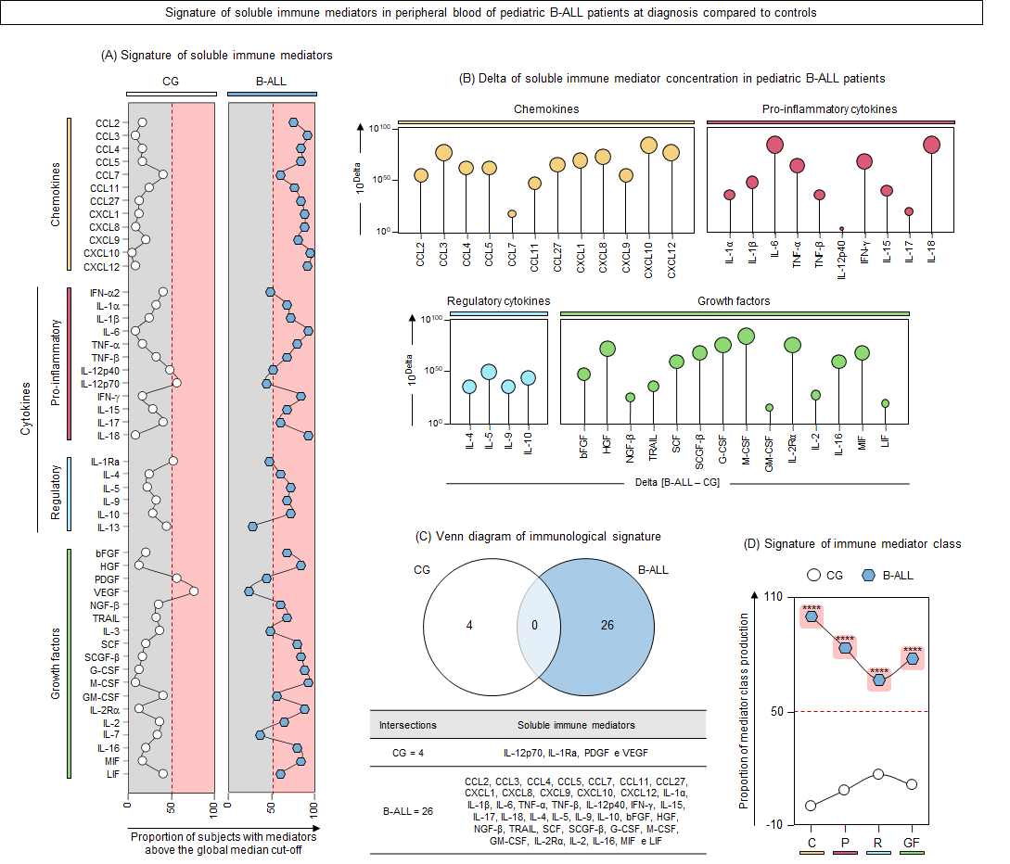
Supplementary Figure 2. Signature of soluble immune mediators in the peripheral blood of pediatric B-ALL patients at diagnosis compared to controls. (A) The signature of soluble immune mediators, including chemokines, pro-inflammatory cytokines, regulatory cytokines, and growth factors, was constructed from the peripheral blood of B-ALL patients () and the control group (CG: ). Soluble immune mediators were quantified using a multiplex assay, as detailed in the Methods section. Data expressed in picograms per milliliter (pg/mL) were converted into categorical data using the global median as a cut-off point. Signatures are presented as line graphs, with the 50th percentile (red central line: ---) used as a threshold to highlight mediators with increased levels (pink background: ). (B) Delta analysis shows the difference in the signature of soluble immune mediators between B-ALL patients and the CG. Delta values for mediators with a significant difference (Fisher's exact test, p < 0.05) are displayed on lollipop charts, with the length of the lollipops representing the magnitude of the difference. (C) A Venn diagram highlights the selective and common immune mediators identified in B-ALL patients and the CG. (D) A signature based on mediator classes provides a panoramic view of the profile of chemokines, pro-inflammatory cytokines, regulatory cytokines, and growth factors in B-ALL patients and controls. Statistical significance of the proportion of mediator classes was determined using Fisher's exact test, with significant differences denoted by asterisks: ****p < 0.0001.
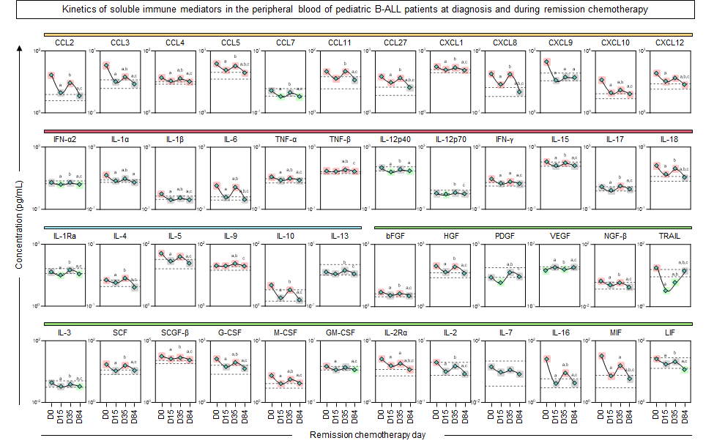
Supplementary Figure 3. Kinetics of soluble immune mediators in the peripheral blood of pediatric B-ALL patients at diagnosis and during remission chemotherapy. The kinetics of soluble immune mediators, including chemokines, pro-inflammatory cytokines, regulatory cytokines, and growth factors, were analyzed in the peripheral blood of B-ALL patients (). The treatment kinetics include four consecutive time points: diagnosis baseline (D0), day 15 of induction therapy (D15), end of induction therapy (D35), and day 84 of consolidation therapy (D84). The interquartile range (IQR) of immune mediator concentrations in the control group (CG) is represented by the shaded background area (bordered by dashed lines) as a reference range. The B-ALL immune mediator patterns in relation to the CG's IQR is indicated by the background squares: decreased levels (), unaltered levels (), and increased levels (). Soluble immune mediators were quantified using a multiplex assay, as detailed in the Methods section. Data are presented in line graphs, with the median value, and expressed in picograms per milliliter (pg/mL). Statistical significance was determined using the Friedman test for longitudinal comparisons among D0, D15, D35, and D84, followed by Dunn's multiple comparisons test and the Wilcoxon test. Statistically significant differences (p < 0.05) between days of induction therapy are represented by the letters "a, b, c," which correspond to comparisons with D0, D15, and D35, respectively. For comparisons with the CG, the Mann-Whitney U test was used, with statistically significant differences (p < 0.05) highlighted by the background squares.

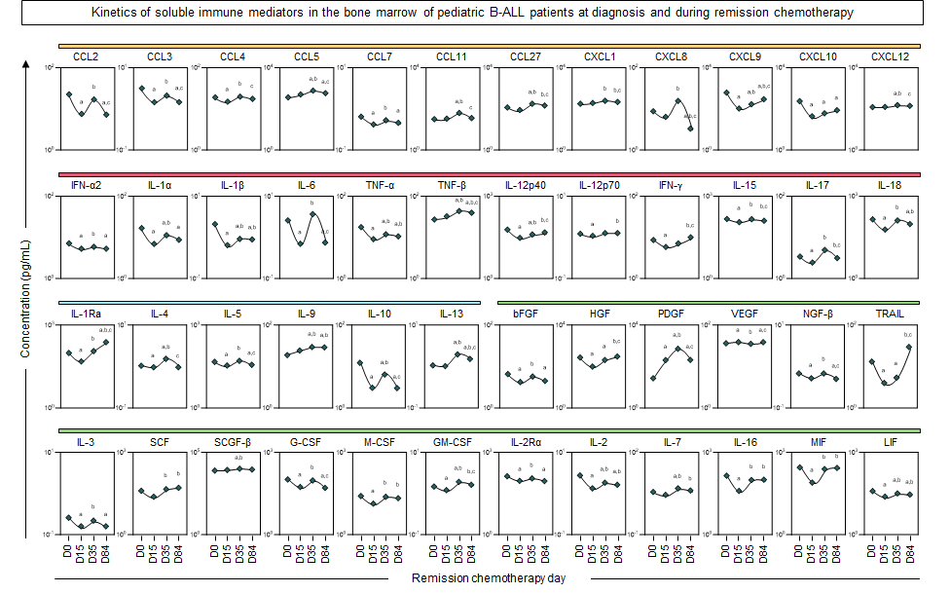
Supplementary Figure 4. Kinetics of soluble immune mediators in the bone marrow of pediatric B-ALL patients at diagnosis and during remission chemotherapy. The kinetics of soluble immune mediators, including chemokines, pro-inflammatory cytokines, regulatory cytokines, and growth factors, were analyzed in the bone marrow of B-ALL patients (). The kinetics of treatment include four consecutive time points: diagnosis baseline (D0), day 15 of induction therapy (D15), end of induction therapy (D35), and day 84 of consolidation therapy (D84). Soluble immune mediators were quantified using a multiplex assay, as detailed in the Methods section. Data are presented in line graphs, with the median value, and expressed in picograms per milliliter (pg/mL). For statistical significance, the Friedman test was used for longitudinal comparisons among D0, D15, D35, and D84, followed by Dunn's multiple comparisons test and the Wilcoxon test. Statistically significant differences (p < 0.05) between days of induction therapy are represented by the letters "a, b, c," which correspond to comparisons with D0, D15, and D35, respectively.

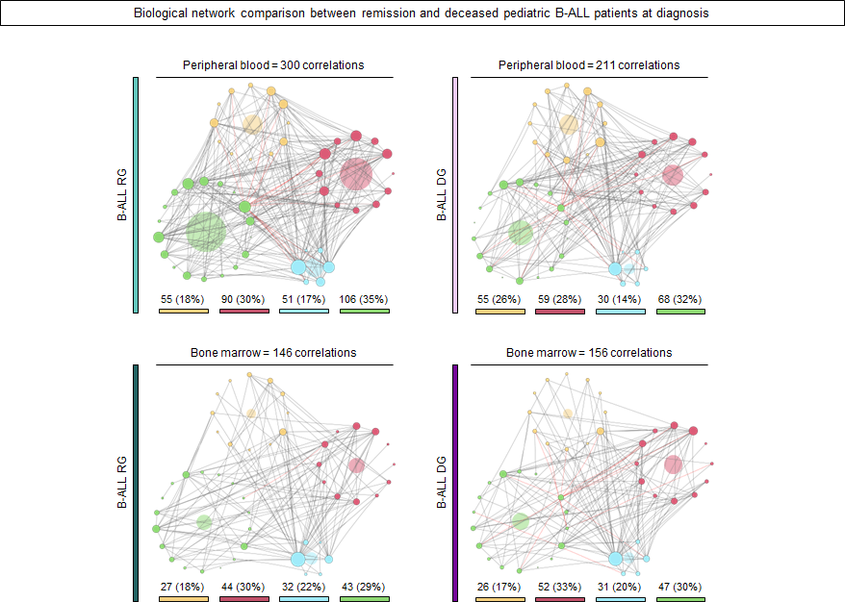
Supplementary Figure 5. Baseline biological network differences between B-cell acute lymphoblastic leukemia remission and the deceased. Biological networks were assembled to identify the complex interactions among soluble immune mediators in the peripheral blood and bone marrow of B-ALL patients who completed remission chemotherapy (Remission Group - RG), and in the B-ALL patients who died during induction therapy (Deceased Group - DG). The analysis was conducted at diagnosis baseline (D0). Correlation analysis was employed to construct biological networks based on significant “r” scores (p < 0.05) using Spearman correlation tests. Significant and strong correlations (r > 0.68) were used to construct the networks. A node color key was applied to identify the different classes of mediators: chemokines (), pro-inflammatory cytokines (), regulatory cytokines (), and growth factors () in B-ALL RG and B-ALL DG. Node size is proportional to the number of correlations. Connecting edges illustrate positive (gray continuous lines) and negative (red dashed lines) correlations between pairs of attributes. The circular background area is proportional to the number of correlations of each cluster within the respective network. The number of correlations observed for each network is provided in the figure and used for comparison between the time points of remission chemotherapy and the evaluated compartments.
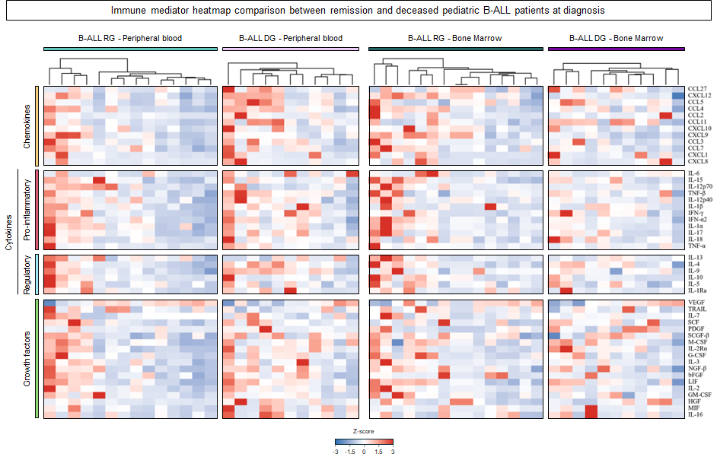
Supplementary Figure 6. Immune mediator heatmap comparison between remission and deceased pediatric B-ALL patients at diagnosis. The relative abundance of 48 soluble immune mediators was assessed in patients who achieved remission (RG) and those who died during induction therapy (DG) at diagnosis (D0). Each column represents an individual sample and each row a mediator, grouped according to functional classes (chemokines, pro-inflammatory cytokines, regulatory cytokines, and growth factors; left annotation bar). Samples were organized using unsupervised hierarchical clustering (top dendrogram), highlighting patterns between outcome groups. Data are presented as Z-scores calculated per mediator, where red indicates higher and blue lower concentrations relative to the overall distribution (scale −3 to +3). Heatmaps were generated using the “ComplexHeatmap” package, with color scaling implemented using the “circlize” package in R. Soluble immune mediators were quantified using a multiplex assay, as described in the Methods section.

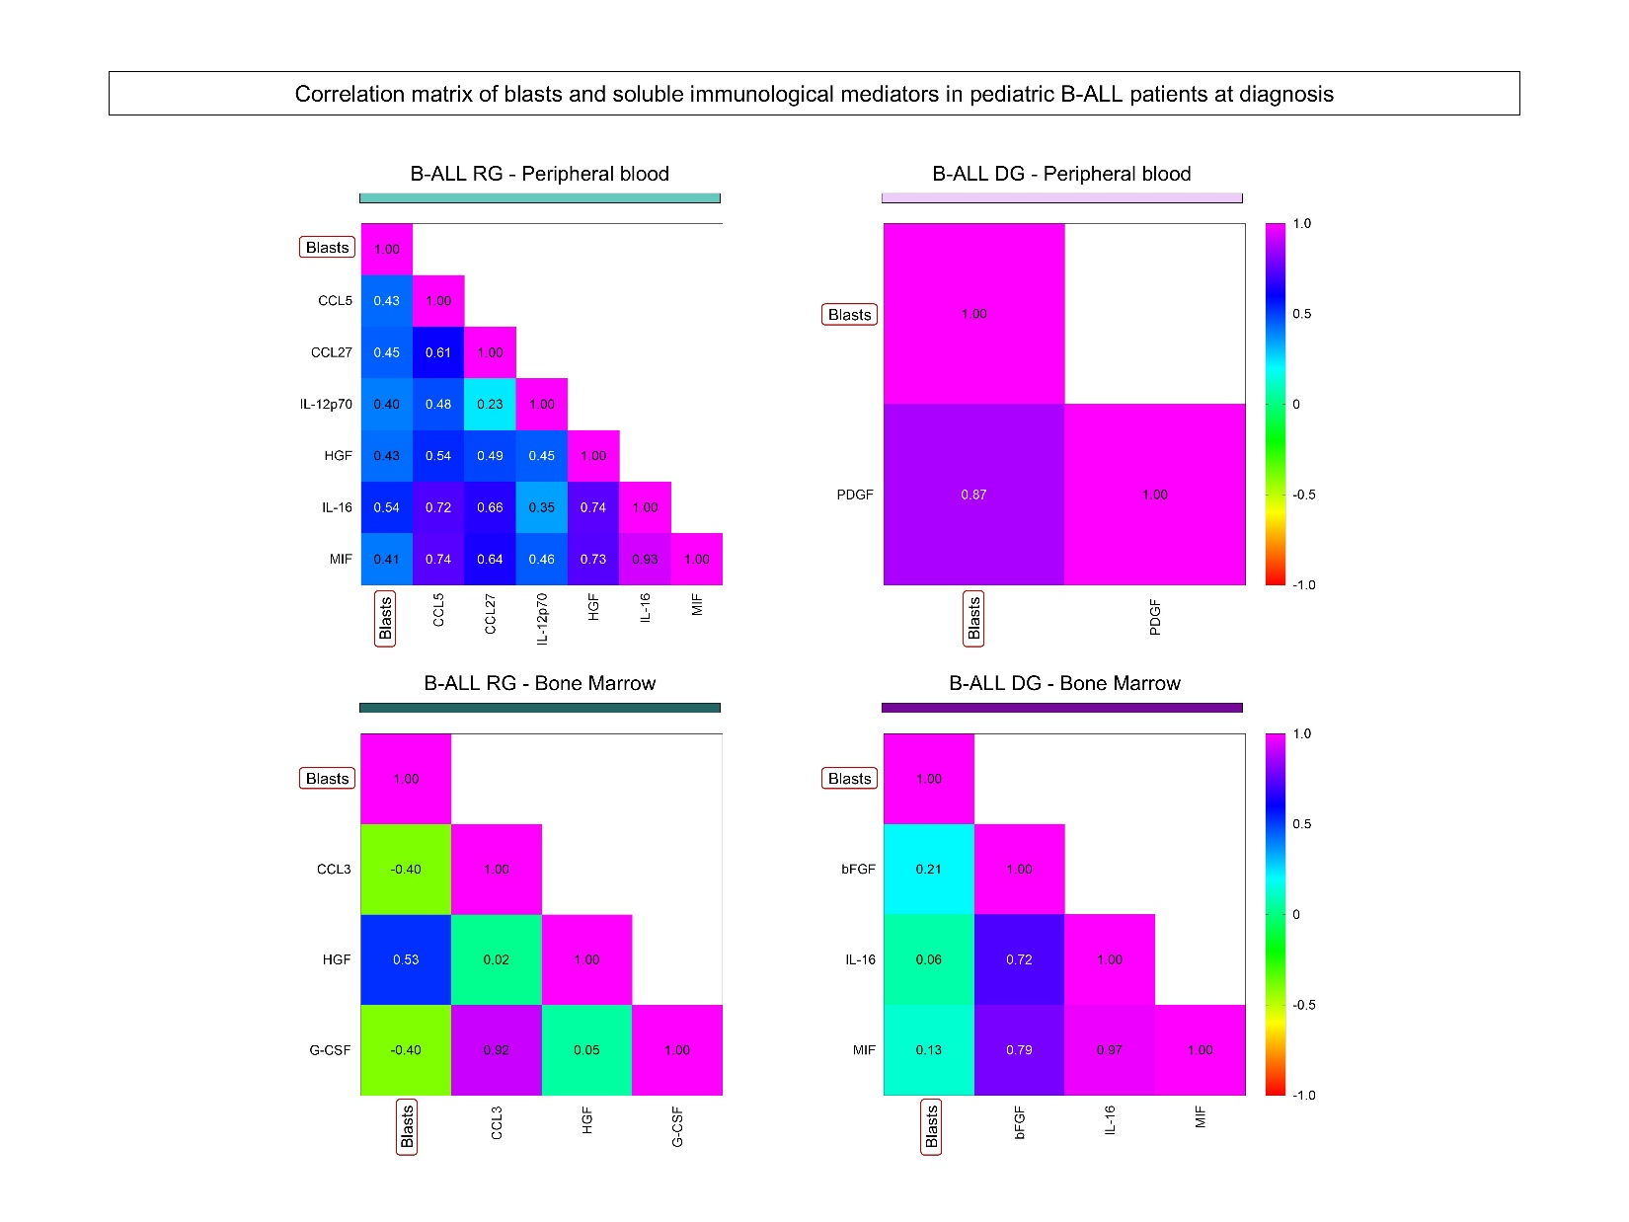Supplementary Figure 7. Baseline correlation matrix of Blasts and soluble immune mediators in pediatric patients with B-cell acute lymphoblastic leukemia. Correlation matrices were assembled to investigate the association between soluble immune mediators and blast counts in the peripheral blood and bone marrow of B-ALL patients who completed remission chemotherapy (Remission Group - RG) and those who died during induction therapy (Deceased Group - DG). The analysis was conducted at diagnosis baseline (D0). Matrices were constructed using Spearman correlation tests to identify significant "r" scores (p < 0.05). Significant correlations are displayed in the matrices, where the color key represents the correlation strength, which is classified as positive strong (r ≥ 0.68), moderate (0.36 ≤ r < 0.68), or weak (r < 0.36), and negative strong (r ≤ -0.68), moderate (-0.68 < r ≤ -0.36), or weak (r > -0.36).
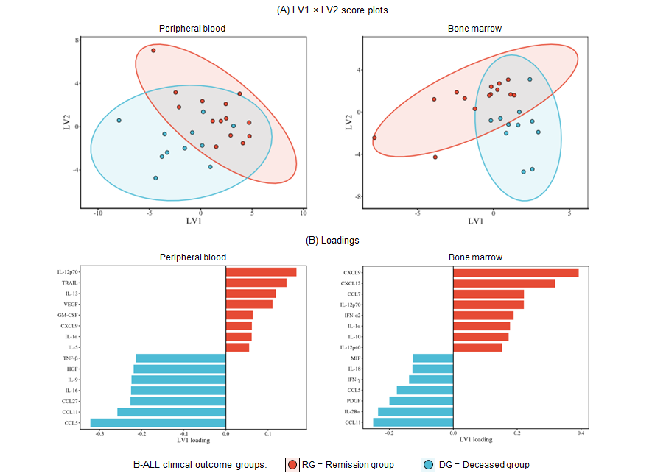
Supplementary Figure 8. Baseline latent-variable modeling distinguishes clinical outcome groups in peripheral blood and bone marrow. The distribution of pediatric B-ALL patients at diagnosis (D0) was evaluated in peripheral blood (PB) and bone marrow (BM) using latent variable modeling. (A) LV1 × LV2 score plots display individual samples stratified by clinical outcome, including remission group (RG) and deceased group (DG), with shaded ellipses representing the 95% confidence region for each group. (B) Loadings show the top LV1 variables contributing to group separation in PB and BM, where positive and negative loadings indicate mediators preferentially associated with RG or DG, respectively. Latent variable modeling was performed using partial least squares–discriminant analysis (PLS-DA) within the mixOmics framework. Data were centered and scaled prior to analysis, as described in the Methods section.

