Supporting information
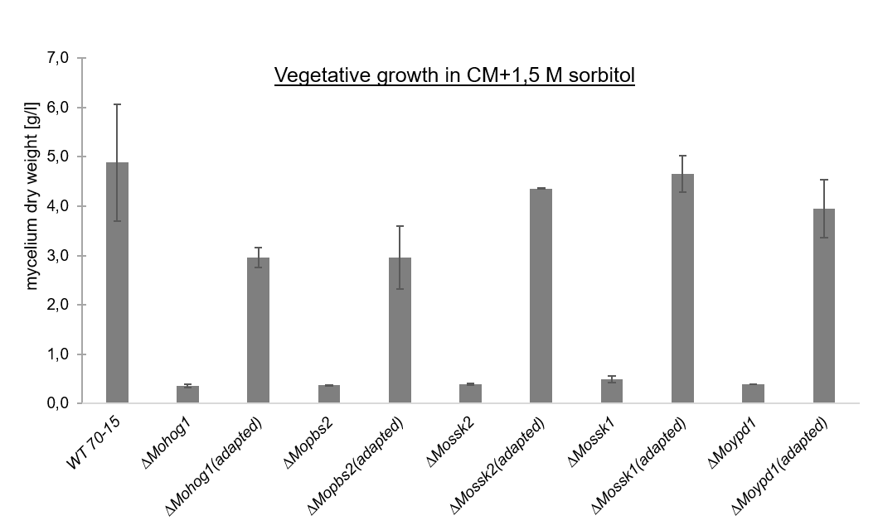
Figure S1: Mycelium dry weight of the Magnaporthe oryzae wildtype strain, mutants with inactivated components of the HOG signaling cascade and the “adapted” strains after growth in liquid culture upon sorbitol-stress. The fungal colonies were grown in 250 ml complete medium inclusive 1,5 M sorbitol for 6 d at 26 °C and 120 rpm. Error bars represent the standard deviation of three biological replicates of each strain.

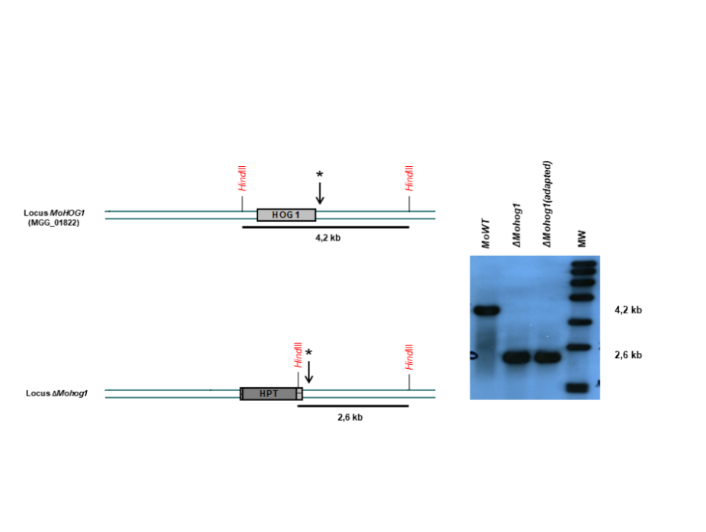
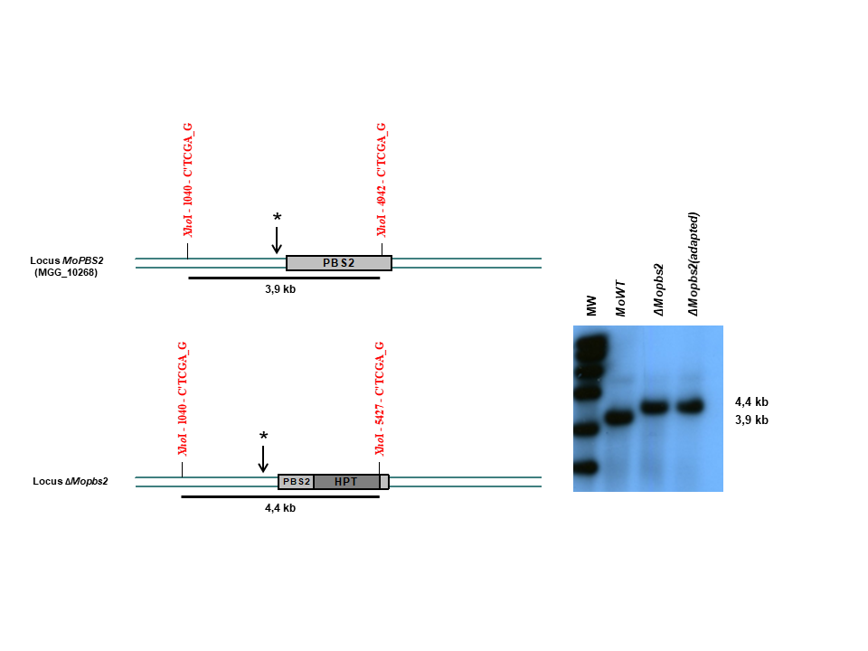
Figure S2: Schematic presentation and verification of the MoWT, the lof-mutants and the adapted strains by southern hybridization within the Magnaporthe oryzae genome. Southern blot analysis of gene deletion/disruption mutants in M. oryzae with gene specific probes. Genomic DNA of M. oryzae strain 70-15 and the mutants was isolated and restricted with restriction enzymes. The probes which we used for hybridization with the genomic DNA of the wildtype strain and the corresponding mutant strains were always identical.

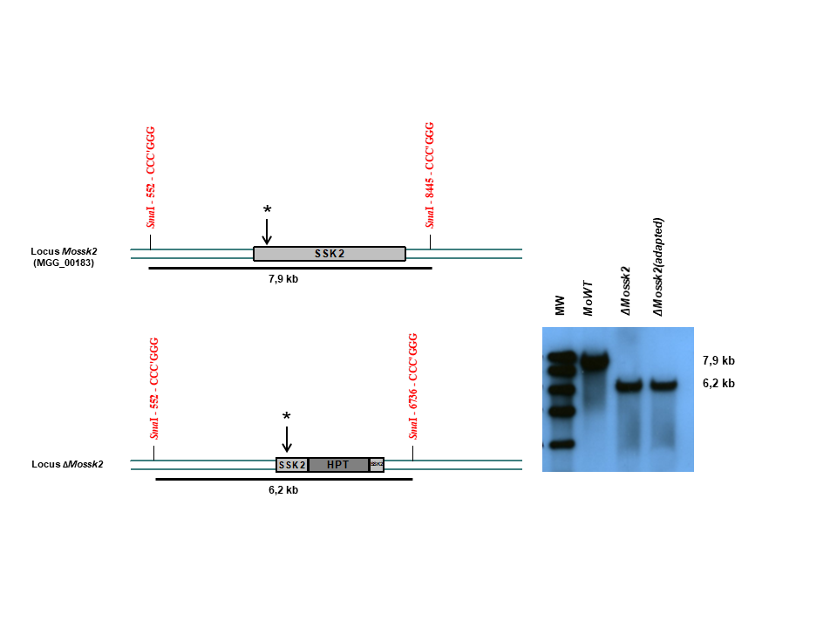
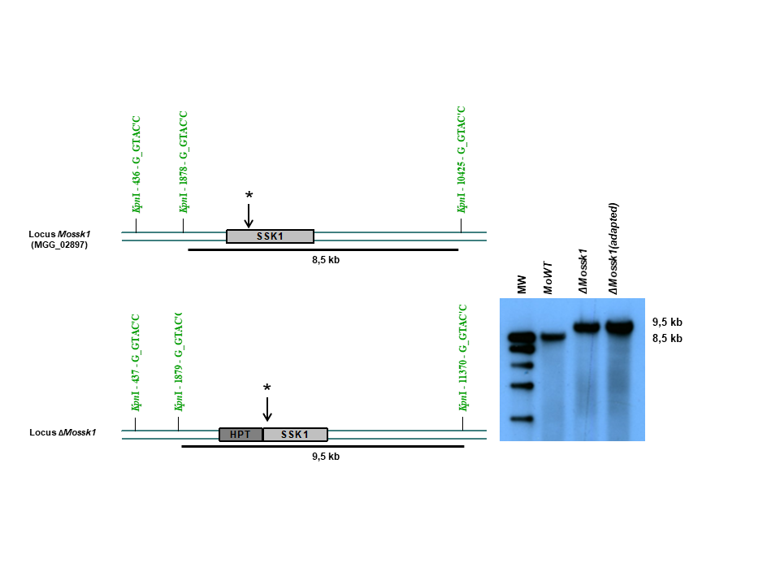
Figure S2 (continued): Schematic presentation and verification of the MoWT, the lof-mutants and the adapted strains by southern hybridization within the Magnaporthe oryzae genome.
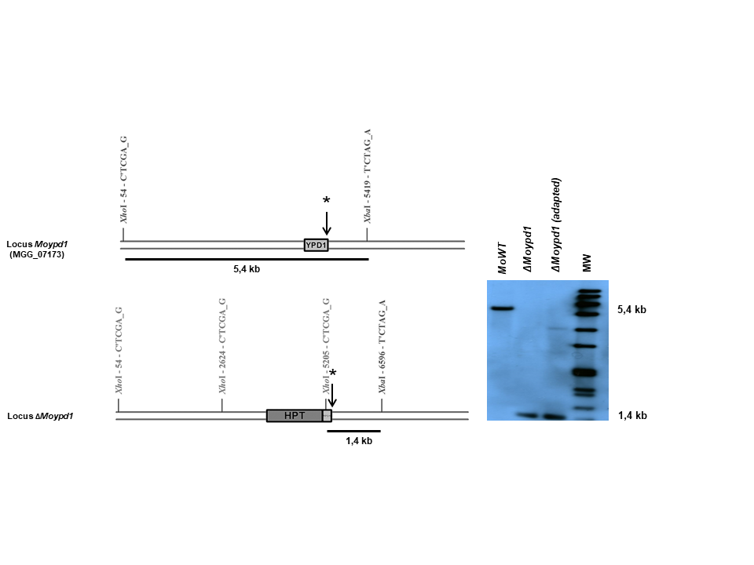
Figure S2 (continued): Schematic presentation and verification of the MoWT, the lof-mutants and the adapted strains by southern hybridization within the Magnaporthe oryzae genome.

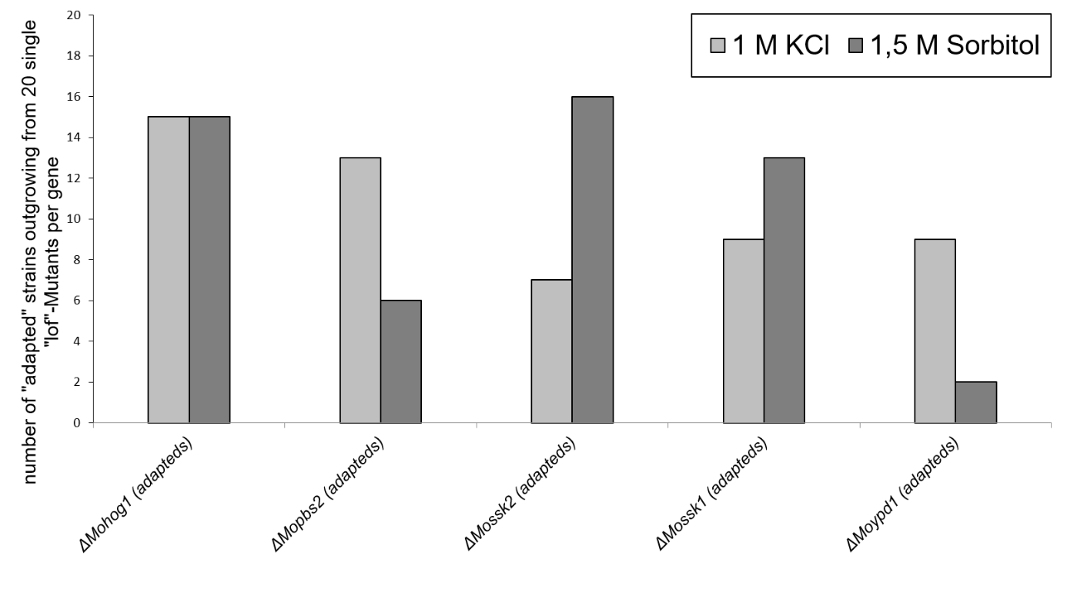
Figure S3: Investigation of the “adaptation-frequency” in Magnaporthe oryzae mutants with inactivated components of the HOG signaling cascade.

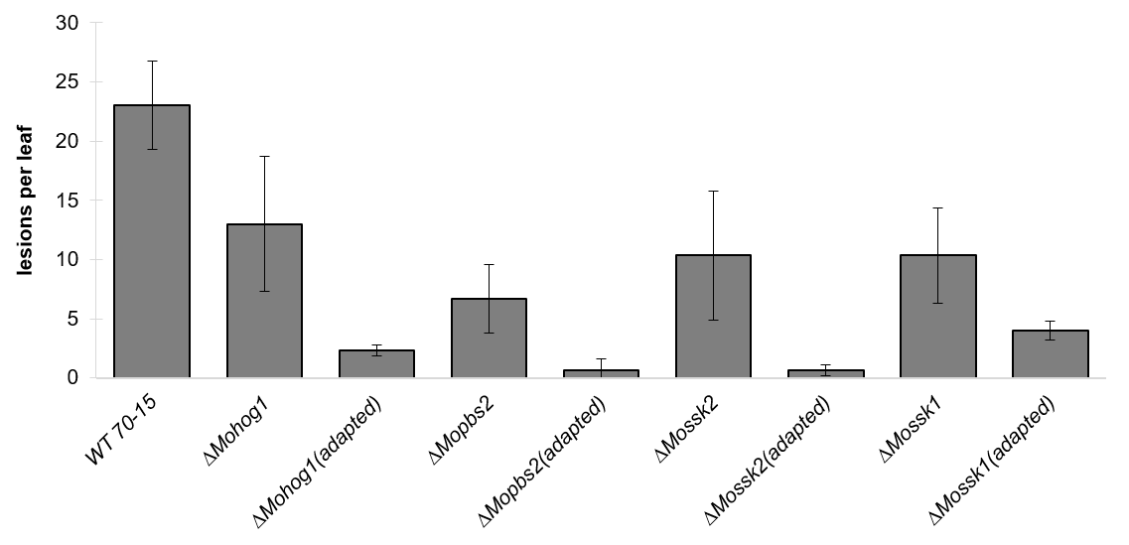
Fig.S4: Pathogenicity assay of the MoWT, the lof mutants and the “adapted” strains. The plant infection assays were carried out as described in experimental procedures. The error bars represent the standard deviation of three experiments with three replicates each.

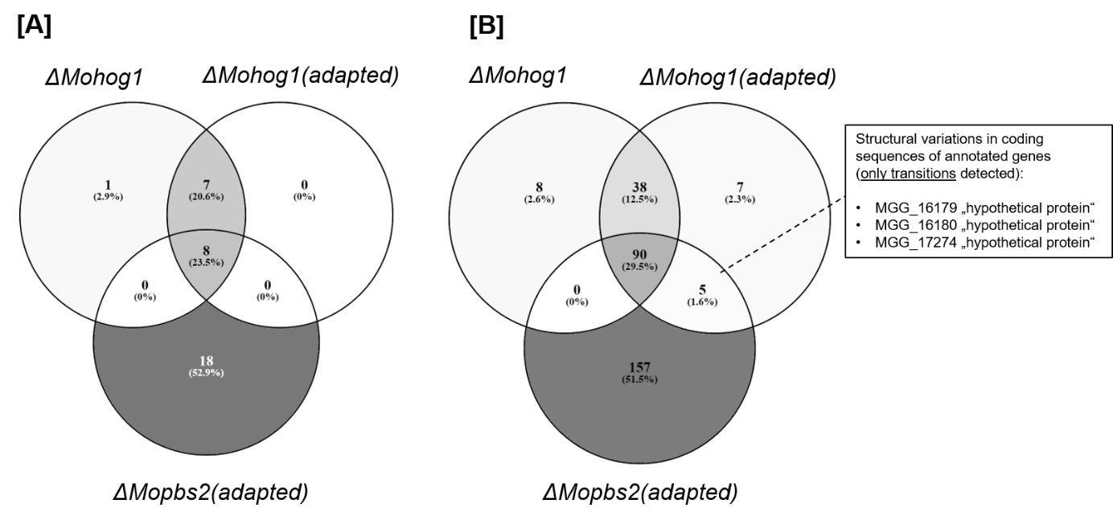
Fig.S5: VENN diagram of putative structural variations in promotor [A] and in coding sequences (CDS) [B] within the genome of ΔMohog1, ΔMohog1(adapted) and ΔMopbs2(adapted). Numbers in the intersection regions represent overlapping SNPs among the strains. Numbers in parentheses show the corresponding relative percentage of genes harbouring the SNPs.

