SUPPLEMENTARY INFORMATIONS

Supplementary methods

Supplementary Table 1. List of primers for quantitative PCR. The table shows information on target gene and 5’3’ sequences of forward and reverse primers.
Gene | 5’ 3’ sequence
 | Forward primer | Reverse primer
GAPDH | TTGAGGTCAATGAAGGGGTC | GAAGGTGAAGGTCGGAGTCA
NDUFS1 | CCCTAACCTCTAAGCCCTATG | ACTTCCAACCGCATCCATTACAT
NLGN1 | GTTAAAACTGGTGACCCAAATCAA | CTGGGAATATCTGGTCCATGC
NLGN2 | GTTTTCTCAGCACCGGGGA | CACTGAGCCAGCGCAGG
NLGN3 | GTGCCGACGGAGGATGTAAA | GCTAAGTCCTCGCCCTGTTT
NLGN4 | CATCGGGCTGCCTTGGAG | TTGGCAGCCCATTGCAAGG
NRX1 | ATTGACCCCTGTGAGCCGA | CCCGTGGTGCTGCTGG
GCH1 | GCTGTAGCAATCACGGAAGC | CACCTCGCATTACCATACACA
GPX4 | GCAACCAGTTTGGGAGGCAGGAG | CCTCCATGGGACCATAGCGCTTC
SCD1 | TCTAGCTCCTACCACCACCA | TCGTCTCCAACTTATCTCCTCC
ACSL3 | CGAAGCTGCTATTTCAGCAAG | CTGTCACCAGACCAGTTTCA
PPAR alpha | CTATCATTTGCTGTGGAGATCG | AAGATATCGTCCGGGTGGTT

Supplementary Table 2. List of antibodies and staining for immunocytochemistry. The table shows information on primary and secondary antibodies’ target, catalog number, manufacturer, host species and dilution used.
Antibody | Cat.-No. | Manufacturer | Host Species | Dilution
PAX6 | 901301 | BioLegend | Rabbit | 1:200
Nestin | MAB5326 | Millipore | Mouse | 1:200
SOX2 | AF2018 | R&D Systems | Goat | 1:200
pVimentin | D076-3 | MBL | Mouse | 1:2000
MAP2 | 188 004 | Synaptic Systems | Guinea Pig | 1:1000
SMI312 | 837904 | BioLegend | Rabbit | 1:500
S100β | Ab52642 | Abcam | Rabbit | 1:500
GFAP | 173 004 | Synaptic Systems | Guinea pig | 1:500
TH | AB152 | Millipore | Rabbit | 1:500
Vimentin | Ab6978 | Abcam | Mouse | 1:50
Alexa FluorTM 488 anti-Goat | A-11055 | Invitrogen | Donkey | 1:1000
Alexa FluorTM 488 anti- Guinea pig | SAB4600033-250UL | Sigma Aldrich | Donkey | 1:1000
Alexa FluorTM 488 anti- Rabbit | R37118 | Invitrogen | Donkey | 1:1000
Alexa FluorTM 488 anti-Mouse | A11029 | Invitrogen | Goat | 1:2000
Alexa FluorTM 568 Donkey anti-Guinea pig | SAB4600470-50UL | Sigma Aldrich | Donkey | 1:1000
Alexa FluorTM 568 anti-Mouse | A10037 | Invitrogen | Donkey | 1:1000
Alexa FluorTM 647 anti-Rabbit | JIM-706-605-148 | Jackson Immuno Research | Donkey | 1:1000
Hoechst 33342 | H3570 | Life Technologies | NA | 1:2500
Supplementary Table 3. List of antibodies used for immunoblotting. The table shows information on primary and secondary antibodies’ target, catalog number, manufacturer, host species and dilution used.
Antibody | Cat.-No. | Manufacturer | Host Species | Dilution
NDUFS1 | 12444-1-AP | Proteintech | Rabbit | 1:1000
NDUFS2 | ab110249 | Abcam | Mouse | 1:1000
NDUFS4 | PA598004 | Invitrogen | Rabbit | 1:1000
NDUFB6 | ab110244 | Abcam | Mouse | 1:1000
SDHA | ab14715 | Abcam | Mouse | 1:1000
UQCRC2 | ab14745 | Abcam | Mouse | 1:1000
NSE | MAB324 | Sigma Aldrich | Mouse | 1:1000
NLGN3 | PA578508 | Invitrogen | Rabbit | 1:1000
ßIII Tubulin | T8578 | Sigma Aldrich | Mouse | 1:1000
GAPDH | ab8245 | Abcam | Mouse | 1:1000
HRP-linked Anti-Mouse IgG | NA931VS | Amersham | Sheep | 1:10000
HRP-linked Anti-Rabbit IgG | NA934VS | Amersham | Donkey | 1:10000

Supplementary Figures and Legends

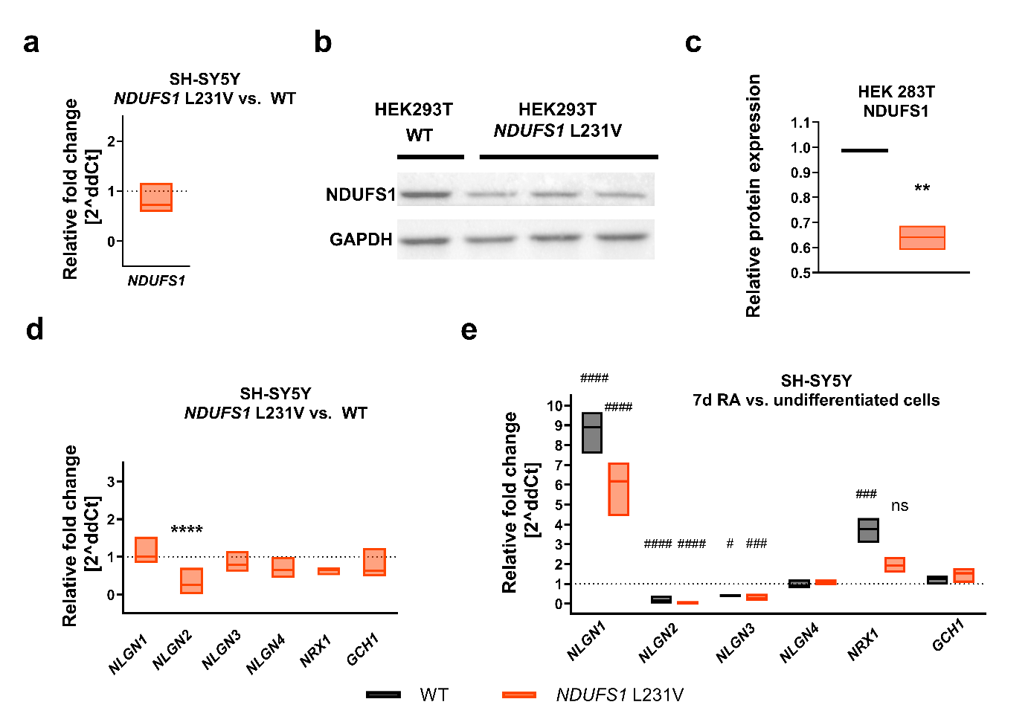
Supplementary Figure 1 (related to main Figure 1). a) Relative fold change of gene expression of NDUFS1 gene in SH-SY5Y NDUFS1 L231V cells vs WT cells. Floating bar shows mean and upper/lower boundaries of N=3 independent replicates. b) Representative images of SDS PAGE and western blot analysis of NDUFS1 protein expression normalized to the expression of housekeeping protein GAPDH in HEK293T WT and in HEK293T NDUFS1 L231V cells. c) Quantification of NDUFS1 in HEK293 NDUFS1 L231V cells, floating bars showing the mean and upper/lower boundary (N= 3 independent replicates). d) Relative fold change of gene expression of neuronal marker genes as indicated in SH-SY5Y NDUFS1 L231V cells vs WT cells. Floating bar shows mean and upper/lower boundaries (N=3 independent replicates). Statistical analysis: Ordinary One-way ANOVA followed by Šídák's multiple comparisons test. ****p<0.0001. e) Relative fold change of gene expression of neuronal marker genes as indicated in undifferentiated SH-SY5Y WT and NDUFS1 L231V cells compared to differentiated cells. Floating bar graphs show mean and upper/lower boundaries (N=3 independent replicates). Statistical analysis: Ordinary One-way ANOVA followed by Šídák's multiple comparisons test. ####p<0.0001 Asterisks (*) denote significant differences vs WT, hashtags (#) denote significant differences between doses within the same cell line.

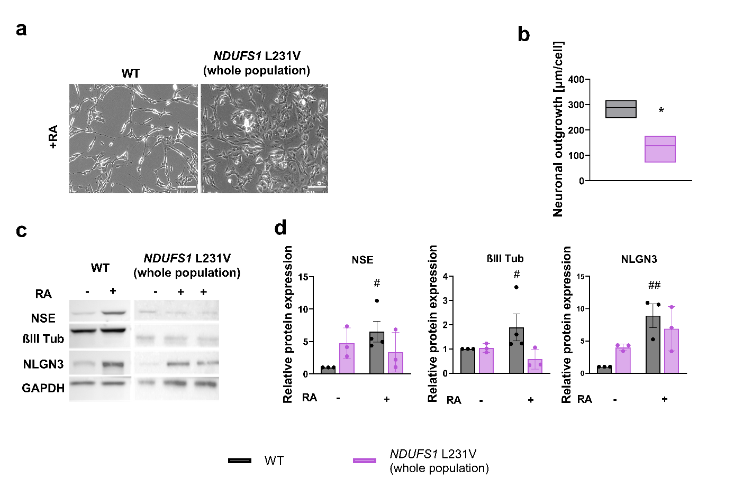Supplementary Figure 2 (related to main Figure 1). a) Representative images of differentiated (RA +) WT and whole population NDUFS1 L231V cells. Cells are differentiated for 7 d with 10 µM ATRA and 1% FCS. Brightfield images acquired at 20x magnification, scale bar = 100 µm. b) Neuronal Outgrowth of undifferentiated and differentiated WT and NDUFS1 L231V (whole population), quantified based on brightfield and nuclear staining fluorescence images with ImageJ Plugin NeuriteTracer. Floating bar graphs show line at mean, min and max value. Statistical analysis: Brown-Forsythe ANOVA followed by Dunnett's T3 multiple comparisons test. *p<0.05 c) Representative images of SDS PAGE and western blot analysis of protein expression of neuronal markers Neuron Specific Enolase (NSE), ßIII Tubulin (ßIII Tub) and Neuroligin3 (NLGN3) normalized to the expression of housekeeping protein GAPDH in WT and NDUFS1 L231V cells. d) Quantification of NSE, ßIII Tubulin and NLGN3 normalized to GAPDH expression and relative to WT are represented in bar graphs, showing the mean ± SD (N= 4 independent replicates). Statistical analysis: Ordinary one-way ANOVA followed by Šídák's multiple comparisons test. #p<0.05, ##p<0.01. Asterisks (*) denote significant differences vs WT, hashtags (#) denote significant differences between treatments within the same cell line.

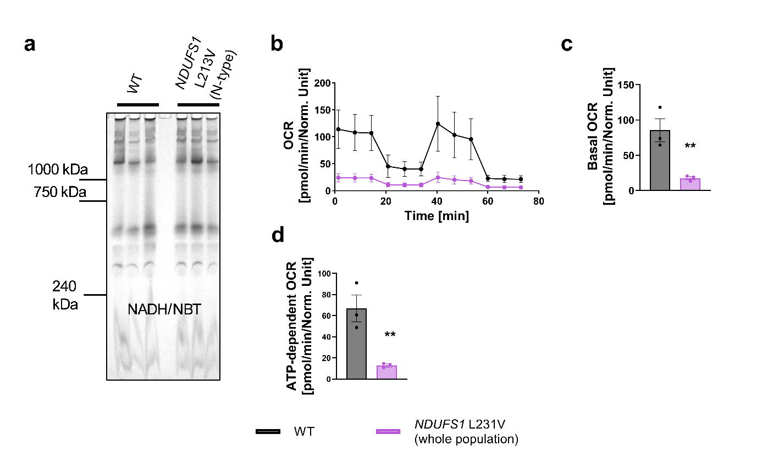Supplementary Figure 3 (related to main Figure 2). a) Representative image of CI NADH oxidase in-gel activity, representing N=3 replicates for WT and NDUFS1 L231V (N-type enriched) each, resolved with Nitro Blue Tetrazolium (NBT) as electron acceptor, showing up as bands. b) Mito Stress test respiration curves of WT and NDUFS1 L231V (whole population) show means and SD of oxygen consumption rate (OCR) in response to indicated injections of mitochondrial modulators oligomycin, FCCP and rotenone/antimycin A of 3 independent replicates, analyzed with Seahorse XFe96 analyzer. c, d) Bar graphs of basal respiration and ATP production of WT and NDUFS1 L231V show means ± SD (N=3 independent replicates with n=15). Statistical analysis: Ordinary One-Way ANOVA followed by Dunnett's multiple comparisons test. **p<0.01. Asterisks (*) denote significant differences vs WT.

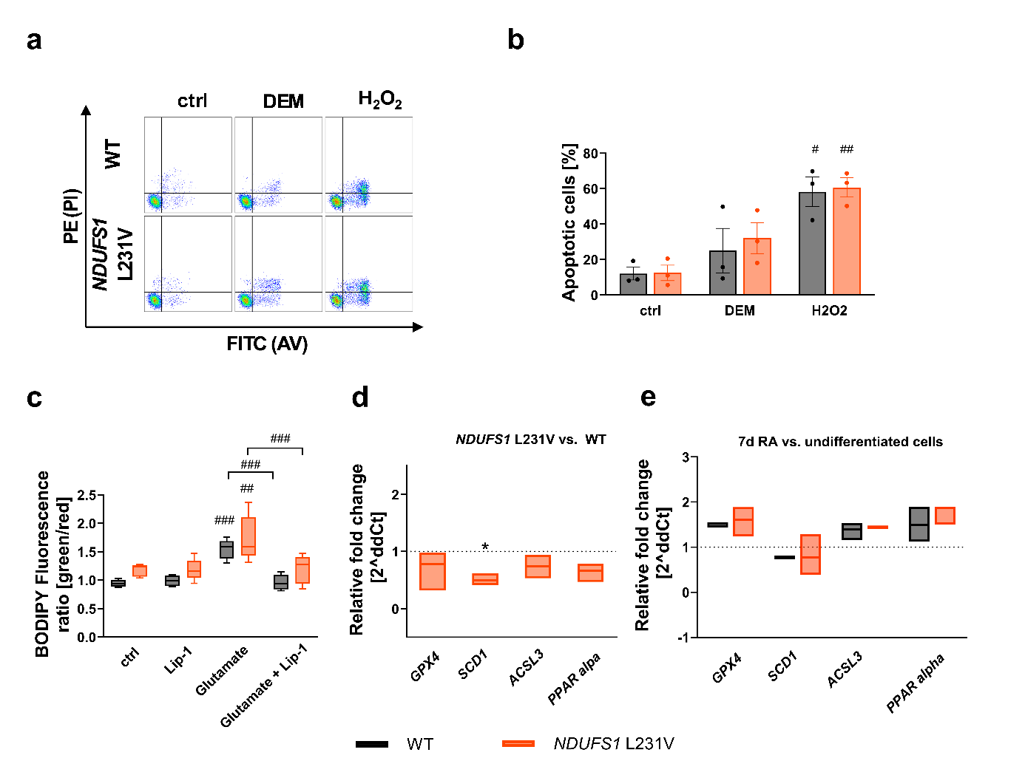Supplementary Figure 4 (related to main Figure 2). a) Representative FACS scatter plot of WT and NDUFS1 L231V showing FITC signal (Annexin V, indicating apoptosis) and PE signal (Propidium Iodide (PI), indicating necrosis) after treatment with DEM (300 µM, 24 h), H2O2 (250 µM, 24h) and of solvent control (ctrl), 10000 events recorded for every sample. b) Bar graph of all FITC + events (total amount of apoptosis) as cell death in % of all recorded events shows means ± SD (N=3 independent replicates). Statistical analysis: two-Way ANOVA followed by Šídák's multiple comparisons test. #p<0.05, ##p<0.01. c) BODIPY™ 581/591 C-11 staining of SH-SY5Y WT and NDUFS1 L231V cells after treatment with Lip-1 and/or glutamate followed by FACS analysis of FITC and PE signal, resulting in a ratio reflective of lipid peroxidation levels. Box plots show mean, 95 quartiles + error (N=3 independent replicates). Statistical analysis: ordinary one-way ANOVA followed by Tukey’s multiple comparison test. ##p<0.01, ###p<0.001. d) Relative fold change of gene expression of ferroptosis related genes as indicated in SH-SY5Y NDUFS1 L231V cells vs WT cells. Floating bar shows mean and upper/lower boundaries (N=3 independent replicates). Statistical analysis: Ordinary One-way ANOVA followed by Dunnett's multiple comparisons test. *p<0.05. e) Relative fold change of gene expression of neuronal marker genes as indicated in undifferentiated SH-SY5Y WT and NDUFS1 L231V cells compared to differentiated cells. Floating bar graphs show mean and upper/lower boundaries (N=3 independent replicates). Asterisks (*) denote significant differences vs WT, hashtags (#) denote significant differences between treatments within the same cell line.

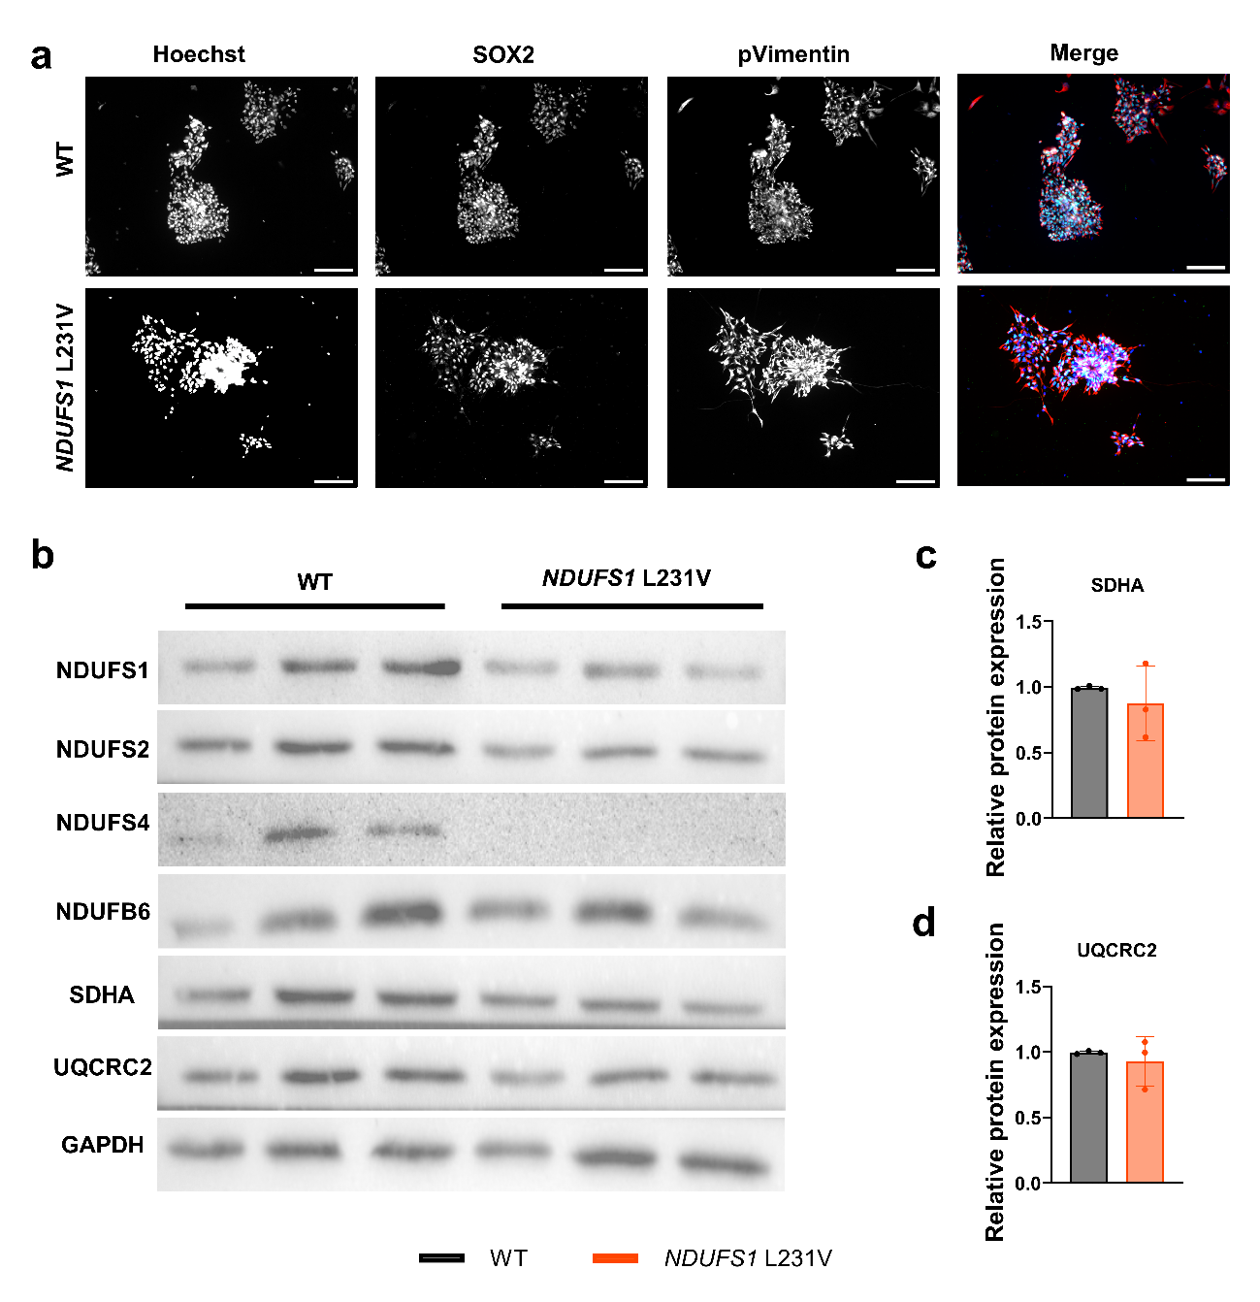Supplementary Figure 5 (related to main Figure 3). a) Generated neuronal progenitor cells (NPCs) express typical NPC markers as visualized with immunocytochemistry staining. Images acquired at 20x magnification, scale bar=100 µm. Hoechst=blue, SOX2=green, pVimentin=red. b) Representative SDS PAGE and western blot analysis of mitochondrial proteins of NDUFS1, NDUFS2, NDUFS4, NDUFB6, SDHA and UQCRC2 normalized on housekeeping protein GAPDH in WT and NDUFS1 L231V NPCs. c, d) Quantification of relative protein expression of SDHA and UQCRC2. Bar graphs show mean ± SD (N=3 independent replicates).

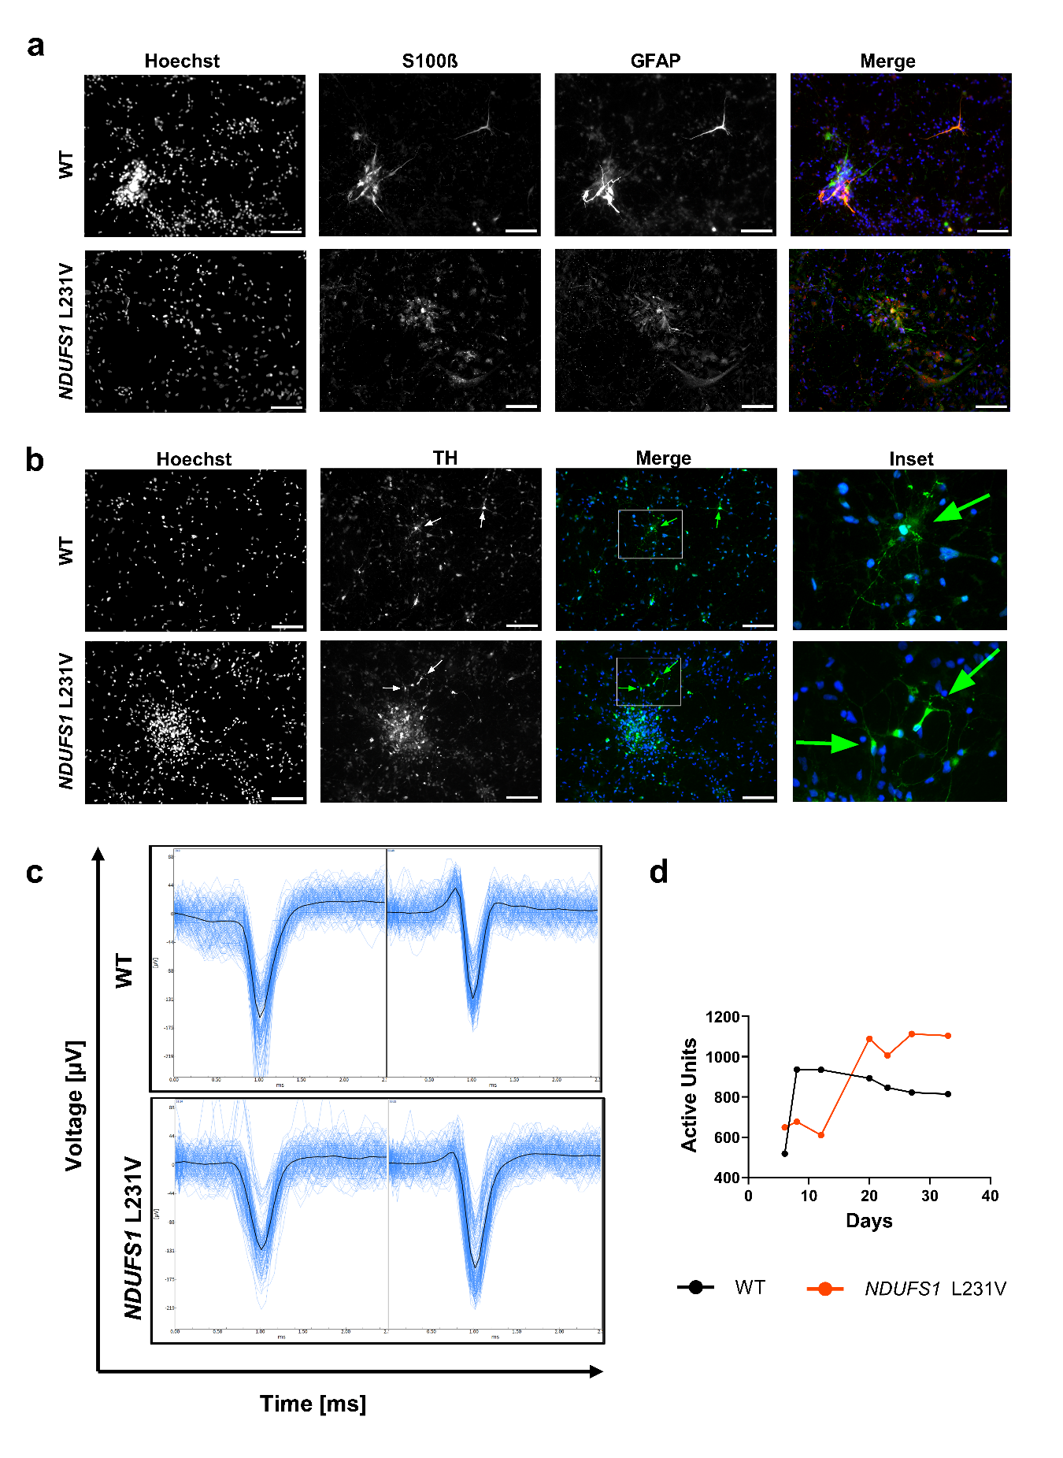Supplementary Figure 6 (related to main Figure 4). a) Representative immunocytochemistry and brightfield images characterizing astrocytic markers S100β and GFAP in WT and NDUFS1 L231V mDANs. Merge colors: Hoechst=blue, S100β=green, GFAP=red. Scale bar=100 μm. b) Representative ICC and brightfield images characterizing dopaminergic neuron marker TH in WT and NDUFS1 L231V mDAN. Arrows indicate typical TH positive cells. Merge colors: Hoechst=blue, TH=green. Scale bar=100 μm. c) Representative average waveform traces of both WT and NDUFS1 L231V mDANs, showing typical externally recorded action potentials. d) Line graph depicting the number of active units (spiking at a rate >0.1 spikes / second) over time from neuron seeding on chip.

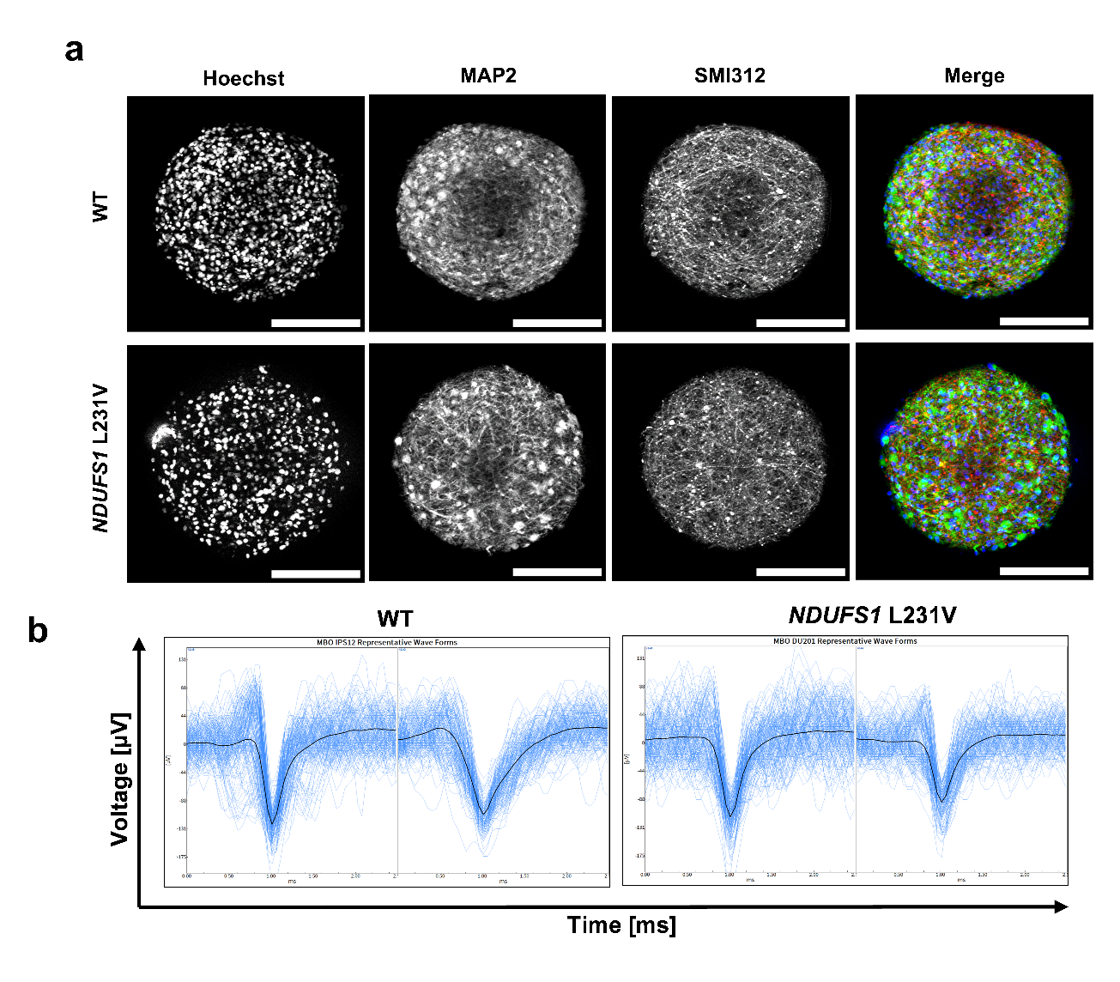Supplementary Figure 7 (related to main Figure 4). a) Representative immunocytochemistry images characterizing dendritic marker MAP2 and axonal marker SMI312 in WT and NDUFS1 L231V MBOs, showing dense neurite networks over the MBOs. Merge colors: Hoechst=blue, MAP2=green, SMI312=red. Scale bar=200 μm. b) Representative average waveform traces of both WT and NDUFS1 L231V MBOs, showing typical externally recorded action potentials.

a
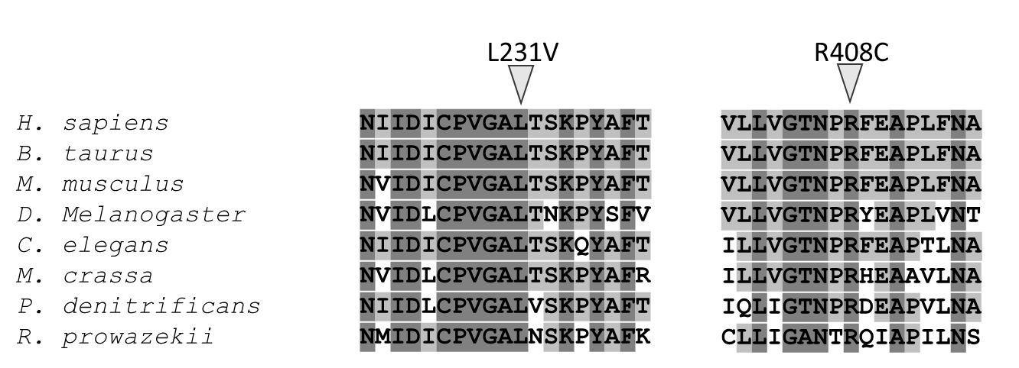
b
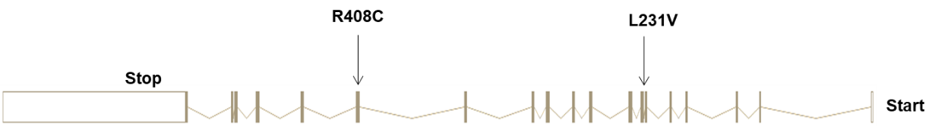
Cc

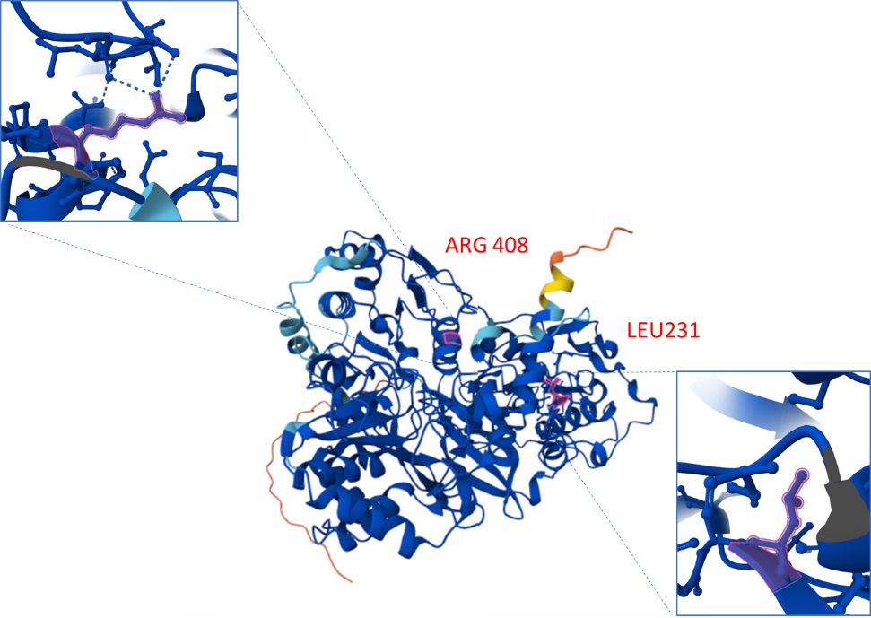

Supplementary Figure 8 (related to main Figure 5-6). a) NDUFS1 isoform 1 and the patient mutations modeled in this study. b) Multiple sequence alignment of NDUFS1/NUO-5 (C. elegans residues 224–242 and 403-420) including homologs from mammals, invertebrates, fungi and bacteria made using ClustalW.
c) Computed structure model of NADH-ubiquinone oxidoreductase 75 kDa subunit, and close-up of the two amino acids whose mutations are described in this paper, highlighted in red. The image was generated with AlphaFold DB: AF-Q66HF1-F1^{97,98}.

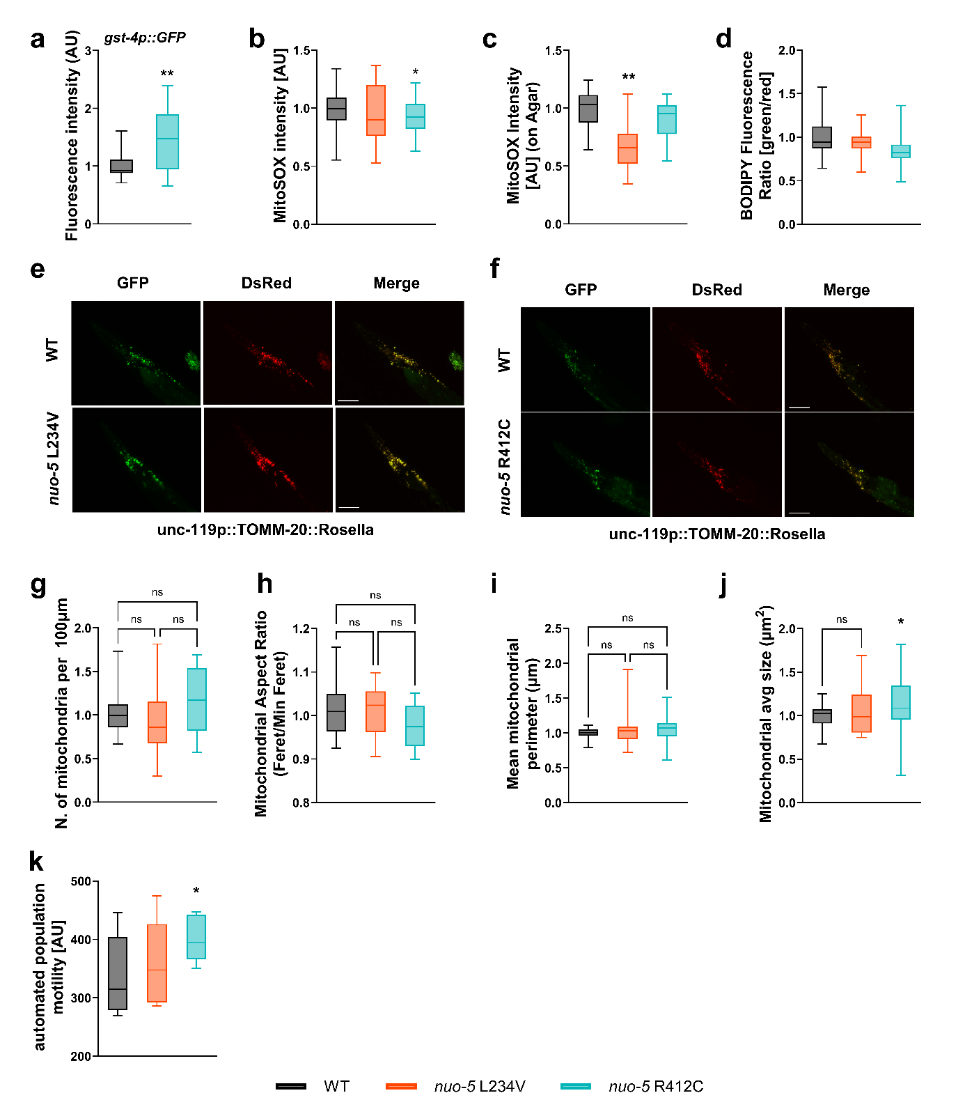Supplementary Figure 9 (related to main Figure 5). a) Quantification of Pgst-4::GFP expression, N=3 n ≥ 45. Unpaired t test with Welch's correction WT vs R412C p=0.0090. ROS production was measured with MitoSOX Red in b) liquid setting, N=3 n ≥ 45 and on c) solid agar plates N=3 n ≥ 45, animals were exposed for 24 h to the dye. d) Quantification of lipid peroxidation using BODIPY C11. Ratio of fluorescence oxidized/non-oxidized signals normalized to the wildtype control, N=3 n ≥ 30. Mean ± SEM, Kruskal-Wallis-Test for multiple comparisons followed by Dunn’s multiple comparison test. e-f) Representative fluorescence images acquired to quantify neuronal mitophagy as ratio of GFP/DsRed mean pixel intensity in the head region of day 1 worms. Nematodes express unc-119p::TOMM-20::Rosella in WT, nuo-5(syb4395) L234V and nuo-5(syb4409) R412C background. N=4, n=15-30 per condition. Scale bar = 50 μm. g) Mitochondrial number, h) aspect ratio, i) perimeter and j) size in rab-3p::RAB-3::GFP; rgef-1p::TOMM-20::mKate2::HA in WT, nuo-5(syb4409) R412C and nuo-5(syb4395) L234V background. N=3, n=10 per condition. Data are presented as mean ± SEM. k) total activity over 4 h, motility (automated assay using WMicrotracker ARENA). N=2, n=50 worms per condition.
One-way ANOVA followed by Tukey's multiple comparisons test. *p<0.05, **p<0.01 Asterisks (*) indicate significant differences vs WT.

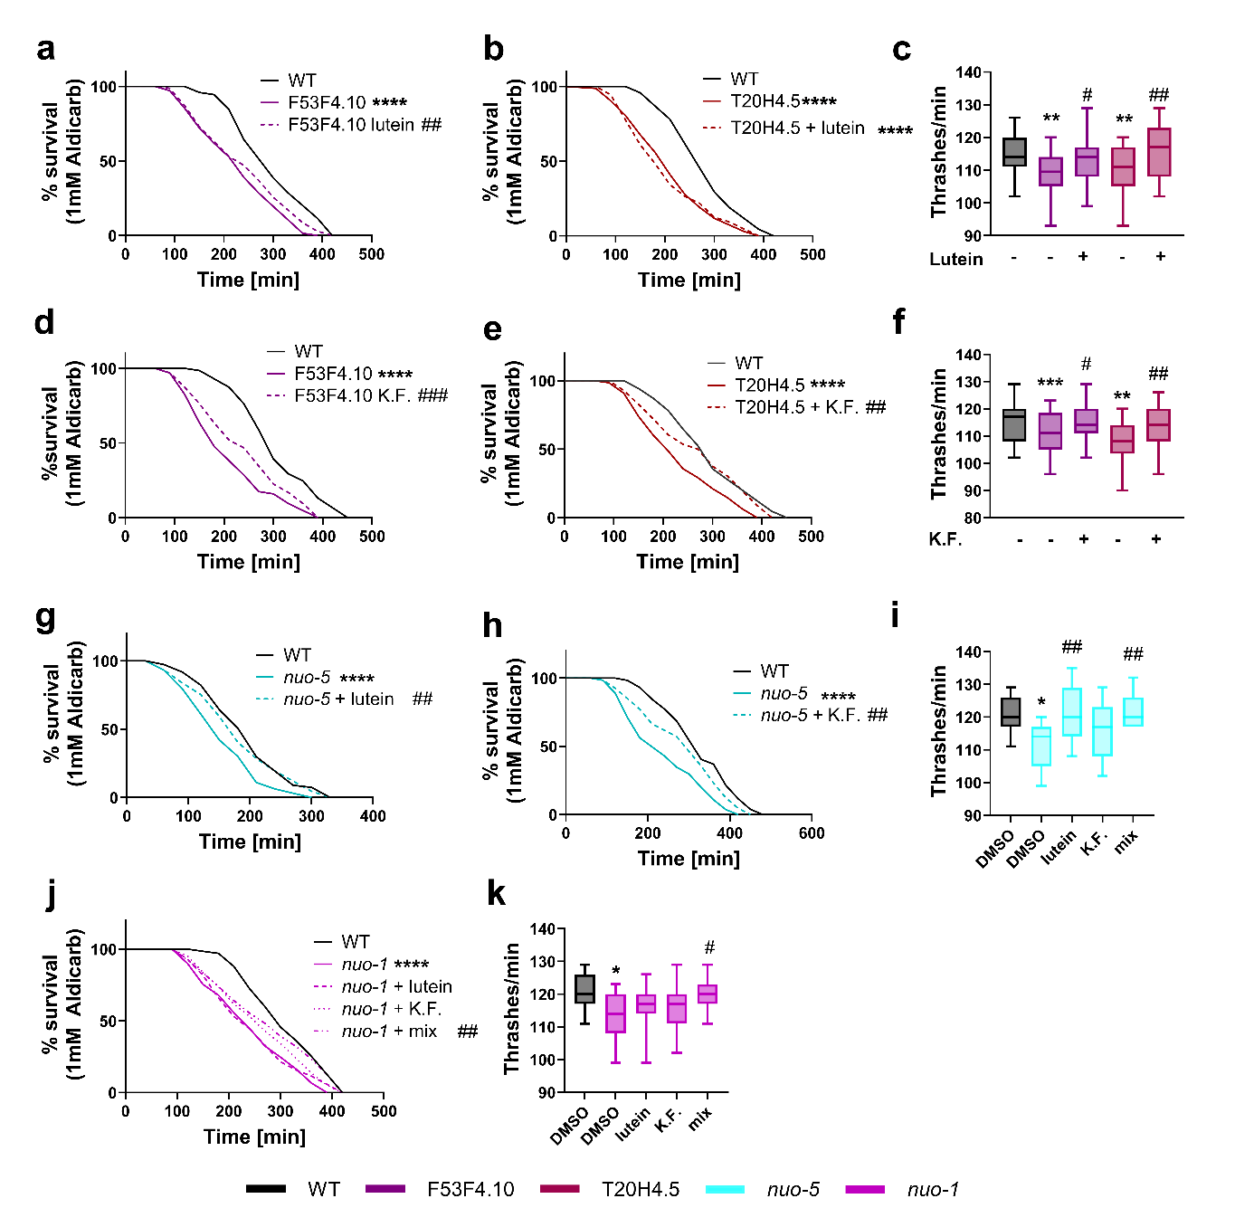Supplementary Figure 10 (related to main Figure 6). Synaptic Transmission and Motility in different Complex I mutants (i.e. F53F4.10, T20H4.5, nuo-1 and nuo-5 RNAi-mediated). Survival curve on 0,1 mM aldicarb plates and manual thrashing assay of F53F4,10 and T20H4.5 RNAi-fed animals treated with a-c) lutein or d-f) kahalalide F. g-k) Survival curve on 0,1 mM aldicarb plates and manual thrashing assay of nuo-5 and nuo-1 RNAi-fed animals treated with lutein, kahalalide F or their combination. 1 µM lutein or 0.5 µM of kahalalide or half dose each compound for the combination. All assessed in one day adult nematodes, inactivated HT115 bacteria. N=3, n=75 worms per condition. Statistical analysis: For survival curves Log-rank Test was used. For Bar graphs 2way ANOVA followed Tukey's multiple comparisons test. **p<0.01, ***p<0.001 ****p<0.0001. Asterisks (*) denote significant differences vs WT, hashtags (#) denote significant differences between doses within the same strain.

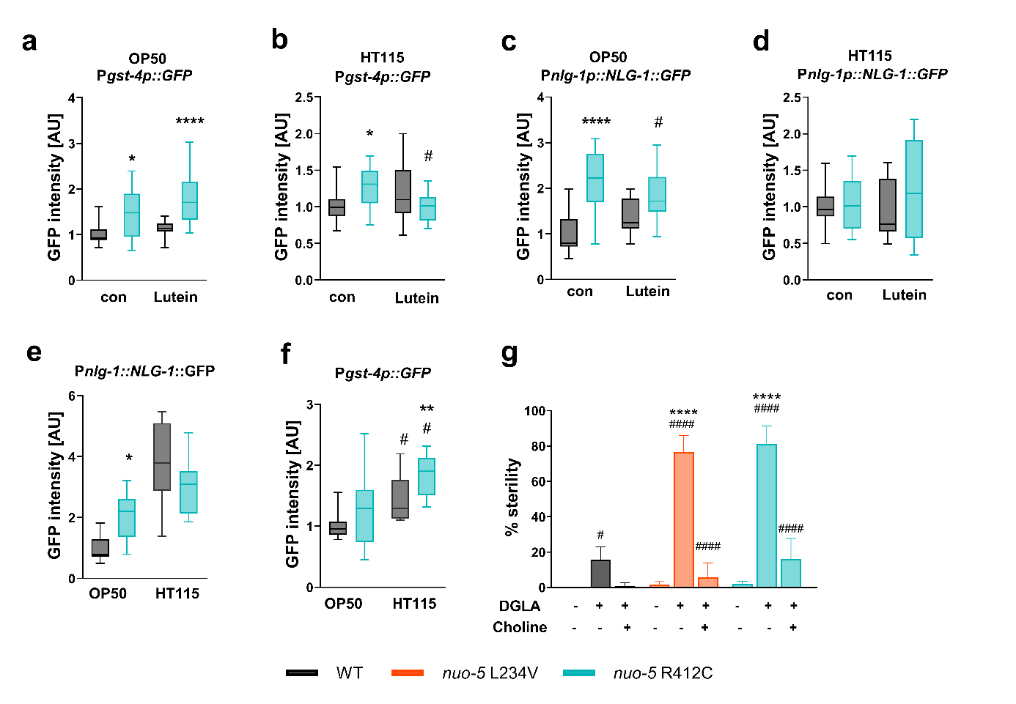
Supplementary Figure 11 (related to main Figure 5-6). a-b) Comparison between animals raised on E. coli OP50 and HT115 in Pgst-4::gfp and c-d) in Pnlg-1::NLG-1::gfp transgenic strains upon 1 µM lutein treatment. In e-f) the comparison between the two bacteria is shown in the absence of lutein and values are normalized on WT-OP50. N=3, n ≥ 30 g) 0,1 mM DGLA-induced sterility upon 30 mM choline treatment, N=4, n=50. For the comparisons of the means two-way ANOVA for multiple comparison analysis followed by Tukey’s multiple comparisons tests was used. *p<0.05, **p<0.01, ***p<0.001 ****p<0.0001. Asterisks (*) indicate significant differences vs WT control, hashtags (#) denote significant differences vs treatment within the same strain.

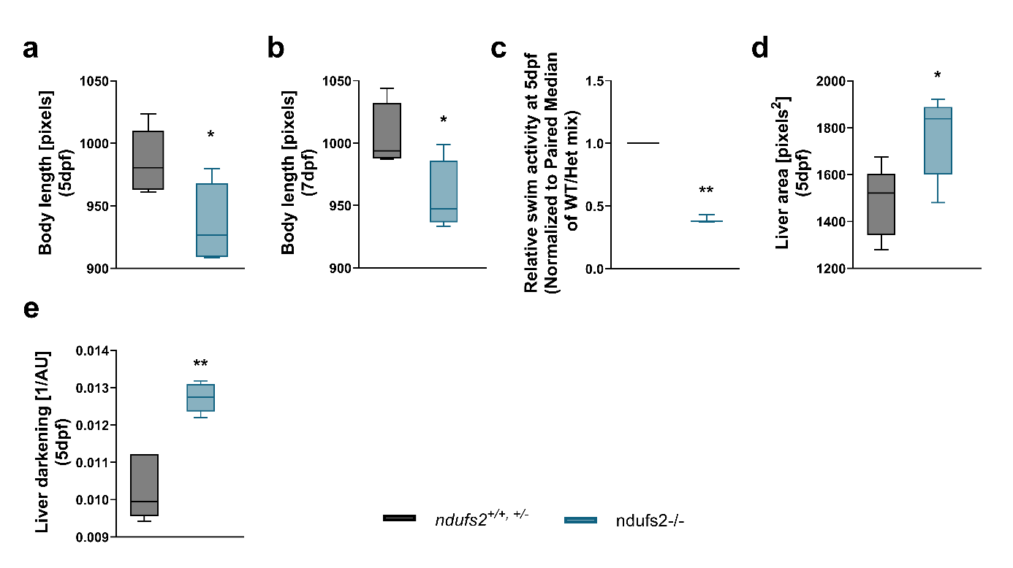
Supplementary Figure 12 (related to main Figure 7). Body length in pixel in ndufs^{2+/+,+/-} and ndufs2^{-/-} zebrafish larvae a) at 5 days post fertilization (dpf) and b) at 7 dpf. c) relative swim activity at 5 dpf in ndufs^{2+/+,+/-} and ndufs2^{-/-} zebrafish larvae. d) Liver area at 5dpf and in ndufs^{2+/+,+/-} and ndufs2^{-/-} zebrafish larvae. e) Liver darkening at 5 dpf in ndufs^{2+/+,+/-} and ndufs2^{-/-} zebrafish larvae. N=5 in all panels. Statistical analysis: Welch’s t test. *p<0.05, **p<0.01. Asterisks (*) denote significant differences vs WT.

