SUPPLEMENTARY MATERIAL

Appendix A

Pairwise comparisons of each model’s predictions (on a final training run with 100% of the data) are in Figure A1.

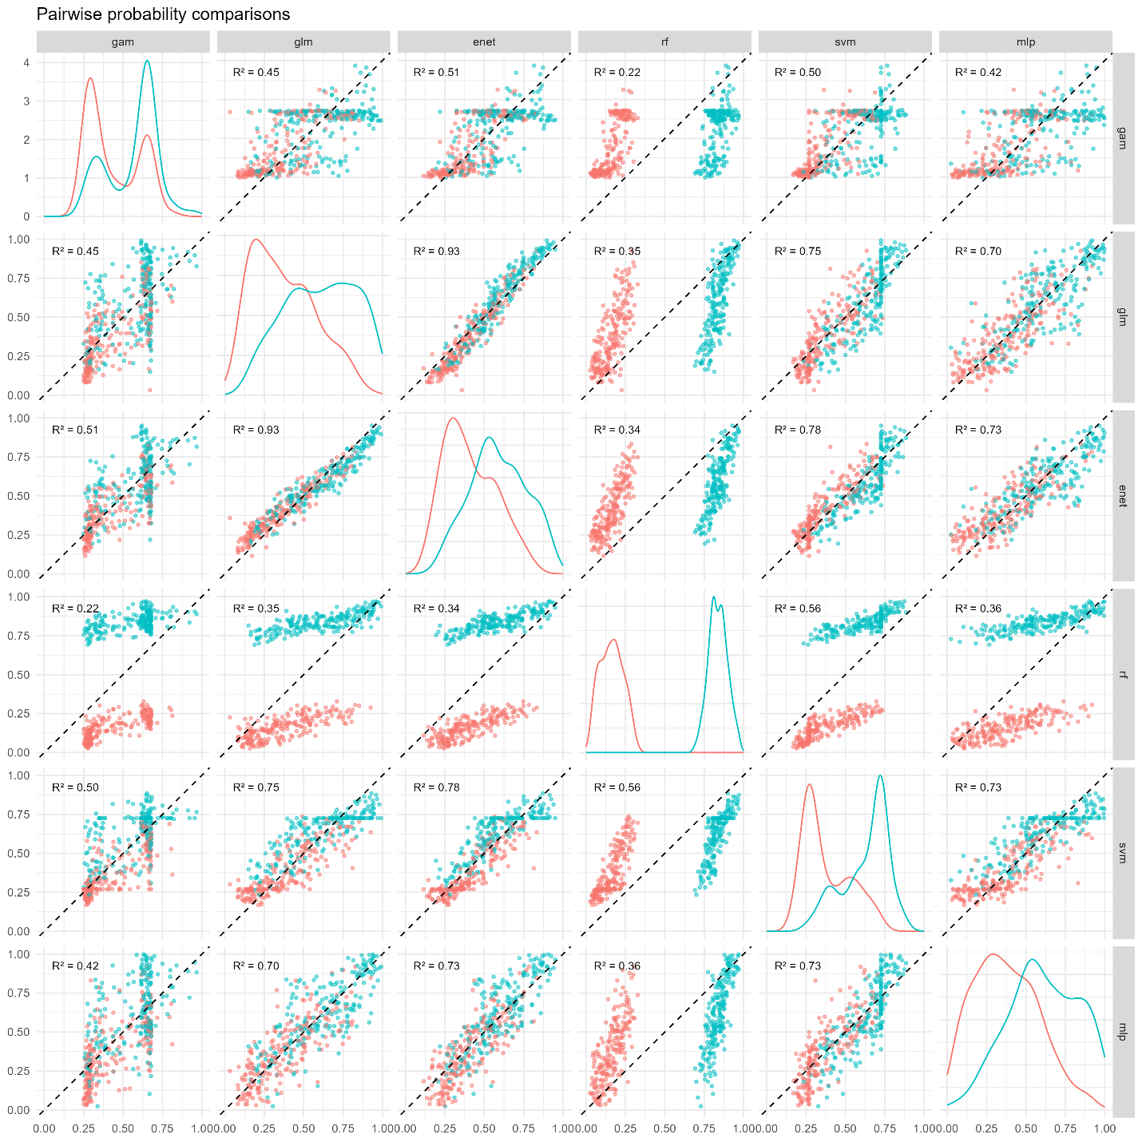
Figure A1. Pairwise probability comparisons of each model, with the probabilities corresponding to pained facial expressions (pain=1) in blue and neutral facial expressions (pain=0) in pink (with Pearson’s correlation). The diagonal plots show kernel densities of the predicted probabilities.

Appendix B

The model calibration plots for the elastic net and multi-layer perceptron models are in Figure B1, with sex-stratified plots in Figure B2.

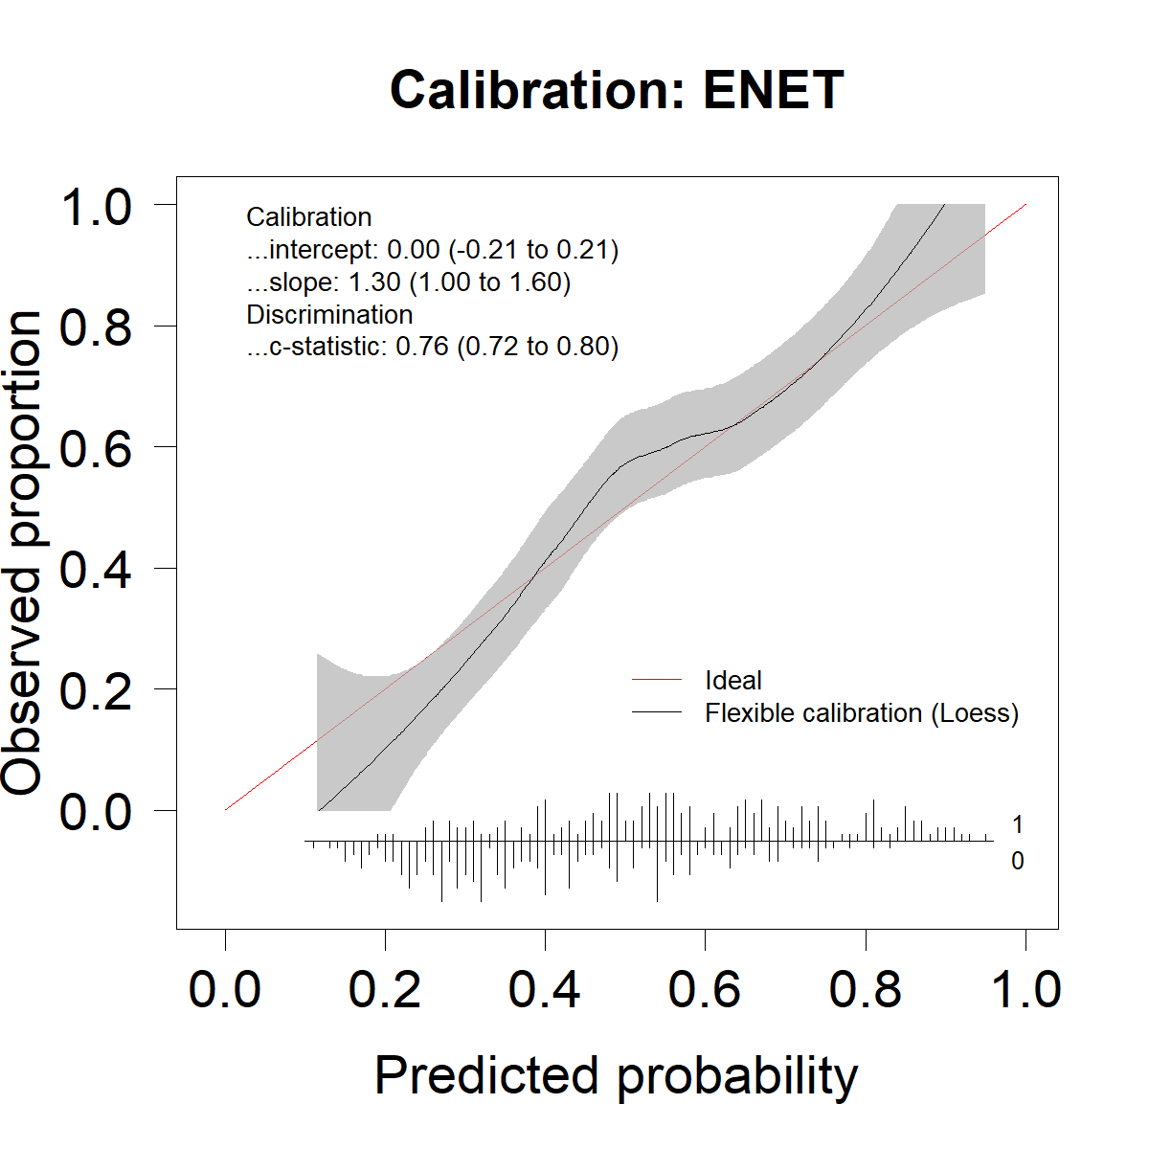
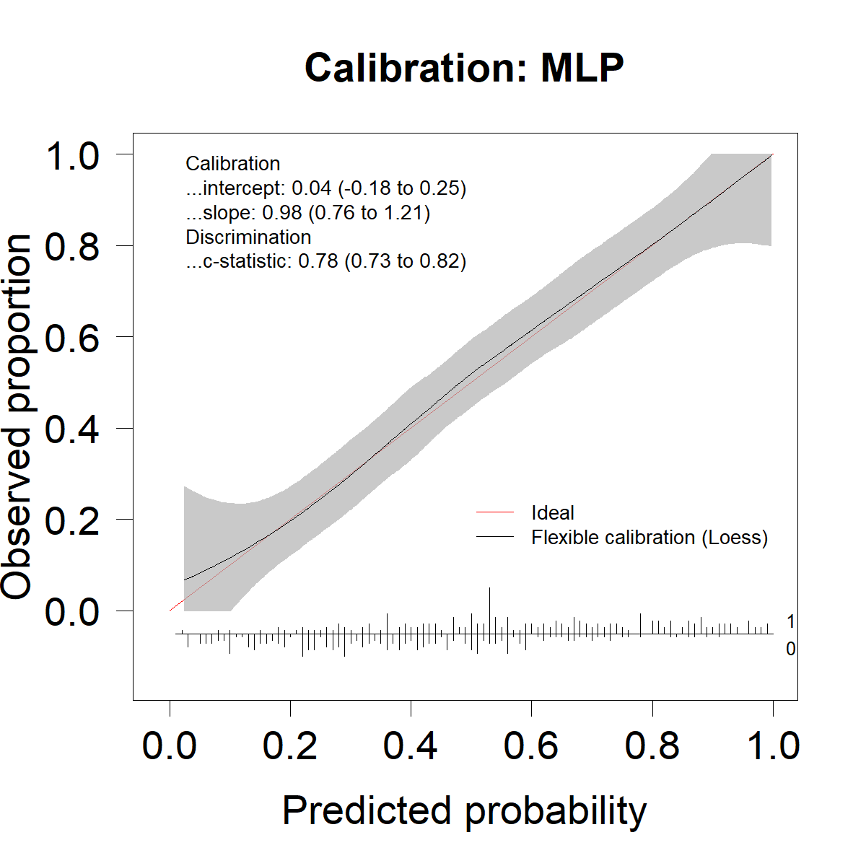
Figure B1. Overall calibration plots for ENET and MLP models.
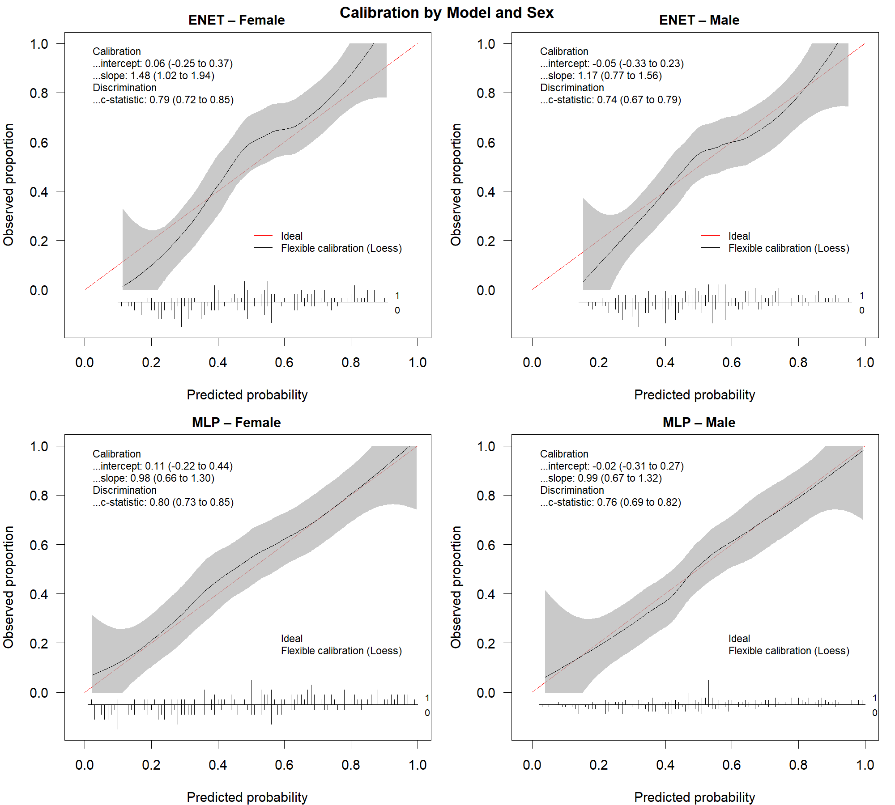

Figure B2. Sex-stratified calibration plots for ENET and MLP models.

Appendix C

Untransformed and transformed AU intensity distributions, with untransformed data displaying right-skew, with almost all distributions concentrated at or near 0 (Figure C1).

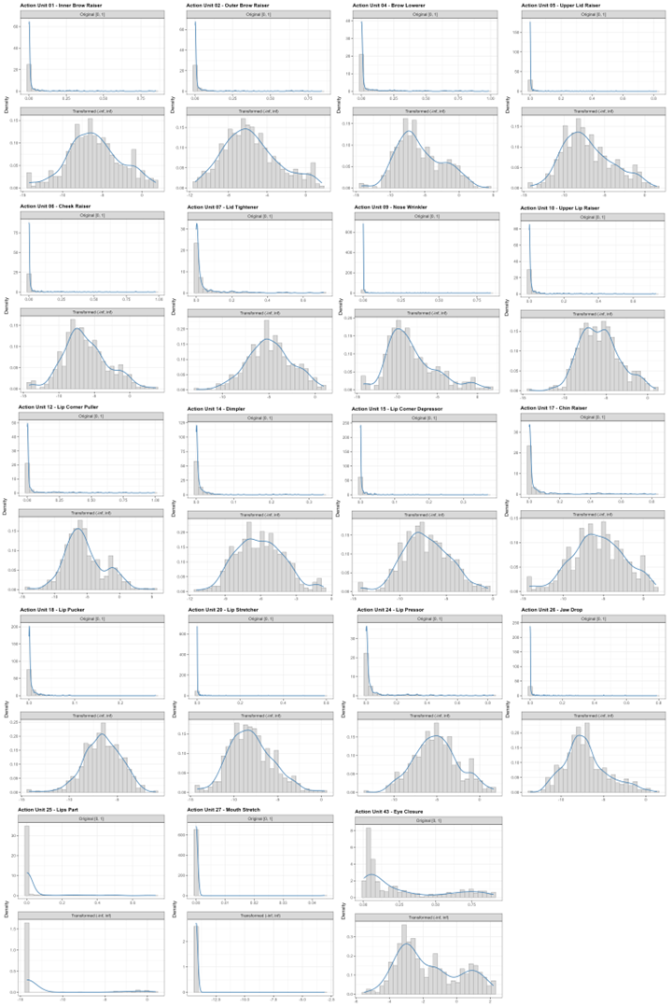

Figure C1. Untransformed and transformed FaceReader-coded AU intensities.

Appendix D

The model parameters used for parametric models (GAM, GLM, ENET) and machine leaning models (RF, SVM, MLP) are in Table D1. The seed number was 80160. Unless otherwise specified, default parameters were used.

Table D1. Model parameter details.
Model abbr. | Model parameters | R package or function
GAM | Family: binomial  Link: logit  Estimation: restricted maximum likelihood  Knots: tprs basis (k=10) | mgcv
GLM | Family: binomial  Link: logit  Estimation: maximum likelihood | stats (glm)
ENET | Family: binomial  Link: logit  Alpha grid: 0.00 to 1.00 (by 0.01)  Lambda grid: default (100 values, log spaced)  Folds for internal parameter tuning: n=10  Standardization: TRUE  Estimation: binomial deviance | glmnet
RF | Type: classification  ntree=500  mtry=sqrt(30) | randomForest
SVM | kernel = radial  Probability: TRUE  Scale: TRUE | e1071
MLP | distribution=bernoulli  loss=CrossEntropy  hidden=c(64, 32)  activation=RectifierWithDropout  hidden_dropout_ratios=c(0.25, 0.25)  input_dropout_ratio=0.25  l1=9e-4  l2=9e-4  adaptive_rate=TRUE  mini_batch_size=32  epochs=200  stopping_metric=logloss  stopping_rounds=20  stopping_tolerance=1e-5 | h2o

