Supplementary Table S1. Search strategies and records retrieved from bibliographic databases and trial registries
Supplementary Table S1A. Search strategies used in each database
Database | Search strategy | Records
PubMed | ((“Osteoarthritis, Knee”[Mesh] OR “knee osteoarthritis”[Title/Abstract] OR “osteoarthritis of knee”[Title/Abstract] OR “osteoarthritis of the knee”[Title/Abstract] OR “knee joint osteoarthritis”[Title/Abstract] OR “gonarthrosis”[Title/Abstract] OR “KOA”[Title/Abstract]) AND (“Probiotics”[Mesh] OR “Prebiotics”[Mesh] OR “Microbiota”[Mesh] OR probiotic*[Title/Abstract] OR prebiotic*[Title/Abstract] OR synbiotic*[Title/Abstract] OR postbiotic*[Title/Abstract] OR microbiota[Title/Abstract] OR microbiome[Title/Abstract] OR microflora[Title/Abstract] OR “microbial community”[Title/Abstract] OR Lactobacillus[Title/Abstract] OR Bifidobacterium[Title/Abstract])) | 76
Embase | (‘knee osteoarthritis’/exp OR ‘knee osteoarthritis’ OR ‘knee joint osteoarthritis’ OR ‘knee arthrosis’ OR ‘knee joint arthrosis’ OR ‘knee osteo-arthritis’ OR ‘knee osteoarthrosis’ OR ‘osteoarthritis, knee’ OR ‘osteoarthrosis, knee’ OR ‘gonarthrosis’ OR ‘femorotibial arthrosis’ OR KOA) AND (‘probiotic agent’/exp OR ‘prebiotic agent’/exp OR ‘synbiotic agent’/exp OR ‘microflora’/exp OR probiotic* OR prebiotic* OR synbiotic* OR postbiotic* OR microbiota OR microbiome OR microflora OR ‘microbial flora’ OR Lactobacillus OR Bifidobacterium) | 201
Cochrane Library | #1 MeSH descriptor: [Osteoarthritis, Knee] explode all trees; #2 (“knee osteoarthritis” OR “osteoarthritis of knee” OR “osteoarthritis of the knee” OR “knee joint osteoarthritis” OR “gonarthrosis” OR KOA):ti,ab,kw; #3 MeSH descriptor: [Probiotics] explode all trees; #4 probiotic*:ti,ab,kw; #5 MeSH descriptor: [Prebiotics] explode all trees; #6 prebiotic*:ti,ab,kw; #7 synbiotic*:ti,ab,kw; #8 postbiotic*:ti,ab,kw; #9 MeSH descriptor: [Microbiota] explode all trees; #10 (microbiota OR microbiome OR microflora OR “microbial community” OR “microbial communities” OR “microbial community composition” OR “microbial community structure” OR Lactobacillus OR Bifidobacterium):ti,ab,kw; #11 #1 OR #2; #12 #3 OR #4 OR #5 OR #6 OR #7 OR #8 OR #9 OR #10; #13 #11 AND #12 | 35
CNKI | 主题 =（膝骨关节炎 OR 膝骨性关节炎 OR 膝关节骨关节炎 OR 膝关节骨性关节炎 OR 膝关节炎 OR KOA）AND 主题 =（益生菌 OR 益生元 OR 合生元 OR 后生元 OR 微生态 OR 肠道菌群 OR 肠道微生态 OR 肠道微生物 OR 乳酸杆菌 OR 乳酸菌 OR 乳杆菌 OR 双歧杆菌 OR probiotic OR probiotics OR prebiotic OR prebiotics OR synbiotic OR synbiotics OR postbiotic OR postbiotics OR Lactobacillus OR Bifidobacterium） | 89
Wanfang | 主题 =（膝骨关节炎 OR 膝骨性关节炎 OR 膝关节骨关节炎 OR 膝关节骨性关节炎 OR 膝关节炎 OR KOA）AND 主题 =（益生菌 OR 益生元 OR 合生元 OR 后生元 OR 微生态 OR 肠道菌群 OR 肠道微生态 OR 肠道微生物 OR 乳酸杆菌 OR 乳酸菌 OR 乳杆菌 OR 双歧杆菌 OR probiotic OR probiotics OR prebiotic OR prebiotics OR synbiotic OR synbiotics OR postbiotic OR postbiotics OR Lactobacillus OR Bifidobacterium） | 129

Supplementary Table S1B. Trial registry search results and deduplication process.
Step | Count | Description
ClinicalTrials.gov raw valid registry records | 48 | Number of valid NCT records after removing blank rows and repeated header rows
ClinicalTrials.gov unique records after internal deduplication | 20 | Records retained after deduplication within ClinicalTrials.gov based on NCT Number
WHO ICTRP raw valid registry records | 30 | Number of valid TrialID records after removing blank rows and repeated header rows
WHO ICTRP unique records after internal deduplication | 19 | Records retained after deduplication within WHO ICTRP based on TrialID
Cross-source duplicate records | 9 | Duplicate registry records identified across the two registry platforms
Final merged unique registry records | 30 | Unique registry records retained after merging the two platforms and removing cross-source duplicates
ChiCTR direct search | 0 | No additional eligible records were identified through direct searching of the ChiCTR website; ChiCTR-sourced records indexed in WHO ICTRP were retained in the WHO ICTRP/merged screening dataset
Additional completed RCTs with extractable results identified | 0 | No additional completed randomized controlled trials with extractable results were identified for inclusion in the meta-analysis

Supplementary Table S1C. Search strategies used for clinical trial registries
Registry | Search method and exact terms used | Search date | Records retrieved or retained
ClinicalTrials.gov | Three separate searches were conducted and the exported results were combined. Disease terms: "knee osteoarthritis" and osteoarthritis. These were combined, as applicable, with the following intervention-related terms: probiotic, prebiotic, synbiotic, postbiotic, microbiota, microbiome, Lactobacillus, and Bifidobacterium. No restrictions on study status or language were applied. | 5 June 2026* | 48 raw valid records; 20 unique records after within-registry deduplication
WHO International Clinical Trials Registry Platform (WHO ICTRP) | Separate searches were conducted and the exported results were combined. Disease terms: "knee osteoarthritis" and osteoarthritis. These were combined, as applicable, with the following intervention-related terms: probiotic, prebiotic, synbiotic, postbiotic, microbiota, microbiome, Lactobacillus, and Bifidobacterium. No restrictions on recruitment status, publication status, or language were applied. | 5 June 2026* | 30 raw valid records; 19 unique records after within-registry deduplication
Chinese Clinical Trial Registry (ChiCTR) | Direct website searches were conducted using English and Chinese disease and intervention terms. English disease terms: "knee osteoarthritis" and osteoarthritis; English intervention terms: probiotic, prebiotic, synbiotic, postbiotic, microbiota, microbiome, Lactobacillus, and Bifidobacterium. Chinese disease terms: 膝骨关节炎, 膝关节骨性关节炎, and 骨关节炎; Chinese intervention terms: 益生菌, 益生元, 合生元, 后生元, 肠道菌群, 肠道微生态, 乳酸杆菌, and 双歧杆菌. | 5 June 2026* | Original number retrieved was not recorded; 0 additional eligible records were identified
Abbreviations: ChiCTR, Chinese Clinical Trial Registry; WHO ICTRP, World Health Organization International Clinical Trials Registry Platform.
*The date should be retained only if June 5, 2026 was the actual date of the final registry search. Search results from ClinicalTrials.gov and WHO ICTRP were exported and combined before within-registry deduplication. The reported raw valid record counts exclude blank rows and repeated header rows but include duplicate records retrieved through more than one search. After within-registry and cross-registry deduplication, 30 unique registry records remained for screening. Records originating from ChiCTR that were indexed in WHO ICTRP were retained in the WHO ICTRP and merged screening datasets. Direct searching of ChiCTR identified no additional eligible records. No additional completed randomized controlled trials with extractable outcome data were identified.

Supplementary Table S2. Descriptive summary of adverse events reported in the included studies
Study | Safety outcome | Intervention events/n  (%) | Control events/n  (%) | Serious adverse events | AE type/details | Study-specific effect estimate | Role in synthesis
Lyu 2020 | Any adverse events | 0/41 (0.0%) | 0/39 (0.0%) | Not specifically reported | No adverse reactions reported | Not estimable because of zero events in both groups | Overall adverse-event descriptive synthesis
Shang 2024 | Any adverse events | 0/30 (0.0%) | 0/30 (0.0%) | Not specifically reported | No adverse events reported | Not estimable because of zero events in both groups | Overall adverse-event descriptive synthesis
Dolatkhah 2024 | Any adverse events | 2/32 (6.3%) | 3/31 (9.7%) | No serious adverse events reported | Intervention: diarrhea and stomach pain; control: constipation, nausea, and heartburn | RR = 0.65 (95% CI 0.12–3.61) | Only study providing an estimable relative effect; no meta-analysis performed
Shine 2025 | Any adverse events | 0/50 (0.0%) | 0/50 (0.0%) | No serious adverse events reported | No adverse events or serious adverse events reported | Not estimable because of zero events in both groups | Overall adverse-event descriptive synthesis
Karim 2026 | Any adverse events | 0/54 (0.0%) | 0/56 (0.0%) | None reported | No adverse reactions or safety concerns reported | Not estimable because of zero events in both groups | Overall adverse-event descriptive synthesis
Kouraki 2026 | Minor gastrointestinal adverse events | 23/50 (46.0%) | 0/67 (0.0%) | No serious adverse events reported | Mild gastrointestinal symptoms, mainly increased flatulence and bloating | Not estimated; raw event data reported descriptively | Exploratory descriptive analysis of gastrointestinal adverse events
Notes: AE, adverse event; CI, confidence interval; PSE, physiotherapy-supported exercise; RR, risk ratio. Safety denominators were based on the populations for which adverse-event information was available and may therefore differ from the efficacy-analysis populations. Five studies involving 413 participants reported overall adverse events. Four of these studies reported zero events in both groups and therefore did not provide estimable relative effects. Only Dolatkhah 2024 provided an estimable study-specific RR; consequently, no meta-analysis of overall adverse events was performed. For Kouraki 2026, the inulin-only and inulin-plus-PSE arms were combined as the intervention group, whereas the PSE-only and placebo arms were combined as the non-inulin comparison group. Because Kouraki 2026 reported specifically solicited minor gastrointestinal symptoms within a 2 × 2 factorial design, its findings were summarized separately as an exploratory descriptive analysis and were not combined with studies reporting overall adverse events.

Supplementary Table S3. GRADE summary of the certainty of evidence for primary, key inflammatory, and safety outcomes
Outcome | Studies / participants | Effect estimate | Risk of bias | Inconsistency | Indirectness | Imprecision | Publication bias | Certainty of evidence | Main reasons
Pain intensity | 8 studies / 662 participants | MD = −1.06, 95% CI −1.42 to −0.70; P < 0.001; I² = 0.0% | Serious | Not serious | Not serious | Not serious | Not assessed (<10 studies) | Moderate | Downgraded one level for risk-of-bias concerns in some included studies that could have affected the pooled estimate.
WOMAC total score | 4 studies / 677 participants | MD = −8.05, 95% CI −19.49 to 3.39; P = 0.111; I² = 90.2% | Not serious | Serious | Not serious | Serious | Not assessed (<10 studies) | Low | Downgraded one level for serious inconsistency because of substantial unexplained heterogeneity and one level for serious imprecision because the confidence interval was wide and crossed the null effect.
CRP/hs-CRP | 5 studies / 483 participants | MD = −0.42, 95% CI −1.77 to 0.94; P = 0.439; I² = 96.9% | Not serious | Serious | Not serious | Serious | Not assessed (<10 studies) | Low | Downgraded one level for serious inconsistency because of substantial unexplained heterogeneity and divergent study estimates, and one level for serious imprecision because the confidence interval crossed the null effect.
Adverse events | 5 studies / 413 participants | No pooled estimate; 4 double-zero studies and only 1 estimable RR (0.65, 95% CI 0.12–3.61) | Serious | Not assessable | Not serious | Very serious | Not assessed (<10 studies) | Very low | Downgraded one level for risk-of-bias concerns because adverse-event ascertainment and reporting were limited or inconsistent across studies, and two levels for very serious imprecision because events were sparse, 4 studies had zero events in both groups, and only 1 study provided an estimable relative effect.
Abbreviations: CI, confidence interval; CRP, C-reactive protein; GRADE, Grading of Recommendations Assessment, Development and Evaluation; hs-CRP, high-sensitivity C-reactive protein; MD, mean difference; RR, risk ratio; WOMAC, Western Ontario and McMaster Universities Osteoarthritis Index. For continuous outcomes, pooled estimates were based on change scores or baseline-adjusted between-group effects. No pooled effect estimate was calculated for overall adverse events because 4 of the 5 studies reported zero events in both groups and only 1 study provided an estimable relative effect. Publication bias was not formally assessed because fewer than 10 studies were available for each outcome.

Supplementary Table S4. Sensitivity analyses using alternative assumed correlation coefficients and excluding studies with imputed change-score standard deviations
Outcome | Analysis | Studies / participants | Pooled effect | 95% CI | P value  (Hartung–Knapp) | I²
Pain intensity | Assumed correlation coefficient, r = 0.3 | 8 / 662 | MD = −1.02 | −1.37 to −0.68 | <0.001 | 0.0%
Pain intensity | Assumed correlation coefficient, r = 0.5 (primary analysis) | 8 / 662 | MD = −1.06 | −1.42 to −0.70 | <0.001 | 0.0%
Pain intensity | Assumed correlation coefficient, r = 0.7 | 8 / 662 | MD = −1.14 | −1.52 to −0.76 | <0.001 | 14.3%
Pain intensity | Excluding studies with imputed SDs of change scores | 5 / 328 | MD = −0.90 | −1.32 to −0.48 | 0.004 | 0.0%
WOMAC total score | Assumed correlation coefficient, r = 0.3 | 4 / 677 | MD = −8.02 | −19.44 to 3.39 | 0.111 | 89.4%
WOMAC total score | Assumed correlation coefficient, r = 0.5 (primary analysis) | 4 / 677 | MD = −8.05 | −19.49 to 3.39 | 0.111 | 90.2%
WOMAC total score | Assumed correlation coefficient, r = 0.7 | 4 / 677 | MD = −8.08 | −19.55 to 3.39 | 0.111 | 91.0%
WOMAC total score | Excluding studies with imputed SDs of change scores | 3 / 244 | MD = −4.50 | −10.73 to 1.73 | 0.090 | 0.0%
CRP/hs-CRP | Assumed correlation coefficient, r = 0.3 | 5 / 483 | MD = −0.42 | −1.77 to 0.94 | 0.440 | 95.9%
CRP/hs-CRP | Assumed correlation coefficient, r = 0.5 (primary analysis) | 5 / 483 | MD = −0.42 | −1.77 to 0.94 | 0.439 | 96.9%
CRP/hs-CRP | Assumed correlation coefficient, r = 0.7 | 5 / 483 | MD = −0.42 | −1.77 to 0.93 | 0.438 | 98.0%
CRP/hs-CRP | Excluding studies with imputed SDs of change scores | 3 / 244 | MD = −0.20 | −4.45 to 4.05 | 0.858 | 88.3%
Note: The assumed correlation coefficient was varied only for studies in which the standard deviation of the change score was estimated from baseline and follow-up standard deviations. Studies that directly reported change-score standard deviations or baseline-adjusted between-group effects remained unchanged. All analyses used a random-effects model with restricted maximum likelihood estimation and the Hartung–Knapp adjustment.
Abbreviations: CI, confidence interval; CRP, C-reactive protein; hs-CRP, high-sensitivity C-reactive protein; MD, mean difference; SD, standard deviation; WOMAC, Western Ontario and McMaster Universities Osteoarthritis Index.
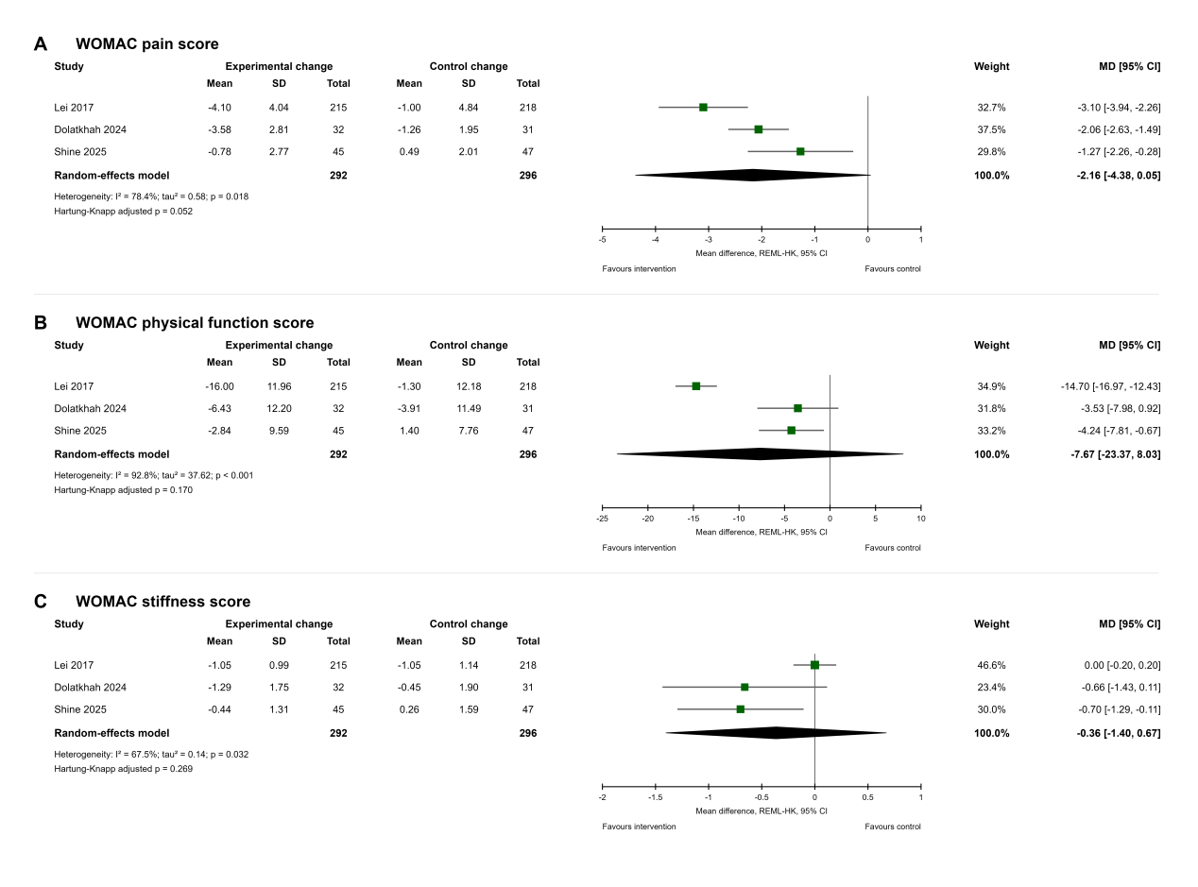
Supplementary Fig. 1 Forest plots for WOMAC subscales. A, WOMAC pain; B, WOMAC physical function; C, WOMAC stiffness.
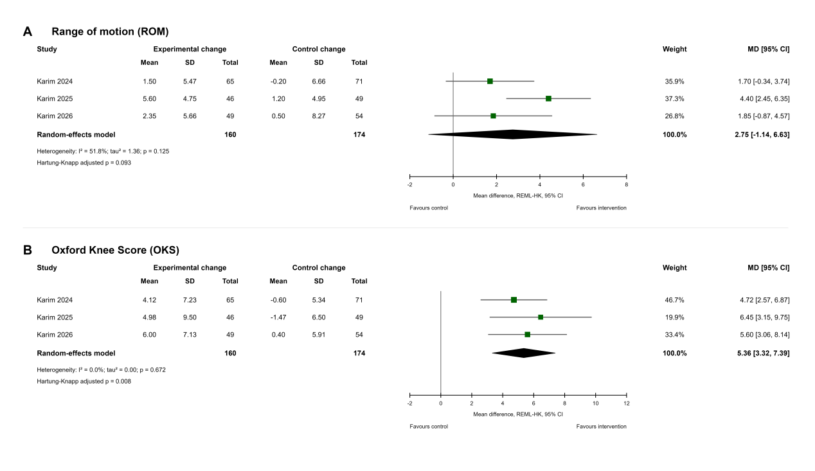
Supplementary Fig. 2 Forest plots for functional outcomes. A, range of motion; B, Oxford Knee Score.
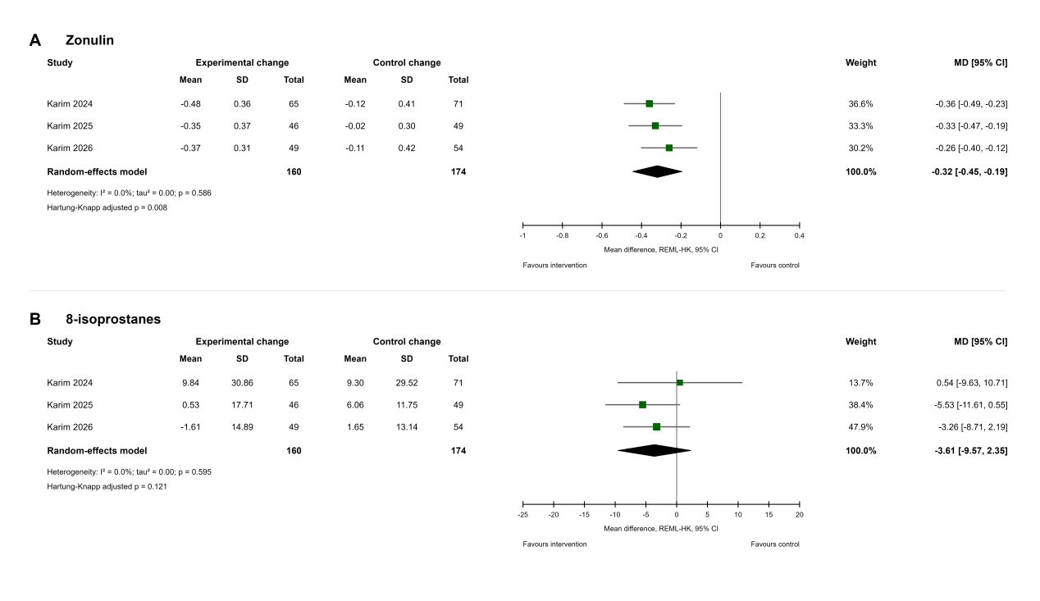
Supplementary Fig. 3 Forest plots for intestinal barrier and oxidative stress markers. A, zonulin; B, 8-isoprostanes.
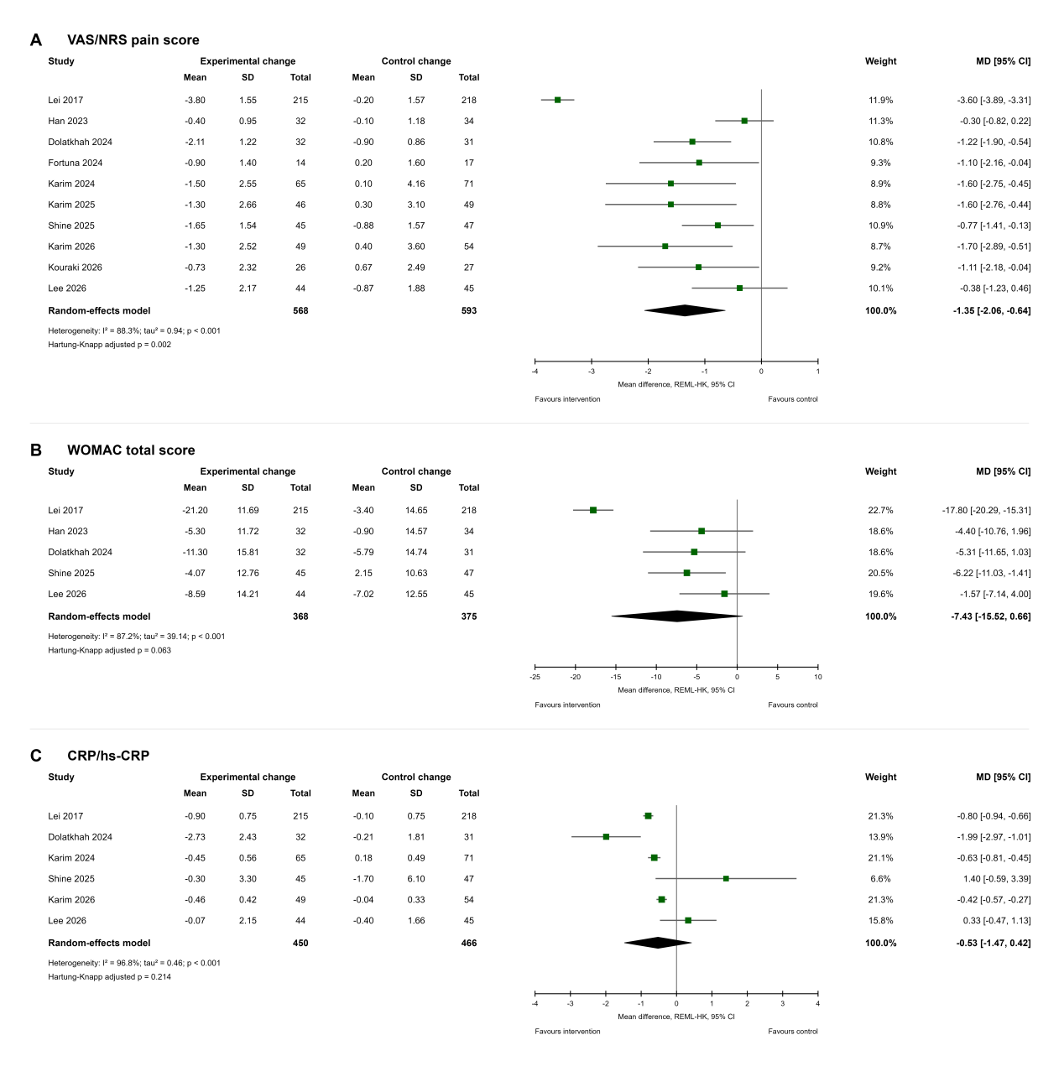
Supplementary Fig. 4 Expanded change-score sensitivity analyses incorporating additional change-score data derived from supplementary materials or digital plot extraction. A, pain intensity; B, WOMAC total score; C, CRP/hs-CRP.

