Supplemental Figures
Supplementary Figure 1. Sample-to-sample correlation heatmaps across gravity conditions. Heatmaps display Pearson correlation coefficients between all pairwise sample combinations within each gravity treatment, calculated from variance-stabilized count data. Panels show simulated microgravity (sim-µg), simulated lunar gravity (sim-Moon), hypergravity (2g), and hypergravity (4g). Hierarchical clustering was applied to both rows and columns. In each condition, biological replicates cluster together and are clearly separated from control groups, indicating reproducible and gravity-specific transcriptional responses across reduced and elevated gravity treatments.

Supplementary Figure 2. Principal component analysis of transcriptomic responses to altered gravity. Principal component analysis (PCA) of normalized gene expression profiles comparing simulated microgravity (sim-µg), simulated lunar gravity (sim-Moon), hypergravity (2g), and hypergravity (4g) samples to their respective simulated gravity controls. Each point represents an individual biological replicate, with color indicating gravity condition as shown in the legends. PC1 and PC2 capture the major sources of variance in the dataset. In all cases, samples exposed to altered gravity separate from simulated gravity controls along PC1, indicating distinct and reproducible transcriptional responses to both reduced and elevated gravity conditions.

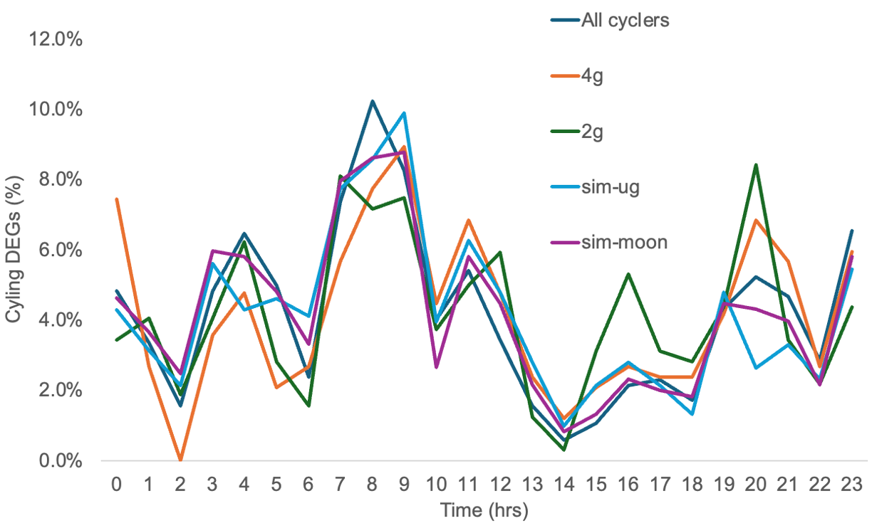
Supplemental Figure 3. Time-of-day (TOD) phase distribution of cycling gravity-responsive differentially expressed genes (DEGs). Cycling DEGs identified under simulated microgravity (sim-µg), simulated lunar gravity (sim-Moon), hypergravity (2g), and hypergravity (4g) conditions were assigned a peak expression time based on a previously published diurnal time-course analysis of W. australiana (Michael et al., 2020). The percentage of cycling DEGs peaking at each hour of the day was compared with the distribution of all cycling genes (“All cyclers”) to assess whether gravity-responsive genes exhibited coordinated or phased circadian expression patterns. Across all gravity conditions, the temporal distribution of cycling DEGs closely mirrored that of the overall cycling transcriptome, indicating no evidence for coordinated TOD regulation specific to gravity-responsive DEGs.

