Supplementary Information
Supplementary Figures
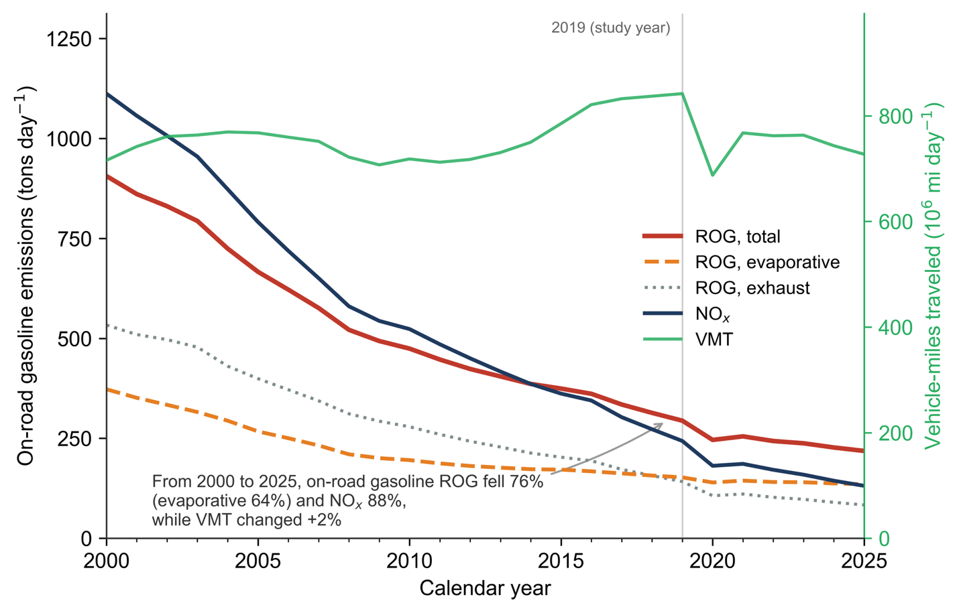
Supplementary Figure S1 | Total ROG, evaporative ROG, exhaust ROG, NOx emissions, and VMT of on-road gasoline vehicles from 2000-2025 in California. ROG falls 76% over time (evaporative 64%, exhaust 84%, NOx 88%) while VMT remains essentially unchanged (+2%), indicating fleet turnover and better evaporative controls.

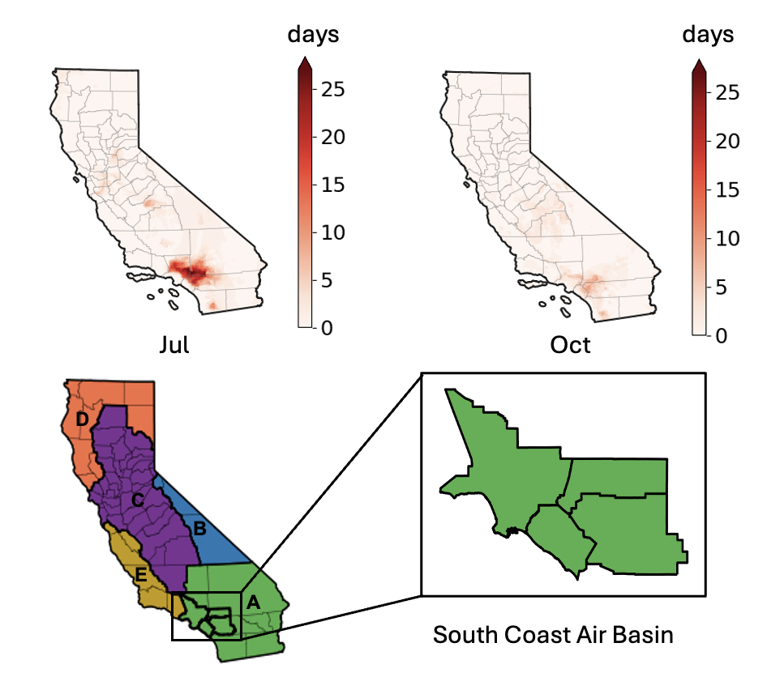
Supplementary Figure S2 | Number of days exceeding 70 ppb MDA8 ozone level in the baseline scenario for California domain in July and October (excluding 3 days of model spin-up time). The maps below show the boundary of South Coast Air Basin.

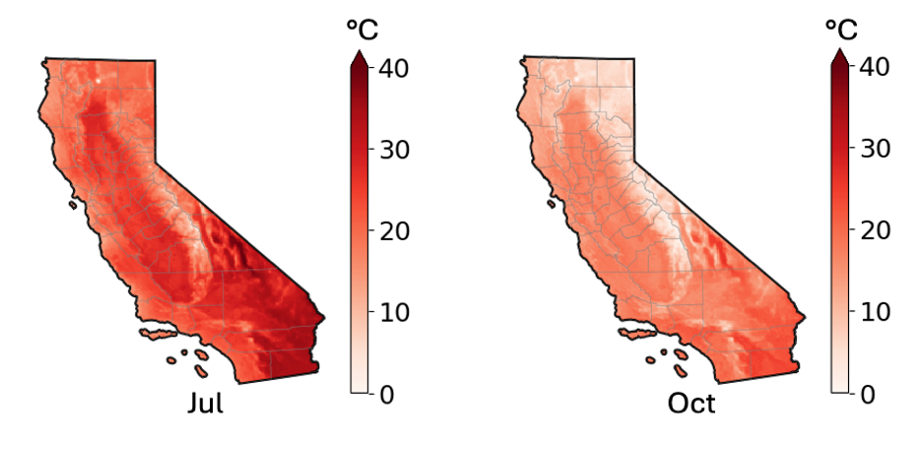
Supplementary Figure S3 | Average temperature for July and October.

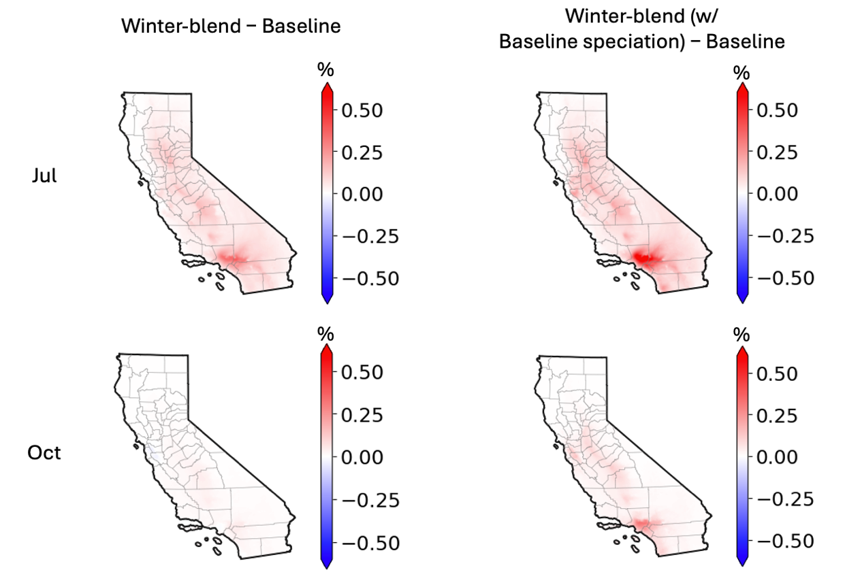
Supplementary Figure S4 | Percentage changes of MDA8 Ozone concentrations relative to Baseline scenario for July and October.

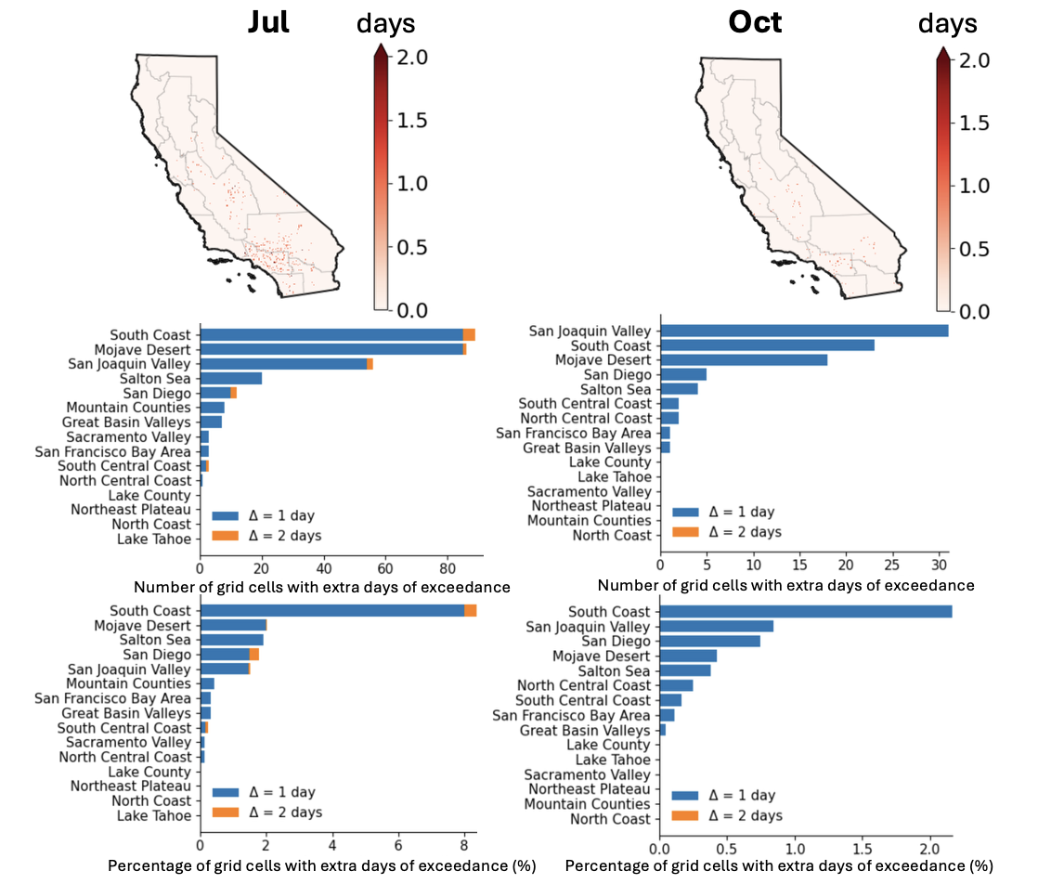
Supplementary Figure S5 | Maps of extra days of exceeding 70 ppb 8h-ozone level in Winter-blend scenario compared to Baseline scenario for July and October. The number and percentage of grid cells with extra days of exceedance for each air basin are shown in the bar plots.

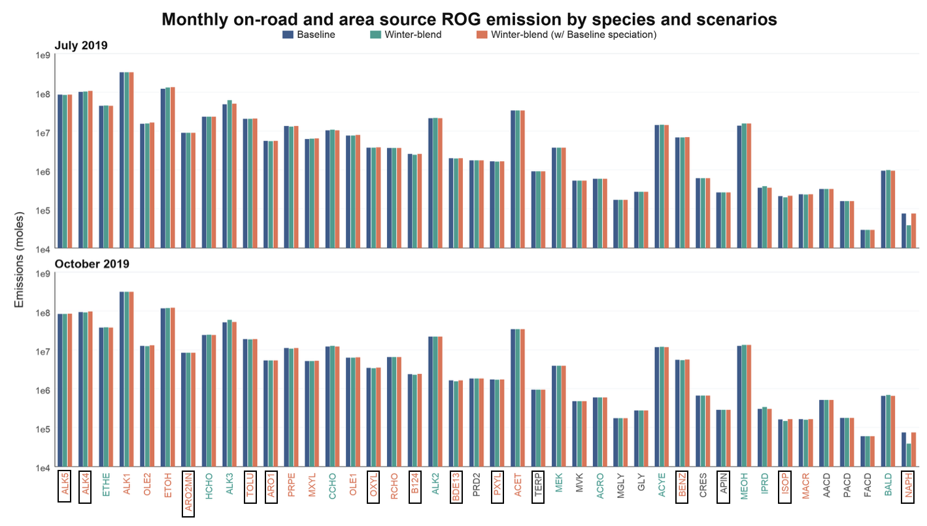
Supplementary Figure S6 | Statewide monthly on-road (including on-road gasoline evaporative sources) and area source (including off-road gasoline evaporative sources) emissions (moles) of different ROG species by species and scenarios. Species are ordered by their relative photochemical reactivity in the SAPRC07 mechanism¹. The color of each x-axis label describes whether Winter-blend or Winter-blend (w/ Baseline speciation) scenario has higher emissions; black represents a tie. Boxed species indicate compounds or lumped species groups considered SOA precursors. Emissions are shown in moles on a logarithmic scale. Detailed explanations of the species are listed in Table S3.

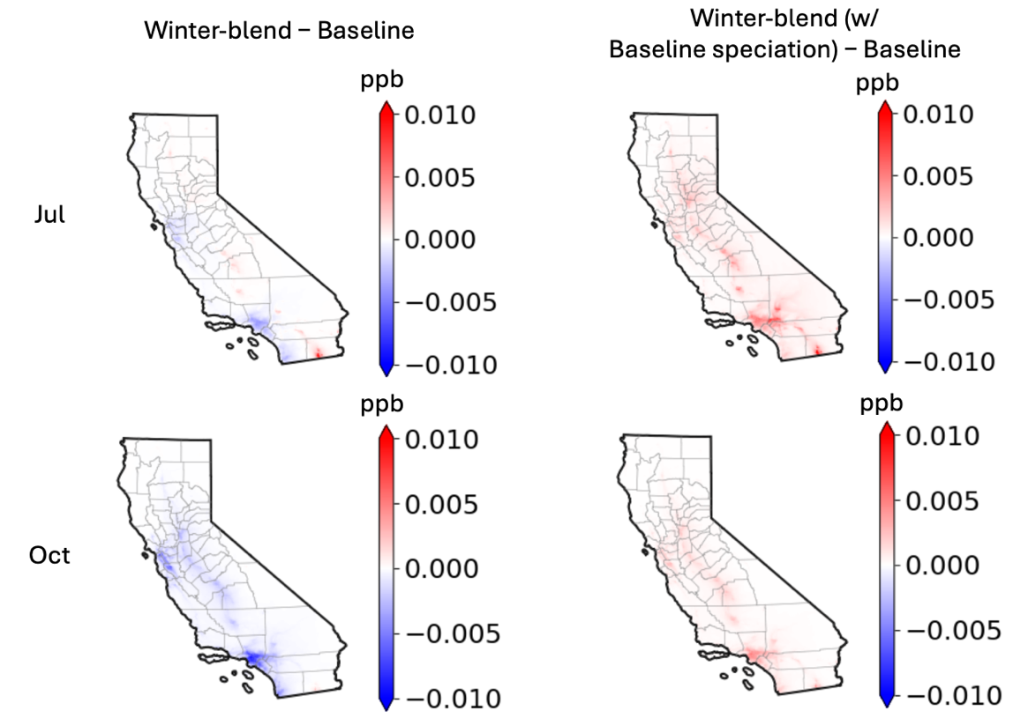
Supplementary Figure S7 | Benzene monthly mean concentration changes relative to Baseline scenario.

Supplementary Tables
Supplementary Table S1 | Summer and winter profile comparison for different gasoline-related emission processes. All data are based on the best available data found in the chemical speciation database of CARB. ALK4, ALK5, APIN, ARO1, ARO2MN, B124, BENZ, ISOP, MXYL, NAPH, OXYL, PXYL, TOL and TERP are considered as SOA precursors².
Emission source sector | Emission category | Seasonal fuel blend | Emission process | SOA precursor percentage
On-road | Evaporative | Summer | Hot soak | 40%
On-road | Evaporative | Summer | Diurnal | 38%
On-road | Exhaust | Summer | Starting Exhaust | 57%
On-road | Exhaust | Summer | Running Exhaust | 49%
On-road | Exhaust | Winter | Starting Exhaust | 55%
On-road | Exhaust | Winter | Running Exhaust | 37%
Off-road mobile | Evaporative | Summer | Offroad equipment Headspace Vapor | 67%
Off-road mobile | Evaporative | Winter | Offroad equipment Headspace Vapor | 46%
Off-road mobile | Evaporative | Not mentioned | Recreational Vehicle Diurnal Evaporative | 56%
Off-road mobile | Exhaust | Not mentioned | Offroad equipment stabilized exhaust | 55%
Off-road mobile | Exhaust | Not mentioned | Recreational Vehicle Diurnal Running Exhaust | 61%

Supplementary Table S2 | Comparison of California gasoline retail price and U.S. average gasoline retail price for winter-blend early transition years and non-early-transition years^{3,4}. Year 2020 is excluded to avoid the impact of COVID.
Year | California early transition? | California average gasoline retail price – US average gasoline retail price in the first week of October | Change after 4 weeks
2016 | No | $0.56 | +$0.03
2017 | No | $0.55 | +$0.03
2018 | No | $0.76 | +$0.11
2019 | No | $1.45 | -$0.1
2021 | No | $1.05 | -$0.00
2022 | Yes | $2.43 | -$0.86
2023 | Yes | $2.10 | -$0.51
2024 | No | $1.27 | -$0.05
2025 | No | $1.33 | -$0.09

Supplementary Table S3 | Definition of ROG species and SOA precursor in speciation profiles²
Species in profiles | Interpretation / representative compounds | Included in SOA-precursor percentage?
AACD | Acetic acid | No
ACET | Acetone | No
ACYE | Acetylene, also called ethyne | No
ACRO | Acrolein | No
ALK1 | Very-low-reactivity alkanes and other non-aromatic compounds, primarily ethane | No
ALK2 | Low-reactivity alkanes and other non-aromatic compounds | No
ALK3 | Intermediate-reactivity alkanes and other non-aromatic compounds | No
ALK4 | Higher-reactivity alkane and other non-aromatic compound lump | Yes
ALK5 | Highly reactive alkane and other non-aromatic compound lump | Yes
APIN | α-Pinene | Yes
ARO1 | Lumped lower-reactivity aromatics | Yes
ARO2MN | Higher-reactivity aromatic lump excluding naphthalene | Yes
BALD | Aromatic aldehydes, represented by benzaldehyde | No
BENZ | Benzene | Yes
BDE13 | 1,3-Butadiene | No
B124 | 1,2,4-Trimethylbenzene | Yes
CCHO | Acetaldehyde | No
CRES | Phenols and cresols | No
ETHE | Ethene, also called ethylene | No
ETOH | Ethanol | No
FACD | Formic acid | No
GLY | Glyoxal | No
HCHO | Formaldehyde | No
IPRD | Lumped isoprene oxidation products | No
ISOP | Isoprene | Yes
MACR | Methacrolein | No
MEK | Methyl ethyl ketone and moderately reactive ketone or oxygenate lump | No
MEOH | Methanol | No
MGLY | Methylglyoxal | No
MVK | Methyl vinyl ketone | No
MXYL | m-Xylene | Yes
NAPH | Naphthalene | Yes
OLE1 | Terminal or less-reactive alkene lump | No
OLE2 | Internal or more-reactive alkene lump | No
OXYL | o-Xylene | Yes
PACD | Higher organic acids, represented by propionic acid | No
PRD2 | Rapidly reacting ketones and other non-aldehyde oxygenated products | No
PRPE | Propene, also called propylene | No
PXYL | p-Xylene | Yes
RCHO | Lumped C3 and higher aldehydes, represented by propionaldehyde | No
TERP | Lumped terpenes, primarily monoterpenes | Yes
TOLU | Toluene | Yes

Supplementary Table S4 | Air quality modeling pipeline configurations
Model | Parameter | Configuration
WRF | Microphysics | Thompson microphysics scheme
WRF | Longwave radiation | RRTMG longwave radiation scheme
WRF | Shortwave radiation | RRTMG shortwave radiation scheme
WRF | Planetary boundary layer | Yonsei University scheme
WRF | Land surface | Noah land surface model
WRF | Surface Layer | Revised MM5 Monin–Obukhov surface layer scheme
WRF | Four-dimensional data assimilation | Grid analysis nudging for the outer domain
CMAQ | Chemical mechanism | SAPRC07tc, AERO6
CMAQ | Horizontal advection | Piecewise parabolic method, PPM
CMAQ | Vertical advection | WRF-consistent vertical advection
CMAQ | Horizontal diffusion | Multiscale horizontal diffusion based on local wind deformation
CMAQ | Vertical diffusion | ACM2 vertical diffusion with M3Dry dry deposition
CMAQ | Initial and boundary conditions | CAM-chem

Supplementary Table S5 | Air quality model evaluation for Baseline scenario*
 | Month | NMB  (benchmark 15%) | NME  (benchmark 25%) | r  (benchmark 0.5)
Ozone | July | 8.7 | 17.4 | 0.82
Ozone | Oct | 15.3 | 19.1 | 0.65

 | Month | MFB  (goal ±0.3, criteria ±0.6) | MFE  (goal ±0.5, criteria ±0.75) | NMB (benchmark 35%) | NME (benchmark 50%) | r  (benchmark 0.4)
PM_{2.5} | July | -0.4 | 0.5 | -38.6 | 42.8 | 0.49
PM_{2.5} | Oct | -0.3 | 0.5 | -20.7 | 43.3 | 0.46
* Model performance benchmarks were based on recommended photochemical model evaluation statistics from Emery et al.⁵; PM_{2.5} goals and criteria are referred from Boylan and Russell⁶ and Zhang et al.⁷

Supplementary Table S6 | Estimated monthly gasoline production cost savings from adopting the upper-bound RVP in California
Month | Average RVP (psi) | Cost savings per gallon*-conservative  (cent per gallon) | Cost savings per gallon-higher (cent per gallon) | Gasoline consumption** (million gallon per day) | Cost savings-conservative (million) | Cost savings-higher (million)
Jan | 13.05 | 0.29 | 0.60 | 37.06 | 3.31 | 6.95
Feb | 12.03 | 1.27 | 2.66 | 38.32 | 13.60 | 28.55
Mar | 9.51 | 3.69 | 7.74 | 37.68 | 43.05 | 90.41
Apr | 7.62 | 5.50 | 11.55 | 39.33 | 64.91 | 136.30
May | 7.19 | 5.91 | 12.42 | 38.89 | 71.29 | 149.71
Jun | 6.98 | 6.12 | 12.84 | 39.70 | 72.82 | 152.93
Jul | 6.98 | 6.12 | 12.84 | 38.71 | 73.39 | 154.12
Aug | 6.98 | 6.12 | 12.84 | 40.54 | 76.85 | 161.38
Sep | 6.98 | 6.12 | 12.84 | 38.78 | 71.14 | 149.39
Oct | 7.24 | 5.87 | 12.32 | 38.72 | 70.41 | 147.85
Nov | 9.93 | 3.28 | 6.89 | 37.53 | 36.96 | 77.62
Dec | 12.56 | 0.76 | 1.59 | 37.17 | 8.74 | 18.35
Annual | - | - | - | - | 606.47 | 1273.59
* The potential production cost saving per gallon for each month is a rough estimate of cost savings if adopting the upper-bound RVP gasoline. The final production cost savings are calculated by the cost savings per gallon and the total amount of gasoline consumption in California. The annual cost savings are calculated by summing up monthly cost savings.
** The averaged California gasoline consumption in year 2019. Data source: EIA, 2022⁸

Supplementary Table S7 | Health impact functions used in BenMAP. All functions are selected from EPA Standard Functions (2021) in BenMAP database.
Pollutant | Category | Endpoint Description | Unit Value (2015 $) | Reference
Ozone | Mortality | Short-term mortality, respiratory | $8.7 Million | Katsouyanni et al, 2009
Ozone | Morbidity | Hospital admissions, respiratory | $36,451 | Katsouyanni et al, 2009
PM_{2.5} | Mortality | Long-term mortality, all cause (convert to short-term using delta PM_{2.5} divided by 12) | $8.7 Million | Pope et al, 2019
PM_{2.5} | Morbidity | Hospital admissions, respiratory | $36,451 | Bell et al, 2009
PM_{2.5} | Morbidity | ED visit, cardiovascular | $875 | Ostro et al, 2016
Monetized health benefits are calculated using the equation listed below. For October concentrations which is out of the ozone epidemiology study period, the daily values are placed on the same days in a year as July. This is the best available method for our study but may overestimate the overall health impact of October.
The concentration-response function for each health outcome is:
$$∆y= \left(1-e^{-β∆x}\right)×y_{0}×Population$$
Where $∆y$ represents change in incidence for the relevant health endpoint, β is the concentration-response coefficient, Δx is the variation in surface concentrations, y₀ is the incidence rate in the baseline scenario, and Population is the impacted population. More details on the functions are available from the BenMAP user manual available at EPA BenMAP official website⁹.

Supplementary Table S8 | Detailed monetized health impact in 2019 dollars for Winter-blend scenarios compared to Baseline scenario. Positive values indicate health benefits and negative values indicate damages.
Health Endpoint | July |  | Oct
Health Endpoint | Winter-blend | Winter-blend  (w/ Baseline speciation) | Winter-blend | Winter-blend  (w/ Baseline speciation)
Ozone Mortality | -$13,725,134 | -$24,906,617 | -$1,487,478 | -$11,643,179
Ozone Hospital Admission | -$187,133 | -$349,516 | -$19,021 | -$166,093
PM_{2.5} Mortality | $2,906,210 | -$3,942,413 | $6,703,366 | -$4,929,890
PM_{2.5} Hospital Admission | $444 | -$670 | $1,023 | -$795
PM_{2.5} Emergency Room | $200 | -$281 | $453 | -$346
Net monetized impact | -$11,005,413 | -$29,199,497 | $5,198,343 | -$16,740,303
2015 dollars before adjustment:
Health Endpoint | July |  | Oct
Health Endpoint | Winter-blend | Winter-blend  (w/ Baseline speciation) | Winter-blend | Winter-blend  (w/ Baseline speciation)
Ozone Mortality | -$12,708,457 | -$23,061,682 | -$1,377,294 | -$10,780,721
Ozone Hospital Admission | -$173,271 | -$323,626 | -$17,612 | -$153,790
PM_{2.5} Mortality | $2,690,935 | -$3,650,382 | $6,206,820 | -$4,564,713
PM_{2.5} Hospital Admission | $411 | -$620 | $947 | -$736
PM_{2.5} Emergency Room | $185 | -$260 | $419 | -$320
Net monetized impact | -$10,190,197 | -$27,036,570 | $4,813,280 | -$15,500,280

Supplementary Table S9 | Summer statewide ROG emissions for selected sectors
Emission sector | Emission source | Vehicle Population | ROG total  (ton per day)
Off-road mobile sector | Lawn and garden (residential) | - | 50¹⁰
Pre-2004 gasoline vehicles | All vehicle categories | 6,447,208 | 213¹¹
The additional ROG emissions under the Winter-blend scenario are 51 tons per day in July and 13 tons per day in October. Off-road mobile sector emissions are from CEPAMv1.0.4 for calendar year 2019. Vehicle population and emissions represent the EMFACv2.0.0 modeled inventory for calendar year 2019 and include both exhaust and evaporative ROG emissions.

Reference:
1. Carter, W. P. L. Updated Maximum Incremental Reactivity Scale and Hydrocarbon Bin Reactivities for Regulatory Applications. https://ww2.arb.ca.gov/sites/default/files/barcu/regact/2009/mir2009/mir10.pdf (2010).
2. GitHub - USEPA/CMAQ: Code for U.S. EPA’s Community Multiscale Air Quality Model (CMAQ) for estimating ozone, particulates, toxics, and deposition of acids and nutrients at neighborhood to global scales. https://github.com/USEPA/cmaq (2026).
3. U.S. Energy Information Administration. Weekly U.S. Regular All Formulations Retail Gasoline Prices. https://www.eia.gov/dnav/pet/hist/LeafHandler.ashx?n=PET&s=EMM_EPMR_PTE_NUS_DPG&f=W (2026).
4. U.S. Energy Information Administration. Weekly California Regular All Formulations Retail Gasoline Prices. https://www.eia.gov/dnav/pet/hist/LeafHandler.ashx?f=W&n=PET&s=EMM_EPMR_PTE_SCA_DPG (2026).
5. Emery, C. et al. Recommendations on statistics and benchmarks to assess photochemical model performance. J. Air Waste Manag. Assoc. 67, 582–598 (2017).
6. Boylan, J. W. & Russell, A. G. PM and light extinction model performance metrics, goals, and criteria for three-dimensional air quality models. Atmos. Environ. 40, 4946–4959 (2006).
7. Zhang, H. et al. Evaluation of a seven-year air quality simulation using the Weather Research and Forecasting (WRF)/Community Multiscale Air Quality (CMAQ) models in the eastern United States. Sci. Total Environ. 473–474, 275–285 (2014).
8. U.S. Energy Information Administration. California Total Gasoline All Sales/Deliveries by Prime Supplier. https://www.eia.gov/dnav/pet/hist/LeafHandler.ashx?n=pet&s=c100050061&f=m (2022).
9. US EPA. BenMAP-CE Manual. https://www.epa.gov/system/files/documents/2025-08/benmap_usermanual_2025_08_11_1.pdf (2025).
10. California Air Resources Board. CEPAM2019v1.04 - Standard Emission Tool. https://ww2.arb.ca.gov/applications/cepam2019v1-04-standard-emission-tool (2026).
11. California Air Resources Board. EMFAC Emissions Inventory. https://emfac.arb.ca.gov/emissions-inventory (2026).

