Supplement.

Table S1. Studies assessing the age effects of sleep macro-architecture. 2
Table S2. Studies assessing the age-effects of sleep micro-architecture. 3
Table S3. Mean, SD, and range for established sleep macro- and micro-architecture variables. 4
Table S4. Effect of age on sleep macro-architecture across adolescence when accounting for 5
weekday/weeknight night of recording. 5
Table S5. Effect of age on sleep macro-architecture across adolescence when accounting
for summer/school year night of recording. 6
Table S6. Effect of age on sleep micro-architecture across adolescence when accounting for
weekday/weekend night of recording. 7
Table S7. Effect of age on sleep micro-architecture across adolescence when accounting for summer/school year night of recording. 8
Table S8. Effect of sex on sleep macro- and microarchitecture variables. 9
Table S9. Effect of age on intra-individual variability of macro- and microarchitecture variables. 11
Figure S1. Significant associations between sleep macro-architecture and age, separated by sex. 13
Figure S2. Associations between sleep micro-architecture and age. 14
Figure S3. Macro- and micro-architecture variables showing significant sex differences. 15
Figure S4. Significant associations between age and intra-individual variability of macro- and micro-architecture variables. 16
Supplemental References. 17

Table S1. Electroencephalography studies assessing the effect of age on sleep macro-architecture.
Variable | Reference #1 | Reference #1 Age(s) Tested | Reference #2 | Reference #2 Age(s) Tested | Age effect
Total Sleep Time (TST) | Kozhemiako et al., 2024¹ | 2.5-17.5 years | Scholle et al., 2011² | 1-18 years | TST decreases with age
Wake After Sleep Onset (WASO) | Kozhemiako et al., 2024¹ | 2.5-17.5 years | Baker et al., 2016³ | 12-21 years | WASO increases with age
N2% | Kozhemiako et al., 2024¹ | 2.5-17.5 years | Scholle et al., 2011² | 1-18 years | N2% increases with age
N3% | Tarokh & Carskadon, 2010⁴ | 9-13 years | Baker et al., 2016³ | 12-21 years | N3% decreases with age
Rapid Eye-Movement (REM) sleep (%) | Jenni & Carskadon, 2004⁵ | 9-16 years | Kozhemiako et al., 2024¹ | 2.5-17.5 years | REM% decreases with age
REM Latency | Coble et al., 1984⁶ | 6-16 years | Gillin et al., 1981⁷ | 15-64 years | REM latency decreases with age
Sleep Efficiency | Kozhemiako et al., 2024¹ | 2.5-17.5 years | Baker et al., 2016³ | 12-21 years | Sleep efficiency decreases with age
Time In Bed (TIB) | Feinberg et al., 2012⁸ | 9-18 years | Coble et al., 1984⁶ | 6-16 years | TIB decreases with age

Table S2. Electroencephalography studies assessing the effect of age on sleep micro-architecture.
Variable | Reference #1 | Reference #1 Age(s) Tested | Reference #2 | Reference #2 Age(s) Tested | Age effect
Absolute NREM delta power | Baker et al., 2016³ | 12-21 years | Tarokh & Carskadon, 2010⁴ | 9-13 years | NREM delta power decreases with age
Absolute NREM sigma power | Goldstone et al., 2019¹⁰ | 12-21 years | Kurth et al., 2010¹¹ | 2.4-19.4 years | NREM sigma power increases until age 11 then decreases with age
Absolute NREM theta power | Campbell & Feinberg, 2009¹² | 6-17 years | Campbell et al., 2012¹³ | 9-18 years | NREM theta decreases with age
Absolute NREM beta power | Tarokh & Carskadon, 2010⁴ | 9-13 years | Gaudreau, Carrier & Montplaisir, 2001¹⁴ | 6-60 years | NREM beta decreases with age
Absolute REM delta power | Baker et al., 2012¹⁵ | 11-14 years | Feinberg & Campbell, 2013¹⁶ | 6-18 years | REM delta power decreases with age
Absolute REM sigma power | Jenni & Carskadon, 2004⁵ | 9-16 years | Baker et al., 2012¹⁵ | 11-14 years | REM sigma power decreases with age
Absolute REM theta power | Tarokh & Carskadon, 2010⁴ | 9-13 years | Baker et al., 2012¹⁵ | 11-14 years | REM theta power decreases with age
Slow oscillation (SO)-spindle coupling | Joechner et al., 2023¹⁷ | 526 years | Hahn et al., 2020¹⁸ | 9.5-16 years (mean ages) | SO-spindle coupling is temporally more precise with age
Slow spindle amplitude | Goldstone et al., 2019¹⁰ | 12-21 years | Nader & Smith, 2015¹⁹ | 12-19 years | Slow spindle amplitude decreases with age
Slow spindle density | Gombos et al., 2022²⁰ | 12-20 years | Nader & Smith, 2015¹⁹ | 12-19 years | Slow spindle density decreases with age
Slow spindle duration | Gombos et al., 2022²⁰ | 12.5-21.3 years (mean ages) | Goldstone et al., 2019¹⁰ | 12-21 years | Slow spindle duration decreases with age
Fast spindle amplitude | Goldstone et al., 2019¹⁰ | 12-21 years | Nader & Smith, 2015¹⁹ | 12-19 years | Fast spindle amplitude decreases with age
Fast spindle density | Goldstone et al., 2019¹⁰ | 12-21 years | Nader & Smith, 2015¹⁹ | 12-19 years | Fast spindle density increases with age
Fast spindle duration | Gombos et al., 2022²⁰ | 12.5-21.3 years (mean ages) | Goldstone et al., 2019¹⁰ | 12-21 years | Fast spindle duration decreases with age
Abbreviations: NREM, non-rapid eye movement sleep; REM, rapid eye movement sleep.

Table S3. Mean, SD, and range for established sleep macro- and micro-architecture variables.
 | Total (N = 100) |  |  | BCH (N = 40) |  |  | PITT (N = 60)
Sleep Variables | Mean | SD | Range | Mean | SD | Range | Mean | SD | Range
Total Sleep Time (min) | 408.59 | 87.74 | 181-622.5 | 426.51 | 89.48 | 203-622.5 | 397.58 | 85.02 | 181-619
Wake After Sleep Onset | 31.25 | 38.18 | 2-249.5 | 26.50 | 27.69 | 3.5-133.5 | 34.17 | 43.20 | 2-249.5
N2% | 41.48 | 8.86 | 14.5-65.97 | 39.31 | 8.42 | 18.73-59.78 | 42.81 | 8.88 | 14.5-65.97
N3% | 28.76 | 9.51 | 5.69-61.36 | 30.77 | 9.39 | 11.26-50.88 | 27.53 | 9.40 | 5.69-61.36
REM% | 24.44 | 8.31 | 1.37-74.93 | 24.84 | 7.21 | 5.91-53.16 | 24.19 | 8.93 | 1.37-74.93
REM Latency | 97.54 | 49.48 | 0-296 | 98.72 | 44.54 | 0-218.5 | 96.81 | 52.38 | 2-296
Sleep Efficiency | 85.72 | 13.68 | 12.67-98.66 | 87.60 | 11.51 | 36.38-97.87 | 84.56 | 14.77 | 12.67-98.66
Time in Bed | 474.69 | 92.72 | 209.5-880.5 | 488.83 | 91.91 | 271-880.5 | 465.99 | 92.39 | 209.5-862
Absolute NREM Delta | 905.34 | 440.58 | 181.66-2375.54 | 940.60 | 461.07 | 181.66-2189.05 | 883.67 | 427.28 | 242.86-2375.54
Absolute NREM Sigma | 11.99 | 8.17 | 2.88-83.81 | 10.50 | 9.09 | 2.88-83.81 | 12.91 | 7.43 | 3.28-48.59
Absolute NREM Theta | 111.14 | 83.99 | 21.97-784.65 | 101.61 | 73.74 | 21.97-574.4 | 117.01 | 89.40 | 25.45-784.65
Absolute NREM Beta | 12.83 | 16.20 | 3.41-195.12 | 12.87 | 22.77 | 3.41-195.12 | 12.80 | 10.35 | 4.5-92.27
Absolute REM Delta | 404.05 | 416.63 | 30.69-3380.83 | 328.31 | 319.93 | 56.75-1581.22 | 450.60 | 460.86 | 30.69-3380.83
Absolute REM Sigma | 9.77 | 12.85 | 1.81-125.4 | 6.65 | 5.68 | 1.81-34.2 | 11.68 | 15.41 | 2.14-125.4
Absolute REM Theta | 102.85 | 117.99 | 12.35-779.64 | 78.40 | 99.96 | 12.78-627.38 | 117.88 | 125.71 | 12.35-779.64
Slow spindle duration | 0.87 | 0.11 | 0.67-1.33 | 0.91 | 0.13 | 0.72-1.33 | 0.84 | 0.09 | 0.67-1.29
Slow spindle amplitude | 45.42 | 14.98 | 21.28-102.79 | 43.39 | 14.46 | 21.28-102.49 | 46.66 | 15.20 | 21.62-102.79
Slow spindle density | 1.29 | 0.63 | 0.01-3.56 | 1.52 | 0.73 | 0.52-3.56 | 1.15 | 0.50 | 0.01-2.65
Fast spindle duration | 0.78 | 0.08 | 0.59-1.17 | 0.80 | 0.08 | 0.68-1.11 | 0.76 | 0.08 | 0.59-1.17
Fast spindle amplitude | 28.84 | 11.69 | 13.02-88.3 | 28.74 | 13.48 | 13.5-88.3 | 28.90 | 10.48 | 13.02-74.97
Fast spindle density | 0.48 | 0.33 | 0.02-1.89 | 0.50 | 0.33 | 0.1-1.72 | 0.47 | 0.32 | 0.02-1.89
Slow oscillation-slow spindle coupling magnitude | 0.21 | 0.11 | 0.02-1 | 0.17 | 0.07 | 0.04-0.36 | 0.23 | 0.12 | 0.02-1
Slow oscillation-fast spindle coupling magnitude | 0.18 | 0.12 | 0.03-0.74 | 0.15 | 0.09 | 0.03-0.52 | 0.20 | 0.13 | 0.04-0.74
Abbreviations: NREM, non-rapid eye movement sleep; REM, rapid eye movement sleep.

Table S4. Effect of age on sleep macro-architecture across adolescence when accounting for weekday/weekend night of recording.
Sleep Macro-architecture
Sleep Variables | β | SE | t | p | p_{FDR}
Total Sleep Time | -0.14 | 0.07 | -1.88 | 6.04e-02 | 9.66e-02
Wake After Sleep Onset | -0.06 | 0.04 | -1.33 | 1.85e-01 | 1.85e-01
N2% | 0.28 | 0.08 | 3.50 | 5.04e-04 | 1.01e-03
N3% | -0.39 | 0.08 | -4.88 | 1.38e-06 | 1.10e-05
REM% | 0.11 | 0.07 | 1.62 | 1.07e-01 | 1.32e-01
REM latency | -0.24 | 0.06 | -3.73 | 2.11e-04 | 8.42e-04
Sleep Efficiency | 0.08 | 0.05 | 1.58 | 1.15e-01 | 1.32e-01
Time In Bed | -0.25 | 0.07 | -3.57 | 3.85e-04 | 1.01e-03
Abbreviations: NREM, non-rapid eye movement sleep; REM, rapid eye movement sleep. Models account
for age, sex, and weekday/weekend night of recording as fixed effects, and participant nested within site as a random effect. Values in bold survive correction for multiple comparisons (false discovery rate, p_{FDR}<0.05).

Table S5. Effect of age on sleep macro-architecture across adolescence when accounting for summer/school year night of recording.
Sleep Macro-architecture
Sleep Variables | β | SE | t | p | p_{FDR}
Total Sleep Time | -0.14 | 0.08 | -1.85 | 6.49e-02 | 8.65e-02
Wake After Sleep Onset | -0.06 | 0.04 | -1.32 | 1.86e-01 | 1.86e-01
N2% | 0.25 | 0.08 | 3.13 | 1.85e-03 | 3.69e-03
N3% | -0.39 | 0.08 | -4.67 | 3.67e-06 | 2.93e-05
REM% | 0.14 | 0.07 | 1.86 | 6.28e-02 | 8.65e-02
REM latency | -0.26 | 0.07 | -3.92 | 9.85e-05 | 3.94e-04
Sleep Efficiency | 0.09 | 0.05 | 1.75 | 8.06e-02 | 9.21e-02
Time In Bed | -0.25 | 0.07 | -3.45 | 5.96e-04 | 1.59e-03
Abbreviations: NREM, non-rapid eye movement sleep; REM, rapid eye movement sleep. Models account for age, sex and summer/school year night of recording as fixed effects, and participant nested within site as a random effect. Values in bold survive correction for multiple comparisons (false discovery rate, p_{FDR}<0.05).

Table S6. Effect of age on sleep micro-architecture across adolescence when accounting for weekday/weekend night of recording.
 | Sleep Micro-architecture
Absolute power during NREM and REM | Sleep Variables | β | SE | t | p | p_{FDR}
Absolute power during NREM and REM | NREM Delta | -0.50 | 0.07 | -7.33 | 8.16e-13 | 6.12e-12
Absolute power during NREM and REM | NREM Sigma | -0.04 | 0.04 | -0.85 | 3.97e-01 | 5.50e-01
Absolute power during NREM and REM | NREM Theta | -0.11 | 0.04 | -2.96 | 3.22e-03 | 8.05e-03
Absolute power during NREM and REM | NREM Beta | -0.01 | 0.02 | -0.71 | 4.77e-01 | 5.50e-01
Absolute power during NREM and REM | REM Delta | -0.02 | 0.03 | -0.75 | 4.54e-01 | 5.50e-01
Absolute power during NREM and REM | REM Sigma | 0.01 | 0.02 | 0.65 | 5.14e-01 | 5.50e-01
Absolute power during NREM and REM | REM Theta | 0.01 | 0.03 | 0.21 | 8.30e-01 | 8.30e-01
Sleep spindle and coupling features | Slow spindle duration | -0.41 | 0.06 | -7.55 | 1.76e-13 | 2.63e-12
Sleep spindle and coupling features | Slow spindle amplitude | -0.11 | 0.06 | -2.00 | 4.57e-02 | 8.56e-02
Sleep spindle and coupling features | Slow spindle density | -0.43 | 0.08 | -5.41 | 9.23e-08 | 4.61e-07
Sleep spindle and coupling features | Fast spindle duration | -0.17 | 0.04 | -4.23 | 2.76e-05 | 1.03e-04
Sleep spindle and coupling features | Fast spindle amplitude | -0.04 | 0.05 | -0.78 | 4.35e-01 | 5.50e-01
Sleep spindle and coupling features | Fast spindle density | -0.06 | 0.06 | -1.10 | 2.71e-01 | 4.52e-01
Sleep spindle and coupling features | Slow oscillation-slow spindle coupling magnitude | 0.15 | 0.04 | 3.42 | 6.73e-04 | 2.02e-03
Sleep spindle and coupling features | Slow oscillation-fast spindle coupling magnitude | 0.10 | 0.04 | 2.78 | 5.67e-03 | 1.22e-02
Abbreviations: NREM, non-rapid eye movement sleep; REM, rapid eye movement sleep; SO, slow oscillation. Models account for age, sex, channel, and weekday/weekend night of recording as fixed effects, and participant nested within site as a random effect. Values in bold survive correction for multiple comparisons (false discovery rate, p_{FDR}<0.05).

Table S7. Effect of age on sleep micro-architecture across adolescence when accounting for summer/school year night of recording.
Outcome |  | β | SE | t | p | p_{FDR}
Absolute power during NREM and REM | NREM Delta | -0.53 | 0.07 | -7.45 | 3.42e-13 | 2.57e-12
Absolute power during NREM and REM | NREM Sigma | -0.04 | 0.04 | -0.85 | 3.97e-01 | 5.45e-01
Absolute power during NREM and REM | NREM Theta | -0.11 | 0.04 | -2.96 | 3.22e-03 | 8.05e-03
Absolute power during NREM and REM | NREM Beta | -0.01 | 0.02 | -0.81 | 4.18e-01 | 5.45e-01
Absolute power during NREM and REM | REM Delta | -0.02 | 0.03 | -0.75 | 4.54e-01 | 5.45e-01
Absolute power during NREM and REM | REM Sigma | 0.01 | 0.02 | 0.65 | 5.14e-01 | 5.50e-01
Absolute power during NREM and REM | REM Theta | 0.01 | 0.03 | 0.21 | 8.30e-01 | 8.30e-01
Sleep spindle and coupling features | Slow spindle duration | -0.41 | 0.06 | -7.55 | 1.76e-13 | 2.57e-12
Sleep spindle and coupling features | Slow spindle amplitude | -0.11 | 0.06 | -2.00 | 4.57e-02 | 8.56e-02
Sleep spindle and coupling features | Slow spindle density | -0.43 | 0.08 | -5.41 | 9.23e-08 | 4.61e-07
Sleep spindle and coupling features | Fast spindle duration | -0.17 | 0.04 | -4.23 | 2.76e-05 | 1.03e-04
Sleep spindle and coupling features | Fast spindle amplitude | -0.03 | 0.05 | -0.72 | 4.73e-01 | 5.45e-01
Sleep spindle and coupling features | Fast spindle density | -0.06 | 0.06 | -0.95 | 3.42e-01 | 5.45e-01
Sleep spindle and coupling features | Slow oscillation-slow spindle coupling magnitude | 0.15 | 0.04 | 3.42 | 6.73e-04 | 2.02e-03
Sleep spindle and coupling features | Slow oscillation-fast spindle coupling magnitude | 0.10 | 0.04 | 2.78 | 5.67e-03 | 1.22e-02
Abbreviations: NREM, non-rapid eye movement sleep; REM, rapid eye movement sleep. Models account for age, sex, channel, and summer/school year night of recording as fixed effects, and participant nested within site as a random effect. Values in bold survive correction for multiple comparisons (false discovery rate, p_{FDR}<0.05).

Table S8. Effect of sex on sleep macro- and microarchitecture variables.
Outcome |  | β | SE | t | p | p_{FDR}
Sleep macro-architecture features | Total Sleep Time | -0.29 | 0.15 | -1.95 | 5.20E-02 | 2.08E-01
Sleep macro-architecture features | Wake After Sleep Onset | -0.05 | 0.08 | -0.63 | 5.30E-01 | 8.49E-01
Sleep macro-architecture features | N2% | -0.19 | 0.16 | -1.23 | 2.20E-01 | 5.69E-01
Sleep macro-architecture features | N3% | 0.17 | 0.16 | 1.07 | 2.85E-01 | 5.69E-01
Sleep macro-architecture features | REM% | 0.05 | 0.14 | 0.38 | 7.01E-01 | 9.20E-01
Sleep macro-architecture features | REM latency | 0.01 | 0.13 | 0.10 | 9.20E-01 | 9.20E-01
Sleep macro-architecture features | Sleep Efficiency | -0.02 | 0.10 | -0.16 | 8.76E-01 | 9.20E-01
Sleep macro-architecture features | Time In Bed | -0.33 | 0.14 | -2.46 | 1.42E-02 | 1.14E-01
Sleep macro-architecture features | Transition index from NREM to REM | -0.03 | 0.15 | -0.17 | 8.67E-01 | 8.67E-01
Sleep macro-architecture features | Total sleep cycles | -0.37 | 0.12 | -2.96 | 3.15E-03 | 1.58E-02
Sleep macro-architecture features | Total cycle duration | -0.28 | 0.15 | -1.90 | 5.78E-02 | 1.14E-01
Sleep macro-architecture features | Total NREM cycle duration | -0.27 | 0.15 | -1.82 | 6.85E-02 | 1.14E-01
Sleep macro-architecture features | Total REM cycle duration | -0.09 | 0.16 | -0.56 | 5.76E-01 | 7.19E-01
Sleep spindle and coupling features | Slow spindle duration | -0.02 | 0.11 | -0.17 | 8.66E-01 | 8.66E-01
Sleep spindle and coupling features | Slow spindle amplitude | 0.02 | 0.11 | 0.21 | 8.35E-01 | 8.66E-01
Sleep spindle and coupling features | Slow spindle density | 0.08 | 0.16 | 0.48 | 6.28E-01 | 8.66E-01
Sleep spindle and coupling features | Fast spindle duration | -0.05 | 0.08 | -0.69 | 4.87E-01 | 8.66E-01
Sleep spindle and coupling features | Fast spindle amplitude | 0.03 | 0.09 | 0.37 | 7.09E-01 | 8.66E-01
Sleep spindle and coupling features | Fast spindle density | -0.17 | 0.11 | -1.45 | 1.47E-01 | 8.66E-01
Sleep spindle and coupling features | Slow oscillation-slow spindle coupling magnitude | 0.03 | 0.09 | 0.29 | 7.69E-01 | 8.66E-01
Sleep spindle and coupling features | Slow oscillation-fast spindle coupling magnitude | 0.04 | 0.07 | 0.62 | 5.34E-01 | 8.66E-01
Slow oscillation features | Slow oscillation duration | 0.14 | 0.15 | 0.93 | 3.53E-01 | 5.30E-01
Slow oscillation features | Median slow oscillation peak to peak amplitude | 0.00 | 0.13 | -0.03 | 9.77E-01 | 9.77E-01
Relative power during NREM and REM | NREM Delta | -0.15 | 0.18 | -0.86 | 3.92E-01 | 5.30E-01
Relative power during NREM and REM | NREM Sigma | -0.10 | 0.11 | -0.99 | 3.23E-01 | 5.30E-01
Relative power during NREM and REM | NREM Theta | -0.06 | 0.11 | -0.56 | 5.73E-01 | 6.81E-01
Relative power during NREM and REM | NREM Beta | -0.06 | 0.04 | -1.31 | 1.92E-01 | 4.05E-01
Relative power during NREM and REM | REM Delta | -0.11 | 0.13 | -0.86 | 3.91E-01 | 5.30E-01
Relative power during NREM and REM | REM Sigma | 0.36 | 0.11 | 3.17 | 1.59E-03 | 1.51E-02
Relative power during NREM and REM | REM Theta | 0.34 | 0.10 | 3.36 | 8.40E-04 | 1.51E-02
Relative power during NREM and REM | REM Alpha | 0.21 | 0.11 | 1.87 | 6.21E-02 | 1.69E-01
Relative power during NREM and REM | REM Beta | 0.17 | 0.06 | 2.90 | 3.89E-03 | 2.46E-02
Absolute power during NREM and REM | NREM Delta | -0.08 | 0.13 | -0.60 | 5.50E-01 | 8.66E-01
Absolute power during NREM and REM | NREM Sigma | -0.07 | 0.08 | -0.82 | 4.10E-01 | 8.66E-01
Absolute power during NREM and REM | NREM Theta | -0.03 | 0.07 | -0.44 | 6.59E-01 | 8.66E-01
Absolute power during NREM and REM | NREM Beta | -0.02 | 0.03 | -0.51 | 6.10E-01 | 8.66E-01
Absolute power during NREM and REM | REM Delta | -0.09 | 0.06 | -1.46 | 1.45E-01 | 8.66E-01
Absolute power during NREM and REM | REM Sigma | -0.01 | 0.04 | -0.27 | 7.86E-01 | 8.66E-01
Absolute power during NREM and REM | REM Theta | -0.04 | 0.05 | -0.81 | 4.19E-01 | 8.66E-01
Absolute power during NREM and REM | REM Alpha | -0.05 | 0.05 | -1.19 | 2.34E-01 | 4.46E-01
Absolute power during NREM and REM | REM Beta | 0.00 | 0.01 | -0.25 | 8.04E-01 | 8.49E-01
Sleep spindle features | Integrated slow spindle activity | -0.06 | 0.12 | -0.45 | 6.52E-01 | 7.28E-01
Sleep spindle features | Integrated fast spindle activity | -0.22 | 0.10 | -2.26 | 2.43E-02 | 1.15E-01
Sleep spindle features | Slow spindle chirp | 0.28 | 0.17 | 1.71 | 8.85E-02 | 2.10E-01
Sleep spindle features | Fast spindle chirp | 0.25 | 0.12 | 2.02 | 4.37E-02 | 1.38E-01
Sleep spindle features | Slow spindle frequency | -0.37 | 0.17 | -2.11 | 3.54E-02 | 1.34E-01
Sleep spindle features | Fast spindle frequency | 0.14 | 0.17 | 0.81 | 4.19E-01 | 5.30E-01
Abbreviations: NREM, non-rapid eye movement sleep; REM, rapid eye movement sleep. Models account for age and sex as fixed effects, and participant nested within site as a random effect. Microarchitecture variables also included channel as fixed effect. Values in bold survive correction for multiple comparisons (false discovery rate, p_{FDR}<0.05).

Table S9. Effect of age on intra-individual variability of macro- and microarchitecture variables.
Outcome |  | β | SE | t | p | p_{FDR}
Sleep macro-architecture features | Total Sleep Time | 0.01 | 0.12 | 0.09 | 9.28e-01 | 9.45e-01
Sleep macro-architecture features | Wake After Sleep Onset | -0.12 | 0.08 | -1.56 | 1.23e-01 | 2.47e-01
Sleep macro-architecture features | N2% | -0.01 | 0.13 | -0.07 | 9.45e-01 | 9.45e-01
Sleep macro-architecture features | N3% | 0.10 | 0.11 | 0.88 | 3.80e-01 | 5.07e-01
Sleep macro-architecture features | REM% | 0.21 | 0.06 | 3.33 | 1.35e-03 | 1.08e-02
Sleep macro-architecture features | REM latency | -0.24 | 0.11 | -2.07 | 4.21e-02 | 1.68e-01
Sleep macro-architecture features | Sleep Efficiency | -0.10 | 0.09 | -1.08 | 2.82e-01 | 4.52e-01
Sleep macro-architecture features | Time In Bed | 0.12 | 0.07 | 1.71 | 9.15e-02 | 2.44e-01
Sleep macro-architecture features | Transition index from NREM to REM | 0.06 | 0.11 | 0.51 | 6.13e-01 | 9.23e-01
Sleep macro-architecture features | Total sleep cycles | -0.16 | 0.10 | -1.62 | 1.09e-01 | 5.44e-01
Sleep macro-architecture features | Total cycle duration | -0.02 | 0.13 | -0.18 | 8.57e-01 | 9.23e-01
Sleep macro-architecture features | Total NREM cycle duration | -0.01 | 0.12 | -0.10 | 9.23e-01 | 9.23e-01
Sleep macro-architecture features | Total REM cycle duration | 0.07 | 0.12 | 0.57 | 5.68e-01 | 9.23e-01
Sleep spindle and coupling features | Slow spindle duration | -0.03 | 0.07 | -0.46 | 6.44e-01 | 8.20e-01
Sleep spindle and coupling features | Slow spindle amplitude | 0.12 | 0.11 | 1.12 | 2.66e-01 | 7.15e-01
Sleep spindle and coupling features | Slow spindle density | 0.07 | 0.09 | -0.83 | 4.07e-01 | 7.70e-01
Sleep spindle and coupling features | Fast spindle duration | -0.02 | 0.10 | -0.23 | 8.21e-01 | 9.32e-01
Sleep spindle and coupling features | Fast spindle amplitude | 0.06 | 0.07 | 0.84 | 4.06e-01 | 7.15e-01
Sleep spindle and coupling features | Fast spindle density | 0.03 | 0.06 | 0.49 | 6.22e-01 | 8.20e-01
Sleep spindle and coupling features | Slow oscillation-slow spindle coupling magnitude | 0.25 | 0.08 | 3.16 | 2.28e-03 | 3.20e-02
Sleep spindle and coupling features | Slow oscillation-fast spindle coupling magnitude | 0.18 | 0.12 | 1.49 | 1.41e-01 | 6.57e-01
Slow oscillation features | Slow oscillation duration | 0.18 | 0.08 | 2.27 | 2.61e-02 | 9.90e-02
Slow oscillation features | Median slow oscillation peak to peak amplitude | -0.03 | 0.08 | -0.45 | 6.55e-01 | 7.32e-01
Relative power during NREM and REM | NREM Delta | 0.16 | 0.11 | 1.48 | 1.44e-01 | 3.04e-01
Relative power during NREM and REM | NREM Sigma | 0.17 | 0.06 | 2.61 | 1.08e-02 | 5.11e-02
Relative power during NREM and REM | NREM Theta | 0.17 | 0.06 | 2.93 | 4.41e-03 | 3.85e-02
Relative power during NREM and REM | NREM Beta | 0.03 | 0.01 | 3.07 | 3.00e-03 | 3.85e-02
Relative power during NREM and REM | REM Delta | 0.19 | 0.14 | 1.34 | 1.83e-01 | 3.06e-01
Relative power during NREM and REM | REM Sigma | 0.10 | 0.05 | 1.98 | 5.18e-02 | 1.41e-01
Relative power during NREM and REM | REM Theta | 0.11 | 0.09 | 1.22 | 2.25e-01 | 3.06e-01
Relative power during NREM and REM | REM Alpha | 0.11 | 0.05 | 2.15 | 3.46e-02 | 1.10e-01
Relative power during NREM and REM | REM Beta | 0.02 | 0.01 | 1.23 | 2.23e-01 | 3.06e-01
Absolute power during NREM and REM | NREM Delta | -0.22 | 0.08 | -2.70 | 8.57e-03 | 6.00e-02
Absolute power during NREM and REM | NREM Sigma | 0.03 | 0.04 | 0.87 | 3.84e-01 | 7.15e-01
Absolute power during NREM and REM | NREM Theta | 0.00 | 0.06 | 0.09 | 9.32e-01 | 9.32e-01
Absolute power during NREM and REM | NREM Beta | 0.03 | 0.02 | 1.28 | 2.04e-01 | 7.13e-01
Absolute power during NREM and REM | REM Delta | -0.04 | 0.06 | -0.65 | 5.18e-01 | 8.06e-01
Absolute power during NREM and REM | REM Sigma | 0.04 | 0.04 | 0.83 | 4.09e-01 | 7.15e-01
Absolute power during NREM and REM | REM Theta | -0.01 | 0.05 | -0.13 | 8.93e-01 | 9.32e-01
Absolute power during NREM and REM | REM Alpha | 0.01 | 0.05 | 0.20 | 8.45e-01 | 8.45e-01
Absolute power during NREM and REM | REM Beta | 0.00 | 0.01 | 0.65 | 5.18e-01 | 6.15e-01
Sleep spindle features | Integrated slow spindle activity | -0.15 | 0.12 | -1.29 | 2.03e-01 | 3.06e-01
Sleep spindle features | Integrated fast spindle activity | -0.03 | 0.09 | -0.35 | 7.25e-01 | 7.66e-01
Sleep spindle features | Slow spindle chirp | 0.25 | 0.09 | 2.82 | 6.07e-03 | 3.85e-02
Sleep spindle features | Fast spindle chirp | 0.15 | 0.10 | 1.50 | 1.39e-01 | 3.04e-01
Sleep spindle features | Slow spindle frequency | 0.16 | 0.12 | 1.34 | 1.85e-01 | 3.06e-01
Sleep spindle features | Fast spindle frequency | 0.08 | 0.12 | 0.69 | 4.90e-01 | 6.15e-01
Note. Only participants with at least 3 nights of data included (N=80). Abbreviations: NREM, non-rapid eye movement sleep; REM, rapid eye movement sleep. Models account for age and sex as fixed effects, and participant nested within site as a random effect. Microarchitecture variables also included channel as fixed effect. Values in bold survive correction for multiple comparisons (false discovery rate, p_{FDR}<0.05).

Figure S1. Significant associations between sleep macro-architecture and age, separated by sex.
For visualization purposes, we averaged data points across channel and night for each individual. (A) N2% sleep, (B) N3% sleep, (C) rapid-eye movement (REM) latency, (D) time in bed. Dashed line = average age effect, red = female, blue = male. Shading represents 95% confidence intervals.
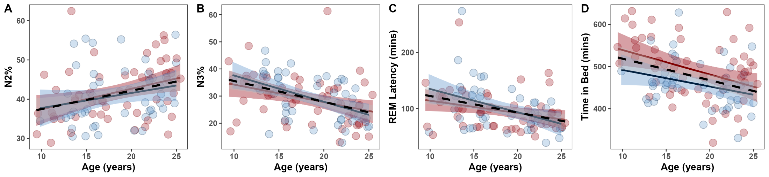

Figure S2. Associations between sleep micro-architecture and age.
For visualization purposes, we averaged data points across channel and night for each individual. (A) non-rapid eye movement (NREM) absolute delta power density, (B) NREM absolute theta power density, (C) slow spindle duration, (D) slow spindle density, (E) fast spindle duration, (F) slow oscillation (SO)-slow spindle coupling magnitude, (G) SO-fast spindle coupling magnitude. Dashed line = average age effect, red = female, blue = male. Shading represents 95% confidence intervals.
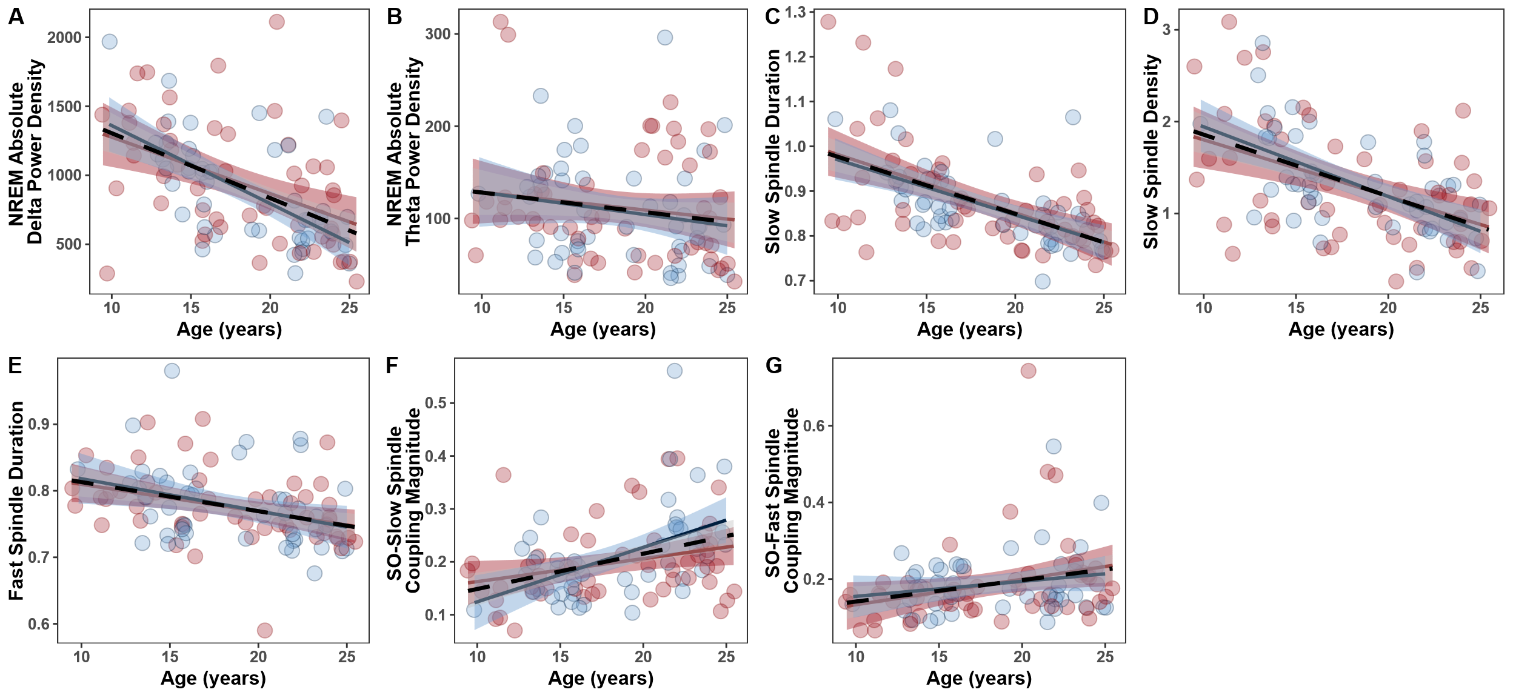

Figure S3. Macro- and micro-architecture variables showing significant sex differences.
For visualization purposes, we averaged data points across channel and night for each individual. (A) Total number of cycles, (B) REM relative sigma power density, (C) REM relative theta power density, (D) REM relative beta power density. Dashed line = average age effect, red = female, blue = male. Shading represents 95% confidence intervals. No variables show significant associations with age.
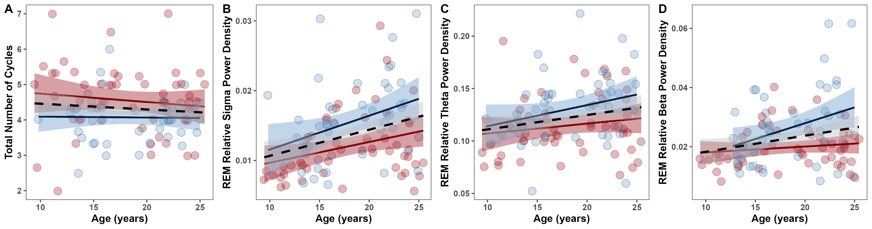

Figure S4. Significant associations between age and intra-individual variability of macro- and micro-architecture variables.
Data points represent average participant values across channel and night. (A) Intra-individual variability (IIV) in REM%, (B) IIV in SO-slow spindle coupling magnitude, (C) IIV in NREM relative theta power density, (D) IIV in NREM relative beta power density, (E) IIV in slow spindle chirp. Shading represents 95% confidence intervals.
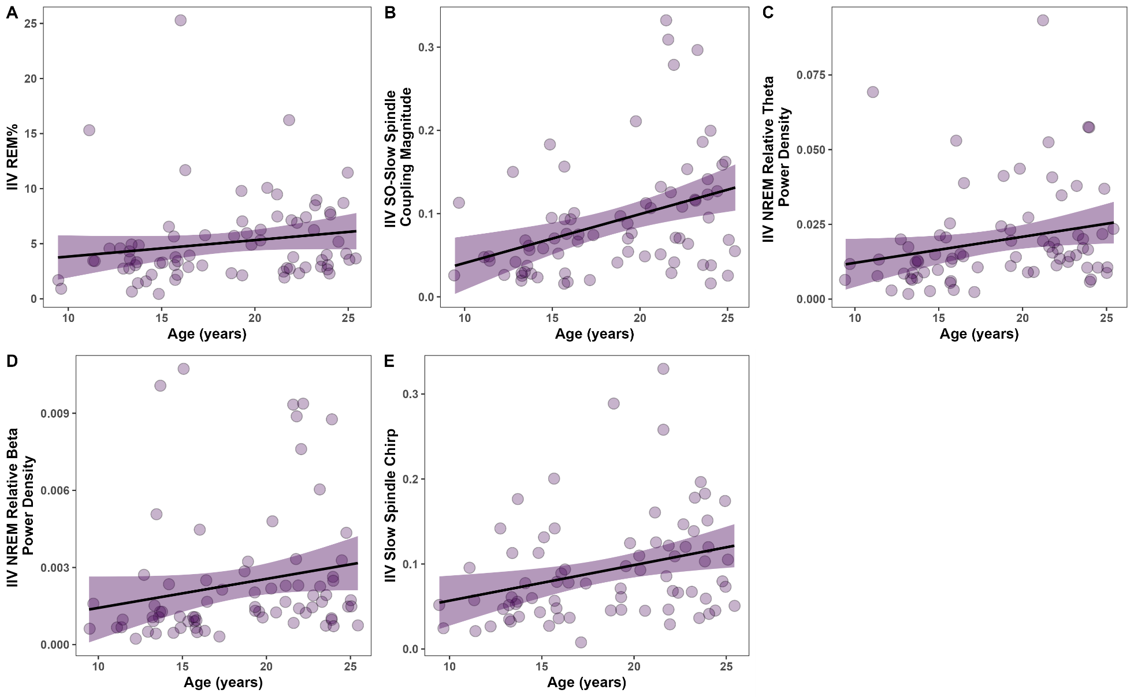

Supplemental References.

1. Kozhemiako, N., Buckley, A. W., Chervin, R. D., Redline, S. & Purcell, S. M. Mapping neurodevelopment with sleep macro- and micro-architecture across multiple pediatric populations. NeuroImage: Clinical 41, 103552 (2024).
2. Scholle, S. et al. Normative values of polysomnographic parameters in childhood and adolescence: Quantitative sleep parameters. Sleep Medicine 12, 542–549 (2011).
3. Baker, F. C. et al. Age-Related Differences in Sleep Architecture and Electroencephalogram in Adolescents in the National Consortium on Alcohol and Neurodevelopment in Adolescence Sample. Sleep 39, 1429–1439 (2016).
4. Tarokh, L. & Carskadon, M. A. Developmental changes in the human sleep EEG during early adolescence. Sleep 33, 801–809 (2010).
5. Jenni, O. G. & Carskadon, M. A. Spectral analysis of the sleep electroencephalogram during adolescence. Sleep 27, 774–783 (2004).
6. Coble, P. A., Kupfer, D. J., Taska, L. S. & Kane, J. EEG Sleep of Normal Healthy Children. Part I: Findings Using Standard Measurement Methods. Sleep 7, 289–303 (1984).
7. Gillin, J. C. et al. Age-related changes in sleep in depressed and normal subjects. Psychiatry Research 4, 73–78 (1981).
8. Feinberg, I., Davis, N. M., de Bie, E., Grimm, K. J. & Campbell, I. G. The maturational trajectories of NREM and REM sleep durations differ across adolescence on both school-night and extended sleep. American Journal of Physiology - Regulatory Integrative and Comparative Physiology 302, 533–540 (2012).
9. Seegers, V. et al. Short Sleep Duration and Body Mass Index: A Prospective Longitudinal Study in Preadolescence. American Journal of Epidemiology 173, 621–629 (2011).
10. Goldstone, A. et al. Sleep spindle characteristics in adolescents. Clinical Neurophysiology 130, 893–902 (2019).
11. Kurth, S. et al. Mapping of cortical activity in the first two decades of life: A high-density sleep electroencephalogram study. Journal of Neuroscience 30, 13211–13219 (2010).
12. Campbell, I. G. & Feinberg, I. Longitudinal trajectories of non-rapid eye movement delta and theta EEG as indicators of adolescent brain maturation. Proc. Natl. Acad. Sci. U.S.A. 106, 5177–5180 (2009).
13. Campbell, I. G., Grimm, K. J., De Bie, E. & Feinberg, I. Sex, puberty, and the timing of sleep EEG measured adolescent brain maturation. Proc. Natl. Acad. Sci. U.S.A. 109, 5740–5743 (2012).
14. Gaudreau, H., Carrier, J. & Montplaisir, J. Age‐related modifications of NREM sleep EEG: from childhood to middle age. Journal of Sleep Research 10, 165–172 (2001).
15. Baker, F. C., Turlington, S. R. & Colrain, I. Developmental changes in the sleep electroencephalogram of adolescent boys and girls. Journal of Sleep Research 21, 59–67 (2012).
16. Feinberg, I. & Campbell, I. G. Longitudinal sleep EEG trajectories indicate complex patterns of adolescent brain maturation. American Journal of Physiology-Regulatory, Integrative and Comparative Physiology 304, R296–R303 (2013).
17. Joechner, A.-K., Hahn, M. A., Gruber, G., Hoedlmoser, K. & Werkle-Bergner, M. Sleep spindle maturity promotes slow oscillation-spindle coupling across child and adolescent development. eLife 12, e83565 (2023).
18. Hahn, M. A., Heib, D., Schabus, M., Hoedlmoser, K. & Helfrich, R. F. Slow oscillation-spindle coupling predicts enhanced memory formation from childhood to adolescence. eLife 9, e53730 (2020).
19. Nader, R. S. & Smith, C. T. Correlations between adolescent processing speed and specific spindle frequencies. Front. Hum. Neurosci. 9, (2015).
20. Gombos, F. et al. Topographical relocation of adolescent sleep spindles reveals a new maturational pattern in the human brain. Sci Rep 12, 7023 (2022).

