Extended Data Figure 1. Full-length uncropped Western blots corresponding to Figures 1–M, GAPDH (left) and IRG1(right).
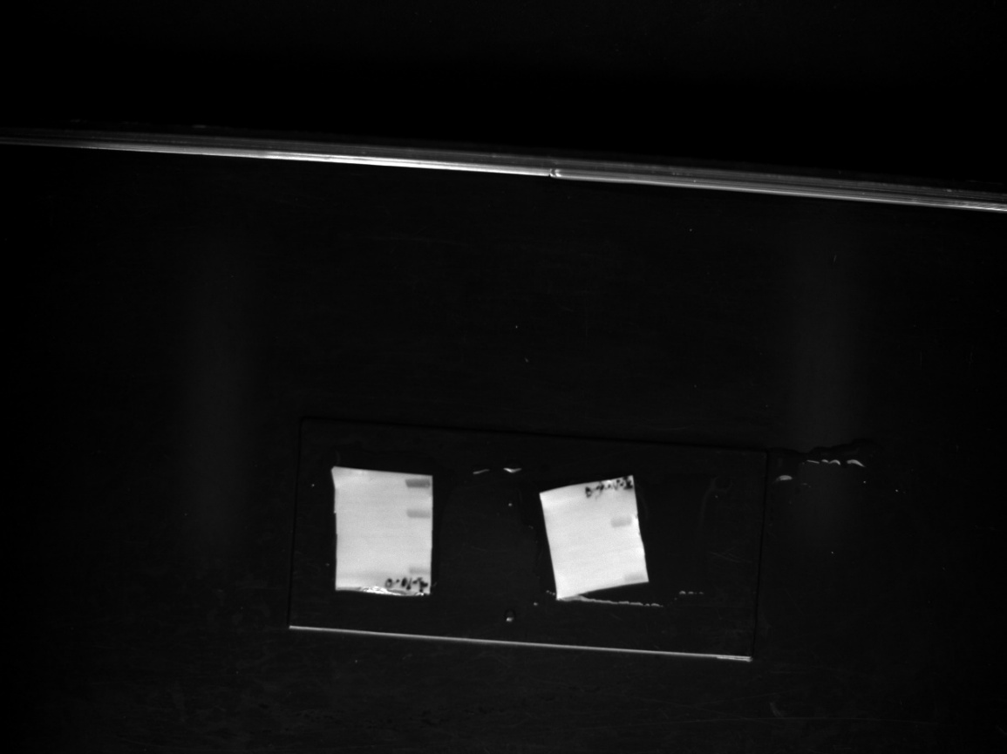

Extended Data Figure 2. Full-length uncropped Western blots corresponding to Figures 5–A
IRG1
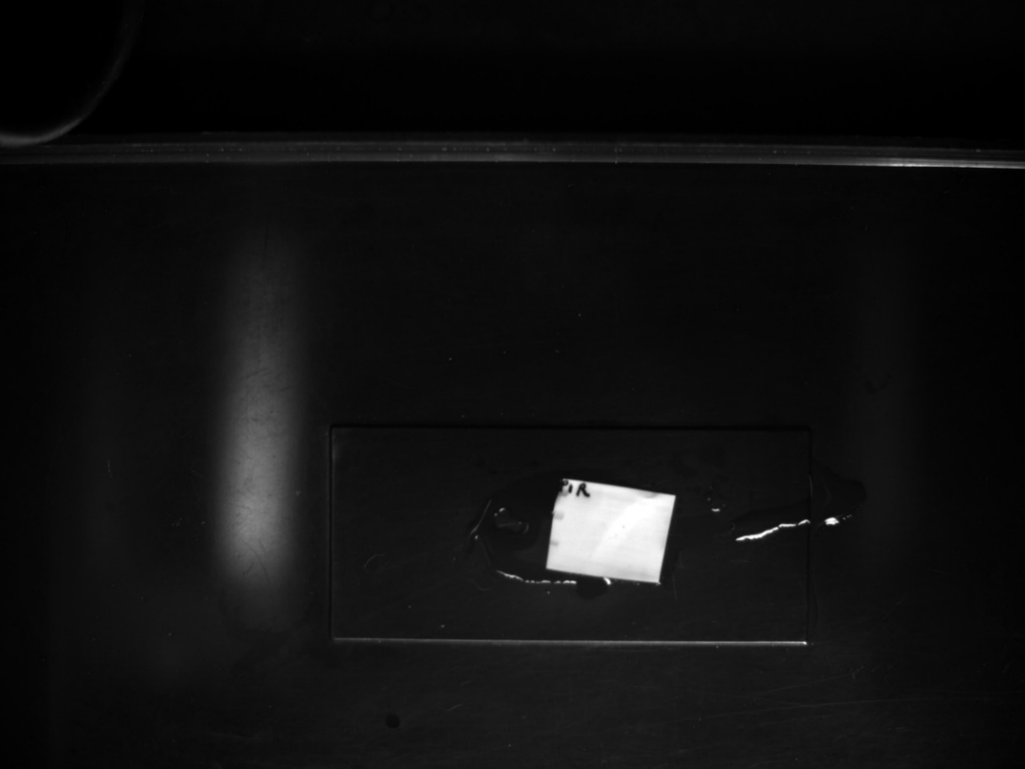

RIPK3
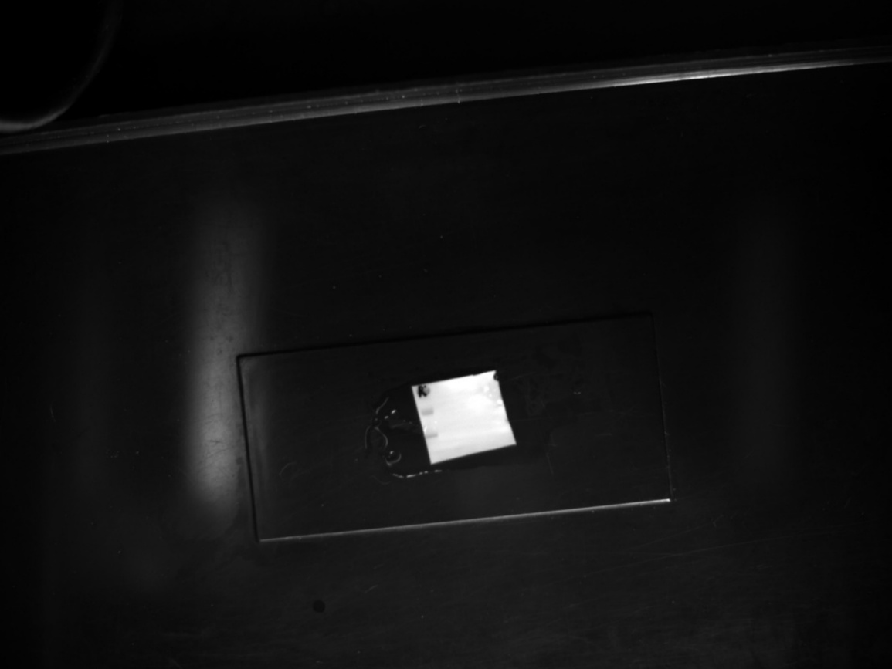

P232RIPK3
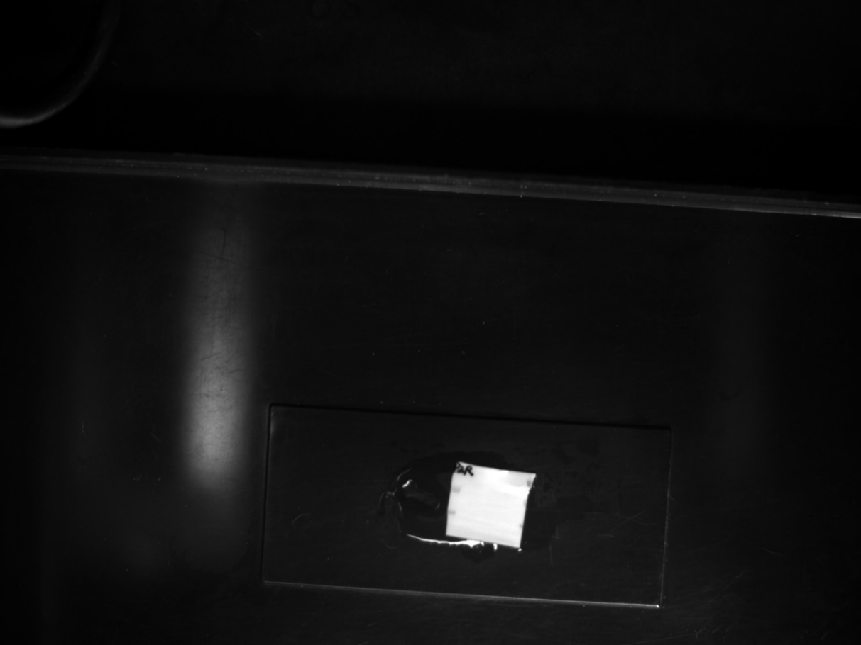

P165RIPK3
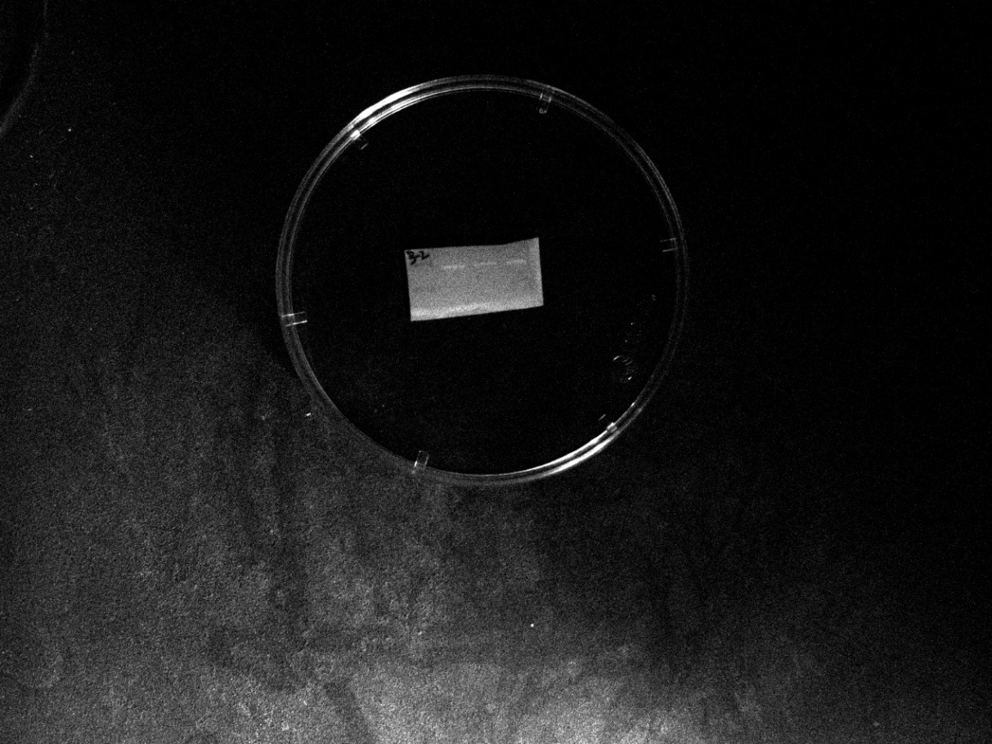

MLKL

PMLKL

GAPDH

Extended Data Figure 3. Full-length uncropped Western blots corresponding to Figures 5–B
IRG1
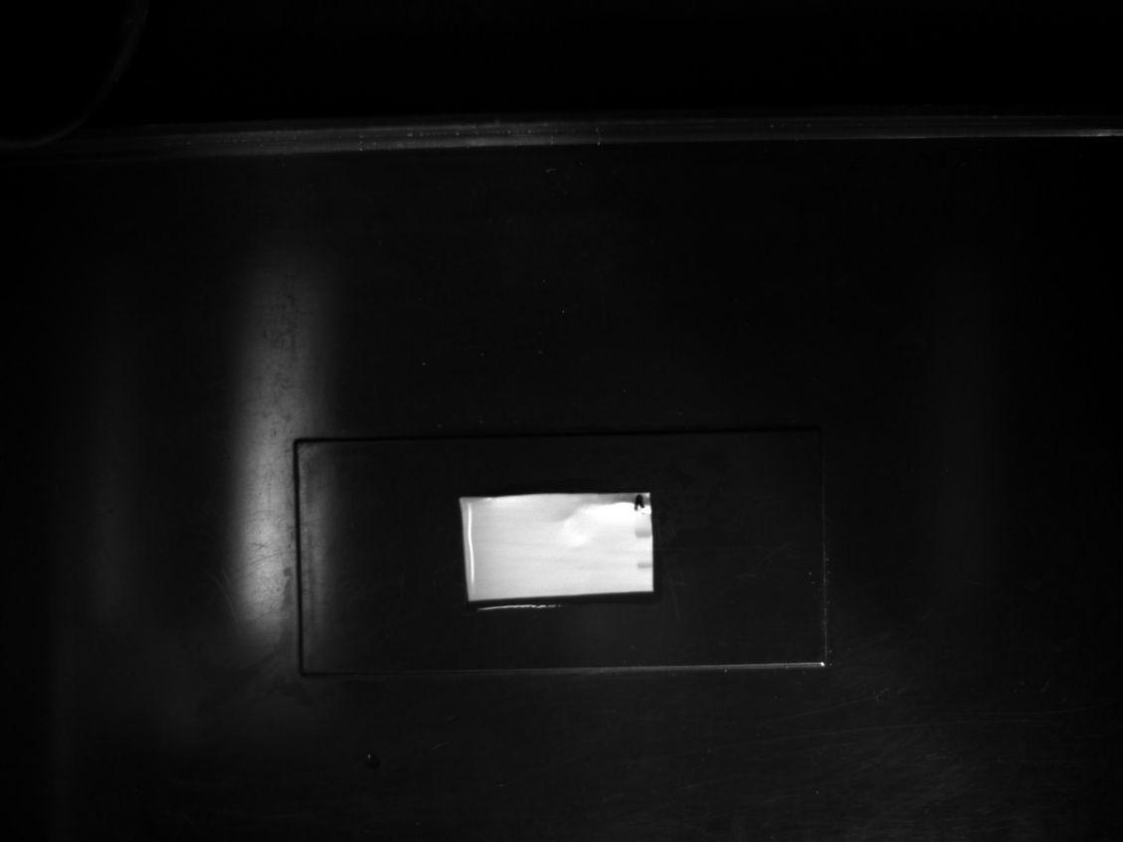
RIPK3
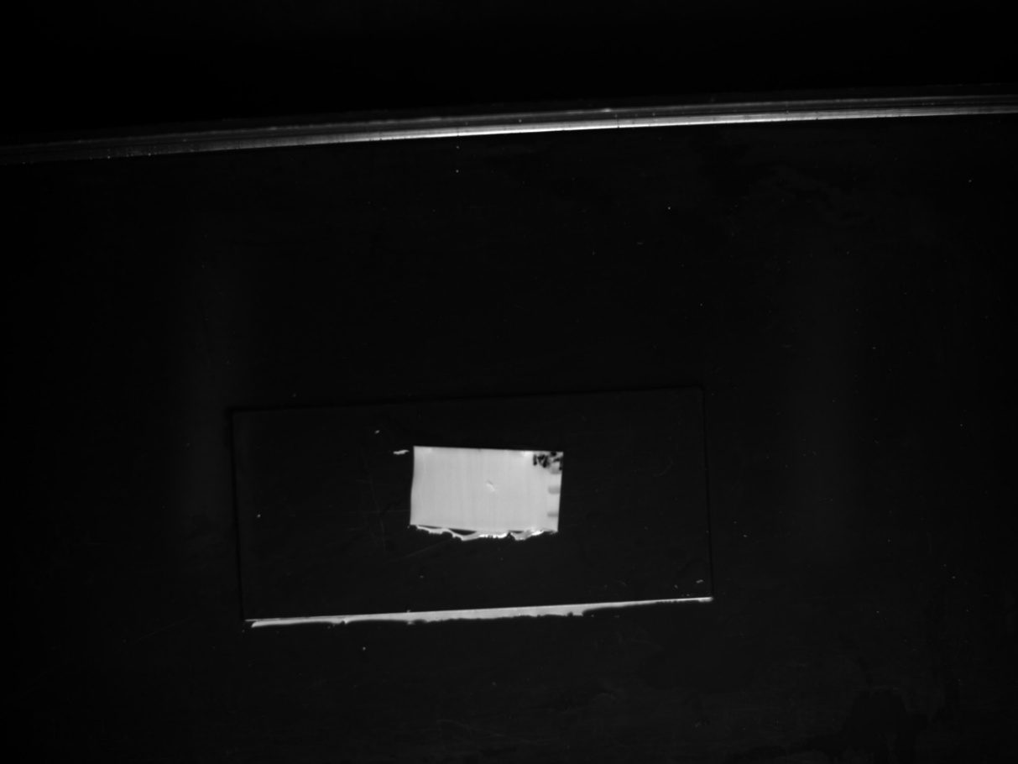

P232RIPK3
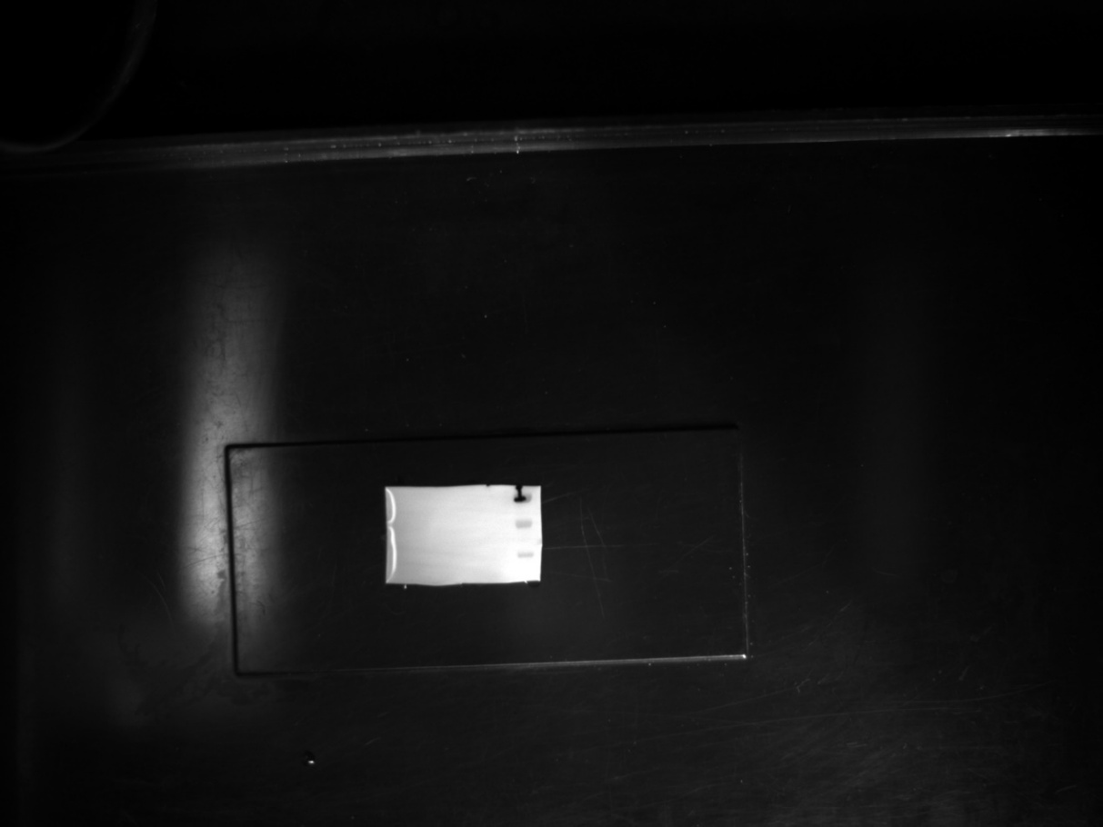

P165RIPK3

MLKL

PMLKL
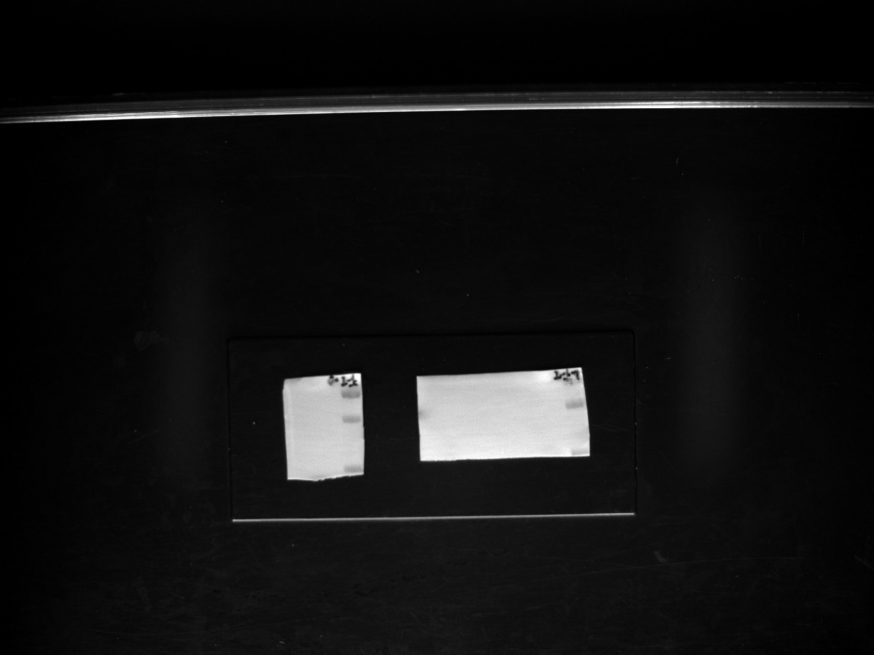

GAPDH

Extended Data Figure 4. Full-length uncropped Western blots corresponding to Figures 5–C
IRG1
RIPK3
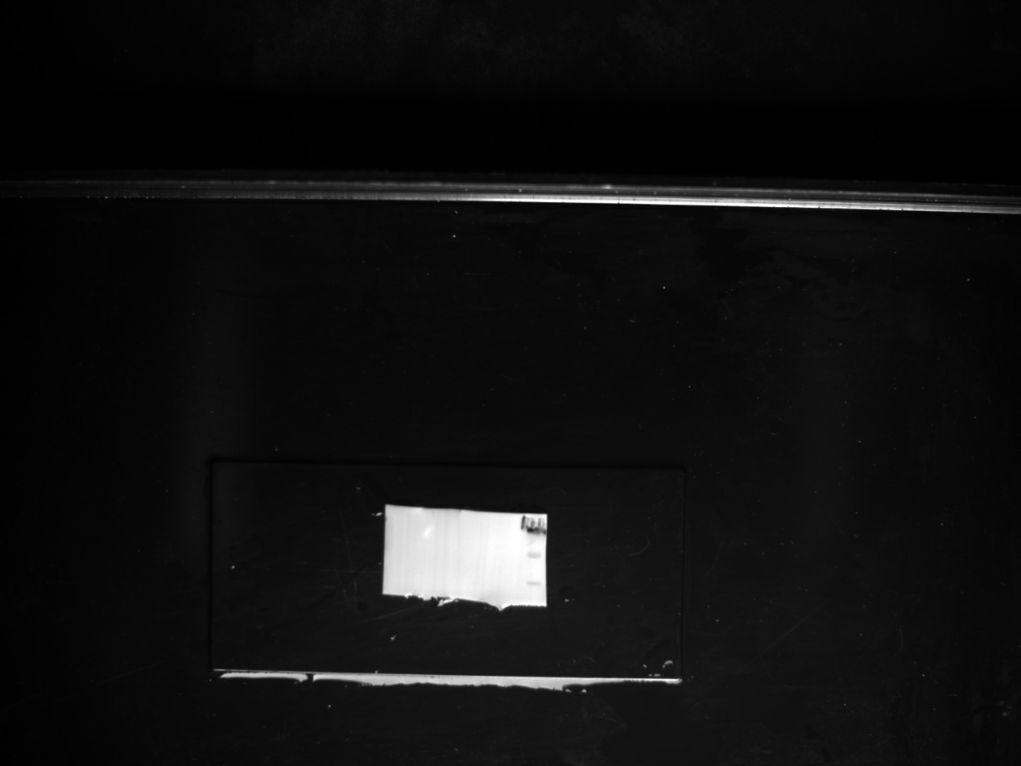
P232RIPK3
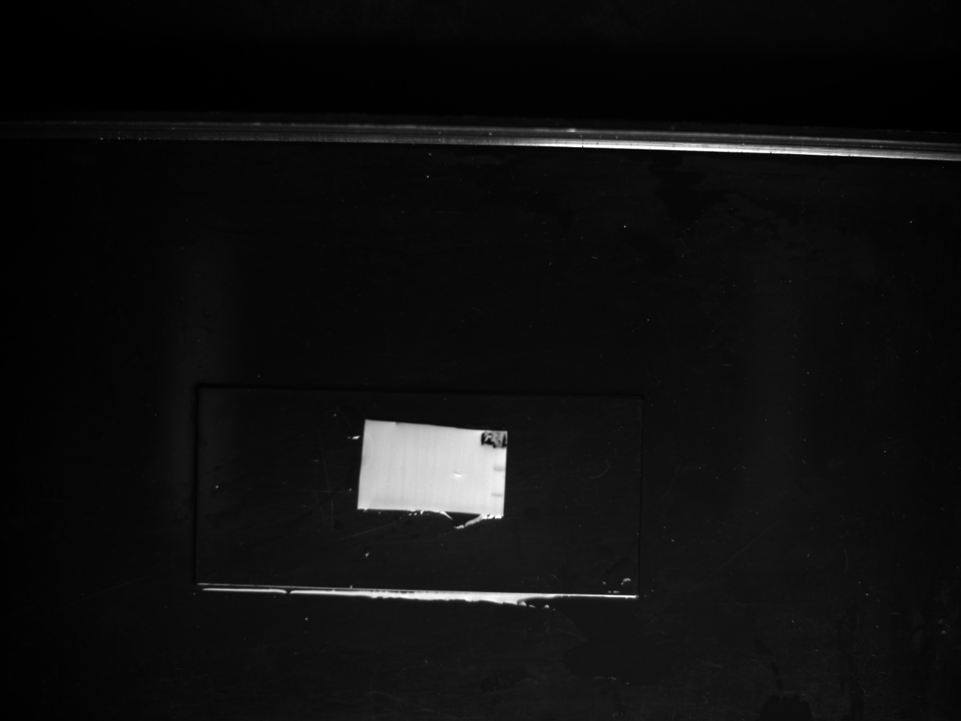
P165RIPK3
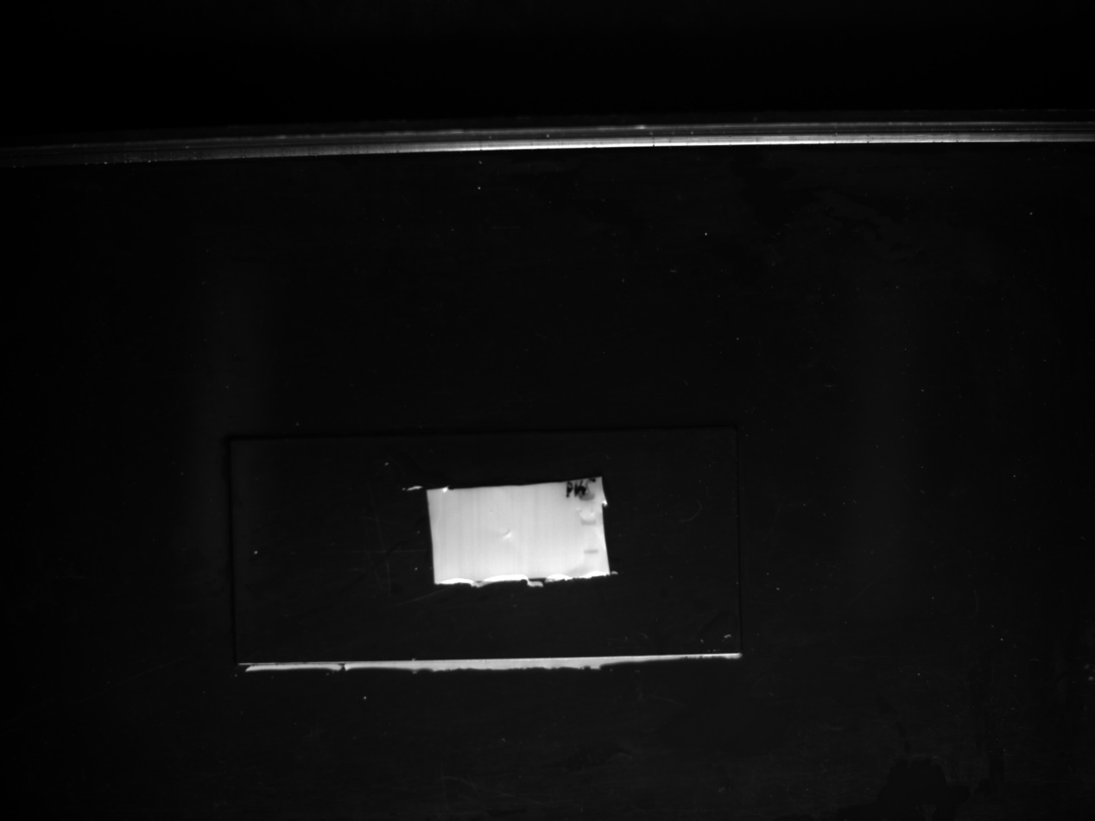
MLKL
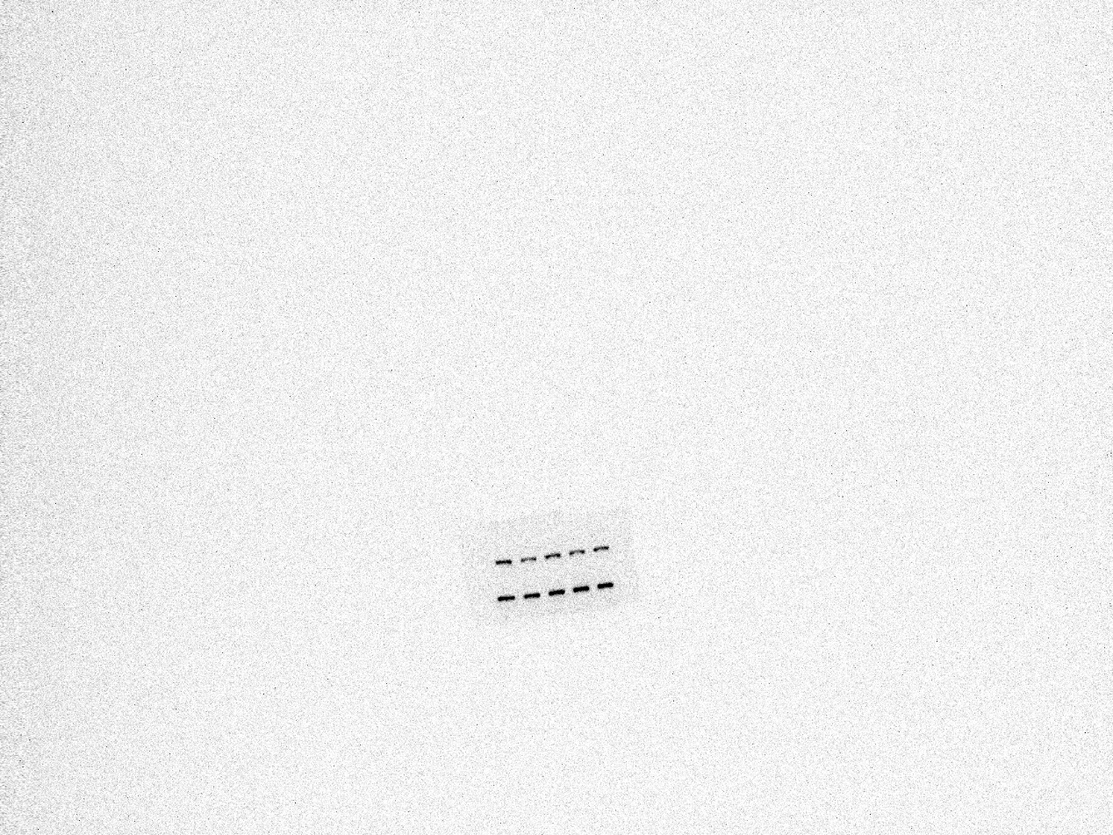
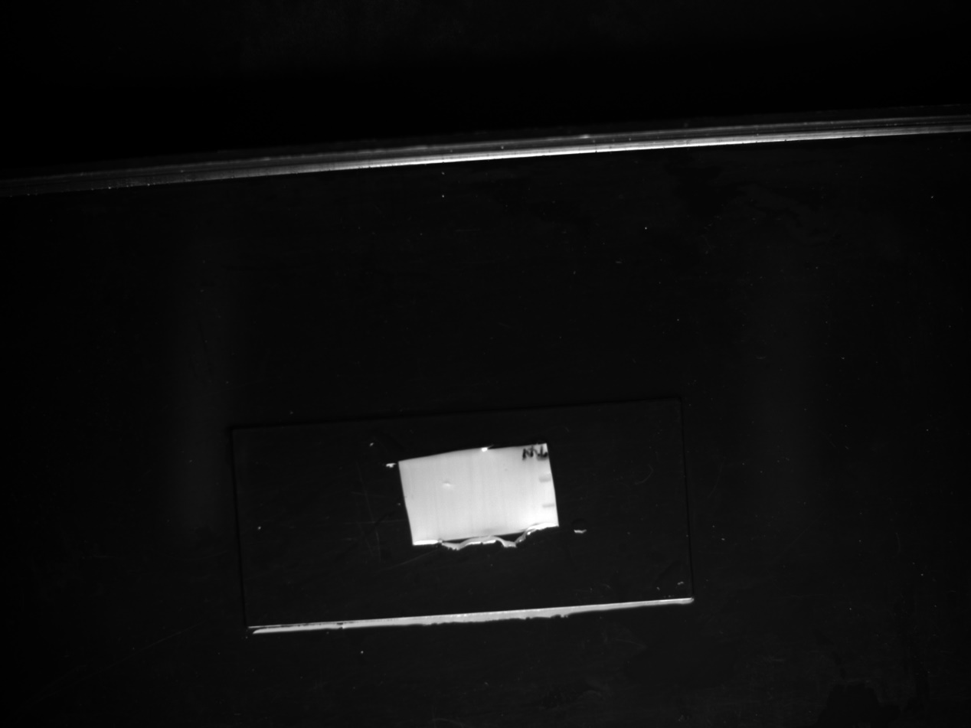
PMLKL
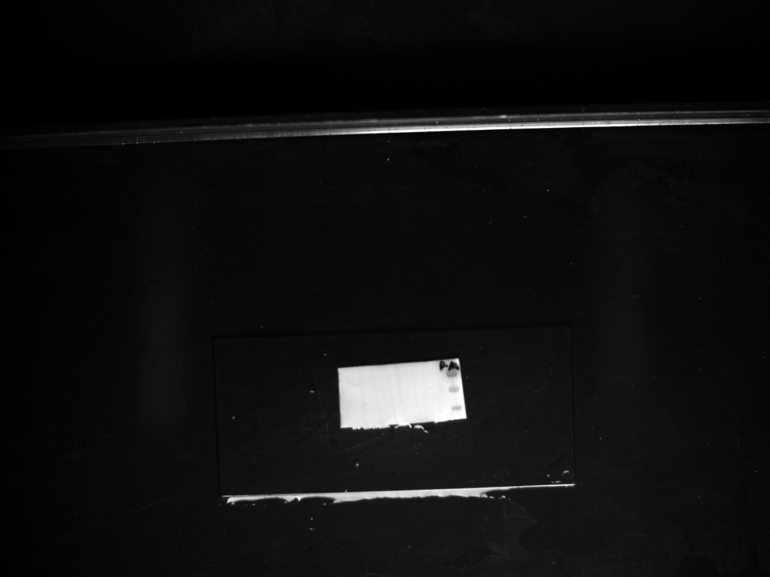
GAPDH
Extended Data Figure 5. Full-length uncropped Western blots corresponding to Figures 5–H
RIPK3
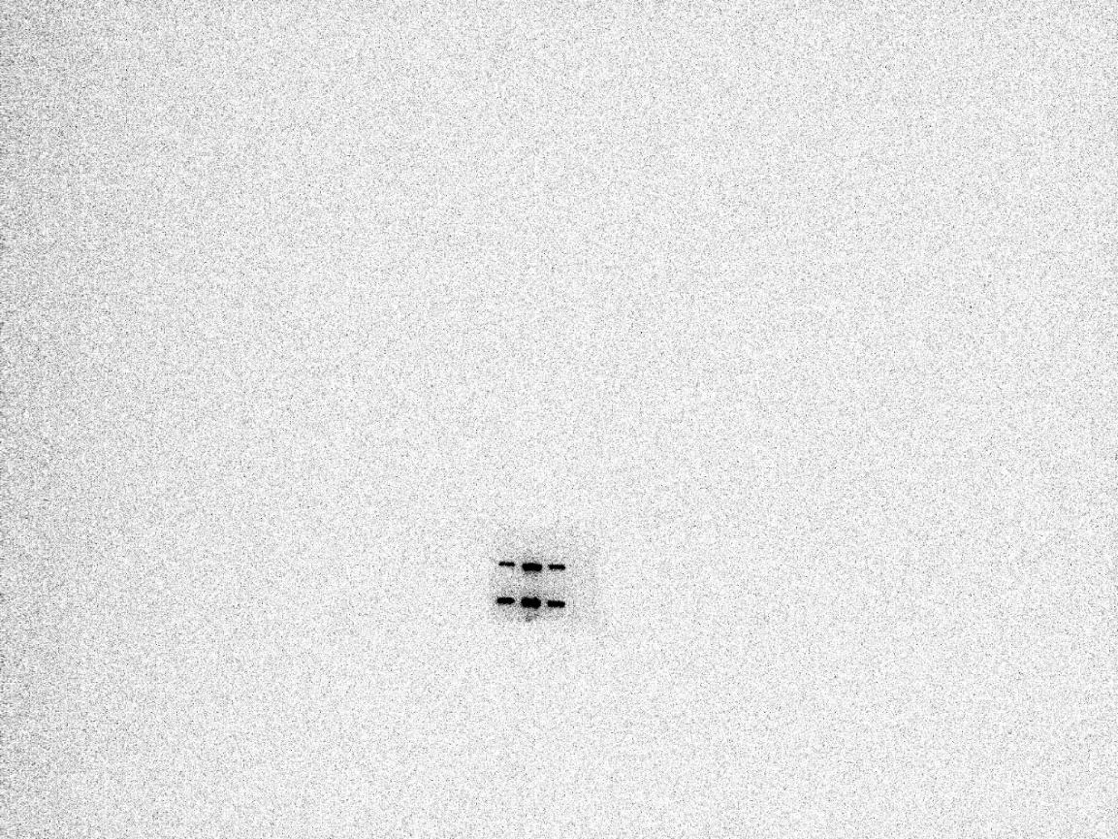
P232RIPK3
MLKL
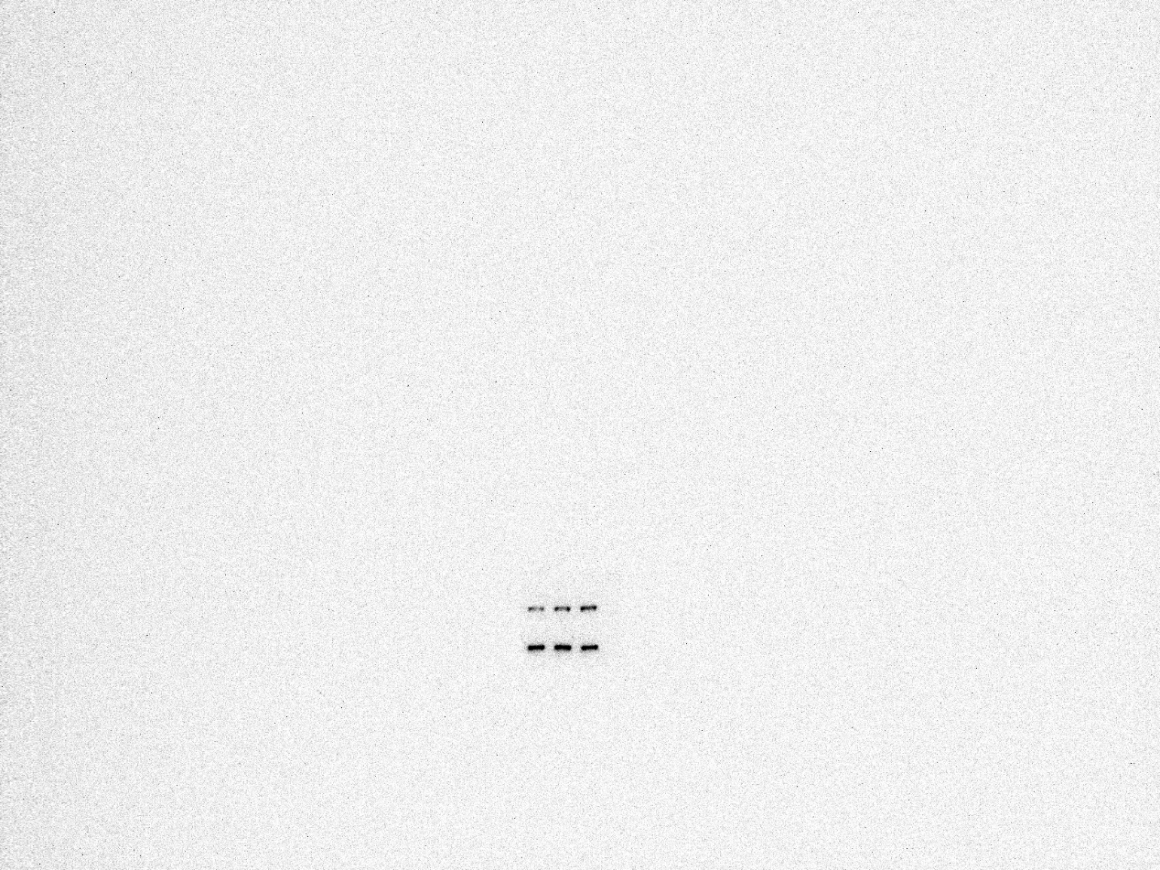
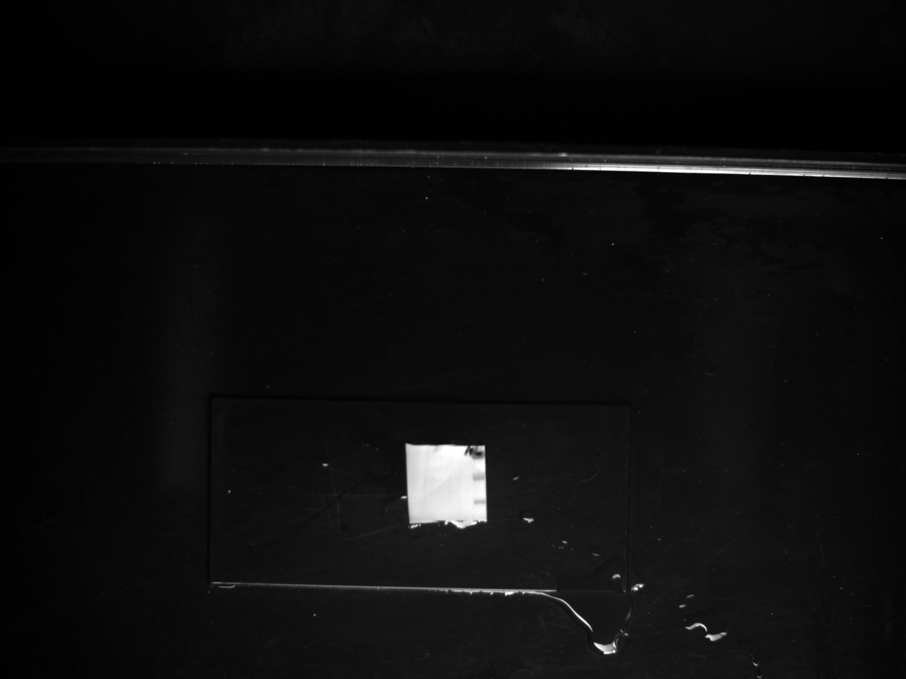
PMLKL
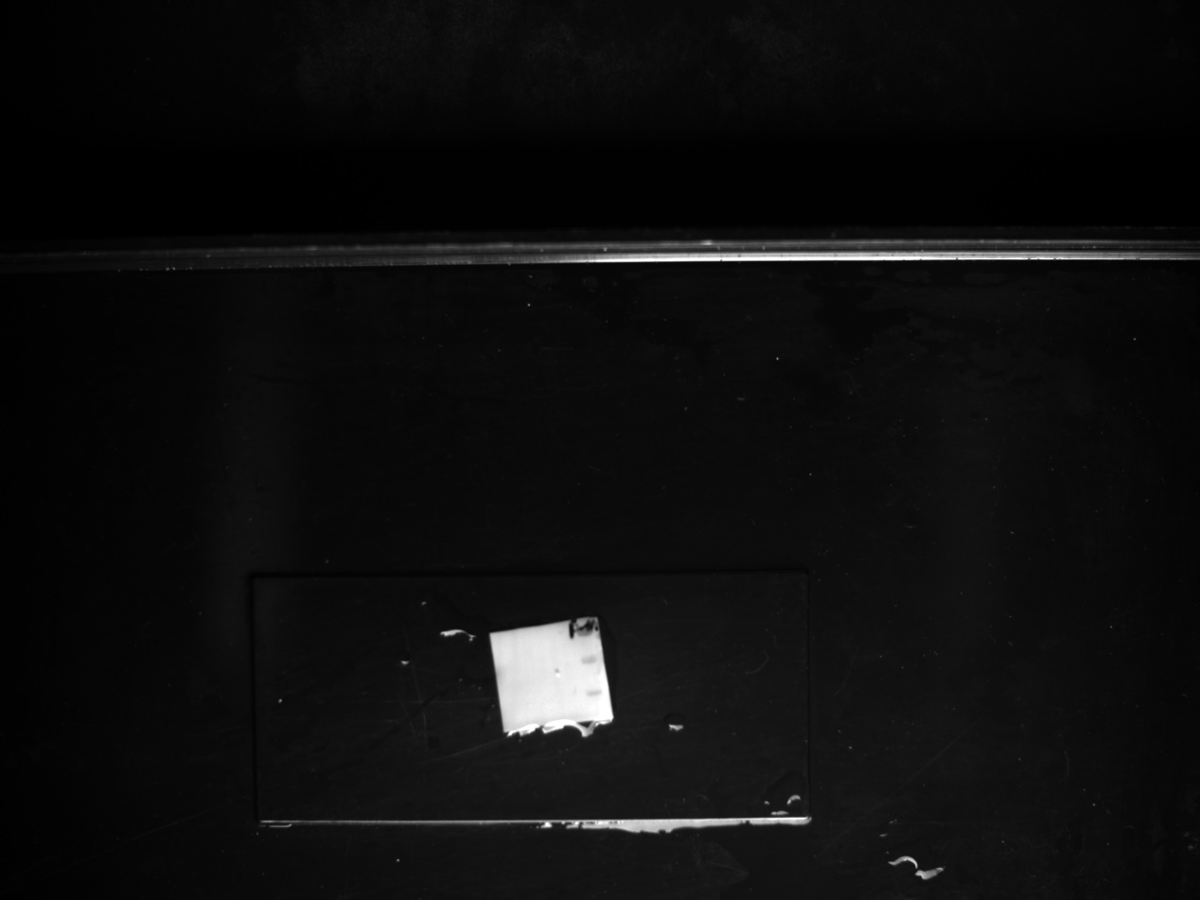
GAPDH

Extended Data Figure 6. Full-length uncropped Western blots corresponding to Figures 5–I
RIPK3
P232RIPK3
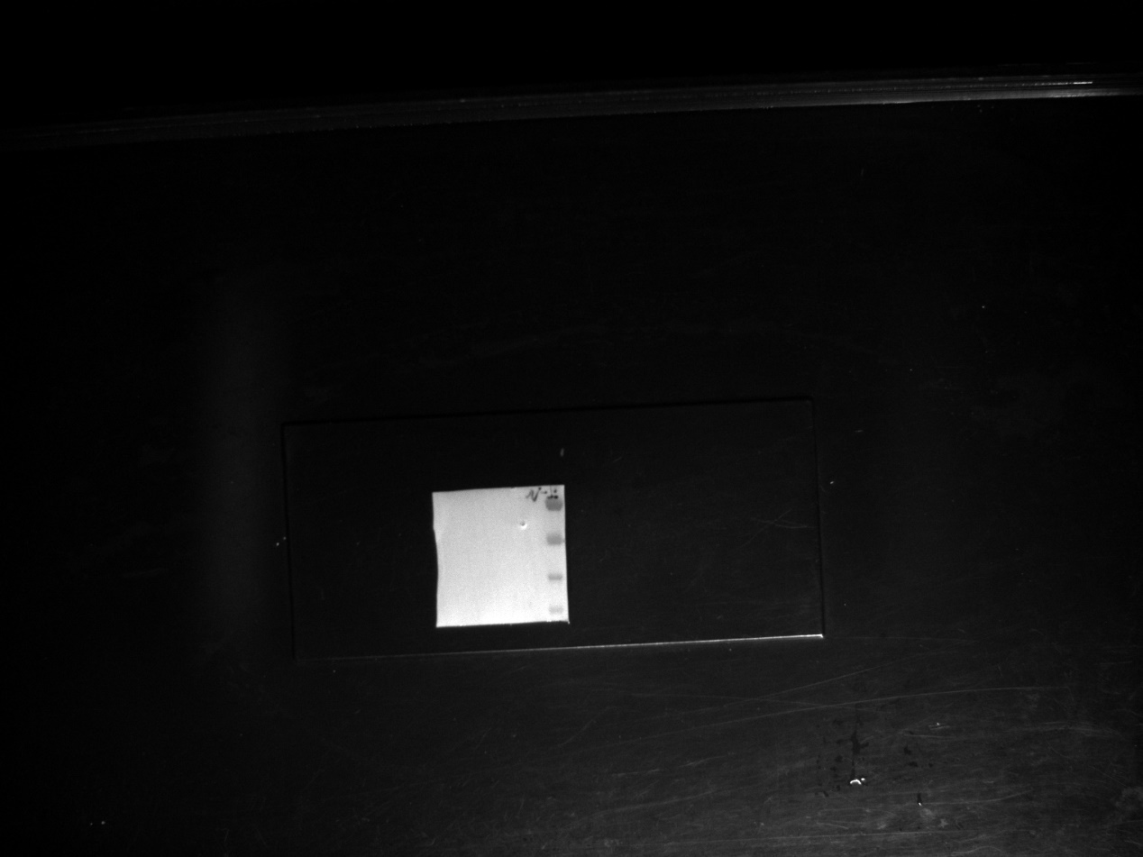
MLKL
PMLKL
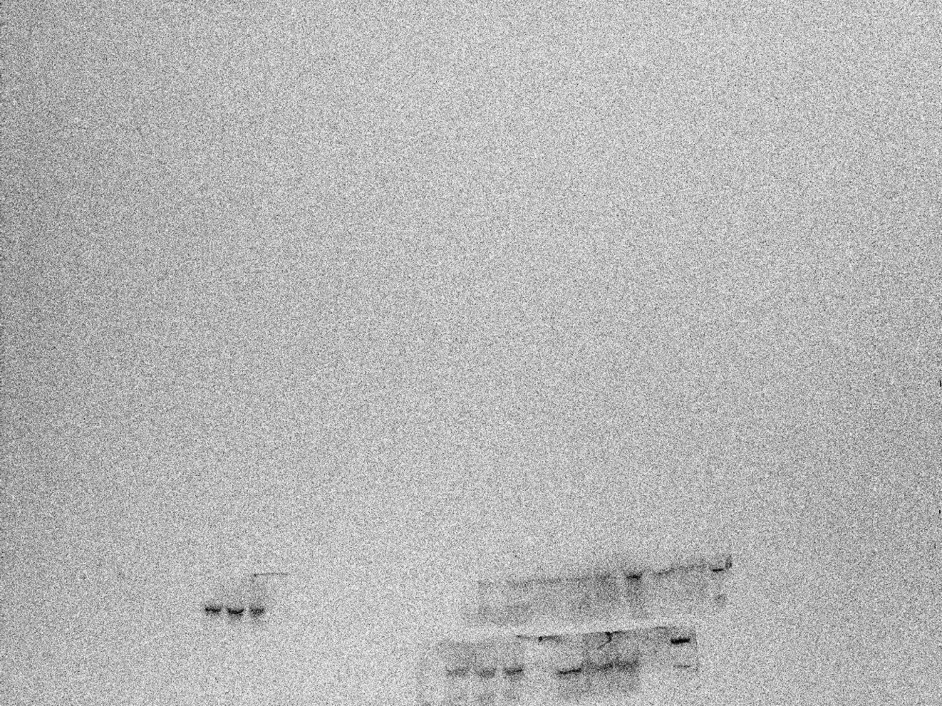
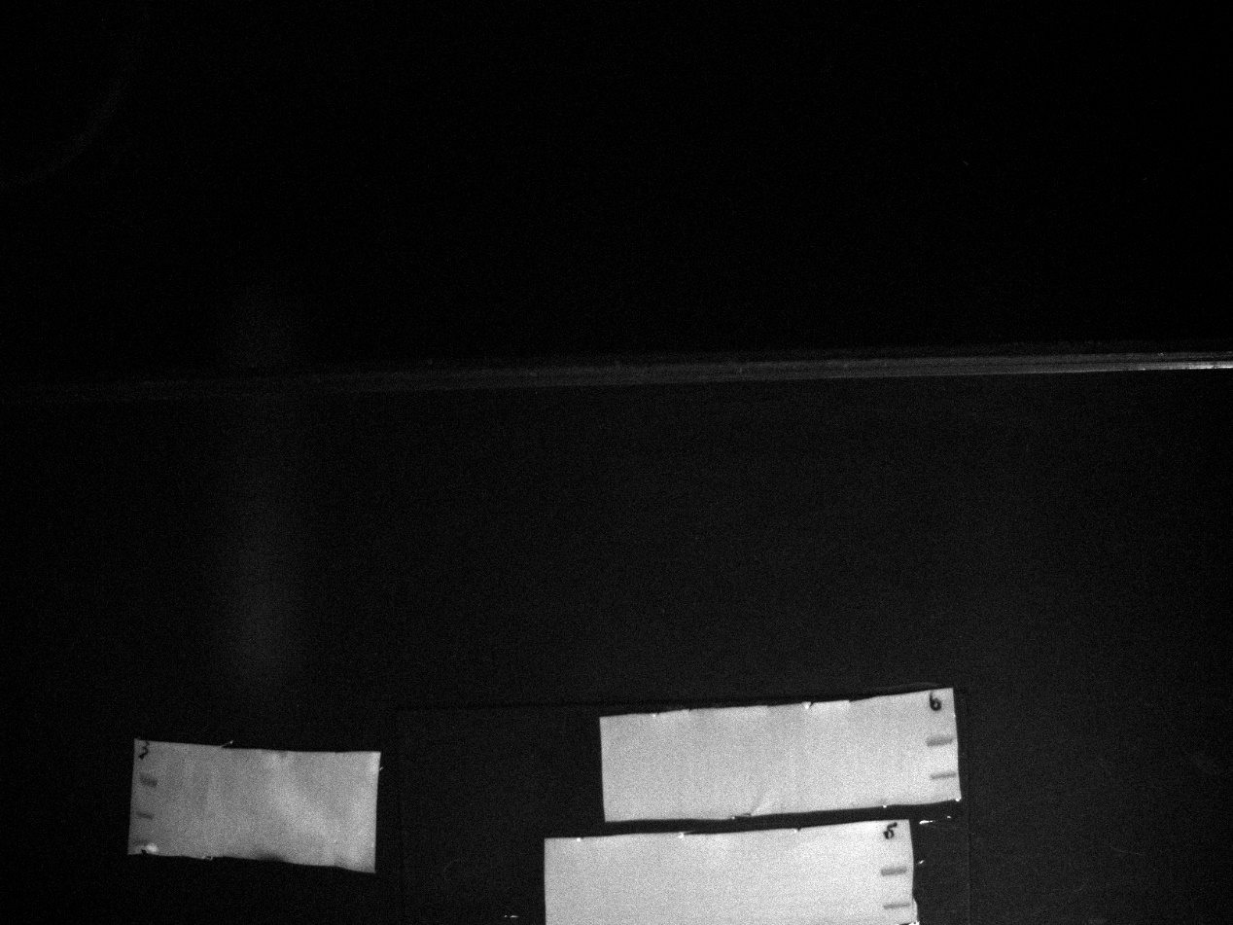
GAPDH
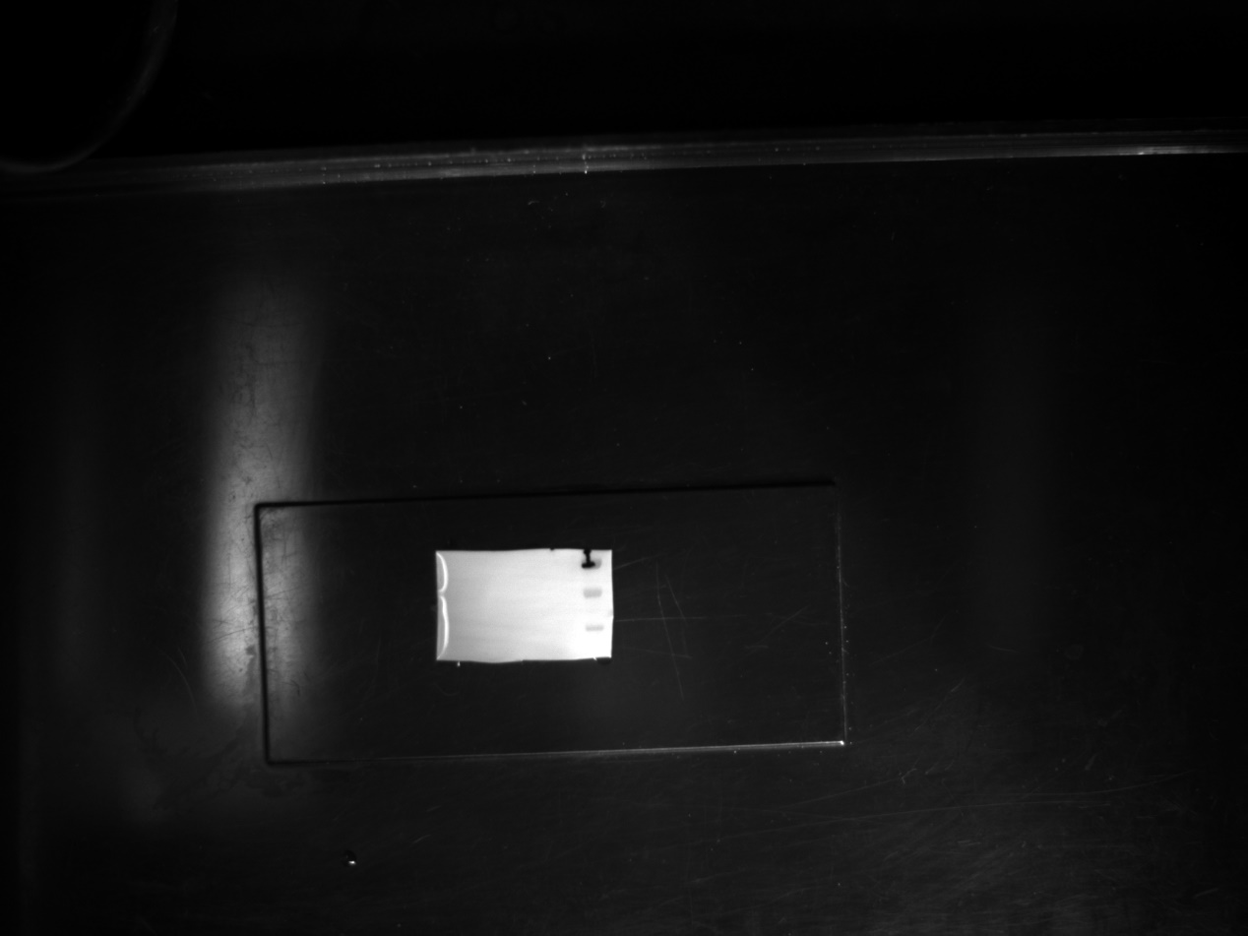

Extended Data Figure 7. Full-length uncropped Western blots corresponding to Figures 5–J
RIPK3
P232RIPK3
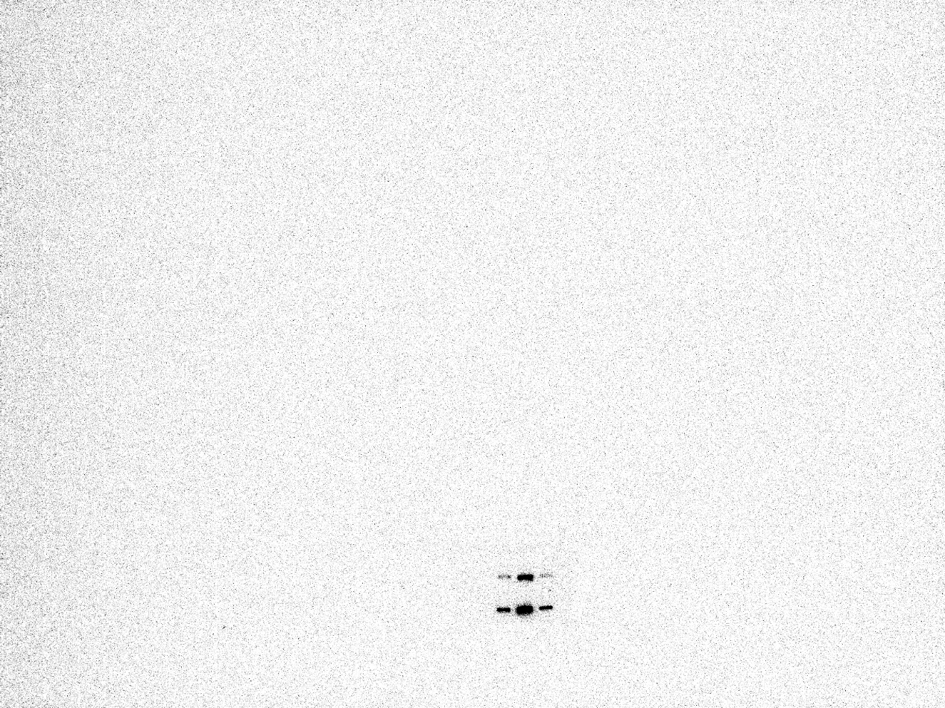
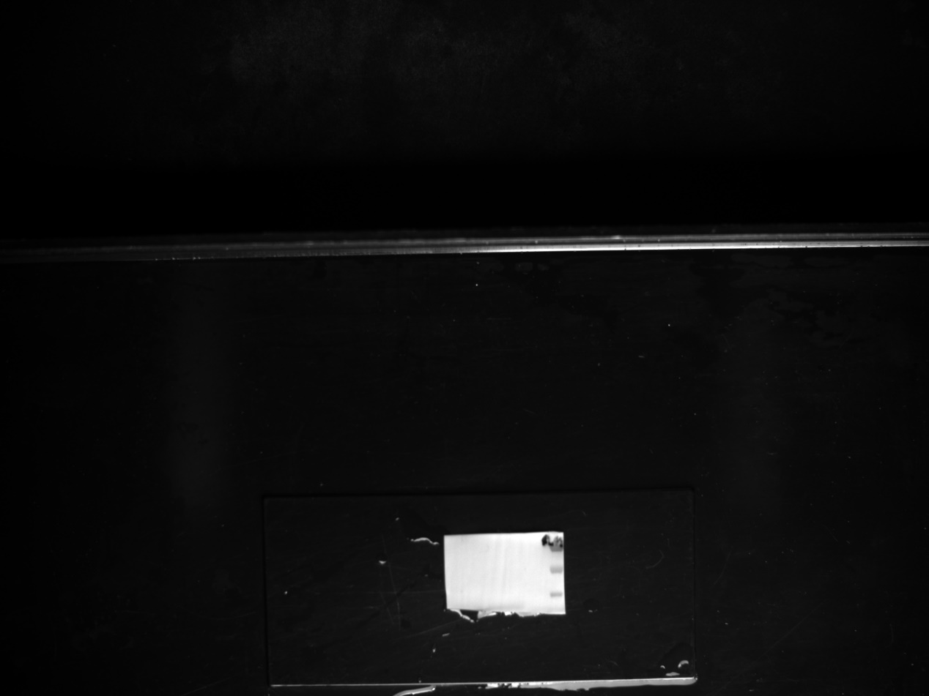
MLKL
PMLKL
GAPDH

