Itaconate delays type 2 diabetes progression by alkylating RIPK3 to inhibit pancreatic β‑cell failure

Authors: Jianmin Wu^{1,2}, Xingshi Gu^{1,2}, Wen Liu^{1,2}, Mengyu Tian⁴, Juan Chen^{1,2}, Zhenhu He¹, Juan Zhang^{1,2}, Cejun Yang^{1,2}, Min Yang^{1,2}, Wei Nie¹, Wei Zheng¹, Qi Cao⁵, Yang Xia⁶, Pengfei Rong^{1,2.3}, Xiaoqian Ma^{1,2,3}*, Wei Wang^{1,2,3}*.
Affiliations:
1 Department of Radiology, The Third Xiangya Hospital, Central South University, Changsha, Hunan, China
2 Engineering and Technology Research Center for Xenotransplantation of Human Province, Changsha, China
3 Clinical Research Center for Minimally Invasive Diagnosis and Therapy under Image Navigation in Hunan Province, Changsha, China
4 Department of Radiology, The Second Affiliated Hospital of Anhui Medical University, Hefei, Anhui, China
5 Henan Key Laboratory of Immunology and Targeted Drugs, School of Laboratory Medicine, Xinxiang Medical University, Xinxiang, China.
6 National Medical Metabolomics International Collaborative Research Center, Xiangya Hospital, Central South University, Changsha, Hunan, China.
Correspondence: Correspondence should be addressed to Xiaoqian Ma* mxq8933@csu.edu.cn, Wei Wang* wang_w@csu.edu.cn
This file includes :
Supplementary Fig. 1 | Monitoring of mouse body weight during the type 2 diabetes modeling process
Supplementary Fig. 2 | Insulin tolerance test assessing systemic insulin sensitivity of mice during T2D modeling process
Supplementary Fig. 3 | Glucose tolerance test evaluating whole-body glucose disposal capacity of mice during T2D modeling process
Supplementary Fig. 4 | Immunohistochemistry demonstrating the insulin secretion function in pancreatic islets of diabetic mice
Supplementary Fig. 5 | The effect of 4-OI injection on major organs in mice as observed by HE staining
Supplementary Fig. 6 | Monitoring of mouse body weight during the 4-OI treatment
Supplementary Fig. 7 | Multiplex cytokine profiling of serum TNF-α, IL-12p70, IL-6, and MCP-1 levels via flow cytometric bead array
Supplementary Fig. 8 | MTS assay monitors the cytotoxicity effects of different concentrations of 4-OI on the viability of primary porcine islet
Supplementary Fig. 9 | MTS assay monitors the cytotoxicity effects of different concentrations of 4-OI on the viability of MIN6 cells
Supplementary Fig. 10 | Quantification of the number of mitochondria in primary islets after 4-OI treatments
Supplementary Fig. 11 | AO/PI assay illustrates the impact of RIPK3 knockout on MIN6 viability under GLT conditions and quantitative analysis
Supplementary Fig. 12 | Expression of p165RIPK3 phosphorylation following incubation with recombinant RIPK3 protein at different concentrations of 4-OI
Supplementary Fig. 13 | Changes in p165RIPK3 phosphorylation over time following co-incubation of recombinant RIPK3 protein with 4-OI
Supplementary Fig. 14 | Western blot analysis showing the effects of itaconate on RIPK3 phosphorylation
Supplementary Fig. 15 | Mass spectrometry reveals the peptide mapping of 4-OI alkylated modifications at different sites on RIPK3
Supplementary Fig. 16 | Mass spectrometry displays the ion map of 4-OI alkylated modifications on RIPK3
Supplementary Fig. 17 | Three-dimensional structure of WT RIPK3 and Cys 360
Supplementary Fig. 18 | Three-dimensional structure of RIPK3 protein after modification by itaconate
Supplementary Fig. 19 | Schematic representation of the alkylates sites of RIPK3 in mouse and their corresponding RIPK3 sites in human
Supplementary Fig. 20 | Quantification of RIPK3 phosphorylation after site-directed mutagenesis of mouse RIPK3
Supplementary Fig. 21 | The three-dimensional structure of ATP molecules
Supplementary Fig. 22 | Molecular recognition study of the structure of phosphorylated RIPK3 before and after Cys360 modification
Supplementary Fig. 23 | Quantification of Annexin V⁻/PI⁻ cells following C360S mutation
Supplementary Fig. 24 | Immunohistochemistry showing the impact of ACOD1^{-/-} on the secretion of inflammatory factors for IL-1β, and TNF-α in the pancreas of diabetic mice
Supplementary Fig. 25 | Complete uncropped gel of western blot images for Fig. 1M
Supplementary Fig. 26 | Complete uncropped gel of western blot images for Fig. 5E
Supplementary Fig. 27 | Complete uncropped gel of western blot images for Fig. 5F
Supplementary Fig. 28 | Complete uncropped gel of western blot images for Fig. 6F
Supplementary Fig. 29 | Complete uncropped gel of western blot images for Fig. S12 and S13
Supplementary Fig. 30 | Complete uncropped gel of western blot images for Fig. S14
Supplementary Table. 1 | Basic characteristics of 124 individuals
Supplementary Table. 2 | qPCR primer list
Supplementary Table. 3 | Antibody of Western blot list
Supplementary Method | Inclusion/Exclusion Criteria and Enrollment Flow

Supplementary Figure

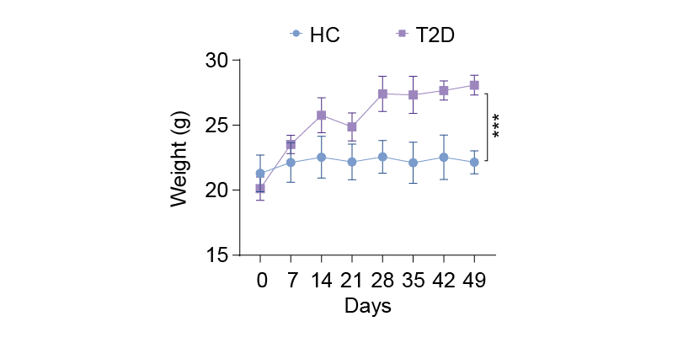
Supplementary Figure 1. Monitoring of mouse body weight during the type 2 diabetes modeling process, (n = 5).

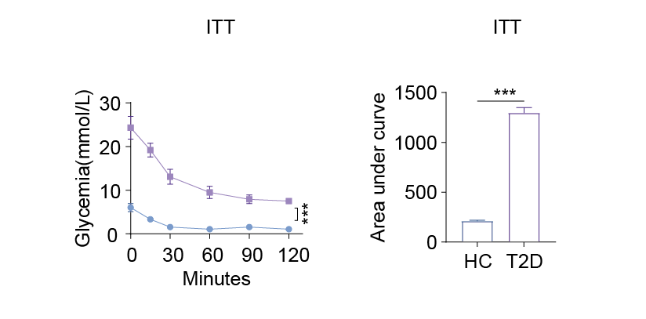
Supplementary Figure 2. Insulin tolerance test assessing systemic insulin sensitivity of mice during T2D modeling process, (n = 5)

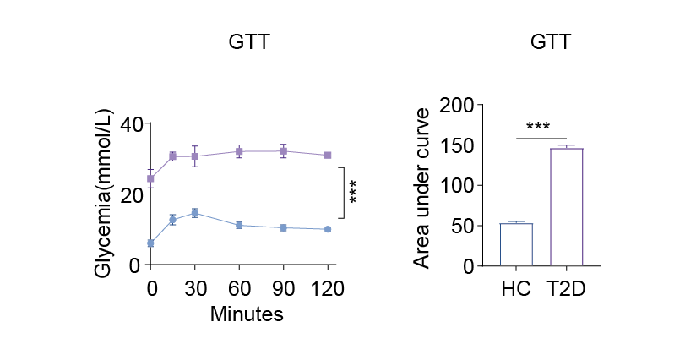
Supplementary Figure 3. Glucose tolerance test evaluating whole-body glucose disposal capacity of mice during T2D modeling process, (n = 5).
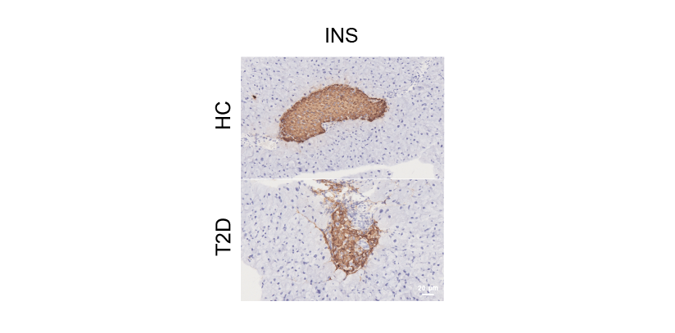
Supplementary Figure 4. Immunohistochemistry demonstrating the insulin secretion function in pancreatic islets of diabetic mice, Orange indicates insulin-positive staining.

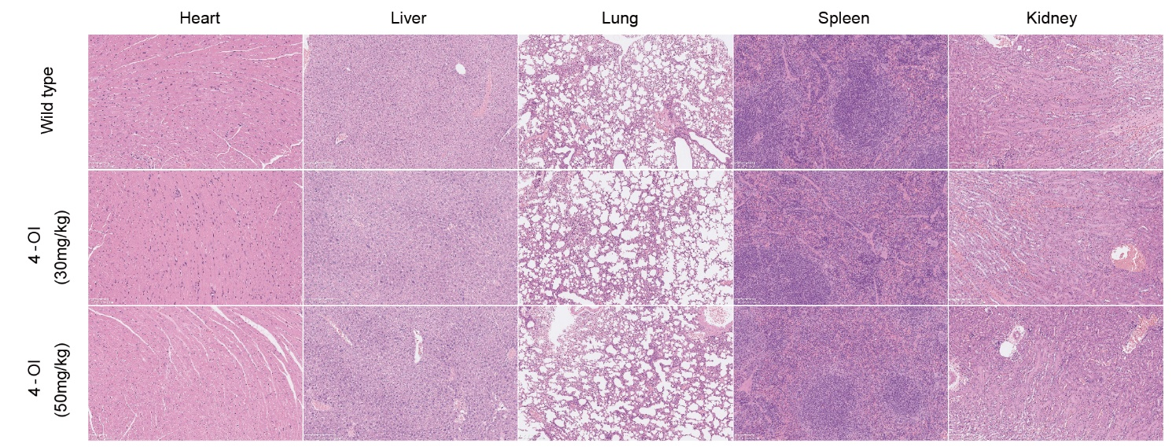
Supplementary Figure 5. The effect of 4-OI injection on major organs in mice as observed by HE staining.

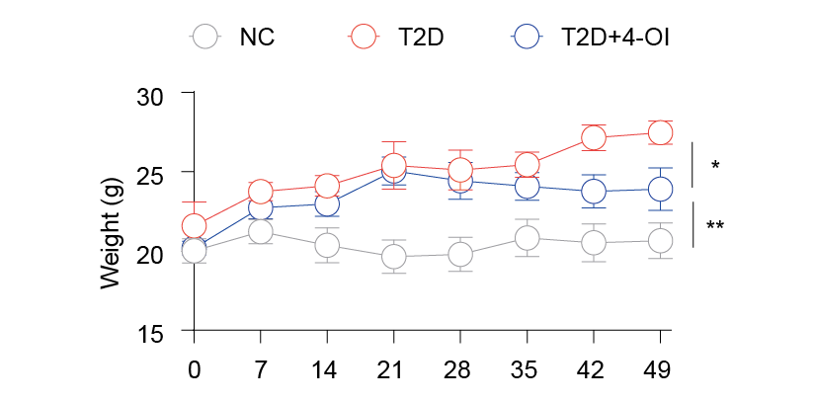
Supplementary Figure 6. Monitoring of mouse body weight during the 4-OI treatment, (n = 5). *P < 0.05，**P < 0.01.

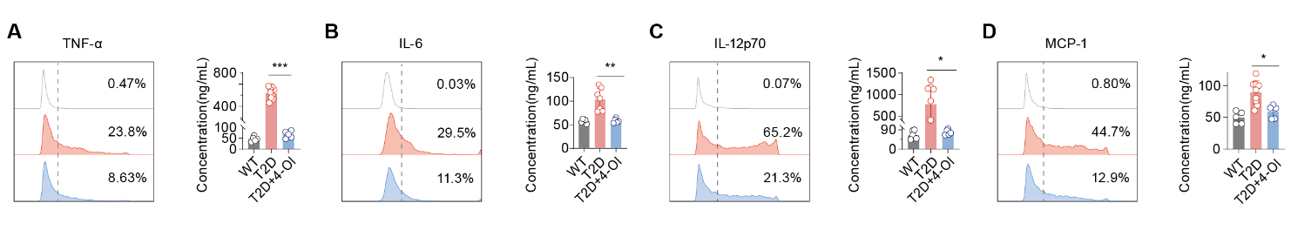
Supplementary Figure 7. Multiplex cytokine profiling of serum TNF-α, IL-12p70, IL-6, and MCP-1 levels via flow cytometric bead array.

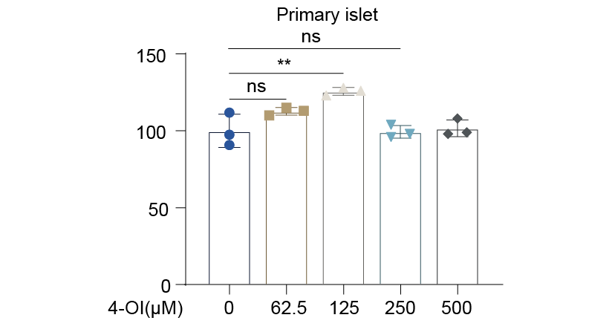
Supplementary Figure 8. MTS assay monitors the cytotoxicity effects of different concentrations of 4-OI on the viability of primary porcine islet, (n = 3).

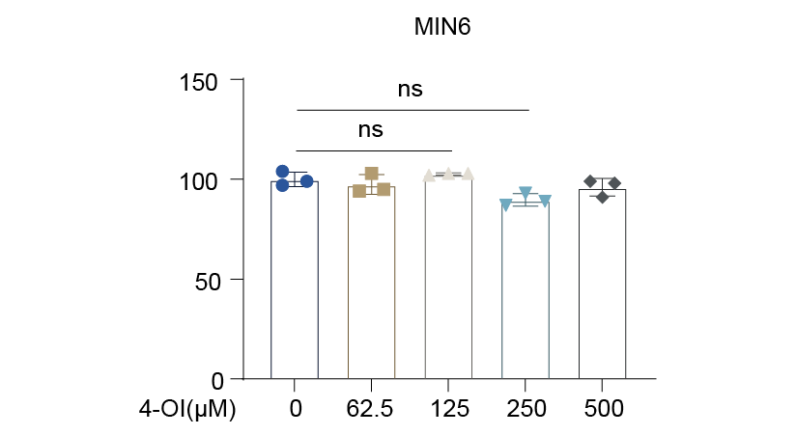
Supplementary Figure 9. MTS assay monitors the cytotoxicity effects of different concentrations of 4-OI on the viability of MIN6 cells (B), (n = 3).

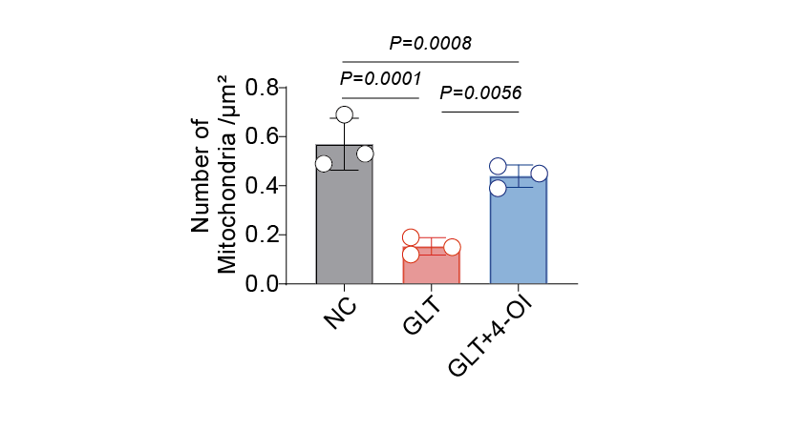
Supplementary Figure 10. Quantification of the number of mitochondria in primary islets after 4-OI treatments, as determined by transmission electron microscopy, (n = 3).

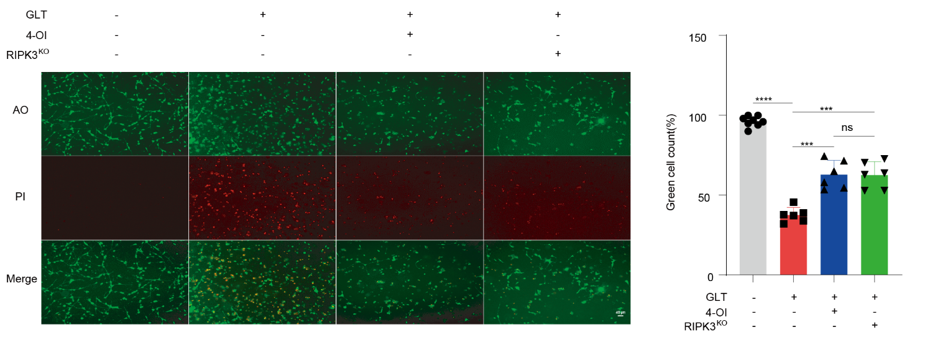
Supplementary Figure 11. AO/PI assay illustrates the impact of RIPK3 knockout on MIN6 viability under GLT conditions and quantitative analysis, (n=6).

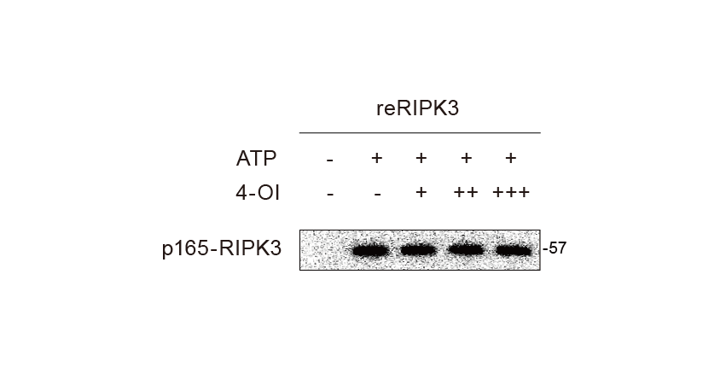
Supplementary Figure 12. Expression of p165RIPK3 phosphorylation following incubation with recombinant RIPK3 protein at different concentrations of 4-OI, (n = 3).

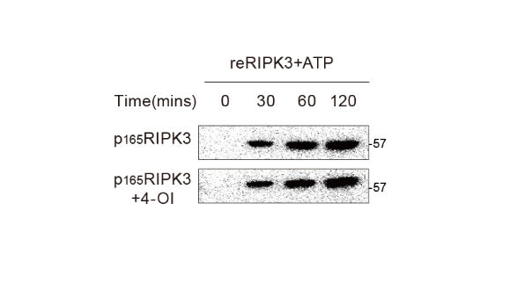
Supplementary Figure 13. Changes in p165RIPK3 phosphorylation over time following co-incubation of recombinant RIPK3 protein with 4-OI, (n = 3).

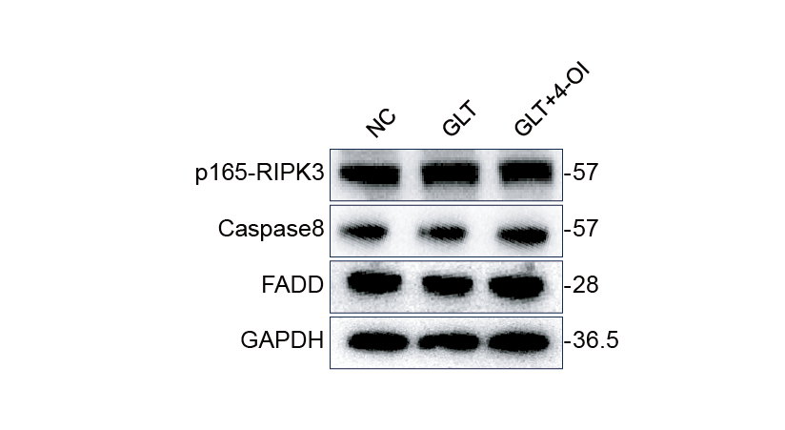
Supplementary Figure 14. Western blot analysis showing the effects of itaconate on RIPK3 phosphorylation at T165 and the downstream apoptotic pathway in MIN6 cells under GLT conditions.

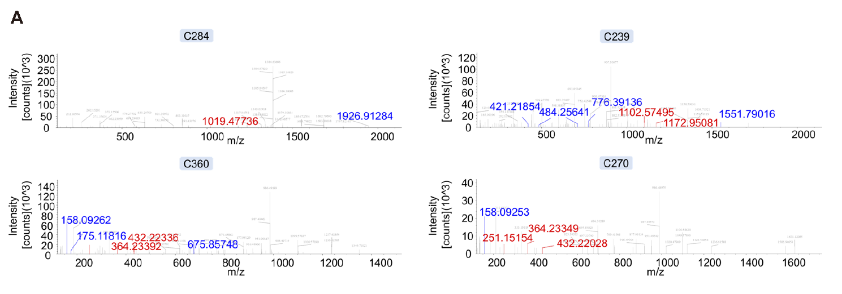
Supplementary Figure 15. Mass spectrometry reveals the peptide mapping of 4-OI alkylated modifications at different sites on RIPK3.

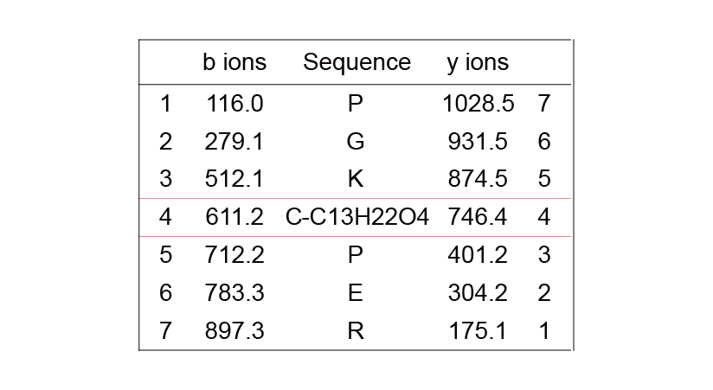
Supplementary Figure 16. Mass spectrometry displays the ion map of 4-OI alkylated modifications on RIPK3.

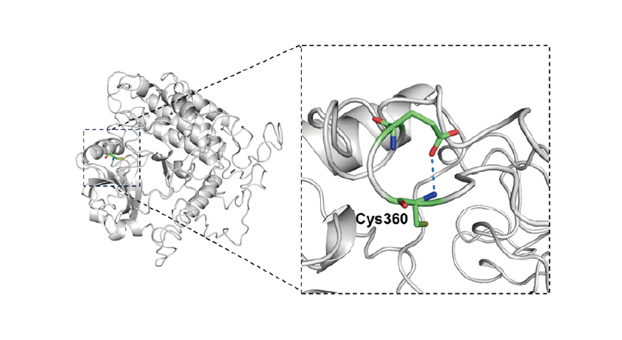
Supplementary Figure 17. Three-dimensional structure of WT RIPK3 and Cys 360.

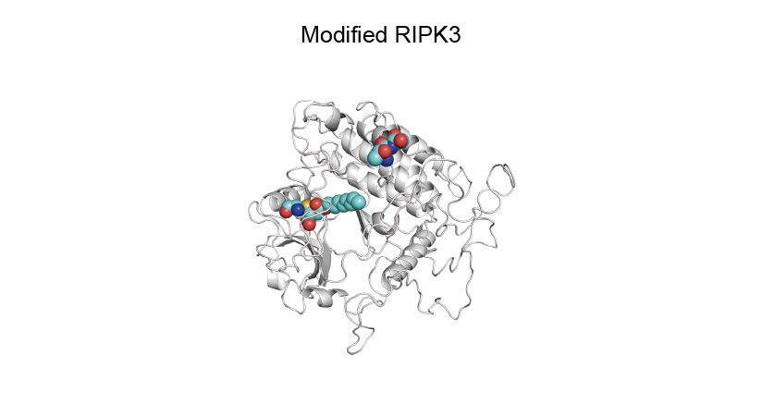
Supplementary Figure 18. Three-dimensional structure of RIPK3 protein after modification by itaconate.

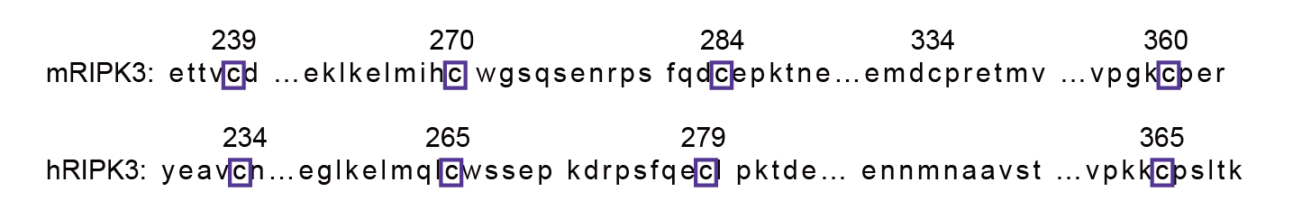
Supplementary Figure 19. Schematic representation of the alkylates sites of RIPK3 in mouse and their corresponding RIPK3 sites in human.

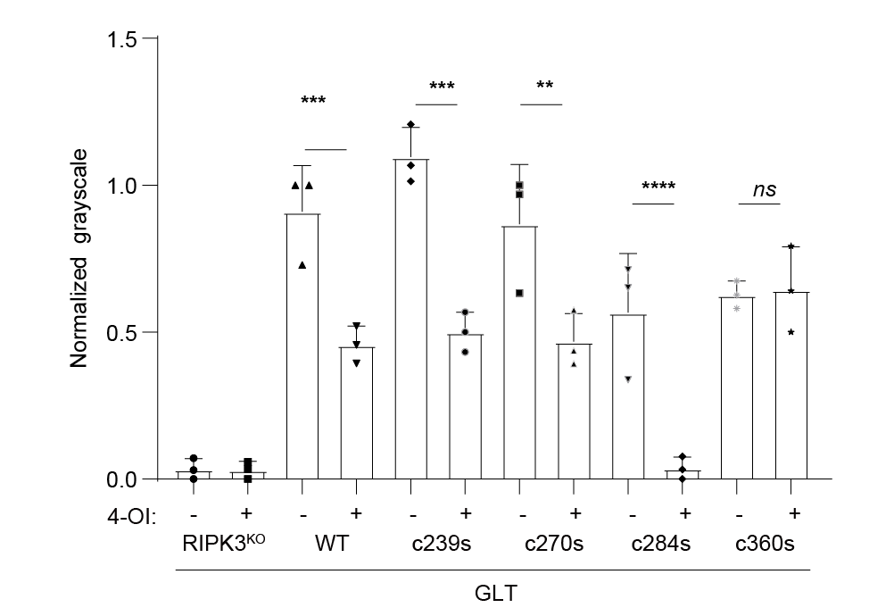
Supplementary Figure 20. Quantification of RIPK3 phosphorylation after site-directed mutagenesis of mouse RIPK3, as determined by Western blot.

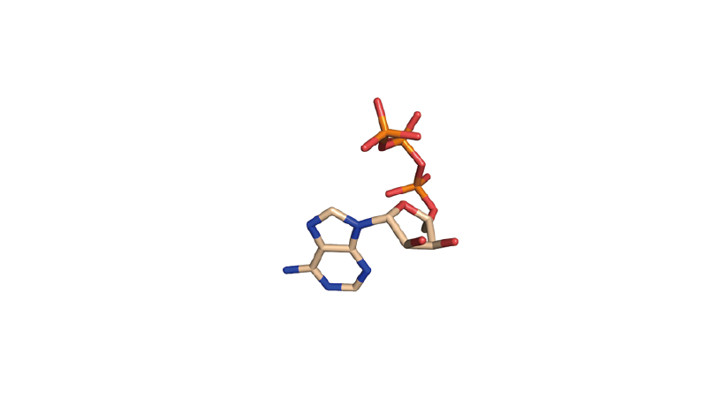
Supplementary Figure 21. The three-dimensional structure of ATP molecules.

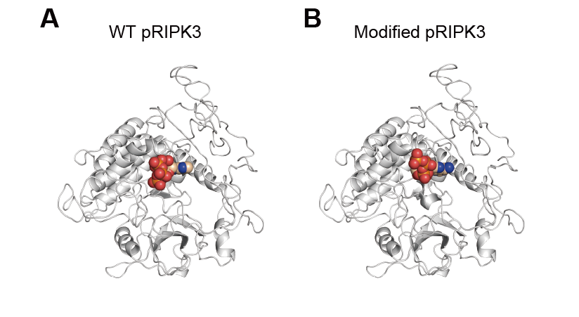
Supplementary Figure 22. Molecular recognition study of the structure of phosphorylated RIPK3 before (A) and after (B) Cys360 modification.

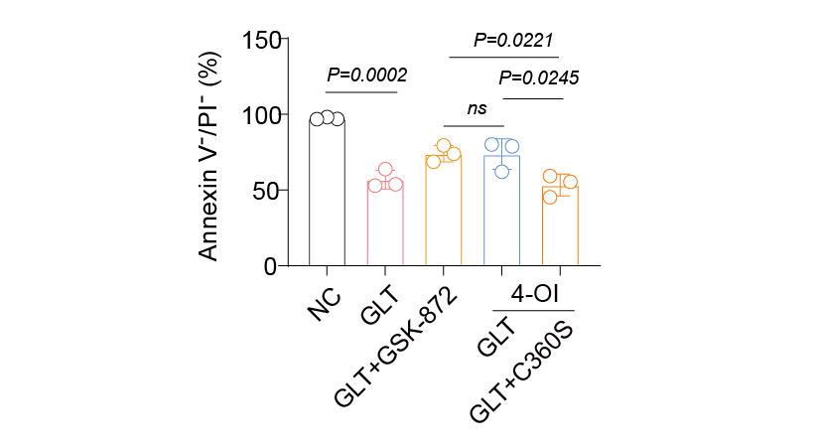
Supplementary Figure 23. Quantification of Annexin V⁻/PI⁻ cells following C360S mutation, (n=3).

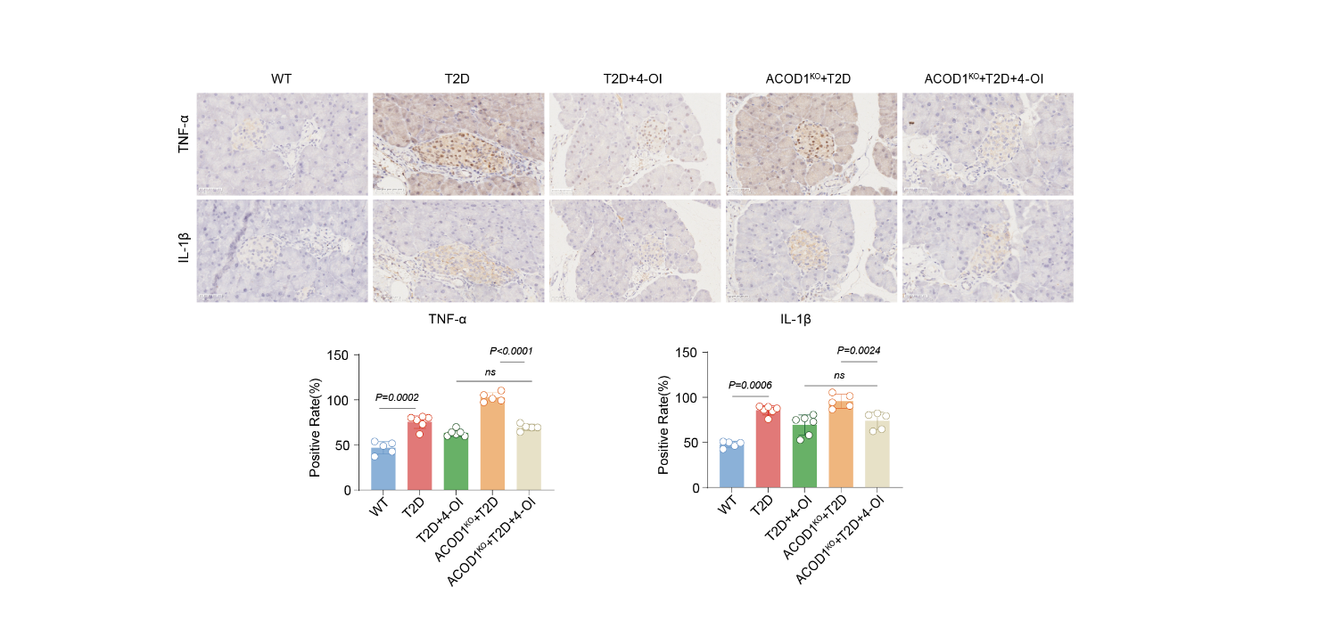
Supplementary Figure 24. Immunohistochemistry showing the impact of ACOD1^{-/-} on the secretion of inflammatory factors for IL-1β, and TNF-α in the pancreas of diabetic mice, (n = 5).

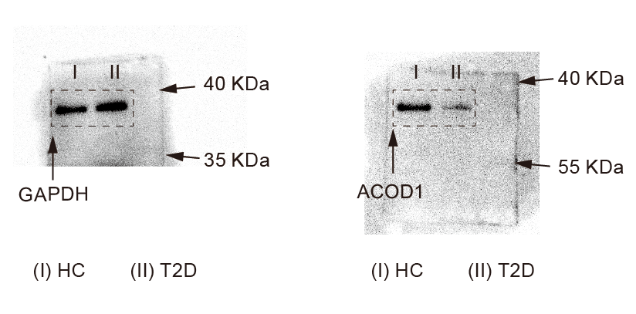
Supplementary Figure 25. Complete uncropped gel of western blot images for Fig. 1M. n=3, All results are representative of at least five independent experiments.

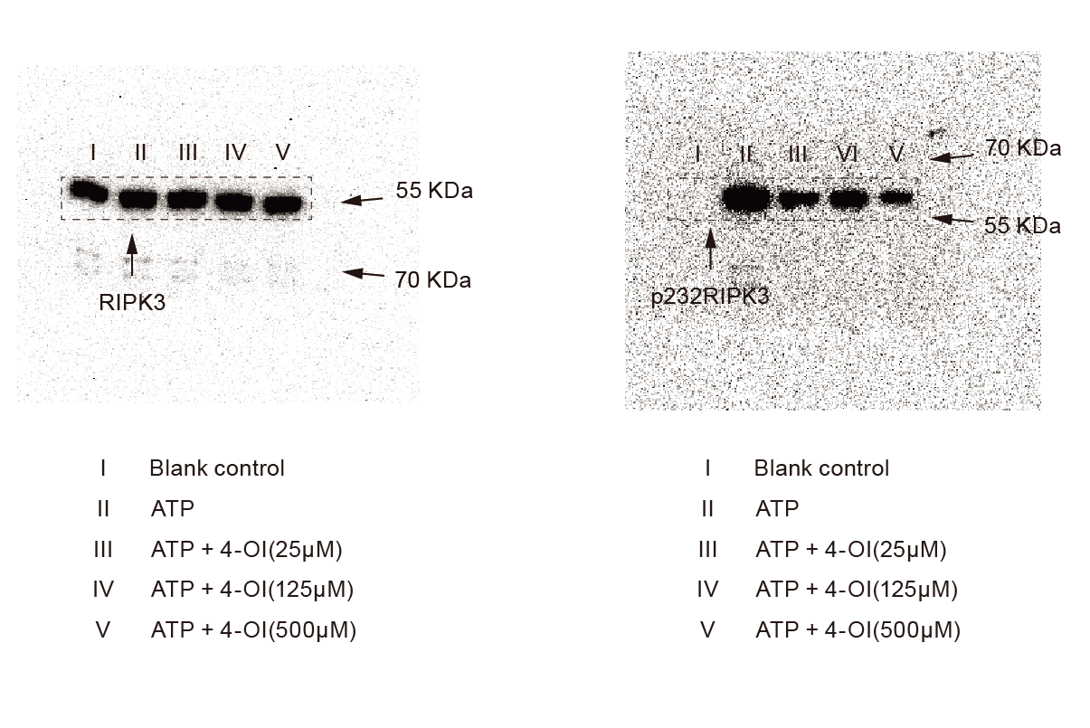
Supplementary Figure 26. Complete uncropped gel of western blot images for Fig. 5E. n=3, All results are representative of at least five independent experiments.

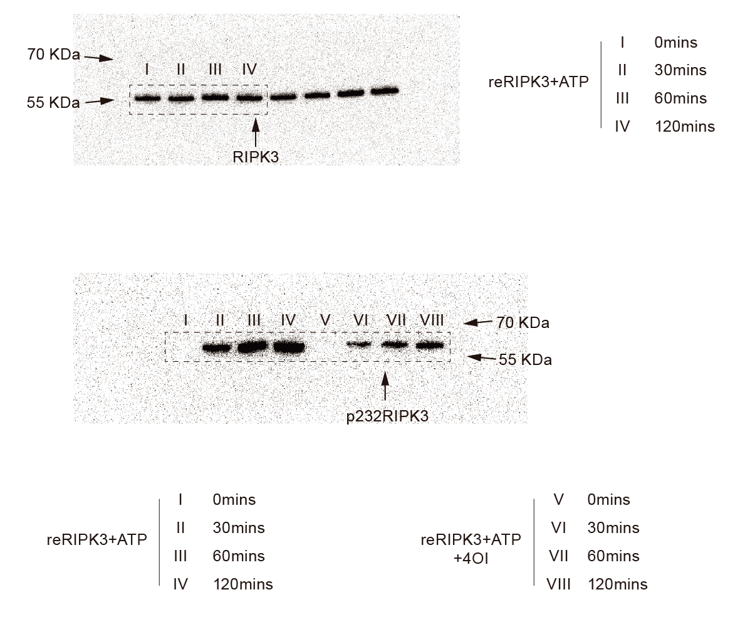
Supplementary Figure 27. Complete uncropped gel of western blot images for Fig. 5F. n=3, All results are representative of at least five independent experiments.

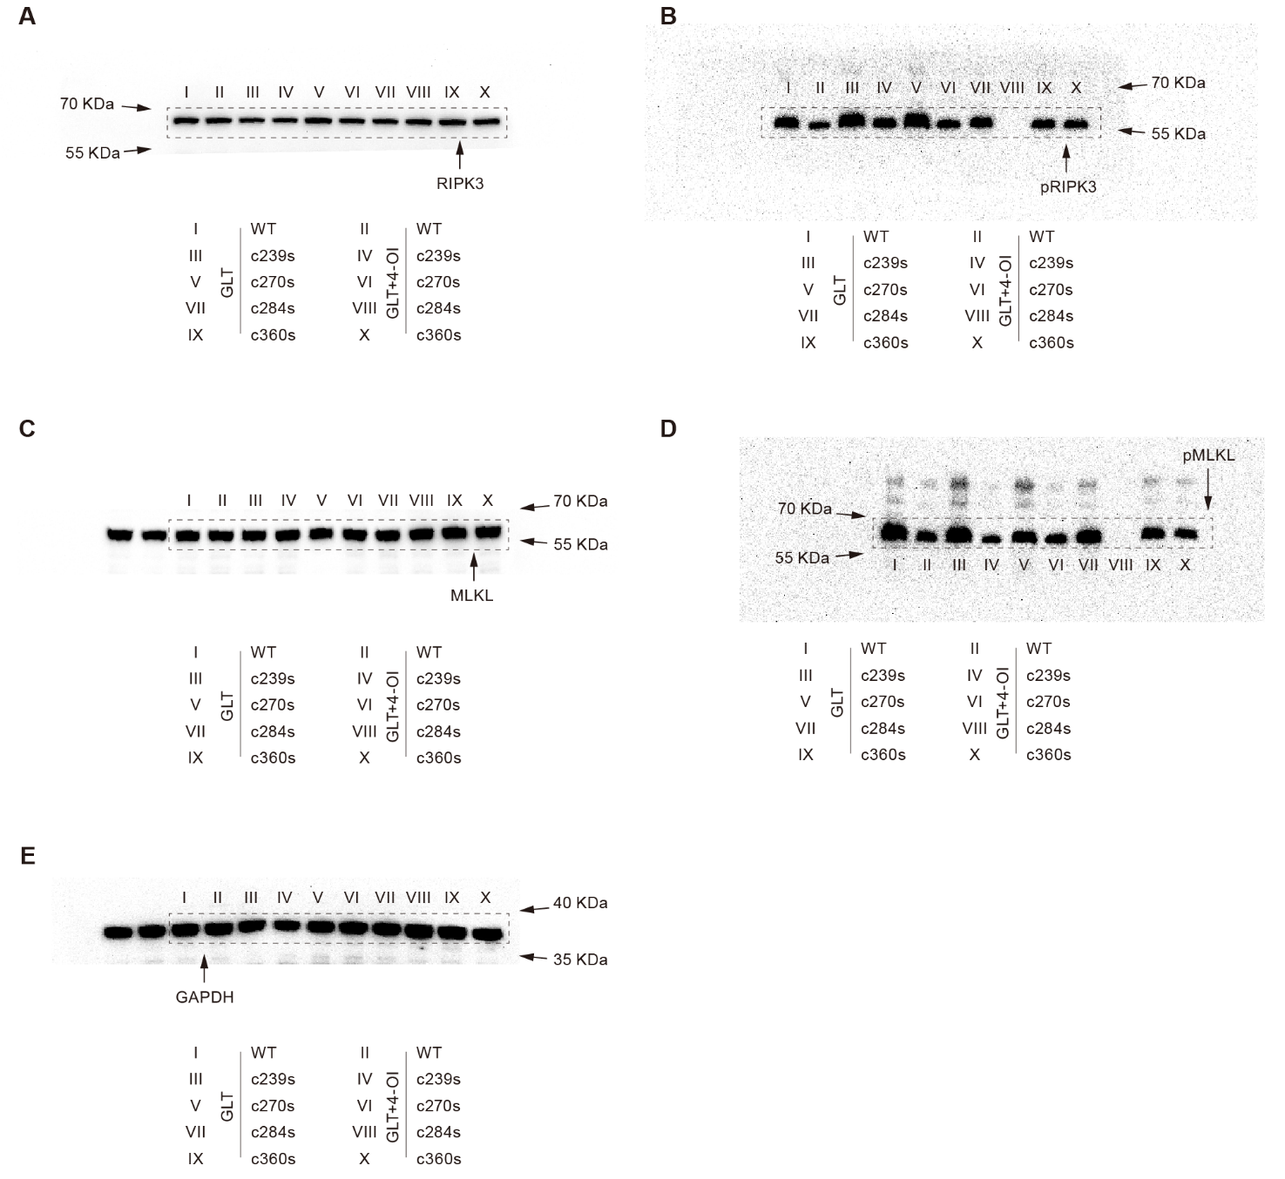
Supplementary Figure 28. Complete uncropped gel of western blot images for Fig. 6F. n=3, All results are representative of at least five independent experiments.

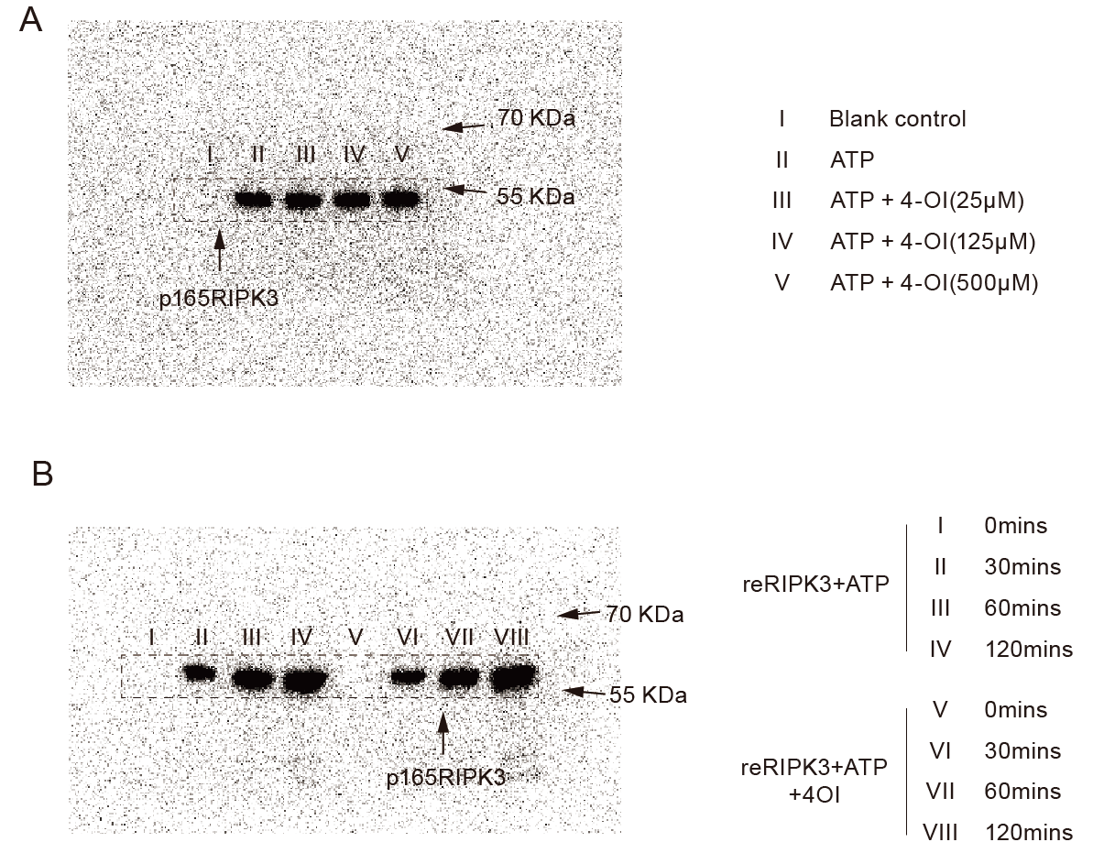
Supplementary Figure 29. Complete uncropped gel of western blot images for Fig. S12(A) and S13(B). n=3, All results are representative of at least five independent experiments.

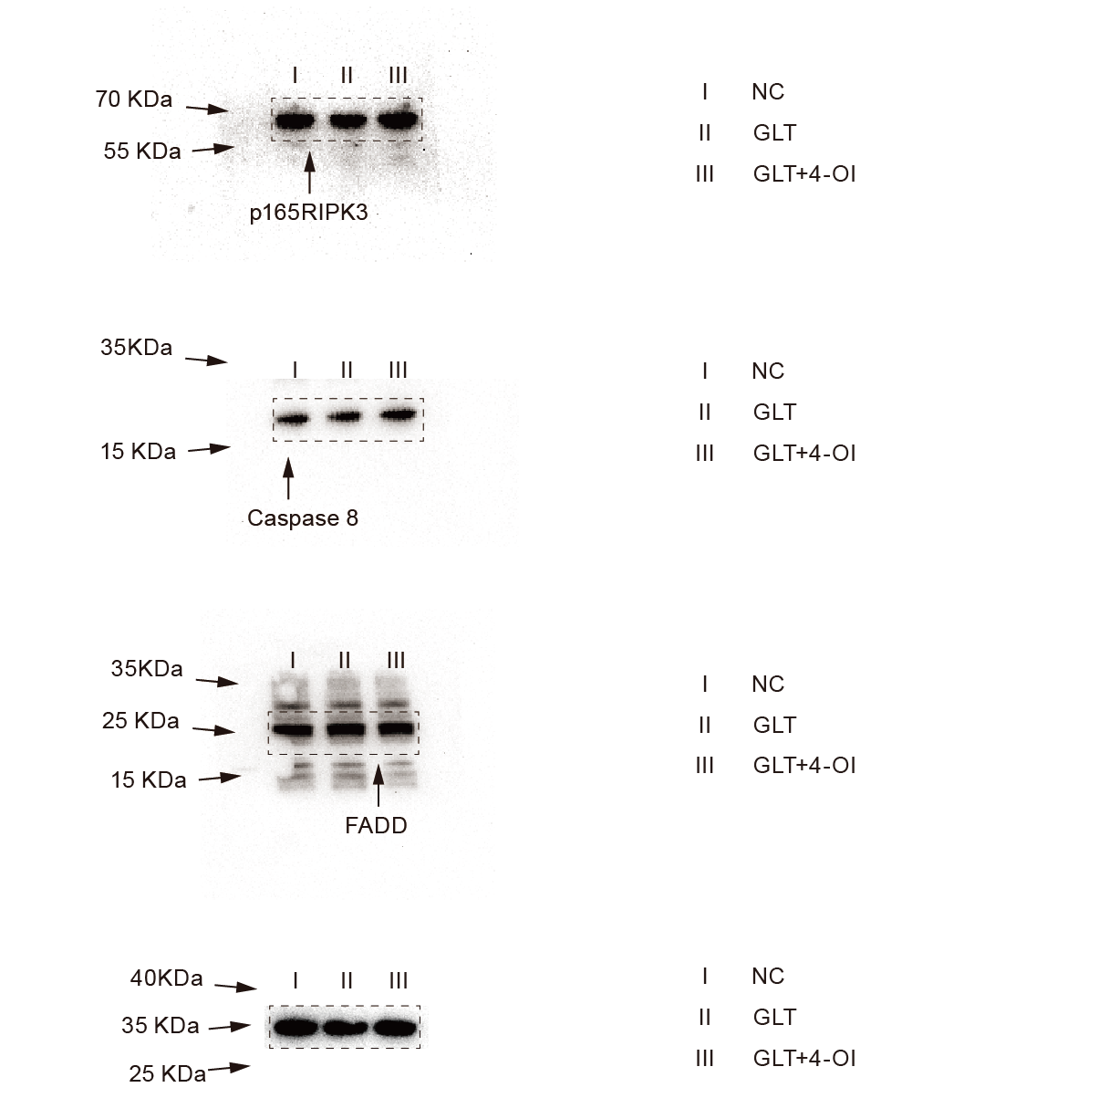 Supplementary Figure 30. Complete uncropped gel of western blot images for Fig. S14. n=3, All results are representative of at least five independent experiments.

Supplementary Table 1. Basic characteristics of 124 individuals
Characteristics | HC(n=48) | T2D(n=76) | t | p
Age (years) | 55.56 ±7.73 | 53.87 ±9.36 | 1.017 | 0.517
Male/Female (n) | 26/22 | 48/32 | 0.601 | 0.438
Education (years) | 55.56 ±7.73 | 53.87 ±9.36 | -1.659 | 0.101
Diabetes duration (years) | 55.56 ±7.73 | 53.87 ±9.36 | 0.613 | 0.541
HDL (mmol/L) | 1.18 ± 0.48 | 1.07 ±0.59 | 1.10 | 0.273
LDL (mmol/L) | 3.09 ± 0.31 | 3.18 ±0.89 | 0.72 | 0.473
BMI (kg/m²) | 24.1 ± 2.4 | 25.95±3.08 | 3.62 | 0.0004
TG (mmol/L) | 1.54 ±0.73 | 2.18±1.15 | 3.56 | 0.0005
TC (mmol/L) | 4.42 ± 0.72 | 5.12+1.01 | 4.38 | < 0.0001
HbA1c(%) | 5.62 ±0.31 | 7.86±1.62 | -11.66 | < 0.0001
FPG (mmol/L) | 5.12 ± 0.46 | 8.17 ±1.30 | -18.64 | < 0.0001

Supplementary Table 2. qPCR primer list
Gene Name | Primer Sequence
IRG-1 | F- GGTATCATTCGGAGGAGCAAGAG
 | R- ACAGTGCTGGAGGTGTTGGAAC
TNF-α | F- GGTGCCTATGTCTCAGCCTCTT
 | R- GCCATAGAACTGATGAGAGGGAG
IL-6 | F- ACGCAGACAAGGAGCAGTGGAA
 | R- ATGCTCTCAGCCAAGTCTGCCA
IL-12p70 | F- ACGAGAGTTGCCTGGCTACTAG
 | R- CCTCATAGATGCTACCAAGGCAC
MCP-1 | F- CATCACGGACAGAGGTTCTGAG
 | R- TCCTCTGTTGTGTGGATTCACTC

Supplementary Table 3. Antibody of Western blot list
Antibody Name | Catalog Number | Source | Molecular weight | Company
IRG-1 | ab222411 | Rabbit | 50KDa | Abcam, USA
RIPK3 | ab62344 | Rabbit | 57KDa | Abcam, USA
P232RIPK3 | ab222320 | Rabbit | 57KDa | Abcam, USA
P165RIPK3 | ab255705 | Rabbit | 57KDa | Abcam, USA
MLKL | ab243142 | Rabbit | 54KDa | Abcam, USA
pMLKL | ab196436 | Rabbit | 54KDa | Abcam, USA
Caspase-8 | A0215 | Rabbit | 57KDa | ABclonal, China
FADD | A19838 | Rabbit | 28KDa | ABclonal, China
GAPDH | 60004-1-Ig | Mouse | 36.5KDa | Proteintech, USA

Supplementary Method
Inclusion/Exclusion Criteria and Enrollment Flow

I. Inclusion Criteria
Healthy Control Group (HC, n = 48)
- Fasting blood glucose≤6.0 mmol/L, with no prior history of diabetes
- Willing to provide signed informed consent
- Able to complete questionnaires and blood sample collection
T2D Group (n = 76)
- Meets International Diabetes Federation (IDF) 2021 diagnostic criteria: fasting blood glucose ≥ 7.0 mmol/L (supplemented with OGTT/HbA1c criteria if applicable)
- Confirmed diagnosis of type 2 diabetes (excluding type 1, gestational, or secondary diabetes)
- Willing to provide signed informed consent

II. Exclusion Criteria
- Diagnosis of type 1 diabetes, gestational diabetes, or other specific types of diabetes
- Severe hepatic or renal insufficiency
- Malignant tumor
- Use of medications known to affect metabolism (e.g., glucocorticoids) within the past 2 months
- Acute infection or other acute stress conditions (may confound metabolomic results)
- Pregnant or lactating women
- Insufficient blood sample volume or poor sample quality (hemolysis, lipemia, etc.)
- Incomplete clinical data
- Refusal to participate or withdrawal during the study

III. Enrollment and Exclusion Flow
Screening Phase
Total screened: __150__ subjects (healthy individuals: _60_; suspected/confirmed T2D patients: _90_ )
Healthy Control Group
Category | Count
Met initial screening criteria | 60
Total excluded | 12
– Fasting glucose 6.0–7.0 mmol/L (pre-diabetes) | 2
– Comorbid chronic disease | 3
– Declined informed consent | 1
– Poor sample quality | 2
– Lost to follow-up / withdrawal | 4
Final enrollment | 48

T2D Group
Category | Count
Met initial screening criteria | 90
Total excluded | 14
– Did not meet IDF diagnostic criteria | 2
– Type 1 diabetes / secondary diabetes | 1
– Recent medication affecting metabolism | 3
– Severe hepatic/renal insufficiency or malignancy | 2
– Pregnancy / lactation | 1
– Poor sample quality | 1
– Lost to follow-up / withdrawal | 4
Final enrollment | 76

T2D Subgroup Stratification (as in Fig. 1D)
Category | Count
Normoglycemia control (NC, < 6 mmol/L) | 20
Pre-diabetes (Pre-T2D, 6–7 mmol/L) | 28
T2D without complications (T2D-N) | 39
T2D with complications (T2D-C) | 37

