Invasive Pulmonary Fungal Infection in Non-ICU Adults With Community-Acquired Pneumonia: Prevalence and Association With Recent Respiratory Viral Infection
Luong Dinh-Van,^{1†} Hoang-Anh Nguyen-Cong,^{2,3†*} Nguyen Tran-Ngoc,^{3,4} Helmut J.F. Salzer,^{3,5} Huyen Hoang-Thu,² Thuy-Quynh Ngo-Thi,² Doan Pham-Van,² Trung Pham-Quang,² Mai-Anh Nguyen,² Hong-Phuc Nguyen-Le,⁶ Bich-Ngoc T. Nguyen^{2,6*}

¹ Lung Transplant Center, National Lung Hospital, Hanoi, Vietnam
² Center for Rare Lung Diseases and Respiratory Infections, National Lung Hospital, Hanoi, Vietnam
³ Faculty of Medicine, Johannes Kepler University Linz, Linz, Austria
⁴ Department of Tuberculosis and Lung Diseases, School of Medicine, University of Medicine and Pharmacy at Ho Chi Minh City, Ho Chi Minh City, Vietnam
⁵ Division of Infectious Diseases and Tropical Medicine, Department of Internal Medicine 4, Kepler University Hospital, Linz, Austria
⁶ University of Medicine and Pharmacy, Vietnam National University, Hanoi, Vietnam
Keywords: chest computed tomography, diabetes, invasive pulmonary aspergillosis, invasive pulmonary mucormycosis, viral infection
*Corresponding author: Hoang-Anh Nguyen-Cong.
Center for Rare Lung Diseases and Respiratory Infections, 3rd floor, S12 building, National Lung Hospital. 463 Hoang Hoa Tham street, Ngoc Ha ward, Hanoi 10000, Vietnam.
Email: hoanganhnguyencong@gmail.com
*Corresponding author: Bich-Ngoc T. Nguyen.
Center for Rare Lung Diseases and Respiratory Infections, 3rd floor, S12 building, National Lung Hospital. 463 Hoang Hoa Tham street, Ngoc Ha ward, Hanoi 10000, Vietnam
Email: ngocn4@hotmail.com
†Luong Dinh-Van and Hoang-Anh Nguyen-Cong contributed equally.
Supplementary material
Table S1. Variables associated with IPFI identified and retained by LASSO penalized regression.
Variables | LASSO coefficient
Peribronchial infiltration | 0.971
Diabetes mellitus | 0.417
Flu-like symptoms | 0.279
Hemoptysis | 0.144
Chronic lung disease | -0.067
Blood urea | 0.060
Neutrophil-to-lymphocyte ratio | 0.019
White blood cell count | 0.010
Neutrophil count | 0.007
Note: The table displays the non-zero coefficients extracted from the LASSO regression at the optimal penalization parameter (λ min) determined by 10-fold cross-validation. Prior to LASSO selection, classic diagnostic variables and those causing complete data separation were intentionally excluded from the candidate pool to prevent incorporation bias and statistical instability. A positive coefficient indicates a positive association with the likelihood of developing invasive pulmonary fungal infection. To prevent overfitting and strictly maintain an acceptable events-per-variable ratio, only the top two predictors with the highest absolute coefficients were selected for the final multivariable logistic regression model, which had “Recent respiratory infection” as the primary variable.
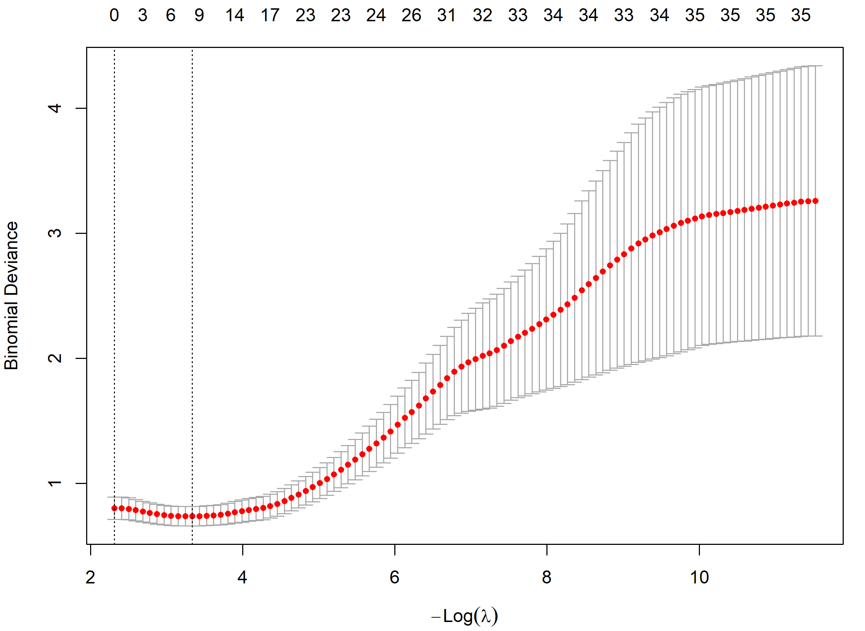
Supplementary Figure S1. Cross-validation plot for the LASSO penalty variable selection.
The plot illustrates the 10-fold cross-validation curve used to select the optimal penalization parameter (λ) for the LASSO logistic regression. The y-axis represents the binomial deviance (model error), and the lower x-axis represents log(λ). The upper x-axis indicates the number of non-zero coefficients corresponding to each λ. The solid red dots indicate the mean binomial deviance for each model, with error bars representing the upper and lower standard deviations. The left vertical dashed line indicates the optimal λ value (λ min) that minimizes the mean cross-validated error, which was subsequently used to extract the retained predictive variables.

Table S2. Sensitivity analyses evaluating the robustness of the multivariable explanatory model for independent factors associated with invasive pulmonary fungal infection.
Variables | Model 1: Excluding mucormycosis (N=187) |  | Model 2: Adjusting for chronic lung disease (N=188) |  | Model 3: Expanded radiological variables (N=188)
Variables | aOR (95% CI) | P-value | aOR (95% CI) | P-value | aOR (95% CI) | P-value
Covariates
Severe CAP | 2.04 (0.55-6.66) | 0.271 | 2.46 (0.67-8.34) | 0.168 | 2.31 (0.62-7.77) | 0.201
Male gender | 1.20 (0.39-4.35) | 0.760 | 1.19 (0.38-4.40) | 0.776 | 1.18 (0.34-5.07) | 0.802
Comorbidities
Diabetes mellitus | 3.94 (1.37-11.21) | 0.012 | 3.49 (1.22-9.93) | 0.020 | 3.31 (1.08-9.82) | 0.037
Chronic lung disease | - | - | 0.41 (0.11-1.25) | 0.121 | - | -
Recent respiratory viral infection | 3.09 (1.23-8.04) | 0.016 | 3.50 (1.38-9.30) | 0.008 | 2.72 (1.02-7.53) | 0.045
Chest computed tomography
Peribronchial infiltration | 4.59 (1.82-12.21) | 0.001 | 4.64 (1.83-12.42) | 0.001 | 3.34 (1.17-9.96) | 0.024
Halo sign | - | - | - | - | 8.31 (2.26-32.37) | 0.002
Reversed halo sign | - | - | - | - | 3.60 (0.39-36.36) | 0.250
Wedge-shaped consolidation | - | - | - | - | 1.97 (0.15-15.07) | 0.574
Macronodule | - | - | - | - | 1.57 (0.35-6.25) | 0.545
Cavitation | - | - | - | - | 1.18 (0.28-4.31) | 0.808
Note: This table presents the adjusted odds ratios (aOR) and 95% confidence intervals (CI) for the three primary variables across three exploratory sensitivity scenarios: (Model 1) excluding the single case of invasive pulmonary mucormycosis to assess the robustness of factors specifically for aspergillosis; (Model 2) additionally adjusting for chronic lung disease; and (Model 3) expanding the model to incorporate all classic radiological EORTC/MSGERC diagnostic criteria simultaneously. Across all models, recent respiratory viral infection, diabetes mellitus, and peribronchial infiltration consistently retained their independent associations with the development of invasive pulmonary fungal infection

