Scatter plot matrix with correlation coefficients among primary study variables (PHQ-9, GAD-7, Destiny, Responsibility, Resilience)
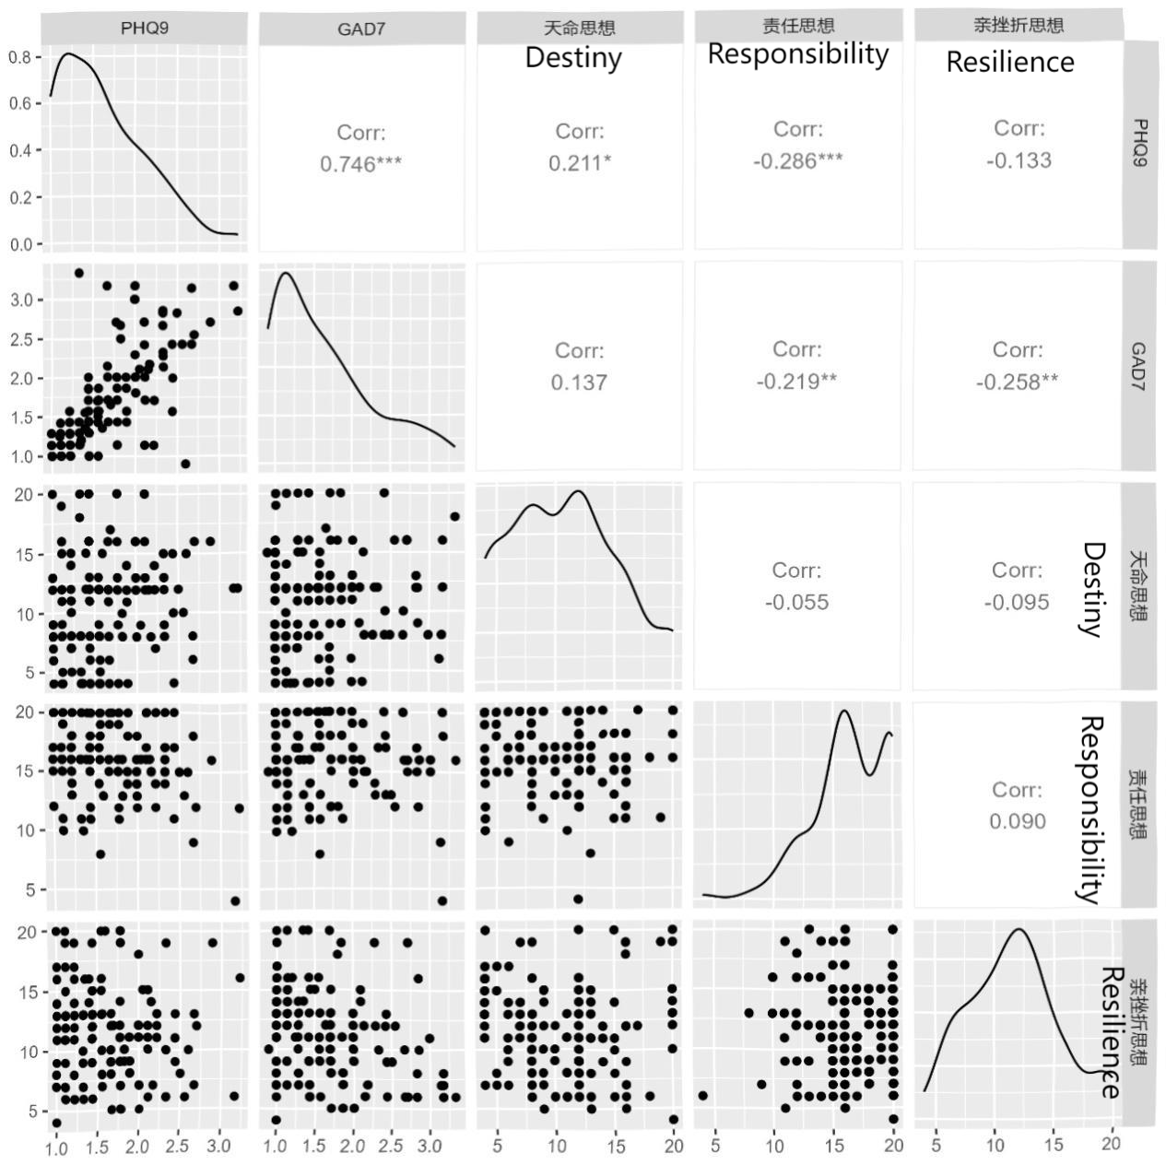
Variable 1 | Variable 2 | Pearson r | P-Value
PHQ-9 | GAD-7 | 0.746 | <0.001
Destiny | PHQ-9 | 0.211 | <0.05
Responsibility | PHQ-9 | -0.286 | <0.001
Responsibility | GAD-7 | -0.219 | <0.01
Resilience | GAD-7 | -0.26 | <0.01

