The human amniotic membrane derived MSC secretome restrains neuroinflammation and peripheral immune cell invasion of 3D neural tissue through conserved CXCL10 blockade and proteostatic rescue

Running title: Human amniotic secretome inhibits neuroinflammation

Alexandro Angelo Bufi^{1,2§}, Andrea Papait^{1,3}*§, Julia Di Stefano^{4,5}, Federica Di Marco^{6,7}, Helena Motaln⁸, Serafina Farigu⁹, Elsa Vertua⁹, Patrizia Bonassi Signoroni⁹, Elisa Scalvini⁹, Elisabetta Giuzzi⁹, Alice Paini⁹, Pietro Romele⁹, Federico Quaglia¹⁰, Elise Van Breedam², Paola Chiodelli^{1,3}, Piero Del Boccio^{6,7}, Damiana Pieragostino^{6,11}, Antonietta Rosa Silini⁹, Peter Ponsaerts², Ornella Parolini^{1,3}

¹Department of Life Science and Public Health, Università Cattolica del Sacro Cuore, Rome 00168, Italy
² Laboratory of Experimental Hematology, Vaccine and Infectious Disease Institute (Vaxinfectio), University of Antwerp, Wilrijk 2610, Belgium
³ Fondazione Policlinico Universitario "Agostino Gemelli", IRCCS, Rome 00168, Italy
⁴School of Medicine, University College Dublin, Dublin, Ireland
⁵Conway Institute of Biomolecular and Biomedical Research, University College Dublin, Dublin, Ireland
⁶Center for Advanced Studies and Technology (CAST), G. d'Annunzio University of Chieti-Pescara, 66100 Chieti, Italy
⁷Department of Pharmacy, G. d'Annunzio University of Chieti-Pescara, 66100 Chieti, Italy
⁸Department of Biotechnology, Jozef Stefan Institute, SI-1000 Ljubljana, Slovenia.
⁹ Centro di Ricerca E. Menni, Fondazione Poliambulanza Istituto Ospedaliero, Brescia 25124, Italy
¹⁰Obstetrics and Gynecology Unit, Fondazione Poliambulanza Istituto Ospedaliero, Brescia 25124, Italy
¹¹Department of Innovative Technologies in Medicine and Dentistry, University "G. d'Annunzio" of Chieti-Pescara, 66100 Chieti, Italy.

§ These authors contributed equally to this work

* Correspondence:
Corresponding Author
andrea.papait@unicatt.it

Supplementary Data
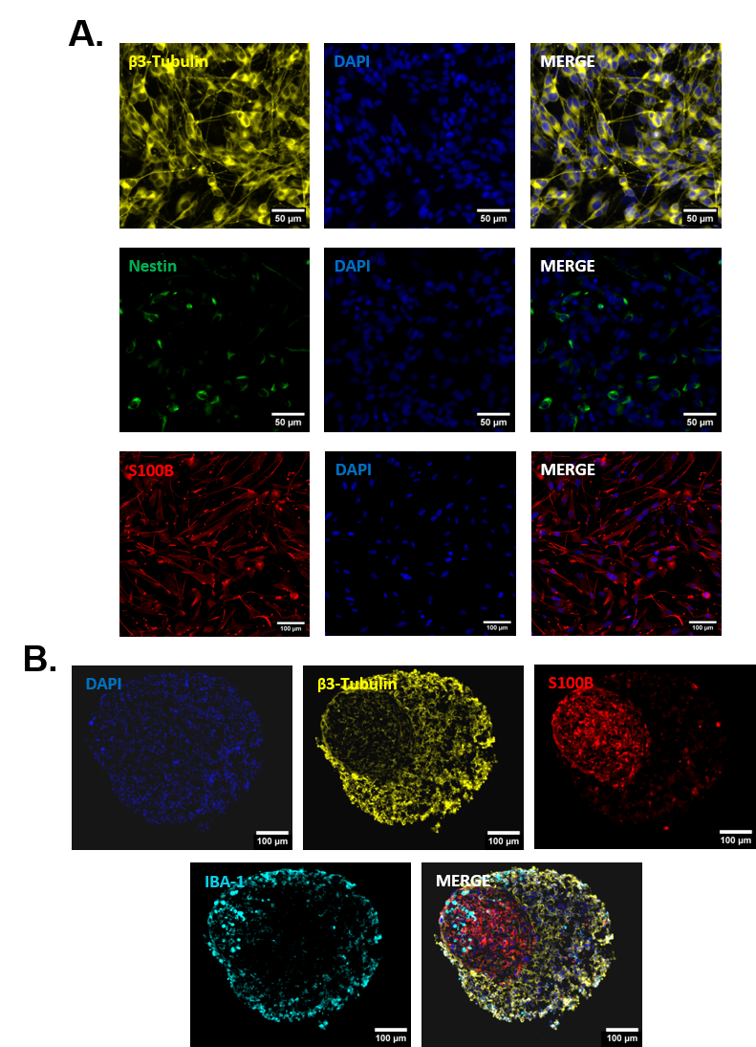

Supplementary Figure S1. Generation and characterization of 2D neural monocultures and 3D tri-hNSPHs. (A) Representative immunofluorescence images of SH-SY5Y differentiated into NLCs expressing β3-tubulin (yellow) and negative for Nestin (green), and U138-MG differentiated into ALCs positive for S100B (red). Nuclei counterstained with DAPI (blue). (B) Representative immunofluorescence of tri-hNSPHs showing the spatial organization of β3-tubulin⁺ NLCs (yellow), S100B⁺ ALCs (red) and Iba-1⁺ HMC-3 microglia (cyan).

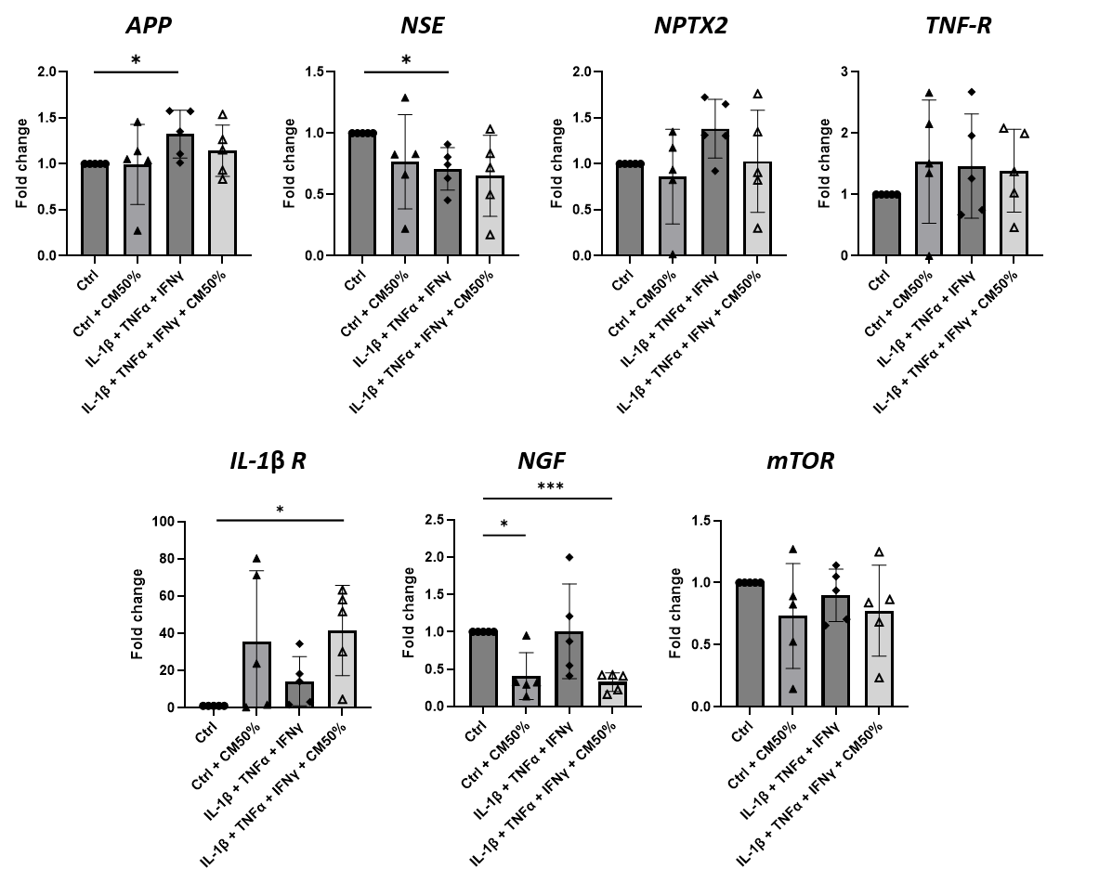
Supplementary Figure S2. Transcripts not modulated by CM-hAMSC treatment in NLCs. Gene expression analysis of transcripts that did not display significant modulation upon pro-inflammatory stimulation or combined treatment with CM-hAMSC. Data shown as mean ± SD, n = 5. Statistical significance was determined by a one-sample t-test and by one-way ANOVA with Tukey’s post-hoc test. Outliers were identified with ROUT method (Q=1%) and excluded from the analysis. *p < 0.03; ***p < 0.0002.

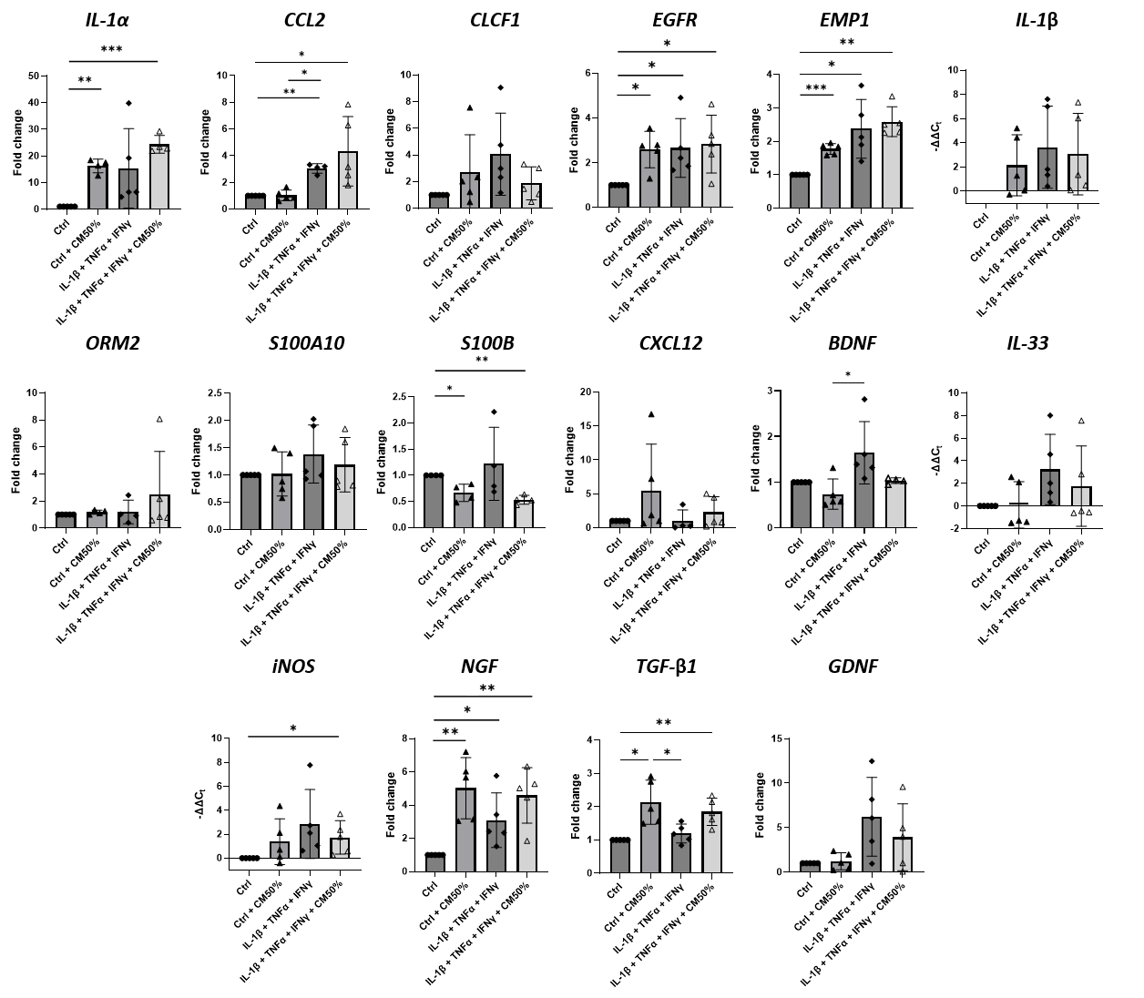
Supplementary Figure S3. Transcripts not modulated by CM-hAMSC treatment in ALCs. qRT-PCR analysis of selected genes related to pro-inflammatory reactive and pro-resolving states of astrocytes that were not significantly modulated by CM-hAMSC treatment under inflammatory conditions. Data shown as mean ± SD, n = 5. Statistical significance was determined by a one-sample t-test and by one-way ANOVA with Tukey’s post-hoc test. Outliers were identified with ROUT method (Q=1%) and excluded from the analysis. *p < 0.03; **p < 0.02; ***p < 0.0002.

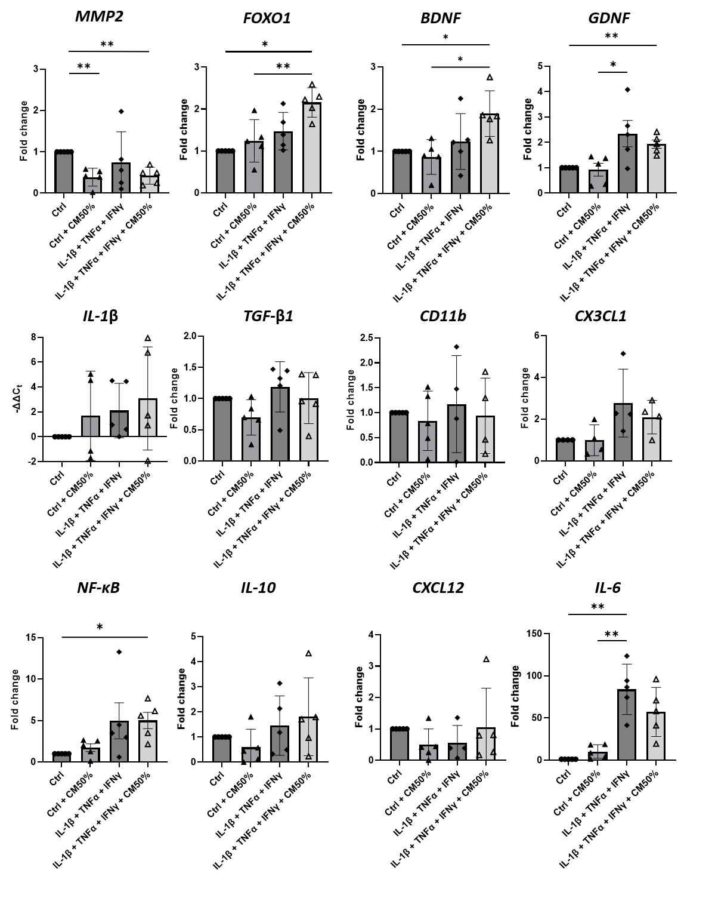
Supplementary Figure S4. Transcripts not modulated by CM-hAMSC treatment in HMC-3 cells. Gene expression analysis of inflammation- and immune-response–related genes in HMC-3 cells showing no significant changes across the indicated experimental conditions. Data shown as mean ± SD, n = 5. Statistical significance was determined by a one-sample t-test and by one-way ANOVA with Tukey’s post-hoc test. Outliers were identified with ROUT method (Q=1%) and excluded from the analysis. *p < 0.03; **p < 0.02.

