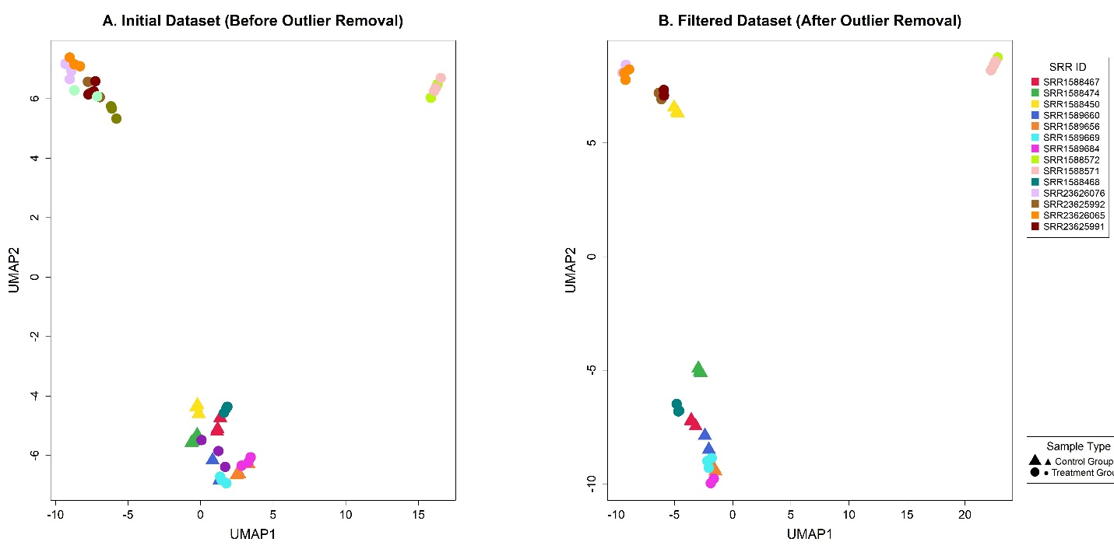
Figure S1. Sample quality assessment and outlier removal from the integrated RNA-seq data. A UMAP visualization of the data set after filtering out several outlier samples, which led to clear clustering of the data points according to their biological conditions.

Figure S2. KEGG pathway enrichment analysis of differentially expressed genes. The donut chart shows the distribution of enriched pathways among DEGs. Percentages indicate the proportion of each pathway category. Primary metabolism accounted for the largest proportion (46.4%), followed by Amino acid metabolism (25.0%), Cofactors & nucleotides (21.4%), Lipid metabolism (17.9%), and Secondary metabolism (14.3%). Colors represent different pathway categories as indicated in the legend.

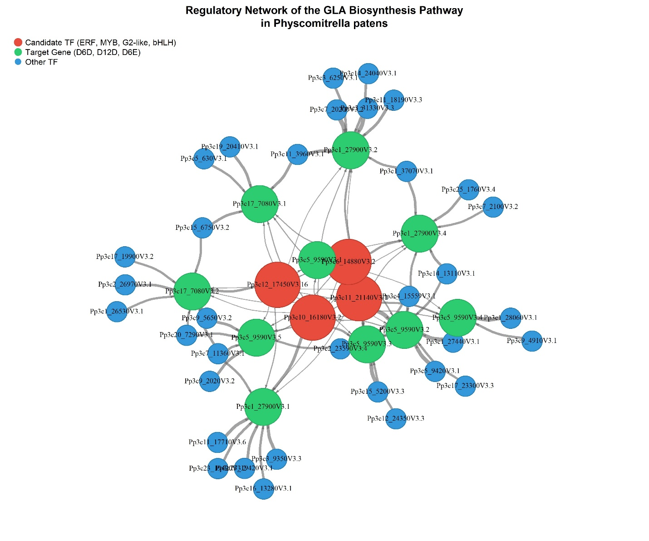
Figure S3. Complete GENIE3-inferred gene regulatory network underlying GLA biosynthesis in P.patens. The network includes the top 100 transcription factors prioritized for regulatory inference and their predicted interactions with the three GLA biosynthetic genes (D6D, D12D, and D6E). Nodes represent transcription factors and target genes, whereas edges represent predicted regulatory interactions inferred by the GENIE3 algorithm. This network is presented as the complete version of the regulatory network, while the simplified network shown in the main manuscript (Figure 7) includes only the top 30 transcription factors for clarity. Transcript isoforms are shown separately as generated by the original GENIE3 output.

