Table 3: Solution-based BCIP/NBT activity confirmation protocol and results
Sample | Sample volume | BCIP/NBT red solution volume | Buffer volume (200mM Tris-HCl, 8.5 pH) | Total reaction volume | Observed result | Color intensity grade | Interpretation  (active ALP present) | Pictorial representation
Blank No enzyme | 100µl | 100µl | 2.3 ml | 2.5 ml | No color (color of substrate remain same) | Grade 0 | Negative control –no background reaction | 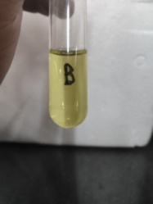
CPP  (crude) | 100µl | 100µl | 2.3 ml | 2.5 ml | Blue -purple coloration (strong/ intense | Grade 1 | Yes – high activity (multiple Isoforms) | 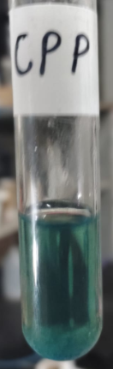
MWOCT | 100µl | 100µl | 2.3 ml | 2.5 ml | Blue –purple coloration (very intense) | Grade 2 | Yes – highest activity retention  (enriched) | 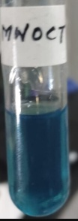
AELXD load | 100µl | 100µl | 2.3 ml | 2.5 ml | Blue purple coloration (moderate) | Grade 1 | Yes- activity retained after dilution | 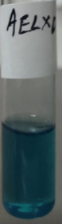
AEET.1 | 100µl | 100µl | 2.3 ml | 2.5 ml | Blue purple coloration- (moderate) | Grade 1 | Yes – active ALP present (partial purification) | 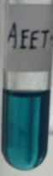
AEET.2 | 100µl | 100µl | 2.3 ml | 2.5 ml | Blue purple coloration (strong-moderate) | Grade 3 | Yes- active ALP present (purest fraction) | 