Supplementary tables and figures

Table I. Baseline laboratory parameters in the study population
Table II: Response rates in the study population (response evaluable population)

Table III. Factors affecting progression free survival using cox regression analysis

Table IV. Post protocol therapy received after progression
Table V : Adverse event profile

Table I. Baseline laboratory parameters in the study population

Laboratory parameter  Median, IQR | Overall  N=26
Hemoglobin, gm/dL | 11 (9-12)
TLC, /mm³ | 6320 (4500-8860)
ANC, /mm³ | 3868 (2340-6552)
Platelets, Lakhs/mm³ | 2.12 (1.78-2.57)
Urea, mg/dL | 27.8 (22.5-33)
Creatinine, mg/dL | 0.68 (0.6-0.86)
Calcium, mg/dL | 9.25 (8.9-9.6)
Phosphate, mg/dL | 3.85 (3.55-4.2)
Uric acid, mg/dL | 4.5 (4.2-5.4)
Sodium, mEq/L | 138.5 (137-141)
Potassium, mEq/L | 4.05 (3.7-4.5)
Total Bilirubin, mg/dL | 0.51 (0.44-0.70)
Albumin, gm/dL | 4.27 (3.98-4.5)
ALP, U/L | 95 (73-114)

Table II: Response rates in the study population (response evaluable population)

Response (n, %) | Overall (n=21) | Phase 1 (n=10) | Phase 2 (n=11)
ORR  CR PR | 14 (66.6%)  0  14 (66.6%) | 7 (70%)  0  7 (70%) | 7 (63.6%)  0  7 (63.6%)
SD | 3 (14.3%) | 2 (20%) | 1 (9%)
PD | 4 (19%) | 1 (10%) | 3 (27%)

Table III. Factors affecting progression free survival using cox regression analysis

Factor | Hazard Ratio (95% CI) | P value
ECOG PS (n=26)  0-1 vs 2
  2.22 (0.67–7.35)
  0.191
Prior Ifosfamide therapy yes/no  (n=26) |  | 0.585
  1.43 (0.40–5.11)
Number of prior lines of therapy  (n=26)  >1 / ≤1
  4.83 (1.40–16.64)
  0.013

Table IV. Post protocol therapy received after progression

Regimen | N, %
Pazopanib | 10, 47.6%
Regorafenib | 5, 23.8%
Gemcitabine Docetaxel | 4, 19.0%
Trabectedin | 1, 4.7%
Anlotinib | 1, 4.7%

Table E : Adverse event profile#
Adverse Event | Any grade (n, %) | Grade 1 or 2 | Grade 3 or 4
Neutropenia | 20 (77%) | 6 (23%) | 14 (54%)
Anemia | 11 (42%) | 5 (19%) | 6 (23%)
Thrombocytopenia | 6 (23%) | 5 (19%) | 1 (4%)
Febrile neutropenia | 4 (15%) | 0 (0%) | 4 (15%)
Nausea & vomiting | 6 (23%) | 6 (23%) | 0 (0%)
Fatigue | 6 (23%) | 6 (23%) | 0 (0%)
Encephalopathy | 4 (15%) | 2 (8%) | 2 (8%)
Renal dysfunction | 1(4%) | 0 (0%) | 1(4%)

#According to Common terminology criteria for adverse events version 5.0 (CTCAE v5.0). * Same patient. #Possibly related to the study drug.

Figure I. Study schema
ASSESS ELGIBILITY
EXCLUDED
START STAGE I
END STAGE I
(r1=1)
START STAGE II
END STAGE II
(r=5)
DECIDE
Do not Reco mmend.
Recommend
≤r responses
>r responses
Recruit n2= 12
Stop early (if futility)
>r1 responses
≤r1 responses
N1=13
Continue treatment until maximum of 6 cycles or intolerable toxicity
Administer Ifosfamide 11 grams/m² divided over 4 days along with Mesna and albumin
q21 day cycle
Exclusion criteria

- Pregnancy or breastfeeding
- Prior use of ifosfamide within 1 last 1 year of recruitment
- Patients amenable for curative surgical resection
- Uncontrolled severe comorbidities
ENROLLMENT
Inclusion criteria

- Histologically confirmed metastatic relapsed synovial sarcoma
- ECOG PS 0-2
- Measurable or evaluable disease as per RECIST 1.1 criteria.
- May have received adjuvant chemotherapy previously at least 6 months prior to inclusion.
- May have received targeted therapy
- Adequate organ function

Response evaluation after 4 cycles, and subsequently after 3 months

(Earlier if suspected progression)

Figure II. Workflow in stage 1

Patients excluded
Creatinine>2mg/dL (n=1)
Not synovial sarcoma on central pathology review (n=1)

(n=2)

Patients screened based on inclusion criteria (n=15)

Responses in Phase I (r1=7)
Patients recruited in Phase I (n=13)
Expired before response evaluation (n=1)
Drug discontinued in view of unacceptable toxicity (n=2)

Figure III. Workflow in stage 2

Patients recruited in Phase II (n=13)

Patients excluded
Worsened before starting the study drug (n=1)

(n=1)
Patients screened based on inclusion criteria (n=14)

Responses seen in Phase II (r2=7)
Drug discontinued in view of unacceptable toxicity (n=2)

Figure IV. EORTC QLQ-C30 quality-of-life outcomes.
IV (A) Global health status/quality of life scores at baseline and after four cycles of chemotherapy.
IV (B) Mean functional domain scores (physical, role, emotional, cognitive, and social functioning).
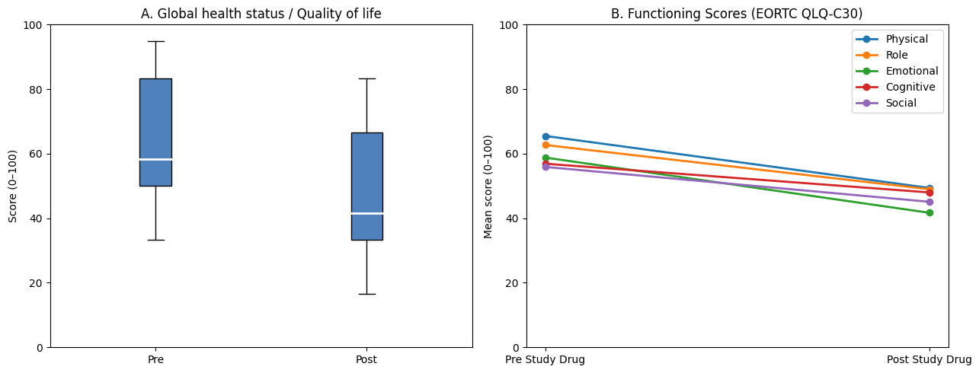

Figure V. EORTC QLQ-C30 symptom scale scores at baseline and after four cycles of chemotherapy. Higher scores indicate greater symptom burden.
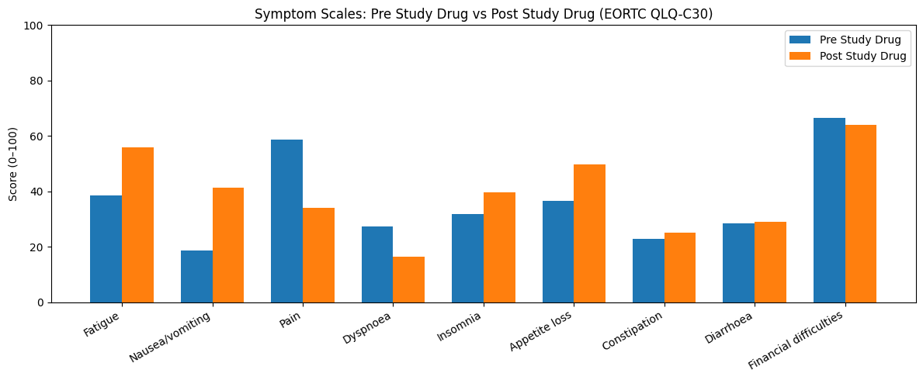

Figure VI. Kaplan Meir curves of Progression free survival in important subgroups: A. Prior Ifosfamide Exposure B. ECOG PS 0-1 vs 2 C. Number of prior lines of therapy ≤1 or >1

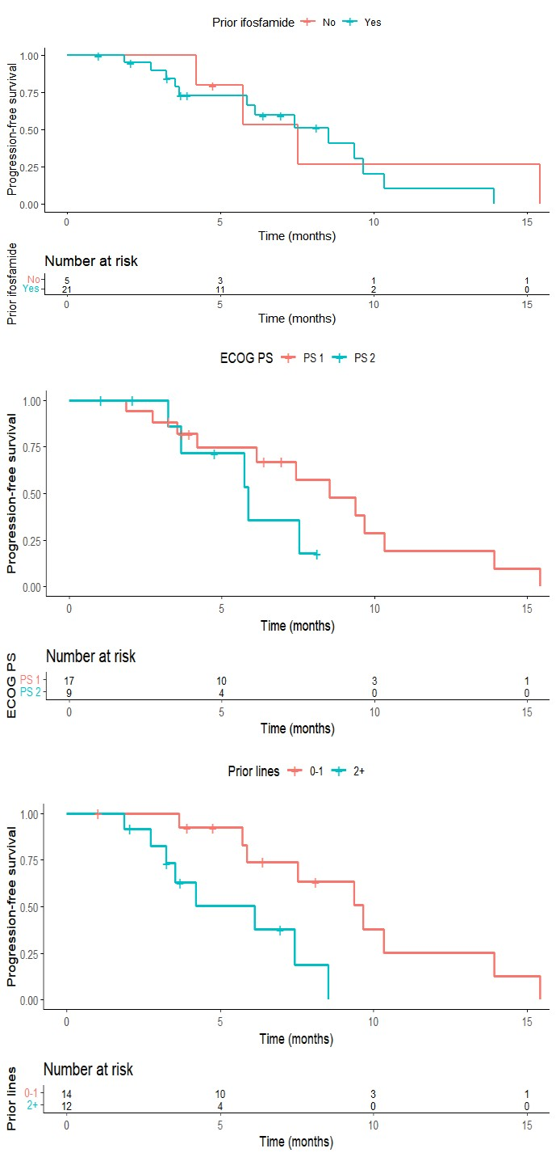

Figure VII. PET CT imaging showing complete response after resection and chemotherapy
Post surgery Post Chemotherapy Pre Chemotherapy
