Appendix A - Coding Instruction and Coding Mask
Inductive content analysis Instruction
You will be given all survey responses in an Excel document (see example below). After familiarizing yourself with the survey responses by skimming through them, you will independently generate codes in the form of concise words or phrases that capture the basic semantic content of each individual response. Priority should be given to using already generated codes for categorization before creating new ones. Depending on the survey response, more than one code may be assigned where required. After coding all survey responses, you will group the resulting codes into overarching themes that represent semantically related codes. Please choose a suitable abstraction level as these themes are then quantitatively evaluated and interpreted in the position paper (not too specific, but also not too broad).
Example for adopting inductive content analysis
A survey response could look like “Doctoral education would be more accessible if tuition fees were reduced and more scholarships were available, especially for students from low-income backgrounds.” and might be coded as “reduced tuition fees; Increased scholarships; financial support for low-income students” (if some of these codes already exist from earlier responses you would reuse them rather than creating new ones). These codes may then be further categorized into the broader theme of “Financial Accessibility”, depending on how all the other codes look like.
Example for the working process in Excel
In one column you find the survey responses. You go through them line by line and generate codes in the column next to it. As different codes can apply to one survey response, you can provide multiple codes in the code column. Please separate each code with a semicolon (;), so that we can automate the process in a later state. The Excel mask for doing that working step is provided below.
Figure A.1
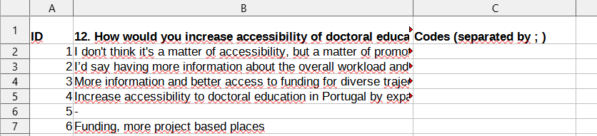
After having all survey responses coded, please try to find overarching themes and assign all codes to the corresponding themes. The Excel mask for doing that working step is provided below.
Figure A.2
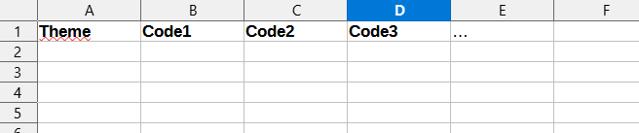
Appendix B - LLM-Supported Inductive Content Analysis
For the inductive content analysis we will follow a two-times two-step approach. First we define codes from the text messages, and then we categorize the survey responses to the codes. Then we define categories from the codes, and then we group the codes to the categories. The following prompts represent the described steps and are used to investigate the six open-format variables from the survey. We accessed GPT-5.4 from OpenAI via their API (https://platform.openai.com/) and inserted the prompts with the survey responses into the user field. A screenshot of the platform with the used model settings can be found below.
Figure B.1
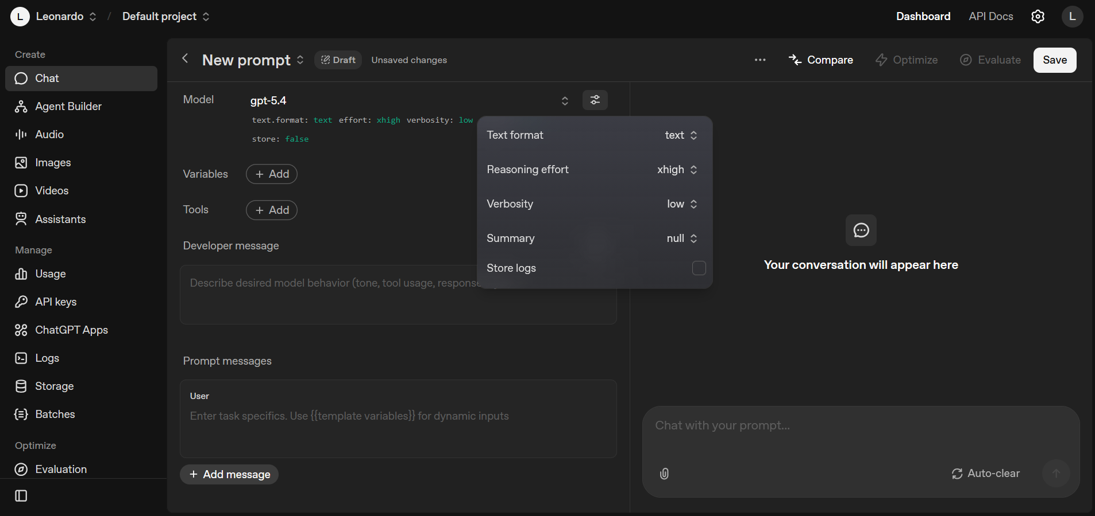
Prompts for Inductive Content Analysis
1. a) Code Generation
You are an experienced scientist, perfectly educated to conduct text categorization as a qualitative research method. Your task is to analyze the given survey responses and to extract appropriate categories. For that go through the provided survey responses below and identify recurring themes, topics, or intents within the survey responses. Finally, output a table that lists each resulting category alongside a short description (1-2 sentences).
Here are the survey responses:
1
Chat 1
...
n
Chat n
Output the table in Markdown format with one row per category. The first column should contain the found category, and the subsequent column should contain the category description. Example:
| Category | Category Description |
|-------------|------------------------|
| [category] | [category description] |
| [category] | [category description] |
| [category] | [category description] |
…

1. b) Coding
You are an advanced language model trained for text classification and categorization. Your task is to analyze the given survey responses and assign them to given categories. Assign each message to one or multiple categories, and explain in 1-2 sentences why you decided to do so.
Here are the survey responses:
1
Chat 1
2
Chat 2
…
n
Chat n
Here are the categories:
[list of all categories from 1. a)]
Output a table in Markdown format with one row per message. The first column should contain the chat number (e.g., Chat 1, Chat 2, ..., Chat n), the second column the corresponding category or categories separated by a semicolon, and the subsequent column should contain the categorization explanation. Example:
| Chat Number | Category | Categorization Explanation |
|-------------|-------------|------------------------|
| Chat 1 | [selected category] | [categorization explanation] |
| Chat 2 | [selected category]; [selected category]; ... | [categorization explanation] |
| Chat 3 | [selected category]; [selected category] | [categorization explanation] |
…

2. a) Category Generation
You are an experienced scientist, perfectly educated to conduct text categorization as a qualitative research method. Your task is to analyze given primary categories and to extract appropriate overarching categories. For that go through the provided primary categories below and identify recurring themes, topics, or intents within the primary categories. Finally, output a table that lists each resulting overarching categories alongside a short description (1-2 sentences).
Here are the primary categories:
[list of all categories from 1. a)]
Output the table in Markdown format with one row per overarching category. The first column should contain the found overarching category, and the subsequent column should contain the category description. Example:
| Overarching Category | Category Description |
|-------------|------------------------|
| [overarching category] | [category description] |
| [overarching category] | [category description] |
| [overarching category] | [category description] |
…
2. b) Grouping Categories
You are an advanced language model trained for text classification and categorization. Your task is to analyze the given primary categories and assign them to given overarching categories. Assign each primary category to the most relevant overarching category, and explain in 1-2 sentences why you decided to do so.
Here are the primary categories:
[list of all categories from 1. a)]
Here are the overarching categories:
[list of all categories from 2. a)]
Output a table in Markdown format with one row per message. The first column should contain the primary categories (e.g., Primary Category 1, Primary Category 2, ..., Primary Category n), the second column the corresponding overarching category, and the subsequent column should contain the categorization explanation. Example:
| Primary Category | Overarching Category | Categorization Explanation |
|-------------|-------------|------------------------|
| Primary Category 1 | [selected overarching category] | [categorization explanation] |
| Primary Category 2 | [selected overarching category] | [categorization explanation] |
| Primary Category 3 | [selected overarching category] | [categorization explanation] |
...
Appendix C - Full Survey Questions
Below for each of the six analysed variables the original full survey question is displayed.
Table C.1
Variable | Survey Question
(1) Accessibility Increase | How would you increase accessibility of doctoral education in your country?
(2) Financial Situation | How would you improve the financial situation of doctoral students in your country?
(3) Well Being | What’s one thing that would most improve doctoral well being in your country?
(4) Mobility Barriers | What barriers if any do you face in mobility or recognition of your work?
(5) Personal Experience | Is there anything more as a personal experience related to your studies you'd like to share?
(6) Anything Else | Is there anything you would like to add about doctoral education in your country from a more general or systemic perspective beyond your personal experience? If relevant you may also mention or cite literature studies or other sources related to doctoral education in your country.

Appendix D - Human Coder Opinion on LLM Coding
(1) Accessibility Increase
Looks great to me. It indeed grouped ideas together which I think is great and creates an umbrella concept.
(2) Financial Situation
The LLM analysis seems fine.
As a general remark, the language model seems to code many variables. I was reluctant to put anything else than "unclear", i.e. it has the tendency to create a (false) signal from full noise, see e.x. variables A1006 and A1239. However, even these fall into the right category even though a proposal is non-existent. My code "possibility to have another job" is often a code it fails to replicate, so one needs to be vigilant when interpreting its code "flexibility to combine work and study".
The financial questions were difficult to evaluate, differentiating between more available grants, larger scholarships and larger salaries seem to point in the same direction even though there are nuanced differences. Similarly, more (system-level) funding and more grants are entirely different things, and I think it [LLM] does an adequate job with the data.
(3) Well Being
Overall, I think the LLM coding is reflective of my categorization. I think my primary concerns are the LLM:
1. overinterpreting some of the responses, particularly where they are relatively short/simple and may not be clear (example: ID 192 lacks clarity, yet LLM coded without necessary context)
2. reducing the precision of the coding (example: IDs 313 & 334 treated identically by the LLM, but not by the human)
3. broadening themes, reducing their usefulness (example: ID 256 reduces multiple human codes and themes into one LLM code and theme that do not fully capture the response)
While I personally note these discrepancies, broadly, the LLM performed well in the subset I've reconsidered, and I would be comfortable with it being used in this manner for the remaining analysis. If my concerns could be noted generally alongside what others find, that would suffice.
(4) Mobility Barriers
The idea is the same in both versions. For some questions mine is shorter and concrete however the main idea is the same
(5) Personal Experience & (6) Anything Else
In general, the categorization of the AI is in line with my output

