Figure S1:
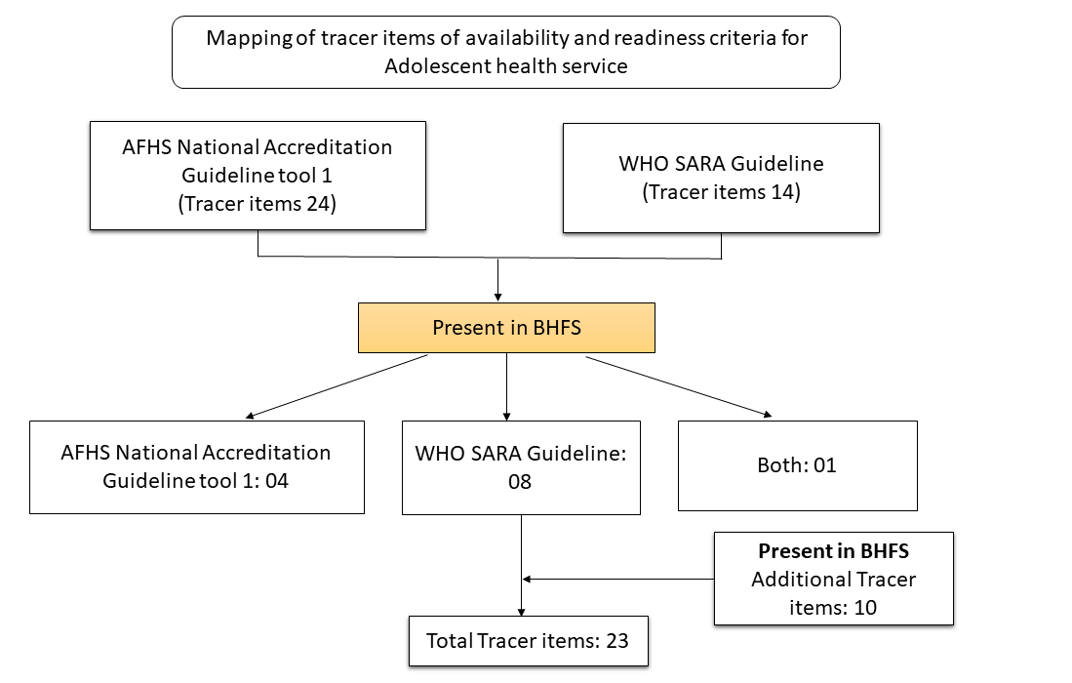
Table S1: Domains along with several indicators for assessing the availability and readiness of adolescent health services:
Service Availability
Domain | Indicator |  | Definition | Source
Availability | Adolescent health services |  | Frequency of health facilities that offer AHS | WHO SARA
Availability | Dedicated room/area for adolescent health services |  | A dedicated room where adolescent health services has been provided | AFHS National Accreditation Guideline Tool 1
Availability | Number of days providing adolescent health services |  | Number of days providing adolescent health services | Additional/BHFS
Availability | Family planning services to adolescents |  | The facility provides condoms and at least one other method of family planning to both married and unmarried adolescents | WHO SARA
Availability | Provision of combined oral contraceptive pills to adolescents |  | The facility provides combined oral contraceptive to adolescents | WHO SARA
Availability | Provision of male condoms to adolescents |  | The facility provides male condoms to adolescents | WHO SARA
Availability | Provision of emergency contraceptive pills to adolescents |  | The facility provides emergency contraceptive pills to adolescents | WHO SARA
Availability | Provision of intrauterine contraceptive device (IUCD) to adolescents |  | The facility provides IUD contraceptive to adolescents | WHO SARA
Service Readiness

Domain |  | Indicator | Definition | Source
Basic Amenities |  | Availability of sitting arrangements for adolescent | The facility has the sitting arrangements for adolescents | AFHS National Accreditation Guideline Tool 1
 |  | Availability of safe drinking water for adolescent | The facility has the drinking water for adolescents | AFHS National Accreditation Guideline Tool 1
 |  | Availability of waste containers in the facility | The facility has the waste containers | AFHS National Accreditation Guideline Tool 1
 |  | Adolescents’ privacy is ensured in the consultation room | The point of health service delivery is located in a place  that ensures the privacy of adolescent users. It has a  layout that is designed to ensure privacy throughout an  adolescent’s visit. This includes the dedicated corner for adolescents and auditory and visual privacy. | Additional/BHFS
Staff and guidelines |  | Guidelines for service provision to adolescents | The country adapts to which standards/guidelines are required/accepted. | Both
 |  | Staff trained in the provision of adolescent health services | At least one staff providing services for adolescents trained in adolescent health in the last two years. | WHO SARA
Medicines |  | Tab iron and Folic acid | The facility has the tab iron and folic acid | Additional/BHFS
 |  | Cap. Doxycycline | The facility has the cap. doxycycline | Additional/BHFS
 |  | Tab. Metronidazole | The facility has the tab metronidazole | Additional/BHFS
 |  | Tab. Ciprofloxacin | The facility has the tab ciprofloxacin | Additional/BHFS
 |  | Tab. Naproxen | The facility has the tab naproxen | Additional/BHFS
 |  | Tab. Pantoprazole | The facility has the tab pantoprazole | Additional/BHFS
 |  | Tab. Albendazole | The facility has the tab albendazole | Additional/BHFS
Commodities and vaccine |  | Condom | The facility has condom | WHO SARA
 |  | TT Vaccine for adolescent | The facility has TT vaccine for adolescent | Additional/BHFS

Table S2: List of functions that should be provided in the adolescent health corner, by facility type
SL# |  | Function | Source | Facility type
1 |  | Information and Counseling on | National Accreditation Guideline for adolescent-friendly health services | CC and above
 | a | Puberty change (Physical & mental) | National Accreditation Guideline for adolescent-friendly health services | CC and above
 | b | Prevention of early marriage | National Accreditation Guideline for adolescent-friendly health services | CC and above
 | c | HIV/AIDS | National Accreditation Guideline for adolescent-friendly health services | CC and above
 | d | STI/RTI | National Accreditation Guideline for adolescent-friendly health services | CC and above
 | e | Contraception | National Accreditation Guideline for adolescent-friendly health services | CC and above
 | f | General and menstrual hygiene | National Accreditation Guideline for adolescent-friendly health services | CC and above
 | g | Nutrition | National Accreditation Guideline for adolescent-friendly health services | CC and above
 | h | Immunization (Tetanus toxoid/TT) | National Accreditation Guideline for adolescent-friendly health services | CC and above
 | i | Violence against adolescent girls and boys | National Accreditation Guideline for adolescent-friendly health services | CC and above
 | j | Drug addiction | National Accreditation Guideline for adolescent-friendly health services | CC and above
 | k | Child marriage | National Accreditation Guideline for adolescent-friendly health services | CC and above
 | l | Reproductive health problems | National Accreditation Guideline for adolescent-friendly health services | CC and above
2 |  | Ensuring privacy | National Accreditation Guideline for adolescent-friendly health services | CC and above
3 |  | Respecting clients while providing the services | National Accreditation Guideline for adolescent-friendly health services | CC and above
4 |  | Immunization | National Accreditation Guideline for adolescent-friendly health services | USC/RD and above
 | a | TD | National Accreditation Guideline for adolescent-friendly health services | USC/RD and above
 | b | Tetanus toxoid | National Accreditation Guideline for adolescent-friendly health services | USC/RD and above
5 |  | Diagnosis and management of menstrual problems | National Accreditation Guideline for adolescent-friendly health services | USC/RD and above
6 |  | Diagnosis and management of STI/RTI | National Accreditation Guideline for adolescent-friendly health services | USC/RD and above
7 |  | Diagnosis and management of general diseases | National Accreditation Guideline for adolescent-friendly health services | USC/RD and above
8 |  | Diagnosis and management of anemia  (with IFA distribution) | National Accreditation Guideline for adolescent-friendly health services | USC/RD and above
9 |  | Diagnosis and management of pregnancy care | National Accreditation Guideline for adolescent-friendly health services | USC/RD and above
10 |  | Diagnosis and management of TT vaccination | National Accreditation Guideline for adolescent-friendly health services | USC/RD and above
11 |  | Diagnosis and management of contraceptive methods | National Accreditation Guideline for adolescent-friendly health services | USC/RD and above
12 |  | Diagnosis and management of menstrual regulation (MR) services | National Accreditation Guideline for adolescent-friendly health services | USC/RD and above
13 |  | Diagnosis and management of post-abortion care (PAC) services | National Accreditation Guideline for adolescent-friendly health services | USC/RD and above
14 |  | Referral | National Accreditation Guideline for adolescent-friendly health services | USC/RD and above

Table S3: Mean readiness score among facilities reporting AHS provision, and percentage of facilities offering AHS, by facility characteristics

 | Mean readiness score (0–25), with 95% CI |  |  |  | Mean readiness score (0–100), with 95% CI
 | Basic Amenities | Guideline and staff | Medicine | Commodities | Total readiness score
Facility type
DH | 15.7  [7.05, 24.33] | 16.6  [7.46, 25.0] | 19.0  [11.41, 25.0] | 18.9  [9.37, 25.0] | 70.1  [51.48, 88.71]
MCWC | 17.8  [12.64, 23.04] | 15.5  [8.41, 22.67] | 20.6  [16.4, 24.77] | 14.1  [10.07, 18.07] | 68.0  [55.26, 80.82]
UHC | 15.6  [13.18, 18.06] | 15.6  [12.59, 18.54] | 21.0  [19.29, 22.64] | 24.3  [23.08, 25.0] | 76.4  [71.1, 81.7]
UH&FWC | 15.1  [14.22, 16.05] | 14.1  [12.9, 15.34] | 18.1  [17.65, 18.63] | 12.8  [12.3, 13.24] | 60.2  [58.27, 62.06]
USC/RD | 12.0  [10.38, 13.58] | 9.3  [7.58, 11.08] | 15.2  [13.92, 16.46] | 6.6  [5.07, 8.22] | 43.2  [39.38, 46.91]
Community Clinic | 11.2  [10.73, 11.57] | 13.2  [12.69, 13.7] | 10.7  [10.51, 10.83] | 10.9  [10.49, 11.24] | 45.9  [45.06, 46.69]
NGO clinic/hospital | 16.7  [14.73, 18.68] | 14.3  [10.45, 18.1] | 17.5  [14.83, 20.16] | 14.4  [10.82, 18.04] | 62.9  [54.63, 71.19]
Private hospital | 15.8  [14.09, 17.53] | 5.8  [4.03, 7.56] | 15.3  [12.52, 18.06] | 7.1  [4.78, 9.37] | 44.0  [38.69, 49.25]
Managing authority
Public | 12.0  [11.64, 12.4] | 13.2  [12.75, 13.64] | 12.5  [12.26, 12.75] | 11.3  [10.93, 11.59] | 49.0  [48.15, 49.81]
NGO | 16.7  [14.73, 18.68] | 14.3  [10.45, 18.1] | 17.5  [14.83, 20.16] | 14.4  [10.82, 18.04] | 62.9  [54.63, 71.19]
Private | 15.8  [14.09, 17.53] | 5.8  [4.03, 7.56] | 15.3  [12.52, 18.06] | 7.1  [4.78, 9.37] | 44.0  [38.69, 49.25]
Division
Barisal | 13.1  [11.65, 14.53] | 12.4  [11.11, 13.72] | 13.2  [12.25, 14.16] | 11.3  [10.21, 12.34] | 50.0  [47.17, 52.8]
Chittagong | 11.0  [10.13, 11.91] | 14.0  [12.94, 14.96] | 12.9  [12.26, 13.51] | 10.8  [10.06, 11.56] | 48.7  [46.5, 50.81]
Dhaka | 11.6  (10.69, 12.47) | 13.2  (12.19, 14.26) | 13.1  (12.43, 13.75) | 11.2  (10.41, 11.96) | 49.1  (47.08, 51.08)
Khulna | 12.7  [11.65, 13.83] | 10.4  [9.18, 11.57] | 12.3  [11.41, 13.11] | 11.5  [10.4, 12.57] | 46.9  [44.48, 49.23]
Rajshahi | 13.3  [12.46, 14.15] | 12.0  [10.85, 13.18] | 12.1  [11.42, 12.79] | 11.0  [10.05, 11.89] | 48.4  [46.34, 50.44]
Rangpur | 13.1  [12.16, 13.98] | 12.6  [11.37, 13.82] | 12.9  [12.23, 13.59] | 11.4  [10.45, 12.41] | 50.0  [47.87, 52.13]
Sylhet | 14.1  [12.8, 15.33] | 14.4  [12.62, 16.16] | 13.1  [12.06, 14.21] | 10.8  [9.34, 12.17] | 52.3  [49.21, 55.48]
Mymensingh | 11.3  [10.14, 12.44] | 14.5  [12.83, 16.09] | 12.1  [11.32, 12.82] | 11.4  [10.47, 12.4] | 49.3  [46.73, 51.77]
Total | 12.3  [11.91, 12.64] | 12.9 [12.47,13.35] | 12.7  [12.45, 12.99] | 11.2  [10.81, 11.49] | 49.1  [48.22, 49.89]

