Supplementary Information
  - Validation design changes wearable stress-state classification performance in hospital nurses
Fuat Kahraman¹, Gözde Özsezer²*, Gülengül Mermer¹
This file contains retained exploratory outputs and an explicit inventory of analytical details that were not available in the supplied materials. It should be read with the main article.

Supplementary Note 1 | Analytical provenance
The source study describes 15 nurses and provides raw sensor streams and survey annotations through Dryad. The retained secondary analysis was based on a merged redistribution containing 18 identifier values. The mapping between these representations, the machine-readable post-windowing table, exact fold assignments, fitted preprocessing objects, model hyperparameters, random seeds and executable secondary analysis code were not present in the supplied manuscript package. No missing details were reconstructed by assumption.
The leave-one-subject-out chart supplied with the prior analysis contained 15 labelled bars and a mean accuracy of 66.11%. Because its x-axis labels are dataset identifiers and their relationship to the 18 identifiers in the merged table was not verified, the main article reports identifier-held-out performance and treats the range as approximate.

Supplementary Figure S1 | Retained XGBoost LOSO accuracy by identifier
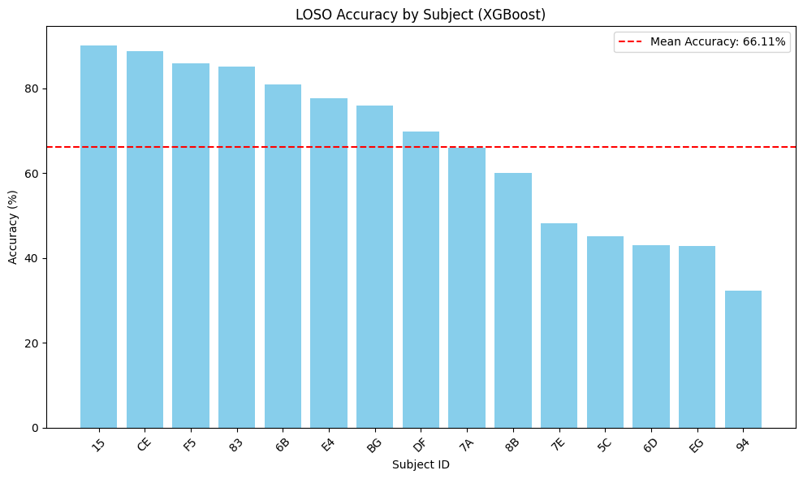
Supplementary Figure S1. Retained leave-one-subject-out XGBoost accuracy. The term “Subject ID” appears in the original output; the main article refers to these labels as identifiers because participant mapping was unavailable.

Supplementary Figure S2 | Exploratory nominal-period map
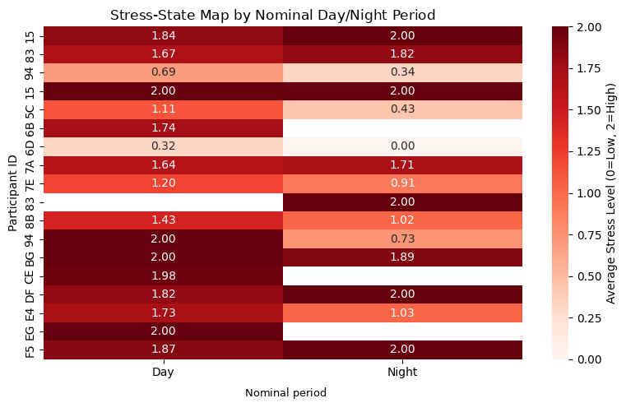
Supplementary Figure S2. Average encoded stress-state level by identifier and nominal day/night period. Blank cells denote unavailable identifier-period combinations. Nominal periods were not linked to verified rosters; the figure does not establish a shift effect.

Supplementary Figure S3 | Mean absolute SHAP contributions
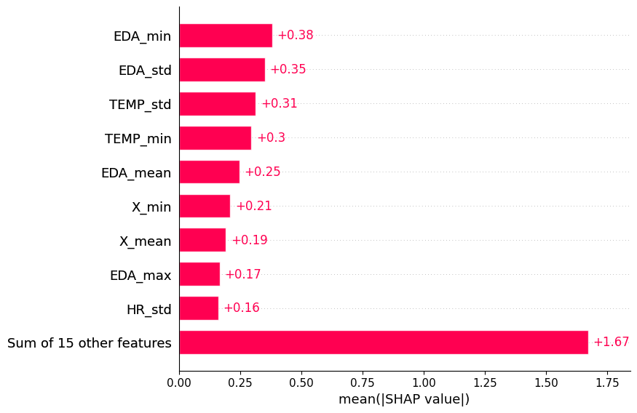
Supplementary Figure S3. Mean absolute SHAP values from the retained XGBoost output. EDA-derived features had the largest individual contributions. Values describe model dependence and are not causal effect estimates.
Supplementary Table S1 | Availability of reproducibility items.
Item | Status | Interpretation
Raw Dryad sensor data | Available | Public source dataset; DOI reported in the main article.
Merged redistribution | Available | Public Kaggle URL reported in the main article.
Verified 15-to-18 identifier mapping | Unavailable | No mapping was present in supplied materials.
Exact window count and overlap | Unavailable | Not recoverable from retained tables and figures.
Fold-specific preprocessing objects | Unavailable | Required for leakage-safe reproduction.
Model hyperparameters and random seeds | Unavailable | Candidate model comparison is descriptive.
Machine-readable LOSO fold results | Unavailable | Fold range recovered approximately from a figure.
Confidence intervals and calibration | Unavailable | No inferential or calibration claims are made.
Secondary executable analysis code | Unavailable | Source-study code exists; secondary pipeline was not archived.

