SUPPLEMENTARY
Table S1: 7-point drug titration concentrations (µM) for four SOC NSCLC chemotherapeutic agents.
Drug titration  Chemotherapy | 1 | 2 | 3 | 4 | 5 | 6 | 7
Cisplatin | 0.500 | 0.925 | 1.710 | 3.162 | 5.848 | 10.815 | 20.000
Carboplatin | 1.000 | 2.076 | 4.309 | 8.944 | 18.566 | 38.540 | 80.000
Docetaxel | 0.001 | 0.003 | 0.010 | 0.032 | 0.100 | 0.316 | 1.000
Gemcitabine | 0.001 | 0.005 | 0.022 | 0.100 | 0.464 | 2.154 | 10.000

Table S2: Drug connectivity analysis using the large-scale pharmacogenomic dataset CTRPv2, top mechanisms of action that target most differently expressed pathways in the TIS A549 cells compared to non-senescent control cells are shown, blue marked rows indicate mechanisms of action that we examined targeting with potential senolytic compounds.
Mode of action | Target | Compound | NES
Inhibitor of p38 MAPK | MAPK14 | Doramapimod  Adezmapimod  Skepinone-l | -2.081
Inhibitor of CRM1-mediated nucleocytoplasmic transport | XPO1 |  | -1.953
Inhibitor of nicotinamide phosphoribosyltransferase | NAMPT |  | -1.769
Activator of BAX | BAX | BTSA1  BAM7 | -1.722
Inhibitor of polo-like kinase 1 | PLK1 |  | -1.685
Activator of Sirtuin-1 | SIRT1 |  | -1.655
Inhibitor of the transforming growth factor beta type 1 receptor | TGFBR1 |  | -1.654
Inhibitor of insulin-like growth factor 1 receptor | IGF1R | Picropodophyllin  AZD-3463 | -1.649
Inhibitor of DNA methyltransferase | DNMT1 |  | -1.550
Inhibitor of BCL2 family proteins | BCL2 | Navitoclax  Venetoclax | -1.495
Inhibitor of chemokine receptor 2 | CXCR2 |  | -1.490
Inhibitor of thioredoxin | TXN | Auranofin | -1.483
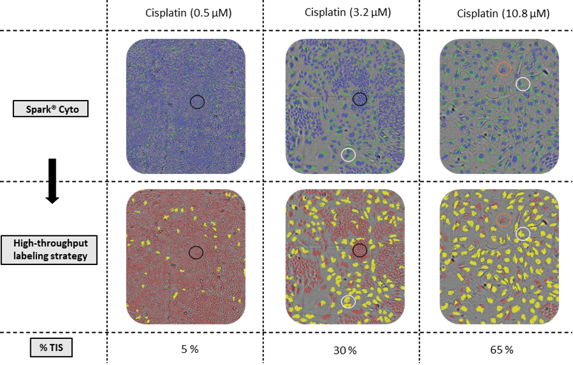
Figure S1: Development of an automated high-throughput senescence detection and classification strategy. Upper panels represent images of individual wells taken with the Spark® Cyto imaging system of A549 cells after staining with the fluorescent blue nuclear dye Hoechst 33342 and fluorescent green probe for SA-β-Gal in different conditions of senescence induction. Lower panels represent classification of TIS cells (yellow cells) and non-senescent cells (red cells) based on the presence or absence of senescent phenotypic features. Cells with a normal nuclear size, without SA-β-Gal activity and/or small cytoplasmic fluorescent green area (i.e., normal cell size) are classified as non-senescent cells (black circles). Cells with an enlarged nucleus, cytoplasmic SA-β-Gal activity and an enlarged cytoplasmic fluorescent green area (i.e., enlarged cell size) are classified as senescent cells (white circles). In case cells do express some (i.e., only an enlarged nuclear size in this case) but not all of these three senescent phenotypic features, cells are classified as non-senescent (orange circles). SA- β-Gal, senescence-associated beta galactosidase; TIS: therapy-induced senescence.

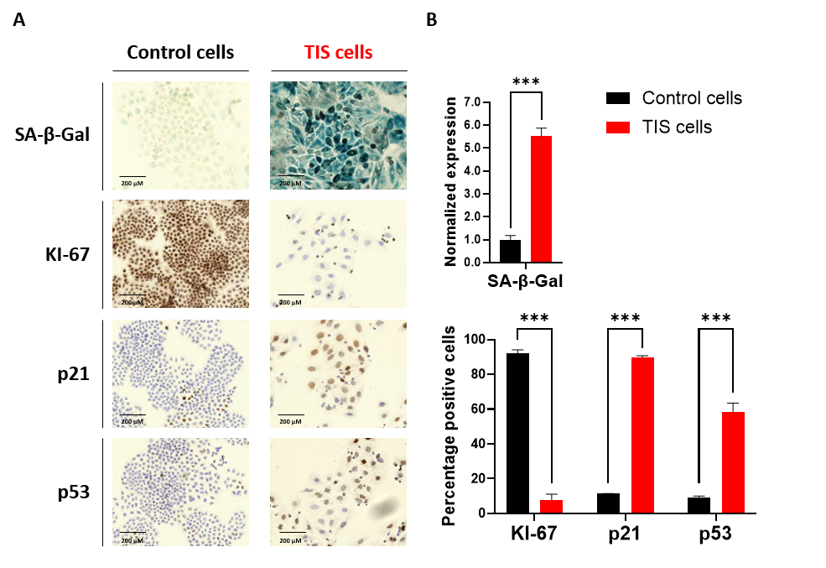
Figure S2: TIS is induced in H460 NSCLC cells by platinum-based chemotherapeutic treatment. (A) Immunohistochemical staining of non-senescent control and TIS H460 cells for the canonical senescence markers SA-β-Gal, KI-67, p21 and p53. (B) Quantification of the normalized SA-β-Gal expression using Fiji software (upper panel) and the percentage positive KI-67, p21 and p53 cells using QuPath software (lower panel) illustrated in (A). Data are represented as mean ± SEM (n=3). Statistical significance was determined using unpaired student’s t-tests. *** p<0.001. TIS, therapy-induced senescence; SA-β-Gal, senescence-associated beta galactosidase; SEM, standard error of means.

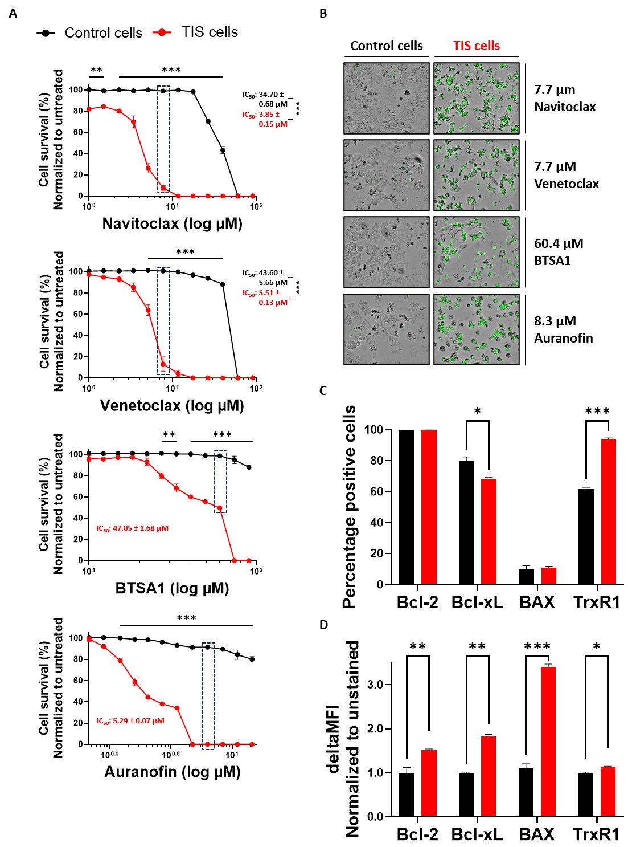
Figure S3: TIS cells are sensitive to Bax activation and thioredoxin reductase inhibition. (A) Percentage survival against untreated conditions of non-senescent control and TIS H460 cells 48 hours after the administration of a concentration range (1.0 µM - 90.0 µM) of the Bcl-2 inhibitors Navitoclax or Venetoclax, a concentration range (10.0 - 90.0 µM) of the BAX activator BTSA1, or a concentration range (3.4 - 11.6 µM) of the thioredoxin reductase inhibitor Auranofin. (B) Representative images of both control and TIS H460 cells 48h after senolytic treatment, obtained with the Spark® Cyto imaging system. Green signal is Incucyte® Cytotox green dye and represents cell death. (C-D) Flow cytometric quantification of the percentage positive cells (C) and mean intensity of positivity per cell (D) for the targets of the senolytic strategies. Survival data were normalized to untreated controls and all data are represented as mean ± SEM (n=3). Statistical significance was determined using linear mixed models’ analysis for survival data and using student’s t tests for the expression levels. *p < 0.05, **p < 0.01, and ***p < 0.001. TIS, therapy-induced senescence; SEM, standard error of means.

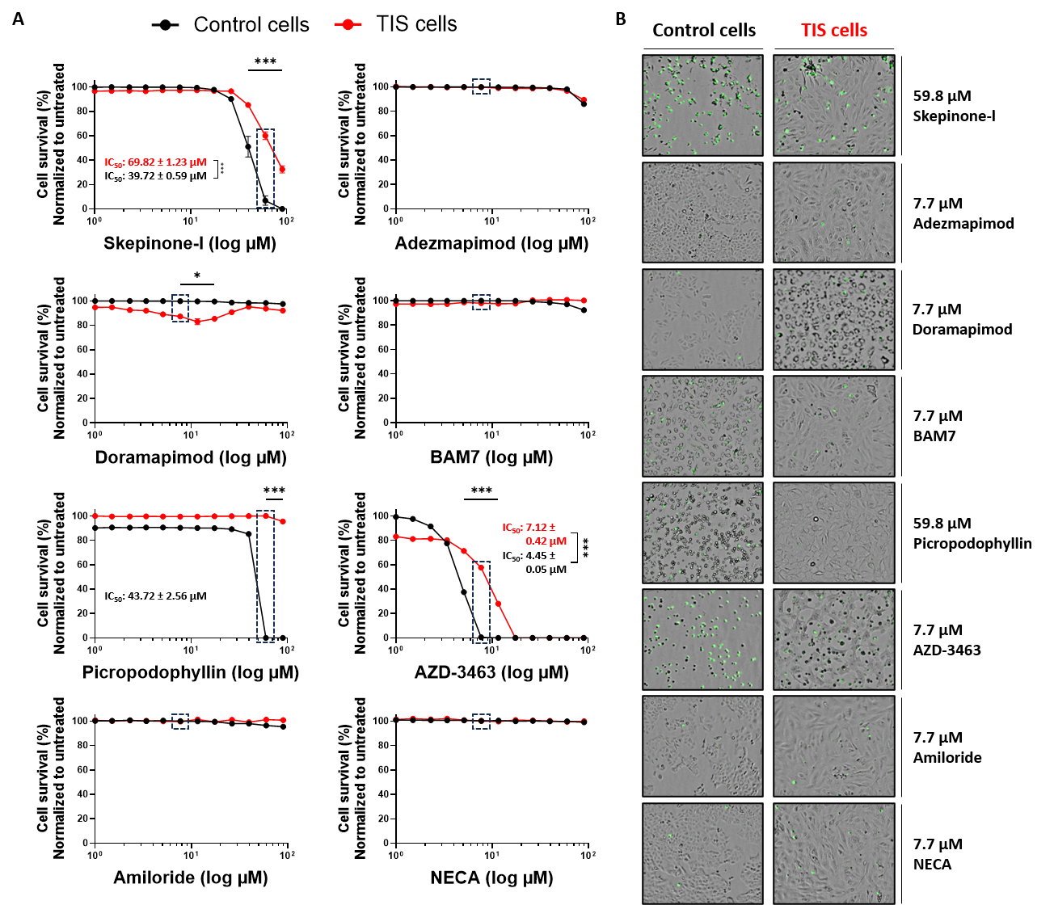
Figure S4: Evaluated strategies that did not demonstrate potent senolytic effects. (A) Percentage survival against untreated conditions of non-senescent control and TIS A549 cells 48 hours after treatment with a concentration range (1.0 µM - 90.0 µM) of the p38 MAPK inhibitors Skepinone-l, Adezmapimod or Doramapimod; the Bax activator BAM7; the IGF1R inhibitors Picropodophyllin or AZD-3463; the sodium channel blocker Amiloride; or the adenosine receptor agonist NECA. (B) Representative images of non-senescent control and TIS A549 cells taken by the Spark® Cyto imaging system 48 hours after treatment. Green signal is Incucyte® Cytotox green dye and represents cell death. Survival data were normalized to untreated controls and are represented as mean ± SEM (n=3). Statistical significance was determined using linear mixed models’ analysis. * p<0.05, *** p< 0.001. TIS, therapy-induced senescence; NECA, 5’-N-Ethylcarboxamide adenosine.

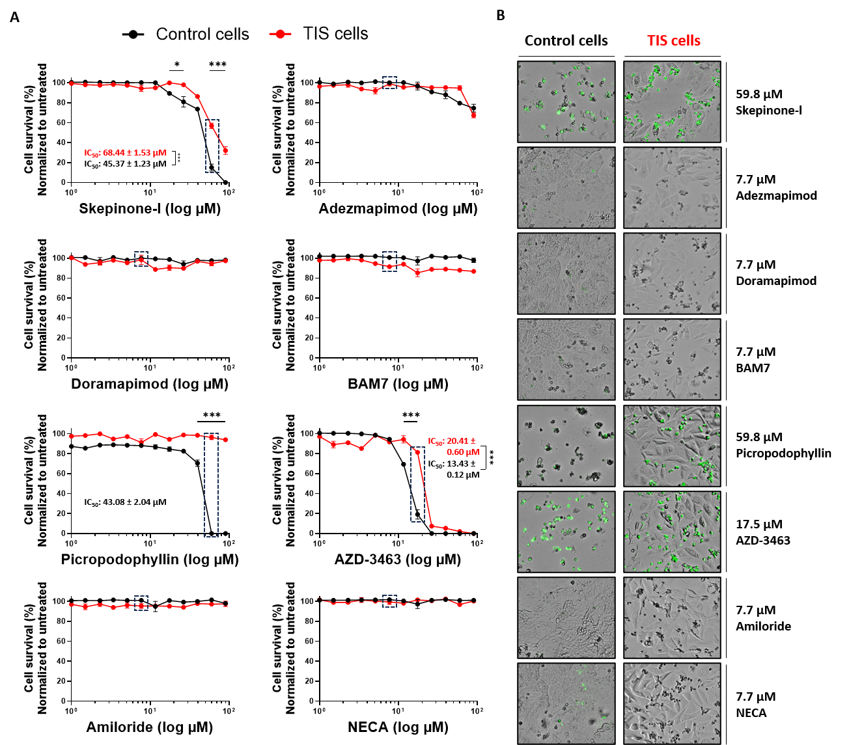
Figure S5: Evaluated strategies that did not demonstrate potent senolytic effects. (A) Percentage survival against untreated conditions of non-senescent control and TIS H460 cells 48 hours after treatment with a concentration range (1.0 µM - 90.0 µM) of the p38 MAPK inhibitors Skepinone-l, Adezmapimod or Doramapimod; the Bax activator BAM7; the IGF1R inhibitors Picropodophyllin or AZD-3463; the sodium channel blocker Amiloride; or the adenosine receptor agonist NECA. (B) Representative images of non-senescent control and TIS H460 cells taken by the Spark® Cyto imaging system 48 hours after treatment. Green signal is Incucyte® Cytotox green dye and represents cell death. Survival data were normalized to untreated controls and are represented as mean ± SEM (n=3). Statistical significance was determined using linear mixed models’ analysis. * p<0.05, *** p< 0.001. TIS, therapy-induced senescence; NECA, 5’-N-Ethylcarboxamide adenosine.

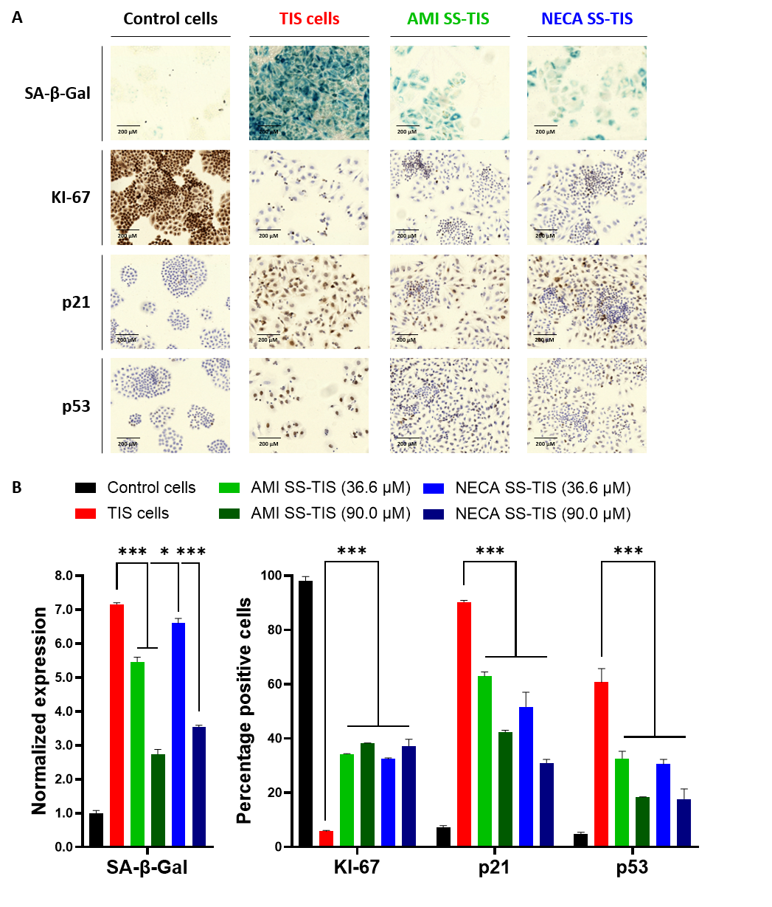

Figure S6: Senescence suppressor treatment decreases the level of TIS induction in H460 cells. (A) Immunohistochemical staining of non-senescent control, TIS, and Amiloride (90.0 µM) or NECA (90.0 µM) treated SS-TIS H460 cells. (B) Quantification of the normalized SA-β-Gal expression using Fiji software (left panel) and the percentage positive KI-67, p21 and p53 cells using QuPath-0.5.1 software (right panel) illustrated in (A). Data are represented as mean ± SEM (n=3). Statistical significance was determined using Student’s t tests. *** p< 0.001. TIS, therapy-induced senescence; SS-TIS, senescence suppressor treated therapy-induced senescence; SA-β-Gal, senescence-associated beta galactosidase; AMI, Amiloride; NECA, 5’-N-Ethylcarboxamide adenosine; SEM, standard error of means.

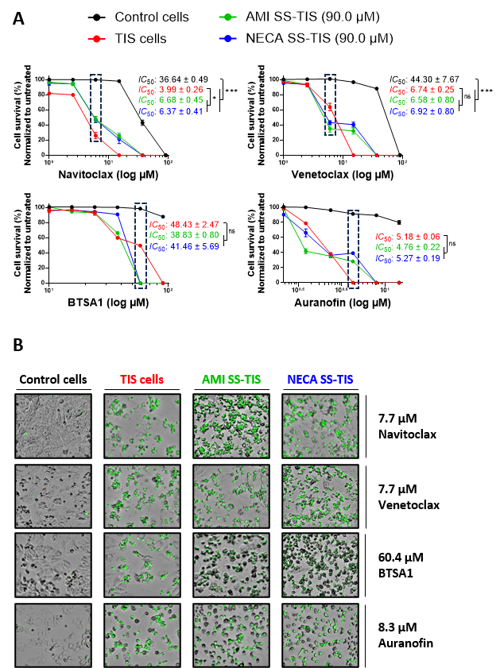

Figure S7: Senescence suppressor treatment alters the drug responses of H460 cells. (A) Percentage survival against untreated conditions of non-senescent control, TIS and SS-TIS H460 cells 48 hours after treatment with a concentration range (1.0 µM - 90.0 µM) of the Bcl-2 inhibitors Navitoclax or Venetoclax, a concentration range (10.0 - 90.0 µM) of the BAX activator BTSA1, or a concentration range (3.4 µM - 11.6 µM) of the thioredoxin reductase inhibitor Auranofin. Highlighted concentrations correspond to images shown in (B) (B) Representative images of non-senescent control, TIS and SS-TIS H460 cells taken by the Spark® Cyto imaging system 48h after senolytic treatment. Green signal is Incucyte® Cytotox green dye and represents cell death. Survival data were normalized to untreated controls and are represented as mean ± SEM (n=3). Statistical significance was determined using linear mixed models analysis. * p<0.05, *** p< 0.001. TIS, therapy-induced senescence; SS-TIS, senescence suppressor treated therapy-induced senescence; AMI, Amiloride; NECA, 5’-N-Ethylcarboxamide adenosine; SEM, standard error of means.

