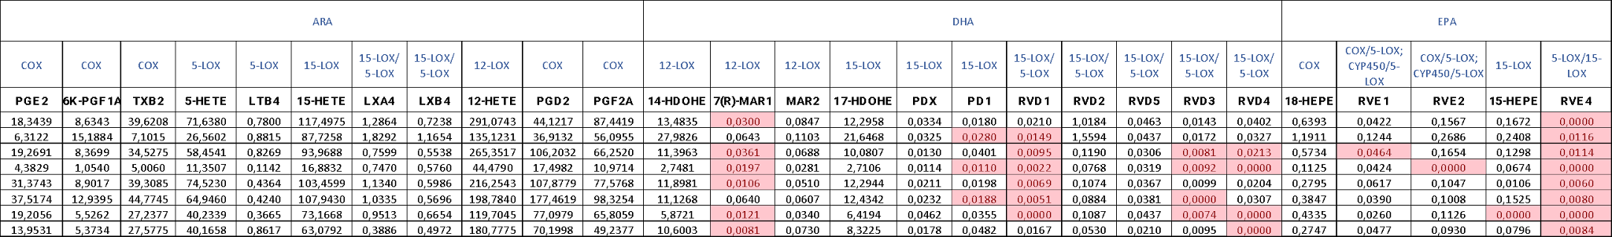
Supplementary Table 1. Targeted-metabololipidomics of lipid mediators in striatal samples from R451C-Nlgn3 mice.

Fifty-four oxylipins and metabolites of AA, EPA and DHA were quantified using very sensitive and selective targeted liquid chromatography coupled to tandem mass spectrometry (LC-MS/MS). Quantification results are reported in pg/mL.

