SUPPORTING INFORMATION FOR:

Belfiore, R., Hoekstra, R., Tonini, D., & Tukker, A. A dynamic Material Flow Analysis of furniture in the EU27 to support future circular strategies. Journal of Industrial Ecology.
This supporting information provides additional details on the methodologHow to cuy used, including: a full list of the products under scope and the code conventions used, a detailed mathematical explanation of the data cleaning steps, the way uncertainty was handled, and the calculations of the final consumption and stock. The second section provides detailed results across multiple graphs including country- and product-level time series for production, trade, consumption, and stock, as well as comprehensive results on stock composition, waste generation, material composition, and waste treatment across EU27 countries.

Contents
1. Methodology 2
1.1 Products under scope 2
1.2 Starting data 8
1.3 PRODCOM data cleaning 8
1.4 Consumption and stock 13
2. Extensive results 16
2.1 Countries’ time series 16
2.2 Products’ time series 19
2.3 Detailed stock 22
2.4 Waste 26
2.4.1 Detailed material composition at the EU level 26
2.4.2 Material composition at the country level 28
2.4.3 Waste treatment at the country level 30
3. Bibliography 32

Methodology

Products under scope
The foundation of the consumption is the production data from PRODCOM and trade data from BACI. However, these two databases employ different classifications, therefore, we need to match each product code to its equivalent (Table S1). Since the PRODCOM codes are developed based on the HS classification (i.e. the one used by BACI), there is a one-to-one correspondence from PRODCOM to HS. Instead, one HS code can correspond to multiple PRODCOM codes, which would require calculating a ratio to distribute products across codes. This approach can introduce errors, and for this reason we choose for our final stock to be classified using HS codes.
Additionally, both the PRODCOM and HS classifications have been reviewed through the years, introducing new codes and removing old ones. While BACI ensures that trade data is available in each historical HS version every year, PRODCOM data is available only during the years the codes are valid (Figure S1). This introduces an additional challenge in code conversion. To ensure consistency over time we match PRODCOM codes to the oldest HS classification from 1992 (HS92). This is because each new PRODCOM code has a correspondence to past codes which in turn have a correspondence to the HS92 classification. For example, the PRODCOM codes 31001155 and 31001159 for swivel seats (upholstered and non-upholstered respectively), were merged in 2011 into 3100150 for swivel seats in general and later split again in 2022 in 31001151 and 310001211 for swivel seats of wood and non-wood respectively. The latest HS classification has codes 940131 and 940139 for swivel seats of wood and non-wood, however there would be no way to match these codes to the PRODCOM codes before 2022. On the other hand, the HS92 code 940130 refers to the oldest classification which includes all swivel seats under one heading (940130) and therefore can be linked to all these 5 PRODCOM codes and ensures that we can calculate consumption from 1995 to 2024.

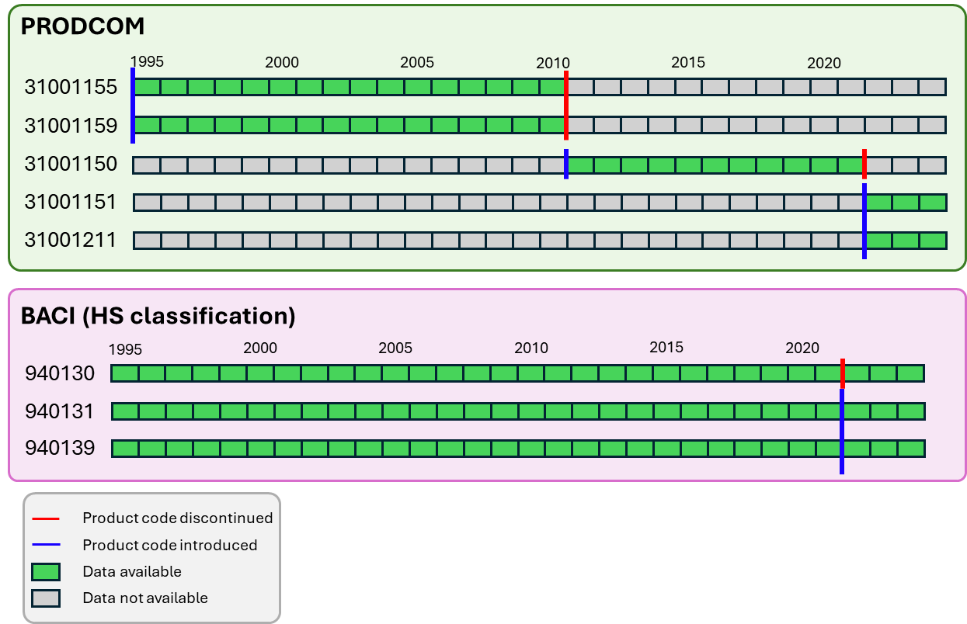
Figure S1. Availability of data when product classifications are updated.
Table S1. Code correspondences between HS 1992 codes and PRODCOM codes.
HS92 Name | HS92 code | PRODCOM code | PRODCOM Name
Seats: swivel with variable height adjustment, excluding medical, surgical, dental, veterinary or barber furniture | 940130 | 31001155 | Upholstered swivel seats with variable height adjustment, with backrest and fitted with castors or glides excluding medical, surgical, dental or veterinary seats - barbers' or similar chairs
 | 940130 | 31001159 | Non-upholstered swivel seats with variable height adjustment (excluding seats with castors or glides, medical, surgical, dental or veterinary seats, barbers' or similar chairs)
 | 940130 | 31001150 | Swivel seats with variable height adjustments (excluding medical, surgical, dental or veterinary, and barbers’ chairs)
 | 940130 | 31001151 | Swivel seats with variable height adjustments (excluding of wood and medical, surgical, dental or veterinary, and barbers’ chairs)
 | 940130 | 31001211 | Swivel seats with variable height adjustments of wood (excluding medical, surgical, dental or veterinary, and barbers’ chairs)
Seats: with metal frames, upholstered, (excluding medical, surgical, dental, veterinary or barber furniture) | 940171 | 31001170 | Upholstered seats with metal frames (excluding swivel seats, medical, surgical, dental or veterinary seats, barbers’ or similar chairs, for motor vehicles, for aircraft)
Seats: with metal frames, not upholstered, (excluding medical, surgical, dental, veterinary or barber furniture) | 940179 | 31001190 | Non-upholstered seats with metal frames (excluding medical, surgical, dental or veterinary seats, barbers’ or similar chairs, swivel seats)
Seats: convertible into beds, other than garden seats or camping equipment | 940140 | 31001210 | Seats convertible into beds (excluding garden seats or camping equipment)
 | 940140 | 31001152 | Seats convertible into beds (excluding of wood and garden seats or camping equipment)
 | 940140 | 31001212 | Seats convertible into beds of wood (excluding garden seats or camping equipment)
Seats: of cane, osier, bamboo or similar materials | 940150 | 31001230 | Seats of cane, osier, bamboo or similar materials
Seats: with wooden frames, upholstered, (excluding medical, surgical, dental, veterinary or barber furniture) | 940161 | 31001250 | Upholstered seats with wooden frames (including three piece suites) (excluding swivel seats)
Seats: with wooden frames, not upholstered, (excluding medical, surgical, dental, veterinary or barber furniture) | 940169 | 31001290 | Non-upholstered seats with wooden frames (excluding swivel seats)
Seats: n.e.s. in heading no. 9401, (excluding medical, surgical, dental, veterinary or barber furniture) | 940180 | 31001300 | Other seats, of HS 9401 , n.e.c.
Furniture: metal, for office use | 940310 | 31011110 | Office metal drawing tables (excluding those designed/fitted with machines or instruments as part of the table)
 | 940310 | 31011140 | Metal furniture of a kind used in offices, of a height <= 80 cm
 | 940310 | 31011170 | Metal furniture of a kind used in offices, of a height > 80 cm
 | 940310 | 31011100 | Metal furniture for offices
Furniture: metal, other than for office use | 940320 | 31091100 | Metal furniture (excluding office, medical, surgical, dental or veterinary furniture; barbers’ chairs — cases and cabinets specially designed for hi-fi systems, videos or televisions)
Furniture: wooden, for office use | 940330 | 31011200 | Wooden furniture of a kind used in offices
Furniture: wooden, for bedroom use | 940350 | 31091230 | Wooden bedroom furniture (excluding builders’ fittings for cupboards to be built into walls, mattress supports, lamps and lighting fittings, floor standing mirrors, seats)
Furniture: wooden, other than for office, kitchen or bedroom us | 940360 | 31011300 | Wooden furniture for shops
 | 940360 | 31091250 | Wooden furniture for the dining-room and living-room (excluding floor standing mirrors, seats)
 | 940360 | 31091300 | Other wooden furniture (excluding bedroom, dining-, living-room, kitchen, office, shop, medical, surgical, dental/veterinary furniture, cases and cabinets designed for hi-fi, videos and televisions)
Furniture: wooden, for kitchen use | 940340 | 31021000 | Kitchen furniture
Mattress supports | 940410 | 31031100 | Mattress supports (including wooden or metal frames fitted with springs or steel wire mesh, upholstered mattress bases, with wooden slats, divans)
Mattresses: of cellular rubber or plastics, whether or not covered | 940421 | 31031230 | Mattresses of cellular rubber (including with a metal frame) (excluding water-mattresses, pneumatic mattresses)
 | 940421 | 31031250 | Mattresses of cellular plastics (including with a metal frame) (excluding water-mattresses, pneumatic mattresses)
Mattresses: of other materials, not cellular rubber or plastics | 940429 | 31031270 | Mattresses with spring interiors (excluding cellular rubber or plastics)
 | 940429 | 31031290 | Mattresses (excluding with spring interiors, of cellular rubber or plastics)
Furniture: plastic | 940370 | 31091430 | Furniture of plastics (excluding medical, surgical, dental or veterinary furniture — cases and cabinets specially designed for hi-fi systems, videos and televisions)
Furniture: materials n.e.s. in heading no. 9403, including cane, osier, bamboo or similar materials | 940380 | 31091450 | Furniture of materials other than metal, wood or plastic (excluding seats, cases and cabinets specially designed for hi-fi systems, videos and televisions)

Starting data
Starting data is obtained from BACI and PRODCOM. For BACI we use the HS92 data from 2026, version 1 (CEPII, 2026). Production data is taken from the PRODCOM database (Eurostat, 2026b). Both PRODCOM and BACI report data at the country and product level in both physical and monetary units. PRODCOM reports production amounts in number of items and euro, while BACI reports imports and exports in kg and in USD (Figure S2).
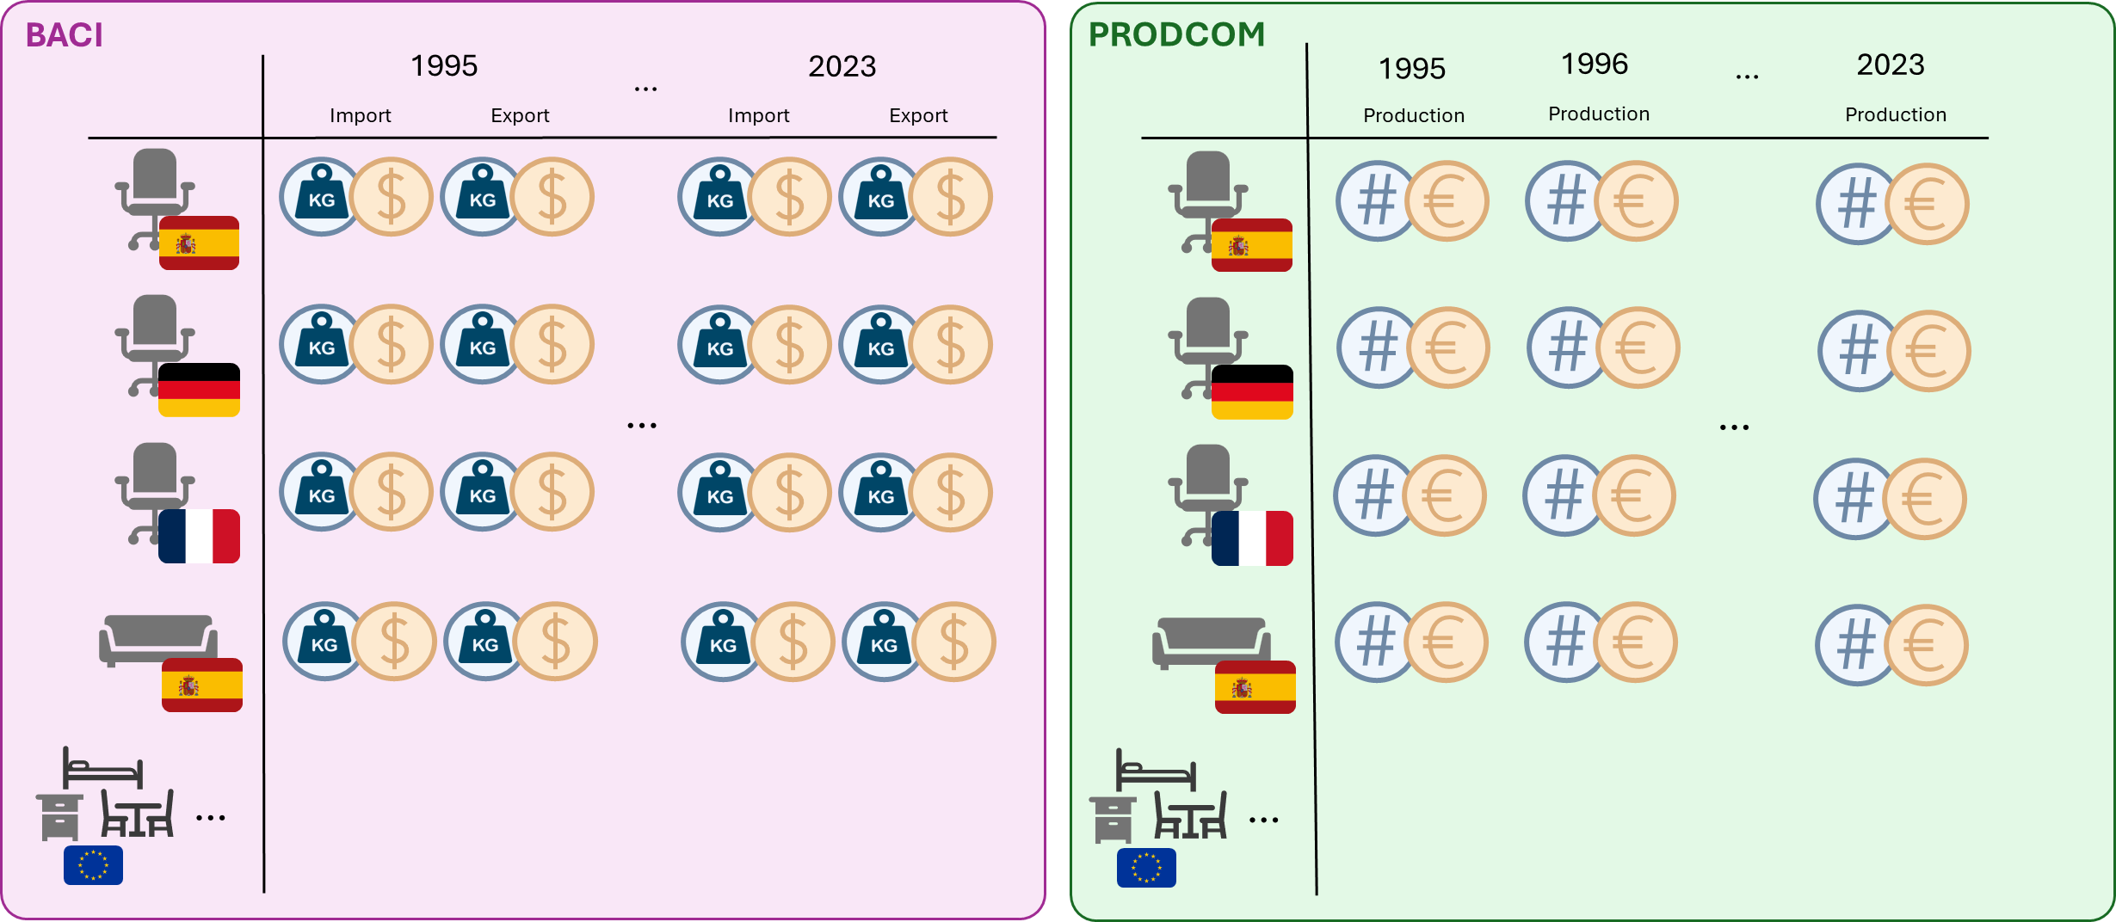
Figure S2. Graphical representation of the available input data. The symbol ‘#’ represents number of items.

PRODCOM data cleaning
The first step in our methodology is processing the PRODCOM data. The data-cleaning process for the PRODCOM production data was performed in Python 3.12.
STEP 1: UNIT PRICE – estimate missing data in number of items
First, monetary values (V) are deflated to the common year 2015 using the average annual inflation index for “furniture and furnishings” under the Classification of Individual Consumption by Purpose (COICOP) with the code CP0511 (Eurostat, 2026a). The database provides an index (I), per year (t), and per country (c), such that for each product (p) produced we deflate value as follows:
$$V_{t,c,p}^{2015​}​=V_{t,c,p}​⋅\frac{100}{I_{t,c}}​$$
Where $V_{t,c,p}^{2015}$is the inflation-adjusted production value.
A unit price (UP) (i.e. the price of a single item) is then defined for each year-product-country observation as the ratio between the deflated value of production and the corresponding number of items (Q):
$$UP_{t,c,p}=\frac{V_{t,c,p}^{2015}}{Q_{t,c,p}}$$
Results are restricted to UPs with positive, non-zero, and finite values. For each country–product combination, we obtain a time series of unit prices. This time series represents the UP of single products in specific countries (e.g. the unit price of swivel chairs in Spain) throughout the years. We use Huber regression to obtain a model function $H\left(t\right)$such that:
$$UP_{c,p}\left(t\right)=H_{c,p}\left(t\right)+ϵ_{t,c,p}$$
To perform Huber regression, a Huber loss threshold (or robustness parameter) must be specified to determine the severity of outlier penalization. It must be higher than 1, the smaller this parameter, the more aggressively large residuals are downweighed. We determine this dynamically for every UP time series as:
$$Huber {loss}_{c,p}=max\left(1.35,\frac{MAD\left(UP_{c,p}\left(t\right)\right)}{max\left(UP_{c,p}\left(t\right)\right)-min\left(UP_{c,p}\left(t\right)\right)}*10\right)$$
Where MAD is the median absolute deviation. This is a reasonable way to define Huber loss because it adapts to the relative dispersion of UP time series, ensuring that the influence of outliers is scaled according to the variability of the data (Sun et al., 2020). We set a minimum of 1.35 as a standard value for Huber loss (Huber, 1964).
Only time series with at least two valid observations are used for model estimation. Then, missing UP are estimated by fitting the Huber function $H_{c,p}\left(t\right)$ on the missing year ($t_{missing})$:
$${\overset{ˆ}{UP}}_{c,p}(t_{missing})= H_{c,p}\left(t_{missing}\right)$$
Because we know that the regression has a certain error in the way it approximates the trend of UPs we keep into consideration the uncertainty of our estimation in the following way. We calculate the prediction errors (residuals):
$$r_{c,p}\left(t\right)=UP{\left(t\right)}_{c,p}-H{\left(t\right)}_{c,p}$$
We then estimate that the missing value will also not exactly match the Huber prediction fully and have some residual. Therefore, we calculate the missing UP from a normal distribution centered at the Huber prediction with variance equal to the variance of the residuals:
$${\overset{ˆ}{UP}}_{c,p}\left(t_{missing}\right)∼N\left(H_{c,p}\left(t_{missing}\right),Var\left(r_{c,p}(t)\right)\right)$$
Finally, we can derive the missing physical quantities from the newly estimated UP:
$$Q_{t,c,p}=\frac{V_{t,c,p}^{2015}}{{\overset{ˆ}{UP}}_{t,c,p}}$$
STEP 2: PRODUCTION TO EXPORT RATIO – estimate confidential data in euro
We reconstruct confidential data based on the example of (Huisman et al., 2017) and on the evidence that export amounts are good proxies for production (Saltarelli et al., 2020). Let $V_{t,c,p}^{P}$ denote production values from PRODCOM and $V_{t,c,p}^{E}$export values from BACI for country c, product p, and year t both expressed in euros.
Export data from BACI are first converted from USD to euros using average annual exchange rates provided by the European Central Bank (European Central Bank, 2026). For the years before introduction of euro in 2001 the fixed rate from that year is used to convert monetary values to euro, in line with the approach followed by PRODCOM for European national currencies before 2001 (Eurostat, 2023). Also, HS codes are converted into PRODOCM codes to align export and production data and calculate the ratio. Full correspondence between the two classifications is ensured by PRODCOM (Eurostat, 2023). If one HS code has multiple correspondence in the PRODCOM classification, trade amounts are divided across the PRODCOM categories according to specific proportions based on production amounts.
Once both $V_{t,c,p}^{P}$and $V_{t,c,p}^{E}$are expressed in the same monetary unit and product category convention we calculate the ratio of the two as:
$$R_{t,c,p}=\frac{V_{t,c,p}^{E}}{V_{t,c,p}^{P}}$$
We then obtain a time series of ratios for every country and product. Because missing ratios are estimated with Huber regression, which is a linear regressor, we apply a log transform:
$$r_{t,c,p}=log\left(R_{t,c,p}\right)$$
This is because log transforms turn the multiplicative variation of ratios into additive variation which is what linear regression is better suited for (Feng et al., 2014).
We model the time series of log ratios using Huber regression (H(t)) via the same calculations for Huber loss as described in STEP 1.
$$r_{c,p}\left(t\right)=H_{c,p}\left(t\right)+ϵ_{t,c,p}$$
$$Huber {loss}_{c,p}=max\left(1.35,\frac{MAD\left(r_{c,p}\left(t\right)\right)}{max\left(r_{c,p}\left(t\right)\right)-min\left(r_{c,p}\left(t\right)\right)}*10\right)$$
$${residuals}_{c,p}\left(t\right)=UP{\left(t\right)}_{c,p}-H{\left(t\right)}_{c,p}$$
$${\overset{ˆ}{r}}_{c,p}\left(t_{missing}\right)∼N\left(H_{c,p}\left(t_{missing}\right),Var\left({residuals}_{c,p}\right)\right)$$
We then recover the original ratio and calculate the confidential production euro values:
$${\overset{ˆ}{R}}_{t,c,p}=exp\left({\overset{ˆ}{r}}_{t,c,p}\right)$$
$${\overset{ˆ}{V}}_{t,c,p}^{P}=\frac{V_{t,c,p}^{E}}{{\overset{ˆ}{R}}_{t,c,p}}$$
We then repeat STEP 1 to recover quantities in number of items from the newly estimated monetary values.
STEP 3: MEDIAN ABSOLUTE DEVIATION & RESIDUALS – identify outliers
We use two separate methods for outlier detection. We perform both methodologies on time series of monetary values and physical quantities for production of each product in each country. The two methods are: a local Median Absolute Deviation (MAD) approach (Huisman et al., 2017) and a global regression residual-based approach (Napolano et al., 2025).
The MAD has been adapted for this study with a sliding window of 5 years. This time range has been identified as appropriate by visual inspection to respect the trends in production and improve reliability of the method. Let $P_{t,c,p,u}$ denote production value for a specific country c, year t, product p, expressed in unit u (either euro or number of items). Then we define a rolling window (w) such that:
$$W_{c,p,u}\left(t\right)=P_{c,p,u,t},P_{c,p,u,t+1},…,P_{c,p,u,t+w-1}$$
For each window, the local median (m) and MAD are computed as:
$$m_{c,p,u}=median\left(W_{c,p,u}\left(t\right)\right)$$
$${MAD}_{c,p,u}=median\left(\left|W_{c,p,u}\left(t\right)-m_{c,p,u}\right|\right)$$
When MAD is 0, we replace it with a global dispersion measure:
$${MAD}_{c,p,u}=0.1⋅median\left(\left|P_{c,p,u}\left(t\right)-median\left(P_{c,p,u}\left(t\right)\right)\right|\right)$$
Then, setting k as a fixed sensitivity parameter (equal to 3), we check for every P in the window:
$$\left|P_{c,p,u,t}-m_{c,p,u}\right|>k⋅{MAD}_{c,p,u}$$
If it is true, we consider $P_{c,p,u,t}$ to be an outlier in the given window. Because each observation appears in multiple overlapping windows, a voting scheme is applied. An observation is classified as an outlier under the MAD rule if it is an outlier in at least 60% of the windows it appears in.
To calculate global outliers, we use distribution of residuals. A linear function f(t) is estimated using ordinary least square (OLS) to approximate production trend such that:
$$P_{c,p,u}\left(t\right)=f_{c,p,u}\left(t\right)+ϵ$$
Residuals are calculated with respect to this estimated trend
$$residuals_{c,p,u}\left(t\right)=P_{c,p,u}\left(t\right)-f_{c,p,u}\left(t\right)$$
We calculate the interquartile range (IQR) of the residuals and define upper and lower bounds for outliers using the standard 1.5 IQR rule:
$Q_{1}=quantile\left(residuals_{c,p,u}\left(t\right),0.25\right), Q_{3}=quantile\left(residuals_{c,p,u}\left(t\right),0.75\right)$
$${IQR}_{c,p,u}=Q_{3}-Q_{1}$$
$$L_{c,p,u}=Q_{1}-1.5⋅{IQR}_{c,p,u }and U_{c,p,u}=Q_{3}+1.5⋅{IQR}_{c,p,u}$$
We define outliers all the values $P_{c,p,u,t}$for which the corresponding residual exceeds the upper and lower bounds:
$$residuals_{c,p,u,t}<L_{c,p,u} \text{or} residuals_{c,p,u,t}>U_{c,p,u}$$
STEP 4: LINEAR INTERPOLATION – estimate missing data in euro
In this step we estimate euro values of production for each country, product, and year, by fitting an OLS through each time series $V_{c,p}\left(t\right)$:
$$V_{c,p}\left(t\right)=f_{c,p}\left(t\right)+ϵ_{t,c,p}$$
We account for uncertainty in the same way as described for Huber regression where for the linear function f(t):
$${residuals}_{c,p}\left(t\right)=V{\left(t\right)}_{c,p}-f{\left(t\right)}_{c,p}$$
$${\overset{ˆ}{V}}_{c,p}\left(t_{missing}\right)∼N\left(f_{c,p}\left(t_{missing}\right),Var\left({residuals}_{c,p}(t)\right)\right)$$
We then repeat STEP 1 to estimate the physical quantities corresponding to the new estimated monetary values $\overset{ˆ}{V}$.
STEP 5: AGGREGATED RATIO & INTERPOLATION – estimate remaining missing data
The remaining gaps in the production dataset are filled using simplified fallback methods. Missing physical quantities are estimated from the median unit price calculated across all available observations for the corresponding product category, while confidential monetary values are reconstructed using median production-to-export ratios computed for comparable products within the same country. Following these imputations, physical quantities are recalculated where necessary and any remaining missing values in the number of items are completed by linear interpolation over time. These fallback procedures are only applied to observations that could not be estimated by the primary methods and are intended to maximize dataset completeness while minimizing the introduction of additional assumptions.

The given steps are used to fill in data gaps of the original dataset. In the end only 72 points are left blank (Table S2). The 72 data points that could not be estimated are as follows: for Latvia, the value of metal furniture (PRODCOM 31091100) production in euros from 2001 to 2024 remains confidential. Although production is known to have occurred, the available data is insufficient to support robust estimation. The remaining gaps concern Slovenia, where both the monetary value and number of items for mattresses with spring interiors (PRODCOM 31031270) produced between 2001 and 2024 cannot be estimated for the same reason, as these observations are also confidential and the database does not contain sufficient information to enable reliable estimation.
To note that some entries are entirely not reported in PRODOCM. In these cases, it is hard to determine if it is because a given product was not produced or its value not reported so we limit ourselves to our definition of missing data where we estimate these missing entries only if its equivalent in another unit is available in the dataset. However, some of these missing data may lead to underestimation of stock of certain products in given countries.
Table S2 Number and percentage (relative to the original dataset of 317,773 observations) of confidential and missing values remaining after each processing step, together with the number of values estimated and outliers removed at each stage.
Step | Confidential remaining | Missing remaining | Values estimated in step | Outliers removed
Start | 5,655 (1.78%) | 771 (0.24%) | – | –
Step 1 | 5,338 (1.68%) | 428 (0.13%) | 660 (0.21%) | –
Step 2 | 1,395 (0.44%) | 404 (0.13%) | 3,967 (1.25%) | –
Step 3 | 2,125 (0.67%) | 3,072 (0.97%) | – | 3,398 (1.07%)
Step 4 | 894 (0.28%) | 249 (0.08%) | 4,054 (1.28%) | –
Step 5 | 72 (0.02%) | 4 (<0.01%) | 1,067 (0.34%) | –

The 5 steps are repeated 500 times following a Monte Carlo approach such that every time a regression is used a new value can be drawn from the given normal distribution. This means that in the end we obtain 500 slightly different production databases.

Consumption and stock
Consumption is obtained from production and trade. We repeat its calculation 500 times from each of the production databases produced by the data cleaning procedure. Stock is then calculated from consumption using standard dMFA methods considering product lifetimes. These product lifetimes are modelled as Weibull functions defined by a shape and scale parameter. The shape parameters are taken from Wiprächtiger et al. (2022) while the scale parameters are calculated from the average lifetime reported for products in each category (Table S3).
Because of uncertainty we have 500 estimates for consumption and therefore repeat the stock calculation 500 times as well. To report the results, a single estimate of production, consumption, and stock is required for each product-country-year combination. We therefore calculate the mean and standard deviation across all iterations of production, consumption, and stock to quantify uncertainty. Before calculating these summary statistics, we apply winsorization. Winsorization is a statistical technique that reduces the influence of extreme values by replacing observations beyond specified percentile thresholds with the threshold values (Dixon & Yuen, 1974). Specifically, production, consumption, and stock are winsorized at the 2.5th and 97.5th percentiles, limiting the influence of extreme simulated values on the reported mean and standard deviation.
Table S3. Weibull parameters for lifetime curves. Shape parameter k is from Wiprächtiger et al. (2022).
HS Code | PRODCOM Code | Short Name | k | λ | Reference for lifetime (λ)
940130 | 31001155 | Upholstered swivel seats | 2,58 | 12,50 | (Gamage et al., 2008; Hoxha & Jusselme, 2017)
940130 | 31001159 | Non-upholstered swivel seats | 2,2 | 5,00 | (Flokk AS, 2024)
940130 | 31001150 | Swivel seats | 2,58 | 11,50 | (Gamage et al., 2008; Wagner et al., 2022)
940130 | 31001151 | Swivel seats (excluding of wood) | 2,58 | 10,00 | (Gamage et al., 2008)
940130 | 31001211 | Swivel seats of wood | 2,58 | 15,00 | (Woods Furniture, 2025)
940171 | 31001170 | Upholstered seats with metal frames | 2,58 | 11,50 | (Scan Sørlie AS, 2025; Wagner et al., 2022)
940179 | 31001190 | Non-upholstered seats with metal frames | 2,2 | 8,00 | (Wagner et al., 2022)
940140 | 31001210 | Seats convertible into beds | 2,58 | 12,00 | (Hoxha & Jusselme, 2017; Wagner et al., 2022; Wiprächtiger et al., 2022)
940140 | 31001152 | Seats convertible into beds (excluding of wood) | 2,58 | 10,00 | (Wagner et al., 2022)
940140 | 31001212 | Seats convertible into beds of wood | 2,58 | 11,00 | (Wagner et al., 2022)
940150 | 31001230 | Seats of cane, osier, bamboo or similar materials | 2,2 | 10,00 | (Wagner et al., 2022)
940161 | 31001250 | Upholstered seats with wooden frames | 2,58 | 11,00 | (Wagner et al., 2022; Wiprächtiger et al., 2022)
940169 | 31001290 | Non-upholstered seats with wooden frames | 2,2 | 12,00 | (Wagner et al., 2022)
940180 | 31001300 | Other seats, of HS 9401 , n.e.c. | 2,2 | 10,00 | (Wagner et al., 2022)
940310 | 31011110 | Office metal drawing tables | 2,47 | 14,00 | (Hoxha & Jusselme, 2017; Wagner et al., 2022)
940310 | 31011140 | Metal furniture of a kind used in offices, of a height <= 80 cm | 2,47 | 13,00 | (Wagner et al., 2022)
940310 | 31011170 | Metal furniture of a kind used in offices, of a height > 80 cm | 2,47 | 15,00 | (Hoxha & Jusselme, 2017)
940310 | 31011100 | Metal furniture for offices | 2,47 | 16,00 | (Hoxha & Jusselme, 2017; Wagner et al., 2022)
940320 | 31091100 | Metal furniture (excluding office) | 2,47 | 10,00 | (Wagner et al., 2022)
940330 | 31011200 | Wooden furniture of a kind used in offices | 2,47 | 16,67 | (Hoxha & Jusselme, 2017; Wagner et al., 2022; Wiprächtiger et al., 2022)
940360 | 31011300 | Wooden furniture for shops | 2,47 | 8,00 | (Wagner et al., 2022)
940350 | 31091230 | Wooden bedroom furniture | 2,47 | 13,60 | (Wagner et al., 2022; Wiprächtiger et al., 2022)
940360 | 31091250 | Wooden furniture for the dining-room and living-room | 1,28 | 12,25 | (Wagner et al., 2022; Wiprächtiger et al., 2022)
940360 | 31091300 | Other wooden furniture | 2,2 | 9,00 | (Wiprächtiger et al., 2022)
940340 | 31021000 | Kitchen furniture | 2,47 | 20,00 | (Aloco Kitchens, 2025; Hoxha & Jusselme, 2017; Wagner et al., 2022)
940410 | 31031100 | Mattress supports | 2,47 | 10,00 | (Sleep Republic, n.d.)
940421 | 31031230 | Mattresses of cellular rubber | 2,47 | 10,00 | (Arias Madero et al., 2025; Lanoë et al., 2013)
940421 | 31031250 | Mattresses of cellular plastics | 2,47 | 10,00 | (Arias Madero et al., 2025; Lanoë et al., 2013)
940429 | 31031270 | Mattresses with spring interiors | 2,47 | 10,00 | (Arias Madero et al., 2025; Lanoë et al., 2013)
940429 | 31031290 | Other Mattresses | 2,47 | 10,00 | (Arias Madero et al., 2025; Lanoë et al., 2013)
940370 | 31091430 | Furniture of plastics | 2,2 | 8,00 | (Wagner et al., 2022)
940380 | 31091450 | Furniture of materials other than metal, wood or plastic | 2,2 | 10,00 | (Wagner et al., 2022)

Extensive results
Note in the results that stock may result negative in the years prior to 2015 because we assume an initial stock of 0. If in those years a lot of the production is exported because products from previous years are discarded and not enough initial stock was assumed, the stock balance may appear negative due to this modelling choice. Some of the non-reported data mentioned in the previous section may also affect some of the detailed stock and appear that specific products in certain countries are absent or disproportionally small in amounts.

Countries’ time series
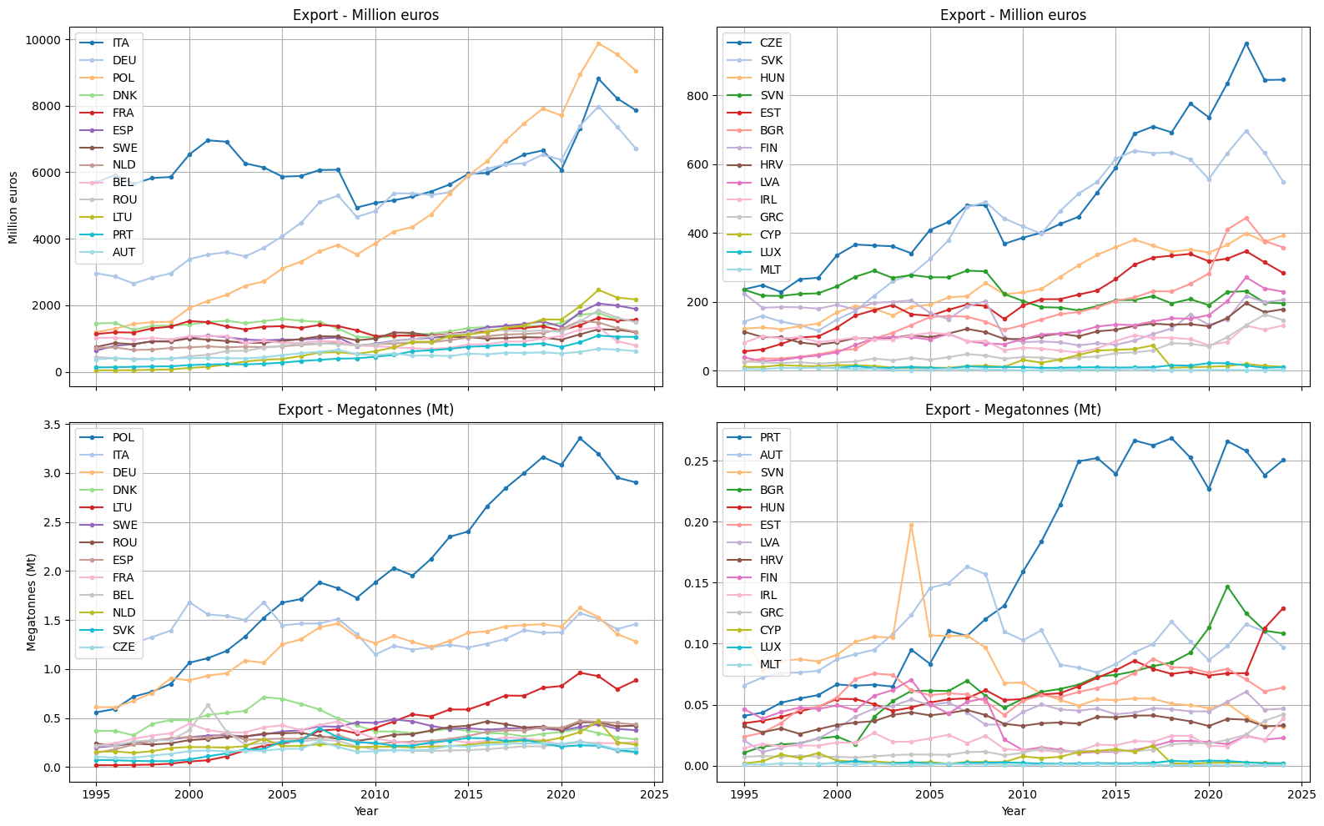
Figure S3. Total yearly export in euro and megatonnes of all furniture products in EU27 countries.
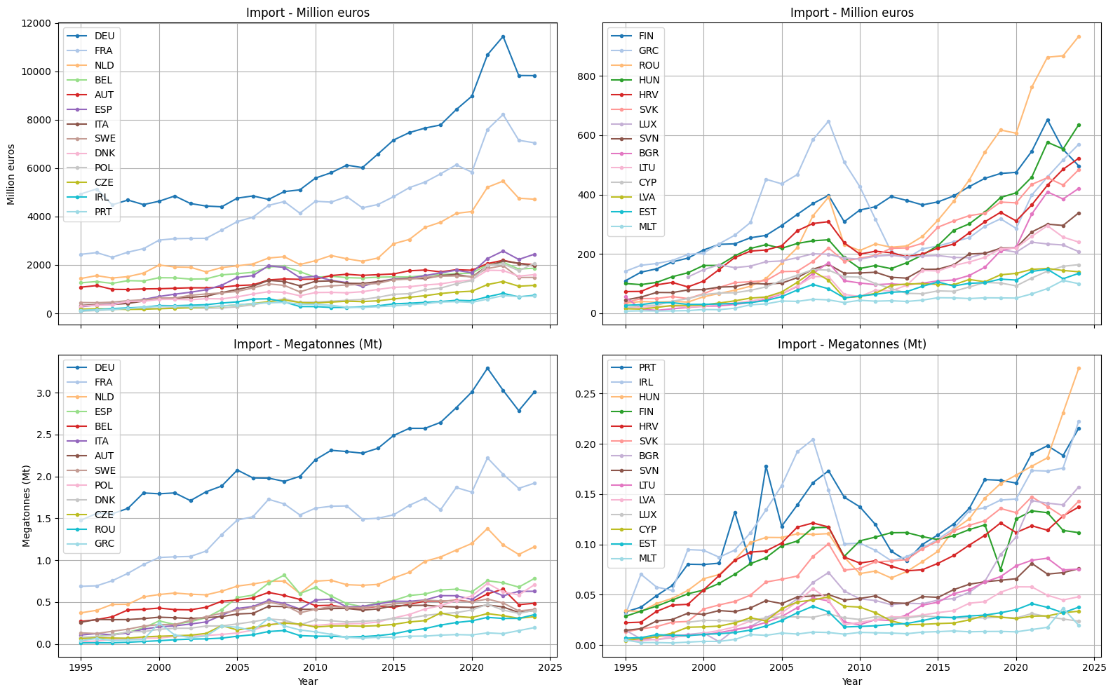
Figure S4. Total yearly import in euro and megatonnes of all furniture products in EU27 countries.
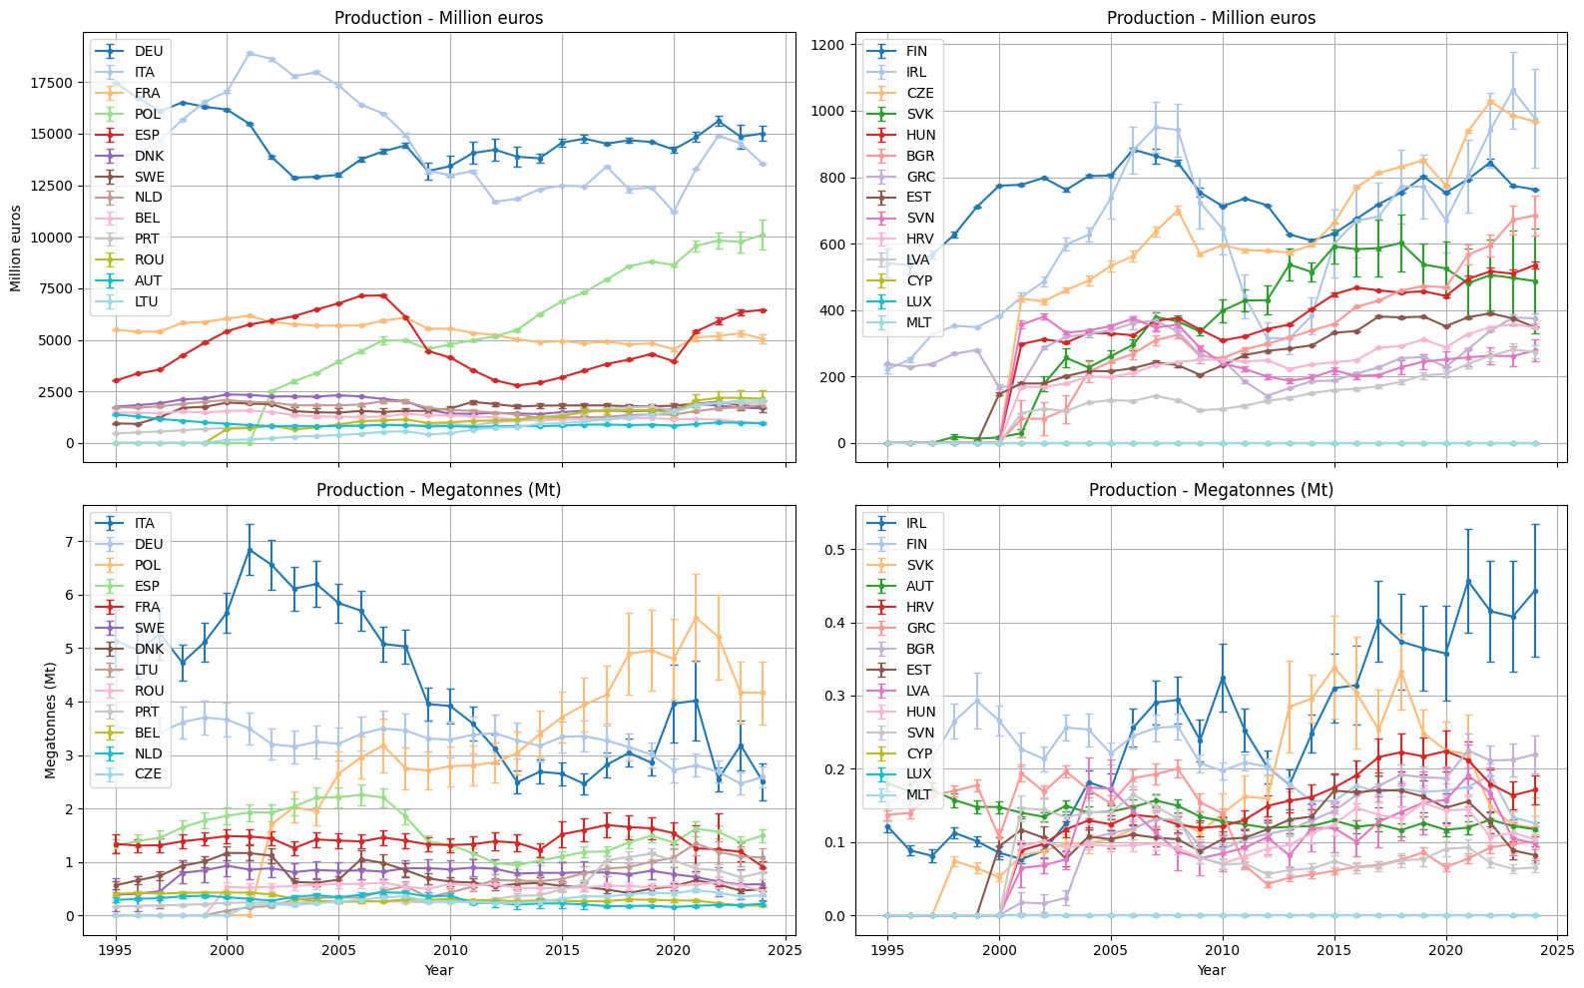
Figure S5. Total yearly production in euro and megatonnes of all furniture products in EU27 countries. Uncertainty reported represents the total std.
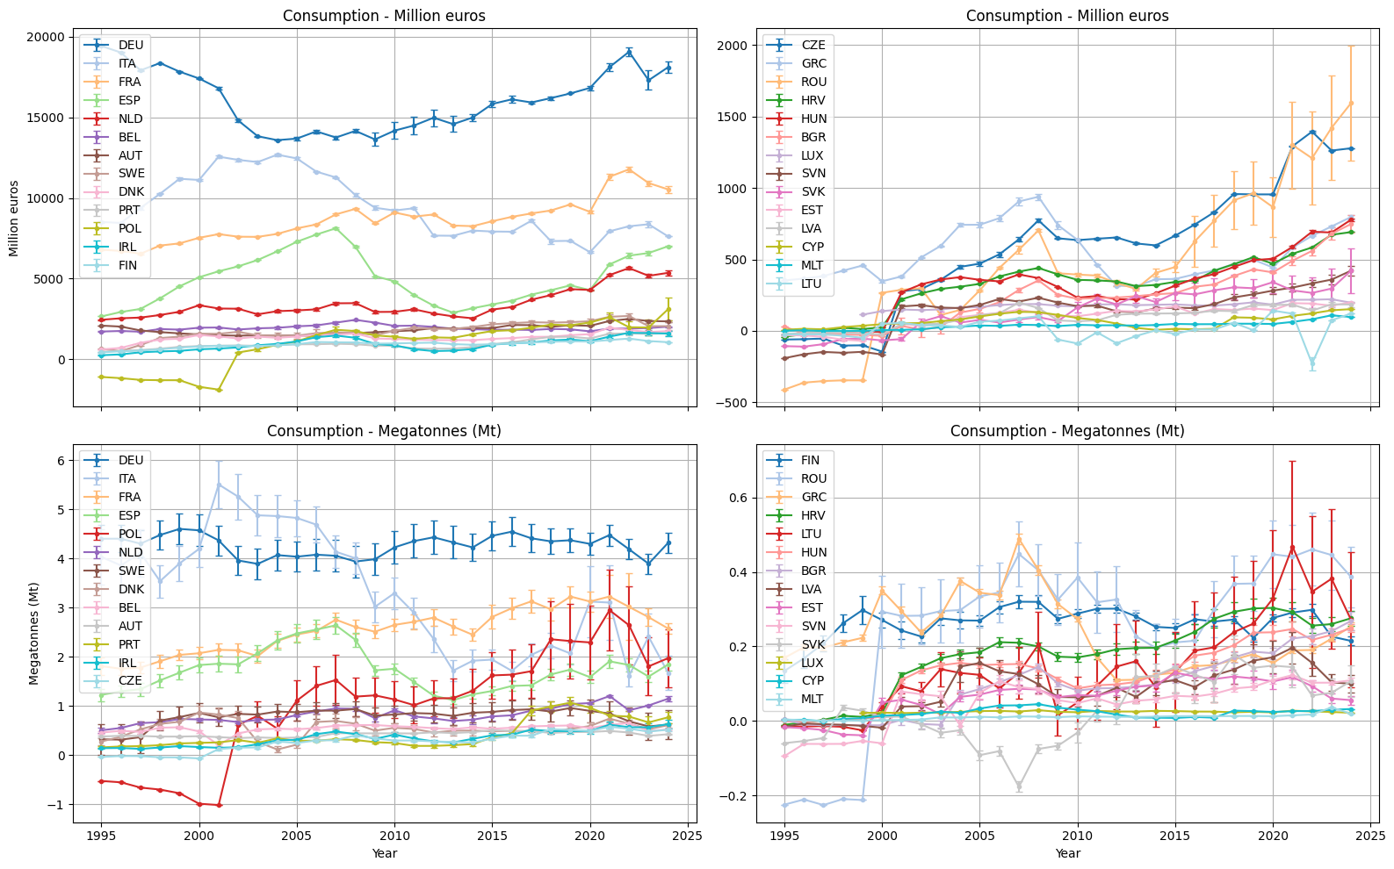
Figure S6. Total yearly consumption in euro and megatonnes of all furniture products in EU27 countries. Uncertainty reported represents the total std.
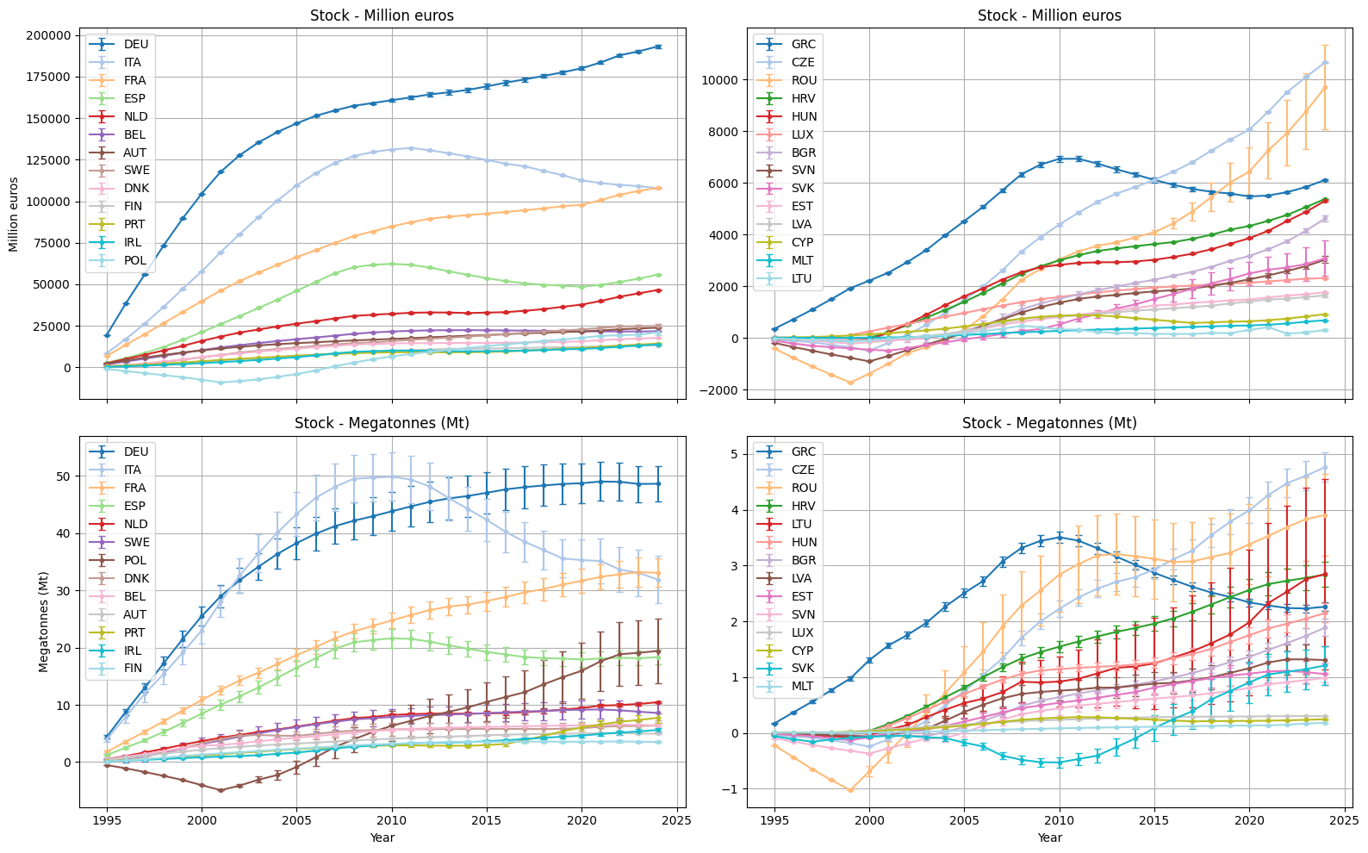
Figure S7. Total yearly stock in euro and megatonnes of all furniture products in EU27 countries. Uncertainty reported represents the total std.

Products’ time series
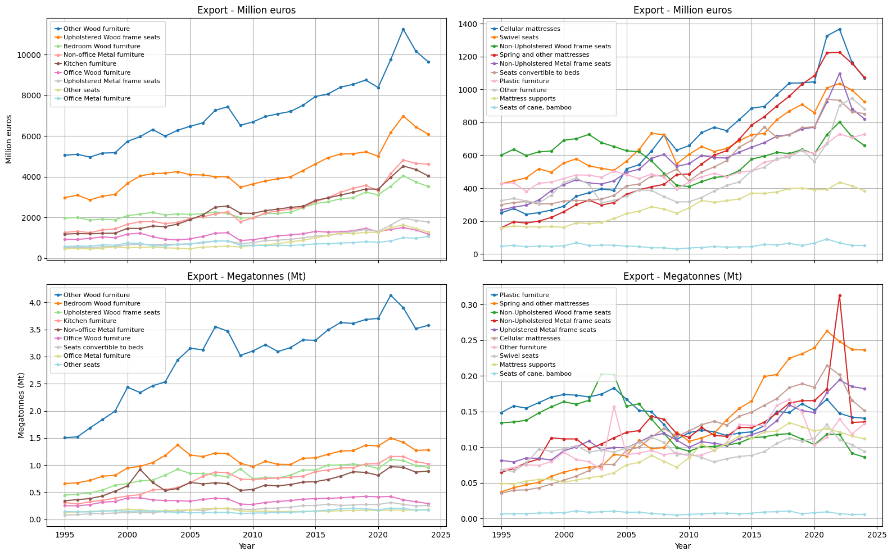
Figure S8. Total yearly exports in euro and megatonnes of all EU27 countries for the given products.
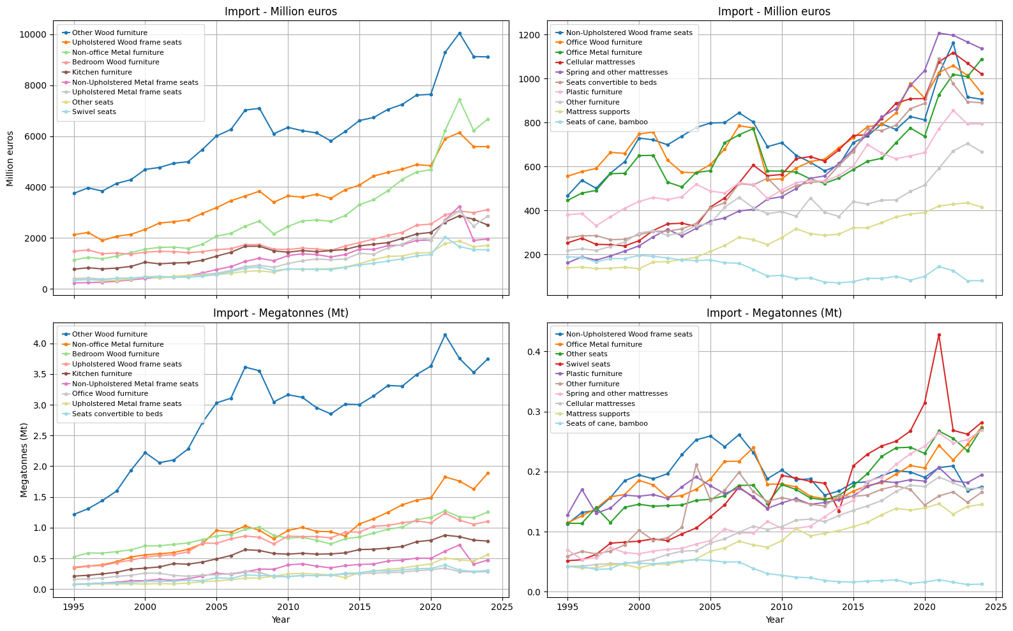
Figure S9. Total yearly exports in euro and megatonnes of all EU27 countries for the given products.
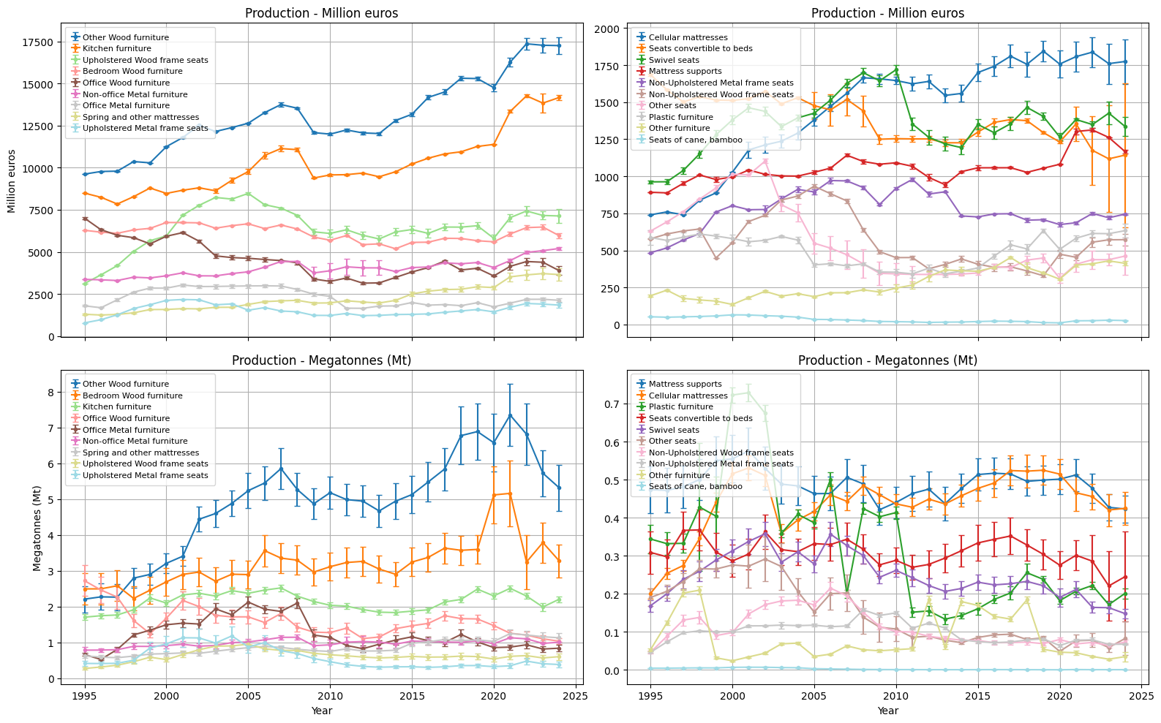
Figure S10. Total yearly production in euro and megatonnes of all EU27 countries for the given products. Uncertainty reported represents the total std.
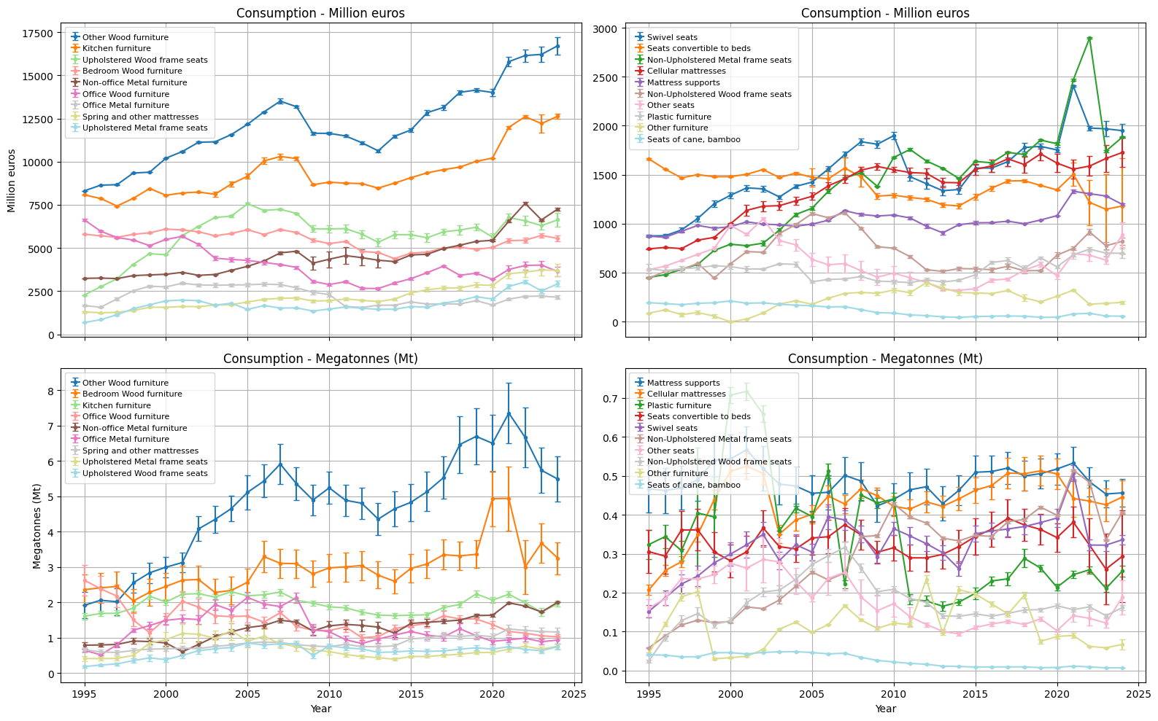
Figure S11. Total yearly consumption in euro and megatonnes of all EU27 countries for the given products. Uncertainty reported represents the total std.
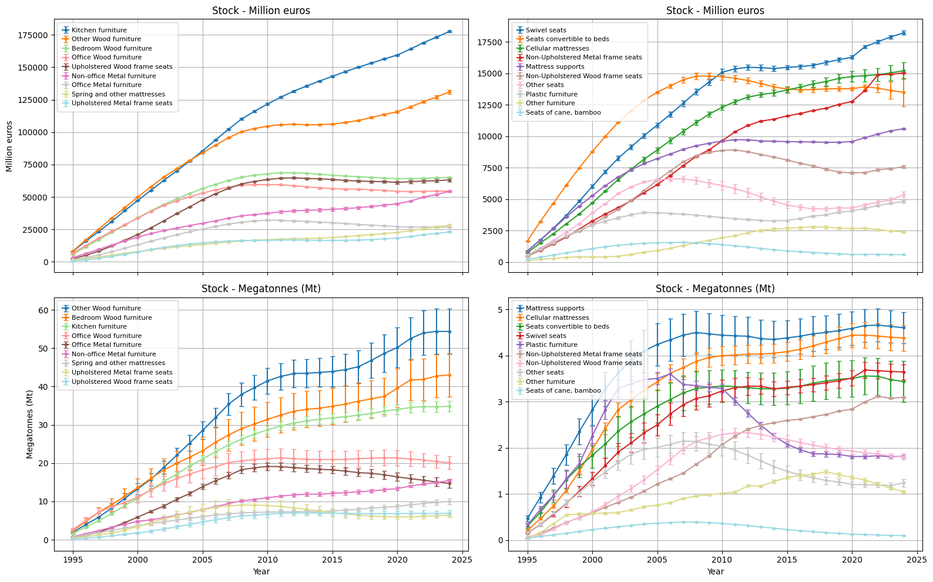
Figure S12. Total yearly consumption in euro and megatonnes of all EU27 countries for the given products. Uncertainty reported represents the total std.

Detailed stock
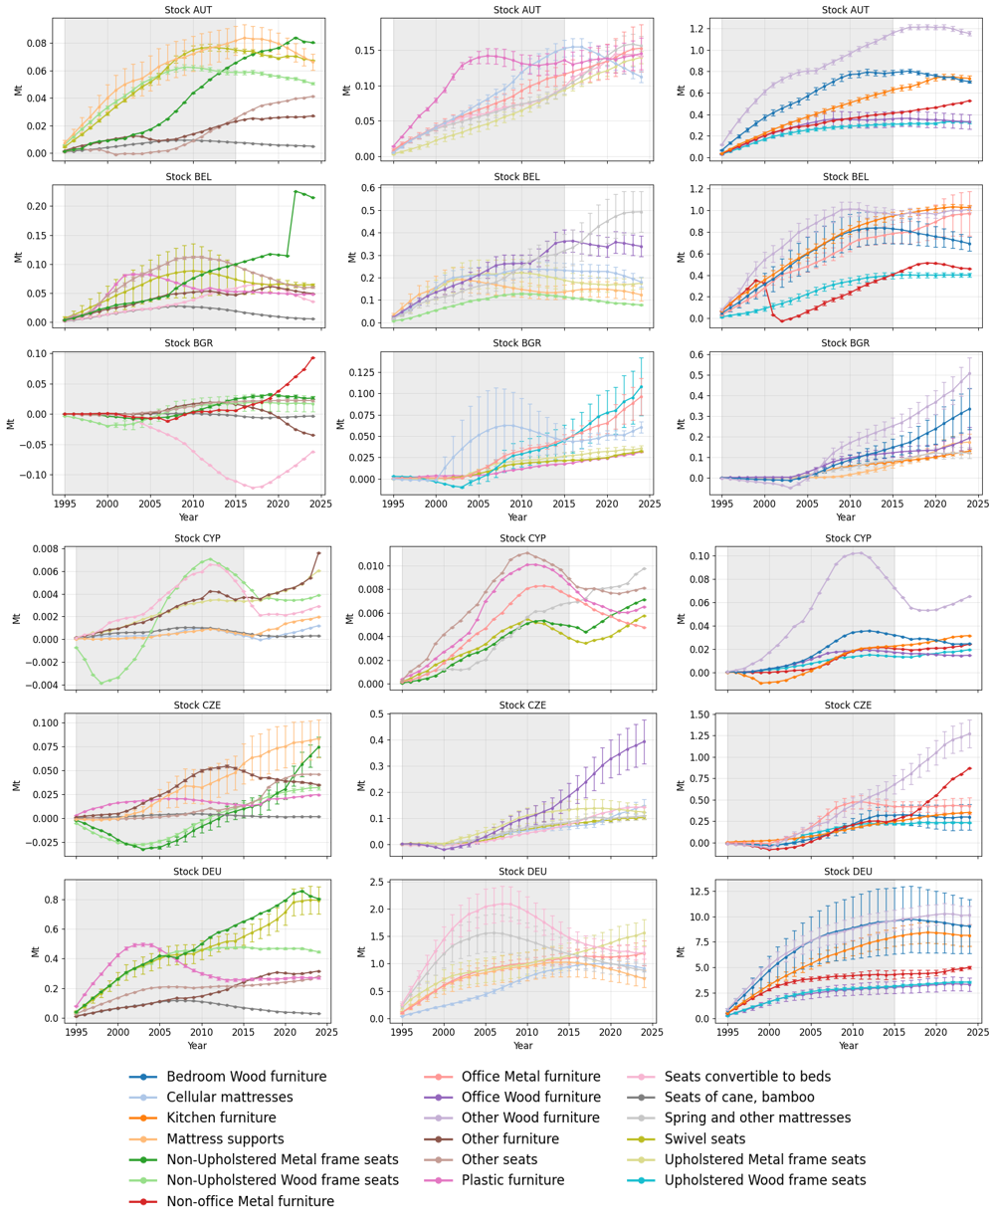
Figure S13. Yearly stock amount in megatonnes for each product category and EU27 country. Stock estimates before 2015 are not considered valid. Countries’ names are reported according to their ISO 3-letter code.
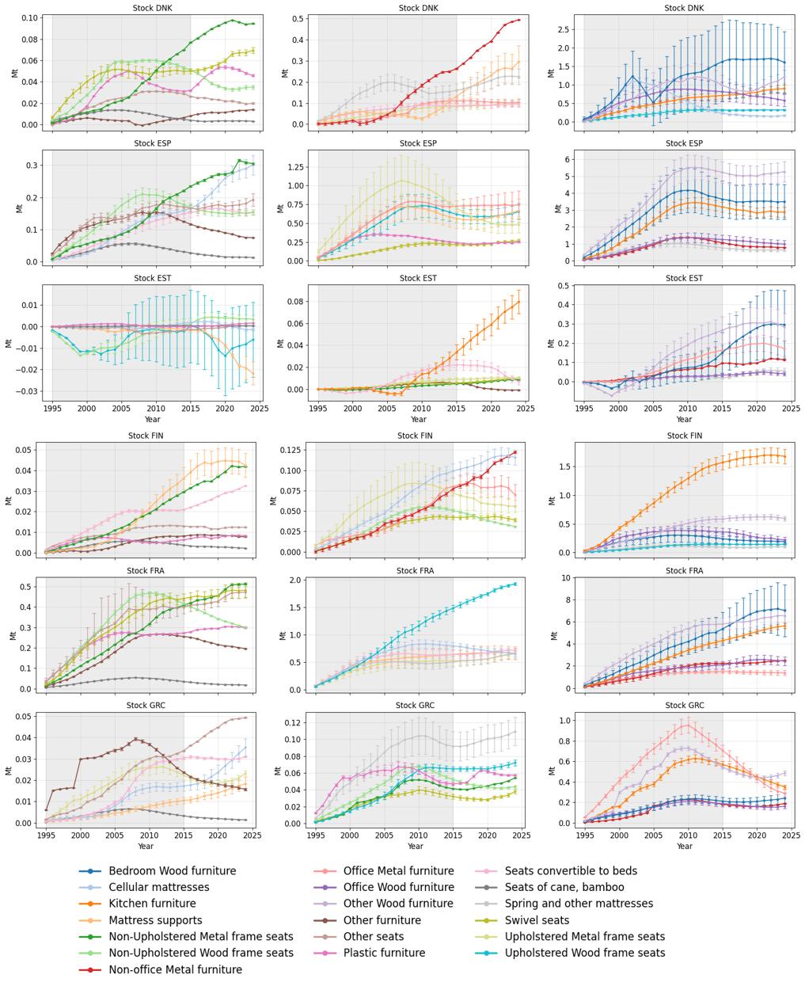
Figure S13 (continued). Yearly stock amount in megatonnes for each product category and EU27 country. Stock estimates before 2015 are not considered valid. Countries’ names are reported according to their ISO 3-letter code.
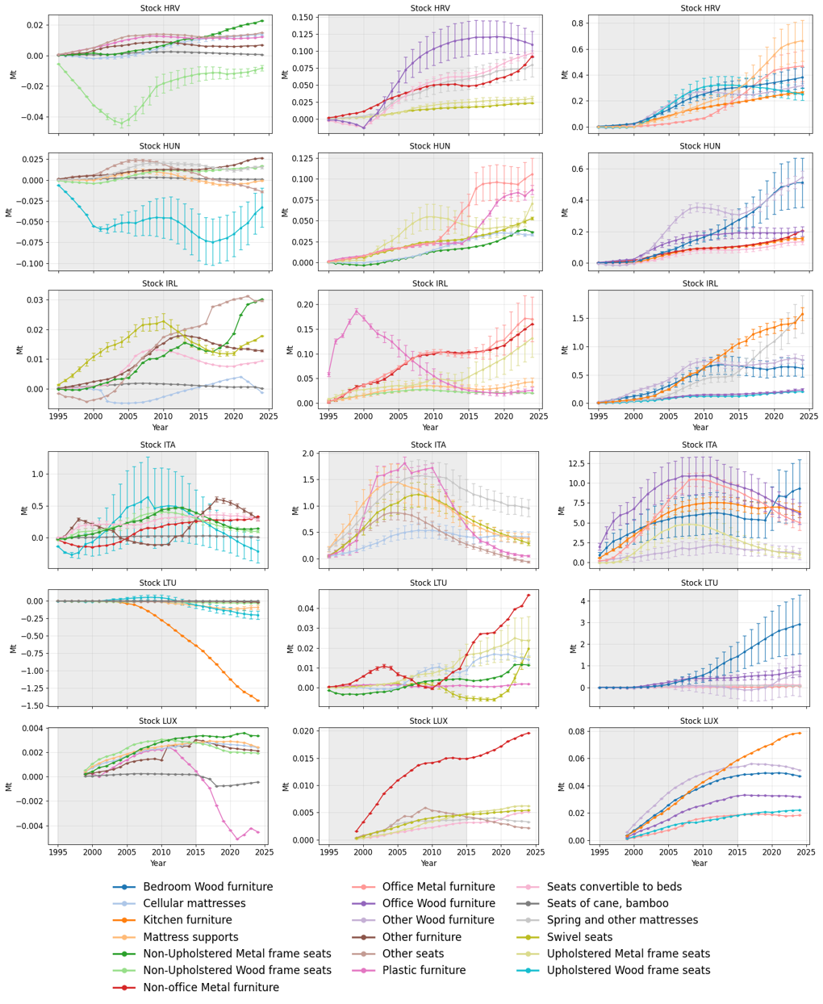
Figure S13 (continued). Yearly stock amount in megatonnes for each product category and EU27 country. Stock estimates before 2015 are not considered valid. Countries’ names are reported according to their ISO 3-letter code.

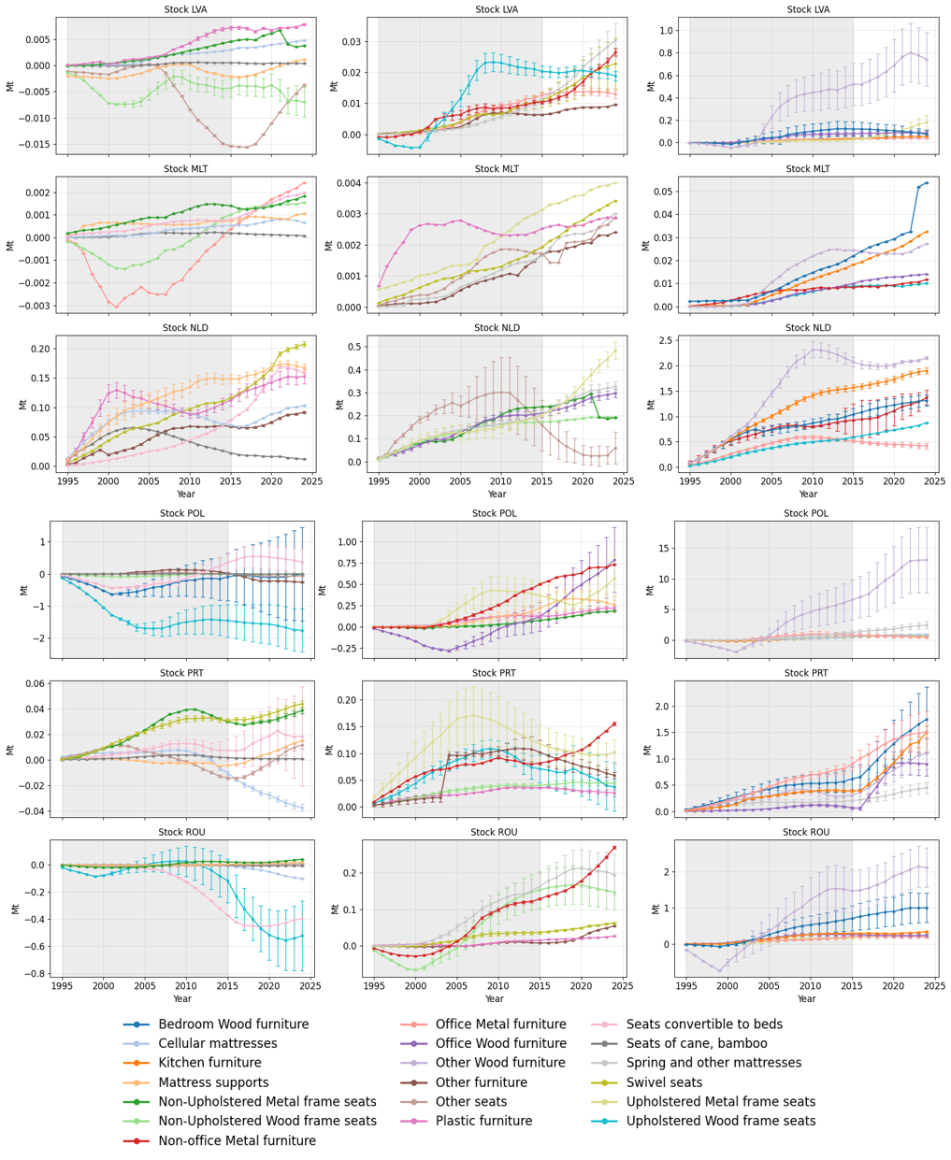
Figure S13 (continued). Yearly stock amount in megatonnes for each product category and EU27 country. Stock estimates before 2015 are not considered valid. Countries’ names are reported according to their ISO 3-letter code.
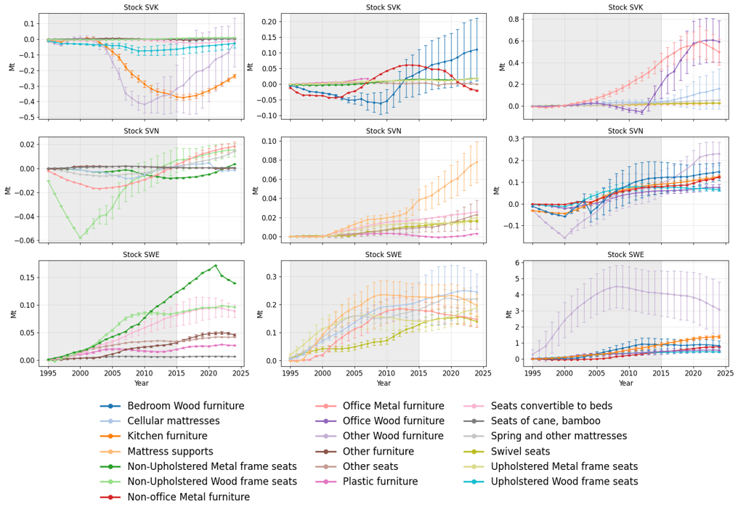
Figure S13 (continued). Yearly stock amount in megatonnes for each product category and EU27 country. Stock estimates before 2015 are not considered valid. Countries’ names are reported according to their ISO 3-letter code.

Waste

Detailed material composition at the EU level
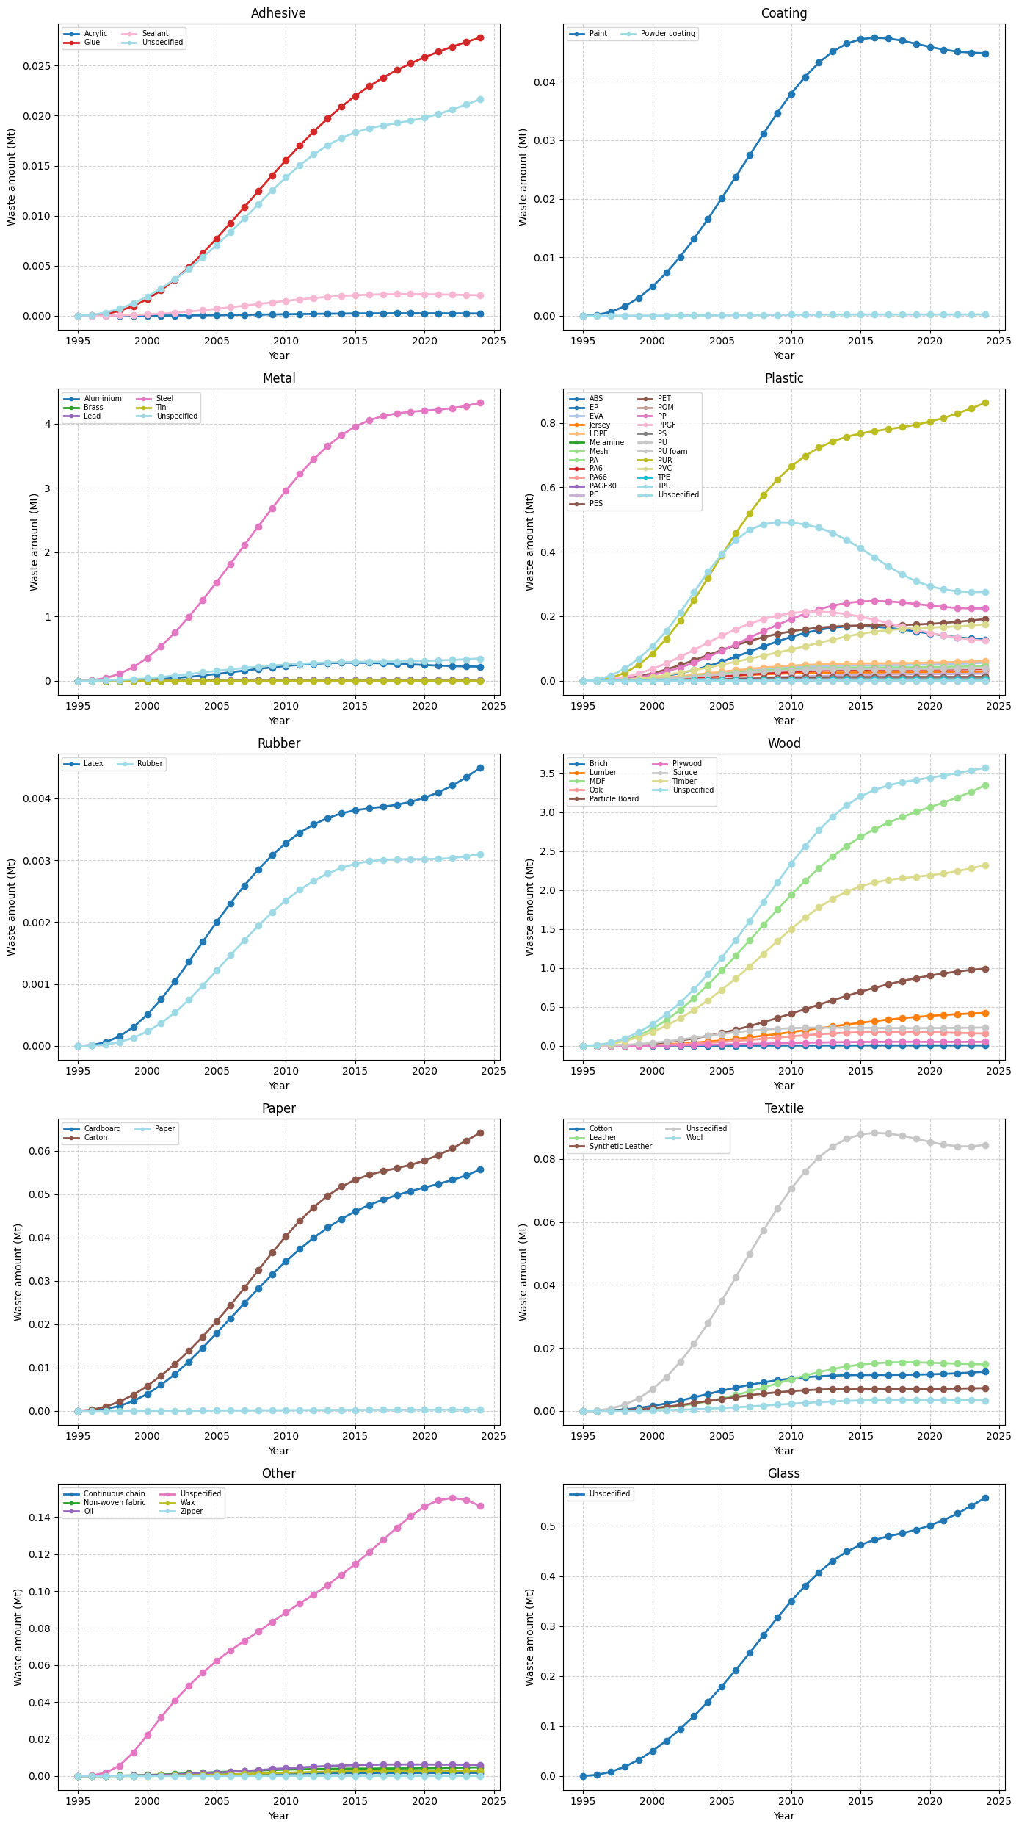
Figure S14. Detailed material composition of stock. Yearly amount of each specific material divided into its macro material category aggregated for all products and EU27 country. Absolute amounts before 2015 are not considered accurate.
Figure S14 (continued). Detailed material composition of stock. Yearly amount of each specific material divided into its macro material category aggregated for all products and EU27 country. Absolute amounts before 2015 are not considered accurate.

Material composition at the country level
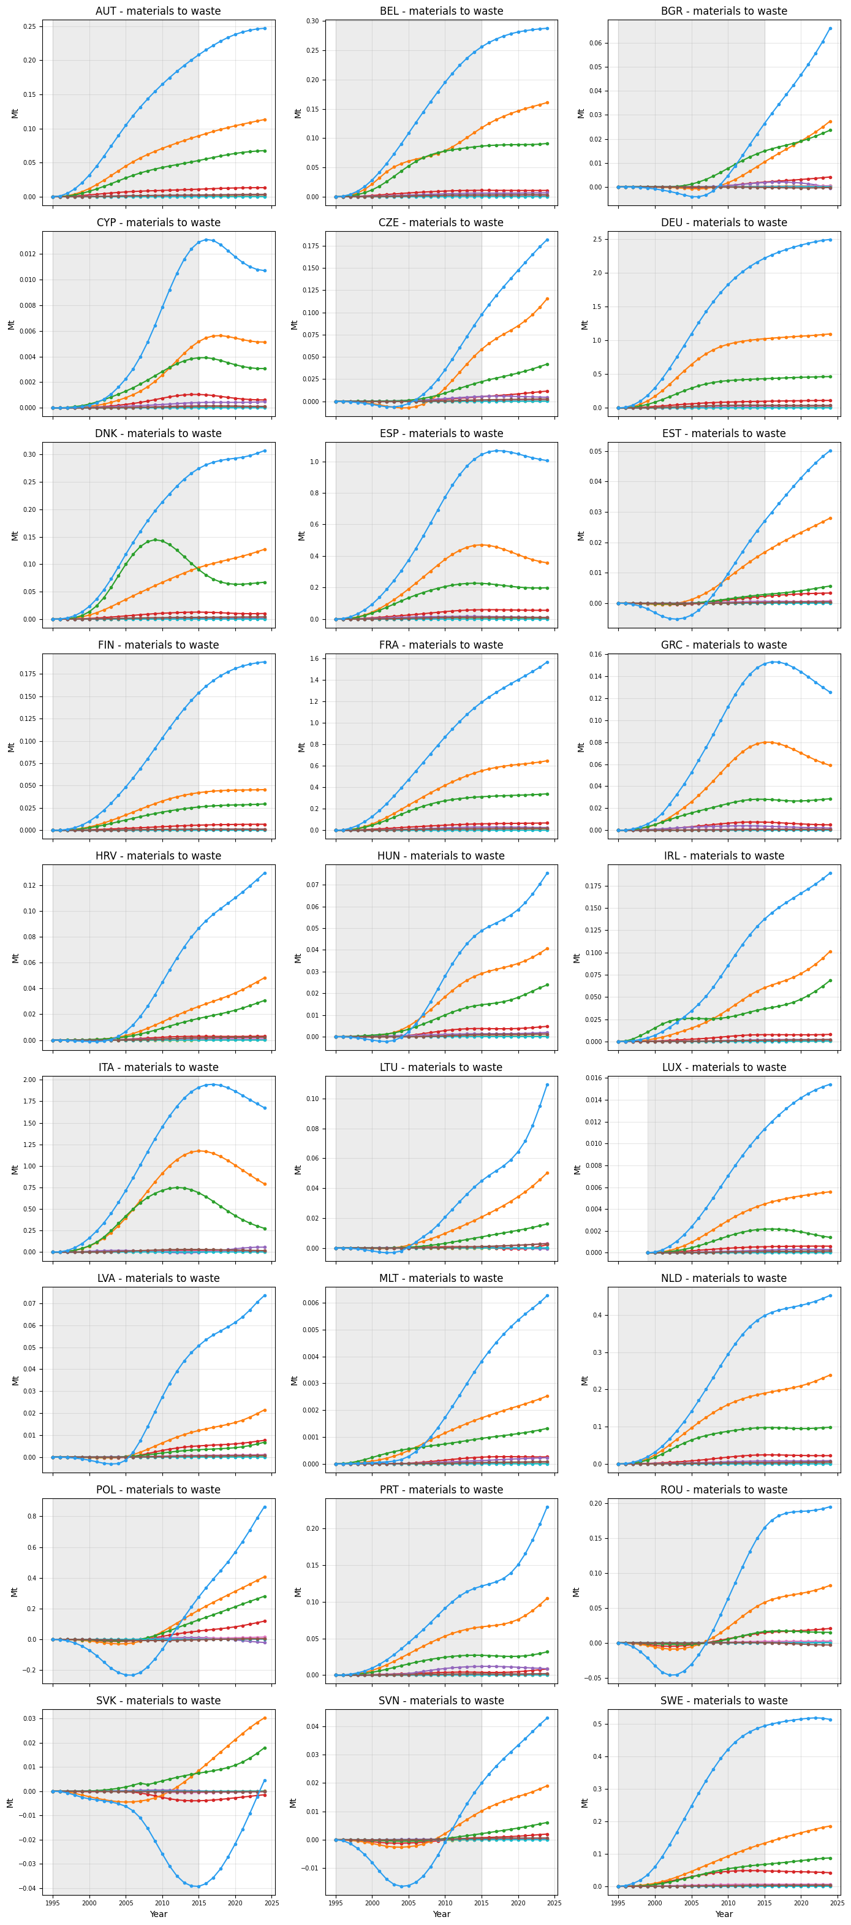
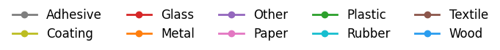
Figure S15. Material composition in megatonnes of total furniture going to waste per EU27 country. Calculations before 2015 are not considered accurate.
Figure S15 (continued). Material composition in megatonnes of total furniture going to waste per EU27 country. Calculations before 2015 are not considered accurate.

Waste treatment at the country level
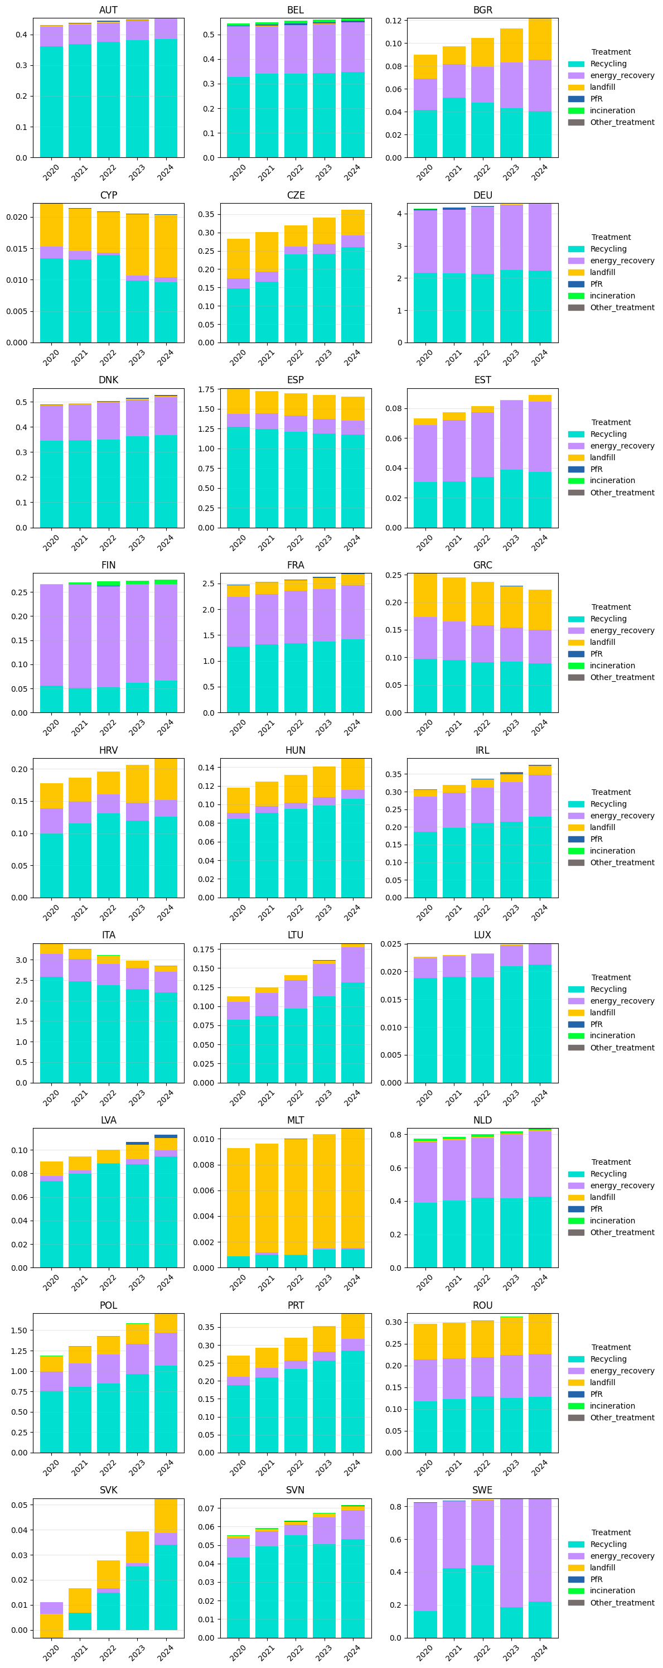
Figure S16. Waste amount in megatonnes and proportion of waste treatment of total furniture going to waste per EU27 country.

Figure S16 (continued). Waste amount in megatonnes and proportion of waste treatment of total furniture going to waste per EU27 country.

Bibliography
Aloco Kitchens. (2025, August 8). How Long Do Kitchen Cabinets Last? A Guide To Cabinet Lifespan. https://alocokitchens.ie/how-long-do-kitchen-cabinets/
Arias Madero, J., Balmori Roiz, J. A., Basterra Otero, L.-A., & Diaz Gonzalez, I. (2025). Discarded Mattresses: From Environmental Problem to Recoverable Resource. Sustainability, 17(18), 8371. https://doi.org/10.3390/su17188371
CEPII. (2026). BACI International Trade Database (BACI_HS92_Y202601; Version 1) [Dataset]. https://www.cepii.fr/DATA_DOWNLOAD/baci/doc/baci_webpage.html
Dixon, W. J., & Yuen, K. K. (1974). Trimming and winsorization: A review. Statistische Hefte, 15(2), 157–170. https://doi.org/10.1007/BF02922904
European Central Bank. (2026). Euro exchange rates charts. https://www.ecb.europa.eu/stats/policy_and_exchange_rates/euro_reference_exchange_rates/html/eurofxref-graph-usd.en.html
Eurostat. (2023). European business statistics user’s manual for PRODCOM: 2023 edition. Publications Office. https://data.europa.eu/doi/10.2785/39767
Eurostat. (2026a). HICP - annual data (average index and rate of change) (Prc_hicp_aind) [Dataset]. https://doi.org/https://doi.org/10.2908/PRC_HICP_AIND
Eurostat. (2026b). Sold production, exports and imports (Ds-059358) [Dataset]. https://ec.europa.eu/eurostat/databrowser/view/ds-059358/legacyMultiFreq/table?lang=en&category=prom
Feng, C., Wang, H., Lu, N., Chen, T., He, H., Lu, Y., & Tu, X. M. (2014). Log-transformation and its implications for data analysis. Shanghai Archives of Psychiatry, 26(2), 105–109. https://doi.org/10.3969/j.issn.1002-0829.2014.02.009
Gamage, G., Boyle, C., McLaren, S. J., & McLaren, J. (2008). Life cycle assessment of commercial furniture: A case study of Formway LIFE chair. The International Journal of Life Cycle Assessment, 13(5), 401–411. https://doi.org/10.1007/s11367-008-0002-3
Hoxha, E., & Jusselme, T. (2017). On the necessity of improving the environmental impacts of furniture and appliances in net-zero energy buildings. Science of The Total Environment, 596–597, 405–416. https://doi.org/10.1016/j.scitotenv.2017.03.107
Huber, P. J. (1964). Robust Estimation of a Location Parameter. The Annals of Mathematical Statistics, 35(1), 73–101. https://doi.org/10.1214/aoms/1177703732
Huisman, J., Habib, H., Baldé, K., Straalen, V. van, Chancerel, P., Chanson, C., Söderman, M., & Kushnir, D. (2017). Prospecting Secondary raw materials in the Urban mine and Mining waste—Product Stocks and Flows (Deliverable 3.3). United Nations University.
Lanoë, T., Simões, C. L., & Simoes, R. (2013). Improving the environmental performance of bedding products by using life cycle assessment at the design stage. Journal of Cleaner Production, 52, 155–164. https://doi.org/10.1016/j.jclepro.2013.03.013
Napolano, L., Foschi, J., Caldeira, C., Huygens, D., & Sala, S. (2025). Understanding textile value chains: Dynamic Probabilistic Material Flow Analysis of textile in the European Union. Resources, Conservation and Recycling, 212, 107888. https://doi.org/10.1016/j.resconrec.2024.107888
Saltarelli, F., Cimini, V., Tacchella, A., Zaccaria, A., & Cristelli, M. (2020). Is Export a Probe for Domestic Production? Frontiers in Physics, 8, 180. https://doi.org/10.3389/fphy.2020.00180
Scan Sørlie AS. (2025). Environmental product declaration: Size chair – Bolt (NEPD-12238-12289). The Norwegian EPD Foundation. https://www.epd-global.com/getfile.php/13234772-1756999352/EPDer/M%C3%B8bler/Sittem%C3%B8bler/NEPD-12238-12289_Size-chair--Bolt.pdf
Sun, Q., Zhou, W.-X., & Fan, J. (2020). Adaptive Huber Regression. Journal of the American Statistical Association, 115(529), 254–265. https://doi.org/10.1080/01621459.2018.1543124
Wagner, J., Steinmetzer, S., Theophil, L., Strues, A.-S., & Kösegi, N. (2022). Evaluation of the collection and recovery of selected waste streams for the further development of circular economy.
Wiprächtiger, M., Rapp, M., Hellweg, S., Shinde, R., & Haupt, M. (2022). Turning trash into treasure: An approach to the environmental assessment of waste prevention and its application to clothing and furniture in Switzerland. Journal of Industrial Ecology, 26(4), 1389–1405. https://doi.org/10.1111/jiec.13275
Woods Furniture. (2025). Environmental product declaration: Woods Club (NEPD-14137-14463-EN). The Norwegian EPD Foundation. https://www.epd-global.com/getfile.php/13240790-1763551599/EPDer/M%C3%B8bler/Sittem%C3%B8bler/NEPD-14137-14463_Woods-Club.pdf

Note that the HS code specifies wooden for kitchen furniture. The PRODCOM regulation ensures that the code 31021000 fully matches the given HS definition beyond the material used.

