Supplementary Materials:

Supplementary Tables:

Total ICU events, N | 9,900
Female sex, n (%) | 3,713 (37.5)
Age in years, mean (+ SD)* | 64.0 (+ 16)
PaO2/FIO2, mean (+ SD) | 322.8 (+193.0)
Available mean PaO2/FIO2, N | 9,900
PaO2/FIO2 > 300, n | 4,656
PaO2/FIO2 = 201-300, n | 2,468
PaO2/FIO2 = 101-200, n | 2,042
PaO2/FIO2 < 100, n | 734
Available SpO2 measurements per unique patient, N | 9,302
1 measurement, n | 8797
2 measurements, n | 433
3 measurements, n | 58
4 measurements, n | 9
5 measurements, n | 4
6 measurements, n | 0
7 measurements, n | 1

Supplementary Table e1. Subject Characteristics in the 7 features models. The 7 feature models captured 9,990 ICU events from 9,302 unique patients. Variables included in the 7 features machine learning models are SpO2, FiO2, TV, MAP, temperature, PEEP and vasopressor administration. *For subjects older than 89 years, the age was assigned as 90 years of age.

 | Entire Dataset 1  (9,900 events) |  | Subset 1 (SpO2 < 97%)  (1,390 events)
 | RMSE | BIC | RMSE | BIC
Neural Network | 86.2 | 8873.1 | 66.6 | 1196.8
Linear Regression | 92.1 | 9002.9 | 67.1 | 1199.0
Support Vector Regression | 87.5 | 8902.3 | 68.5 | 1203.5
Log-linear | 130.2 | NA | 73.1 | NA
Non-linear | 97.7 | NA | 82.4 | NA

Supplementary Table e2. RMSE and BIC of the 7 features machine learning models compared to published methods. The RMSE and BIC for the 7 features models were calculated for the entire dataset (9,900 ICU events) and a subset of the dataset with SpO2 < 97% (1,390 ICU events) and compared to the published log-linear and non-linear models.

 | Entire Dataset 1  (9,900 events) |  |  |  |  | Subset 1 (SpO2 < 97%)  (1,390 events)
 | Neural  Network | Logistic Regression | SVM | Log-linear | Non-linear | Neural Network | Logistic regression | SVM | Log-linear | Non-linear
Total, No. | 9,900 | 9,900 | 9,900 | 9,900 | 9,900 | 1,390 | 1,390 | 1,390 | 1,390 | 1,390
Sensitivity | 0.96 | 0.98 | 0.98 | 0.80 | 0.93 | 0.79 | 0.84 | 0.81 | 0.82 | 0.53
Specificity | 0.43 | 0.28 | 0.33 | 0.62 | 0.52 | 0.77 | 0.68 | 0.71 | 0.65 | 0.92
Positive  LR | 1.71 | 1.37 | 1.48 | 2.12 | 1.94 | 3.73 | 2.68 | 2.91 | 2.36 | 6.37
Negative  LR | 0.09 | 0.07 | 0.06 | 0.33 | 0.13 | 0.28 | 0.24 | 0.27 | 0.27 | 0.51
Diagnostic  OR | 20.08 | 18.96 | 25.48 | 6.43 | 15.04 | 13.45 | 11.42 | 10.83 | 8.67 | 12.40
AUROC | 0.84 | 0.82 | 0.79 | NA | NA | 0.85 | 0.84 | 0.85 | NA | NA
F1 | 0.93 | 0.93 | 0.93 | 0.85 | 0.92 | 0.79 | 0.79 | 0.79 | 0.78 | 0.66
BIC | -2312.40 | -2212.10 | -2243.50 | NA | NA | -221.30 | -216.40 | -222.30 | NA | NA

Supplementary Table e3. Prediction performance of machine learning classification models based on 7 features. Prediction performance statistics were calculated for the machine learning models based on 7 features and compared to the Log-linear and Non-linear methods for the entire dataset (9,900 ICU events) and for a subset of the events where SpO2 <97% (1,390 ICU events). Variables included in the 7 features machine learning models are SpO2, FiO2, TV, MAP, temperature, PEEP and vasopressor administration.

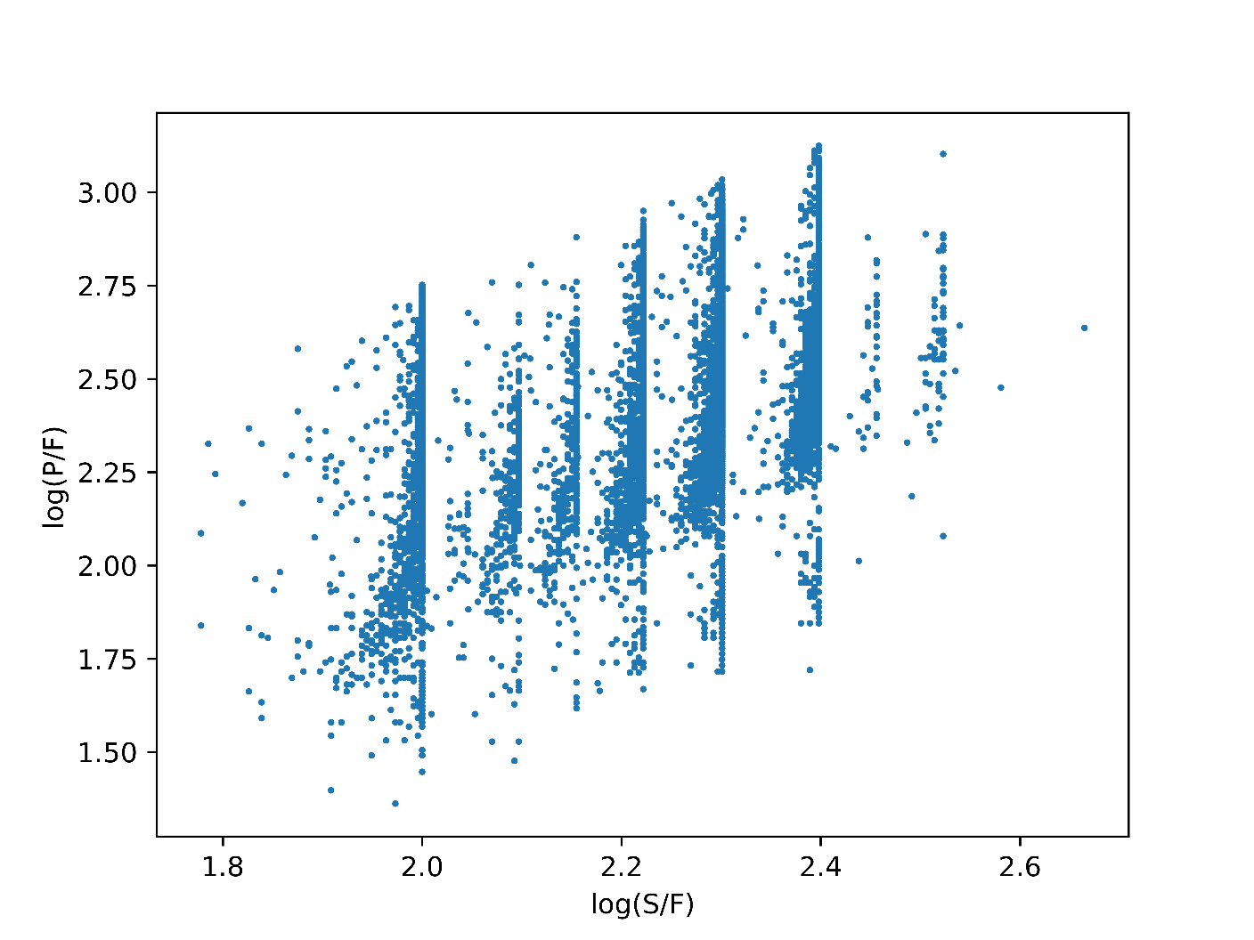

Supplementary Figure e1. Log linear regression between SpO2/FIO2 (S/F) and PaO2/FIO2 (P/F). The log-linear relationship between the transformed logarithmic value of the SF and PF ratios is shown. Dataset 1 includes 9,900 ICU events. R² = 0.21. Each point represents a unique ICU event.

Supplementary Figure e2: Bland-Altman Plots of imputed versus measured PaO2/FIO2 ratios comparing the published equations and the 3 features Neural Network machine-learning algorithm for Subset 2 (SpO2 < 97%). Bland-Altman plots of imputed versus measured PaO2/FiO2 ratio comparing the Neural Network machine learning algorithm using 3 features to the published log-linear and non-linear equations. Subset 2 of the entire dataset 2 where SpO2 <97% (3,280 ICU events) is shown and the slope of each least squared line is reported. Each point represents a single ICU event.

