Supplementary:

Table 1: Risk ratio analysis (CI95% and p-value based on a chi-squared method) comparing the incidence of Pertussis requests in Antibioclic, quarterly and annually in 2024 and 2025 versus 2018-2019, by population subgroup. 2
Figure 1: Comparison of Pertussis requests observed vs predicted, for 2024, with a BSTS model trained on 2018 to 2023 Antibioclic data. Type of data: observed (blue) vs predicted (red), Log10 version. 4
Figure 2: NUTS-3 level French area 5
Figure 3: Representation of NUTS-3 level Pertussis impact. NUTS-3 level distribution of annual Pertussis requests (CDSS usage) adjusted to the CDSS use from june 2024 to august 2024. 6
Table 2 : Regional vaccinal coverage of children under 21 month, 3 doses vaccinal schedule, from the 2025 national vaccination coverage report 7
Table 3 : Regional DTP vaccine booster coverage of 6 and 11 to13 years old children, from the 2025 national vaccination coverage report. At the 6-year-old booster, 98.2% of children were vaccinated with a vaccine containing pertussis. At the 11-13-year-old booster, 95.7% of children were vaccinated with a vaccine containing pertussis. 8
Figure 4 : comparison of annual incidence between Antibioclic Pertusis requests (red) and the Sentinelles network whooping cough indiences (blue), from 2018 to july 2024, per 100,000 inhabitants. 9
Figure 5 : NUTS-3 vaccinal coverage of pregnant women,in 2024, from the 2025 national vaccination coverage report 10

Table 1: Risk ratio analysis (CI95% and p-value based on a chi-squared method) comparing the incidence of Pertussis requests in Antibioclic, quarterly and annually in 2024 and 2025 versus 2018-2019, by population subgroup.

 | Incidence per 100,000 inhabitants |  |  |  |  |  |  |  | 2024 vs 2018–2019 |  | 2025 vs 2018–2019
Quarter | 2018 | 2019 | 2020 | 2021 | 2022 | 2023 | 2024 | 2025 | RR (95% CI) | p-value | RR (95% CI) | p-value
Overall population | 43.469 | 42.924 | 22.388 | 20.657 | 19.416 | 17.622 | 383.203 | 50.881 | 8.87 (8.79–8.95) | < 0.001 | 1.18 (1.16–1.19) | < 0.001
Q1 | 10.643 | 11.630 | 11.534 | 4.275 | 6.003 | 4.294 | 7.715 | 21.812 | 0.69 (0.67–0.72) | < 0.001 | 1.96 (1.91–2.00) | < 0.001
Q2 | 9.627 | 9.867 | 3.270 | 3.858 | 5.299 | 3.525 | 95.800 | 12.154 | 9.83 (9.65–10.02) | < 0.001 | 1.25 (1.21–1.28) | < 0.001
Q3 | 11.301 | 9.819 | 3.390 | 4.900 | 2.728 | 3.719 | 200.116 | 7.834 | 18.95 (18.62–19.28) | < 0.001 | 0.74 (0.72–0.77) | < 0.001
Q4 | 11.897 | 11.607 | 4.194 | 7.624 | 5.387 | 6.084 | 79.572 | 9.081 | 6.77 (6.65–6.89) | < 0.001 | 0.77 (0.75–0.80) | < 0.001
Adults | 41.109 | 39.895 | 20.488 | 19.050 | 17.223 | 15.382 | 283.745 | 44.027 | 7.01 (6.93–7.08) | < 0.001 | 1.09 (1.07–1.10) | < 0.001
Q1 | 10.204 | 10.979 | 10.843 | 3.704 | 5.500 | 4.048 | 6.267 | 19.109 | 0.59 (0.57–0.61) | < 0.001 | 1.80 (1.76–1.85) | < 0.001
Q2 | 9.206 | 9.169 | 2.954 | 3.468 | 4.689 | 3.171 | 70.568 | 10.421 | 7.68 (7.52–7.85) | < 0.001 | 1.13 (1.10–1.17) | < 0.001
Q3 | 10.610 | 8.909 | 3.018 | 4.860 | 2.367 | 3.260 | 144.535 | 6.829 | 14.81 (14.52–15.11) | < 0.001 | 0.70 (0.67–0.73) | < 0.001
Q4 | 11.089 | 10.837 | 3.674 | 7.018 | 4.667 | 4.903 | 62.375 | 7.668 | 5.69 (5.57–5.81) | < 0.001 | 0.70 (0.68–0.72) | < 0.001
Children | 53.034 | 55.642 | 30.526 | 27.479 | 29.032 | 27.521 | 836.355 | 81.264 | 15.39 (15.11–15.68) | < 0.001 | 1.50 (1.46–1.54) | < 0.001
Q1 | 12.339 | 14.280 | 14.381 | 6.802 | 8.153 | 5.300 | 14.237 | 33.733 | 1.07 (1.01–1.13) | 0.03 | 2.53 (2.42–2.66) | < 0.001
Q2 | 11.267 | 12.794 | 4.642 | 5.553 | 7.975 | 5.064 | 210.810 | 19.858 | 17.52 (16.86–18.22) | < 0.001 | 1.65 (1.56–1.74) | < 0.001
Q3 | 14.153 | 13.748 | 5.013 | 4.920 | 4.329 | 5.747 | 453.843 | 12.279 | 32.53 (31.41–33.70) | < 0.001 | 0.88 (0.83–0.94) | < 0.001
Q4 | 15.276 | 14.820 | 6.490 | 10.203 | 8.575 | 11.410 | 157.464 | 15.394 | 10.46 (10.10–10.85) | < 0.001 | 1.02 (0.97–1.08) | 0.43
Pregnant | 117.150 | 114.608 | 125.498 | 169.137 | 60.055 | 21.091 | 483.409 | 60.615 | 4.17 (3.94–4.42) | < 0.001 | 0.52 (0.47–0.58) | < 0.001
Q1 | 22.823 | 30.544 | 36.653 | 42.318 | 36.501 | 4.277 | 4.827 | 25.846 | 0.18 (0.13–0.26) | < 0.001 | 0.97 (0.81–1.16) | 0.73
Q2 | 24.406 | 32.271 | 21.248 | 40.162 | 16.391 | 5.162 | 109.050 | 15.385 | 3.85 (3.41–4.34) | < 0.001 | 0.54 (0.44–0.67) | < 0.001
Q3 | 34.301 | 26.295 | 26.560 | 47.844 | 2.755 | 4.572 | 272.549 | 9.846 | 9.00 (8.12–9.97) | < 0.001 | 0.32 (0.25–0.42) | < 0.001
Q4 | 35.620 | 25.498 | 41.036 | 38.814 | 4.408 | 7.080 | 96.983 | 9.538 | 3.17 (2.82–3.58) | < 0.001 | 0.31 (0.24–0.41) | < 0.001
Kidney failure | 42.000 | 47.688 | 76.000 | 78.188 | 33.562 | 4.375 | 87.812 | 13.188 | 1.96 (1.82–2.11) | < 0.001 | 0.29 (0.25–0.34) | < 0.001
Q1 | 8.562 | 13.813 | 16.938 | 20.375 | 19.438 | 1.625 | 1.438 | 5.500 | 0.13 (0.08–0.20) | < 0.001 | 0.49 (0.39–0.62) | < 0.001
Q2 | 8.188 | 14.750 | 16.688 | 20.812 | 12.750 | 0.875 | 18.062 | 3.438 | 1.57 (1.35–1.84) | < 0.001 | 0.30 (0.23–0.40) | < 0.001
Q3 | 12.937 | 9.500 | 17.375 | 23.062 | 0.500 | 1.000 | 48.812 | 2.562 | 4.35 (3.84–4.93) | < 0.001 | 0.23 (0.17–0.32) | < 0.001
Q4 | 12.312 | 9.625 | 25.000 | 13.938 | 0.875 | 0.875 | 19.500 | 1.688 | 1.78 (1.53–2.07) | < 0.001 | 0.15 (0.10–0.23) | < 0.001

Figure 1: Comparison of Pertussis requests observed vs predicted, for 2024, with a BSTS model trained on 2018 to 2023 Antibioclic data. Type of data: observed (blue) vs predicted (red), Log10 version.
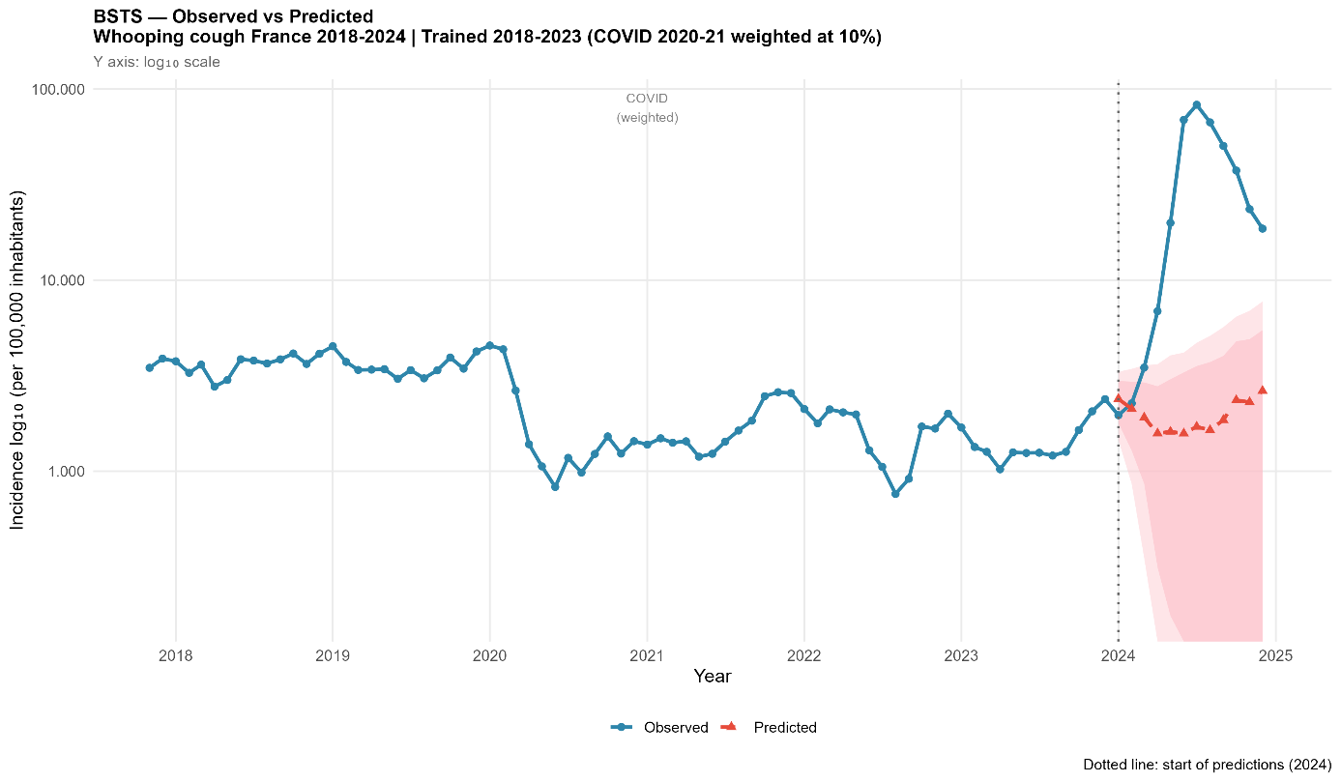

Figure 2: NUTS-3 level French area

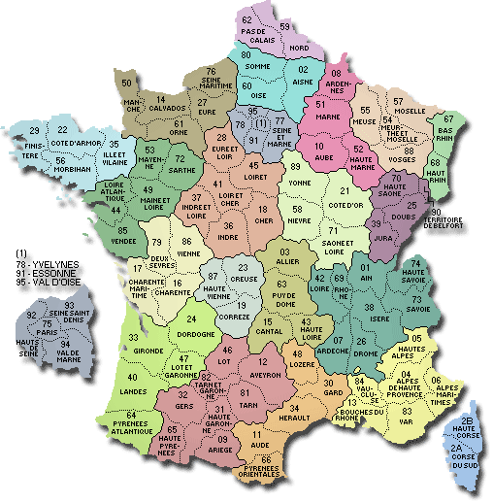
source : https://www.cartesfrance.fr/carte-france-departement/carte-france-departements.html

Figure 3: Representation of NUTS-3 level Pertussis impact. NUTS-3 level distribution of annual Pertussis requests (CDSS usage) adjusted to the CDSS use from june 2024 to august 2024.

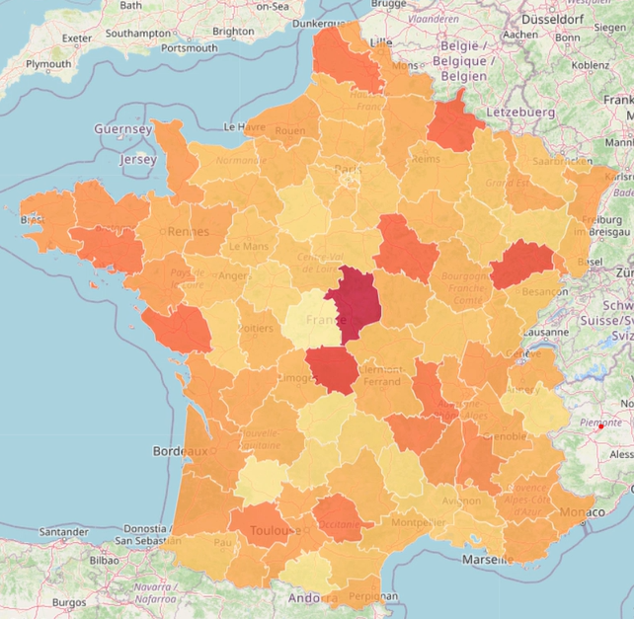
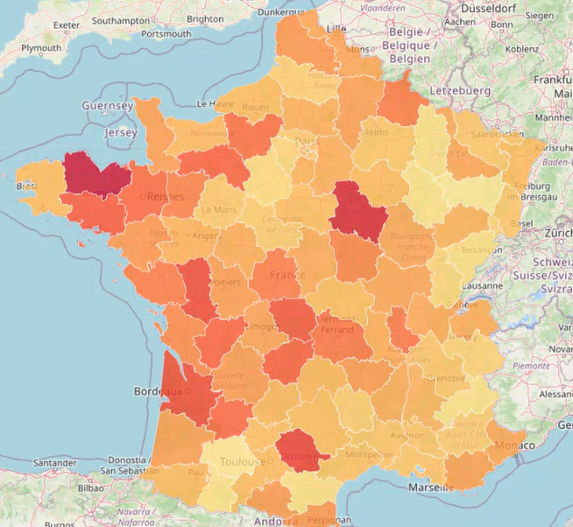
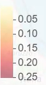
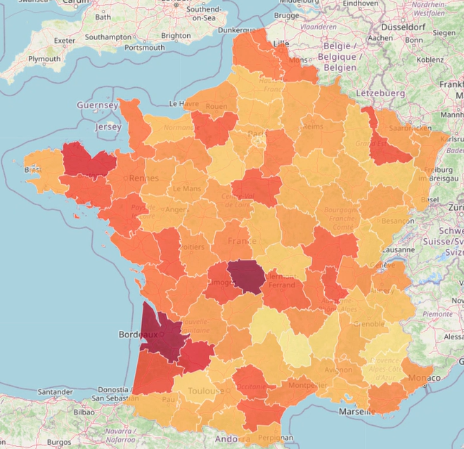
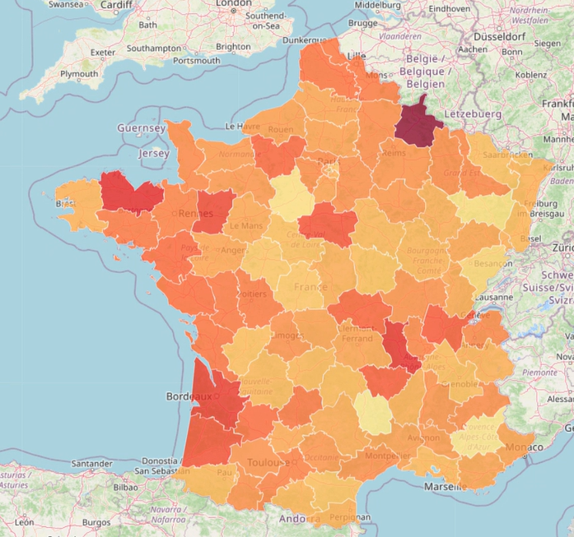
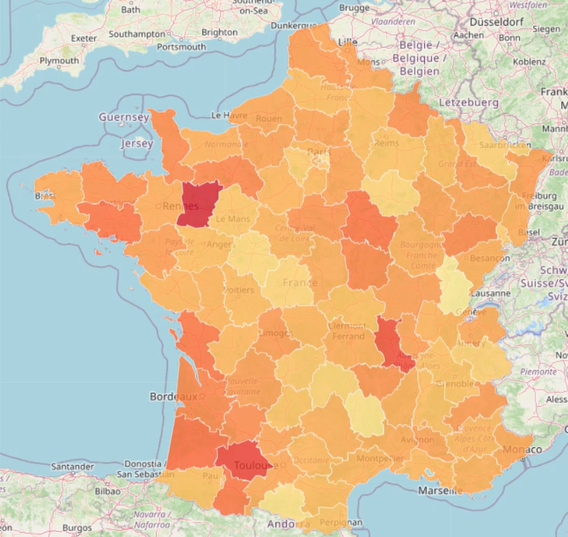
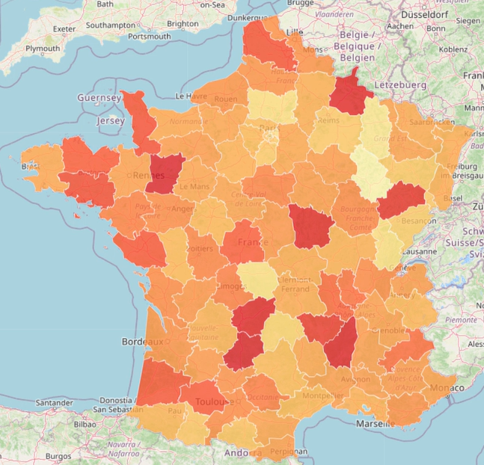
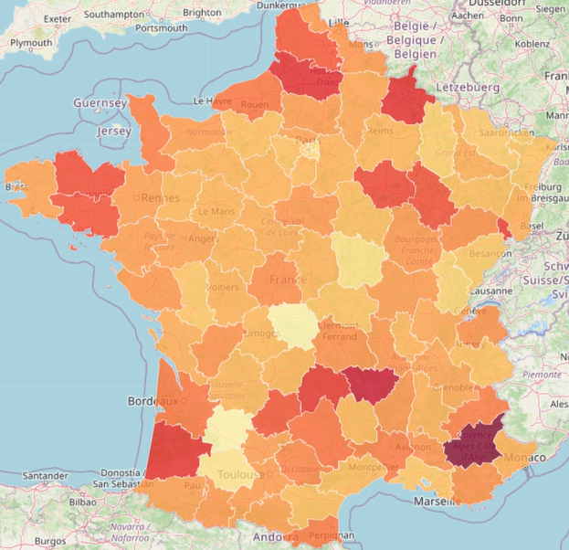
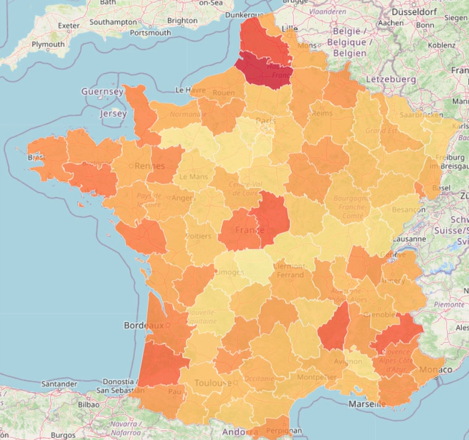
10-17 June 2024 17-30 June 2024 01-08 July 2024 08-15 July 2024
15-22 July 2024 22-29 July 2024 29 July – 05 August 2024 05-12 August 2024

Table 2 : Regional vaccinal coverage of children under 21 month, 3 doses vaccinal schedule, from the 2025 national vaccination coverage report

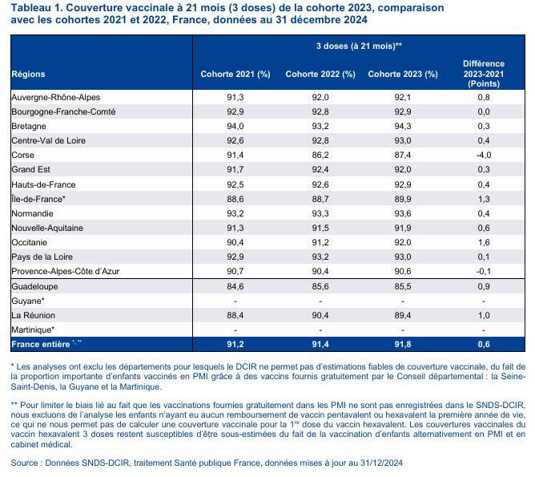

Table 3 : Regional DTP vaccine booster coverage of 6 and 11 to13 years old children, from the 2025 national vaccination coverage report. At the 6-year-old booster, 98.2% of children were vaccinated with a vaccine containing pertussis. At the 11-13-year-old booster, 95.7% of children were vaccinated with a vaccine containing pertussis.
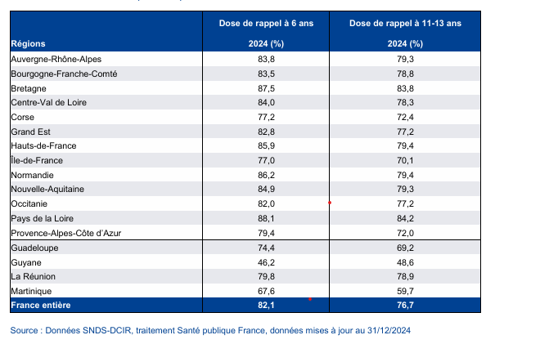

Figure 4 : comparison of annual incidence between Antibioclic Pertusis requests (red) and the Sentinelles network whooping cough indiences (blue), from 2018 to july 2024, per 100,000 inhabitants.

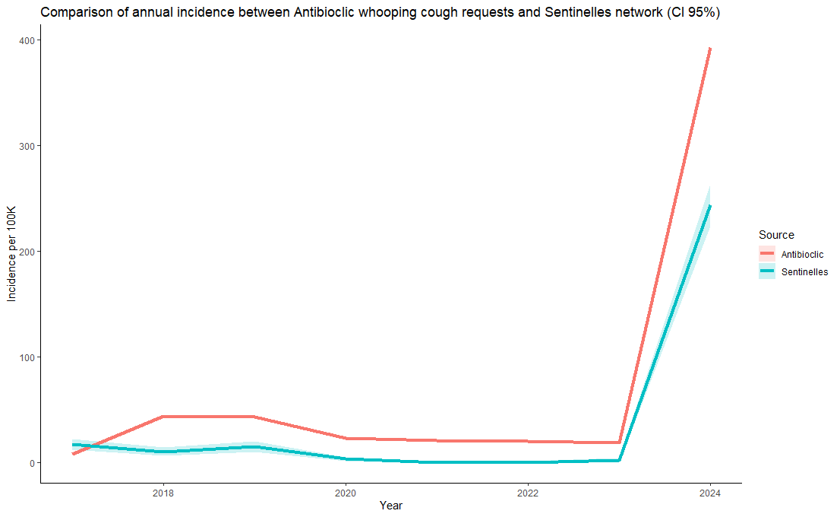

Figure 5 : NUTS-3 vaccinal coverage of pregnant women,in 2024, from the 2025 national vaccination coverage report
