Table S1. Robustness analyses for PVS-behavior associations across alternative estimators and influential-point sensitivity.
Outcome measure | Method | β (per SD increase in PVS) | 95% CI | p value
PSQI | OLS (classic SE) | 0.01 | [-0.52, 0.54] | 0.97
PSQI | OLS (HC3 robust SE) | 0.01 | [-0.41, 0.43] | 0.97
PSQI | Leave-out flagged (classic) | -0.30 | [-1.11, 0.51] | 0.47
PSQI | Leave-out flagged (HC3) | -0.30 | [-1.10, 0.51] | 0.47
Stroop time | OLS (classic SE) | -0.81 | [-2.40, 0.77] | 0.31
Stroop time | OLS (HC3 robust SE) | -0.81 | [-2.67, 1.05] | 0.39
Stroop time | Leave-out flagged (classic) | -2.28 | [-4.74, 0.19] | 0.07
Stroop time | Leave-out flagged (HC3) | -2.28 | [-4.57, 0.02] | 0.052
Stroop accuracy | OLS (classic SE) | -0.04 | [-0.30, 0.23] | 0.79
Stroop accuracy | OLS (HC3 robust SE) | -0.04 | [-0.33, 0.26] | 0.81
Stroop accuracy | Leave-out flagged (classic) | -0.15 | [-0.53, 0.22] | 0.42
Stroop accuracy | Leave-out flagged (HC3) | -0.15 | [-0.61, 0.31] | 0.51
Note: HC3 denotes heteroscedasticity-consistent standard errors. CI = confidence interval; OLS = ordinary least squares; SD = standard deviation.

Table S2. Deleted influential-point analysis: linear regression associations after removing flagged observations.
Outcome measure | β (per SD increase in PVS) | SE | 95% CI | p value
PSQI | -0.30 | 0.41 | [-1.10, 0.51] | 0.47
Stroop time | -2.28 | 1.15 | [-4.57, 0.02] | 0.052
Stroop accuracy | -0.15 | 0.23 | [-0.62, 0.31] | 0.51
Note: Flagged observations were identified using Cook’s distance (4/n) and leverage (2p/n) thresholds; p denotes the number of model parameters including the intercept. Models were refit after removing flagged observations; CI = confidence interval; SD = standard deviation.

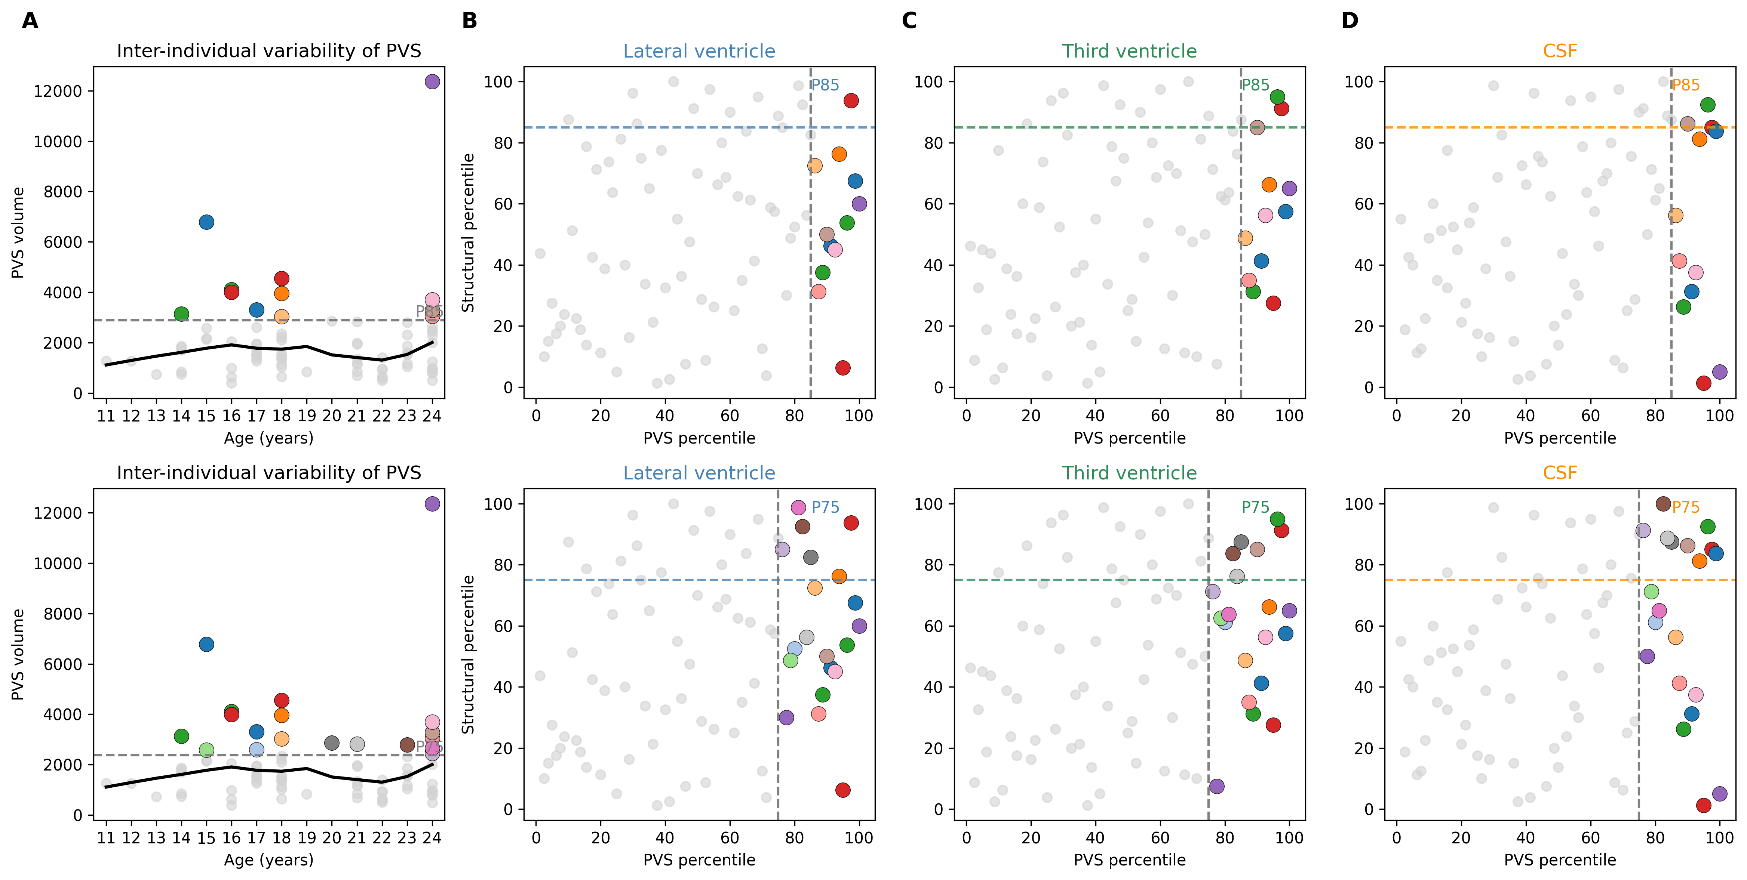
Figure S1. Inter-individual variability in PVS burden and rank-rank dissociation from global structural volumes at P85 (top row) and P75 (bottom row) thresholds. Panels mirror Fig. 2, with colored points indicating participants exceeding the corresponding PVS percentile threshold.

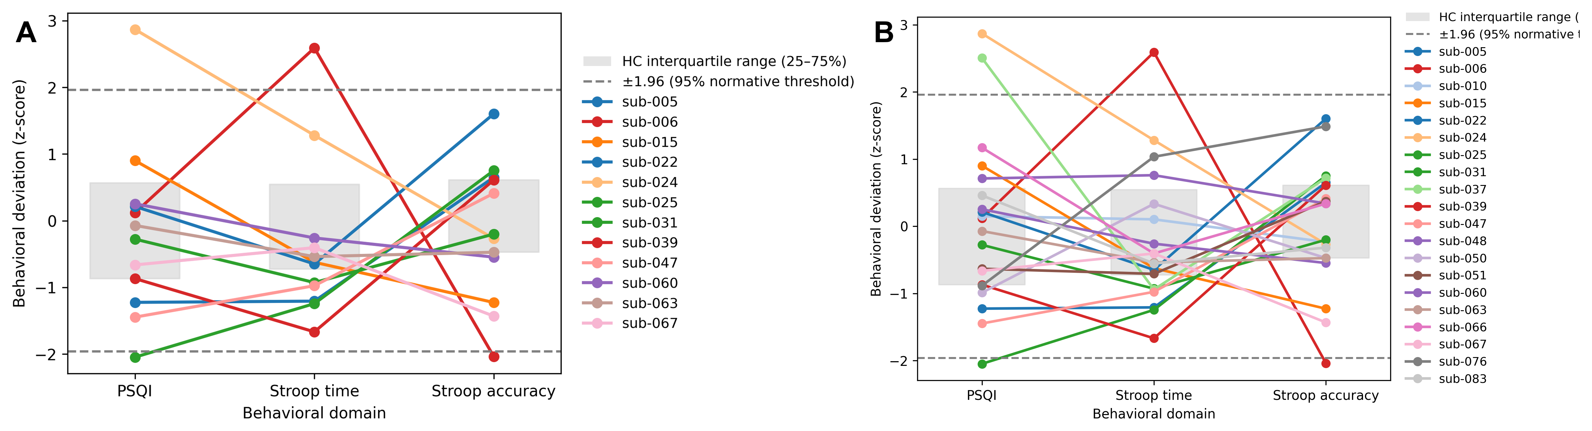
Figure S2. Behavioral deviation profiles for participants exceeding P85 (panel A) and P75 (panel B) thresholds. Profiles are shown as z-scored deviations across PSQI, Stroop time, and Stroop accuracy; grey boxes denote the interquartile range of the median-range of the cohort and dashed lines indicate ±1.96.

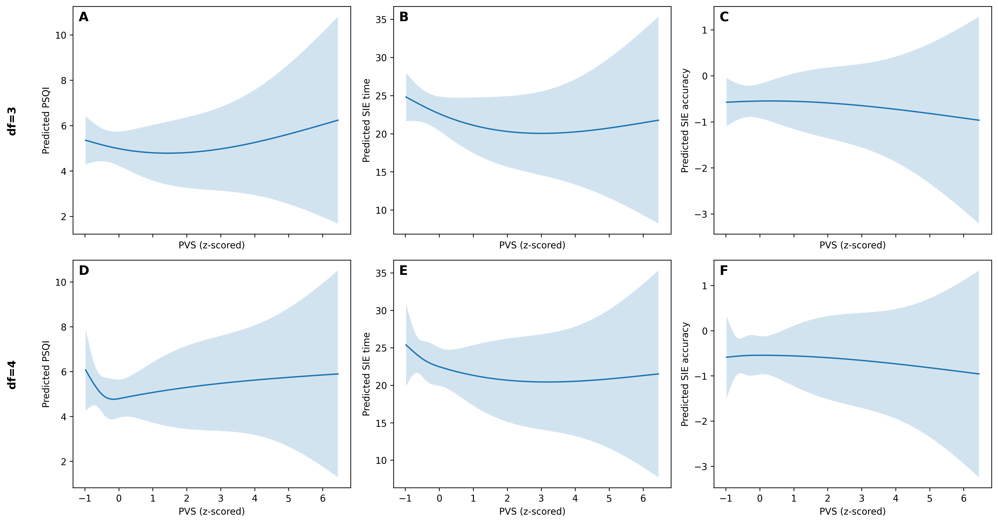
Figure S3. Natural cubic spline fits for PVS-behavior associations. Top row (A-C) shows df=3 spline models (primary); bottom row (D-F) shows df=4 spline models (sensitivity). Lines indicate predicted outcome values across the observed range of PVS (z-scored), holding covariates constant (age at the sample mean; sex at the modal category). Shaded bands indicate 95% confidence intervals.

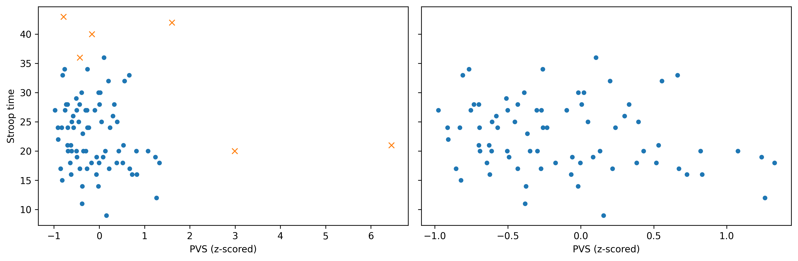
Figure S4. Influential-point sensitivity for Stroop time. Scatterplots show Stroop time versus PVS (z-scored) with fitted OLS lines before (left) and after (right) removal of observations flagged by Cook's distance and/or leverage criteria.

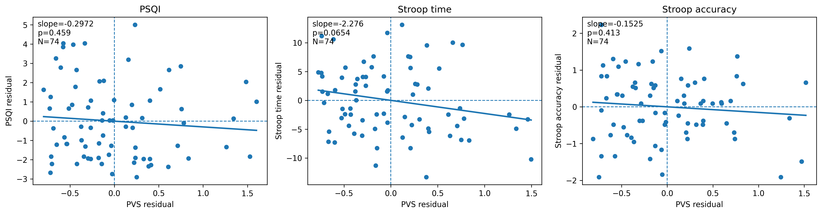
Figure S5. Deleted influential-point associations. Added-variable style visualizations after removing flagged observations, illustrating how estimated associations change relative to the full-sample models.

