Supplementary Information

S1. Additional TG–DTG processing equations

S1.1. Linear heating and TG normalisation
The programmed non-isothermal heating rate was defined as follows (Tu et al., 2019):
 | $$β = \frac{dT}{dt}$$ | (S1)
Each TG curve was normalised independently to its first valid paired temperature–mass datum using the expression reported by Conesa and Domene (2011):
 | $$w = \frac{m}{m_{0}}$$ | (S2)
Here, w(T) is the dimensionless mass fraction, m(T) is the instantaneous mass, and m₀ is the first valid mass of the corresponding run. Percentage mass remaining was reported as 100w.

S1.2. DTG definitions and stage-wise mass loss
To distinguish the derivative per unit time from the derivative per unit temperature, the following operational definitions were used:
 | $${DTG}_{t}(T) = -\frac{d[100w(T)]}{dt}$$ | (S3a)
 | $${DTG}_{T}(T) = -\frac{d[100w(T)]}{dT}$$ | (S3b)
 | $${DTG}_{t}(T) = β{DTG}_{T}(T)$$ | (S3c)
DTGₜ is expressed in % min⁻¹ and DTG_{T} in % °C⁻¹. The supplied rosehip DTG data were verified as time-based rates; therefore, reported peak heights were not divided by β.
For the diagnostic profile at 20 °C min⁻¹, the mass losses in the study-defined intervals ending at 150, 400, and 700 °C, together with the residue at 700 °C, were calculated by direct subtraction of cumulative mass-loss values:
 | $${ΔW}_{I} = W(150 °C) - W(T_{0})$$ | (S4a)
 | $${ΔW}_{II} = W(400 °C) - W(150 °C)$$ | (S4b)
 | $${ΔW}_{III} = W(700 °C) - W(400 °C)$$ | (S4c)
 | $$R_{700} = 100\% - W(700 °C)$$ | (S4d)
In Eqs. (S4a)–(S4d), T₀ is the first valid temperature, ΔW is the interval mass loss, and R₇₀₀ is the mass remaining at 700 °C. The analytical boundaries follow the diagnostic comparison used for fractionated food-processing residues and are not universal constituent boundaries (Soomro et al., 2026).

S1.3. Interpolation and non-isothermal conversion rate
Characteristic mass-loss temperatures and conversion temperatures were obtained from the first pair of measurements bracketing the target by two-point linear interpolation (Wang et al., 2026; de Castro et al., 2026):
 | $$T_C = T₁ + \frac{P_S - P₁}{P₂ - P₁}(T₂ - T₁)$$ | (S5)

The non-isothermal conversion-rate relationship was written as reported by Liu et al. (2019):
 | $$\frac{dα}{dt} = (\frac{dα}{dT})(\frac{dT}{dt}) = β\frac{dα}{dT}$$ | (S6)

S2. Additional DTG peak-domain and Gaussian diagnostics

S2.1. Across-rate variability and conditional Kissinger analysis
Descriptive dispersion across the four programmed heating rates was summarised using the coefficient of variation (Mishra et al., 2019), with thermal-analysis precedent provided by Müller et al. (2020):
 | $$CV(\%) = 100 \frac{s_{x}}{\bar{x}}$$ | (S7)
The coefficient of variation was used only as a descriptive measure because heating rates were experimental conditions rather than replicate measurements.
For a persistent peak domain represented unambiguously at all four heating rates, the secondary Kissinger peak-shift diagnostic was evaluated using the following relation (Kissinger, 1956):
 | $$ln(\frac{β}{{T_{p}}^{2}}) = -\frac{E_{K,p}}{R T_{p}} + C$$ | (S8)
The slope of ln(β/Tₚ²) against 1/Tₚ equals −E_K,p/R. The estimate was retained only when peak identity and ordering were preserved and R² ≥ 0.95; it was not treated as evidence of single-step kinetics (Vyazovkin, 2020).

S2.2. Gaussian area, width, residuals, and information criteria
For the area-normalised Gaussian parameterisation used in the conditional DTG decomposition, the component-area identity was (Singh et al., 2023):
 | $$∫_{-∞}^{∞} G_{j}(T) dT = A_{j}$$ | (S9)
When the fitted ordinate was DTGₜ, Aⱼ retained units of %·°C·min⁻¹ and was not interpreted directly as percentage mass loss.
For a retained symmetric Gaussian component, full width at half maximum was calculated as (Li et al., 1999):
 | $${FWHM}_{j} = 2{(2 ln 2)}^{1/2} σ_{j}$$ | (S10)
Pointwise DTG residuals were defined as observed minus fitted values at the same temperature (Kim, 2019):
 | $$e_{i} = y_{i} - ŷ_{i}$$ | (S11)
Candidate Gaussian component numbers were compared using the finite-sample corrected Akaike information criterion and the Bayesian information criterion in the locked least-squares forms (Burnham and Anderson, 2004):
 | $${AIC}_{c} = n ln(\frac{RSS}{n}) + 2k + \frac{2k(k+1)}{n-k-1}$$ | (S12)
 | $$BIC = n ln(\frac{RSS}{n}) + k ln n$$ | (S13)

S3. Supporting distributed-reactivity equations

S3.1. Model notation, active-interval normalisation, and activation-energy density
For a standalone specification of the distributed-reactivity calculations, the feedstock index, complete heating-rate set, parameter vector, model-start temperature, parameter constraints, and ordered distribution centres were defined as follows:
$$r∈\{seed, skin, whole fruit\}.$$
$$B=\{5,10,15,20\} K min^{-1}.$$
$$θ_{r,K}={\left\{A_{rj},μ_{rj},σ_{rj},c_{rj}\right\}}_{j=1}^{K}.$$
$$T_{0}=423.15 K={150}^{∘}C.$$
$$A_{rj}>0, σ_{rj}>0, c_{rj}≥0, \sum_{j=1}^{K}{c_{rj}}≤1,$$
$$μ_{r1}<μ_{r2}<⋯<μ_{rK}.$$
These are study-defined model specifications. They identify the fitted parameter space and prevent label switching; they do not assign the formal domains to anatomical tissues or individual biomass constituents.
Within the distributed-reactivity analysis only, measured mass was normalised to the value at the 150 °C model boundary so that the observed and predicted trajectories began from unity. This active-interval adaptation follows the post-drying normalisation principle described by Várhegyi et al. (2011):
 | $$m_{r,β}^{obs}\left(T\right)=\frac{M_{r,β}\left(T\right)}{M_{r,β}\left(T_{0}\right)}.$$ | (S14)
The activation-energy distribution within each formal reactivity domain was represented by the locked non-negative normalised Gaussian density, based on the Gaussian form reported by Mani et al. (2009) and the distributed-energy formulation of Várhegyi et al. (2011):
 | $$D_{rj}\left(E\right)=\frac{exp​\left[-\frac{{\left(E-μ_{rj}\right)}^{2}}{2σ_{rj}^{2}}\right]}{\int_{0}^{∞}{exp}​\left[-\frac{{\left(u-μ_{rj}\right)}^{2}}{2σ_{rj}^{2}}\right]du}, E≥0.$$  $$\int_{0}^{∞}{D_{rj}}\left(E\right) dE=1.$$ | (S15)
The fitted distributions describe formal regions of apparent thermal reactivity and were not interpreted as anatomical or chemical fractions.

S3.2. Predicted DTG and fit diagnostics
Predicted DTG was derived from the fitted normalised-mass trajectory as a positive time-based percentage mass-loss rate (Várhegyi et al., 2011):
 | $${\hat{DTG}}_{r,β}\left(T\right)=-100 β \frac{d{\hat{m}}_{r,β}\left(T\right)}{dT}.$$ | (S16)
Predicted DTG was used as a derivative-based diagnostic after fitting TG and was not assigned equal weight in the primary optimisation.
Global fit quality was reported as the root-mean-square discrepancy in normalised-mass percentage points using the structurally adapted metric based on Várhegyi et al. (2011):
 | $${RMSE}_{r,K}^{global}=100\sqrt{J_{r,K}​\left({\hat{θ}}_{r,K}\right)}.$$  RMSEr,Kglobal=1001Bfitβ∈Bfit​1Nr,βi=1Nr,βmr,βobsTi-mr,β​Ti;θr,K21/2. | (S17)
Signed pointwise TG residuals were retained to identify temperature-dependent underprediction and overprediction. The residual identity follows the observed-minus-predicted difference contained in the global fitting framework of Várhegyi et al. (2011):
 | $$e_{r,β,K}^{global}\left(T_{i}\right)=100\left[m_{r,β}^{obs}\left(T_{i}\right)-{\hat{m}}_{r,β}​\left(T_{i};{\hat{θ}}_{r,K}\right)\right].$$ | (S18)
Residuals were interpreted as deterministic model–data discrepancies rather than replicate errors.

S4. Supporting equations for analytical-support-screened isoconversional analysis
The four activation-energy estimators are reported in the main methodology. The equations below document the secondary calculations used to quantify regression precision, agreement among methods, and pointwise regression diagnostics.

S4.1. Regression-slope uncertainty and activation-energy precision
For each conversion level α and isoconversional method, the ordinary-least-squares standard error of the fitted slope was calculated from the regression residuals (Kim, 2019):
 | $$SE\left(m_{α}\right)=\sqrt{\frac{\sum_{i=1}^{n}{{\left(y_{α,i}-{\hat{y}}_{α,i}\right)}^{2}}}{\left(n-2\right)\sum_{i=1}^{n}{{\left(x_{α,i}-{\overset{‾}{x}}_{α}\right)}^{2}}}}$$ | (S19)
The slope uncertainty was propagated to the apparent activation-energy standard error using the method-specific slope factors. These factors follow Friedman Eq. (5), KAS Eq. (10), FWO Eq. (27), and Starink Eq. (29) in Starink (2003):
 | $$SE\left(E_{a,α}\right)=\left\{\begin{matrix}R SE\left(m_{α}\right), & \text{Friedman and KAS} \\ \frac{R SE\left(m_{α}\right)}{1.0518}, & \text{FWO} \\ \frac{R SE\left(m_{α}\right)}{1.0008}, & \text{Starink}\end{matrix}\right.$$ | (S20)
Pointwise 95% confidence intervals were calculated as:
 | $$CI_{95\%}\left(E_{a,α}\right)=E_{a,α}±t_{0.975,n-2} SE\left(E_{a,α}\right)$$ | (S21)
Here, n is the number of heating rates used in the fixed-conversion regression. For the present four-rate analysis, n = 4 and the regression degrees of freedom were n − 2 = 2. The error bars in the principal Eₐ(α) figure represent ±SE(Eₐ), whereas the wider 95% confidence intervals are reported in the supplementary tables.

S4.2. Integral-method agreement and regression diagnostics
Agreement among KAS, FWO, and Starink at each conversion level was summarised using the integral-method mean, sample standard deviation, and coefficient of variation (Mishra et al., 2019; Müller et al., 2020):
 | $${\overset{‾}{E}}_{a,α,int}=\frac{E_{a,α,KAS}+E_{a,α,FWO}+E_{a,α,St}}{3}$$ | (S22)
 | $$SD_{a,α,int}=\sqrt{\frac{\sum_{j=1}^{3}{{\left(E_{a,α,j}-{\overset{‾}{E}}_{a,α,int}\right)}^{2}}}{3-1}}$$ | (S23)
 | $$CV_{a,α,int}=100\frac{SD_{a,α,int}}{{\overset{‾}{E}}_{a,α,int}}$$ | (S24)
The relative deviation of Friedman from the integral-method mean was calculated as:
 | $$D_{α,Fr}=100\frac{\left|E_{a,α,Fr}-{\overset{‾}{E}}_{a,α,int}\right|}{{\overset{‾}{E}}_{a,α,int}}$$ | (S25)
For descriptive cross-method reporting only, the four-method mean was calculated as:
 | $${\overset{‾}{E}}_{a,α,4}=\frac{E_{a,α,Fr}+E_{a,α,KAS}+E_{a,α,FWO}+E_{a,α,St}}{4}$$ | (S26)
Regression RMSE and the maximum absolute regression residual were retained as pointwise linearity diagnostics (Kim, 2019):
 | $$RMSE_{α,M}=\sqrt{\frac{1}{n}\sum_{i=1}^{n}{{\left(y_{α,i,M}-{\hat{y}}_{α,i,M}\right)}^{2}}}$$ | (S27)
 | $$e_{max,α,M}=\max_{i}\left|y_{α,i,M}-{\hat{y}}_{α,i,M}\right|$$ | (S28)

S5. Supporting equations for endpoint-sensitivity analysis

S5.1. Endpoint-sensitivity equations
Fixed-conversion temperature by first-bracket interpolation
For each target conversion, the first adjacent observations satisfying $α_{1,β}^{\left(T_{f}\right)}≤α≤α_{2,β}^{\left(T_{f}\right)}$ were identified, and the endpoint-conditioned fixed-conversion temperature was calculated as
$T_{α,β}^{\left(T_{f}\right)}=T_{1}+\frac{α-α_{1,β}^{\left(T_{f}\right)}}{α_{2,β}^{\left(T_{f}\right)}-α_{1,β}^{\left(T_{f}\right)}}\left(T_{2}-T_{1}\right).$ | (S29)
where $T_{1}$ and $T_{2}$ are the temperatures bracketing the target conversion. Equation (S29) is the standard two-point linear-interpolation relation. The first forward bracket was used, and extrapolation was not permitted.
Study-defined endpoint-sensitivity diagnostics
The signed change in apparent activation energy relative to the adopted 700 °C basis was calculated as
$${ΔE}_{a,k}^{\left(T_{f}\right)}\left(α\right)=E_{a,k}^{\left(T_{f}\right)}\left(α\right)-E_{a,k}^{\left(700\right)}\left(α\right).$$ | (S30)
The corresponding absolute relative deviation was calculated as
$${δE}_{a,k}^{\left(T_{f}\right)}\left(α\right)=100\frac{\left|E_{a,k}^{\left(T_{f}\right)}\left(α\right)-E_{a,k}^{\left(700\right)}\left(α\right)\right|}{E_{a,k}^{\left(700\right)}\left(α\right)}.$$ | (S31)
The complete pointwise spread across the three terminal-temperature definitions was calculated as
$$R_{E,k}\left(α\right)=\max_{T_{f}∈\{600,650,700\}}E_{a,k}^{\left(T_{f}\right)}\left(α\right)-\min_{T_{f}∈\{600,650,700\}}E_{a,k}^{\left(T_{f}\right)}\left(α\right).$$ | (S32)
In Eqs. (S30)–(S32), $k$ denotes Friedman, KAS, FWO, Starink, or the integral-method mean. Positive ${ΔE}_{a}$ values indicate estimates above the adopted 700 °C result, whereas ${δE}_{a}$ reports only the magnitude of the relative deviation and is expressed as a percentage.
Endpoint mass retention and cross-heating-rate spread
Normalized mass remaining at a selected endpoint was obtained by extending the manuscript definition of normalized residual mass:
$$R_{T_{f},β}=100w_{β}\left(T_{f}\right)=100\frac{m_{β}\left(T_{f}\right)}{m_{0,β}}.$$ | (S33)
The cross-heating-rate spread in endpoint mass retention was then defined as
$$S_{R}\left(T_{f}\right)=\max_{β∈\{5,10,15,20\}}R_{T_{f},β}-\min_{β∈\{5,10,15,20\}}R_{T_{f},β}.$$ | (S34)
Here, $m_{0,β}$ is the first valid mass of the corresponding run, and $w_{β}\left(T\right)$ is the normalized mass fraction already defined in the manuscript. Equation (S33) generalizes $R_{700,β}$ to the selected endpoints of 600 and 650 °C, and Eq. (S34) is a study-defined range descriptor over $β∈\{5,10,15,20\}$ °C min⁻¹.
Principal-window endpoint summary
For feedstock $f$ and endpoint $T_{f}$, the descriptive mean apparent activation energy over the retained conversion set was calculated as
$${\left\langle E_{a}\right\rangle }_{f,A_{f}}^{\left(T_{f}\right)}=\frac{1}{N_{f}}\sum_{α∈A_{f}}{{\overline{E}}_{a,f}^{\left(T_{f}\right)}\left(α\right)}, N_{f}=\left|A_{f}\right|.$$ | (S35)
where $A_{f}$ is the preparation-specific retained conversion set, $N_{f}$ is the number of included conversion levels, and ${\overline{E}}_{a,f}^{\left(T_{f}\right)}\left(α\right)$ is the arithmetic mean of the KAS, FWO, and Starink estimates at the same conversion. The discrete retained sets were $A_{seed}=\{0.10,0.20,0.30,0.40,0.50,0.60,0.70\}$, $A_{skin}=\{0.40,0.50,0.60\}$, and $A_{whole}=\{0.30,0.40,0.50,0.60\}$. All conversion levels $α=0.10,0.20,…,0.90$ were nevertheless recalculated and are reported for transparency.

S6. Supplementary information for Section 3.1.1: TG–DTG behaviour

S6.1. Supplementary tables S1–S9
Table S1. Characteristic mass-loss temperatures and principal DTG descriptors for rosehip feedstocks at 5–20 °C min⁻¹
Feedstock | β  (°C min⁻¹) | T₅%  (°C) | T₁₀%  (°C) | T₅₀%  (°C) | Tₘₐₓ  (°C) | DTGₘₐₓ  (% min⁻¹) | Resolved peaks  (n)
Rosehip seed | 5 | 180.3 | 231.2 | 342.3 | 332.0 | 3.598 | 1
Rosehip seed | 10 | 204.4 | 253.4 | 354.6 | 346.0 | 7.397 | 2
Rosehip seed | 15 | 213.6 | 257.6 | 363.4 | 354.0 | 10.310 | 1
Rosehip seed | 20 | 228.0 | 268.9 | 368.3 | 360.0 | 14.060 | 1
Rosehip skin | 5 | 141.8 | 165.5 | 351.4 | 173.0 | 1.516 | 2
Rosehip skin | 10 | 153.8 | 180.3 | 368.1 | 209.0 | 2.840 | 3
Rosehip skin | 15 | 162.6 | 185.7 | 372.1 | 198.0 | 5.187 | 2
Rosehip skin | 20 | 175.1 | 197.9 | 372.3 | 223.0 | 6.975 | 3
Whole-fruit rosehip | 5 | 116.0 | 164.5 | 338.6 | 334.0 | 1.886 | 2
Whole-fruit rosehip | 10 | 128.3 | 178.8 | 349.7 | 341.0 | 3.640 | 2
Whole-fruit rosehip | 15 | 133.4 | 189.9 | 357.9 | 352.0 | 5.966 | 2
Whole-fruit rosehip | 20 | 136.9 | 193.9 | 355.6 | 351.0 | 7.871 | 2
Note. T₅%, T₁₀%, and T₅₀% are temperatures at 5%, 10%, and 50% cumulative loss of the initial mass, obtained by first-bracket linear interpolation. Tₘₐₓ is the raw experimental temperature of the largest eligible DTGₜ maximum. DTGₘₐₓ is reported in % min⁻¹.
Table S2. Stage-wise mass loss and residue at 700 °C for the diagnostic comparison at 20 °C min⁻¹
Feedstock | Stage I loss  (%) | Stage II loss  (%) | Stage III loss  (%) | R₇₀₀  (%) | Bookkeeping closure  (%) | Closure error  (pp)
Rosehip seed | 2.03 | 56.85 | 18.21 | 22.91 | 100.00 | 0.000
Rosehip skin | 1.78 | 50.95 | 17.30 | 29.97 | 100.00 | 0.000
Whole-fruit rosehip | 5.70 | 53.27 | 20.10 | 20.93 | 100.00 | 0.000
Note. Stage boundaries are study-defined diagnostic intervals: first valid temperature–150 °C, 150–400 °C, and 400–700 °C. Closure was calculated as Stage I + Stage II + Stage III + R₇₀₀. Exact closure is a bookkeeping identity obtained from partitioning the same normalised curve; it is not an independent test of calibration or reproducibility.
Table S3. Resolved principal and secondary DTG peaks across feedstocks and heating rates
Feedstock | β  (°C min⁻¹) | Peak type | Peak T  (°C) | Raw DTGₜ  (% min⁻¹) | Smoothed DTGₜ  (% min⁻¹) | Prominence  (% min⁻¹)
Rosehip seed | 5 | Principal | 332.0 | 3.598 | 3.551 | 3.449
Rosehip seed | 10 | Secondary | 278.0 | 3.614 | 3.614 | 0.292
Rosehip seed | 10 | Principal | 346.0 | 7.397 | 7.328 | 7.111
Rosehip seed | 15 | Principal | 354.0 | 10.310 | 10.233 | 9.858
Rosehip seed | 20 | Principal | 360.0 | 14.060 | 13.992 | 13.476
Rosehip skin | 5 | Principal | 173.0 | 1.516 | 1.512 | 1.343
Rosehip skin | 5 | Secondary | 310.0 | 1.440 | 1.432 | 0.505
Rosehip skin | 10 | Principal | 211.0 | 2.836 | 2.837 | 2.584
Rosehip skin | 10 | Secondary | 318.0 | 2.830 | 2.829 | 0.874
Rosehip skin | 10 | Secondary | 444.0 | 0.935 | 0.931 | 0.132
Rosehip skin | 15 | Principal | 198.0 | 5.187 | 5.177 | 4.789
Rosehip skin | 15 | Secondary | 328.0 | 3.888 | 3.869 | 1.127
Rosehip skin | 20 | Principal | 222.0 | 6.972 | 6.975 | 6.423
Rosehip skin | 20 | Secondary | 335.0 | 5.857 | 5.832 | 1.841
Rosehip skin | 20 | Secondary | 456.0 | 1.907 | 1.900 | 0.340
Whole-fruit rosehip | 5 | Secondary | 174.0 | 0.973 | 0.971 | 0.140
Whole-fruit rosehip | 5 | Principal | 333.0 | 1.884 | 1.877 | 1.667
Whole-fruit rosehip | 10 | Secondary | 214.0 | 2.014 | 2.015 | 0.350
Whole-fruit rosehip | 10 | Principal | 341.0 | 3.640 | 3.638 | 3.180
Whole-fruit rosehip | 15 | Secondary | 222.0 | 2.964 | 2.960 | 0.529
Whole-fruit rosehip | 15 | Principal | 352.0 | 5.966 | 5.953 | 5.276
Whole-fruit rosehip | 20 | Secondary | 225.0 | 4.281 | 4.280 | 0.793
Whole-fruit rosehip | 20 | Principal | 351.0 | 7.871 | 7.875 | 6.894
Note. Peak positions were identified from the Savitzky–Golay-smoothed DTGₜ signal, and the raw DTGₜ value at the detected temperature was retained as the reported peak height. A detected peak temperature can therefore differ slightly from the raw experimental Tₘₐₓ in Table S1. Principal and secondary labels are descriptive; competing and recurring peaks are classified in Table S10.
Table S4. Heating-rate shifts in characteristic and principal-peak temperatures between 5 and 20 °C min⁻¹
Feedstock | T₅%, 5 | T₅%, 20 | ΔT₅% | T₁₀%, 5 | T₁₀%, 20 | ΔT₁₀% | T₅₀%, 5 | T₅₀%, 20 | ΔT₅₀% | Tₘₐₓ, 5 | Tₘₐₓ, 20 | ΔTₘₐₓ
Rosehip seed | 180.3 | 228.0 | 47.7 | 231.2 | 268.9 | 37.7 | 342.3 | 368.3 | 26.0 | 332.0 | 360.0 | 28.0
Rosehip skin | 141.8 | 175.1 | 33.4 | 165.5 | 197.9 | 32.4 | 351.4 | 372.3 | 20.9 | 173.0 | 223.0 | 50.0
Whole-fruit rosehip | 116.0 | 136.9 | 20.9 | 164.5 | 193.9 | 29.4 | 338.6 | 355.6 | 17.0 | 334.0 | 351.0 | 17.0
Note. All temperature entries are in °C. Δ values equal the full-precision value at 20 °C min⁻¹ minus that at 5 °C min⁻¹; displayed operands are rounded. For rosehip skin, ΔTₘₐₓ reflects a change in the automatically assigned dominant maximum and should not be interpreted as migration of one homologous reaction peak because competing peaks exchange relative dominance.
Table S5. Across-rate variation in residue at 700 °C
Feedstock | Minimum R₇₀₀  (%) | Maximum R₇₀₀  (%) | Range  (pp)
Rosehip seed | 22.91 | 26.79 | 3.88
Rosehip skin | 29.36 | 33.47 | 4.11
Whole-fruit rosehip | 20.93 | 29.44 | 8.51
Note. The predefined screening threshold for the across-rate R₇₀₀ range was 5.0 percentage points. The whole-fruit range exceeded this threshold and therefore requires replicate and sample-homogeneity verification before it is attributed solely to heating rate.
Table S6. Conversion-temperature matrix for the selected analytical interval of 150–700 °C
Feedstock | β  (°C min⁻¹) | Tα=0.10  (°C) | Tα=0.20  (°C) | Tα=0.30  (°C) | Tα=0.40  (°C) | Tα=0.50  (°C) | Tα=0.60  (°C) | Tα=0.70  (°C) | Tα=0.80  (°C) | Tα=0.90  (°C)
Rosehip seed | 5 | 236.4 | 264.2 | 287.2 | 308.8 | 324.4 | 335.1 | 351.5 | 389.9 | 451.0
Rosehip seed | 10 | 254.7 | 278.2 | 299.1 | 320.7 | 336.6 | 347.1 | 359.6 | 396.7 | 467.8
Rosehip seed | 15 | 257.0 | 283.4 | 305.6 | 328.3 | 345.4 | 356.9 | 373.0 | 417.1 | 510.9
Rosehip seed | 20 | 266.5 | 292.7 | 314.4 | 336.2 | 352.2 | 363.5 | 379.5 | 419.5 | 512.9
Rosehip skin | 5 | 174.0 | 197.4 | 223.8 | 257.0 | 286.4 | 310.5 | 340.7 | 400.1 | 481.4
Rosehip skin | 10 | 183.0 | 206.7 | 231.3 | 263.7 | 293.5 | 318.6 | 350.9 | 413.4 | 493.0
Rosehip skin | 15 | 185.5 | 206.7 | 230.9 | 266.6 | 302.4 | 332.0 | 376.0 | 450.4 | 531.0
Rosehip skin | 20 | 192.8 | 215.2 | 236.4 | 268.2 | 302.8 | 331.8 | 368.2 | 445.4 | 529.0
Whole-fruit rosehip | 5 | 187.7 | 225.0 | 258.4 | 284.4 | 307.0 | 326.3 | 345.0 | 391.5 | 469.1
Whole-fruit rosehip | 10 | 194.4 | 228.7 | 264.7 | 291.3 | 315.0 | 334.8 | 354.3 | 402.9 | 485.3
Whole-fruit rosehip | 15 | 203.5 | 239.7 | 275.8 | 302.1 | 325.7 | 344.9 | 362.6 | 399.0 | 463.7
Whole-fruit rosehip | 20 | 210.4 | 248.2 | 284.5 | 311.1 | 335.0 | 354.9 | 384.1 | 458.0 | 547.1
Note. Tα is the temperature at fractional conversion α defined by manuscript Eq. (2), with m₁₅₀ and m₇₀₀ as the rate-specific masses at 150 and 700 °C. Values were obtained from the first bracketing α(T) pair by Eq. (S5), without extrapolation. All rows increase monotonically from α = 0.10 to 0.90.
Table S7. Comparison between T₅₀% and Tα=0.50
Feedstock | β  (°C min⁻¹) | T₅₀%  (°C) | Tα=0.50  (°C) | Tα=0.50 − T₅₀%  (°C)
Rosehip seed | 5 | 342.3 | 324.4 | -18.0
Rosehip seed | 10 | 354.6 | 336.6 | -18.1
Rosehip seed | 15 | 363.4 | 345.4 | -18.1
Rosehip seed | 20 | 368.3 | 352.2 | -16.1
Rosehip skin | 5 | 351.4 | 286.4 | -65.0
Rosehip skin | 10 | 368.1 | 293.5 | -74.6
Rosehip skin | 15 | 372.1 | 302.4 | -69.7
Rosehip skin | 20 | 372.3 | 302.8 | -69.5
Whole-fruit rosehip | 5 | 338.6 | 307.0 | -31.6
Whole-fruit rosehip | 10 | 349.7 | 315.0 | -34.7
Whole-fruit rosehip | 15 | 357.9 | 325.7 | -32.2
Whole-fruit rosehip | 20 | 355.6 | 335.0 | -20.6
Table S8. Run-level quality-control summary
Feedstock | β | Valid end T  (°C) | Initial mass gain  (%) | Loss decreases  (n) | Detected peaks  (n) | DTG–TG derivative  r | DTG integral difference  (pp) | Closure error  (pp)
Rosehip seed | 5 | 788 | 0.40 | 4 | 1 | 0.9999 | 2.09 | 0.000
Rosehip seed | 10 | 785 | 0.30 | 3 | 2 | 0.9999 | 2.38 | 0.000
Rosehip seed | 15 | 783 | 1.00 | 9 | 1 | 0.9998 | 2.47 | 0.000
Rosehip seed | 20 | 781 | 1.20 | 11 | 1 | 0.9998 | 2.76 | 0.000
Rosehip skin | 5 | 788 | 1.30 | 9 | 2 | 0.9996 | 1.93 | 0.000
Rosehip skin | 10 | 785 | 0.80 | 7 | 3 | 0.9997 | 2.26 | 0.000
Rosehip skin | 15 | 783 | 1.70 | 14 | 2 | 0.9988 | 2.47 | 0.000
Rosehip skin | 20 | 781 | 1.30 | 11 | 3 | 0.9983 | 2.71 | 0.000
Whole-fruit rosehip | 5 | 788 | 0.20 | 2 | 2 | 0.9997 | 1.32 | 0.000
Whole-fruit rosehip | 10 | 785 | 0.20 | 2 | 2 | 0.9997 | 1.78 | 0.000
Whole-fruit rosehip | 15 | 783 | 0.30 | 3 | 2 | 0.9997 | 1.92 | 0.000
Whole-fruit rosehip | 20 | 781 | 0.50 | 5 | 2 | 0.9993 | 2.30 | 0.000

Table S9. Numerical diagnostics for the conversion coordinate and conversion-rate relation.
Feedstock | β  (°C min⁻¹) | Eq. (S6) max |difference|  (min⁻¹) | Eq. (S6) vs DTG RMSE  (min⁻¹) | Processed α < 0  (n) | Processed α > 1  (n)
Rosehip seed | 5 | 8.33e-16 | 0.000630 | 0 | 0
Rosehip seed | 10 | 2.33e-15 | 0.001298 | 0 | 0
Rosehip seed | 15 | 2.94e-15 | 0.001820 | 0 | 0
Rosehip seed | 20 | 4.44e-15 | 0.002385 | 0 | 0
Rosehip skin | 5 | 6.11e-16 | 0.000540 | 0 | 0
Rosehip skin | 10 | 1.22e-15 | 0.001084 | 0 | 0
Rosehip skin | 15 | 1.55e-15 | 0.001580 | 0 | 0
Rosehip skin | 20 | 2.44e-15 | 0.002234 | 0 | 0
Whole-fruit rosehip | 5 | 6.66e-16 | 0.000555 | 0 | 0
Whole-fruit rosehip | 10 | 1.44e-15 | 0.001116 | 0 | 0
Whole-fruit rosehip | 15 | 2.61e-15 | 0.001670 | 0 | 0
Whole-fruit rosehip | 20 | 2.89e-15 | 0.002138 | 0 | 0
N

S6.2. Supplementary figure S1
Figure S1. Conversion and conversion-rate profiles calculated over 150–700 °C using manuscript Eq. (2) and Supplementary Eq. (S6).
Note. Panels (a,b), (c,d), and (e,f) correspond to rosehip seed, rosehip skin, and whole-fruit rosehip, respectively. Left panels show α(T), with α = 0 at 150 °C and α = 1 at 700 °C by construction. Right panels show dα/dt in min⁻¹ calculated from Eq. (S6). The conversion-rate curves are interval-normalised kinetic descriptors and are not numerically identical to the raw DTGₜ curves in % min⁻¹.

S7. Supplementary information for Section 3.1.2: DTG feature analysis and peak-domain metrics

S7.1. Supplementary tables S10–S14
Table S10. Direct DTG peaks and cross-heating-rate persistence classification for rosehip feedstocks.
Feedstock | β  (°C min⁻¹) | Tₚ  (°C) | Hₚ  (% min⁻¹) | Prominence  (% min⁻¹) | Peak identity | Classification
Rosehip seed | 5 | 332 | 3.598 | 2.944 | Persistent peak 1 | Principal persistent
Rosehip seed | 10 | 278 | 3.614 | 0.292 | — | Non-persistent shoulder
Rosehip seed | 10 | 346 | 7.397 | 6.099 | Persistent peak 1 | Principal persistent
Rosehip seed | 15 | 354 | 10.310 | 8.186 | Persistent peak 1 | Principal persistent
Rosehip seed | 20 | 360 | 14.060 | 10.871 | Persistent peak 1 | Principal persistent
Rosehip skin | 5 | 173 | 1.516 | 1.101 | Lower-temperature peak | Principal persistent
Rosehip skin | 5 | 310 | 1.440 | 0.505 | Higher-temperature peak | Secondary persistent
Rosehip skin | 10 | 211 | 2.836 | 2.039 | Lower-temperature peak | Principal persistent
Rosehip skin | 10 | 318 | 2.830 | 0.874 | Higher-temperature peak | Secondary persistent
Rosehip skin | 15 | 198 | 5.187 | 3.848 | Lower-temperature peak | Principal persistent
Rosehip skin | 15 | 328 | 3.888 | 1.127 | Higher-temperature peak | Secondary persistent
Rosehip skin | 20 | 222 | 6.972 | 5.384 | Lower-temperature peak | Principal persistent
Rosehip skin | 20 | 335 | 5.857 | 1.841 | Higher-temperature peak | Secondary persistent
Whole-fruit rosehip | 5 | 174 | 0.973 | 0.140 | Lower-temperature peak | Secondary persistent
Whole-fruit rosehip | 5 | 333 | 1.884 | 1.429 | Higher-temperature peak | Principal persistent
Whole-fruit rosehip | 10 | 214 | 2.014 | 0.350 | Lower-temperature peak | Secondary persistent
Whole-fruit rosehip | 10 | 341 | 3.640 | 2.734 | Higher-temperature peak | Principal persistent
Whole-fruit rosehip | 15 | 222 | 2.964 | 0.529 | Lower-temperature peak | Secondary persistent
Whole-fruit rosehip | 15 | 352 | 5.966 | 4.227 | Higher-temperature peak | Principal persistent
Whole-fruit rosehip | 20 | 225 | 4.281 | 0.793 | Lower-temperature peak | Secondary persistent
Whole-fruit rosehip | 20 | 351 | 7.871 | 5.916 | Higher-temperature peak | Principal persistent
Note. Peak positions were located from the smoothed DTGₜ signal, whereas Hₚ is the raw experimental ordinate at the detected temperature. The 100–420 °C search interval excludes later minor features from persistence classification. The seed feature at 278 °C occurred only at 10 °C min⁻¹ and is retained as a non-persistent shoulder.

Table S11. Peak-height ratios and inter-peak temperature separations for feedstocks containing two persistent DTG domains.
Feedstock | β  (°C min⁻¹) | Tₚ,₁  (°C) | Hₚ,₁  (% min⁻¹) | Tₚ,₂  (°C) | Hₚ,₂  (% min⁻¹) | RH = Hₚ,₂/Hₚ,₁  (–) | ΔTₚ  (°C)
Rosehip skin | 5 | 173 | 1.516 | 310 | 1.440 | 0.950 | 137
Rosehip skin | 10 | 211 | 2.836 | 318 | 2.830 | 0.998 | 107
Rosehip skin | 15 | 198 | 5.187 | 328 | 3.888 | 0.750 | 130
Rosehip skin | 20 | 222 | 6.972 | 335 | 5.857 | 0.840 | 113
Whole-fruit rosehip | 5 | 174 | 0.973 | 333 | 1.884 | 1.937 | 159
Whole-fruit rosehip | 10 | 214 | 2.014 | 341 | 3.640 | 1.807 | 127
Whole-fruit rosehip | 15 | 222 | 2.964 | 352 | 5.966 | 2.013 | 130
Whole-fruit rosehip | 20 | 225 | 4.281 | 351 | 7.871 | 1.839 | 126

Table S12. Descriptive variability of persistent peak-domain descriptors and two-peak metrics across 5–20 °C min⁻¹
Feedstock | Peak/metric group | Descriptor | n | Mean | Sample SD | Range | CV  (%) | CV basis
Rosehip seed | Persistent peak 1 | Tₚ (°C) | 4 | 348.00 | 12.11 | 28 | 1.95 | Kelvin mean
Rosehip seed | Persistent peak 1 | Hₚ (% min⁻¹) | 4 | 8.841 | 4.434 | 10.462 | 50.15 | Native ratio scale
Rosehip seed | Persistent peak 1 | Prominence (% min⁻¹) | 4 | 7.025 | 3.349 | 7.927 | 47.68 | Native ratio scale
Rosehip skin | Lower-temperature peak | Tₚ (°C) | 4 | 201.00 | 21.09 | 49 | 4.45 | Kelvin mean
Rosehip skin | Lower-temperature peak | Hₚ (% min⁻¹) | 4 | 4.128 | 2.429 | 5.456 | 58.85 | Native ratio scale
Rosehip skin | Lower-temperature peak | Prominence (% min⁻¹) | 4 | 3.093 | 1.906 | 4.283 | 61.62 | Native ratio scale
Rosehip skin | Higher-temperature peak | Tₚ (°C) | 4 | 322.75 | 11.00 | 25 | 1.85 | Kelvin mean
Rosehip skin | Higher-temperature peak | Hₚ (% min⁻¹) | 4 | 3.504 | 1.862 | 4.417 | 53.14 | Native ratio scale
Rosehip skin | Higher-temperature peak | Prominence (% min⁻¹) | 4 | 1.087 | 0.564 | 1.336 | 51.88 | Native ratio scale
Whole-fruit rosehip | Lower-temperature peak | Tₚ (°C) | 4 | 208.75 | 23.63 | 51 | 4.90 | Kelvin mean
Whole-fruit rosehip | Lower-temperature peak | Hₚ (% min⁻¹) | 4 | 2.558 | 1.407 | 3.308 | 55.02 | Native ratio scale
Whole-fruit rosehip | Lower-temperature peak | Prominence (% min⁻¹) | 4 | 0.453 | 0.277 | 0.653 | 61.15 | Native ratio scale
Whole-fruit rosehip | Higher-temperature peak | Tₚ (°C) | 4 | 344.25 | 9.00 | 19 | 1.46 | Kelvin mean
Whole-fruit rosehip | Higher-temperature peak | Hₚ (% min⁻¹) | 4 | 4.840 | 2.623 | 5.987 | 54.18 | Native ratio scale
Whole-fruit rosehip | Higher-temperature peak | Prominence (% min⁻¹) | 4 | 3.576 | 1.934 | 4.487 | 54.07 | Native ratio scale
Rosehip skin | Two-peak metrics | R_H (–) | 4 | 0.884 | 0.112 | 0.248 | 12.61 | Native ratio scale
Rosehip skin | Two-peak metrics | ΔTₚ (°C) | 4 | 121.75 | 14.08 | 30 | 11.56 | Temperature interval
Whole-fruit rosehip | Two-peak metrics | R_H (–) | 4 | 1.899 | 0.094 | 0.205 | 4.94 | Native ratio scale
Whole-fruit rosehip | Two-peak metrics | ΔTₚ (°C) | 4 | 135.50 | 15.76 | 33 | 11.63 | Temperature interval

Table S13. Complete Kissinger peak-shift analysis for persistent DTG domains.
Feedstock | Peak identity | Tₚ,5  (°C) | Tₚ,10  (°C) | Tₚ,15  (°C) | Tₚ,20  (°C) | E_K  (kJ mol⁻¹) | R²
Rosehip seed | Persistent peak 1 | 332 | 346 | 354 | 360 | 147.60 | 0.9998
Rosehip skin | Lower-temperature peak | 173 | 211 | 198 | 222 | 37.34 | 0.6708
Rosehip skin | Higher-temperature peak | 310 | 318 | 328 | 335 | 148.56 | 0.9619
Whole-fruit rosehip | Lower-temperature peak | 174 | 214 | 222 | 225 | 36.73 | 0.8654
Whole-fruit rosehip | Higher-temperature peak | 333 | 341 | 352 | 351 | 192.95 | 0.9221

Table S14. Run-level diagnostics for the information-criterion-selected Gaussian candidates.
Feedstock | β  (°C min⁻¹) | Selected m | AICc | BIC | |r₁| | Max residual/peak | Mean residual/peak
Rosehip skin | 5 | 3 | -1143.04 | -1105.08 | 0.9874 | 0.114 | 0.0025
Rosehip skin | 10 | 3 | -897.12 | -859.16 | 0.9891 | 0.086 | 0.0024
Rosehip skin | 15 | 3 | -614.73 | -576.77 | 0.9885 | 0.087 | 0.0003
Rosehip skin | 20 | 3 | -238.49 | -200.53 | 0.9912 | 0.091 | 0.0033
Whole-fruit rosehip | 5 | 3 | -1056.76 | -1018.80 | 0.9873 | 0.102 | 0.0028
Whole-fruit rosehip | 10 | 3 | -872.24 | -834.28 | 0.9865 | 0.065 | 0.0015
Whole-fruit rosehip | 15 | 3 | -504.84 | -466.88 | 0.9898 | 0.055 | 0.0030
Whole-fruit rosehip | 20 | 3 | -501.53 | -463.57 | 0.9886 | 0.048 | 0.0031

S7.2. Supplementary figures S2–S4
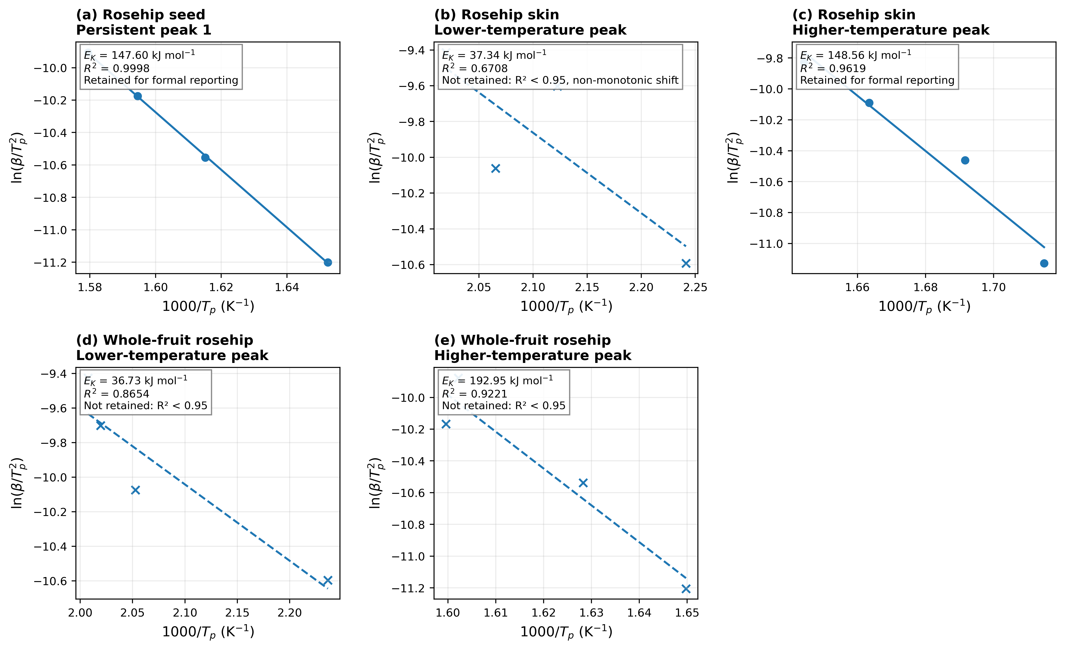
Figure S2. Complete Kissinger diagnostic set for all persistent DTG domains. Solid lines and circular markers denote the two regressions retained for formal peak-shift reporting; dashed lines and cross markers denote regressions not retained because of insufficient linearity and/or non-monotonic displacement. Non-retained apparent energies are diagnostic outputs only and are not used as principal kinetic results.

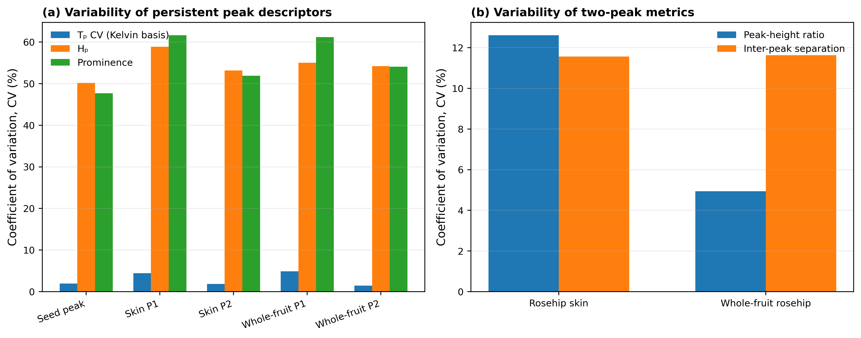
Figure S3. Descriptive coefficients of variation calculated using Eq. (S7). (a) Relative variability of persistent peak temperature, peak height, and prominence; absolute peak-temperature CVs use kelvin, while means, SDs, and ranges remain reported in °C in Table S12. (b) Variability of R_H and ΔTₚ for rosehip skin and whole-fruit rosehip. The values summarize four programmed heating rates and are not inferential measures of repeatability.

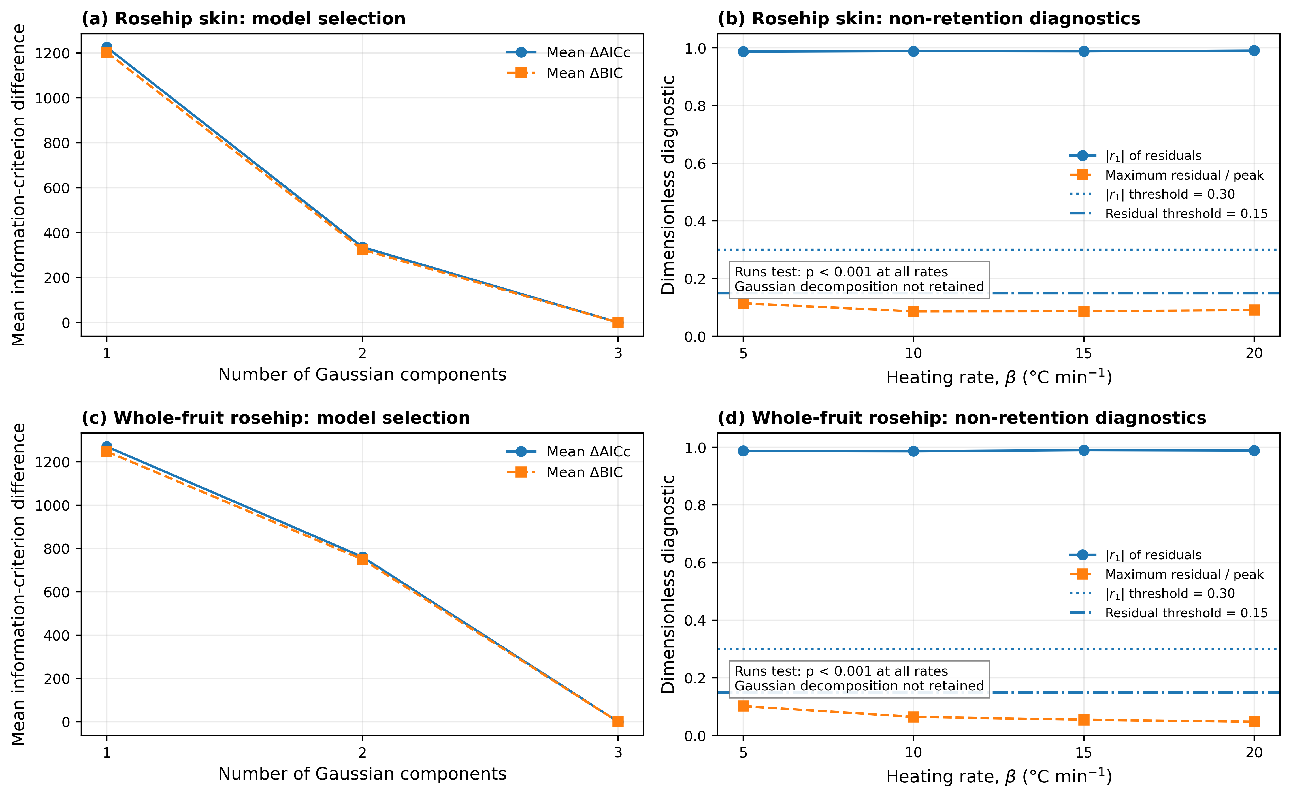
Figure S4. Gaussian-decomposition retention-decision diagnostics. Panels (a,c) show the mean AICc and BIC differences for one-, two-, and three-component candidates. Panels (b,d) show the lag-one residual correlation and maximum residual-to-peak ratio for the selected three-component models.

S8. Supplementary information for Section 3.1.3: Analytical-support-screened isoconversional analysis

S8.1. Supplementary tables S15–S22
Table S15. Input-data normalization and TG–DTG quality control.
Sample | β (K min⁻¹) | TG–DTG scale | DTG unit | DTG sign | DTG correlation | m150 | m700 | Mass loss | n TG points
Rosehip seed | 5 | 1.000000 | per_min | 1 | 0.999887 | 96.200 | 25.980 | 70.220 | 768
Rosehip seed | 10 | 0.999001 | per_min | 1 | 0.999895 | 96.743 | 26.793 | 69.950 | 765
Rosehip seed | 15 | 0.999001 | per_min | 1 | 0.999842 | 97.353 | 24.755 | 72.597 | 763
Rosehip seed | 20 | 1.000000 | per_min | 1 | 0.999810 | 97.970 | 22.910 | 75.060 | 761
Rosehip skin | 5 | 0.999001 | per_min | 1 | 0.999674 | 93.576 | 33.367 | 60.210 | 768
Rosehip skin | 10 | 0.999001 | per_min | 1 | 0.999696 | 95.534 | 33.467 | 62.068 | 765
Rosehip skin | 15 | 0.999001 | per_min | 1 | 0.999603 | 96.793 | 29.361 | 67.433 | 763
Rosehip skin | 20 | 0.999001 | per_min | 1 | 0.999603 | 98.222 | 29.970 | 68.252 | 761
Whole-fruit rosehip | 5 | 1.000000 | per_min | 1 | 0.999740 | 92.110 | 29.190 | 62.920 | 766
Whole-fruit rosehip | 10 | 0.999001 | per_min | 1 | 0.999734 | 93.546 | 29.441 | 64.106 | 763
Whole-fruit rosehip | 15 | 1.000000 | per_min | 1 | 0.999755 | 94.120 | 28.740 | 65.380 | 761
Whole-fruit rosehip | 20 | 0.999001 | per_min | 1 | 0.999391 | 94.296 | 20.929 | 73.367 | 759

Table S16. Fixed-conversion temperatures and Friedman rate inputs for all heating rates.
Sample | α | β | Tα (°C) | Tα (K) | dα/dT (K⁻¹) | βdα/dT (min⁻¹) | Relative DTG
Rosehip seed | 0.10 | 5 | 236.424 | 509.574 | 0.0025509 | 0.0127547 | 0.2489
Rosehip seed | 0.20 | 5 | 264.247 | 537.397 | 0.0045286 | 0.0226429 | 0.4419
Rosehip seed | 0.30 | 5 | 287.213 | 560.363 | 0.0045868 | 0.0229340 | 0.4476
Rosehip seed | 0.40 | 5 | 308.805 | 581.955 | 0.0054589 | 0.0272943 | 0.5327
Rosehip seed | 0.50 | 5 | 324.397 | 597.547 | 0.0085139 | 0.0425697 | 0.8308
Rosehip seed | 0.60 | 5 | 335.109 | 608.259 | 0.0098645 | 0.0493226 | 0.9626
Rosehip seed | 0.70 | 5 | 351.456 | 624.606 | 0.0036649 | 0.0183245 | 0.3576
Rosehip seed | 0.80 | 5 | 389.913 | 663.062 | 0.0023138 | 0.0115689 | 0.2258
Rosehip seed | 0.90 | 5 | 450.971 | 724.121 | 0.0009838 | 0.0049189 | 0.0960
Rosehip seed | 0.10 | 10 | 254.660 | 527.810 | 0.0030744 | 0.0307438 | 0.2910
Rosehip seed | 0.20 | 10 | 278.183 | 551.333 | 0.0051609 | 0.0516086 | 0.4885
Rosehip seed | 0.30 | 10 | 299.113 | 572.263 | 0.0048226 | 0.0482257 | 0.4565
Rosehip seed | 0.40 | 10 | 320.651 | 593.801 | 0.0052776 | 0.0527762 | 0.4996
Rosehip seed | 0.50 | 10 | 336.589 | 609.739 | 0.0084551 | 0.0845506 | 0.8004
Rosehip seed | 0.60 | 10 | 347.144 | 620.294 | 0.0104898 | 0.1048976 | 0.9930
Rosehip seed | 0.70 | 10 | 359.632 | 632.782 | 0.0054684 | 0.0546845 | 0.5176
Rosehip seed | 0.80 | 10 | 396.707 | 669.857 | 0.0021383 | 0.0213828 | 0.2024
Rosehip seed | 0.90 | 10 | 467.760 | 740.910 | 0.0008204 | 0.0082045 | 0.0777
Rosehip seed | 0.10 | 15 | 257.039 | 530.189 | 0.0025444 | 0.0381653 | 0.2690
Rosehip seed | 0.20 | 15 | 283.424 | 556.574 | 0.0048252 | 0.0723778 | 0.5102
Rosehip seed | 0.30 | 15 | 305.628 | 578.778 | 0.0045839 | 0.0687590 | 0.4846
Rosehip seed | 0.40 | 15 | 328.280 | 601.430 | 0.0049705 | 0.0745573 | 0.5255
Rosehip seed | 0.50 | 15 | 345.373 | 618.523 | 0.0078725 | 0.1180881 | 0.8323
Rosehip seed | 0.60 | 15 | 356.882 | 630.032 | 0.0092107 | 0.1381601 | 0.9738
Rosehip seed | 0.70 | 15 | 373.036 | 646.186 | 0.0037134 | 0.0557005 | 0.3926
Rosehip seed | 0.80 | 15 | 417.114 | 690.264 | 0.0019249 | 0.0288742 | 0.2035
Rosehip seed | 0.90 | 15 | 510.860 | 784.010 | 0.0008131 | 0.0121967 | 0.0860
Rosehip seed | 0.10 | 20 | 266.478 | 539.628 | 0.0026049 | 0.0520976 | 0.2781
Rosehip seed | 0.20 | 20 | 292.691 | 565.841 | 0.0048705 | 0.0974090 | 0.5200
Rosehip seed | 0.30 | 20 | 314.406 | 587.556 | 0.0047048 | 0.0940969 | 0.5023
Rosehip seed | 0.40 | 20 | 336.247 | 609.397 | 0.0052958 | 0.1059165 | 0.5654
Rosehip seed | 0.50 | 20 | 352.183 | 625.333 | 0.0082695 | 0.1653899 | 0.8829
Rosehip seed | 0.60 | 20 | 363.524 | 636.674 | 0.0090114 | 0.1802287 | 0.9622
Rosehip seed | 0.70 | 20 | 379.507 | 652.657 | 0.0040702 | 0.0814043 | 0.4346
Rosehip seed | 0.80 | 20 | 419.453 | 692.603 | 0.0020917 | 0.0418337 | 0.2233
Rosehip seed | 0.90 | 20 | 512.880 | 786.030 | 0.0007268 | 0.0145366 | 0.0776
Rosehip skin | 0.10 | 5 | 174.024 | 447.174 | 0.0050170 | 0.0250851 | 0.9973
Rosehip skin | 0.20 | 5 | 197.392 | 470.542 | 0.0041069 | 0.0205344 | 0.8164
Rosehip skin | 0.30 | 5 | 223.805 | 496.955 | 0.0033845 | 0.0169226 | 0.6728
Rosehip skin | 0.40 | 5 | 256.989 | 530.139 | 0.0032549 | 0.0162744 | 0.6470
Rosehip skin | 0.50 | 5 | 286.386 | 559.536 | 0.0039459 | 0.0197294 | 0.7844
Rosehip skin | 0.60 | 5 | 310.452 | 583.602 | 0.0047725 | 0.0238625 | 0.9487
Rosehip skin | 0.70 | 5 | 340.727 | 613.877 | 0.0025749 | 0.0128746 | 0.5118
Rosehip skin | 0.80 | 5 | 400.067 | 673.217 | 0.0014713 | 0.0073565 | 0.2925
Rosehip skin | 0.90 | 5 | 481.383 | 754.533 | 0.0009620 | 0.0048102 | 0.1912
Rosehip skin | 0.10 | 10 | 182.972 | 456.122 | 0.0042541 | 0.0425406 | 0.9307
Rosehip skin | 0.20 | 10 | 206.689 | 479.839 | 0.0045284 | 0.0452835 | 0.9907
Rosehip skin | 0.30 | 10 | 231.329 | 504.479 | 0.0035964 | 0.0359645 | 0.7868
Rosehip skin | 0.40 | 10 | 263.747 | 536.897 | 0.0032609 | 0.0326089 | 0.7134
Rosehip skin | 0.50 | 10 | 293.543 | 566.693 | 0.0038396 | 0.0383957 | 0.8400
Rosehip skin | 0.60 | 10 | 318.585 | 591.735 | 0.0045503 | 0.0455026 | 0.9954
Rosehip skin | 0.70 | 10 | 350.936 | 624.086 | 0.0022725 | 0.0227249 | 0.4971
Rosehip skin | 0.80 | 10 | 413.425 | 686.575 | 0.0013227 | 0.0132271 | 0.2894
Rosehip skin | 0.90 | 10 | 492.950 | 766.100 | 0.0010234 | 0.0102339 | 0.2239
Rosehip skin | 0.10 | 15 | 185.517 | 458.667 | 0.0043800 | 0.0656996 | 0.8550
Rosehip skin | 0.20 | 15 | 206.710 | 479.860 | 0.0048322 | 0.0724836 | 0.9433
Rosehip skin | 0.30 | 15 | 230.917 | 504.067 | 0.0037191 | 0.0557864 | 0.7260
Rosehip skin | 0.40 | 15 | 266.556 | 539.706 | 0.0027286 | 0.0409284 | 0.5326
Rosehip skin | 0.50 | 15 | 302.429 | 575.579 | 0.0032141 | 0.0482116 | 0.6274
Rosehip skin | 0.60 | 15 | 332.042 | 605.192 | 0.0037661 | 0.0564920 | 0.7351
Rosehip skin | 0.70 | 15 | 376.000 | 649.150 | 0.0015960 | 0.0239407 | 0.3115
Rosehip skin | 0.80 | 15 | 450.400 | 723.550 | 0.0014438 | 0.0216563 | 0.2818
Rosehip skin | 0.90 | 15 | 531.000 | 804.150 | 0.0009174 | 0.0137615 | 0.1791
Rosehip skin | 0.10 | 20 | 192.777 | 465.927 | 0.0039119 | 0.0782379 | 0.7663
Rosehip skin | 0.20 | 20 | 215.164 | 488.314 | 0.0050364 | 0.1007287 | 0.9866
Rosehip skin | 0.30 | 20 | 236.366 | 509.516 | 0.0043986 | 0.0879726 | 0.8617
Rosehip skin | 0.40 | 20 | 268.200 | 541.350 | 0.0029242 | 0.0584836 | 0.5728
Rosehip skin | 0.50 | 20 | 302.762 | 575.912 | 0.0032892 | 0.0657836 | 0.6443
Rosehip skin | 0.60 | 20 | 331.757 | 604.907 | 0.0041542 | 0.0830840 | 0.8138
Rosehip skin | 0.70 | 20 | 368.218 | 641.368 | 0.0017149 | 0.0342974 | 0.3359
Rosehip skin | 0.80 | 20 | 445.400 | 718.550 | 0.0013236 | 0.0264725 | 0.2593
Rosehip skin | 0.90 | 20 | 528.967 | 802.117 | 0.0008968 | 0.0179352 | 0.1757
Whole-fruit rosehip | 0.10 | 5 | 187.659 | 460.809 | 0.0028034 | 0.0140169 | 0.4676
Whole-fruit rosehip | 0.20 | 5 | 224.963 | 498.113 | 0.0026440 | 0.0132199 | 0.4410
Whole-fruit rosehip | 0.30 | 5 | 258.417 | 531.567 | 0.0037855 | 0.0189276 | 0.6315
Whole-fruit rosehip | 0.40 | 5 | 284.415 | 557.565 | 0.0042768 | 0.0213842 | 0.7134
Whole-fruit rosehip | 0.50 | 5 | 307.032 | 580.182 | 0.0051672 | 0.0258362 | 0.8619
Whole-fruit rosehip | 0.60 | 5 | 326.300 | 599.450 | 0.0056338 | 0.0281691 | 0.9398
Whole-fruit rosehip | 0.70 | 5 | 345.015 | 618.165 | 0.0042972 | 0.0214859 | 0.7168
Whole-fruit rosehip | 0.80 | 5 | 391.509 | 664.659 | 0.0017625 | 0.0088126 | 0.2940
Whole-fruit rosehip | 0.90 | 5 | 469.133 | 742.283 | 0.0009443 | 0.0047213 | 0.1575
Whole-fruit rosehip | 0.10 | 10 | 194.372 | 467.522 | 0.0030766 | 0.0307660 | 0.5424
Whole-fruit rosehip | 0.20 | 10 | 228.729 | 501.879 | 0.0027752 | 0.0277524 | 0.4893
Whole-fruit rosehip | 0.30 | 10 | 264.732 | 537.882 | 0.0036045 | 0.0360453 | 0.6354
Whole-fruit rosehip | 0.40 | 10 | 291.338 | 564.488 | 0.0041931 | 0.0419312 | 0.7392
Whole-fruit rosehip | 0.50 | 10 | 314.983 | 588.133 | 0.0047802 | 0.0478022 | 0.8427
Whole-fruit rosehip | 0.60 | 10 | 334.829 | 607.979 | 0.0055474 | 0.0554742 | 0.9780
Whole-fruit rosehip | 0.70 | 10 | 354.304 | 627.454 | 0.0042613 | 0.0426134 | 0.7512
Whole-fruit rosehip | 0.80 | 10 | 402.860 | 676.010 | 0.0015986 | 0.0159863 | 0.2818
Whole-fruit rosehip | 0.90 | 10 | 485.260 | 758.410 | 0.0009473 | 0.0094727 | 0.1670
Whole-fruit rosehip | 0.10 | 15 | 203.544 | 476.694 | 0.0029214 | 0.0438207 | 0.4802
Whole-fruit rosehip | 0.20 | 15 | 239.725 | 512.875 | 0.0025703 | 0.0385546 | 0.4225
Whole-fruit rosehip | 0.30 | 15 | 275.850 | 549.000 | 0.0037291 | 0.0559368 | 0.6130
Whole-fruit rosehip | 0.40 | 15 | 302.085 | 575.235 | 0.0041735 | 0.0626022 | 0.6860
Whole-fruit rosehip | 0.50 | 15 | 325.700 | 598.850 | 0.0049202 | 0.0738024 | 0.8088
Whole-fruit rosehip | 0.60 | 15 | 344.883 | 618.033 | 0.0058323 | 0.0874847 | 0.9587
Whole-fruit rosehip | 0.70 | 15 | 362.594 | 635.744 | 0.0051655 | 0.0774821 | 0.8491
Whole-fruit rosehip | 0.80 | 15 | 398.950 | 672.100 | 0.0019521 | 0.0292819 | 0.3209
Whole-fruit rosehip | 0.90 | 15 | 463.743 | 736.893 | 0.0011506 | 0.0172587 | 0.1891
Whole-fruit rosehip | 0.10 | 20 | 210.370 | 483.520 | 0.0028351 | 0.0567018 | 0.5291
Whole-fruit rosehip | 0.20 | 20 | 248.165 | 521.315 | 0.0024049 | 0.0480988 | 0.4488
Whole-fruit rosehip | 0.30 | 20 | 284.546 | 557.696 | 0.0037212 | 0.0744249 | 0.6944
Whole-fruit rosehip | 0.40 | 20 | 311.057 | 584.207 | 0.0040964 | 0.0819289 | 0.7644
Whole-fruit rosehip | 0.50 | 20 | 335.029 | 608.179 | 0.0048822 | 0.0976431 | 0.9111
Whole-fruit rosehip | 0.60 | 20 | 354.905 | 628.055 | 0.0052884 | 0.1057673 | 0.9869
Whole-fruit rosehip | 0.70 | 20 | 384.138 | 657.288 | 0.0019435 | 0.0388692 | 0.3627
Whole-fruit rosehip | 0.80 | 20 | 458.022 | 731.172 | 0.0012284 | 0.0245679 | 0.2292
Whole-fruit rosehip | 0.90 | 20 | 547.086 | 820.236 | 0.0009351 | 0.0187021 | 0.1745
Table S17. Activation energies and regression-derived uncertainty at each conversion
Sample | α | Method | n | R² | Eₐ | SE(Eₐ) | CI low | CI high | RMSE | Max |residual|
Rosehip seed | 0.10 | Friedman | 4 | 0.9918 | 109.029 | 7.007 | 78.879 | 139.179 | 0.04735 | 0.08040
Rosehip seed | 0.20 | Friedman | 4 | 0.9850 | 132.803 | 11.577 | 82.992 | 182.615 | 0.06677 | 0.09410
Rosehip seed | 0.30 | Friedman | 4 | 0.9874 | 144.057 | 11.517 | 94.505 | 193.610 | 0.05906 | 0.06811
Rosehip seed | 0.40 | Friedman | 4 | 0.9976 | 145.623 | 5.016 | 124.041 | 167.206 | 0.02436 | 0.03647
Rosehip seed | 0.50 | Friedman | 4 | 0.9952 | 149.539 | 7.331 | 117.997 | 181.082 | 0.03471 | 0.05844
Rosehip seed | 0.60 | Friedman | 4 | 0.9734 | 143.537 | 16.782 | 71.328 | 215.746 | 0.07897 | 0.13338
Rosehip seed | 0.70 | Friedman | 4 | 0.7655 | 150.079 | 58.740 | -102.657 | 402.815 | 0.26957 | 0.44100
Rosehip seed | 0.80 | Friedman | 4 | 0.8685 | 131.633 | 36.226 | -24.233 | 287.500 | 0.17070 | 0.21890
Rosehip seed | 0.90 | Friedman | 4 | 0.9389 | 71.281 | 12.862 | 15.939 | 126.622 | 0.10299 | 0.14379
Rosehip skin | 0.10 | Friedman | 4 | 0.9337 | 109.634 | 20.662 | 20.732 | 198.535 | 0.11319 | 0.19286
Rosehip skin | 0.20 | Friedman | 4 | 0.9009 | 172.276 | 40.400 | -1.549 | 346.101 | 0.18811 | 0.32330
Rosehip skin | 0.30 | Friedman | 4 | 0.9179 | 273.722 | 57.899 | 24.604 | 522.841 | 0.17416 | 0.24838
Rosehip skin | 0.40 | Friedman | 4 | 0.9800 | 257.429 | 26.034 | 145.413 | 369.445 | 0.06612 | 0.09210
Rosehip skin | 0.50 | Friedman | 4 | 0.9113 | 166.495 | 36.726 | 8.476 | 324.514 | 0.13172 | 0.17811
Rosehip skin | 0.60 | Friedman | 4 | 0.8559 | 134.549 | 39.034 | -33.402 | 302.499 | 0.17170 | 0.22937
Rosehip skin | 0.70 | Friedman | 4 | 0.6088 | 65.254 | 36.987 | -93.890 | 224.398 | 0.21942 | 0.25350
Rosehip skin | 0.80 | Friedman | 4 | 0.9137 | 90.591 | 19.691 | 5.869 | 175.312 | 0.14533 | 0.16742
Rosehip skin | 0.90 | Friedman | 4 | 0.8157 | 103.227 | 34.700 | -46.074 | 252.529 | 0.21141 | 0.28595
Whole-fruit rosehip | 0.10 | Friedman | 4 | 0.9246 | 108.305 | 21.876 | 14.181 | 202.429 | 0.14462 | 0.21827
Whole-fruit rosehip | 0.20 | Friedman | 4 | 0.8239 | 104.636 | 34.202 | -42.521 | 251.794 | 0.20510 | 0.28643
Whole-fruit rosehip | 0.30 | Friedman | 4 | 0.9436 | 122.912 | 21.249 | 31.484 | 214.339 | 0.12261 | 0.17157
Whole-fruit rosehip | 0.40 | Friedman | 4 | 0.9355 | 130.299 | 24.185 | 26.239 | 234.360 | 0.12842 | 0.17844
Whole-fruit rosehip | 0.50 | Friedman | 4 | 0.9629 | 136.177 | 18.903 | 54.845 | 217.508 | 0.09662 | 0.12535
Whole-fruit rosehip | 0.60 | Friedman | 4 | 0.9324 | 143.603 | 27.343 | 25.954 | 261.252 | 0.13249 | 0.13778
Whole-fruit rosehip | 0.70 | Friedman | 4 | 0.1531 | 41.660 | 69.284 | -256.445 | 339.765 | 0.41840 | 0.62511
Whole-fruit rosehip | 0.80 | Friedman | 4 | 0.2427 | 35.132 | 43.878 | -153.658 | 223.923 | 0.40288 | 0.61387
Whole-fruit rosehip | 0.90 | Friedman | 4 | 0.2450 | 41.674 | 51.726 | -180.886 | 264.235 | 0.48030 | 0.68732
Rosehip seed | 0.10 | KAS | 4 | 0.9518 | 98.010 | 15.597 | 30.900 | 165.119 | 0.10538 | 0.15812
Rosehip seed | 0.20 | KAS | 4 | 0.9828 | 117.561 | 10.996 | 70.251 | 164.872 | 0.06341 | 0.10711
Rosehip seed | 0.30 | KAS | 4 | 0.9851 | 133.108 | 11.572 | 83.318 | 182.898 | 0.05934 | 0.08712
Rosehip seed | 0.40 | KAS | 4 | 0.9912 | 141.127 | 9.386 | 100.743 | 181.510 | 0.04558 | 0.05429
Rosehip seed | 0.50 | KAS | 4 | 0.9963 | 145.114 | 6.229 | 118.310 | 171.917 | 0.02949 | 0.04237
Rosehip seed | 0.60 | KAS | 4 | 0.9942 | 145.740 | 7.878 | 111.845 | 179.635 | 0.03707 | 0.06084
Rosehip seed | 0.70 | KAS | 4 | 0.9474 | 146.095 | 24.335 | 41.391 | 250.799 | 0.11168 | 0.18259
Rosehip seed | 0.80 | KAS | 4 | 0.8794 | 136.570 | 35.769 | -17.331 | 290.471 | 0.16855 | 0.24500
Rosehip seed | 0.90 | KAS | 4 | 0.8746 | 74.919 | 20.064 | -11.409 | 161.246 | 0.16065 | 0.21618
Rosehip skin | 0.10 | KAS | 4 | 0.9597 | 124.388 | 18.016 | 46.873 | 201.904 | 0.09869 | 0.16845
Rosehip skin | 0.20 | KAS | 4 | 0.8919 | 142.215 | 35.003 | -8.389 | 292.819 | 0.16298 | 0.28043
Rosehip skin | 0.30 | KAS | 4 | 0.8936 | 223.902 | 54.621 | -11.115 | 458.919 | 0.16430 | 0.26538
Rosehip skin | 0.40 | KAS | 4 | 0.9850 | 278.928 | 24.338 | 174.210 | 383.646 | 0.06182 | 0.09033
Rosehip skin | 0.50 | KAS | 4 | 0.9516 | 191.264 | 30.499 | 60.040 | 322.489 | 0.10938 | 0.15486
Rosehip skin | 0.60 | KAS | 4 | 0.9204 | 151.469 | 31.491 | 15.974 | 286.964 | 0.13852 | 0.17862
Rosehip skin | 0.70 | KAS | 4 | 0.7822 | 101.498 | 37.875 | -61.465 | 264.462 | 0.22468 | 0.27442
Rosehip skin | 0.80 | KAS | 4 | 0.8276 | 81.056 | 26.155 | -31.482 | 193.594 | 0.19305 | 0.21833
Rosehip skin | 0.90 | KAS | 4 | 0.8330 | 99.405 | 31.472 | -36.010 | 234.820 | 0.19175 | 0.23822
Whole-fruit rosehip | 0.10 | KAS | 4 | 0.9495 | 101.068 | 16.486 | 30.133 | 172.003 | 0.10899 | 0.16337
Whole-fruit rosehip | 0.20 | KAS | 4 | 0.8640 | 106.777 | 29.955 | -22.110 | 235.663 | 0.17964 | 0.25196
Whole-fruit rosehip | 0.30 | KAS | 4 | 0.9179 | 113.932 | 24.098 | 10.247 | 217.617 | 0.13904 | 0.20065
Whole-fruit rosehip | 0.40 | KAS | 4 | 0.9275 | 124.731 | 24.666 | 18.601 | 230.861 | 0.13097 | 0.18494
Whole-fruit rosehip | 0.50 | KAS | 4 | 0.9401 | 130.378 | 23.266 | 30.272 | 230.484 | 0.11892 | 0.16527
Whole-fruit rosehip | 0.60 | KAS | 4 | 0.9435 | 137.970 | 23.885 | 35.202 | 240.737 | 0.11573 | 0.14804
Whole-fruit rosehip | 0.70 | KAS | 4 | 0.8220 | 101.775 | 33.489 | -42.317 | 245.866 | 0.20224 | 0.25748
Whole-fruit rosehip | 0.80 | KAS | 4 | 0.4430 | 47.933 | 38.007 | -115.600 | 211.466 | 0.34898 | 0.50520
Whole-fruit rosehip | 0.90 | KAS | 4 | 0.2468 | 35.777 | 44.195 | -154.380 | 225.934 | 0.41037 | 0.57954
Rosehip seed | 0.10 | FWO | 4 | 0.9590 | 101.456 | 14.838 | 37.614 | 165.299 | 0.10545 | 0.15852
Rosehip seed | 0.20 | FWO | 4 | 0.9852 | 120.481 | 10.430 | 75.602 | 165.359 | 0.06327 | 0.10686
Rosehip seed | 0.30 | FWO | 4 | 0.9871 | 135.619 | 10.961 | 88.459 | 182.779 | 0.05912 | 0.08690
Rosehip seed | 0.40 | FWO | 4 | 0.9924 | 143.586 | 8.879 | 105.384 | 181.787 | 0.04535 | 0.05403
Rosehip seed | 0.50 | FWO | 4 | 0.9968 | 147.626 | 5.878 | 122.336 | 172.915 | 0.02927 | 0.04207
Rosehip seed | 0.60 | FWO | 4 | 0.9950 | 148.396 | 7.448 | 116.349 | 180.443 | 0.03686 | 0.06054
Rosehip seed | 0.70 | FWO | 4 | 0.9541 | 148.994 | 23.107 | 49.573 | 248.414 | 0.11154 | 0.18238
Rosehip seed | 0.80 | FWO | 4 | 0.8953 | 140.566 | 33.988 | -5.672 | 286.803 | 0.16845 | 0.24479
Rosehip seed | 0.90 | FWO | 4 | 0.9053 | 83.182 | 19.027 | 1.314 | 165.050 | 0.16024 | 0.21532
Rosehip skin | 0.10 | FWO | 4 | 0.9642 | 125.475 | 17.107 | 51.869 | 199.081 | 0.09857 | 0.16826
Rosehip skin | 0.20 | FWO | 4 | 0.9021 | 142.787 | 33.262 | -0.327 | 285.901 | 0.16290 | 0.28026
Rosehip skin | 0.30 | FWO | 4 | 0.9004 | 220.826 | 51.925 | -2.590 | 444.242 | 0.16428 | 0.26531
Rosehip skin | 0.40 | FWO | 4 | 0.9859 | 273.657 | 23.155 | 174.027 | 373.286 | 0.06186 | 0.09039
Rosehip skin | 0.50 | FWO | 4 | 0.9559 | 190.825 | 28.986 | 66.109 | 315.542 | 0.10934 | 0.15484
Rosehip skin | 0.60 | FWO | 4 | 0.9293 | 153.415 | 29.922 | 24.673 | 282.158 | 0.13843 | 0.17857
Rosehip skin | 0.70 | FWO | 4 | 0.8142 | 106.479 | 35.965 | -48.267 | 261.225 | 0.22440 | 0.27419
Rosehip skin | 0.80 | FWO | 4 | 0.8630 | 88.108 | 24.818 | -18.677 | 194.893 | 0.19267 | 0.21803
Rosehip skin | 0.90 | FWO | 4 | 0.8647 | 106.843 | 29.882 | -21.729 | 235.416 | 0.19149 | 0.23776
Whole-fruit rosehip | 0.10 | FWO | 4 | 0.9563 | 103.552 | 15.643 | 36.244 | 170.861 | 0.10877 | 0.16313
Whole-fruit rosehip | 0.20 | FWO | 4 | 0.8811 | 109.572 | 28.457 | -12.868 | 232.013 | 0.17949 | 0.25186
Whole-fruit rosehip | 0.30 | FWO | 4 | 0.9289 | 116.928 | 22.878 | 18.491 | 215.366 | 0.13884 | 0.20046
Whole-fruit rosehip | 0.40 | FWO | 4 | 0.9369 | 127.611 | 23.415 | 26.863 | 228.359 | 0.13077 | 0.18474
Whole-fruit rosehip | 0.50 | FWO | 4 | 0.9480 | 133.348 | 22.080 | 38.347 | 228.349 | 0.11870 | 0.16505
Whole-fruit rosehip | 0.60 | FWO | 4 | 0.9508 | 140.875 | 22.664 | 43.362 | 238.388 | 0.11550 | 0.14781
Whole-fruit rosehip | 0.70 | FWO | 4 | 0.8497 | 106.852 | 31.775 | -29.864 | 243.568 | 0.20183 | 0.25695
Whole-fruit rosehip | 0.80 | FWO | 4 | 0.5517 | 56.625 | 36.096 | -98.685 | 211.935 | 0.34860 | 0.50495
Whole-fruit rosehip | 0.90 | FWO | 4 | 0.3777 | 46.330 | 42.053 | -134.609 | 227.270 | 0.41071 | 0.57938
Rosehip seed | 0.10 | Starink | 4 | 0.9521 | 98.279 | 15.585 | 31.222 | 165.336 | 0.10539 | 0.15813
Rosehip seed | 0.20 | Starink | 4 | 0.9829 | 117.833 | 10.986 | 70.565 | 165.102 | 0.06341 | 0.10710
Rosehip seed | 0.30 | Starink | 4 | 0.9852 | 133.383 | 11.561 | 83.640 | 183.126 | 0.05933 | 0.08711
Rosehip seed | 0.40 | Starink | 4 | 0.9913 | 141.409 | 9.376 | 101.066 | 181.753 | 0.04557 | 0.05428
Rosehip seed | 0.50 | Starink | 4 | 0.9964 | 145.404 | 6.223 | 118.630 | 172.178 | 0.02948 | 0.04235
Rosehip seed | 0.60 | Starink | 4 | 0.9942 | 146.037 | 7.870 | 112.177 | 179.897 | 0.03706 | 0.06083
Rosehip seed | 0.70 | Starink | 4 | 0.9477 | 146.402 | 24.314 | 41.787 | 251.018 | 0.11167 | 0.18258
Rosehip seed | 0.80 | Starink | 4 | 0.8801 | 136.911 | 35.739 | -16.863 | 290.686 | 0.16854 | 0.24499
Rosehip seed | 0.90 | Starink | 4 | 0.8760 | 75.361 | 20.046 | -10.889 | 161.611 | 0.16063 | 0.21615
Rosehip skin | 0.10 | Starink | 4 | 0.9599 | 124.592 | 18.000 | 47.142 | 202.042 | 0.09869 | 0.16844
Rosehip skin | 0.20 | Starink | 4 | 0.8924 | 142.420 | 34.974 | -8.060 | 292.900 | 0.16298 | 0.28042
Rosehip skin | 0.30 | Starink | 4 | 0.8939 | 224.057 | 54.578 | -10.771 | 458.885 | 0.16430 | 0.26538
Rosehip skin | 0.40 | Starink | 4 | 0.9850 | 279.061 | 24.319 | 174.424 | 383.698 | 0.06182 | 0.09033
Rosehip skin | 0.50 | Starink | 4 | 0.9518 | 191.489 | 30.474 | 60.371 | 322.607 | 0.10938 | 0.15486
Rosehip skin | 0.60 | Starink | 4 | 0.9208 | 151.743 | 31.465 | 16.360 | 287.127 | 0.13851 | 0.17862
Rosehip skin | 0.70 | Starink | 4 | 0.7836 | 101.837 | 37.843 | -60.989 | 264.662 | 0.22467 | 0.27441
Rosehip skin | 0.80 | Starink | 4 | 0.8293 | 81.455 | 26.133 | -30.984 | 193.895 | 0.19303 | 0.21831
Rosehip skin | 0.90 | Starink | 4 | 0.8345 | 99.844 | 31.446 | -35.455 | 235.143 | 0.19174 | 0.23820
Whole-fruit rosehip | 0.10 | Starink | 4 | 0.9498 | 101.301 | 16.472 | 30.428 | 172.174 | 0.10898 | 0.16336
Whole-fruit rosehip | 0.20 | Starink | 4 | 0.8648 | 107.030 | 29.930 | -21.749 | 235.809 | 0.17963 | 0.25196
Whole-fruit rosehip | 0.30 | Starink | 4 | 0.9184 | 114.203 | 24.077 | 10.607 | 217.799 | 0.13903 | 0.20065
Whole-fruit rosehip | 0.40 | Starink | 4 | 0.9279 | 125.011 | 24.645 | 18.972 | 231.049 | 0.13096 | 0.18493
Whole-fruit rosehip | 0.50 | Starink | 4 | 0.9405 | 130.669 | 23.246 | 30.650 | 230.687 | 0.11891 | 0.16526
Whole-fruit rosehip | 0.60 | Starink | 4 | 0.9438 | 138.267 | 23.864 | 35.590 | 240.944 | 0.11572 | 0.14803
Whole-fruit rosehip | 0.70 | Starink | 4 | 0.8232 | 102.117 | 33.459 | -41.847 | 246.082 | 0.20222 | 0.25746
Whole-fruit rosehip | 0.80 | Starink | 4 | 0.4478 | 48.359 | 37.975 | -115.036 | 211.754 | 0.34897 | 0.50519
Whole-fruit rosehip | 0.90 | Starink | 4 | 0.2522 | 36.266 | 44.161 | -153.745 | 226.277 | 0.41039 | 0.57953
Table S18. Linear-regression slope and intercept diagnostics
Sample | α | Method | Slope, m | Intercept | SE(m) | m CI low | m CI high
Rosehip seed | 0.10 | Friedman | -13113.136635 | 21.386720 | 842.783604 | -16739.341809 | -9486.931460
Rosehip seed | 0.20 | Friedman | -15972.587303 | 25.978112 | 1392.394465 | -21963.577149 | -9981.597456
Rosehip seed | 0.30 | Friedman | -17326.125614 | 27.193150 | 1385.140457 | -23285.903981 | -11366.347248
Rosehip seed | 0.40 | Friedman | -17514.471607 | 26.517340 | 603.289665 | -20110.217532 | -14918.725683
Rosehip seed | 0.50 | Friedman | -17985.454808 | 26.968118 | 881.717543 | -21779.179200 | -14191.730416
Rosehip seed | 0.60 | Friedman | -17263.567118 | 25.443132 | 2018.467937 | -25948.333696 | -8578.800540
Rosehip seed | 0.70 | Friedman | -18050.362524 | 25.178205 | 7064.749573 | -48447.526559 | 12346.801511
Rosehip seed | 0.80 | Friedman | -15831.859449 | 19.570633 | 4356.946849 | -34578.288702 | 2914.569805
Rosehip seed | 0.90 | Friedman | -8573.103973 | 6.624181 | 1546.964193 | -15229.153680 | -1917.054265
Rosehip skin | 0.10 | Friedman | -13185.885208 | 25.832742 | 2485.064862 | -23878.256319 | -2493.514097
Rosehip skin | 0.20 | Friedman | -20720.031504 | 40.231658 | 4858.949647 | -41626.404468 | 186.341460
Rosehip skin | 0.30 | Friedman | -32921.228438 | 62.176652 | 6963.628877 | -62883.305232 | -2959.151643
Rosehip skin | 0.40 | Friedman | -30961.568562 | 54.263691 | 3131.185646 | -44433.973029 | -17489.164095
Rosehip skin | 0.50 | Friedman | -20024.729698 | 31.936562 | 4417.111373 | -39030.026003 | -1019.433392
Rosehip skin | 0.60 | Friedman | -16182.490892 | 24.095162 | 4694.736197 | -36382.310404 | 4017.328621
Rosehip skin | 0.70 | Friedman | -7848.260408 | 8.611380 | 4448.566866 | -26988.898775 | 11292.377959
Rosehip skin | 0.80 | Friedman | -10895.551282 | 11.393421 | 2368.229277 | -21085.219444 | -705.883120
Rosehip skin | 0.90 | Friedman | -12415.364058 | 11.337934 | 4173.435822 | -30372.209092 | 5541.480976
Whole-fruit rosehip | 0.10 | Friedman | -13026.060449 | 24.162292 | 2631.053724 | -24346.570938 | -1705.549959
Whole-fruit rosehip | 0.20 | Friedman | -12584.877749 | 21.204637 | 4113.500801 | -30283.843200 | 5114.087701
Whole-fruit rosehip | 0.30 | Friedman | -14782.863424 | 23.988932 | 2555.688071 | -25779.101681 | -3786.625168
Whole-fruit rosehip | 0.40 | Friedman | -15671.419186 | 24.411994 | 2908.801472 | -28186.981780 | -3155.856591
Whole-fruit rosehip | 0.50 | Friedman | -16378.287083 | 24.681906 | 2273.458731 | -26160.190497 | -6596.383668
Whole-fruit rosehip | 0.60 | Friedman | -17271.498871 | 25.380493 | 3288.652957 | -31421.430493 | -3121.567249
Whole-fruit rosehip | 0.70 | Friedman | -5010.493003 | 4.698484 | 8332.949704 | -40864.281793 | 30843.295786
Whole-fruit rosehip | 0.80 | Friedman | -4225.446201 | 2.142279 | 5277.274254 | -26931.724677 | 18480.832274
Whole-fruit rosehip | 0.90 | Friedman | -5012.247449 | 2.055102 | 6221.245366 | -31780.105804 | 21755.610907
Rosehip seed | 0.10 | KAS | 11787.847210 | -12.256734 | 1875.911389 | 3716.451953 | 19859.242466
Rosehip seed | 0.20 | KAS | 14139.368748 | -15.361654 | 1322.477772 | 8449.206153 | 19829.531343
Rosehip seed | 0.30 | KAS | 16009.243758 | -17.559508 | 1391.784957 | 10020.876416 | 21997.611101
Rosehip seed | 0.40 | KAS | 16973.640980 | -18.078235 | 1128.844130 | 12116.616701 | 21830.665259
Rosehip seed | 0.50 | KAS | 17453.169654 | -18.058143 | 749.235658 | 14229.468805 | 20676.870502
Rosehip seed | 0.60 | KAS | 17528.500550 | -17.639750 | 947.470351 | 13451.864658 | 21605.136441
Rosehip seed | 0.70 | KAS | 17571.162152 | -16.987833 | 2926.804746 | 4978.137721 | 30164.186584
Rosehip seed | 0.80 | KAS | 16425.566997 | -13.564479 | 4302.009039 | -2084.483937 | 34935.617930
Rosehip seed | 0.90 | KAS | 9010.640562 | -1.032232 | 2413.123310 | -1372.191035 | 19393.472158
Rosehip skin | 0.10 | KAS | 14960.497174 | -22.900271 | 2166.799240 | 5637.512509 | 24283.481838
Rosehip skin | 0.20 | KAS | 17104.548666 | -25.725531 | 4209.838426 | -1008.924131 | 35218.021463
Rosehip skin | 0.30 | KAS | 26929.197023 | -43.421129 | 6569.450724 | -1336.868065 | 55195.262111
Rosehip skin | 0.40 | KAS | 33547.376730 | -52.305077 | 2927.187852 | 20952.703928 | 46142.049532
Rosehip skin | 0.50 | KAS | 23003.824053 | -30.118597 | 3668.137150 | 7221.103731 | 38786.544374
Rosehip skin | 0.60 | KAS | 18217.548682 | -20.177692 | 3787.506889 | 1921.221828 | 34513.875536
Rosehip skin | 0.70 | KAS | 12207.427730 | -8.827518 | 4555.335739 | -7392.600022 | 31807.455482
Rosehip skin | 0.80 | KAS | 9748.792853 | -3.231596 | 3145.780742 | -3786.409242 | 23283.994948
Rosehip skin | 0.90 | KAS | 11955.651796 | -4.387607 | 3785.257316 | -4330.995927 | 28242.299520
Whole-fruit rosehip | 0.10 | KAS | 12155.696771 | -15.844573 | 1982.855395 | 3624.158592 | 20687.234950
Whole-fruit rosehip | 0.20 | KAS | 12842.263426 | -15.202248 | 3602.762428 | -2659.172168 | 28343.699021
Whole-fruit rosehip | 0.30 | KAS | 13702.885942 | -15.002299 | 2898.313788 | 1232.448212 | 26173.323671
Whole-fruit rosehip | 0.40 | KAS | 15001.728069 | -16.021602 | 2966.657338 | 2237.231777 | 27766.224360
Whole-fruit rosehip | 0.50 | KAS | 15680.876186 | -16.045545 | 2798.264347 | 3640.916456 | 27720.835916
Whole-fruit rosehip | 0.60 | KAS | 16593.933195 | -16.627844 | 2872.657967 | 4233.883550 | 28953.982839
Whole-fruit rosehip | 0.70 | KAS | 12240.663749 | -8.795058 | 4027.791434 | -5089.524060 | 29570.851558
Whole-fruit rosehip | 0.80 | KAS | 5764.976577 | 2.240404 | 4571.245888 | -13903.507022 | 25433.460176
Whole-fruit rosehip | 0.90 | KAS | 4302.949795 | 5.233578 | 5315.474125 | -18567.689457 | 27173.589047
Rosehip seed | 0.10 | FWO | -12834.495549 | 26.777608 | 1877.041726 | -20910.754253 | -4758.236845
Rosehip seed | 0.20 | FWO | -15241.091699 | 29.984980 | 1319.481950 | -20918.364312 | -9563.819085
Rosehip seed | 0.30 | FWO | -17156.113047 | 32.263099 | 1386.557547 | -23121.988660 | -11190.237433
Rosehip seed | 0.40 | FWO | -18163.953029 | 32.856176 | 1123.163506 | -22996.535556 | -13331.370502
Rosehip seed | 0.50 | FWO | -18674.998364 | 32.888354 | 743.545444 | -21874.216197 | -15475.780531
Rosehip seed | 0.60 | FWO | -18772.486654 | 32.505912 | 942.214842 | -22826.509915 | -14718.463393
Rosehip seed | 0.70 | FWO | -18848.047999 | 31.906195 | 2923.075446 | -31425.026544 | -6271.069454
Rosehip seed | 0.80 | FWO | -17781.884449 | 28.603595 | 4299.528444 | -36281.262245 | 717.493346
Rosehip seed | 0.90 | FWO | -10522.722687 | 16.289698 | 2406.996761 | -20879.193873 | -166.251502
Rosehip skin | 0.10 | FWO | -15872.887375 | 37.146330 | 2164.103211 | -25184.271964 | -6561.502787
Rosehip skin | 0.20 | FWO | -18062.893170 | 40.069825 | 4207.710992 | -36167.212357 | 41.426016
Rosehip skin | 0.30 | FWO | -27935.034880 | 57.862068 | 6568.667980 | -56197.732096 | 327.662336
Rosehip skin | 0.40 | FWO | -34618.254759 | 66.871323 | 2929.208332 | -47221.620986 | -22014.888532
Rosehip skin | 0.50 | FWO | -24139.890160 | 44.803105 | 3666.799281 | -39916.854097 | -8362.926222
Rosehip skin | 0.60 | FWO | -19407.410078 | 34.954824 | 3785.168349 | -35693.675006 | -3121.145151
Rosehip skin | 0.70 | FWO | -13469.876878 | 23.723327 | 4549.685786 | -33045.594843 | 6105.841087
Rosehip skin | 0.80 | FWO | -11145.933194 | 18.330590 | 3139.590652 | -24654.501483 | 2362.635095
Rosehip skin | 0.90 | FWO | -13515.905729 | 19.707303 | 3780.164577 | -29780.641165 | 2748.829708
Whole-fruit rosehip | 0.10 | FWO | -13099.626369 | 30.158718 | 1978.932827 | -21614.287098 | -4584.965639
Whole-fruit rosehip | 0.20 | FWO | -13861.164306 | 29.669239 | 3599.870877 | -29350.158562 | 1627.829949
Whole-fruit rosehip | 0.30 | FWO | -14791.738228 | 29.602105 | 2894.155490 | -27244.284249 | -2339.192207
Whole-fruit rosehip | 0.40 | FWO | -16143.120480 | 30.715634 | 2962.087394 | -28887.953889 | -3398.287070
Whole-fruit rosehip | 0.50 | FWO | -16868.821038 | 30.819529 | 2793.135536 | -28886.713275 | -4850.928801
Whole-fruit rosehip | 0.60 | FWO | -17821.049177 | 31.466700 | 2866.988974 | -30156.707114 | -5485.391241
Whole-fruit rosehip | 0.70 | FWO | -13517.058900 | 23.712902 | 4019.588577 | -30811.952661 | 3777.834861
Whole-fruit rosehip | 0.80 | FWO | -7163.214152 | 12.861061 | 4566.263838 | -26810.261719 | 12483.833415
Whole-fruit rosehip | 0.90 | FWO | -5860.915645 | 10.084613 | 5319.809287 | -28750.207597 | 17028.376307
Rosehip seed | 0.10 | Starink | -11829.713143 | 12.837569 | 1875.956192 | -19901.301174 | -3758.125113
Rosehip seed | 0.20 | Starink | -14183.437666 | 15.946587 | 1322.357462 | -19873.082609 | -8493.792723
Rosehip seed | 0.30 | Starink | -16055.118530 | 18.147652 | 1391.575722 | -22042.585610 | -10067.651450
Rosehip seed | 0.40 | Starink | -17021.253462 | 18.669352 | 1128.616853 | -21877.299844 | -12165.207081
Rosehip seed | 0.50 | Starink | -17502.042802 | 18.651351 | 749.008034 | -20724.764264 | -14279.321340
Rosehip seed | 0.60 | Starink | -17578.259994 | 18.234397 | 947.260020 | -21653.990904 | -13502.529083
Rosehip seed | 0.70 | Starink | -17622.237586 | 17.584567 | 2926.655509 | -30214.619900 | -5029.855273
Rosehip seed | 0.80 | Starink | -16479.819695 | 14.166043 | 4301.909788 | -34989.443587 | 2029.804198
Rosehip seed | 0.90 | Starink | -9071.123847 | 1.642531 | 2412.878022 | -19452.900052 | 1310.652359
Rosehip skin | 0.10 | Starink | -14996.992782 | 23.470113 | 2166.691285 | -24319.512952 | -5674.472612
Rosehip skin | 0.20 | Starink | -17142.882446 | 26.299303 | 4209.753261 | -35255.988805 | 970.223912
Rosehip skin | 0.30 | Starink | -26969.430537 | 43.998766 | 6569.419389 | -55235.360806 | 1296.499731
Rosehip skin | 0.40 | Starink | -33590.211851 | 52.887727 | 2927.268671 | -46185.232390 | -20995.191313
Rosehip skin | 0.50 | Starink | -23049.266697 | 30.705977 | 3668.083602 | -38831.756620 | -7266.776774
Rosehip skin | 0.60 | Starink | -18265.143138 | 20.768777 | 3787.413313 | -34561.067366 | -1969.218910
Rosehip skin | 0.70 | Starink | -12257.925696 | 9.423350 | 4555.109722 | -31856.980975 | 7341.129583
Rosehip skin | 0.80 | Starink | -9804.678467 | 3.835555 | 3145.533086 | -23338.814987 | 3729.458054
Rosehip skin | 0.90 | Starink | -12018.061953 | 5.000395 | 3785.053571 | -28303.833033 | 4267.709126
Whole-fruit rosehip | 0.10 | Starink | -12193.453955 | 16.417139 | 1982.698454 | -20724.316869 | -3662.591042
Whole-fruit rosehip | 0.20 | Starink | -12883.019461 | 15.780927 | 3602.646723 | -28383.957218 | 2617.918295
Whole-fruit rosehip | 0.30 | Starink | -13746.440033 | 15.586291 | 2898.147411 | -26216.161902 | -1276.718164
Whole-fruit rosehip | 0.40 | Starink | -15047.383765 | 16.609363 | 2966.474503 | -27811.093383 | -2283.674147
Whole-fruit rosehip | 0.50 | Starink | -15728.393980 | 16.636504 | 2798.059162 | -27767.470871 | -3689.317089
Whole-fruit rosehip | 0.60 | Starink | -16643.017834 | 17.221398 | 2872.431190 | -29002.091732 | -4283.943936
Whole-fruit rosehip | 0.70 | Starink | -12291.719555 | 9.391772 | 4027.463320 | -29620.495601 | 5037.056491
Whole-fruit rosehip | 0.80 | Starink | -5820.906080 | -1.636345 | 4571.046503 | -25488.531794 | 13846.719634
Whole-fruit rosehip | 0.90 | Starink | -4365.268429 | -4.620850 | 5315.647103 | -27236.651947 | 18506.115090

Table S19. Inter-method agreement and Friedman cross-check
Sample | α | Integral mean Eₐ | Integral SD | Integral CV (%) | Min integral R² | Friedman Eₐ | Friedman R² | Friedman deviation (%) | Four-method mean Eₐ
Rosehip seed | 0.10 | 99.248 | 1.917 | 1.932 | 0.9518 | 109.029 | 0.9918 | 9.854 | 101.693
Rosehip seed | 0.20 | 118.625 | 1.613 | 1.359 | 0.9828 | 132.803 | 0.9850 | 11.952 | 122.170
Rosehip seed | 0.30 | 134.037 | 1.377 | 1.027 | 0.9851 | 144.057 | 0.9874 | 7.476 | 136.542
Rosehip seed | 0.40 | 142.041 | 1.346 | 0.947 | 0.9912 | 145.623 | 0.9976 | 2.522 | 142.936
Rosehip seed | 0.50 | 146.048 | 1.374 | 0.941 | 0.9963 | 149.539 | 0.9952 | 2.391 | 146.921
Rosehip seed | 0.60 | 146.724 | 1.455 | 0.992 | 0.9942 | 143.537 | 0.9734 | 2.172 | 145.928
Rosehip seed | 0.70 | 147.164 | 1.592 | 1.082 | 0.9474 | 150.079 | 0.7655 | 1.981 | 147.892
Rosehip seed | 0.80 | 138.016 | 2.215 | 1.605 | 0.8794 | 131.633 | 0.8685 | 4.624 | 136.420
Rosehip seed | 0.90 | 77.821 | 4.648 | 5.973 | 0.8746 | 71.281 | 0.9389 | 8.404 | 76.186
Rosehip skin | 0.10 | 124.819 | 0.577 | 0.463 | 0.9597 | 109.634 | 0.9337 | 12.166 | 121.022
Rosehip skin | 0.20 | 142.474 | 0.290 | 0.203 | 0.8919 | 172.276 | 0.9009 | 20.917 | 149.924
Rosehip skin | 0.30 | 222.928 | 1.822 | 0.817 | 0.8936 | 273.722 | 0.9179 | 22.785 | 235.627
Rosehip skin | 0.40 | 277.215 | 3.083 | 1.112 | 0.9850 | 257.429 | 0.9800 | 7.138 | 272.269
Rosehip skin | 0.50 | 191.193 | 0.338 | 0.177 | 0.9516 | 166.495 | 0.9113 | 12.918 | 185.018
Rosehip skin | 0.60 | 152.209 | 1.053 | 0.692 | 0.9204 | 134.549 | 0.8559 | 11.603 | 147.794
Rosehip skin | 0.70 | 103.271 | 2.783 | 2.695 | 0.7822 | 65.254 | 0.6088 | 36.813 | 93.767
Rosehip skin | 0.80 | 83.540 | 3.961 | 4.742 | 0.8276 | 90.591 | 0.9137 | 8.440 | 85.303
Rosehip skin | 0.90 | 102.031 | 4.173 | 4.090 | 0.8330 | 103.227 | 0.8157 | 1.173 | 102.330
Whole-fruit rosehip | 0.10 | 101.974 | 1.372 | 1.345 | 0.9495 | 108.305 | 0.9246 | 6.208 | 103.557
Whole-fruit rosehip | 0.20 | 107.793 | 1.546 | 1.434 | 0.8640 | 104.636 | 0.8239 | 2.928 | 107.004
Whole-fruit rosehip | 0.30 | 115.021 | 1.657 | 1.441 | 0.9179 | 122.912 | 0.9436 | 6.860 | 116.994
Whole-fruit rosehip | 0.40 | 125.784 | 1.588 | 1.263 | 0.9275 | 130.299 | 0.9355 | 3.589 | 126.913
Whole-fruit rosehip | 0.50 | 131.465 | 1.637 | 1.245 | 0.9401 | 136.177 | 0.9629 | 3.584 | 132.643
Whole-fruit rosehip | 0.60 | 139.037 | 1.599 | 1.150 | 0.9435 | 143.603 | 0.9324 | 3.284 | 140.179
Whole-fruit rosehip | 0.70 | 103.581 | 2.838 | 2.740 | 0.8220 | 41.660 | 0.1531 | 59.781 | 88.101
Whole-fruit rosehip | 0.80 | 50.972 | 4.900 | 9.613 | 0.4430 | 35.132 | 0.2427 | 31.076 | 47.012
Whole-fruit rosehip | 0.90 | 39.458 | 5.957 | 15.097 | 0.2468 | 41.674 | 0.2450 | 5.617 | 40.012

Table S20. Conversion-level correspondence with TG–DTG stages and domains.
Sample | α | Mean Tα (°C) | Min Tα | Max Tα | Median rel. DTG | TG–DTG stage | DTG domain
Rosehip seed | 0.10 | 253.650 | 236.424 | 266.478 | 0.2736 | Stage II: 150-400 °C | Moderate-rate DTG domain
Rosehip seed | 0.20 | 279.636 | 264.247 | 292.691 | 0.4993 | Stage II: 150-400 °C | Moderate-rate DTG domain
Rosehip seed | 0.30 | 301.590 | 287.213 | 314.406 | 0.4706 | Stage II: 150-400 °C | Moderate-rate DTG domain
Rosehip seed | 0.40 | 323.496 | 308.805 | 336.247 | 0.5291 | Stage II: 150-400 °C | High-rate DTG core
Rosehip seed | 0.50 | 339.635 | 324.397 | 352.183 | 0.8316 | Stage II: 150-400 °C | High-rate DTG core
Rosehip seed | 0.60 | 350.665 | 335.109 | 363.524 | 0.9682 | Stage II: 150-400 °C | High-rate DTG core
Rosehip seed | 0.70 | 365.908 | 351.456 | 379.507 | 0.4136 | Stage II: 150-400 °C | Moderate-rate DTG domain
Rosehip seed | 0.80 | 405.797 | 389.913 | 419.453 | 0.2134 | Stage III: 400-700 °C | Moderate-rate DTG domain
Rosehip seed | 0.90 | 485.618 | 450.971 | 512.880 | 0.0818 | Stage III: 400-700 °C | DTG shoulder/transition
Rosehip skin | 0.10 | 183.823 | 174.024 | 192.777 | 0.8928 | Stage II: 150-400 °C | High-rate DTG core
Rosehip skin | 0.20 | 206.488 | 197.392 | 215.164 | 0.9649 | Stage II: 150-400 °C | High-rate DTG core
Rosehip skin | 0.30 | 230.604 | 223.805 | 236.366 | 0.7564 | Stage II: 150-400 °C | High-rate DTG core
Rosehip skin | 0.40 | 263.873 | 256.989 | 268.200 | 0.6099 | Stage II: 150-400 °C | High-rate DTG core
Rosehip skin | 0.50 | 296.280 | 286.386 | 302.762 | 0.7144 | Stage II: 150-400 °C | High-rate DTG core
Rosehip skin | 0.60 | 323.209 | 310.452 | 332.042 | 0.8812 | Stage II: 150-400 °C | High-rate DTG core
Rosehip skin | 0.70 | 358.970 | 340.727 | 376.000 | 0.4165 | Stage II: 150-400 °C | Moderate-rate DTG domain
Rosehip skin | 0.80 | 427.323 | 400.067 | 450.400 | 0.2856 | Stage III: 400-700 °C | Moderate-rate DTG domain
Rosehip skin | 0.90 | 508.575 | 481.383 | 531.000 | 0.1852 | Stage III: 400-700 °C | DTG shoulder/transition
Whole-fruit rosehip | 0.10 | 198.986 | 187.659 | 210.370 | 0.5046 | Stage II: 150-400 °C | High-rate DTG core
Whole-fruit rosehip | 0.20 | 235.395 | 224.963 | 248.165 | 0.4449 | Stage II: 150-400 °C | Moderate-rate DTG domain
Whole-fruit rosehip | 0.30 | 270.886 | 258.417 | 284.546 | 0.6335 | Stage II: 150-400 °C | High-rate DTG core
Whole-fruit rosehip | 0.40 | 297.224 | 284.415 | 311.057 | 0.7263 | Stage II: 150-400 °C | High-rate DTG core
Whole-fruit rosehip | 0.50 | 320.686 | 307.032 | 335.029 | 0.8523 | Stage II: 150-400 °C | High-rate DTG core
Whole-fruit rosehip | 0.60 | 340.230 | 326.300 | 354.905 | 0.9683 | Stage II: 150-400 °C | High-rate DTG core
Whole-fruit rosehip | 0.70 | 361.513 | 345.015 | 384.138 | 0.7340 | Stage II: 150-400 °C | High-rate DTG core
Whole-fruit rosehip | 0.80 | 412.835 | 391.509 | 458.022 | 0.2879 | Stage III: 400-700 °C | Moderate-rate DTG domain
Whole-fruit rosehip | 0.90 | 491.305 | 463.743 | 547.086 | 0.1707 | Stage III: 400-700 °C | DTG shoulder/transition

Table S21. Principal reliable conversion intervals, reliable isolated points, and low-confidence conversion regions.
Sample | Principal reliable interval | Reliable isolated point(s) | Low-confidence conversion region(s)
Rosehip seed | α = 0.10–0.70 |  | α = 0.80–0.90
Rosehip skin | α = 0.40–0.60 | α = 0.10 | α = 0.20–0.30; α = 0.70–0.90
Whole-fruit rosehip | α = 0.30–0.60 | α = 0.10 | α = 0.20; α = 0.70–0.90

Table S22. Principal-reliable-interval means, ranges, conversion dependence, and uncertainty.
Sample | Series | Principal reliable interval | nα | Mean Eₐ | Min Eₐ | Max Eₐ | Range | SD across α | SE of mean | CI low | CI high | RMS pointwise SE
Rosehip seed | Friedman | α = 0.10–0.70 | 7 | 139.238 | 109.029 | 150.079 | 41.050 | 14.492 | 5.478 | 125.835 | 152.641 | 24.280
Rosehip seed | KAS | α = 0.10–0.70 | 7 | 132.393 | 98.010 | 146.095 | 48.085 | 18.288 | 6.912 | 115.480 | 149.307 | 13.518
Rosehip seed | FWO | α = 0.10–0.70 | 7 | 135.165 | 101.456 | 148.994 | 47.537 | 18.003 | 6.804 | 118.516 | 151.815 | 12.828
Rosehip seed | Starink | α = 0.10–0.70 | 7 | 132.678 | 98.279 | 146.402 | 48.123 | 18.299 | 6.916 | 115.754 | 149.602 | 13.507
Rosehip seed | Integral-method mean | α = 0.10–0.70 | 7 | 133.412 | 99.248 | 147.164 | 47.915 | 18.196 | 6.878 | 116.584 | 150.241
Rosehip seed | Four-method descriptive mean | α = 0.10–0.70 | 7 | 134.869 | 101.693 | 147.892 | 46.199 | 17.161 | 6.486 | 118.998 | 150.740
Rosehip skin | Friedman | α = 0.40–0.60 | 3 | 186.157 | 134.549 | 257.429 | 122.880 | 63.756 | 36.810 | 27.778 | 344.536 | 34.401
Rosehip skin | KAS | α = 0.40–0.60 | 3 | 207.221 | 151.469 | 278.928 | 127.459 | 65.211 | 37.649 | 45.229 | 369.213 | 28.949
Rosehip skin | FWO | α = 0.40–0.60 | 3 | 205.966 | 153.415 | 273.657 | 120.241 | 61.534 | 35.527 | 53.107 | 358.825 | 27.518
Rosehip skin | Starink | α = 0.40–0.60 | 3 | 207.431 | 151.743 | 279.061 | 127.318 | 65.139 | 37.608 | 45.617 | 369.245 | 28.926
Rosehip skin | Integral-method mean | α = 0.40–0.60 | 3 | 206.873 | 152.209 | 277.215 | 125.006 | 63.961 | 36.928 | 47.984 | 365.761
Rosehip skin | Four-method descriptive mean | α = 0.40–0.60 | 3 | 201.694 | 147.794 | 272.269 | 124.475 | 63.891 | 36.887 | 42.980 | 360.407
Whole-fruit rosehip | Friedman | α = 0.30–0.60 | 4 | 133.248 | 122.912 | 143.603 | 20.692 | 8.781 | 4.391 | 119.274 | 147.221 | 23.138
Whole-fruit rosehip | KAS | α = 0.30–0.60 | 4 | 126.753 | 113.932 | 137.970 | 24.038 | 10.123 | 5.061 | 110.645 | 142.860 | 23.984
Whole-fruit rosehip | FWO | α = 0.30–0.60 | 4 | 129.691 | 116.928 | 140.875 | 23.947 | 10.094 | 5.047 | 113.629 | 145.752 | 22.764
Whole-fruit rosehip | Starink | α = 0.30–0.60 | 4 | 127.037 | 114.203 | 138.267 | 24.064 | 10.134 | 5.067 | 110.911 | 143.164 | 23.963
Whole-fruit rosehip | Integral-method mean | α = 0.30–0.60 | 4 | 127.827 | 115.021 | 139.037 | 24.016 | 10.117 | 5.059 | 111.728 | 143.925
Whole-fruit rosehip | Four-method descriptive mean | α = 0.30–0.60 | 4 | 129.182 | 116.994 | 140.179 | 23.185 | 9.774 | 4.887 | 113.629 | 144.735

S9. Supplementary information for Section 3.2: Distributed-reactivity modelling and model-adequacy assessment

S9.1. Data audit and validation eligibility
Table S23. Preflight data audit and calibration/prediction eligibility for the curves used in the DAEM assessment.
Feedstock | β (°C min⁻¹) | Rows | TG at 150 °C (%) | TG at 700 °C (%) | Normalized mass at 700 °C | Upward steps > 0.05 pp
Rosehip seed | 5 | 551 | 96.20 | 25.98 | 0.270062 | 0
Rosehip seed | 10 | 551 | 96.84 | 26.82 | 0.276952 | 0
Rosehip seed | 15 | 551 | 97.45 | 24.78 | 0.254284 | 0
Rosehip seed | 20 | 551 | 97.97 | 22.91 | 0.233847 | 0
Rosehip skin | 5 | 551 | 93.67 | 33.40 | 0.356571 | 0
Rosehip skin | 10 | 551 | 95.63 | 33.50 | 0.350308 | 0
Rosehip skin | 15 | 551 | 96.89 | 29.39 | 0.303334 | 0
Rosehip skin | 20 | 551 | 98.32 | 30.00 | 0.305126 | 0
Whole-fruit rosehip | 5 | 551 | 92.11 | 29.19 | 0.316904 | 0
Whole-fruit rosehip | 10 | 551 | 93.64 | 29.47 | 0.314716 | 0
Whole-fruit rosehip | 15 | 551 | 94.12 | 28.74 | 0.305355 | 0
Note. Every included curve contains 551 points over 150–700 °C and no upward TG step larger than 0.05 percentage points. The whole-fruit 20 °C min⁻¹ curve was excluded from DAEM calibration because it exceeded the predefined R₇₀₀ consistency criterion. Consequently, the whole-fruit K = 3 result is a three-rate calibration model and does not support a four-rate leave-one-heating-rate-out validation design.

S9.2. Candidate-model comparison and stability evidence
Table S24. Calibration and information-criterion comparison for K = 1–3 candidate DAEMs.
Feedstock | K | Rates | Parameters | Global RMSE (pp) | Pooled SSE (fraction) | Max. stage |bias| (pp) | AICc | ΔAICc | BIC | ΔBIC
Rosehip seed | 1 | 4 | 4 | 2.025 | 0.903893 | 0.334 | -17181.14 | 3312.18 | -17158.37 | 3266.72
Rosehip seed | 2 | 4 | 8 | 1.095 | 0.264493 | 0.198 | -19881.58 | 611.75 | -19836.06 | 589.03
Rosehip seed | 3 | 4 | 12 | 0.952 | 0.199655 | 0.072 | -20493.32 | 0.00 | -20425.09 | 0.00
Rosehip skin | 1 | 4 | 4 | 2.693 | 1.598097 | 0.579 | -15925.17 | 2828.53 | -15902.40 | 2783.07
Rosehip skin | 2 | 4 | 8 | 1.713 | 0.646460 | 0.183 | -17911.87 | 841.83 | -17866.35 | 819.11
Rosehip skin | 3 | 4 | 12 | 1.412 | 0.439612 | 0.046 | -18753.70 | 0.00 | -18685.47 | 0.00
Whole-fruit rosehip | 1 | 3 | 4 | 1.604 | 0.425375 | 0.408 | -13654.24 | 2118.25 | -13632.62 | 2075.14
Whole-fruit rosehip | 2 | 3 | 8 | 1.173 | 0.227343 | 0.075 | -14681.80 | 1090.69 | -14638.60 | 1069.15
Whole-fruit rosehip | 3 | 3 | 12 | 0.841 | 0.116948 | 0.151 | -15772.49 | 0.00 | -15707.76 | 0.00
Table S25. Multistart convergence, bound-contact diagnostics, and candidate-level LOO performance.
Feedstock | K | Near-optimal n | μ spread (kJ mol⁻¹) | σ spread (kJ mol⁻¹) | log₁₀A spread | Capacity spread | LOO mean RMSE (pp) | LOO max RMSE (pp) | LOO max |error| (pp) | Mean |T₅₀ error| (K)
Rosehip seed | 1 | 12 | 0.000 | 0.000 | 0.000 | 0.0000 | 2.133 | 2.663 | 6.557 | 4.035
Rosehip seed | 2 | 6 | 0.022 | 0.003 | 0.002 | 0.0000 | 1.315 | 2.003 | 3.694 | 3.270
Rosehip seed | 3 | 4 | 61.248 | 7.155 | 5.311 | 0.2755 | 1.219 | 1.962 | 3.912 | 3.151
Rosehip skin | 1 | 12 | 0.002 | 0.000 | 0.000 | 0.0000 | 3.228 | 3.821 | 6.613 | 6.222
Rosehip skin | 2 | 2 | 0.001 | 0.000 | 0.000 | 0.0000 | 2.126 | 2.436 | 4.630 | 7.399
Rosehip skin | 3 | 4 | 0.742 | 7.771 | 0.655 | 0.0409 | 1.846 | 2.140 | 4.576 | 3.638
Whole-fruit rosehip | 1 | 12 | 0.001 | 0.000 | 0.000 | 0.0000 | — | — | — | —
Whole-fruit rosehip | 2 | 5 | 77.901 | 27.936 | 3.151 | 0.0432 | — | — | — | —
Whole-fruit rosehip | 3 | 4 | 13.755 | 11.963 | 0.812 | 0.0597 | — | — | — | —

S9.3. Higher-complexity K = 3 diagnostic candidates and performance metrics
Table S26. Parameters of the higher-complexity K = 3 diagnostic candidates for seed and skin and the retained three-rate K = 3 calibration model for whole-fruit rosehip.
Feedstock | Domain | μ (kJ mol⁻¹) | σ (kJ mol⁻¹) | log₁₀(A/min⁻¹) | A (min⁻¹) | Capacity cⱼ | Residual fraction
Rosehip seed | 1 | 146.052731 | 14.299999 | 12.536741 | 3.4414e+12 | 0.495801 | 0.259750
Rosehip seed | 2 | 244.526103 | 2.000000 | 20.421389 | 2.6387e+20 | 0.099353 | —
Rosehip seed | 3 | 330.000000 | 49.423038 | 22.328305 | 2.1296e+22 | 0.145096 | —
Rosehip skin | 1 | 227.967045 | 14.047582 | 25.000000 | 1.0000e+25 | 0.230758 | 0.339013
Rosehip skin | 2 | 278.334496 | 18.762328 | 25.000000 | 1.0000e+25 | 0.223264 | —
Rosehip skin | 3 | 330.000000 | 45.739326 | 23.468449 | 2.9407e+23 | 0.206965 | —
Whole-fruit rosehip | 1 | 128.496524 | 8.506626 | 13.599298 | 3.9746e+13 | 0.157778 | 0.317601
Whole-fruit rosehip | 2 | 195.692746 | 12.667979 | 16.856814 | 7.1914e+16 | 0.311480 | —
Whole-fruit rosehip | 3 | 316.244920 | 54.297238 | 23.659394 | 4.5645e+23 | 0.213142 | —
Note. Domains are ordered by μ and are formal kinetic reactivity domains. Capacity plus residual fraction closes to unity for each feedstock. Boundary contacts are evident for seed (μ₃ and σ₂) and skin (μ₃ and log₁₀A₁/log₁₀A₂).
Table S27. Heating-rate-specific calibration metrics for the K = 3 diagnostic candidates and whole-fruit calibration model.
Feedstock | β (°C min⁻¹) | RMSE (pp) | MAE (pp) | Maximum |error| (pp) | Mean signed error (pp)
Rosehip seed | 5 | 0.694 | 0.577 | 1.811 | 0.155
Rosehip seed | 10 | 0.914 | 0.754 | 1.626 | 0.684
Rosehip seed | 15 | 0.560 | 0.469 | 1.106 | 0.067
Rosehip seed | 20 | 1.411 | 1.178 | 3.202 | -0.964
Rosehip skin | 5 | 1.590 | 1.342 | 3.019 | 1.246
Rosehip skin | 10 | 1.120 | 0.969 | 2.132 | 0.969
Rosehip skin | 15 | 1.403 | 1.092 | 3.753 | -1.038
Rosehip skin | 20 | 1.493 | 1.317 | 3.591 | -1.156
Whole-fruit rosehip | 5 | 0.681 | 0.549 | 1.628 | 0.475
Whole-fruit rosehip | 10 | 0.678 | 0.563 | 1.989 | 0.181
Whole-fruit rosehip | 15 | 1.095 | 0.912 | 2.584 | -0.640
Note. Signed error is 100 × (observed − predicted). Positive values therefore indicate underprediction of normalized residual mass, while negative values indicate overprediction.
Table S28. Complete leave-one-heating-rate-out metrics for the higher-complexity K = 3 diagnostic candidates of rosehip seed and skin.
Feedstock | Held β (°C min⁻¹) | RMSE (pp) | MAE (pp) | Maximum |error| (pp) | T₁₀ error (K) | T₅₀ error (K) | T₉₀ error (K)
Rosehip seed | 5 | 1.006 | 0.826 | 3.377 | 4.248 | 3.611 | 30.330
Rosehip seed | 10 | 1.186 | 0.980 | 2.103 | -6.740 | -0.220 | 17.762
Rosehip seed | 15 | 0.721 | 0.607 | 1.431 | -1.369 | -3.067 | -34.263
Rosehip seed | 20 | 1.962 | 1.640 | 3.912 | -7.083 | -5.705 | -22.524
Rosehip skin | 5 | 2.140 | 1.807 | 3.894 | 5.304 | 0.016 | 18.789
Rosehip skin | 10 | 1.469 | 1.292 | 2.663 | 0.302 | -1.717 | 11.877
Rosehip skin | 15 | 1.831 | 1.433 | 4.576 | 1.420 | -8.141 | -30.753
Rosehip skin | 20 | 1.942 | 1.742 | 4.288 | -5.508 | -4.680 | -20.379
Note. Each held-rate curve was excluded in full from fitting and predicted from the remaining three rates. Temperature errors are predicted minus observed values as exported by the analysis. Whole-fruit rosehip has no corresponding LOO table because its 20 °C min⁻¹ curve was excluded before DAEM calibration.

S9.4. Supplementary diagnostic figures S5–S15
Figures S5–S12 document the non-retained higher-complexity K = 3 candidates for seed and skin, whereas Figures S13–S15 document the retained three-rate K = 3 calibration model for whole-fruit rosehip. DTG panels are explicitly diagnostic because DTG was not included in the fitting objective.
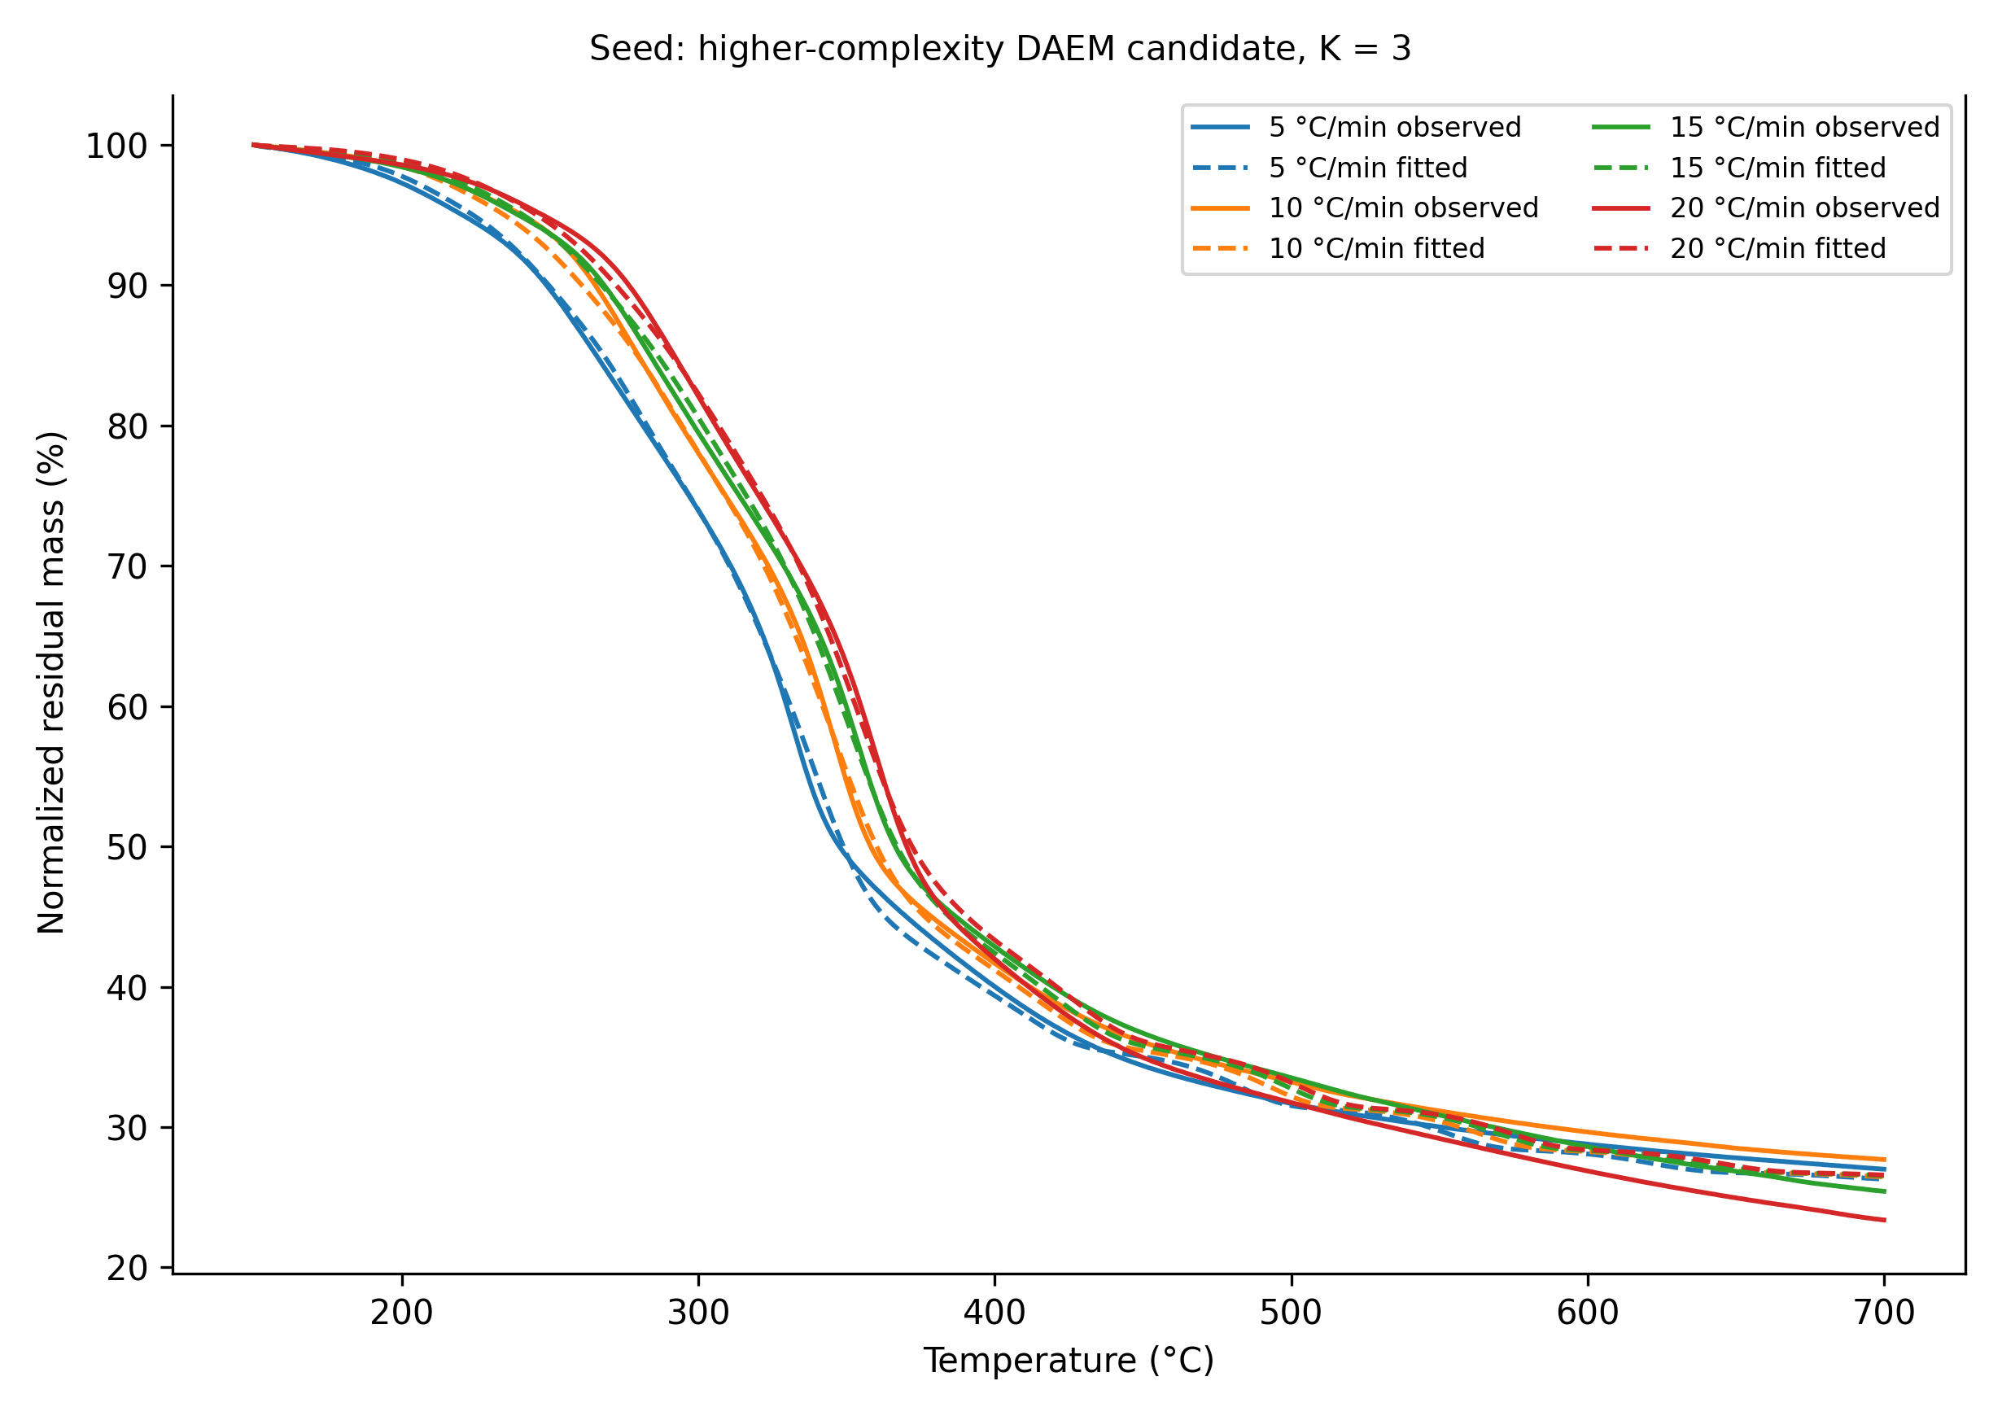
Figure S5. TG calibration for the higher-complexity K = 3 rosehip-seed candidate over 150–700 °C. Solid lines are observed normalised residual mass and dashed lines are fitted values. Although the candidate reduced in-sample error, parameter instability and bound contact prevented its retention over the parsimonious K = 2 model.

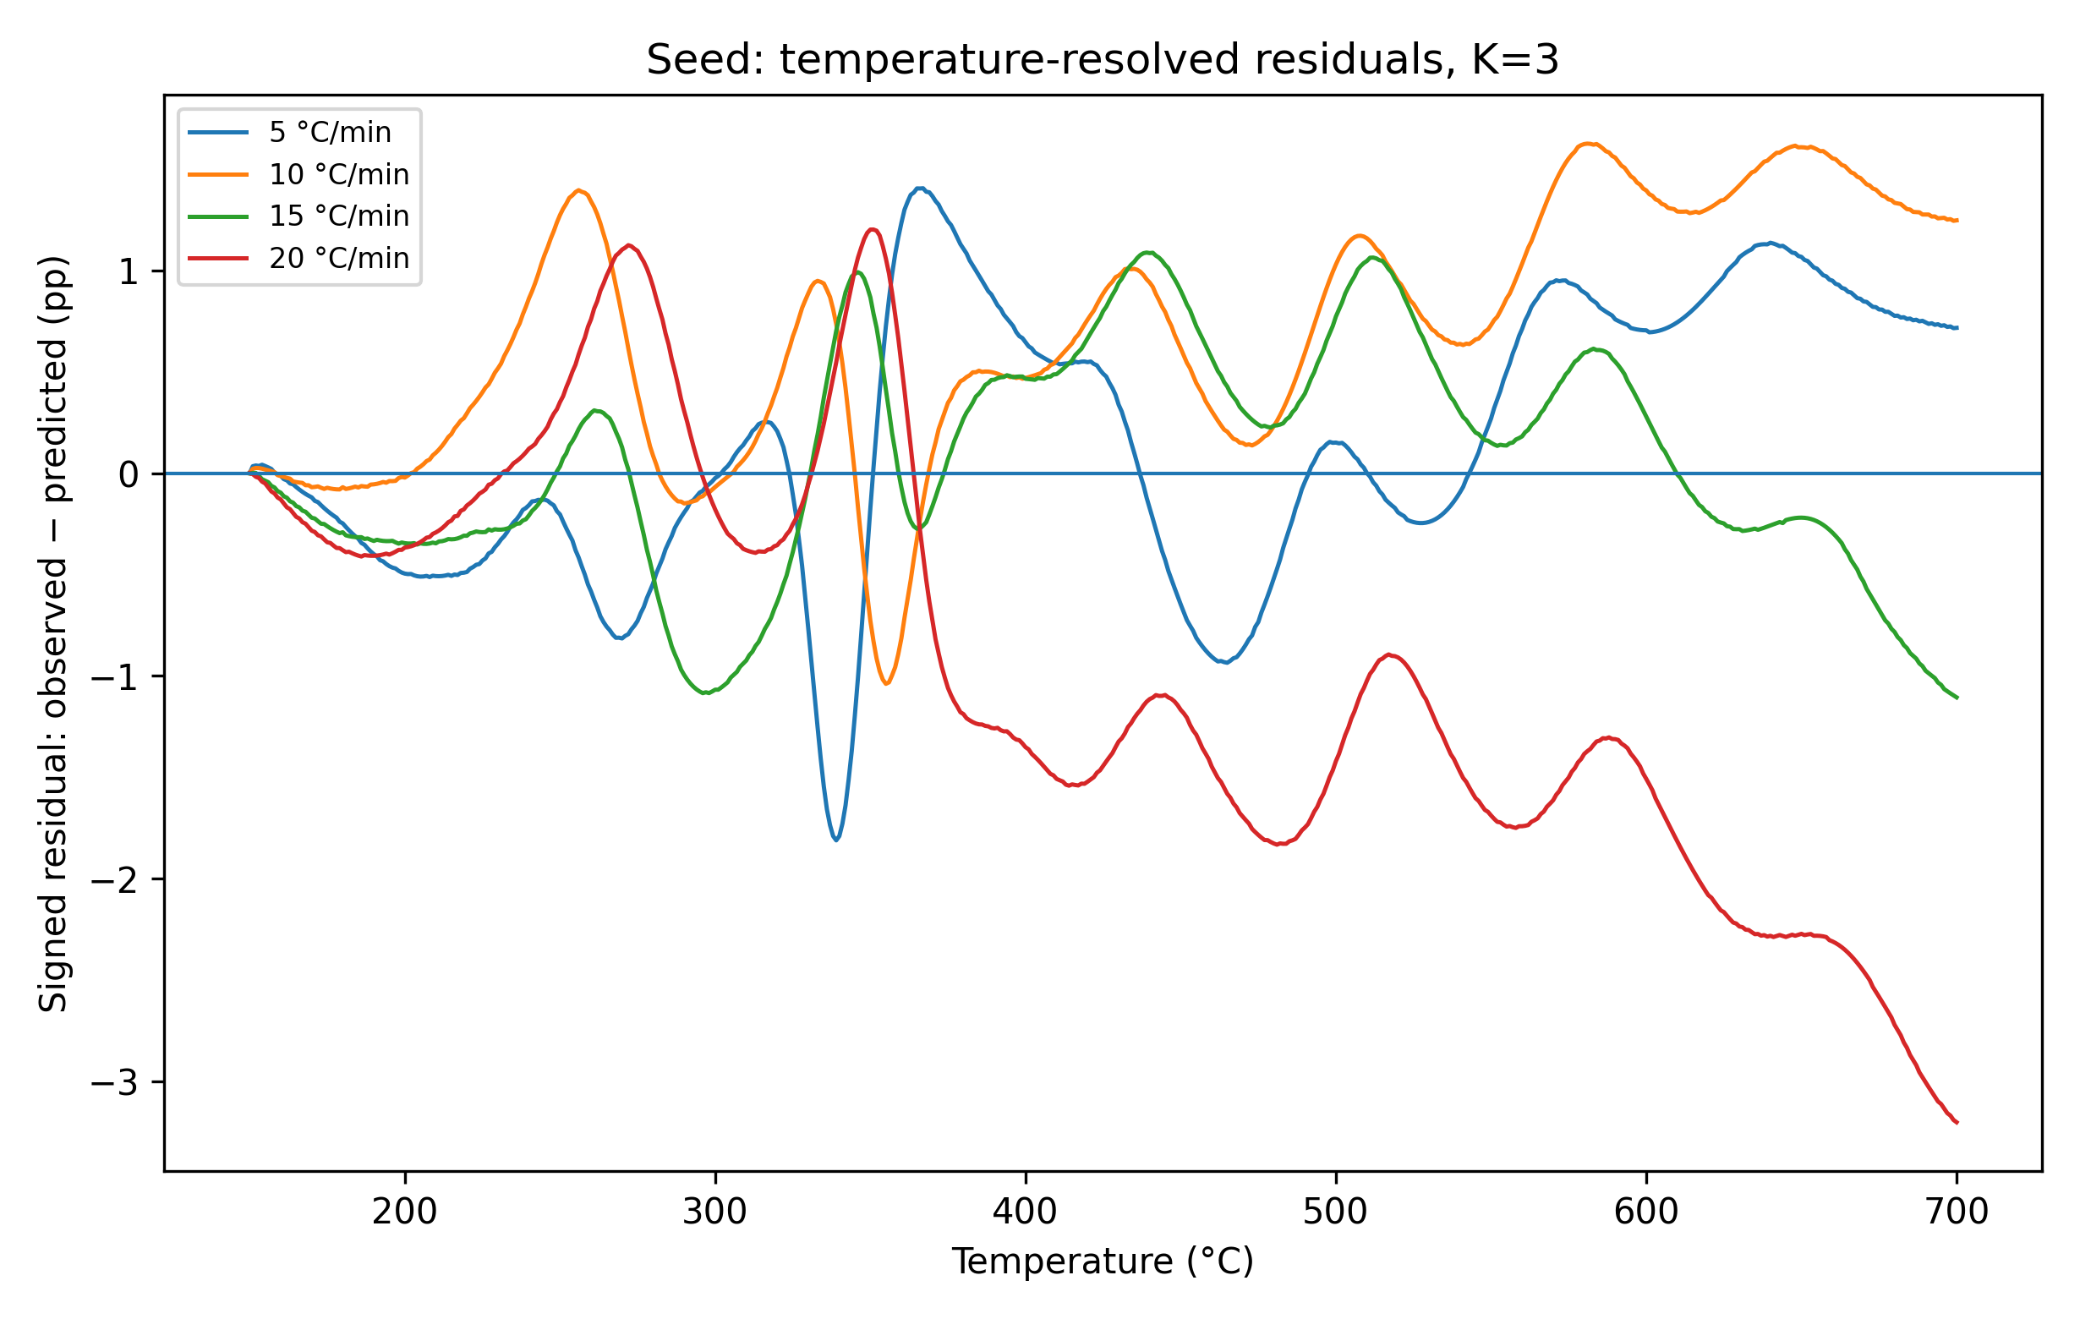
Figure S6. Temperature-resolved signed residuals for the K = 3 rosehip-seed candidate, defined as 100 × (observed − predicted). The residual curves show heating-rate-dependent and structured departures rather than random scatter.

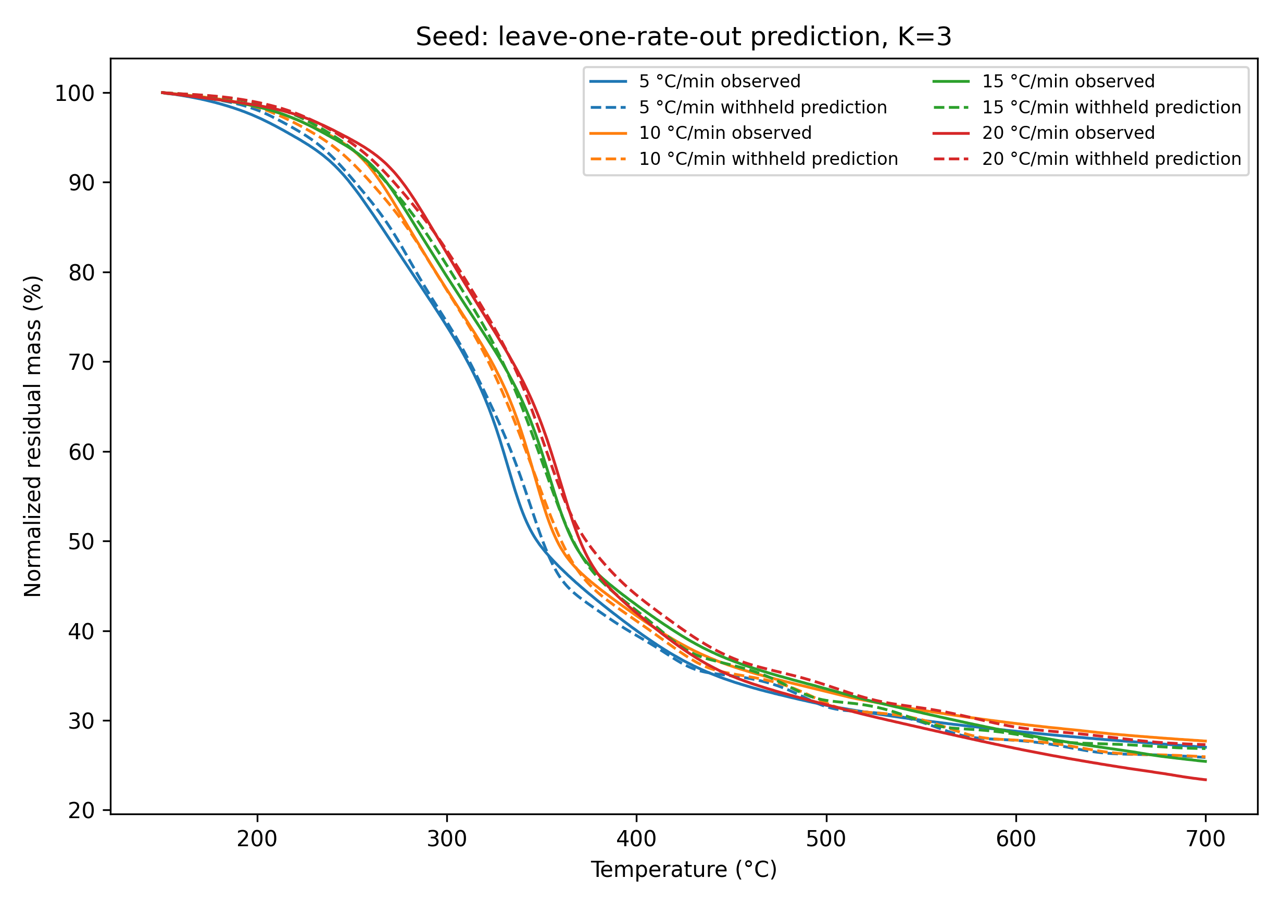
Figure S7. Complete leave-one-heating-rate-out prediction for the K = 3 rosehip-seed candidate. Each observed heating-rate curve is compared with a prediction obtained after excluding that complete rate from fitting. The modest numerical improvement relative to K = 2 did not offset the K = 3 parameter-instability evidence.

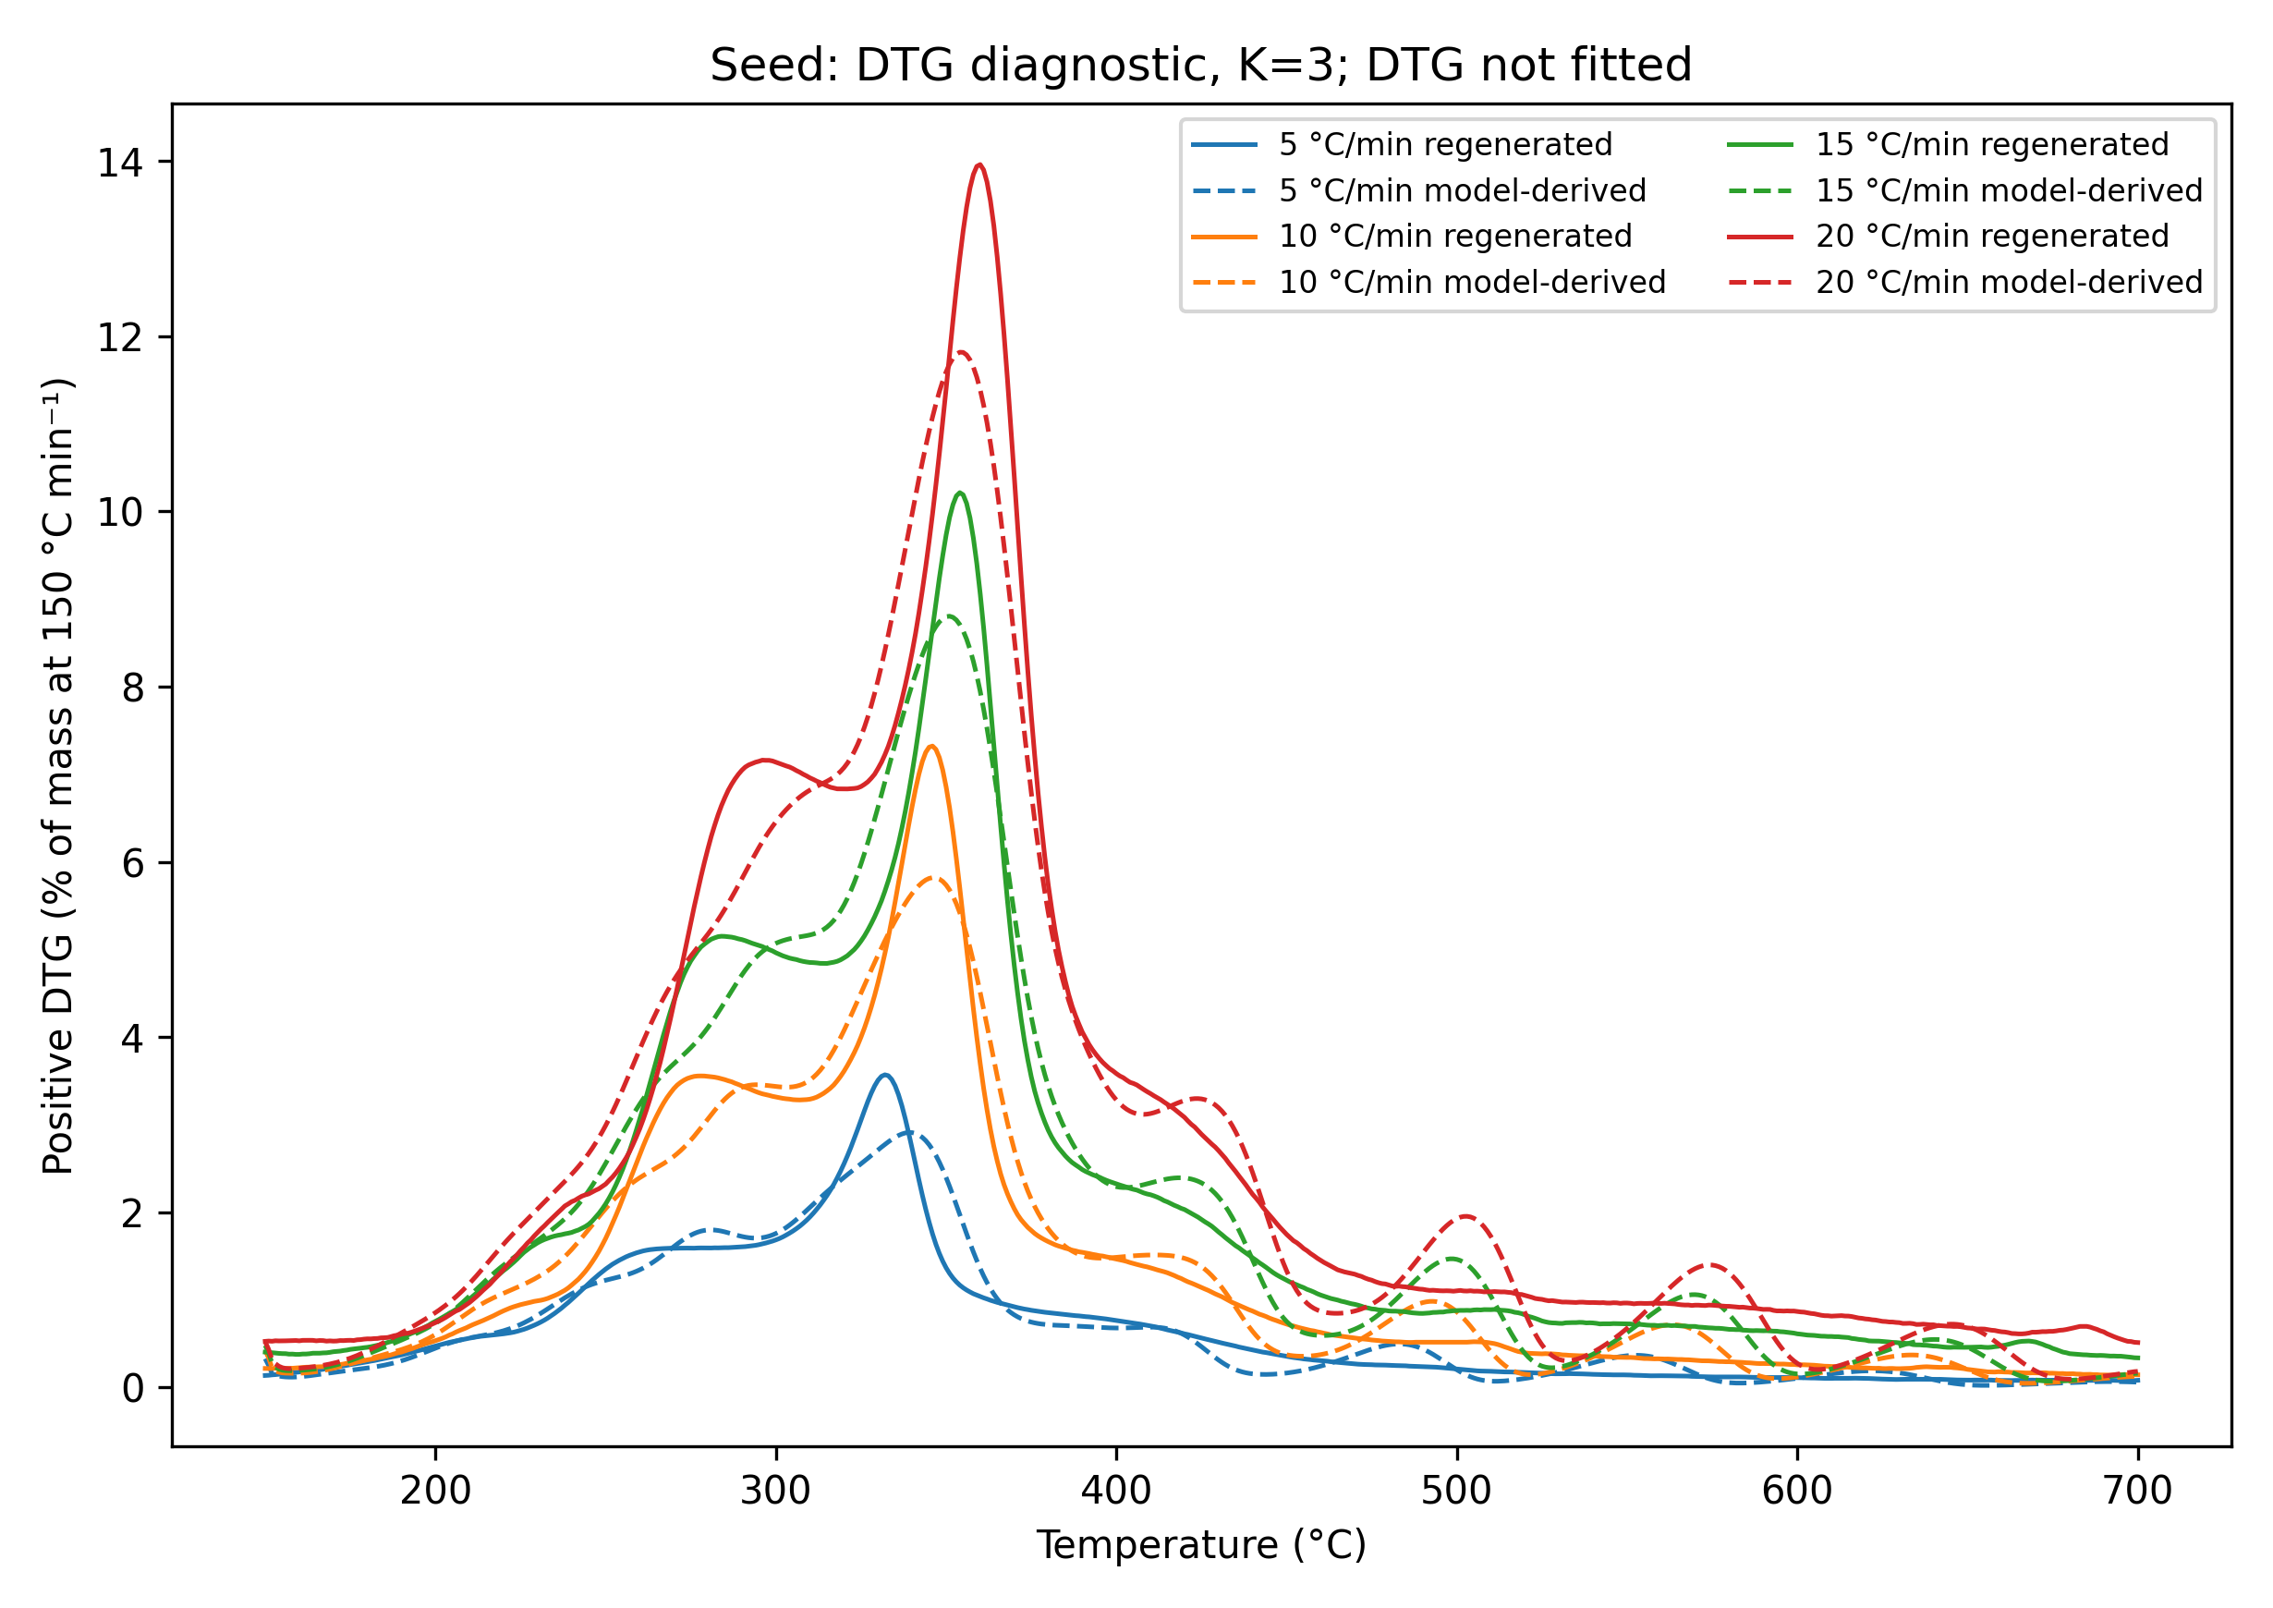
Figure S8. Regenerated observed DTG and model-derived DTG for the K = 3 rosehip-seed candidate. DTG was not fitted. Differences in peak magnitude and profile provide an independent diagnostic of derivative-shape inadequacy and must not be interpreted as validated component kinetics.

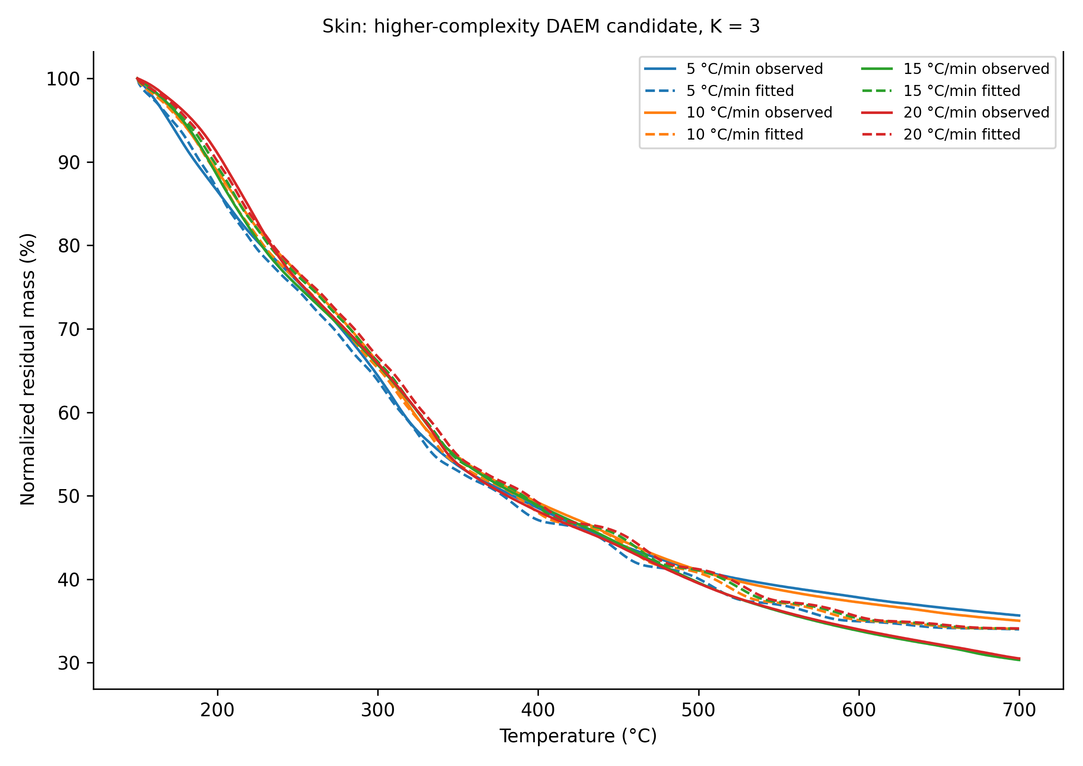
Figure S9. TG calibration for the higher-complexity K = 3 rosehip-skin candidate over 150–700 °C. Despite improved in-sample fit relative to lower-complexity candidates, bound contact, structured residuals, and derivative-shape mismatch prevented retention as the preferred representation.

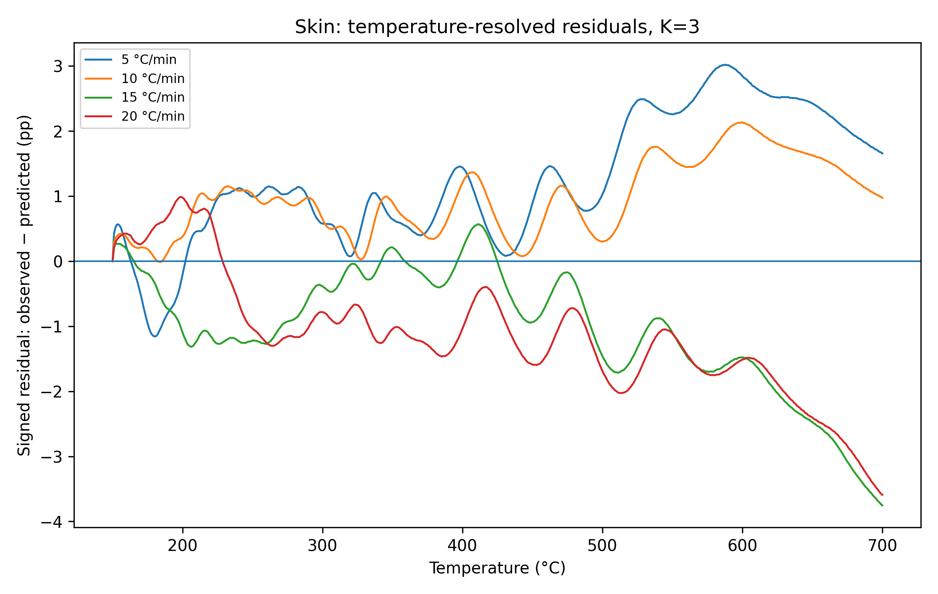
Figure S10. Temperature-resolved signed residuals for the K = 3 rosehip-skin candidate. Persistent heating-rate-dependent sign changes and late-temperature drift show that the remaining errors are structured rather than numerical noise.

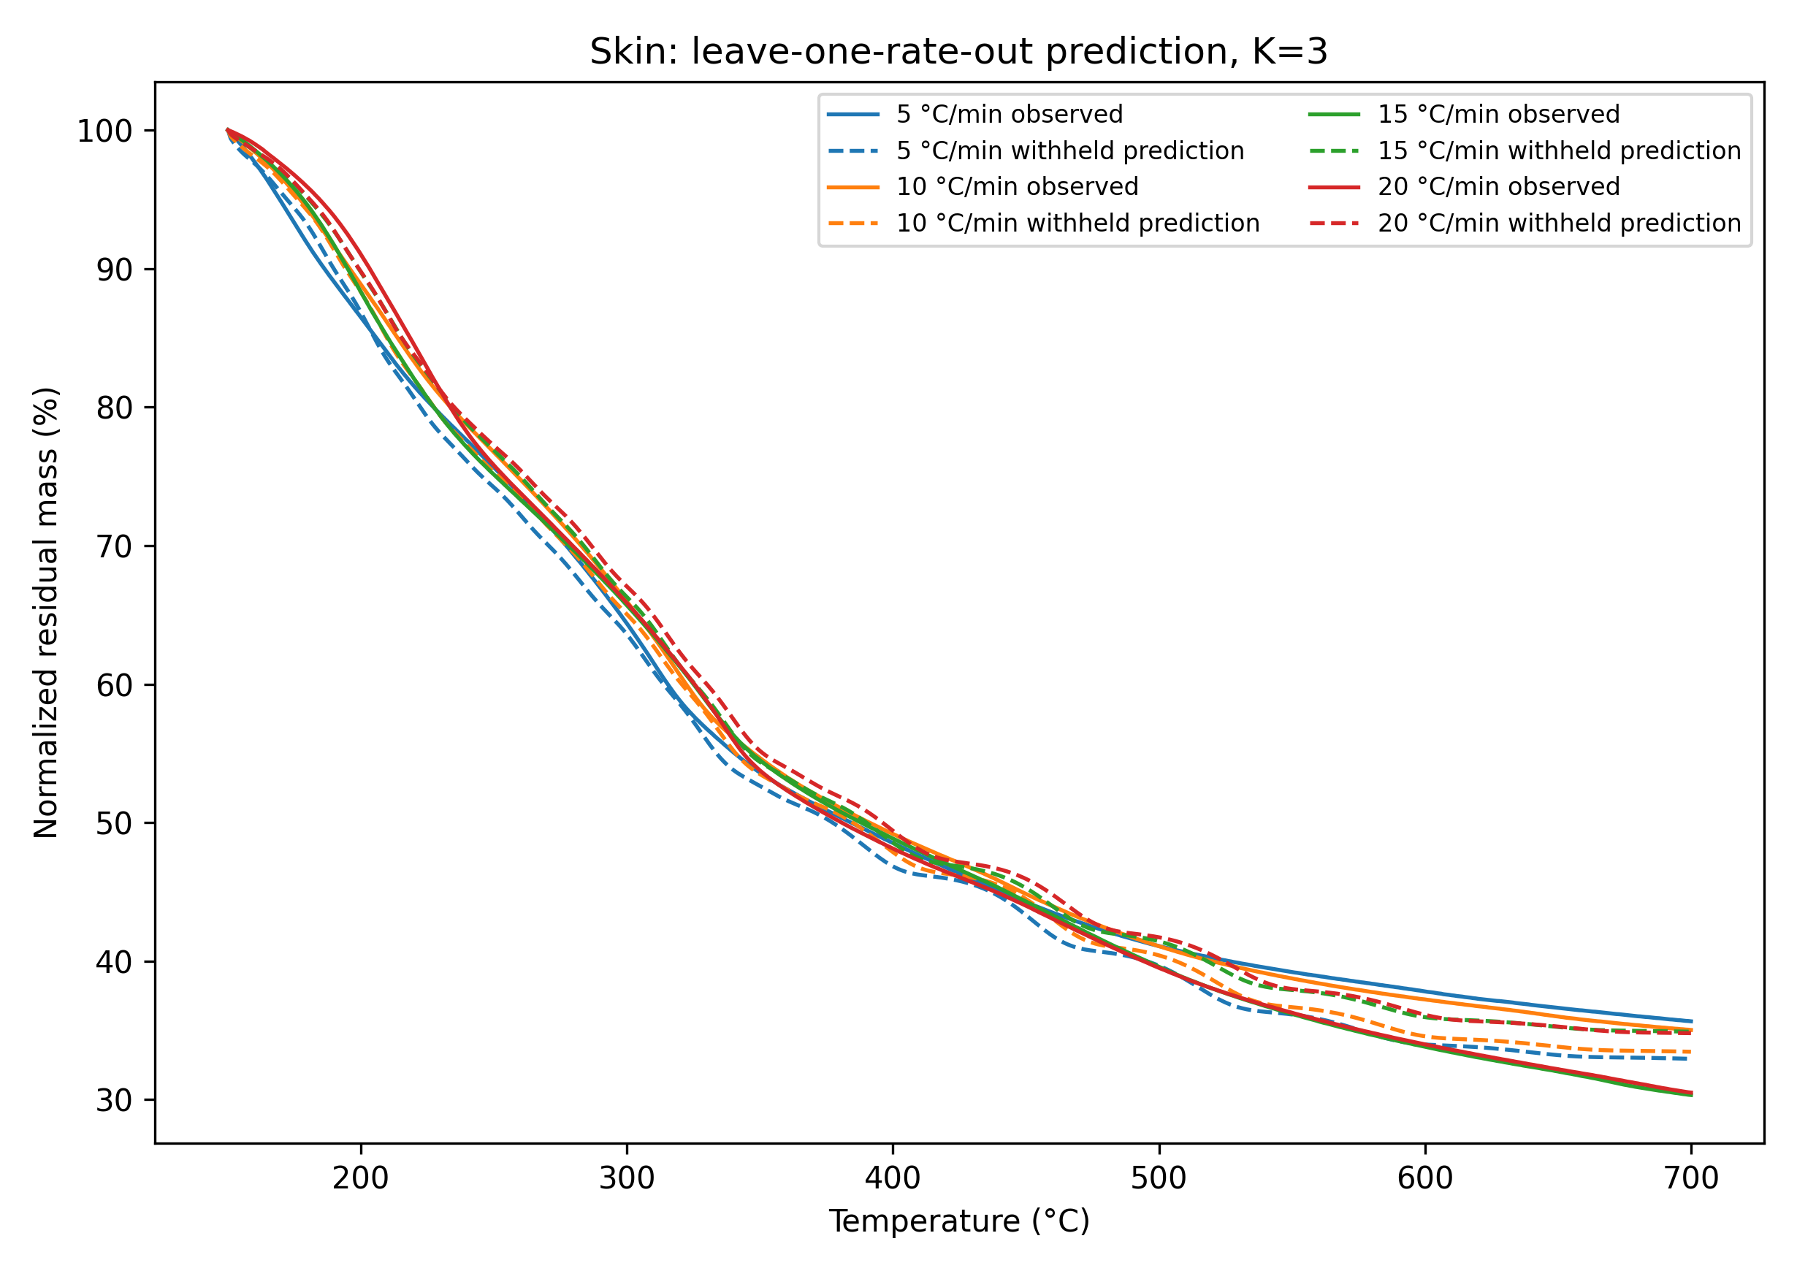
Figure S11. Complete leave-one-heating-rate-out prediction for the K = 3 rosehip-skin candidate. Prediction errors, together with bound contact in μ₃ and log₁₀A₁/log₁₀A₂ and loss of derivative-shape fidelity, prevented model retention.

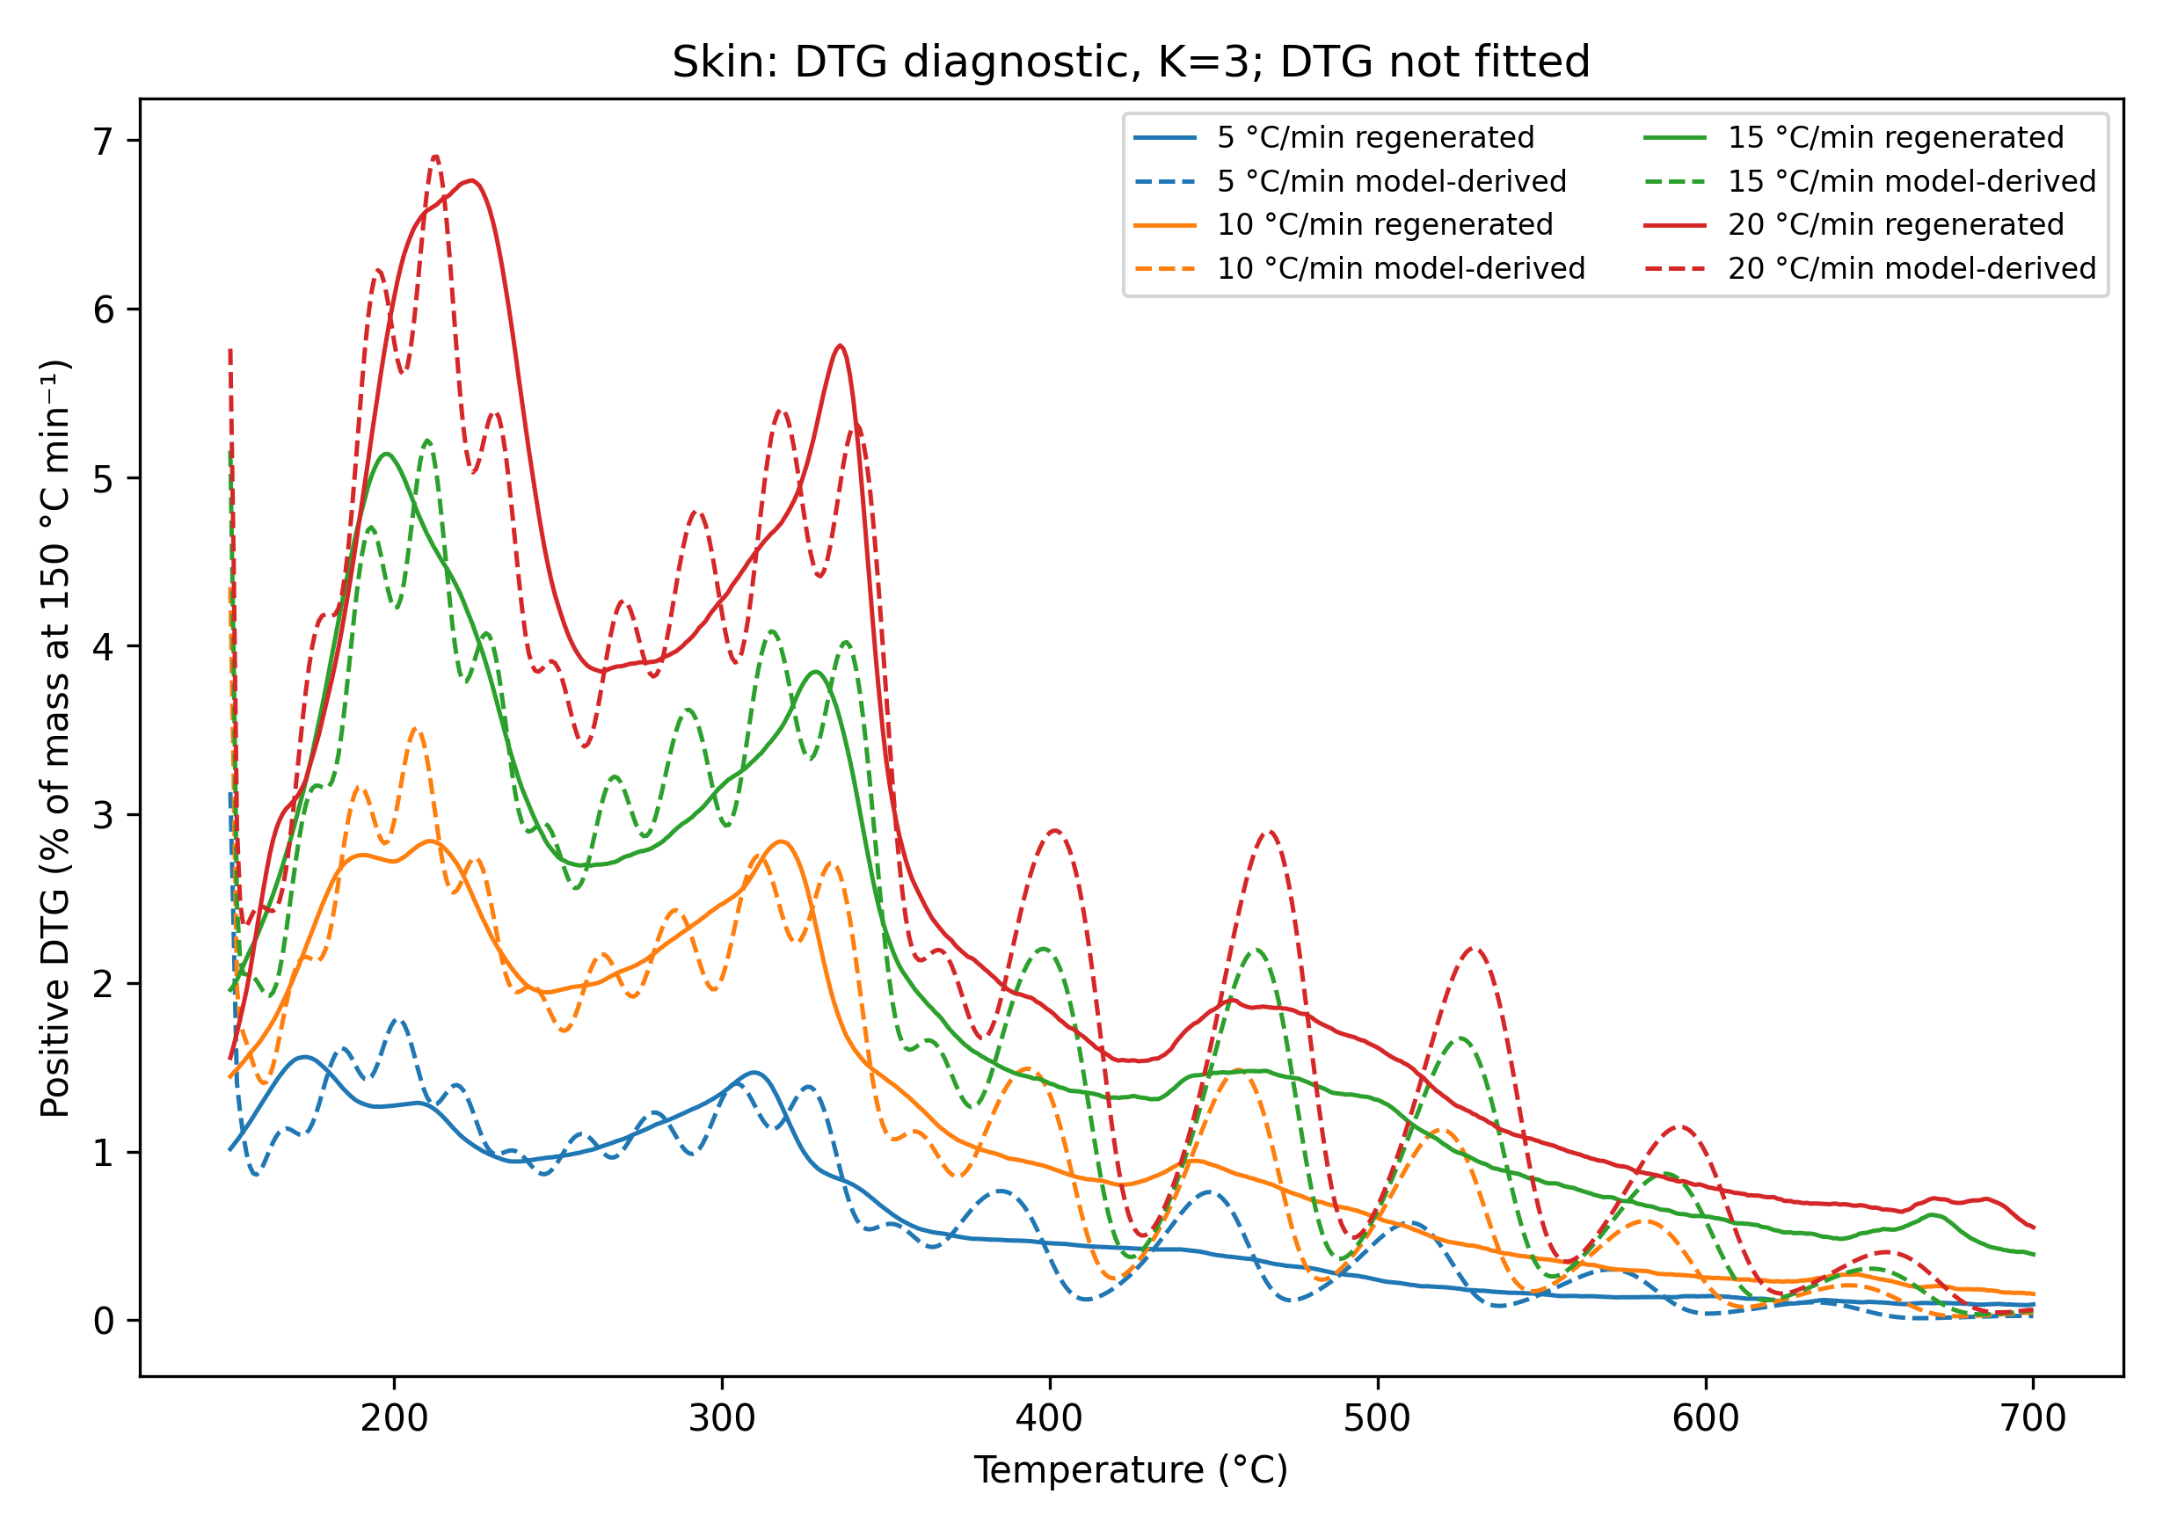
Figure S12. Regenerated observed DTG and model-derived DTG for the K = 3 rosehip-skin candidate. DTG was not fitted. The substantial peak-shape and peak-intensity discrepancies provide independent evidence against mechanistic interpretation of the fitted domains.

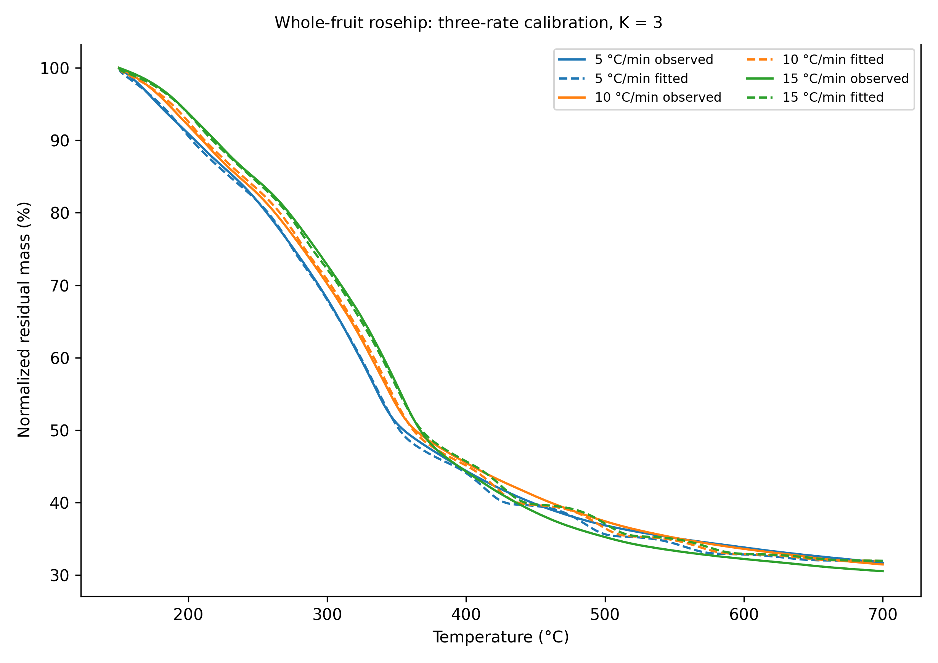
Figure S13. TG calibration for the retained three-rate K = 3 whole-fruit rosehip model at 5, 10, and 15 °C min⁻¹. The 20 °C min⁻¹ curve was excluded from calibration under the predefined R₇₀₀ consistency criterion; therefore, this result is calibration-only and is not independently predictively validated.

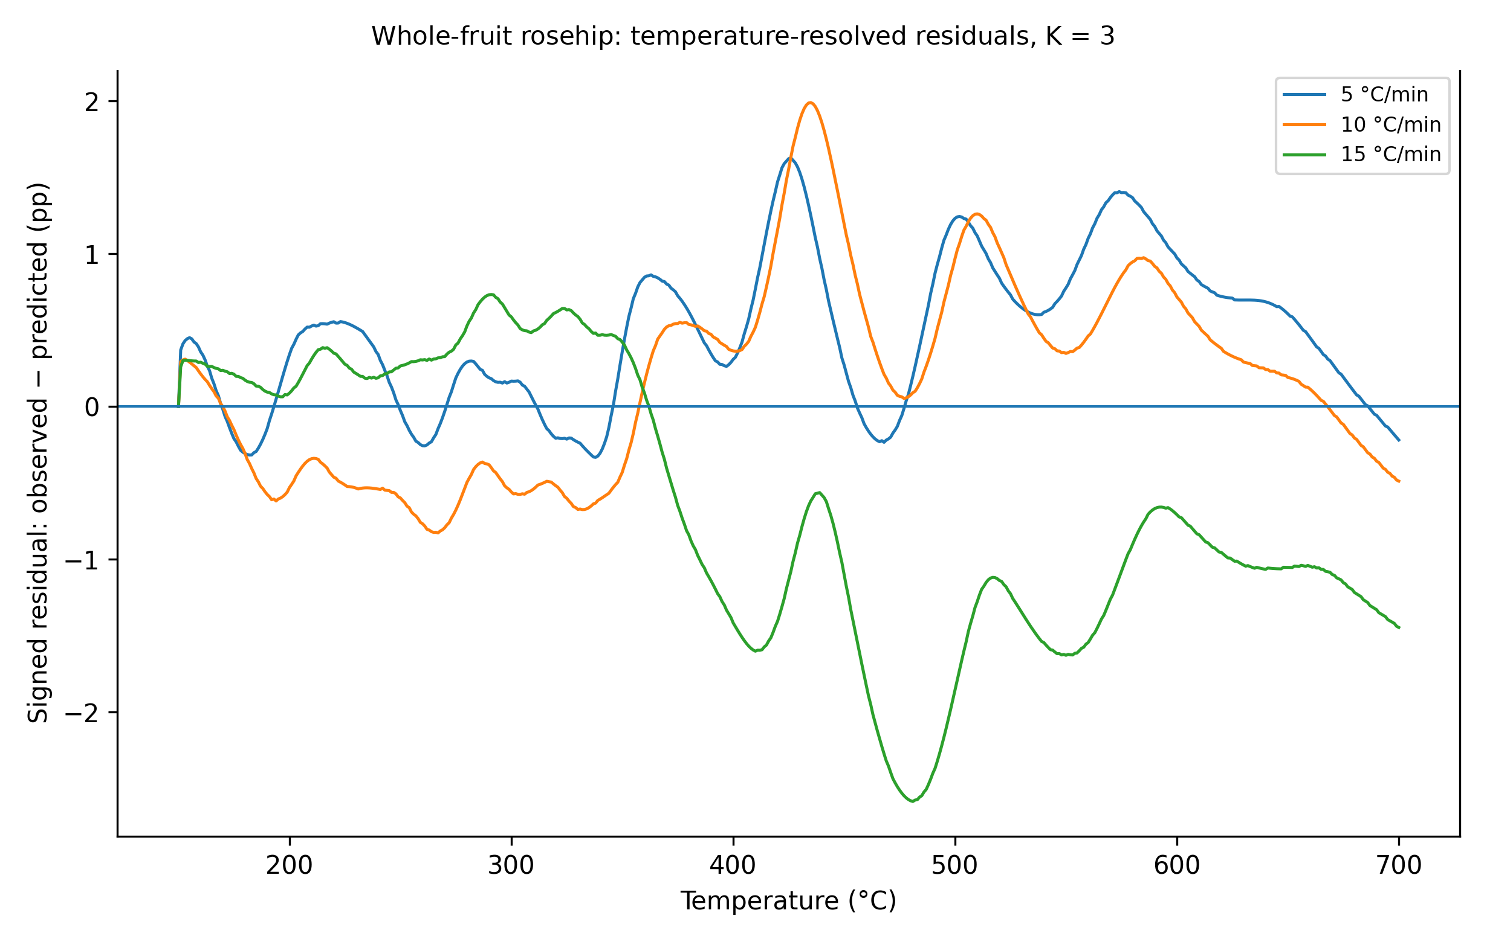
Figure S14. Temperature-resolved signed residuals for the retained three-rate K = 3 whole-fruit rosehip calibration model. The structured residual patterns, particularly at 15 °C min⁻¹, limit interpretation beyond descriptive calibration.

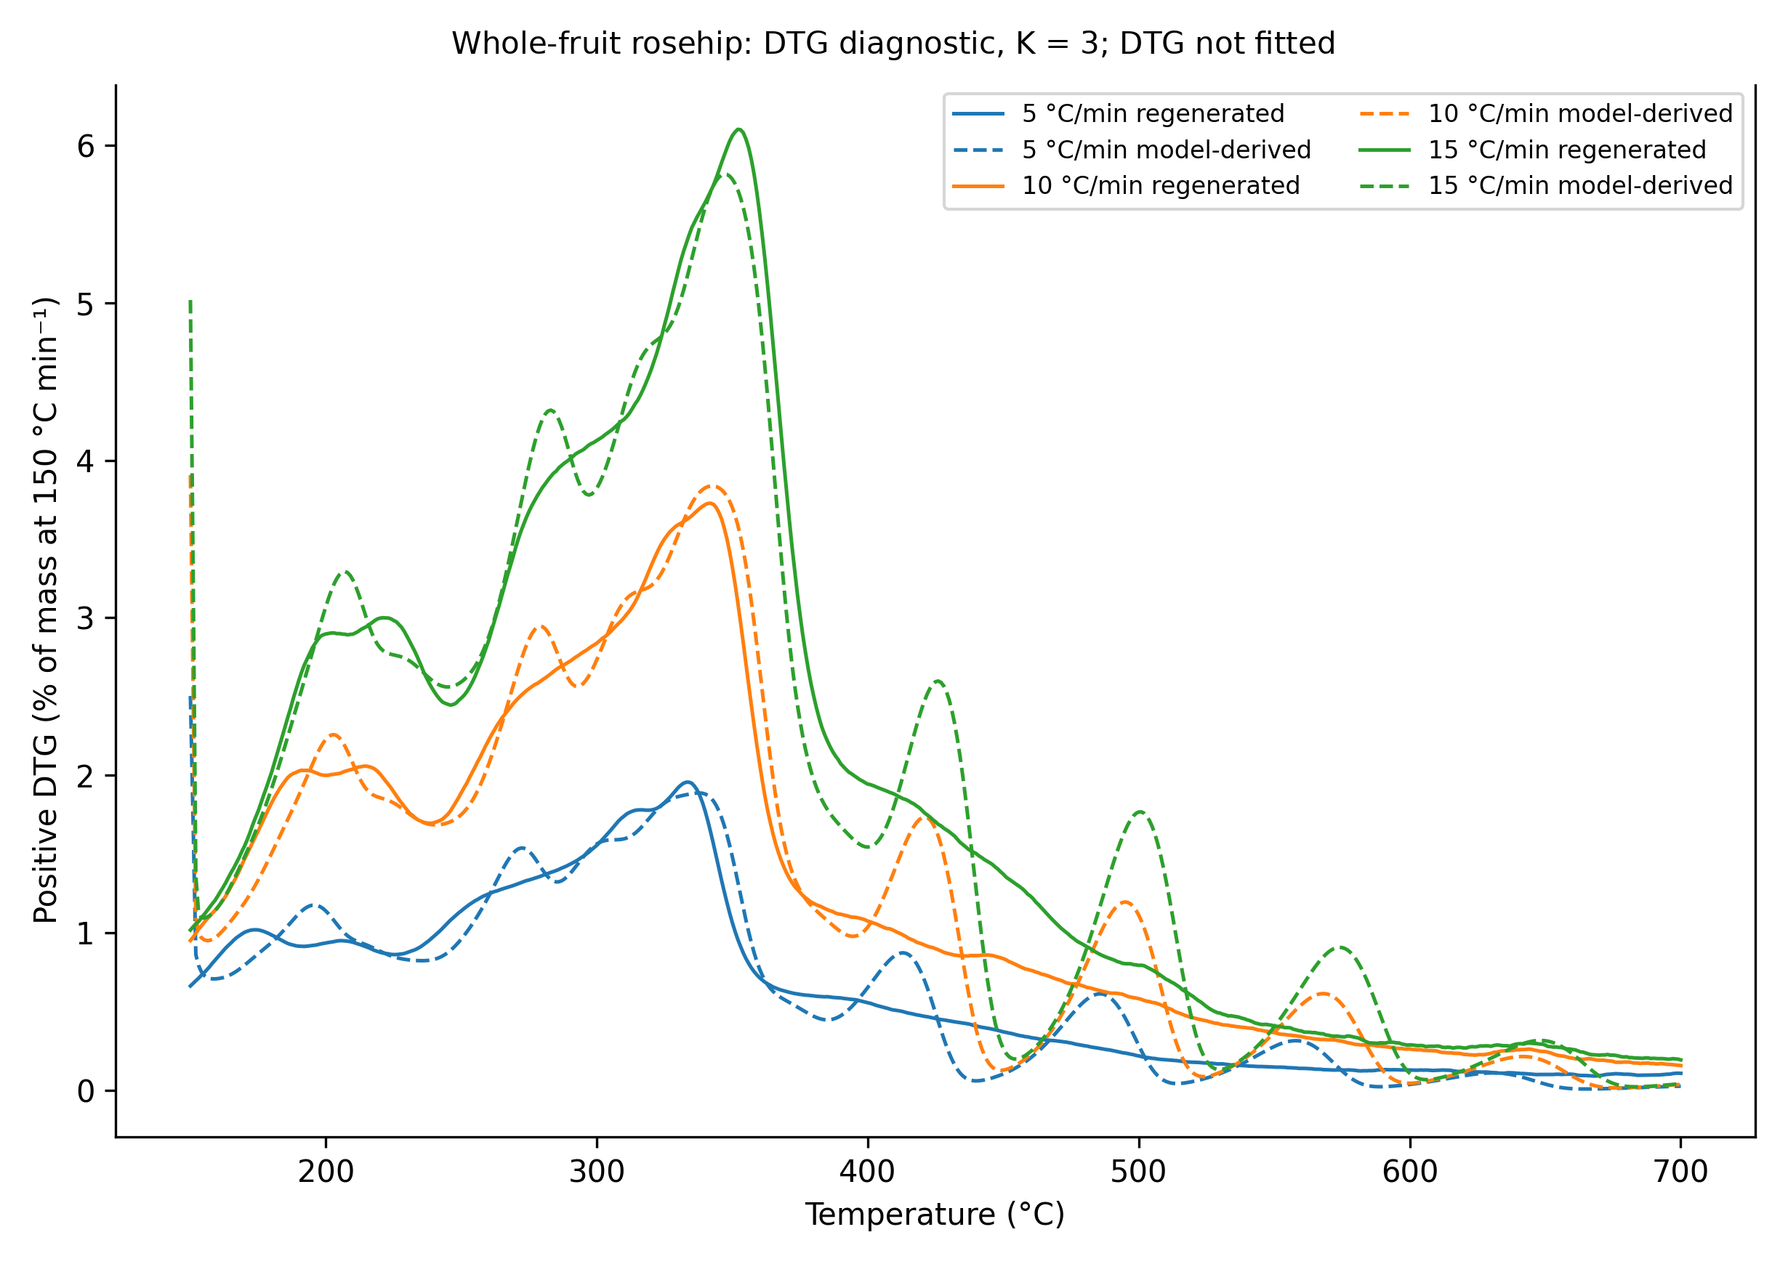
Figure S15. Regenerated observed DTG and model-derived DTG for the retained three-rate K = 3 whole-fruit rosehip calibration model. DTG was not fitted, and the mismatch in peak structure demonstrates why a smooth TG calibration must not be treated as a validated or transferable kinetic representation.

S10. Supplementary information for Section 3.1.4: Endpoint robustness of preparation-specific Eₐ(α) trajectories

S10.1. Supplementary tables S29–S31
Table S29. Endpoint-conditioned fixed-conversion temperatures and Friedman rate inputs for rosehip seed, skin, and whole-fruit rosehip at terminal temperatures of 600, 650, and 700 °C.
Feedstock | Tf (°C) | α | β (°C min⁻¹) | Tα (°C) | Tα (K) | dα/dt (min⁻¹) | Relative DTG
Rosehip seed | 600 | 0.10 | 5 | 235.412 | 508.562 | 0.0126372 | 0.2406
Rosehip seed | 600 | 0.10 | 10 | 253.710 | 526.860 | 0.0302431 | 0.2785
Rosehip seed | 600 | 0.10 | 15 | 255.169 | 528.319 | 0.0369803 | 0.2495
Rosehip seed | 600 | 0.10 | 20 | 264.553 | 537.703 | 0.0504973 | 0.2573
Rosehip seed | 600 | 0.20 | 5 | 263.100 | 536.250 | 0.0231182 | 0.4401
Rosehip seed | 600 | 0.20 | 10 | 277.071 | 550.221 | 0.0530261 | 0.4883
Rosehip seed | 600 | 0.20 | 15 | 281.558 | 554.708 | 0.0752709 | 0.5079
Rosehip seed | 600 | 0.20 | 20 | 290.729 | 563.879 | 0.1012942 | 0.5161
Rosehip seed | 600 | 0.30 | 5 | 285.516 | 558.666 | 0.0234674 | 0.4468
Rosehip seed | 600 | 0.30 | 10 | 297.352 | 570.502 | 0.0498353 | 0.4589
Rosehip seed | 600 | 0.30 | 15 | 302.691 | 575.841 | 0.0722971 | 0.4878
Rosehip seed | 600 | 0.30 | 20 | 311.359 | 584.509 | 0.0993504 | 0.5062
Rosehip seed | 600 | 0.40 | 5 | 306.914 | 580.064 | 0.0270148 | 0.5143
Rosehip seed | 600 | 0.40 | 10 | 318.465 | 591.615 | 0.0524403 | 0.4829
Rosehip seed | 600 | 0.40 | 15 | 324.600 | 597.750 | 0.0743366 | 0.5016
Rosehip seed | 600 | 0.40 | 20 | 332.517 | 605.667 | 0.1044833 | 0.5324
Rosehip seed | 600 | 0.50 | 5 | 322.852 | 596.002 | 0.0413252 | 0.7868
Rosehip seed | 600 | 0.50 | 10 | 334.865 | 608.015 | 0.0814564 | 0.7501
Rosehip seed | 600 | 0.50 | 15 | 342.410 | 615.560 | 0.1113740 | 0.7515
Rosehip seed | 600 | 0.50 | 20 | 349.182 | 622.332 | 0.1579742 | 0.8049
Rosehip seed | 600 | 0.60 | 5 | 333.594 | 606.744 | 0.0520705 | 0.9913
Rosehip seed | 600 | 0.60 | 10 | 345.544 | 618.694 | 0.1084741 | 0.9990
Rosehip seed | 600 | 0.60 | 15 | 354.078 | 627.228 | 0.1481626 | 0.9998
Rosehip seed | 600 | 0.60 | 20 | 360.476 | 633.626 | 0.1959265 | 0.9983
Rosehip seed | 600 | 0.70 | 5 | 347.067 | 620.217 | 0.0238268 | 0.4536
Rosehip seed | 600 | 0.70 | 10 | 356.443 | 629.593 | 0.0717705 | 0.6609
Rosehip seed | 600 | 0.70 | 15 | 366.322 | 639.472 | 0.0918231 | 0.6196
Rosehip seed | 600 | 0.70 | 20 | 372.723 | 645.873 | 0.1269481 | 0.6468
Rosehip seed | 600 | 0.80 | 5 | 381.294 | 654.444 | 0.0123583 | 0.2353
Rosehip seed | 600 | 0.80 | 10 | 386.440 | 659.590 | 0.0233124 | 0.2147
Rosehip seed | 600 | 0.80 | 15 | 399.850 | 673.000 | 0.0338113 | 0.2282
Rosehip seed | 600 | 0.80 | 20 | 402.659 | 675.809 | 0.0500588 | 0.2551
Rosehip seed | 600 | 0.90 | 5 | 431.800 | 704.950 | 0.0072388 | 0.1378
Rosehip seed | 600 | 0.90 | 10 | 441.867 | 715.017 | 0.0123286 | 0.1135
Rosehip seed | 600 | 0.90 | 15 | 462.717 | 735.867 | 0.0147741 | 0.0997
Rosehip seed | 600 | 0.90 | 20 | 459.700 | 732.850 | 0.0206240 | 0.1051
Rosehip seed | 650 | 0.10 | 5 | 235.965 | 509.115 | 0.0126875 | 0.2449
Rosehip seed | 650 | 0.10 | 10 | 254.270 | 527.420 | 0.0305381 | 0.2859
Rosehip seed | 650 | 0.10 | 15 | 256.224 | 529.374 | 0.0376594 | 0.2604
Rosehip seed | 650 | 0.10 | 20 | 265.617 | 538.767 | 0.0513635 | 0.2685
Rosehip seed | 650 | 0.20 | 5 | 263.727 | 536.877 | 0.0228594 | 0.4412
Rosehip seed | 650 | 0.20 | 10 | 277.729 | 550.879 | 0.0521874 | 0.4885
Rosehip seed | 650 | 0.20 | 15 | 282.594 | 555.744 | 0.0736914 | 0.5095
Rosehip seed | 650 | 0.20 | 20 | 291.806 | 564.956 | 0.0991861 | 0.5186
Rosehip seed | 650 | 0.30 | 5 | 286.440 | 559.590 | 0.0231694 | 0.4472
Rosehip seed | 650 | 0.30 | 10 | 298.381 | 571.531 | 0.0488673 | 0.4574
Rosehip seed | 650 | 0.30 | 15 | 304.303 | 577.453 | 0.0702955 | 0.4860
Rosehip seed | 650 | 0.30 | 20 | 313.009 | 586.159 | 0.0963795 | 0.5039
Rosehip seed | 650 | 0.40 | 5 | 307.961 | 581.111 | 0.0271417 | 0.5238
Rosehip seed | 650 | 0.40 | 10 | 319.760 | 592.910 | 0.0525933 | 0.4923
Rosehip seed | 650 | 0.40 | 15 | 326.653 | 599.803 | 0.0742810 | 0.5136
Rosehip seed | 650 | 0.40 | 20 | 334.578 | 607.728 | 0.1050216 | 0.5491
Rosehip seed | 650 | 0.50 | 5 | 323.709 | 596.859 | 0.0420224 | 0.8110
Rosehip seed | 650 | 0.50 | 10 | 335.891 | 609.041 | 0.0832850 | 0.7796
Rosehip seed | 650 | 0.50 | 15 | 344.093 | 617.243 | 0.1152030 | 0.7965
Rosehip seed | 650 | 0.50 | 20 | 350.851 | 624.001 | 0.1623565 | 0.8488
Rosehip seed | 650 | 0.60 | 5 | 334.418 | 607.568 | 0.0506806 | 0.9781
Rosehip seed | 650 | 0.60 | 10 | 346.485 | 619.635 | 0.1065584 | 0.9974
Rosehip seed | 650 | 0.60 | 15 | 355.618 | 628.768 | 0.1434394 | 0.9917
Rosehip seed | 650 | 0.60 | 20 | 362.128 | 635.278 | 0.1884686 | 0.9854
Rosehip seed | 650 | 0.70 | 5 | 349.338 | 622.488 | 0.0204726 | 0.3951
Rosehip seed | 650 | 0.70 | 10 | 358.220 | 631.370 | 0.0617426 | 0.5779
Rosehip seed | 650 | 0.70 | 15 | 369.644 | 642.794 | 0.0708639 | 0.4899
Rosehip seed | 650 | 0.70 | 20 | 376.079 | 649.229 | 0.1009481 | 0.5278
Rosehip seed | 650 | 0.80 | 5 | 385.950 | 659.100 | 0.0119026 | 0.2297
Rosehip seed | 650 | 0.80 | 10 | 392.413 | 665.563 | 0.0221300 | 0.2071
Rosehip seed | 650 | 0.80 | 15 | 409.160 | 682.310 | 0.0313193 | 0.2165
Rosehip seed | 650 | 0.80 | 20 | 411.613 | 684.763 | 0.0457802 | 0.2394
Rosehip seed | 650 | 0.90 | 5 | 441.450 | 714.600 | 0.0059682 | 0.1152
Rosehip seed | 650 | 0.90 | 10 | 455.933 | 729.083 | 0.0094972 | 0.0889
Rosehip seed | 650 | 0.90 | 15 | 488.700 | 761.850 | 0.0119335 | 0.0825
Rosehip seed | 650 | 0.90 | 20 | 486.983 | 760.133 | 0.0155088 | 0.0811
Rosehip seed | 700 | 0.10 | 5 | 236.424 | 509.574 | 0.0127547 | 0.2489
Rosehip seed | 700 | 0.10 | 10 | 254.660 | 527.810 | 0.0307438 | 0.2910
Rosehip seed | 700 | 0.10 | 15 | 257.039 | 530.189 | 0.0381653 | 0.2690
Rosehip seed | 700 | 0.10 | 20 | 266.478 | 539.628 | 0.0520976 | 0.2781
Rosehip seed | 700 | 0.20 | 5 | 264.247 | 537.397 | 0.0226429 | 0.4419
Rosehip seed | 700 | 0.20 | 10 | 278.183 | 551.333 | 0.0516086 | 0.4885
Rosehip seed | 700 | 0.20 | 15 | 283.424 | 556.574 | 0.0723778 | 0.5102
Rosehip seed | 700 | 0.20 | 20 | 292.691 | 565.841 | 0.0974090 | 0.5200
Rosehip seed | 700 | 0.30 | 5 | 287.213 | 560.363 | 0.0229340 | 0.4476
Rosehip seed | 700 | 0.30 | 10 | 299.113 | 572.263 | 0.0482257 | 0.4565
Rosehip seed | 700 | 0.30 | 15 | 305.628 | 578.778 | 0.0687590 | 0.4846
Rosehip seed | 700 | 0.30 | 20 | 314.406 | 587.556 | 0.0940969 | 0.5023
Rosehip seed | 700 | 0.40 | 5 | 308.805 | 581.955 | 0.0272943 | 0.5327
Rosehip seed | 700 | 0.40 | 10 | 320.651 | 593.801 | 0.0527762 | 0.4996
Rosehip seed | 700 | 0.40 | 15 | 328.280 | 601.430 | 0.0745573 | 0.5255
Rosehip seed | 700 | 0.40 | 20 | 336.247 | 609.397 | 0.1059165 | 0.5654
Rosehip seed | 700 | 0.50 | 5 | 324.397 | 597.547 | 0.0425697 | 0.8308
Rosehip seed | 700 | 0.50 | 10 | 336.589 | 609.739 | 0.0845506 | 0.8004
Rosehip seed | 700 | 0.50 | 15 | 345.373 | 618.523 | 0.1180881 | 0.8323
Rosehip seed | 700 | 0.50 | 20 | 352.183 | 625.333 | 0.1653899 | 0.8829
Rosehip seed | 700 | 0.60 | 5 | 335.109 | 608.259 | 0.0493226 | 0.9626
Rosehip seed | 700 | 0.60 | 10 | 347.144 | 620.294 | 0.1048976 | 0.9930
Rosehip seed | 700 | 0.60 | 15 | 356.882 | 630.032 | 0.1381601 | 0.9738
Rosehip seed | 700 | 0.60 | 20 | 363.524 | 636.674 | 0.1802287 | 0.9622
Rosehip seed | 700 | 0.70 | 5 | 351.456 | 624.606 | 0.0183245 | 0.3576
Rosehip seed | 700 | 0.70 | 10 | 359.632 | 632.782 | 0.0546845 | 0.5176
Rosehip seed | 700 | 0.70 | 15 | 373.036 | 646.186 | 0.0557005 | 0.3926
Rosehip seed | 700 | 0.70 | 20 | 379.507 | 652.657 | 0.0814043 | 0.4346
Rosehip seed | 700 | 0.80 | 5 | 389.913 | 663.062 | 0.0115689 | 0.2258
Rosehip seed | 700 | 0.80 | 10 | 396.707 | 669.857 | 0.0213828 | 0.2024
Rosehip seed | 700 | 0.80 | 15 | 417.114 | 690.264 | 0.0288742 | 0.2035
Rosehip seed | 700 | 0.80 | 20 | 419.453 | 692.603 | 0.0418337 | 0.2233
Rosehip seed | 700 | 0.90 | 5 | 450.971 | 724.121 | 0.0049189 | 0.0960
Rosehip seed | 700 | 0.90 | 10 | 467.760 | 740.910 | 0.0082045 | 0.0777
Rosehip seed | 700 | 0.90 | 15 | 510.860 | 784.010 | 0.0121967 | 0.0860
Rosehip seed | 700 | 0.90 | 20 | 512.880 | 786.030 | 0.0145366 | 0.0776
Rosehip skin | 600 | 0.10 | 5 | 173.328 | 446.478 | 0.0260033 | 0.9991
Rosehip skin | 600 | 0.10 | 10 | 182.128 | 455.278 | 0.0435580 | 0.9205
Rosehip skin | 600 | 0.10 | 15 | 184.304 | 457.454 | 0.0672377 | 0.8312
Rosehip skin | 600 | 0.10 | 20 | 191.417 | 464.567 | 0.0794684 | 0.7394
Rosehip skin | 600 | 0.20 | 5 | 195.708 | 468.858 | 0.0212411 | 0.8162
Rosehip skin | 600 | 0.20 | 10 | 205.092 | 478.242 | 0.0462715 | 0.9779
Rosehip skin | 600 | 0.20 | 15 | 204.561 | 477.711 | 0.0778500 | 0.9624
Rosehip skin | 600 | 0.20 | 20 | 213.061 | 486.211 | 0.1054559 | 0.9812
Rosehip skin | 600 | 0.30 | 5 | 220.775 | 493.925 | 0.0183185 | 0.7039
Rosehip skin | 600 | 0.30 | 10 | 228.391 | 501.541 | 0.0388337 | 0.8207
Rosehip skin | 600 | 0.30 | 15 | 226.831 | 499.981 | 0.0628895 | 0.7774
Rosehip skin | 600 | 0.30 | 20 | 232.903 | 506.053 | 0.0993613 | 0.9245
Rosehip skin | 600 | 0.40 | 5 | 252.611 | 525.761 | 0.0165082 | 0.6343
Rosehip skin | 600 | 0.40 | 10 | 259.305 | 532.455 | 0.0333694 | 0.7052
Rosehip skin | 600 | 0.40 | 15 | 258.822 | 531.972 | 0.0427196 | 0.5281
Rosehip skin | 600 | 0.40 | 20 | 261.000 | 534.150 | 0.0617874 | 0.5749
Rosehip skin | 600 | 0.50 | 5 | 281.881 | 555.031 | 0.0197605 | 0.7593
Rosehip skin | 600 | 0.50 | 10 | 288.826 | 561.976 | 0.0386770 | 0.8174
Rosehip skin | 600 | 0.50 | 15 | 294.053 | 567.203 | 0.0483304 | 0.5974
Rosehip skin | 600 | 0.50 | 20 | 294.550 | 567.700 | 0.0657589 | 0.6119
Rosehip skin | 600 | 0.60 | 5 | 306.037 | 579.187 | 0.0240769 | 0.9251
Rosehip skin | 600 | 0.60 | 10 | 313.896 | 587.046 | 0.0463063 | 0.9786
Rosehip skin | 600 | 0.60 | 15 | 323.842 | 596.992 | 0.0589312 | 0.7285
Rosehip skin | 600 | 0.60 | 20 | 323.760 | 596.910 | 0.0785904 | 0.7313
Rosehip skin | 600 | 0.70 | 5 | 331.719 | 604.869 | 0.0146003 | 0.5610
Rosehip skin | 600 | 0.70 | 10 | 340.627 | 613.777 | 0.0266320 | 0.5628
Rosehip skin | 600 | 0.70 | 15 | 355.743 | 628.893 | 0.0324699 | 0.4014
Rosehip skin | 600 | 0.70 | 20 | 349.824 | 622.974 | 0.0541104 | 0.5035
Rosehip skin | 600 | 0.80 | 5 | 381.667 | 654.817 | 0.0079914 | 0.3071
Rosehip skin | 600 | 0.80 | 10 | 393.400 | 666.550 | 0.0154942 | 0.3275
Rosehip skin | 600 | 0.80 | 15 | 419.844 | 692.994 | 0.0207184 | 0.2561
Rosehip skin | 600 | 0.80 | 20 | 410.750 | 683.900 | 0.0262096 | 0.2439
Rosehip skin | 600 | 0.90 | 5 | 452.929 | 726.079 | 0.0062834 | 0.2414
Rosehip skin | 600 | 0.90 | 10 | 465.475 | 738.625 | 0.0133663 | 0.2825
Rosehip skin | 600 | 0.90 | 15 | 490.422 | 763.572 | 0.0208318 | 0.2575
Rosehip skin | 600 | 0.90 | 20 | 487.125 | 760.275 | 0.0267200 | 0.2486
Rosehip skin | 650 | 0.10 | 5 | 173.710 | 446.860 | 0.0254912 | 0.9981
Rosehip skin | 650 | 0.10 | 10 | 182.600 | 455.750 | 0.0429804 | 0.9262
Rosehip skin | 650 | 0.10 | 15 | 184.944 | 458.094 | 0.0664735 | 0.8439
Rosehip skin | 650 | 0.10 | 20 | 192.138 | 465.288 | 0.0788645 | 0.7537
Rosehip skin | 650 | 0.20 | 5 | 196.633 | 469.783 | 0.0208496 | 0.8164
Rosehip skin | 650 | 0.20 | 10 | 206.000 | 479.150 | 0.0457353 | 0.9856
Rosehip skin | 650 | 0.20 | 15 | 205.656 | 478.806 | 0.0750465 | 0.9527
Rosehip skin | 650 | 0.20 | 20 | 214.131 | 487.281 | 0.1029607 | 0.9840
Rosehip skin | 650 | 0.30 | 5 | 222.411 | 495.561 | 0.0175344 | 0.6866
Rosehip skin | 650 | 0.30 | 10 | 230.045 | 503.195 | 0.0370722 | 0.7989
Rosehip skin | 650 | 0.30 | 15 | 228.900 | 502.050 | 0.0593364 | 0.7533
Rosehip skin | 650 | 0.30 | 20 | 234.660 | 507.810 | 0.0935221 | 0.8938
Rosehip skin | 650 | 0.40 | 5 | 255.022 | 528.172 | 0.0163585 | 0.6405
Rosehip skin | 650 | 0.40 | 10 | 261.789 | 534.939 | 0.0329438 | 0.7099
Rosehip skin | 650 | 0.40 | 15 | 262.778 | 535.928 | 0.0417548 | 0.5301
Rosehip skin | 650 | 0.40 | 20 | 264.705 | 537.855 | 0.0599248 | 0.5727
Rosehip skin | 650 | 0.50 | 5 | 284.364 | 557.514 | 0.0197654 | 0.7739
Rosehip skin | 650 | 0.50 | 10 | 291.478 | 564.628 | 0.0385330 | 0.8304
Rosehip skin | 650 | 0.50 | 15 | 298.405 | 571.555 | 0.0482442 | 0.6125
Rosehip skin | 650 | 0.50 | 20 | 298.810 | 571.960 | 0.0657316 | 0.6282
Rosehip skin | 650 | 0.60 | 5 | 308.486 | 581.636 | 0.0240966 | 0.9435
Rosehip skin | 650 | 0.60 | 10 | 316.519 | 589.669 | 0.0461220 | 0.9939
Rosehip skin | 650 | 0.60 | 15 | 328.040 | 601.190 | 0.0590439 | 0.7496
Rosehip skin | 650 | 0.60 | 20 | 327.985 | 601.135 | 0.0806610 | 0.7709
Rosehip skin | 650 | 0.70 | 5 | 336.575 | 609.725 | 0.0136965 | 0.5363
Rosehip skin | 650 | 0.70 | 10 | 346.267 | 619.417 | 0.0242070 | 0.5216
Rosehip skin | 650 | 0.70 | 15 | 365.500 | 638.650 | 0.0278740 | 0.3539
Rosehip skin | 650 | 0.70 | 20 | 358.477 | 631.627 | 0.0402606 | 0.3848
Rosehip skin | 650 | 0.80 | 5 | 391.644 | 664.794 | 0.0076883 | 0.3010
Rosehip skin | 650 | 0.80 | 10 | 404.250 | 677.400 | 0.0141720 | 0.3054
Rosehip skin | 650 | 0.80 | 15 | 436.111 | 709.261 | 0.0204083 | 0.2591
Rosehip skin | 650 | 0.80 | 20 | 428.850 | 702.000 | 0.0234578 | 0.2242
Rosehip skin | 650 | 0.90 | 5 | 467.629 | 740.779 | 0.0055353 | 0.2167
Rosehip skin | 650 | 0.90 | 10 | 480.000 | 753.150 | 0.0114330 | 0.2464
Rosehip skin | 650 | 0.90 | 15 | 509.071 | 782.221 | 0.0180627 | 0.2293
Rosehip skin | 650 | 0.90 | 20 | 506.800 | 779.950 | 0.0231983 | 0.2217
Rosehip skin | 700 | 0.10 | 5 | 174.024 | 447.174 | 0.0250851 | 0.9973
Rosehip skin | 700 | 0.10 | 10 | 182.972 | 456.122 | 0.0425406 | 0.9307
Rosehip skin | 700 | 0.10 | 15 | 185.517 | 458.667 | 0.0656996 | 0.8550
Rosehip skin | 700 | 0.10 | 20 | 192.777 | 465.927 | 0.0782379 | 0.7663
Rosehip skin | 700 | 0.20 | 5 | 197.392 | 470.542 | 0.0205344 | 0.8164
Rosehip skin | 700 | 0.20 | 10 | 206.689 | 479.839 | 0.0452835 | 0.9907
Rosehip skin | 700 | 0.20 | 15 | 206.710 | 479.860 | 0.0724836 | 0.9433
Rosehip skin | 700 | 0.20 | 20 | 215.164 | 488.314 | 0.1007287 | 0.9866
Rosehip skin | 700 | 0.30 | 5 | 223.805 | 496.955 | 0.0169226 | 0.6728
Rosehip skin | 700 | 0.30 | 10 | 231.329 | 504.479 | 0.0359645 | 0.7868
Rosehip skin | 700 | 0.30 | 15 | 230.917 | 504.067 | 0.0557864 | 0.7260
Rosehip skin | 700 | 0.30 | 20 | 236.366 | 509.516 | 0.0879726 | 0.8617
Rosehip skin | 700 | 0.40 | 5 | 256.989 | 530.139 | 0.0162744 | 0.6470
Rosehip skin | 700 | 0.40 | 10 | 263.747 | 536.897 | 0.0326089 | 0.7134
Rosehip skin | 700 | 0.40 | 15 | 266.556 | 539.706 | 0.0409284 | 0.5326
Rosehip skin | 700 | 0.40 | 20 | 268.200 | 541.350 | 0.0584836 | 0.5728
Rosehip skin | 700 | 0.50 | 5 | 286.386 | 559.536 | 0.0197294 | 0.7844
Rosehip skin | 700 | 0.50 | 10 | 293.543 | 566.693 | 0.0383957 | 0.8400
Rosehip skin | 700 | 0.50 | 15 | 302.429 | 575.579 | 0.0482116 | 0.6274
Rosehip skin | 700 | 0.50 | 20 | 302.762 | 575.912 | 0.0657836 | 0.6443
Rosehip skin | 700 | 0.60 | 5 | 310.452 | 583.602 | 0.0238625 | 0.9487
Rosehip skin | 700 | 0.60 | 10 | 318.585 | 591.735 | 0.0455026 | 0.9954
Rosehip skin | 700 | 0.60 | 15 | 332.042 | 605.192 | 0.0564920 | 0.7351
Rosehip skin | 700 | 0.60 | 20 | 331.757 | 604.907 | 0.0830840 | 0.8138
Rosehip skin | 700 | 0.70 | 5 | 340.727 | 613.877 | 0.0128746 | 0.5118
Rosehip skin | 700 | 0.70 | 10 | 350.936 | 624.086 | 0.0227249 | 0.4971
Rosehip skin | 700 | 0.70 | 15 | 376.000 | 649.150 | 0.0239407 | 0.3115
Rosehip skin | 700 | 0.70 | 20 | 368.218 | 641.368 | 0.0342974 | 0.3359
Rosehip skin | 700 | 0.80 | 5 | 400.067 | 673.217 | 0.0073565 | 0.2925
Rosehip skin | 700 | 0.80 | 10 | 413.425 | 686.575 | 0.0132271 | 0.2894
Rosehip skin | 700 | 0.80 | 15 | 450.400 | 723.550 | 0.0216563 | 0.2818
Rosehip skin | 700 | 0.80 | 20 | 445.400 | 718.550 | 0.0264725 | 0.2593
Rosehip skin | 700 | 0.90 | 5 | 481.383 | 754.533 | 0.0048102 | 0.1912
Rosehip skin | 700 | 0.90 | 10 | 492.950 | 766.100 | 0.0102339 | 0.2239
Rosehip skin | 700 | 0.90 | 15 | 531.000 | 804.150 | 0.0137615 | 0.1791
Rosehip skin | 700 | 0.90 | 20 | 528.967 | 802.117 | 0.0179352 | 0.1757
Whole-fruit rosehip | 600 | 0.10 | 5 | 186.506 | 459.656 | 0.0145884 | 0.4715
Whole-fruit rosehip | 600 | 0.10 | 10 | 193.330 | 466.480 | 0.0318267 | 0.5435
Whole-fruit rosehip | 600 | 0.10 | 15 | 202.679 | 475.829 | 0.0449080 | 0.4802
Whole-fruit rosehip | 600 | 0.10 | 20 | 208.220 | 481.370 | 0.0596037 | 0.5243
Whole-fruit rosehip | 600 | 0.20 | 5 | 222.480 | 495.630 | 0.0137118 | 0.4432
Whole-fruit rosehip | 600 | 0.20 | 10 | 226.365 | 499.515 | 0.0294280 | 0.5025
Whole-fruit rosehip | 600 | 0.20 | 15 | 237.800 | 510.950 | 0.0403950 | 0.4319
Whole-fruit rosehip | 600 | 0.20 | 20 | 243.211 | 516.361 | 0.0535890 | 0.4714
Whole-fruit rosehip | 600 | 0.30 | 5 | 255.809 | 528.959 | 0.0191780 | 0.6199
Whole-fruit rosehip | 600 | 0.30 | 10 | 261.945 | 535.095 | 0.0360123 | 0.6150
Whole-fruit rosehip | 600 | 0.30 | 15 | 273.770 | 546.920 | 0.0559868 | 0.5986
Whole-fruit rosehip | 600 | 0.30 | 20 | 279.648 | 552.798 | 0.0749991 | 0.6598
Whole-fruit rosehip | 600 | 0.40 | 5 | 281.336 | 554.486 | 0.0217249 | 0.7022
Whole-fruit rosehip | 600 | 0.40 | 10 | 288.176 | 561.326 | 0.0427435 | 0.7299
Whole-fruit rosehip | 600 | 0.40 | 15 | 299.624 | 572.774 | 0.0637069 | 0.6812
Whole-fruit rosehip | 600 | 0.40 | 20 | 305.164 | 578.314 | 0.0856485 | 0.7534
Whole-fruit rosehip | 600 | 0.50 | 5 | 303.833 | 576.983 | 0.0257245 | 0.8315
Whole-fruit rosehip | 600 | 0.50 | 10 | 311.500 | 584.650 | 0.0477960 | 0.8162
Whole-fruit rosehip | 600 | 0.50 | 15 | 323.083 | 596.233 | 0.0730535 | 0.7811
Whole-fruit rosehip | 600 | 0.50 | 20 | 328.677 | 601.827 | 0.0964523 | 0.8485
Whole-fruit rosehip | 600 | 0.60 | 5 | 322.776 | 595.926 | 0.0283134 | 0.9152
Whole-fruit rosehip | 600 | 0.60 | 10 | 331.282 | 604.432 | 0.0566252 | 0.9670
Whole-fruit rosehip | 600 | 0.60 | 15 | 342.233 | 615.383 | 0.0879547 | 0.9404
Whole-fruit rosehip | 600 | 0.60 | 20 | 348.300 | 621.450 | 0.1132683 | 0.9964
Whole-fruit rosehip | 600 | 0.70 | 5 | 340.319 | 613.469 | 0.0275741 | 0.8913
Whole-fruit rosehip | 600 | 0.70 | 10 | 349.475 | 622.625 | 0.0529971 | 0.9050
Whole-fruit rosehip | 600 | 0.70 | 15 | 359.323 | 632.473 | 0.0867842 | 0.9279
Whole-fruit rosehip | 600 | 0.70 | 20 | 367.993 | 641.143 | 0.0794724 | 0.6991
Whole-fruit rosehip | 600 | 0.80 | 5 | 377.164 | 650.314 | 0.0095208 | 0.3077
Whole-fruit rosehip | 600 | 0.80 | 10 | 387.180 | 660.330 | 0.0177564 | 0.3032
Whole-fruit rosehip | 600 | 0.80 | 15 | 388.862 | 662.012 | 0.0322693 | 0.3450
Whole-fruit rosehip | 600 | 0.80 | 20 | 420.356 | 693.506 | 0.0282354 | 0.2484
Whole-fruit rosehip | 600 | 0.90 | 5 | 441.914 | 715.064 | 0.0062292 | 0.2013
Whole-fruit rosehip | 600 | 0.90 | 10 | 457.629 | 730.779 | 0.0120465 | 0.2057
Whole-fruit rosehip | 600 | 0.90 | 15 | 446.233 | 719.383 | 0.0216596 | 0.2316
Whole-fruit rosehip | 600 | 0.90 | 20 | 498.622 | 771.772 | 0.0260309 | 0.2290
Whole-fruit rosehip | 650 | 0.10 | 5 | 187.129 | 460.279 | 0.0142690 | 0.4692
Whole-fruit rosehip | 650 | 0.10 | 10 | 193.900 | 467.050 | 0.0312085 | 0.5427
Whole-fruit rosehip | 650 | 0.10 | 15 | 203.150 | 476.300 | 0.0443018 | 0.4802
Whole-fruit rosehip | 650 | 0.10 | 20 | 209.384 | 482.534 | 0.0579885 | 0.5270
Whole-fruit rosehip | 650 | 0.20 | 5 | 223.838 | 496.988 | 0.0134162 | 0.4412
Whole-fruit rosehip | 650 | 0.20 | 10 | 227.706 | 500.856 | 0.0284342 | 0.4945
Whole-fruit rosehip | 650 | 0.20 | 15 | 238.847 | 511.997 | 0.0393604 | 0.4267
Whole-fruit rosehip | 650 | 0.20 | 20 | 245.859 | 519.009 | 0.0503236 | 0.4573
Whole-fruit rosehip | 650 | 0.30 | 5 | 257.209 | 530.359 | 0.0190531 | 0.6265
Whole-fruit rosehip | 650 | 0.30 | 10 | 263.545 | 536.695 | 0.0360462 | 0.6268
Whole-fruit rosehip | 650 | 0.30 | 15 | 274.959 | 548.109 | 0.0560118 | 0.6072
Whole-fruit rosehip | 650 | 0.30 | 20 | 282.342 | 555.492 | 0.0748944 | 0.6806
Whole-fruit rosehip | 650 | 0.40 | 5 | 283.031 | 556.181 | 0.0215449 | 0.7085
Whole-fruit rosehip | 650 | 0.40 | 10 | 290.000 | 563.150 | 0.0422907 | 0.7354
Whole-fruit rosehip | 650 | 0.40 | 15 | 300.992 | 574.142 | 0.0631034 | 0.6840
Whole-fruit rosehip | 650 | 0.40 | 20 | 308.386 | 581.536 | 0.0835425 | 0.7592
Whole-fruit rosehip | 650 | 0.50 | 5 | 305.567 | 578.717 | 0.0257670 | 0.8473
Whole-fruit rosehip | 650 | 0.50 | 10 | 313.483 | 586.633 | 0.0477491 | 0.8304
Whole-fruit rosehip | 650 | 0.50 | 15 | 324.532 | 597.682 | 0.0734426 | 0.7961
Whole-fruit rosehip | 650 | 0.50 | 20 | 332.197 | 605.347 | 0.0971758 | 0.8831
Whole-fruit rosehip | 650 | 0.60 | 5 | 324.682 | 597.832 | 0.0281662 | 0.9262
Whole-fruit rosehip | 650 | 0.60 | 10 | 333.294 | 606.444 | 0.0559325 | 0.9727
Whole-fruit rosehip | 650 | 0.60 | 15 | 343.700 | 616.850 | 0.0876403 | 0.9500
Whole-fruit rosehip | 650 | 0.60 | 20 | 351.916 | 625.066 | 0.1099609 | 0.9993
Whole-fruit rosehip | 650 | 0.70 | 5 | 342.713 | 615.863 | 0.0244978 | 0.8056
Whole-fruit rosehip | 650 | 0.70 | 10 | 352.107 | 625.257 | 0.0475959 | 0.8277
Whole-fruit rosehip | 650 | 0.70 | 15 | 361.088 | 634.238 | 0.0819504 | 0.8883
Whole-fruit rosehip | 650 | 0.70 | 20 | 375.394 | 648.544 | 0.0541601 | 0.4922
Whole-fruit rosehip | 650 | 0.80 | 5 | 384.873 | 658.023 | 0.0091259 | 0.3001
Whole-fruit rosehip | 650 | 0.80 | 10 | 396.000 | 669.150 | 0.0167299 | 0.2909
Whole-fruit rosehip | 650 | 0.80 | 15 | 394.354 | 667.504 | 0.0302884 | 0.3283
Whole-fruit rosehip | 650 | 0.80 | 20 | 440.600 | 713.750 | 0.0259248 | 0.2356
Whole-fruit rosehip | 650 | 0.90 | 5 | 455.686 | 728.836 | 0.0053040 | 0.1744
Whole-fruit rosehip | 650 | 0.90 | 10 | 472.667 | 745.817 | 0.0104397 | 0.1815
Whole-fruit rosehip | 650 | 0.90 | 15 | 455.538 | 728.688 | 0.0194754 | 0.2111
Whole-fruit rosehip | 650 | 0.90 | 20 | 523.087 | 796.237 | 0.0221250 | 0.2011
Whole-fruit rosehip | 700 | 0.10 | 5 | 187.659 | 460.809 | 0.0140169 | 0.4676
Whole-fruit rosehip | 700 | 0.10 | 10 | 194.372 | 467.522 | 0.0307660 | 0.5424
Whole-fruit rosehip | 700 | 0.10 | 15 | 203.544 | 476.694 | 0.0438207 | 0.4802
Whole-fruit rosehip | 700 | 0.10 | 20 | 210.370 | 483.520 | 0.0567018 | 0.5291
Whole-fruit rosehip | 700 | 0.20 | 5 | 224.962 | 498.113 | 0.0132199 | 0.4410
Whole-fruit rosehip | 700 | 0.20 | 10 | 228.729 | 501.879 | 0.0277524 | 0.4893
Whole-fruit rosehip | 700 | 0.20 | 15 | 239.725 | 512.875 | 0.0385546 | 0.4225
Whole-fruit rosehip | 700 | 0.20 | 20 | 248.165 | 521.315 | 0.0480988 | 0.4488
Whole-fruit rosehip | 700 | 0.30 | 5 | 258.417 | 531.567 | 0.0189276 | 0.6315
Whole-fruit rosehip | 700 | 0.30 | 10 | 264.732 | 537.882 | 0.0360453 | 0.6354
Whole-fruit rosehip | 700 | 0.30 | 15 | 275.850 | 549.000 | 0.0559368 | 0.6130
Whole-fruit rosehip | 700 | 0.30 | 20 | 284.546 | 557.696 | 0.0744249 | 0.6944
Whole-fruit rosehip | 700 | 0.40 | 5 | 284.415 | 557.565 | 0.0213842 | 0.7134
Whole-fruit rosehip | 700 | 0.40 | 10 | 291.338 | 564.488 | 0.0419312 | 0.7392
Whole-fruit rosehip | 700 | 0.40 | 15 | 302.085 | 575.235 | 0.0626022 | 0.6860
Whole-fruit rosehip | 700 | 0.40 | 20 | 311.057 | 584.207 | 0.0819289 | 0.7644
Whole-fruit rosehip | 700 | 0.50 | 5 | 307.032 | 580.182 | 0.0258362 | 0.8619
Whole-fruit rosehip | 700 | 0.50 | 10 | 314.983 | 588.133 | 0.0478022 | 0.8427
Whole-fruit rosehip | 700 | 0.50 | 15 | 325.700 | 598.850 | 0.0738024 | 0.8088
Whole-fruit rosehip | 700 | 0.50 | 20 | 335.029 | 608.179 | 0.0976431 | 0.9111
Whole-fruit rosehip | 700 | 0.60 | 5 | 326.300 | 599.450 | 0.0281691 | 0.9398
Whole-fruit rosehip | 700 | 0.60 | 10 | 334.829 | 607.979 | 0.0554742 | 0.9780
Whole-fruit rosehip | 700 | 0.60 | 15 | 344.883 | 618.033 | 0.0874847 | 0.9587
Whole-fruit rosehip | 700 | 0.60 | 20 | 354.905 | 628.055 | 0.1057673 | 0.9869
Whole-fruit rosehip | 700 | 0.70 | 5 | 345.015 | 618.165 | 0.0214859 | 0.7168
Whole-fruit rosehip | 700 | 0.70 | 10 | 354.304 | 627.454 | 0.0426134 | 0.7512
Whole-fruit rosehip | 700 | 0.70 | 15 | 362.594 | 635.744 | 0.0774821 | 0.8491
Whole-fruit rosehip | 700 | 0.70 | 20 | 384.138 | 657.288 | 0.0388692 | 0.3627
Whole-fruit rosehip | 700 | 0.80 | 5 | 391.509 | 664.659 | 0.0088126 | 0.2940
Whole-fruit rosehip | 700 | 0.80 | 10 | 402.860 | 676.010 | 0.0159863 | 0.2818
Whole-fruit rosehip | 700 | 0.80 | 15 | 398.950 | 672.100 | 0.0292819 | 0.3209
Whole-fruit rosehip | 700 | 0.80 | 20 | 458.022 | 731.172 | 0.0245679 | 0.2292
Whole-fruit rosehip | 700 | 0.90 | 5 | 469.133 | 742.283 | 0.0047213 | 0.1575
Whole-fruit rosehip | 700 | 0.90 | 10 | 485.260 | 758.410 | 0.0094727 | 0.1670
Whole-fruit rosehip | 700 | 0.90 | 15 | 463.743 | 736.893 | 0.0172587 | 0.1891
Whole-fruit rosehip | 700 | 0.90 | 20 | 547.086 | 820.236 | 0.0187021 | 0.1745

Table S30. Endpoint-specific apparent activation-energy estimates and four-rate regression statistics for the Friedman, KAS, FWO, and Starink methods.
Feedstock | Tf (°C) | α | Method | Eₐ (kJ mol⁻¹) | SE(Eₐ) | 95% CI (kJ mol⁻¹) | R² | Regression RMSE
Rosehip seed | 600 | 0.10 | Friedman | 109.818 | 8.038 | 75.232 to 144.405 | 0.9894 | 0.05297
Rosehip seed | 600 | 0.10 | KAS | 100.057 | 18.197 | 21.761 to 178.353 | 0.9380 | 0.11990
Rosehip seed | 600 | 0.10 | FWO | 103.380 | 17.309 | 28.905 to 177.855 | 0.9469 | 0.11996
Rosehip seed | 600 | 0.10 | Starink | 100.324 | 18.183 | 22.089 to 178.559 | 0.9384 | 0.11990
Rosehip seed | 600 | 0.20 | Friedman | 138.089 | 12.621 | 83.786 to 192.392 | 0.9836 | 0.07090
Rosehip seed | 600 | 0.20 | KAS | 120.699 | 12.647 | 66.282 to 175.117 | 0.9785 | 0.07105
Rosehip seed | 600 | 0.20 | FWO | 123.439 | 12.007 | 71.779 to 175.100 | 0.9814 | 0.07095
Rosehip seed | 600 | 0.20 | Starink | 120.968 | 12.637 | 66.597 to 175.339 | 0.9786 | 0.07105
Rosehip seed | 600 | 0.30 | Friedman | 154.793 | 12.687 | 100.208 to 209.379 | 0.9867 | 0.06194
Rosehip seed | 600 | 0.30 | KAS | 140.104 | 13.453 | 82.220 to 197.988 | 0.9819 | 0.06568
Rosehip seed | 600 | 0.30 | FWO | 142.232 | 12.757 | 87.343 to 197.122 | 0.9842 | 0.06551
Rosehip seed | 600 | 0.30 | Starink | 140.372 | 13.441 | 82.540 to 198.203 | 0.9820 | 0.06568
Rosehip seed | 600 | 0.40 | Friedman | 155.909 | 6.006 | 130.068 to 181.750 | 0.9970 | 0.02722
Rosehip seed | 600 | 0.40 | KAS | 151.797 | 11.370 | 102.874 to 200.719 | 0.9889 | 0.05154
Rosehip seed | 600 | 0.40 | FWO | 153.686 | 10.774 | 107.329 to 200.043 | 0.9903 | 0.05136
Rosehip seed | 600 | 0.40 | Starink | 152.069 | 11.360 | 103.192 to 200.945 | 0.9890 | 0.05153
Rosehip seed | 600 | 0.50 | Friedman | 155.439 | 5.618 | 131.266 to 179.612 | 0.9974 | 0.02520
Rosehip seed | 600 | 0.50 | KAS | 153.800 | 5.769 | 128.979 to 178.621 | 0.9972 | 0.02588
Rosehip seed | 600 | 0.50 | FWO | 155.847 | 5.443 | 132.427 to 179.268 | 0.9976 | 0.02568
Rosehip seed | 600 | 0.50 | Starink | 154.081 | 5.762 | 129.287 to 178.875 | 0.9972 | 0.02587
Rosehip seed | 600 | 0.60 | Friedman | 155.939 | 12.030 | 104.178 to 207.700 | 0.9882 | 0.05364
Rosehip seed | 600 | 0.60 | KAS | 154.634 | 5.820 | 129.594 to 179.675 | 0.9972 | 0.02595
Rosehip seed | 600 | 0.60 | FWO | 156.816 | 5.490 | 133.193 to 180.439 | 0.9976 | 0.02575
Rosehip seed | 600 | 0.60 | Starink | 154.923 | 5.813 | 129.910 to 179.936 | 0.9972 | 0.02594
Rosehip seed | 600 | 0.70 | Friedman | 204.355 | 46.702 | 3.415 to 405.296 | 0.9054 | 0.19336
Rosehip seed | 600 | 0.70 | KAS | 165.687 | 16.958 | 92.723 to 238.652 | 0.9795 | 0.07021
Rosehip seed | 600 | 0.70 | FWO | 167.532 | 16.087 | 98.313 to 236.750 | 0.9819 | 0.07006
Rosehip seed | 600 | 0.70 | Starink | 165.976 | 16.943 | 93.076 to 238.875 | 0.9796 | 0.07021
Rosehip seed | 600 | 0.80 | Friedman | 202.606 | 44.527 | 11.023 to 394.189 | 0.9119 | 0.15295
Rosehip seed | 600 | 0.80 | KAS | 193.781 | 44.656 | 1.640 to 385.923 | 0.9040 | 0.15339
Rosehip seed | 600 | 0.80 | FWO | 194.755 | 42.442 | 12.141 to 377.370 | 0.9133 | 0.15334
Rosehip seed | 600 | 0.80 | Starink | 194.069 | 44.620 | 2.084 to 386.054 | 0.9044 | 0.15339
Rosehip seed | 600 | 0.90 | Friedman | 114.442 | 41.233 | -62.968 to 291.852 | 0.7939 | 0.17203
Rosehip seed | 600 | 0.90 | KAS | 154.038 | 42.333 | -28.107 to 336.182 | 0.8688 | 0.17662
Rosehip seed | 600 | 0.90 | FWO | 157.845 | 40.217 | -15.195 to 330.885 | 0.8851 | 0.17649
Rosehip seed | 600 | 0.90 | Starink | 154.393 | 42.298 | -27.600 to 336.387 | 0.8695 | 0.17662
Rosehip seed | 650 | 0.10 | Friedman | 109.439 | 7.450 | 77.382 to 141.496 | 0.9908 | 0.04980
Rosehip seed | 650 | 0.10 | KAS | 98.868 | 16.767 | 26.725 to 171.012 | 0.9456 | 0.11208
Rosehip seed | 650 | 0.10 | FWO | 102.262 | 15.950 | 33.634 to 170.891 | 0.9536 | 0.11214
Rosehip seed | 650 | 0.10 | Starink | 99.137 | 16.754 | 27.050 to 171.224 | 0.9460 | 0.11208
Rosehip seed | 650 | 0.20 | Friedman | 135.206 | 11.879 | 84.095 to 186.318 | 0.9848 | 0.06771
Rosehip seed | 650 | 0.20 | KAS | 118.954 | 11.726 | 68.503 to 169.405 | 0.9809 | 0.06684
Rosehip seed | 650 | 0.20 | FWO | 121.794 | 11.128 | 73.915 to 169.673 | 0.9836 | 0.06672
Rosehip seed | 650 | 0.20 | Starink | 119.225 | 11.715 | 68.818 to 169.632 | 0.9811 | 0.06683
Rosehip seed | 650 | 0.30 | Friedman | 148.917 | 11.632 | 98.870 to 198.964 | 0.9879 | 0.05832
Rosehip seed | 650 | 0.30 | KAS | 136.328 | 12.205 | 83.813 to 188.842 | 0.9842 | 0.06119
Rosehip seed | 650 | 0.30 | FWO | 138.662 | 11.567 | 88.894 to 188.431 | 0.9863 | 0.06100
Rosehip seed | 650 | 0.30 | Starink | 136.599 | 12.194 | 84.133 to 189.065 | 0.9843 | 0.06118
Rosehip seed | 650 | 0.40 | Friedman | 149.966 | 4.796 | 129.331 to 170.602 | 0.9980 | 0.02259
Rosehip seed | 650 | 0.40 | KAS | 145.828 | 9.863 | 103.391 to 188.266 | 0.9909 | 0.04646
Rosehip seed | 650 | 0.40 | FWO | 148.036 | 9.337 | 107.863 to 188.208 | 0.9921 | 0.04625
Rosehip seed | 650 | 0.40 | Starink | 146.106 | 9.854 | 103.710 to 188.503 | 0.9910 | 0.04645
Rosehip seed | 650 | 0.50 | Friedman | 152.248 | 6.447 | 124.507 to 179.990 | 0.9964 | 0.02982
Rosehip seed | 650 | 0.50 | KAS | 148.871 | 5.564 | 124.931 to 172.812 | 0.9972 | 0.02573
Rosehip seed | 650 | 0.50 | FWO | 151.182 | 5.245 | 128.612 to 173.751 | 0.9976 | 0.02552
Rosehip seed | 650 | 0.50 | Starink | 149.158 | 5.558 | 125.244 to 173.071 | 0.9972 | 0.02572
Rosehip seed | 650 | 0.60 | Friedman | 149.745 | 14.077 | 89.178 to 210.311 | 0.9826 | 0.06462
Rosehip seed | 650 | 0.60 | KAS | 149.780 | 6.642 | 121.203 to 178.357 | 0.9961 | 0.03049
Rosehip seed | 650 | 0.60 | FWO | 152.220 | 6.272 | 125.232 to 179.208 | 0.9966 | 0.03029
Rosehip seed | 650 | 0.60 | Starink | 150.073 | 6.635 | 121.526 to 178.620 | 0.9961 | 0.03048
Rosehip seed | 650 | 0.70 | Friedman | 179.437 | 53.219 | -49.547 to 408.420 | 0.8504 | 0.23070
Rosehip seed | 650 | 0.70 | KAS | 156.793 | 20.503 | 68.575 to 245.011 | 0.9669 | 0.08888
Rosehip seed | 650 | 0.70 | FWO | 159.120 | 19.461 | 75.388 to 242.853 | 0.9710 | 0.08873
Rosehip seed | 650 | 0.70 | Starink | 157.090 | 20.485 | 68.948 to 245.231 | 0.9671 | 0.08887
Rosehip seed | 650 | 0.80 | Friedman | 162.317 | 38.275 | -2.369 to 327.004 | 0.8999 | 0.15675
Rosehip seed | 650 | 0.80 | KAS | 160.383 | 38.017 | -3.191 to 323.958 | 0.8990 | 0.15570
Rosehip seed | 650 | 0.80 | FWO | 163.112 | 36.127 | 7.671 to 318.552 | 0.9107 | 0.15562
Rosehip seed | 650 | 0.80 | Starink | 160.702 | 37.986 | -2.738 to 324.142 | 0.8995 | 0.15569
Rosehip seed | 650 | 0.90 | Friedman | 73.177 | 20.546 | -15.224 to 161.579 | 0.8638 | 0.12947
Rosehip seed | 650 | 0.90 | KAS | 98.543 | 26.205 | -14.208 to 211.294 | 0.8761 | 0.16513
Rosehip seed | 650 | 0.90 | FWO | 105.374 | 24.872 | -1.641 to 212.389 | 0.8997 | 0.16484
Rosehip seed | 650 | 0.90 | Starink | 98.955 | 26.182 | -13.698 to 211.609 | 0.8772 | 0.16512
Rosehip seed | 700 | 0.10 | Friedman | 109.029 | 7.007 | 78.879 to 139.179 | 0.9918 | 0.04735
Rosehip seed | 700 | 0.10 | KAS | 98.010 | 15.597 | 30.900 to 165.119 | 0.9518 | 0.10538
Rosehip seed | 700 | 0.10 | FWO | 101.456 | 14.838 | 37.614 to 165.299 | 0.9590 | 0.10545
Rosehip seed | 700 | 0.10 | Starink | 98.279 | 15.585 | 31.222 to 165.336 | 0.9521 | 0.10539
Rosehip seed | 700 | 0.20 | Friedman | 132.803 | 11.577 | 82.992 to 182.615 | 0.9850 | 0.06677
Rosehip seed | 700 | 0.20 | KAS | 117.561 | 10.996 | 70.251 to 164.872 | 0.9828 | 0.06341
Rosehip seed | 700 | 0.20 | FWO | 120.481 | 10.430 | 75.602 to 165.359 | 0.9852 | 0.06327
Rosehip seed | 700 | 0.20 | Starink | 117.833 | 10.986 | 70.565 to 165.102 | 0.9829 | 0.06341
Rosehip seed | 700 | 0.30 | Friedman | 144.057 | 11.517 | 94.505 to 193.610 | 0.9874 | 0.05906
Rosehip seed | 700 | 0.30 | KAS | 133.108 | 11.572 | 83.318 to 182.898 | 0.9851 | 0.05934
Rosehip seed | 700 | 0.30 | FWO | 135.619 | 10.961 | 88.459 to 182.779 | 0.9871 | 0.05912
Rosehip seed | 700 | 0.30 | Starink | 133.383 | 11.561 | 83.640 to 183.126 | 0.9852 | 0.05933
Rosehip seed | 700 | 0.40 | Friedman | 145.623 | 5.016 | 124.041 to 167.206 | 0.9976 | 0.02436
Rosehip seed | 700 | 0.40 | KAS | 141.127 | 9.386 | 100.743 to 181.510 | 0.9912 | 0.04558
Rosehip seed | 700 | 0.40 | FWO | 143.586 | 8.879 | 105.384 to 181.787 | 0.9924 | 0.04535
Rosehip seed | 700 | 0.40 | Starink | 141.409 | 9.376 | 101.066 to 181.753 | 0.9913 | 0.04557
Rosehip seed | 700 | 0.50 | Friedman | 149.539 | 7.331 | 117.997 to 181.082 | 0.9952 | 0.03471
Rosehip seed | 700 | 0.50 | KAS | 145.114 | 6.229 | 118.310 to 171.917 | 0.9963 | 0.02949
Rosehip seed | 700 | 0.50 | FWO | 147.626 | 5.878 | 122.336 to 172.915 | 0.9968 | 0.02927
Rosehip seed | 700 | 0.50 | Starink | 145.404 | 6.223 | 118.630 to 172.178 | 0.9964 | 0.02948
Rosehip seed | 700 | 0.60 | Friedman | 143.537 | 16.782 | 71.328 to 215.746 | 0.9734 | 0.07897
Rosehip seed | 700 | 0.60 | KAS | 145.740 | 7.878 | 111.845 to 179.635 | 0.9942 | 0.03707
Rosehip seed | 700 | 0.60 | FWO | 148.396 | 7.448 | 116.349 to 180.443 | 0.9950 | 0.03686
Rosehip seed | 700 | 0.60 | Starink | 146.037 | 7.870 | 112.177 to 179.897 | 0.9942 | 0.03706
Rosehip seed | 700 | 0.70 | Friedman | 150.079 | 58.740 | -102.657 to 402.815 | 0.7655 | 0.26957
Rosehip seed | 700 | 0.70 | KAS | 146.095 | 24.335 | 41.391 to 250.799 | 0.9474 | 0.11168
Rosehip seed | 700 | 0.70 | FWO | 148.994 | 23.107 | 49.573 to 248.414 | 0.9541 | 0.11154
Rosehip seed | 700 | 0.70 | Starink | 146.402 | 24.314 | 41.787 to 251.018 | 0.9477 | 0.11167
Rosehip seed | 700 | 0.80 | Friedman | 131.633 | 36.226 | -24.233 to 287.500 | 0.8685 | 0.17070
Rosehip seed | 700 | 0.80 | KAS | 136.570 | 35.769 | -17.331 to 290.471 | 0.8794 | 0.16855
Rosehip seed | 700 | 0.80 | FWO | 140.566 | 33.988 | -5.672 to 286.803 | 0.8953 | 0.16845
Rosehip seed | 700 | 0.80 | Starink | 136.911 | 35.739 | -16.863 to 290.686 | 0.8801 | 0.16854
Rosehip seed | 700 | 0.90 | Friedman | 71.281 | 12.862 | 15.939 to 126.622 | 0.9389 | 0.10299
Rosehip seed | 700 | 0.90 | KAS | 74.919 | 20.064 | -11.409 to 161.246 | 0.8746 | 0.16065
Rosehip seed | 700 | 0.90 | FWO | 83.182 | 19.027 | 1.314 to 165.050 | 0.9053 | 0.16024
Rosehip seed | 700 | 0.90 | Starink | 75.361 | 20.046 | -10.889 to 161.611 | 0.8760 | 0.16063
Rosehip skin | 600 | 0.10 | Friedman | 111.038 | 22.404 | 14.643 to 207.434 | 0.9247 | 0.11871
Rosehip skin | 600 | 0.10 | KAS | 128.587 | 19.657 | 44.010 to 213.165 | 0.9553 | 0.10415
Rosehip skin | 600 | 0.10 | FWO | 129.451 | 18.670 | 49.122 to 209.780 | 0.9601 | 0.10405
Rosehip skin | 600 | 0.10 | Starink | 128.787 | 19.641 | 44.281 to 213.294 | 0.9556 | 0.10415
Rosehip skin | 600 | 0.20 | Friedman | 174.504 | 48.176 | -32.782 to 381.791 | 0.8677 | 0.22089
Rosehip skin | 600 | 0.20 | KAS | 143.165 | 38.453 | -22.285 to 308.615 | 0.8739 | 0.17631
Rosehip skin | 600 | 0.20 | FWO | 143.660 | 36.544 | -13.577 to 300.896 | 0.8854 | 0.17624
Rosehip skin | 600 | 0.20 | Starink | 143.368 | 38.422 | -21.947 to 308.682 | 0.8744 | 0.17631
Rosehip skin | 600 | 0.30 | Friedman | 275.454 | 83.136 | -82.252 to 633.160 | 0.8459 | 0.24573
Rosehip skin | 600 | 0.30 | KAS | 219.218 | 71.704 | -89.301 to 527.737 | 0.8237 | 0.21194
Rosehip skin | 600 | 0.30 | FWO | 216.323 | 68.166 | -76.972 to 509.617 | 0.8343 | 0.21192
Rosehip skin | 600 | 0.30 | Starink | 219.375 | 71.647 | -88.897 to 527.646 | 0.8242 | 0.21194
Rosehip skin | 600 | 0.40 | Friedman | 337.723 | 74.349 | 17.824 to 657.621 | 0.9116 | 0.14330
Rosehip skin | 600 | 0.40 | KAS | 347.446 | 97.509 | -72.102 to 766.995 | 0.8639 | 0.18794
Rosehip skin | 600 | 0.40 | FWO | 338.708 | 92.710 | -60.191 to 737.607 | 0.8697 | 0.18794
Rosehip skin | 600 | 0.40 | Starink | 347.521 | 97.432 | -71.693 to 766.735 | 0.8642 | 0.18794
Rosehip skin | 600 | 0.50 | Friedman | 220.760 | 36.451 | 63.924 to 377.596 | 0.9483 | 0.10046
Rosehip skin | 600 | 0.50 | KAS | 254.283 | 30.666 | 122.339 to 386.227 | 0.9717 | 0.08451
Rosehip skin | 600 | 0.50 | FWO | 250.635 | 29.159 | 125.176 to 376.095 | 0.9736 | 0.08452
Rosehip skin | 600 | 0.50 | Starink | 254.453 | 30.641 | 122.614 to 386.292 | 0.9718 | 0.08451
Rosehip skin | 600 | 0.60 | Friedman | 161.006 | 35.490 | 8.305 to 313.707 | 0.9114 | 0.12992
Rosehip skin | 600 | 0.60 | KAS | 186.099 | 32.269 | 47.258 to 324.940 | 0.9433 | 0.11813
Rosehip skin | 600 | 0.60 | FWO | 186.238 | 30.667 | 54.287 to 318.188 | 0.9486 | 0.11808
Rosehip skin | 600 | 0.60 | Starink | 186.341 | 32.242 | 47.614 to 325.069 | 0.9435 | 0.11813
Rosehip skin | 600 | 0.70 | Friedman | 130.800 | 68.172 | -162.523 to 424.122 | 0.6480 | 0.27825
Rosehip skin | 600 | 0.70 | KAS | 152.933 | 54.399 | -81.125 to 386.991 | 0.7981 | 0.22203
Rosehip skin | 600 | 0.70 | FWO | 155.150 | 51.688 | -67.247 to 377.546 | 0.8183 | 0.22190
Rosehip skin | 600 | 0.70 | Starink | 153.220 | 54.354 | -80.645 to 387.086 | 0.7989 | 0.22203
Rosehip skin | 600 | 0.80 | Friedman | 100.678 | 36.611 | -56.848 to 258.203 | 0.7908 | 0.20366
Rosehip skin | 600 | 0.80 | KAS | 107.917 | 40.861 | -67.893 to 283.726 | 0.7772 | 0.22729
Rosehip skin | 600 | 0.80 | FWO | 113.251 | 38.798 | -53.685 to 280.186 | 0.8099 | 0.22700
Rosehip skin | 600 | 0.80 | Starink | 108.278 | 40.826 | -67.382 to 283.938 | 0.7786 | 0.22728
Rosehip skin | 600 | 0.90 | Friedman | 156.013 | 35.858 | 1.728 to 310.299 | 0.9044 | 0.17002
Rosehip skin | 600 | 0.90 | KAS | 134.335 | 35.986 | -20.501 to 289.171 | 0.8745 | 0.17063
Rosehip skin | 600 | 0.90 | FWO | 139.499 | 34.177 | -7.552 to 286.550 | 0.8928 | 0.17044
Rosehip skin | 600 | 0.90 | Starink | 134.723 | 35.956 | -19.983 to 289.428 | 0.8753 | 0.17062
Rosehip skin | 650 | 0.10 | Friedman | 110.509 | 21.640 | 17.398 to 203.621 | 0.9288 | 0.11662
Rosehip skin | 650 | 0.10 | KAS | 126.426 | 18.855 | 45.299 to 207.552 | 0.9574 | 0.10161
Rosehip skin | 650 | 0.10 | FWO | 127.405 | 17.906 | 50.360 to 204.449 | 0.9620 | 0.10150
Rosehip skin | 650 | 0.10 | Starink | 126.628 | 18.839 | 45.570 to 207.686 | 0.9576 | 0.10161
Rosehip skin | 650 | 0.20 | Friedman | 173.940 | 44.893 | -19.220 to 367.100 | 0.8824 | 0.20665
Rosehip skin | 650 | 0.20 | KAS | 143.081 | 37.258 | -17.226 to 303.388 | 0.8806 | 0.17150
Rosehip skin | 650 | 0.20 | FWO | 143.596 | 35.407 | -8.749 to 295.941 | 0.8916 | 0.17142
Rosehip skin | 650 | 0.20 | Starink | 143.285 | 37.227 | -16.892 to 303.461 | 0.8811 | 0.17150
Rosehip skin | 650 | 0.30 | Friedman | 276.439 | 74.528 | -44.230 to 597.109 | 0.8731 | 0.22058
Rosehip skin | 650 | 0.30 | KAS | 222.572 | 65.462 | -59.089 to 504.233 | 0.8525 | 0.19374
Rosehip skin | 650 | 0.30 | FWO | 219.538 | 62.232 | -48.224 to 487.300 | 0.8615 | 0.19372
Rosehip skin | 650 | 0.30 | Starink | 222.727 | 65.410 | -58.708 to 504.162 | 0.8529 | 0.19374
Rosehip skin | 650 | 0.40 | Friedman | 301.693 | 38.828 | 134.631 to 468.756 | 0.9679 | 0.08492
Rosehip skin | 650 | 0.40 | KAS | 318.949 | 54.168 | 85.881 to 552.017 | 0.9455 | 0.11847
Rosehip skin | 650 | 0.40 | FWO | 311.662 | 51.510 | 90.030 to 533.293 | 0.9482 | 0.11850
Rosehip skin | 650 | 0.40 | Starink | 319.048 | 54.125 | 86.165 to 551.931 | 0.9456 | 0.11847
Rosehip skin | 650 | 0.50 | Friedman | 191.359 | 36.673 | 33.569 to 349.148 | 0.9316 | 0.11546
Rosehip skin | 650 | 0.50 | KAS | 220.630 | 29.791 | 92.448 to 348.812 | 0.9648 | 0.09380
Rosehip skin | 650 | 0.50 | FWO | 218.695 | 28.320 | 96.845 to 340.546 | 0.9676 | 0.09378
Rosehip skin | 650 | 0.50 | Starink | 220.829 | 29.767 | 92.751 to 348.908 | 0.9649 | 0.09380
Rosehip skin | 650 | 0.60 | Friedman | 148.509 | 35.246 | -3.141 to 300.158 | 0.8988 | 0.14130
Rosehip skin | 650 | 0.60 | KAS | 168.388 | 31.347 | 33.513 to 303.264 | 0.9352 | 0.12567
Rosehip skin | 650 | 0.60 | FWO | 169.454 | 29.788 | 41.286 to 297.621 | 0.9418 | 0.12561
Rosehip skin | 650 | 0.60 | Starink | 168.647 | 31.321 | 33.882 to 303.413 | 0.9355 | 0.12567
Rosehip skin | 650 | 0.70 | Friedman | 92.404 | 45.847 | -104.862 to 289.669 | 0.6701 | 0.22272
Rosehip skin | 650 | 0.70 | KAS | 126.318 | 46.334 | -73.042 to 325.678 | 0.7880 | 0.22509
Rosehip skin | 650 | 0.70 | FWO | 129.961 | 44.014 | -59.416 to 319.338 | 0.8134 | 0.22489
Rosehip skin | 650 | 0.70 | Starink | 126.632 | 46.296 | -72.562 to 325.825 | 0.7891 | 0.22508
Rosehip skin | 650 | 0.80 | Friedman | 87.831 | 23.593 | -13.681 to 189.344 | 0.8739 | 0.15320
Rosehip skin | 650 | 0.80 | KAS | 92.718 | 31.766 | -43.960 to 229.397 | 0.8099 | 0.20627
Rosehip skin | 650 | 0.80 | FWO | 99.011 | 30.151 | -30.720 to 228.742 | 0.8435 | 0.20593
Rosehip skin | 650 | 0.80 | Starink | 93.101 | 31.739 | -43.459 to 229.661 | 0.8114 | 0.20626
Rosehip skin | 650 | 0.90 | Friedman | 142.060 | 32.473 | 2.341 to 281.779 | 0.9054 | 0.16761
Rosehip skin | 650 | 0.90 | KAS | 121.910 | 33.473 | -22.111 to 265.931 | 0.8690 | 0.17277
Rosehip skin | 650 | 0.90 | FWO | 127.955 | 31.786 | -8.808 to 264.718 | 0.8901 | 0.17256
Rosehip skin | 650 | 0.90 | Starink | 122.319 | 33.444 | -21.579 to 266.218 | 0.8699 | 0.17276
Rosehip skin | 700 | 0.10 | Friedman | 109.634 | 20.662 | 20.732 to 198.535 | 0.9337 | 0.11319
Rosehip skin | 700 | 0.10 | KAS | 124.388 | 18.016 | 46.873 to 201.904 | 0.9597 | 0.09869
Rosehip skin | 700 | 0.10 | FWO | 125.475 | 17.107 | 51.869 to 199.081 | 0.9642 | 0.09857
Rosehip skin | 700 | 0.10 | Starink | 124.592 | 18.000 | 47.142 to 202.042 | 0.9599 | 0.09869
Rosehip skin | 700 | 0.20 | Friedman | 172.276 | 40.400 | -1.549 to 346.101 | 0.9009 | 0.18811
Rosehip skin | 700 | 0.20 | KAS | 142.215 | 35.003 | -8.389 to 292.819 | 0.8919 | 0.16298
Rosehip skin | 700 | 0.20 | FWO | 142.787 | 33.262 | -0.327 to 285.901 | 0.9021 | 0.16290
Rosehip skin | 700 | 0.20 | Starink | 142.420 | 34.974 | -8.060 to 292.900 | 0.8924 | 0.16298
Rosehip skin | 700 | 0.30 | Friedman | 273.722 | 57.899 | 24.604 to 522.841 | 0.9179 | 0.17416
Rosehip skin | 700 | 0.30 | KAS | 223.902 | 54.621 | -11.115 to 458.919 | 0.8936 | 0.16430
Rosehip skin | 700 | 0.30 | FWO | 220.826 | 51.925 | -2.590 to 444.242 | 0.9004 | 0.16428
Rosehip skin | 700 | 0.30 | Starink | 224.057 | 54.578 | -10.771 to 458.885 | 0.8939 | 0.16430
Rosehip skin | 700 | 0.40 | Friedman | 257.429 | 26.034 | 145.413 to 369.445 | 0.9800 | 0.06612
Rosehip skin | 700 | 0.40 | KAS | 278.928 | 24.338 | 174.210 to 383.646 | 0.9850 | 0.06182
Rosehip skin | 700 | 0.40 | FWO | 273.657 | 23.155 | 174.027 to 373.286 | 0.9859 | 0.06186
Rosehip skin | 700 | 0.40 | Starink | 279.061 | 24.319 | 174.424 to 383.698 | 0.9850 | 0.06182
Rosehip skin | 700 | 0.50 | Friedman | 166.495 | 36.726 | 8.476 to 324.514 | 0.9113 | 0.13172
Rosehip skin | 700 | 0.50 | KAS | 191.264 | 30.499 | 60.040 to 322.489 | 0.9516 | 0.10938
Rosehip skin | 700 | 0.50 | FWO | 190.825 | 28.986 | 66.109 to 315.542 | 0.9559 | 0.10934
Rosehip skin | 700 | 0.50 | Starink | 191.489 | 30.474 | 60.371 to 322.607 | 0.9518 | 0.10938
Rosehip skin | 700 | 0.60 | Friedman | 134.549 | 39.034 | -33.402 to 302.499 | 0.8559 | 0.17170
Rosehip skin | 700 | 0.60 | KAS | 151.469 | 31.491 | 15.974 to 286.964 | 0.9204 | 0.13852
Rosehip skin | 700 | 0.60 | FWO | 153.415 | 29.922 | 24.673 to 282.158 | 0.9293 | 0.13843
Rosehip skin | 700 | 0.60 | Starink | 151.743 | 31.465 | 16.360 to 287.127 | 0.9208 | 0.13851
Rosehip skin | 700 | 0.70 | Friedman | 65.254 | 36.987 | -93.890 to 224.398 | 0.6088 | 0.21942
Rosehip skin | 700 | 0.70 | KAS | 101.498 | 37.875 | -61.465 to 264.462 | 0.7822 | 0.22468
Rosehip skin | 700 | 0.70 | FWO | 106.479 | 35.965 | -48.267 to 261.225 | 0.8142 | 0.22440
Rosehip skin | 700 | 0.70 | Starink | 101.837 | 37.843 | -60.989 to 264.662 | 0.7836 | 0.22467
Rosehip skin | 700 | 0.80 | Friedman | 90.591 | 19.691 | 5.869 to 175.312 | 0.9137 | 0.14533
Rosehip skin | 700 | 0.80 | KAS | 81.056 | 26.155 | -31.482 to 193.594 | 0.8276 | 0.19305
Rosehip skin | 700 | 0.80 | FWO | 88.108 | 24.818 | -18.677 to 194.893 | 0.8630 | 0.19267
Rosehip skin | 700 | 0.80 | Starink | 81.455 | 26.133 | -30.984 to 193.895 | 0.8293 | 0.19303
Rosehip skin | 700 | 0.90 | Friedman | 103.227 | 34.700 | -46.074 to 252.529 | 0.8157 | 0.21141
Rosehip skin | 700 | 0.90 | KAS | 99.405 | 31.472 | -36.010 to 234.820 | 0.8330 | 0.19175
Rosehip skin | 700 | 0.90 | FWO | 106.843 | 29.882 | -21.729 to 235.416 | 0.8647 | 0.19149
Rosehip skin | 700 | 0.90 | Starink | 99.844 | 31.446 | -35.455 to 235.143 | 0.8345 | 0.19174
Whole-fruit rosehip | 600 | 0.10 | Friedman | 112.367 | 20.181 | 25.535 to 199.199 | 0.9394 | 0.12977
Whole-fruit rosehip | 600 | 0.10 | KAS | 104.652 | 15.196 | 39.268 to 170.037 | 0.9595 | 0.09772
Whole-fruit rosehip | 600 | 0.10 | FWO | 106.934 | 14.421 | 44.885 to 168.983 | 0.9649 | 0.09754
Whole-fruit rosehip | 600 | 0.10 | Starink | 104.881 | 15.183 | 39.554 to 170.208 | 0.9598 | 0.09771
Whole-fruit rosehip | 600 | 0.20 | Friedman | 119.618 | 34.647 | -29.458 to 268.693 | 0.8563 | 0.19301
Whole-fruit rosehip | 600 | 0.20 | KAS | 117.056 | 29.407 | -9.474 to 243.586 | 0.8879 | 0.16382
Whole-fruit rosehip | 600 | 0.20 | FWO | 119.288 | 27.943 | -0.942 to 239.517 | 0.9011 | 0.16372
Whole-fruit rosehip | 600 | 0.20 | Starink | 117.299 | 29.383 | -9.127 to 243.724 | 0.8885 | 0.16381
Whole-fruit rosehip | 600 | 0.30 | Friedman | 129.900 | 19.385 | 46.493 to 213.307 | 0.9574 | 0.10609
Whole-fruit rosehip | 600 | 0.30 | KAS | 121.381 | 23.520 | 20.182 to 222.581 | 0.9302 | 0.12872
Whole-fruit rosehip | 600 | 0.30 | FWO | 123.952 | 22.338 | 27.838 to 220.066 | 0.9390 | 0.12858
Whole-fruit rosehip | 600 | 0.30 | Starink | 121.644 | 23.501 | 20.529 to 222.758 | 0.9305 | 0.12871
Whole-fruit rosehip | 600 | 0.40 | Friedman | 143.164 | 22.141 | 47.899 to 238.429 | 0.9543 | 0.10982
Whole-fruit rosehip | 600 | 0.40 | KAS | 135.422 | 22.999 | 36.466 to 234.378 | 0.9455 | 0.11408
Whole-fruit rosehip | 600 | 0.40 | FWO | 137.705 | 21.841 | 43.730 to 231.681 | 0.9521 | 0.11395
Whole-fruit rosehip | 600 | 0.40 | Starink | 135.691 | 22.979 | 36.818 to 234.563 | 0.9458 | 0.11407
Whole-fruit rosehip | 600 | 0.50 | Friedman | 146.199 | 17.124 | 72.519 to 219.879 | 0.9733 | 0.08140
Whole-fruit rosehip | 600 | 0.50 | KAS | 142.032 | 21.680 | 48.750 to 235.314 | 0.9555 | 0.10306
Whole-fruit rosehip | 600 | 0.50 | FWO | 144.353 | 20.586 | 55.780 to 232.926 | 0.9609 | 0.10293
Whole-fruit rosehip | 600 | 0.50 | Starink | 142.310 | 21.662 | 49.107 to 235.513 | 0.9557 | 0.10305
Whole-fruit rosehip | 600 | 0.60 | Friedman | 162.293 | 19.394 | 78.848 to 245.737 | 0.9722 | 0.08764
Whole-fruit rosehip | 600 | 0.60 | KAS | 150.450 | 19.570 | 66.247 to 234.652 | 0.9673 | 0.08844
Whole-fruit rosehip | 600 | 0.60 | FWO | 152.660 | 18.575 | 72.737 to 232.583 | 0.9712 | 0.08829
Whole-fruit rosehip | 600 | 0.60 | Starink | 150.734 | 19.553 | 66.604 to 234.864 | 0.9674 | 0.08843
Whole-fruit rosehip | 600 | 0.70 | Friedman | 130.803 | 39.958 | -41.122 to 302.728 | 0.8427 | 0.17948
Whole-fruit rosehip | 600 | 0.70 | KAS | 150.825 | 20.853 | 61.102 to 240.548 | 0.9632 | 0.09367
Whole-fruit rosehip | 600 | 0.70 | FWO | 153.311 | 19.783 | 68.193 to 238.429 | 0.9678 | 0.09346
Whole-fruit rosehip | 600 | 0.70 | Starink | 151.121 | 20.834 | 61.478 to 240.765 | 0.9634 | 0.09366
Whole-fruit rosehip | 600 | 0.80 | Friedman | 72.692 | 59.459 | -183.141 to 328.525 | 0.4277 | 0.36133
Whole-fruit rosehip | 600 | 0.80 | KAS | 90.703 | 46.408 | -108.974 to 290.381 | 0.6564 | 0.28202
Whole-fruit rosehip | 600 | 0.80 | FWO | 96.879 | 44.068 | -92.728 to 286.487 | 0.7073 | 0.28167
Whole-fruit rosehip | 600 | 0.80 | Starink | 91.078 | 46.369 | -108.430 to 290.586 | 0.6586 | 0.28200
Whole-fruit rosehip | 600 | 0.90 | Friedman | 75.516 | 61.266 | -188.091 to 339.124 | 0.4317 | 0.42161
Whole-fruit rosehip | 600 | 0.90 | KAS | 64.217 | 52.843 | -163.149 to 291.583 | 0.4248 | 0.36365
Whole-fruit rosehip | 600 | 0.90 | FWO | 72.818 | 50.224 | -143.280 to 288.915 | 0.5124 | 0.36353
Whole-fruit rosehip | 600 | 0.90 | Starink | 64.660 | 52.800 | -162.521 to 291.841 | 0.4285 | 0.36364
Whole-fruit rosehip | 650 | 0.10 | Friedman | 110.249 | 20.947 | 20.120 to 200.378 | 0.9327 | 0.13671
Whole-fruit rosehip | 650 | 0.10 | KAS | 102.743 | 15.822 | 34.668 to 170.819 | 0.9547 | 0.10326
Whole-fruit rosehip | 650 | 0.10 | FWO | 105.133 | 15.013 | 40.536 to 169.731 | 0.9608 | 0.10306
Whole-fruit rosehip | 650 | 0.10 | Starink | 102.974 | 15.808 | 34.958 to 170.990 | 0.9550 | 0.10325
Whole-fruit rosehip | 650 | 0.20 | Friedman | 111.866 | 34.033 | -34.565 to 258.296 | 0.8438 | 0.19668
Whole-fruit rosehip | 650 | 0.20 | KAS | 111.992 | 29.409 | -14.544 to 238.528 | 0.8788 | 0.16995
Whole-fruit rosehip | 650 | 0.20 | FWO | 114.504 | 27.941 | -5.715 to 234.723 | 0.8936 | 0.16983
Whole-fruit rosehip | 650 | 0.20 | Starink | 112.240 | 29.384 | -14.191 to 238.672 | 0.8794 | 0.16995
Whole-fruit rosehip | 650 | 0.30 | Friedman | 126.378 | 19.694 | 41.643 to 211.113 | 0.9537 | 0.11100
Whole-fruit rosehip | 650 | 0.30 | KAS | 117.411 | 23.239 | 17.421 to 217.400 | 0.9273 | 0.13099
Whole-fruit rosehip | 650 | 0.30 | FWO | 120.208 | 22.065 | 25.268 to 215.149 | 0.9369 | 0.13082
Whole-fruit rosehip | 650 | 0.30 | Starink | 117.677 | 23.219 | 17.773 to 217.581 | 0.9278 | 0.13098
Whole-fruit rosehip | 650 | 0.40 | Friedman | 136.499 | 22.451 | 39.900 to 233.099 | 0.9487 | 0.11536
Whole-fruit rosehip | 650 | 0.40 | KAS | 130.022 | 23.237 | 30.041 to 230.003 | 0.9400 | 0.11940
Whole-fruit rosehip | 650 | 0.40 | FWO | 132.609 | 22.061 | 37.688 to 227.530 | 0.9476 | 0.11923
Whole-fruit rosehip | 650 | 0.40 | Starink | 130.296 | 23.217 | 30.401 to 230.191 | 0.9403 | 0.11940
Whole-fruit rosehip | 650 | 0.50 | Friedman | 140.950 | 17.124 | 67.272 to 214.629 | 0.9713 | 0.08475
Whole-fruit rosehip | 650 | 0.50 | KAS | 135.721 | 21.730 | 42.223 to 229.220 | 0.9512 | 0.10755
Whole-fruit rosehip | 650 | 0.50 | FWO | 138.394 | 20.625 | 49.651 to 227.137 | 0.9575 | 0.10737
Whole-fruit rosehip | 650 | 0.50 | Starink | 136.006 | 21.712 | 42.589 to 229.424 | 0.9515 | 0.10755
Whole-fruit rosehip | 650 | 0.60 | Friedman | 153.389 | 22.620 | 56.061 to 250.717 | 0.9583 | 0.10614
Whole-fruit rosehip | 650 | 0.60 | KAS | 143.896 | 21.118 | 53.033 to 234.759 | 0.9587 | 0.09909
Whole-fruit rosehip | 650 | 0.60 | FWO | 146.472 | 20.038 | 60.255 to 232.690 | 0.9639 | 0.09889
Whole-fruit rosehip | 650 | 0.60 | Starink | 144.187 | 21.099 | 53.404 to 234.970 | 0.9589 | 0.09908
Whole-fruit rosehip | 650 | 0.70 | Friedman | 82.003 | 61.697 | -183.457 to 347.463 | 0.4690 | 0.31617
Whole-fruit rosehip | 650 | 0.70 | KAS | 127.464 | 28.390 | 5.310 to 249.618 | 0.9097 | 0.14549
Whole-fruit rosehip | 650 | 0.70 | FWO | 131.182 | 26.936 | 15.286 to 247.078 | 0.9222 | 0.14518
Whole-fruit rosehip | 650 | 0.70 | Starink | 127.782 | 28.365 | 5.736 to 249.829 | 0.9103 | 0.14548
Whole-fruit rosehip | 650 | 0.80 | Friedman | 47.062 | 49.849 | -167.422 to 261.546 | 0.3083 | 0.38704
Whole-fruit rosehip | 650 | 0.80 | KAS | 62.609 | 41.949 | -117.883 to 243.100 | 0.5269 | 0.32570
Whole-fruit rosehip | 650 | 0.80 | FWO | 70.392 | 39.835 | -101.004 to 241.787 | 0.6096 | 0.32531
Whole-fruit rosehip | 650 | 0.80 | Starink | 63.015 | 41.913 | -117.323 to 243.354 | 0.5306 | 0.32568
Whole-fruit rosehip | 650 | 0.90 | Friedman | 56.385 | 57.739 | -192.046 to 304.816 | 0.3229 | 0.46728
Whole-fruit rosehip | 650 | 0.90 | KAS | 47.451 | 48.273 | -160.253 to 255.155 | 0.3257 | 0.39068
Whole-fruit rosehip | 650 | 0.90 | FWO | 57.161 | 45.904 | -140.347 to 254.669 | 0.4367 | 0.39074
Whole-fruit rosehip | 650 | 0.90 | Starink | 47.919 | 48.235 | -159.620 to 255.459 | 0.3304 | 0.39068
Whole-fruit rosehip | 700 | 0.10 | Friedman | 108.305 | 21.876 | 14.181 to 202.429 | 0.9246 | 0.14462
Whole-fruit rosehip | 700 | 0.10 | KAS | 101.068 | 16.486 | 30.133 to 172.003 | 0.9495 | 0.10899
Whole-fruit rosehip | 700 | 0.10 | FWO | 103.552 | 15.643 | 36.244 to 170.861 | 0.9563 | 0.10877
Whole-fruit rosehip | 700 | 0.10 | Starink | 101.301 | 16.472 | 30.428 to 172.174 | 0.9498 | 0.10898
Whole-fruit rosehip | 700 | 0.20 | Friedman | 104.636 | 34.202 | -42.521 to 251.794 | 0.8239 | 0.20510
Whole-fruit rosehip | 700 | 0.20 | KAS | 106.777 | 29.955 | -22.110 to 235.663 | 0.8640 | 0.17964
Whole-fruit rosehip | 700 | 0.20 | FWO | 109.572 | 28.457 | -12.868 to 232.013 | 0.8811 | 0.17949
Whole-fruit rosehip | 700 | 0.20 | Starink | 107.030 | 29.930 | -21.749 to 235.809 | 0.8648 | 0.17963
Whole-fruit rosehip | 700 | 0.30 | Friedman | 122.912 | 21.249 | 31.484 to 214.339 | 0.9436 | 0.12261
Whole-fruit rosehip | 700 | 0.30 | KAS | 113.932 | 24.098 | 10.247 to 217.617 | 0.9179 | 0.13904
Whole-fruit rosehip | 700 | 0.30 | FWO | 116.928 | 22.878 | 18.491 to 215.366 | 0.9289 | 0.13884
Whole-fruit rosehip | 700 | 0.30 | Starink | 114.203 | 24.077 | 10.607 to 217.799 | 0.9184 | 0.13903
Whole-fruit rosehip | 700 | 0.40 | Friedman | 130.299 | 24.185 | 26.239 to 234.360 | 0.9355 | 0.12842
Whole-fruit rosehip | 700 | 0.40 | KAS | 124.731 | 24.666 | 18.601 to 230.861 | 0.9275 | 0.13097
Whole-fruit rosehip | 700 | 0.40 | FWO | 127.611 | 23.415 | 26.863 to 228.359 | 0.9369 | 0.13077
Whole-fruit rosehip | 700 | 0.40 | Starink | 125.011 | 24.645 | 18.972 to 231.049 | 0.9279 | 0.13096
Whole-fruit rosehip | 700 | 0.50 | Friedman | 136.177 | 18.903 | 54.845 to 217.508 | 0.9629 | 0.09662
Whole-fruit rosehip | 700 | 0.50 | KAS | 130.378 | 23.266 | 30.272 to 230.484 | 0.9401 | 0.11892
Whole-fruit rosehip | 700 | 0.50 | FWO | 133.348 | 22.080 | 38.347 to 228.349 | 0.9480 | 0.11870
Whole-fruit rosehip | 700 | 0.50 | Starink | 130.669 | 23.246 | 30.650 to 230.687 | 0.9405 | 0.11891
Whole-fruit rosehip | 700 | 0.60 | Friedman | 143.603 | 27.343 | 25.954 to 261.252 | 0.9324 | 0.13249
Whole-fruit rosehip | 700 | 0.60 | KAS | 137.970 | 23.885 | 35.202 to 240.737 | 0.9435 | 0.11573
Whole-fruit rosehip | 700 | 0.60 | FWO | 140.875 | 22.664 | 43.362 to 238.388 | 0.9508 | 0.11550
Whole-fruit rosehip | 700 | 0.60 | Starink | 138.267 | 23.864 | 35.590 to 240.944 | 0.9438 | 0.11572
Whole-fruit rosehip | 700 | 0.70 | Friedman | 41.660 | 69.284 | -256.445 to 339.765 | 0.1531 | 0.41840
Whole-fruit rosehip | 700 | 0.70 | KAS | 101.775 | 33.489 | -42.317 to 245.866 | 0.8220 | 0.20224
Whole-fruit rosehip | 700 | 0.70 | FWO | 106.852 | 31.775 | -29.864 to 243.568 | 0.8497 | 0.20183
Whole-fruit rosehip | 700 | 0.70 | Starink | 102.117 | 33.459 | -41.847 to 246.082 | 0.8232 | 0.20222
Whole-fruit rosehip | 700 | 0.80 | Friedman | 35.132 | 43.878 | -153.658 to 223.923 | 0.2427 | 0.40288
Whole-fruit rosehip | 700 | 0.80 | KAS | 47.933 | 38.007 | -115.600 to 211.466 | 0.4430 | 0.34898
Whole-fruit rosehip | 700 | 0.80 | FWO | 56.625 | 36.096 | -98.685 to 211.935 | 0.5517 | 0.34860
Whole-fruit rosehip | 700 | 0.80 | Starink | 48.359 | 37.975 | -115.036 to 211.754 | 0.4478 | 0.34897
Whole-fruit rosehip | 700 | 0.90 | Friedman | 41.674 | 51.726 | -180.886 to 264.235 | 0.2450 | 0.48030
Whole-fruit rosehip | 700 | 0.90 | KAS | 35.777 | 44.195 | -154.380 to 225.934 | 0.2468 | 0.41037
Whole-fruit rosehip | 700 | 0.90 | FWO | 46.330 | 42.053 | -134.609 to 227.270 | 0.3777 | 0.41071
Whole-fruit rosehip | 700 | 0.90 | Starink | 36.266 | 44.161 | -153.745 to 226.277 | 0.2522 | 0.41039
Note. Each estimate is based on the four programmed heating rates. Confidence intervals are two-sided 95% t intervals for the regression slope with 2 degrees of freedom, transformed to Eₐ using the locked method-specific slope relations. KAS uses the manuscript sign convention ln(Tα²/β), giving Eₐ = Rsα.

Table S31. Endpoint-sensitivity diagnostics, reliability classifications, principal-reliable-interval summaries, endpoint mass retention, and robustness of preparation ordering.
Panel A. Pointwise reliability classification.
Feedstock | Tf (°C) | α | Integral mean Eₐ | Integral CV (%) | Minimum integral R² | Friedman Eₐ | Friedman deviation (%)
Rosehip seed | 600 | 0.10 | 101.254 | 1.82 | 0.9380 | 109.818 | 8.46
Rosehip seed | 600 | 0.20 | 121.702 | 1.24 | 0.9785 | 138.089 | 13.46
Rosehip seed | 600 | 0.30 | 140.903 | 0.82 | 0.9819 | 154.793 | 9.86
Rosehip seed | 600 | 0.40 | 152.517 | 0.67 | 0.9889 | 155.909 | 2.22
Rosehip seed | 600 | 0.50 | 154.576 | 0.72 | 0.9972 | 155.439 | 0.56
Rosehip seed | 600 | 0.60 | 155.458 | 0.76 | 0.9972 | 155.939 | 0.31
Rosehip seed | 600 | 0.70 | 166.398 | 0.60 | 0.9795 | 204.355 | 22.81
Rosehip seed | 600 | 0.80 | 194.202 | 0.26 | 0.9040 | 202.606 | 4.33
Rosehip seed | 600 | 0.90 | 155.425 | 1.35 | 0.8688 | 114.442 | 26.37
Rosehip seed | 650 | 0.10 | 100.089 | 1.89 | 0.9456 | 109.439 | 9.34
Rosehip seed | 650 | 0.20 | 119.991 | 1.31 | 0.9809 | 135.206 | 12.68
Rosehip seed | 650 | 0.30 | 137.196 | 0.93 | 0.9842 | 148.917 | 8.54
Rosehip seed | 650 | 0.40 | 146.657 | 0.82 | 0.9909 | 149.966 | 2.26
Rosehip seed | 650 | 0.50 | 149.737 | 0.84 | 0.9972 | 152.248 | 1.68
Rosehip seed | 650 | 0.60 | 150.691 | 0.88 | 0.9961 | 149.745 | 0.63
Rosehip seed | 650 | 0.70 | 157.668 | 0.80 | 0.9669 | 179.437 | 13.81
Rosehip seed | 650 | 0.80 | 161.399 | 0.92 | 0.8990 | 162.317 | 0.57
Rosehip seed | 650 | 0.90 | 100.957 | 3.79 | 0.8761 | 73.177 | 27.52
Rosehip seed | 700 | 0.10 | 99.248 | 1.93 | 0.9518 | 109.029 | 9.85
Rosehip seed | 700 | 0.20 | 118.625 | 1.36 | 0.9828 | 132.803 | 11.95
Rosehip seed | 700 | 0.30 | 134.037 | 1.03 | 0.9851 | 144.057 | 7.48
Rosehip seed | 700 | 0.40 | 142.041 | 0.95 | 0.9912 | 145.623 | 2.52
Rosehip seed | 700 | 0.50 | 146.048 | 0.94 | 0.9963 | 149.539 | 2.39
Rosehip seed | 700 | 0.60 | 146.724 | 0.99 | 0.9942 | 143.537 | 2.17
Rosehip seed | 700 | 0.70 | 147.164 | 1.08 | 0.9474 | 150.079 | 1.98
Rosehip seed | 700 | 0.80 | 138.016 | 1.60 | 0.8794 | 131.633 | 4.62
Rosehip seed | 700 | 0.90 | 77.821 | 5.97 | 0.8746 | 71.281 | 8.40
Rosehip skin | 600 | 0.10 | 128.942 | 0.35 | 0.9553 | 111.038 | 13.88
Rosehip skin | 600 | 0.20 | 143.397 | 0.17 | 0.8739 | 174.504 | 21.69
Rosehip skin | 600 | 0.30 | 218.305 | 0.79 | 0.8237 | 275.454 | 26.18
Rosehip skin | 600 | 0.40 | 344.558 | 1.47 | 0.8639 | 337.723 | 1.98
Rosehip skin | 600 | 0.50 | 253.124 | 0.85 | 0.9717 | 220.760 | 12.79
Rosehip skin | 600 | 0.60 | 186.226 | 0.07 | 0.9433 | 161.006 | 13.54
Rosehip skin | 600 | 0.70 | 153.768 | 0.78 | 0.7981 | 130.800 | 14.94
Rosehip skin | 600 | 0.80 | 109.815 | 2.71 | 0.7772 | 100.678 | 8.32
Rosehip skin | 600 | 0.90 | 136.186 | 2.11 | 0.8745 | 156.013 | 14.56
Rosehip skin | 650 | 0.10 | 126.819 | 0.41 | 0.9574 | 110.509 | 12.86
Rosehip skin | 650 | 0.20 | 143.321 | 0.18 | 0.8806 | 173.940 | 21.36
Rosehip skin | 650 | 0.30 | 221.612 | 0.81 | 0.8525 | 276.439 | 24.74
Rosehip skin | 650 | 0.40 | 316.553 | 1.34 | 0.9455 | 301.693 | 4.69
Rosehip skin | 650 | 0.50 | 220.052 | 0.54 | 0.9648 | 191.359 | 13.04
Rosehip skin | 650 | 0.60 | 168.830 | 0.33 | 0.9352 | 148.509 | 12.04
Rosehip skin | 650 | 0.70 | 127.637 | 1.58 | 0.7880 | 92.404 | 27.60
Rosehip skin | 650 | 0.80 | 94.943 | 3.72 | 0.8099 | 87.831 | 7.49
Rosehip skin | 650 | 0.90 | 124.062 | 2.72 | 0.8690 | 142.060 | 14.51
Rosehip skin | 700 | 0.10 | 124.819 | 0.46 | 0.9597 | 109.634 | 12.17
Rosehip skin | 700 | 0.20 | 142.474 | 0.20 | 0.8919 | 172.276 | 20.92
Rosehip skin | 700 | 0.30 | 222.928 | 0.82 | 0.8936 | 273.722 | 22.78
Rosehip skin | 700 | 0.40 | 277.215 | 1.11 | 0.9850 | 257.429 | 7.14
Rosehip skin | 700 | 0.50 | 191.193 | 0.18 | 0.9516 | 166.495 | 12.92
Rosehip skin | 700 | 0.60 | 152.209 | 0.69 | 0.9204 | 134.549 | 11.60
Rosehip skin | 700 | 0.70 | 103.271 | 2.70 | 0.7822 | 65.254 | 36.81
Rosehip skin | 700 | 0.80 | 83.540 | 4.74 | 0.8276 | 90.591 | 8.44
Rosehip skin | 700 | 0.90 | 102.031 | 4.09 | 0.8330 | 103.227 | 1.17
Whole-fruit rosehip | 600 | 0.10 | 105.489 | 1.19 | 0.9595 | 112.367 | 6.52
Whole-fruit rosehip | 600 | 0.20 | 117.881 | 1.04 | 0.8879 | 119.618 | 1.47
Whole-fruit rosehip | 600 | 0.30 | 122.326 | 1.16 | 0.9302 | 129.900 | 6.19
Whole-fruit rosehip | 600 | 0.40 | 136.273 | 0.92 | 0.9455 | 143.164 | 5.06
Whole-fruit rosehip | 600 | 0.50 | 142.898 | 0.89 | 0.9555 | 146.199 | 2.31
Whole-fruit rosehip | 600 | 0.60 | 151.281 | 0.79 | 0.9673 | 162.293 | 7.28
Whole-fruit rosehip | 600 | 0.70 | 151.753 | 0.89 | 0.9632 | 130.803 | 13.81
Whole-fruit rosehip | 600 | 0.80 | 92.887 | 3.73 | 0.6564 | 72.692 | 21.74
Whole-fruit rosehip | 600 | 0.90 | 67.232 | 7.20 | 0.4248 | 75.516 | 12.32
Whole-fruit rosehip | 650 | 0.10 | 103.617 | 1.27 | 0.9547 | 110.249 | 6.40
Whole-fruit rosehip | 650 | 0.20 | 112.912 | 1.23 | 0.8788 | 111.866 | 0.93
Whole-fruit rosehip | 650 | 0.30 | 118.432 | 1.30 | 0.9273 | 126.378 | 6.71
Whole-fruit rosehip | 650 | 0.40 | 130.976 | 1.09 | 0.9400 | 136.499 | 4.22
Whole-fruit rosehip | 650 | 0.50 | 136.707 | 1.07 | 0.9512 | 140.950 | 3.10
Whole-fruit rosehip | 650 | 0.60 | 144.852 | 0.97 | 0.9587 | 153.389 | 5.89
Whole-fruit rosehip | 650 | 0.70 | 128.809 | 1.60 | 0.9097 | 82.003 | 36.34
Whole-fruit rosehip | 650 | 0.80 | 65.339 | 6.71 | 0.5269 | 47.062 | 27.97
Whole-fruit rosehip | 650 | 0.90 | 50.844 | 10.77 | 0.3257 | 56.385 | 10.90
Whole-fruit rosehip | 700 | 0.10 | 101.974 | 1.35 | 0.9495 | 108.305 | 6.21
Whole-fruit rosehip | 700 | 0.20 | 107.793 | 1.43 | 0.8640 | 104.636 | 2.93
Whole-fruit rosehip | 700 | 0.30 | 115.021 | 1.44 | 0.9179 | 122.912 | 6.86
Whole-fruit rosehip | 700 | 0.40 | 125.784 | 1.26 | 0.9275 | 130.299 | 3.59
Whole-fruit rosehip | 700 | 0.50 | 131.465 | 1.25 | 0.9401 | 136.177 | 3.58
Whole-fruit rosehip | 700 | 0.60 | 139.037 | 1.15 | 0.9435 | 143.603 | 3.28
Whole-fruit rosehip | 700 | 0.70 | 103.581 | 2.74 | 0.8220 | 41.660 | 59.78
Whole-fruit rosehip | 700 | 0.80 | 50.972 | 9.61 | 0.4430 | 35.132 | 31.08
Whole-fruit rosehip | 700 | 0.90 | 39.458 | 15.10 | 0.2468 | 41.674 | 5.62

Panel B. Pointwise endpoint sensitivity of the integral-method mean.
Feedstock | α | Eₐ,600 | Eₐ,650 | Eₐ,700 | ΔEₐ,600 | ΔEₐ,650 | δEₐ,600 (%) | δEₐ,650 (%) | Endpoint range
Rosehip seed | 0.10 | 101.254 | 100.089 | 99.248 | 2.005 | 0.841 | 2.02 | 0.85 | 2.005
Rosehip seed | 0.20 | 121.702 | 119.991 | 118.625 | 3.077 | 1.366 | 2.59 | 1.15 | 3.077
Rosehip seed | 0.30 | 140.903 | 137.196 | 134.037 | 6.866 | 3.160 | 5.12 | 2.36 | 6.866
Rosehip seed | 0.40 | 152.517 | 146.657 | 142.041 | 10.476 | 4.616 | 7.38 | 3.25 | 10.476
Rosehip seed | 0.50 | 154.576 | 149.737 | 146.048 | 8.528 | 3.689 | 5.84 | 2.53 | 8.528
Rosehip seed | 0.60 | 155.458 | 150.691 | 146.724 | 8.733 | 3.967 | 5.95 | 2.70 | 8.733
Rosehip seed | 0.70 | 166.398 | 157.668 | 147.164 | 19.235 | 10.504 | 13.07 | 7.14 | 19.235
Rosehip seed | 0.80 | 194.202 | 161.399 | 138.016 | 56.186 | 23.383 | 40.71 | 16.94 | 56.186
Rosehip seed | 0.90 | 155.425 | 100.957 | 77.821 | 77.605 | 23.137 | 99.72 | 29.73 | 77.605
Rosehip skin | 0.10 | 128.942 | 126.819 | 124.819 | 4.123 | 2.001 | 3.30 | 1.60 | 4.123
Rosehip skin | 0.20 | 143.397 | 143.321 | 142.474 | 0.923 | 0.847 | 0.65 | 0.59 | 0.923
Rosehip skin | 0.30 | 218.305 | 221.612 | 222.928 | -4.623 | -1.316 | 2.07 | 0.59 | 4.623
Rosehip skin | 0.40 | 344.558 | 316.553 | 277.215 | 67.343 | 39.337 | 24.29 | 14.19 | 67.343
Rosehip skin | 0.50 | 253.124 | 220.052 | 191.193 | 61.931 | 28.859 | 32.39 | 15.09 | 61.931
Rosehip skin | 0.60 | 186.226 | 168.830 | 152.209 | 34.017 | 16.620 | 22.35 | 10.92 | 34.017
Rosehip skin | 0.70 | 153.768 | 127.637 | 103.271 | 50.496 | 24.366 | 48.90 | 23.59 | 50.496
Rosehip skin | 0.80 | 109.815 | 94.943 | 83.540 | 26.275 | 11.403 | 31.45 | 13.65 | 26.275
Rosehip skin | 0.90 | 136.186 | 124.062 | 102.031 | 34.155 | 22.031 | 33.48 | 21.59 | 34.155
Whole-fruit rosehip | 0.10 | 105.489 | 103.617 | 101.974 | 3.515 | 1.643 | 3.45 | 1.61 | 3.515
Whole-fruit rosehip | 0.20 | 117.881 | 112.912 | 107.793 | 10.088 | 5.119 | 9.36 | 4.75 | 10.088
Whole-fruit rosehip | 0.30 | 122.326 | 118.432 | 115.021 | 7.304 | 3.411 | 6.35 | 2.97 | 7.304
Whole-fruit rosehip | 0.40 | 136.273 | 130.976 | 125.784 | 10.488 | 5.191 | 8.34 | 4.13 | 10.488
Whole-fruit rosehip | 0.50 | 142.898 | 136.707 | 131.465 | 11.433 | 5.242 | 8.70 | 3.99 | 11.433
Whole-fruit rosehip | 0.60 | 151.281 | 144.852 | 139.037 | 12.244 | 5.814 | 8.81 | 4.18 | 12.244
Whole-fruit rosehip | 0.70 | 151.753 | 128.809 | 103.581 | 48.171 | 25.228 | 46.51 | 24.36 | 48.171
Whole-fruit rosehip | 0.80 | 92.887 | 65.339 | 50.972 | 41.915 | 14.366 | 82.23 | 28.18 | 41.915
Whole-fruit rosehip | 0.90 | 67.232 | 50.844 | 39.458 | 27.774 | 11.386 | 70.39 | 28.86 | 27.774
Panel C. Principal-window endpoint summaries.
Feedstock | T_f (°C) | Principal interval | Mean Eₐ | Range Eₐ | Minimum R² | Maximum CV (%) | Direction
Rosehip seed | 600 | α = 0.10–0.70 | 141.830 | 101.254–166.398 | 0.9380 | 1.82 | Increasing
Rosehip seed | 650 | α = 0.10–0.70 | 137.433 | 100.089–157.668 | 0.9456 | 1.89 | Increasing
Rosehip seed | 700 | α = 0.10–0.70 | 133.412 | 99.248–147.164 | 0.9474 | 1.93 | Increasing
Rosehip skin | 600 | α = 0.40–0.60 | 261.303 | 186.226–344.558 | 0.8639 | 1.47 | Decreasing
Rosehip skin | 650 | α = 0.40–0.60 | 235.145 | 168.830–316.553 | 0.9352 | 1.34 | Decreasing
Rosehip skin | 700 | α = 0.40–0.60 | 206.873 | 152.209–277.215 | 0.9204 | 1.11 | Decreasing
Whole-fruit rosehip | 600 | α = 0.30–0.60 | 138.194 | 122.326–151.281 | 0.9302 | 1.16 | Increasing
Whole-fruit rosehip | 650 | α = 0.30–0.60 | 132.742 | 118.432–144.852 | 0.9273 | 1.30 | Increasing
Whole-fruit rosehip | 700 | α = 0.30–0.60 | 127.827 | 115.021–139.037 | 0.9179 | 1.44 | Increasing
Panel D. Endpoint mass retention and cross-heating-rate spread.
Feedstock | T_f (°C) | R₅ | R₁₀ | R₁₅ | R₂₀ | Minimum | Maximum | Spread (pp)
Rosehip seed | 600 | 27.700 | 28.691 | 27.852 | 26.330 | 26.330 | 28.691 | 2.361
Rosehip seed | 650 | 26.760 | 27.572 | 26.144 | 24.460 | 24.460 | 27.572 | 3.112
Rosehip seed | 700 | 25.980 | 26.793 | 24.755 | 22.910 | 22.910 | 26.793 | 3.883
Rosehip skin | 600 | 35.385 | 35.574 | 32.737 | 33.387 | 32.737 | 35.574 | 2.837
Rosehip skin | 650 | 34.276 | 34.396 | 31.009 | 31.628 | 31.009 | 34.396 | 3.387
Rosehip skin | 700 | 33.367 | 33.467 | 29.361 | 29.970 | 29.361 | 33.467 | 4.106
Whole-fruit rosehip | 600 | 31.150 | 31.449 | 30.330 | 25.125 | 25.125 | 31.449 | 6.324
Whole-fruit rosehip | 650 | 30.090 | 30.310 | 29.450 | 22.837 | 22.837 | 30.310 | 7.473
Whole-fruit rosehip | 700 | 29.190 | 29.441 | 28.740 | 20.929 | 20.929 | 29.441 | 8.511

Panel E. Shared-window preparation ordering and trajectory-direction robustness.
T_f (°C) | Shared interval | Skin mean | Seed mean | Whole-fruit mean | Ordering
600 | α = 0.40–0.60 | 261.303 | 154.184 | 143.484 | Rosehip skin > Rosehip seed > Whole-fruit rosehip
650 | α = 0.40–0.60 | 235.145 | 149.028 | 137.511 | Rosehip skin > Rosehip seed > Whole-fruit rosehip
700 | α = 0.40–0.60 | 206.873 | 144.938 | 132.096 | Rosehip skin > Rosehip seed > Whole-fruit rosehip

S10.2. Supplementary figure S16
Figure S16. Endpoint sensitivity of integral-method mean apparent activation-energy profiles for rosehip seed (a), rosehip skin (b), and whole-fruit rosehip (c). Open markers identify low-confidence points under the unchanged analytical-support rules; shaded regions denote the preparation-specific principal reliable conversion intervals on the adopted 700 °C basis.
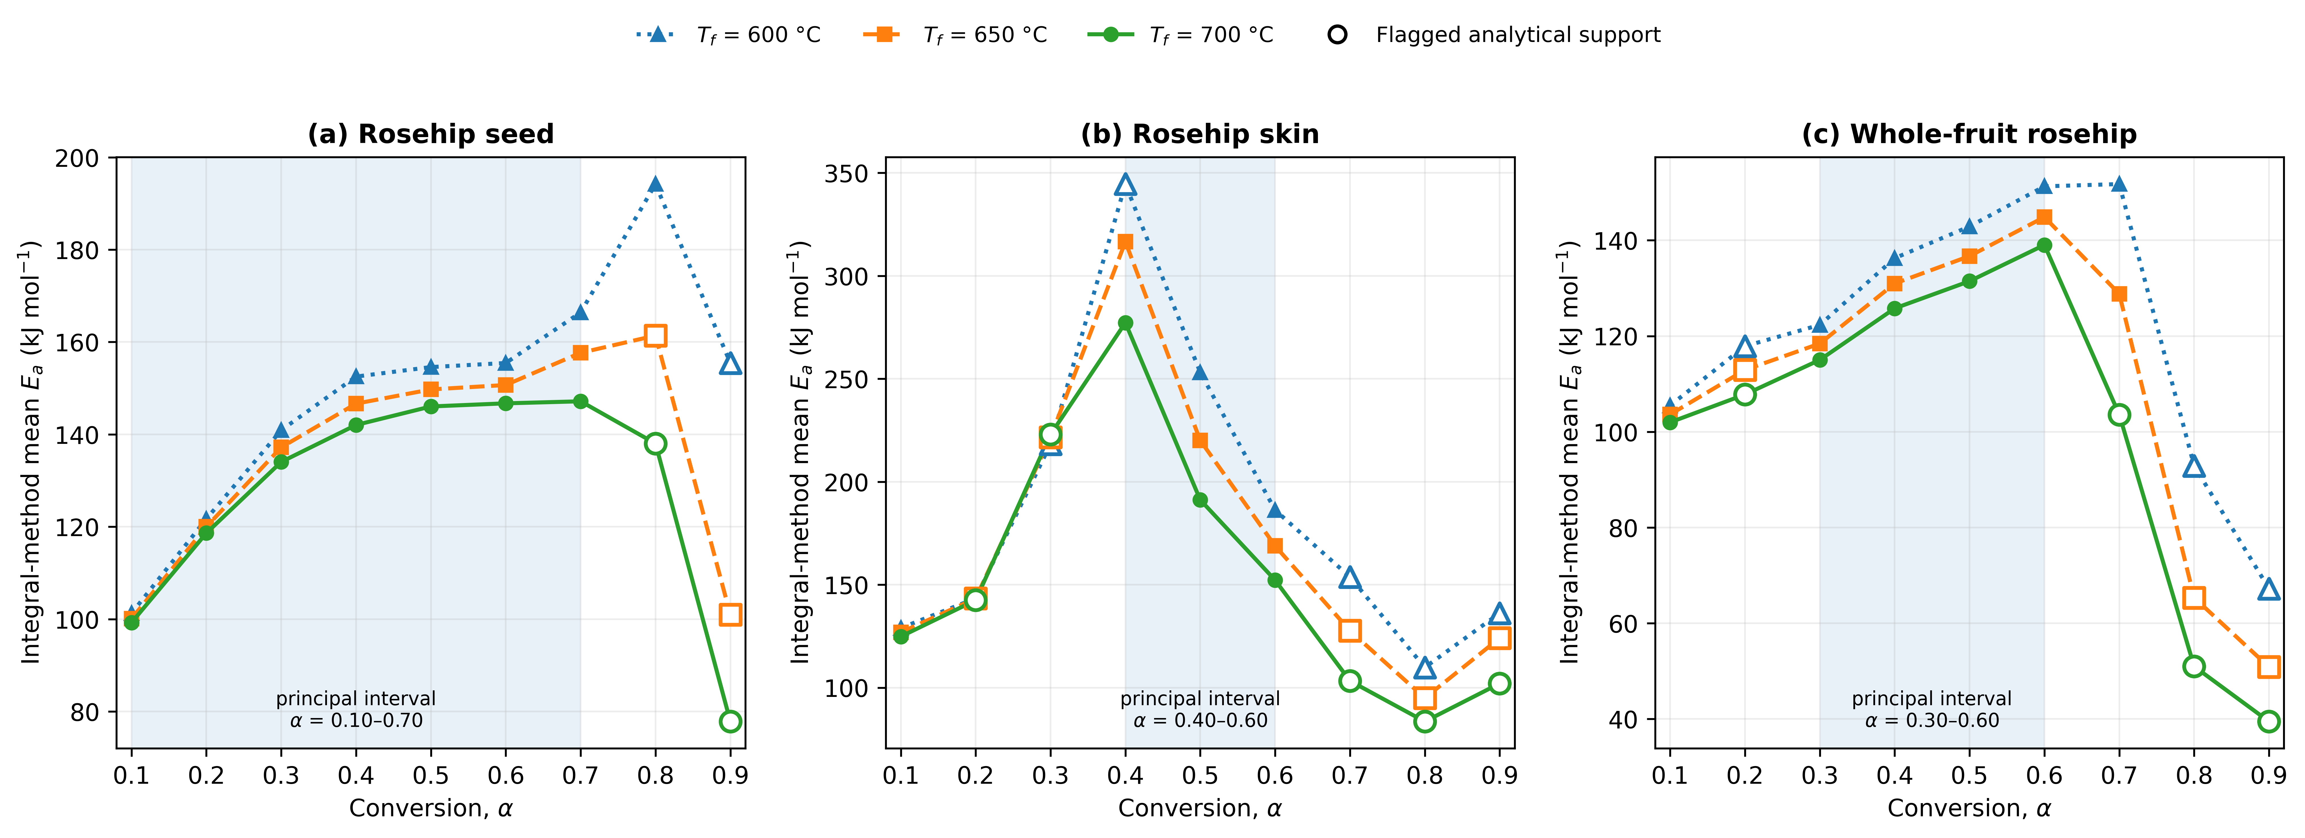
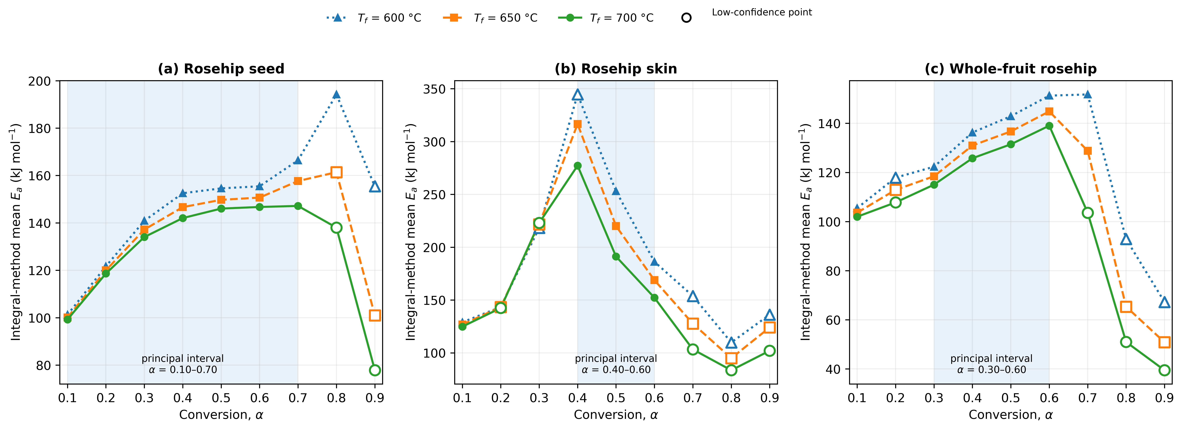

References
Burnham, K. P., & Anderson, D. R. (2004). Multimodel inference: Understanding AIC and BIC in model selection. Sociological Methods & Research, 33(2), 261–304. https://doi.org/10.1177/0049124104268644.
Conesa, J. A., & Domene, A. (2011). Biomasses pyrolysis and combustion kinetics through n-th order parallel reactions. Thermochimica Acta, 523, 176–181. https://doi.org/10.1016/j.tca.2011.05.021.
de Castro, L. L. R. L., de Sousa Neiva, L. G., Andrade, D. S. C., de Almeida, Y. M. B., de Sousa e Silva, H., Alves, T. S., & Barbosa, R. (2026). Sustainable hybrid films based on Ecovio, sodium nitrite, and babassu mesocarp starch for potential packaging applications. Polymers for Advanced Technologies, e70550. https://doi.org/10.1002/pat.70550.
Kim, H.-Y. (2019). Statistical notes for clinical researchers: Simple linear regression 3 - residual analysis. Restorative Dentistry & Endodontics, 44(1), e11. https://doi.org/10.5395/rde.2019.44.e11.
Kissinger, H. E. (1956). Variation of peak temperature with heating rate in differential thermal analysis. Journal of Research of the National Bureau of Standards, 57(4), 217–221. https://doi.org/10.6028/jres.057.026.
Li, J., Valentine, J. D., & Rana, A. E. (1999). The modified three point Gaussian method for determining Gaussian peak parameters. Nuclear Instruments and Methods in Physics Research Section A, 422(1–3), 438–443. https://doi.org/10.1016/S0168-9002(98)01113-9.
Liu, Y., Yang, L., Ma, C., & Zhang, Y. (2019). Thermal behavior of sweet potato starch by non-isothermal thermogravimetric analysis. Materials, 12(5), 699. https://doi.org/10.3390/ma12050699.
Mani, T., Murugan, P., & Mahinpey, N. (2009). Determination of distributed activation energy model kinetic parameters using simulated annealing optimization method for nonisothermal pyrolysis of lignin. Industrial & Engineering Chemistry Research, 48, 1464–1467. https://doi.org/10.1021/ie8013605.
Mishra, P., Pandey, C. M., Singh, U., Gupta, A., Sahu, C., & Keshri, A. (2019). Descriptive statistics and normality tests for statistical data. Annals of Cardiac Anaesthesia, 22(1), 67–72. https://doi.org/10.4103/aca.ACA_157_18.
Müller, L., Rubio-Pérez, G., Bach, A., Muñoz-Rujas, N., Aguilar, F., & Worlitschek, J. (2020). Consistent DSC and TGA methodology as basis for the measurement and comparison of thermo-physical properties of phase change materials. Materials, 13(20), 4486. https://doi.org/10.3390/ma13204486.
Singh, V. K., Musharraf, M., Swain, S. K., Dey, R. K., & Shekhar, S. (2023). Thermal kinetics of poly(amidoamine) functionalized silica gel. Bulgarian Chemical Communications, 55(Special Issue A), 225–231. https://doi.org/10.34049/bcc.55.A.0034.
Starink, M. J. (2003). The determination of activation energy from linear heating rate experiments: a comparison of the accuracy of isoconversion methods. Thermochimica Acta, 404, 163–176. https://doi.org/10.1016/S0040-6031(03)00144-8.
Soomro, A., Koçer, A. T., & Balkanlı, D. (2026). Fraction-resolved pyrolysis behavior, conversion-dependent kinetics, and predictive severity framework for engineered biochars from fig-processing residues. Biomass and Bioenergy, 214, 109556. https://doi.org/10.1016/j.biombioe.2026.109556.
Tu, R., Sun, Y., Wu, Y., Fan, X., Wang, J., Cheng, S., Jia, Z., Jiang, E., & Xu, X. (2019). Improvement of corn stover fuel properties via hydrothermal carbonization combined with surfactant. Biotechnology for Biofuels, 12, 249. https://doi.org/10.1186/s13068-019-1581-x.
Várhegyi, G., Bobály, B., Jakab, E., & Chen, H. (2011). Thermogravimetric study of biomass pyrolysis kinetics: A distributed activation energy model with prediction tests. Energy & Fuels, 25, 24–32. https://doi.org/10.1021/ef101079r.
Vyazovkin, S. (2020). Kissinger method in kinetics of materials: Things to beware and be aware of. Molecules, 25(12), 2813. https://doi.org/10.3390/molecules25122813.
Wang, H., Yan, X., Wang, Q., Wu, W., Tian, Y., & Xu, Q. (2026). Study on the modification mechanism and rheological properties of bio-oil-based composite-modified material for TOP-DOWN crack treatment in long-life pavement. Journal of Composites Science, 10(6), 298. https://doi.org/10.3390/jcs10060298.

