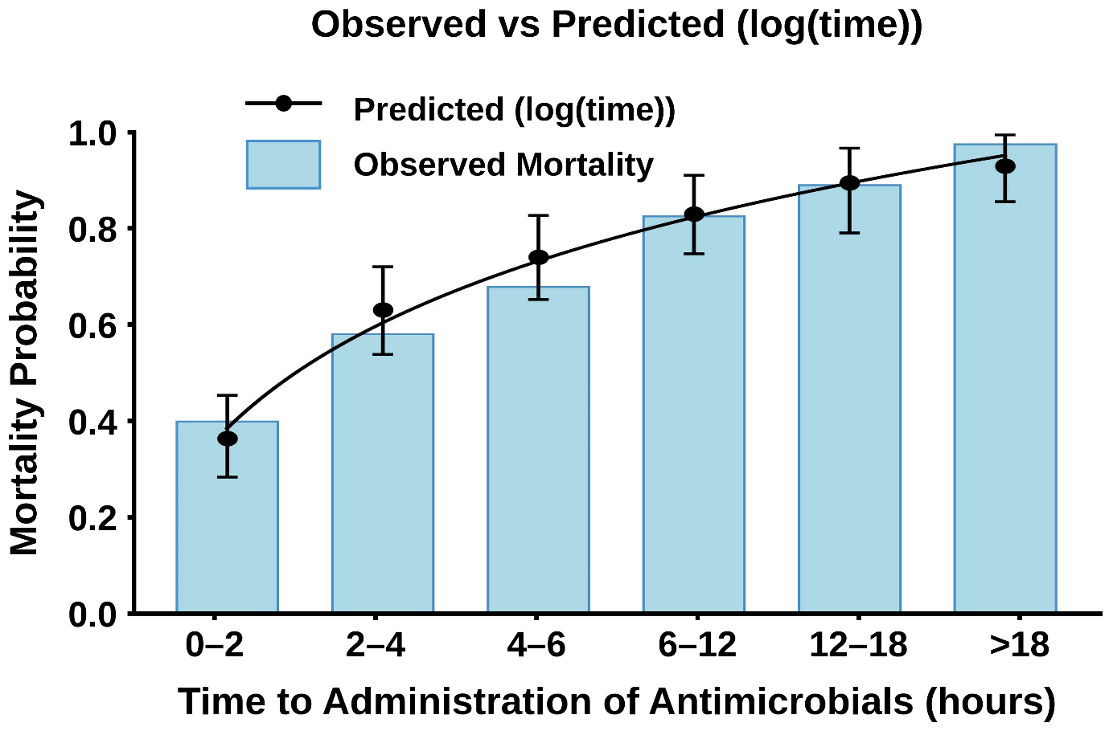
Supplemental Figure 1: Mortality Probability vs Log Time. Regression analysis demonstrates the association between in-hospital mortality and delays in administering antimicrobials after initial documentation of persistent hypotension. The bars display the crude mortality rates for each time interval, which increases as the delay in antimicrobial administration grows longer. The blue line represents the predicted mortality probabilities, adjusted for confidence intervals, starting at around 45% for delays of 0-3 hours and steadily rising to nearly 100% for delays exceeding 24 hours. This analysis underscores the critical role of timely antimicrobial administration in reducing mortality.
Supplemental Table 1: Chronic Co-morbidities of Patients with Neutropenic Septic Shock (n=508)
Condition | Frequency | Survival
Lymphoma | 24.6% | 27.23%
Leukemia/multiple myeloma | 44.1% | 25.4%
Metastatic solid cancer | 18.5% | 27.7%
Immunosuppressive chemotherapy | 86.8% | 27.0%
liver failure (biopsy proven cirrhosis, documented variceal hemorrhage or portal hypertension, hepatic ascites or encephalopathy) | 3.3% | 5.9%
COPD (medication or oxygen requiring) | 3.7% | 21.7%
Chronic renal failure (serum creatinine >1.5 upper limit of normal) | 6.5% | 12.1%
Diabetes mellitus (medication dependent) | 7.9% | 22.5%
Diabetes mellitus (insulin dependent) | 5.5% | 21.4%
Systemic autoimmune disease | 4.3% | 22.7%
Alcohol abuse | 3.2% | 12.5%
Elective surgery | 3.5% | 27.8%
Emergency surgery/major trauma | 2.0% | 0%

Supplemental Table 2: Clinical site infections (n=508)

Site | n | Frequency (%) | Survival (%)
Pneumonia | 162 | 31.9 | 30.2
Primary blood stream infection | 172 | 33.9 | 29.7
Systemic disseminated infection | 51 | 10.0% | 7.8
Catheter-related blood stream infection | 25 | 4.9 | 36.0
Intraabdominal infection | 70 | 13.8 | 18.6
Enterocolitis/typhlitis | 23 | 4.5 | 21.7
Bowel perforation/peritonitis (spontaneous) | 15 | 3.0 | 20.0
Toxic megacolon | 8 | 1.6 | 0.0
Ischemic bowel | 7 | 1.4 | 28.8
Spontaneous peritonitis | 4 | 0.8 | 0.0
Cholecystitis | 4 | 0.8 | 0.0
Ascending cholangitis | 3 | 0.6 | 66.7
Bowel obstruction | 2 | 0.4 | 50.0
Intraabdominal abscess | 2 | 0.4 | 0.0
Pancreatitis | 2 | 0.4 | 0.0
Skin & soft tissue infection | 13 | 2.5 | 46.2
Necrotizing soft tissue infection | 7 | 1.4 | 42.9
Cellulitis | 4 | 0.8 | 50.0
Soft tissue abscess | 2 | 0.4 | 50.0
Urinary tract infection | 13 | 2.6 | 30.8
CNS-meningitis | 1 | 0.2 | 0.0
Septic arthritis | 1 | 0.2 | 100.0

Supplemental Table 3: Suspected primary microbiologic pathogens in septic shock (n=385)
Pathogen | n | Frequency (%) |  | Survival (%)
Gram-negative organisms | 148 | 38.4 | 29.7
Enterobacteriaceae | 99 | 25.7 | 31.3
Escherichia coli | 56 | 14.5 | 23.2
Klebsiella species | 29 | 7.5 | 51.7
Enterobacter species | 10 | 2.6 | 10.0
Proteus species | 2 | 0.5 | 50.0
Serratia species | 1 | 0.3 | 0.0
Citrobacter species | 1 | 0.3 | 0.0
Non-enterobacteriaceae | 49 | 12.7 | 28.6
Pseudomonas aeruginosa | 41 | 10.6 | 26.8
Acinetobacter species | 2 | 0.5 | 50.0
Stenotrophomonas maltophila | 3 | 0.8 | 33.3
Burkholderia cepacia | 1 | 0.3 | 100.0
Haemophilus influenza | 2 | 0.5 | 0.0
Gram-positive organisms | 103 | 26.7 | 35.9
Staphylococcus aureus | 42 | 10.9 | 42.9
Streptococcus pneumoniae | 16 | 4.2 | 25.0
Viridans streptococci | 18 | 4.7 | 50.0
Streptococcus faecium | 12 | 3.1 | 8.3
Streptococcus faecalis | 3 | 0.8 | 0.0
Other β-hemolytic streptococci | 7 | 1.8 | 57.1
Group A streptococci (S. pyogenes) | 1 | 0.3 | 100.0
Corynebacterium jeijkeium | 2 | 0.5 | 0.0
Bacillus species | 1 | 0.3 | 0.0
Other gram positive | 1 | 0.3 | 0.0
Yeast/fungi | 122 | 31.7 | 9.0
Candida albicans | 67 | 17.4 | 10.4
Candida glabrata | 6 | 1.6 | 0.0
Candida tropicalis | 17 | 4.4 | 11.8
Candida krusei | 13 | 3.4 | 15.4
Candida parapsilosis | 4 | 1.0 | 0.0
Other yeast | 3 | 0.8 | 0.0
Aspergillus/Mucor species | 12 | 3.1 | 0.0
Anaerobes | 9 | 2.3 | 11.1
Clostridium difficile | 5 | 1.3 | 0.0
Other clostridia | 4 | 1.0 | 25.0
Legionella species | 2 | 0.6 | 0.0
Mycobacterium tuberculosis | 1 | 0.3 | 0.0

Supplemental Table 4: Multivariable analysis identifying independent predictors of hospital mortality and Pearson Correlation. The model included antimicrobial delay, APACHE II score, age, antimicrobial class, and infection acquisition. Adjusted odds ratios (OR) with 95% confidence intervals (CI) were calculated using a binomial generalized linear model with robust standard errors. Variables with significant associations indicate independent contributions to mortality risk after adjustment for other factors.

Variable | Adjusted  OR | 95% CI | p value | Pearson Coefficient
Antimicrobial delay (hour) | 1.161 | 1.052 - 1.281 | 0.003 | 30.9%
APACHE II score (point) | 1.111 | 1.065 - 1.158 | <.0001 | 33.0%
Age (year) | 1.017 | 0.994 - 1.041 | 0.148 | 15.1%
Antimicrobial Drug Class | 3.852 | 1.179 - 7.890 | 0.021 | 5.5%
Infection Acquisition (nosocomial vs community) | 1.515 | 0.789 – 2.906 | 0.212 | 15.2%

aOR = adjusted odds ratio, Antimicrobial Drug Class refers to carbapenem vs all others

