SUPPLEMENTARY MATERIAL related to work:
Electrochemical fingerprints of sequential double-regenerative
enzymatic mechanisms in protein-film voltammetry

Milkica Janeva, Pavlinka Kokoskarova, Rubin Gulaboski
Faculty of Medical Sciences, Goce Delcev University, Stip, Macedonia

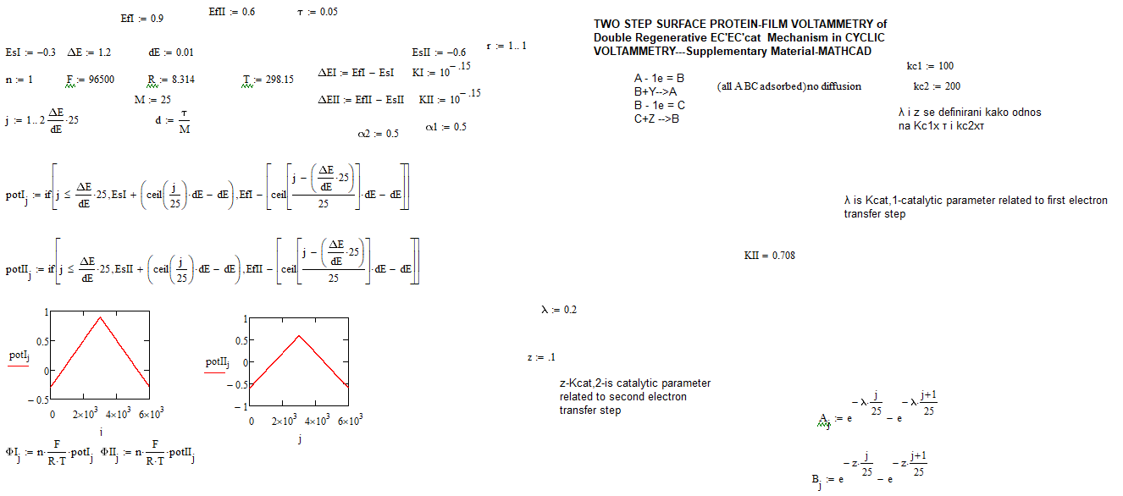
Mathcad Simulation Protocol
