Supplementary Information
Widespread, non-random mammal community incompleteness in China’s protected areas revealed by multidimensional dark diversity
This Supplementary Information contains four appendices, five supplementary figures that elaborate the methodology, present per-reserve and per-species results, list every primary study used to construct the dataset, and document the sensitivity of our conclusions to key analytical choices.

Contents
- Appendix S1. Reserve inventory.
- Appendix S2. Species-level dark-diversity affinity rankings.
- Appendix S3. Full generalized additive model output (log EPD, SES_EPD, log FDI, FDis_dark).
- Appendix S4. Sensitivity analyses (sampling-effort threshold, pool definition, phylogeny choice, multiple-testing correction).
- Figure S1. Sampling effort and reserve area across the 199-reserve network.
- Figure S2. Pairwise Spearman correlation matrix among the nine candidate environmental / sampling covariates.
- Figure S3. Residual spatial smoother from the log(EPD) GAM.
- Figure S4. Residual spatial smoother from the SES(EPD) GAM.
- Figure S5. Residual spatial smoother from the log(FDI) GAM.

Appendix S1 — Reserve inventory and primary literature sources
The final analytical dataset comprises 199 terrestrial nature reserves, retained from an initial pool of 256 reserves recovered from 421 published camera-trap studies (China National Knowledge Infrastructure, Web of Science and Scopus, through June 2025) after applying the standardized filter (>30 deployed cameras, >400 effective camera-days, complete species list). The 199 reserves are distributed across all seven of China’s zoogeographic regions and include national, provincial, municipal and county-level protected areas. Summary counts:
Region | Reserves (n)
Central China | 58
South China | 48
Southwest China | 39
North China | 26
Northeast China | 12
Mongolian-Xinjiang | 8
Qinghai-Tibet | 8
The full reserve-level metadata table (name, province, year of establishment, area, geographic coordinates, protected-area level, number of camera traps, cumulative trap-days, biogeographic region) is provided in the Science Data Bank deposit. Primary literature were filtered to retain only studies that (i) used unbaited camera traps, (ii) reported a complete species inventory, (iii) achieved at least 400 effective camera-days per survey, and (iv) provided unambiguous reserve identification (Tobler et al., 2008).

Appendix S2 — Species-level dark-diversity affinity rankings
The 105 medium- and large-sized mammals included in this study were ranked by their cumulative dark-diversity probability across all reserves to identify the species most frequently absent from sites in which they should ecologically occur. The ten species at greatest hidden-extinction risk were:
- Manis pentadactyla — Chinese pangolin
- Neofelis nebulosa — clouded leopard
- Lutra lutra — Eurasian otter
- Rusa unicolor — sambar
- Viverricula indica — small Indian civet
- Vulpes vulpes — red fox
- Nyctereutes procyonoides — raccoon dog
- Macaca mulatta — rhesus macaque
- Martes flavigula — yellow-throated marten
- Herpestes urva — crab-eating mongoose
A set of species with near-zero dark-diversity probability — including Rhinopithecus roxellana (golden snub-nosed monkey), Macaca thibetana (Tibetan macaque), Elephas maximus (Asian elephant), Camelus ferus (wild Bactrian camel), Marmota himalayana (Himalayan marmot), Pseudois nayaur (bharal), Prionailurus bengalensis (leopard cat), Muntiacus vaginalis (Indian muntjac), Equus hemionus (Asiatic wild ass), Naemorhedus baileyi (red goral), Rhinopithecus brelichi (grey snub-nosed monkey), Macaca leucogenys (white-cheeked macaque), Moschus anhuiensis (Anhui musk deer), Capricornis swinhoei (Taiwan serow), Macaca cyclopis (Formosan rock macaque) and Marmota baibacina (grey marmot) — was consistently observed within its potential range.
The full per-species table with body mass, diet, activity, IUCN status is provided in the Science Data Bank deposit.

Appendix S3 — Full GAM output
We fitted generalized additive models (GAMs) implemented in the mgcv R package (Wood, 2017) for four response variables: log(EPD), SES_EPD, log(FDI), and FDis_dark (Gaussian family, identity link throughout). All models contained a two-dimensional thin-plate smooth on (longitude, latitude, k = 20) to absorb residual large-scale spatial autocorrelation; non-spatial smooth terms used k = 4. Smoothing parameters were estimated via REML and model simplification was conducted by backward AIC selection. Residual Moran’s I tests confirmed that spatial autocorrelation was negligible in the final models.
Table S3.1 — log(EPD) GAM smooth-term significance (backward-selected model, n = 199).
Smooth term | edf | Ref.df | P | Significance
s(ELEV) | 2.53 | 2.84 | < 0.001 | ***
s(ER) | 1.00 | 1.00 | 0.017 | *
s(PRECIPITATION) | 2.72 | 2.92 | < 0.001 | ***
s(logTRAPDAY) | 1.92 | 2.35 | 0.017 | *
s(Npp) | 2.74 | 2.94 | < 0.001 | ***
s(longitude, latitude) | 17.39 | 18.70 | < 0.001 | ***
Adjusted R² = 0.727; deviance explained = 76.6%.
Table S3.2 — SES_EPD GAM smooth-term significance (backward-selected model, n = 199).
Smooth term | edf | Ref.df | P | Significance
s(es_time) | 1.00 | 1.00 | 0.395 | ns
s(longitude, latitude) | 16.97 | 22.83 | < 0.001 | ***
Table S3.3 — log(FDI) GAM smooth-term significance (backward-selected model, n = 198).
Smooth term | edf | Ref.df | P | Significance
s(logTRAPDAY) | 1.00 | 1.00 | 0.003 | **
s(longitude, latitude) | 12.24 | 15.36 | < 0.001 | ***
Adjusted R² = 0.249; deviance explained = 30.0%.
Table S3.4 — FDis_dark GAM smooth-term significance (backward-selected model, n = 198).
Smooth term | edf | Ref.df | P | Significance
s(ER) | 1.00 | 1.00 | 0.096 | ns
s(BKMD) | 1.00 | 1.00 | 0.105 | ns
s(Npp) | 1.00 | 1.00 | 0.020 | *
s(longitude, latitude) | 9.77 | 12.80 | 0.039 | *

Appendix S4 — Sensitivity analyses
We evaluated four methodological choices that could conceivably bias our conclusions:
S4.1 Sampling-effort threshold. Our operating threshold requires >30 deployed cameras and >400 effective camera-days per reserve, and yields the 199-reserve analytical dataset. Loosening the camera-count threshold to ≥10 restored the 256-reserve dataset used in an earlier iteration of the analysis, but produced substantially noisier region-level FDI estimates because low-effort reserves inflate dark-diversity probabilities (Fujinuma & Pärtel, 2023). Tightening the camera-count threshold to ≥50 reduced the sample to 138 reserves but preserved the qualitative multidimensional pattern and the regional null-model signal — South China remained significantly above null on all three dimensions. We retained the >30-camera threshold to balance statistical power against sampling homogeneity, while including logTRAPDAY as a covariate in every model.
S4.2 Species-pool definition. We define pools by intersecting IUCN range polygons with habitat-type and elevational filters, then augmenting the modern IUCN polygons with CESIS historical records buffered by 50 km (Liu et al., 2025). Alternative pools defined by (i) IUCN polygons alone (unfiltered), and (ii) probabilistic site-specific pools sensu Carmona and Pärtel (2021) yielded reserve-level DD_adj rankings that correlated with the main analysis at Spearman ρ > 0.85. The South-China null-model signal was preserved in every alternative.
S4.3 Phylogeny choice. EPD was computed on 200 posterior trees drawn from the mammal supertree (Upham et al., 2019); reserve-level EPD ranks across these 200 draws were highly consistent (per-tree Spearman ρ > 0.95 with the mean estimate).
S4.4 Multiple-testing correction. Regional null-model P-values were adjusted with the Benjamini–Hochberg false-discovery-rate procedure (Benjamini & Hochberg, 1995). Under the more conservative Holm–Bonferroni correction, South China remained significantly above null on all three dimensions; North China, Northeast China and Qinghai-Tibet remained significantly below null on the taxonomic and phylogenetic dimensions.

Supplementary Figures
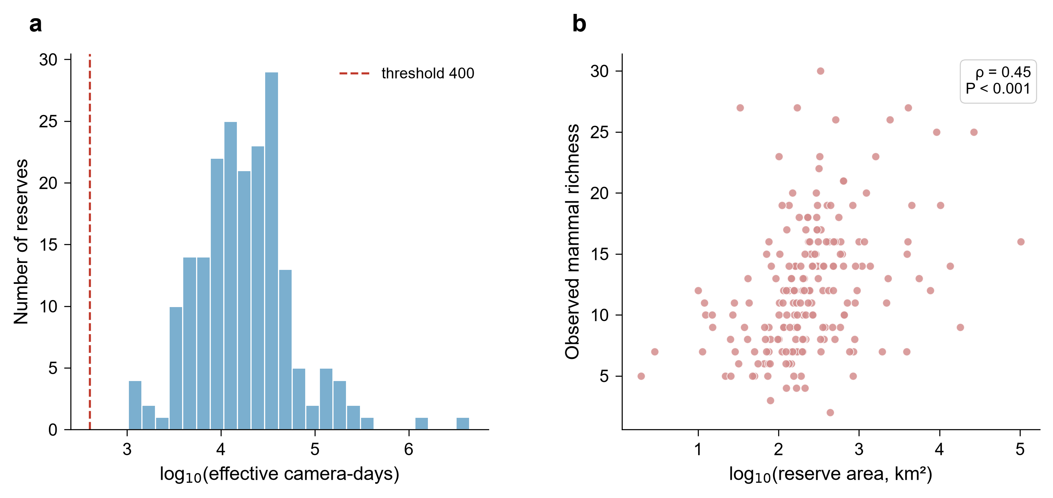
Figure S1 | Sampling effort and reserve area across the 199-reserve network. a, Distribution of effective camera-days per reserve (log-scale); dashed red line indicates the 400-day inclusion threshold. b, Relationship between reserve area and observed mammal richness across the 199 retained reserves.
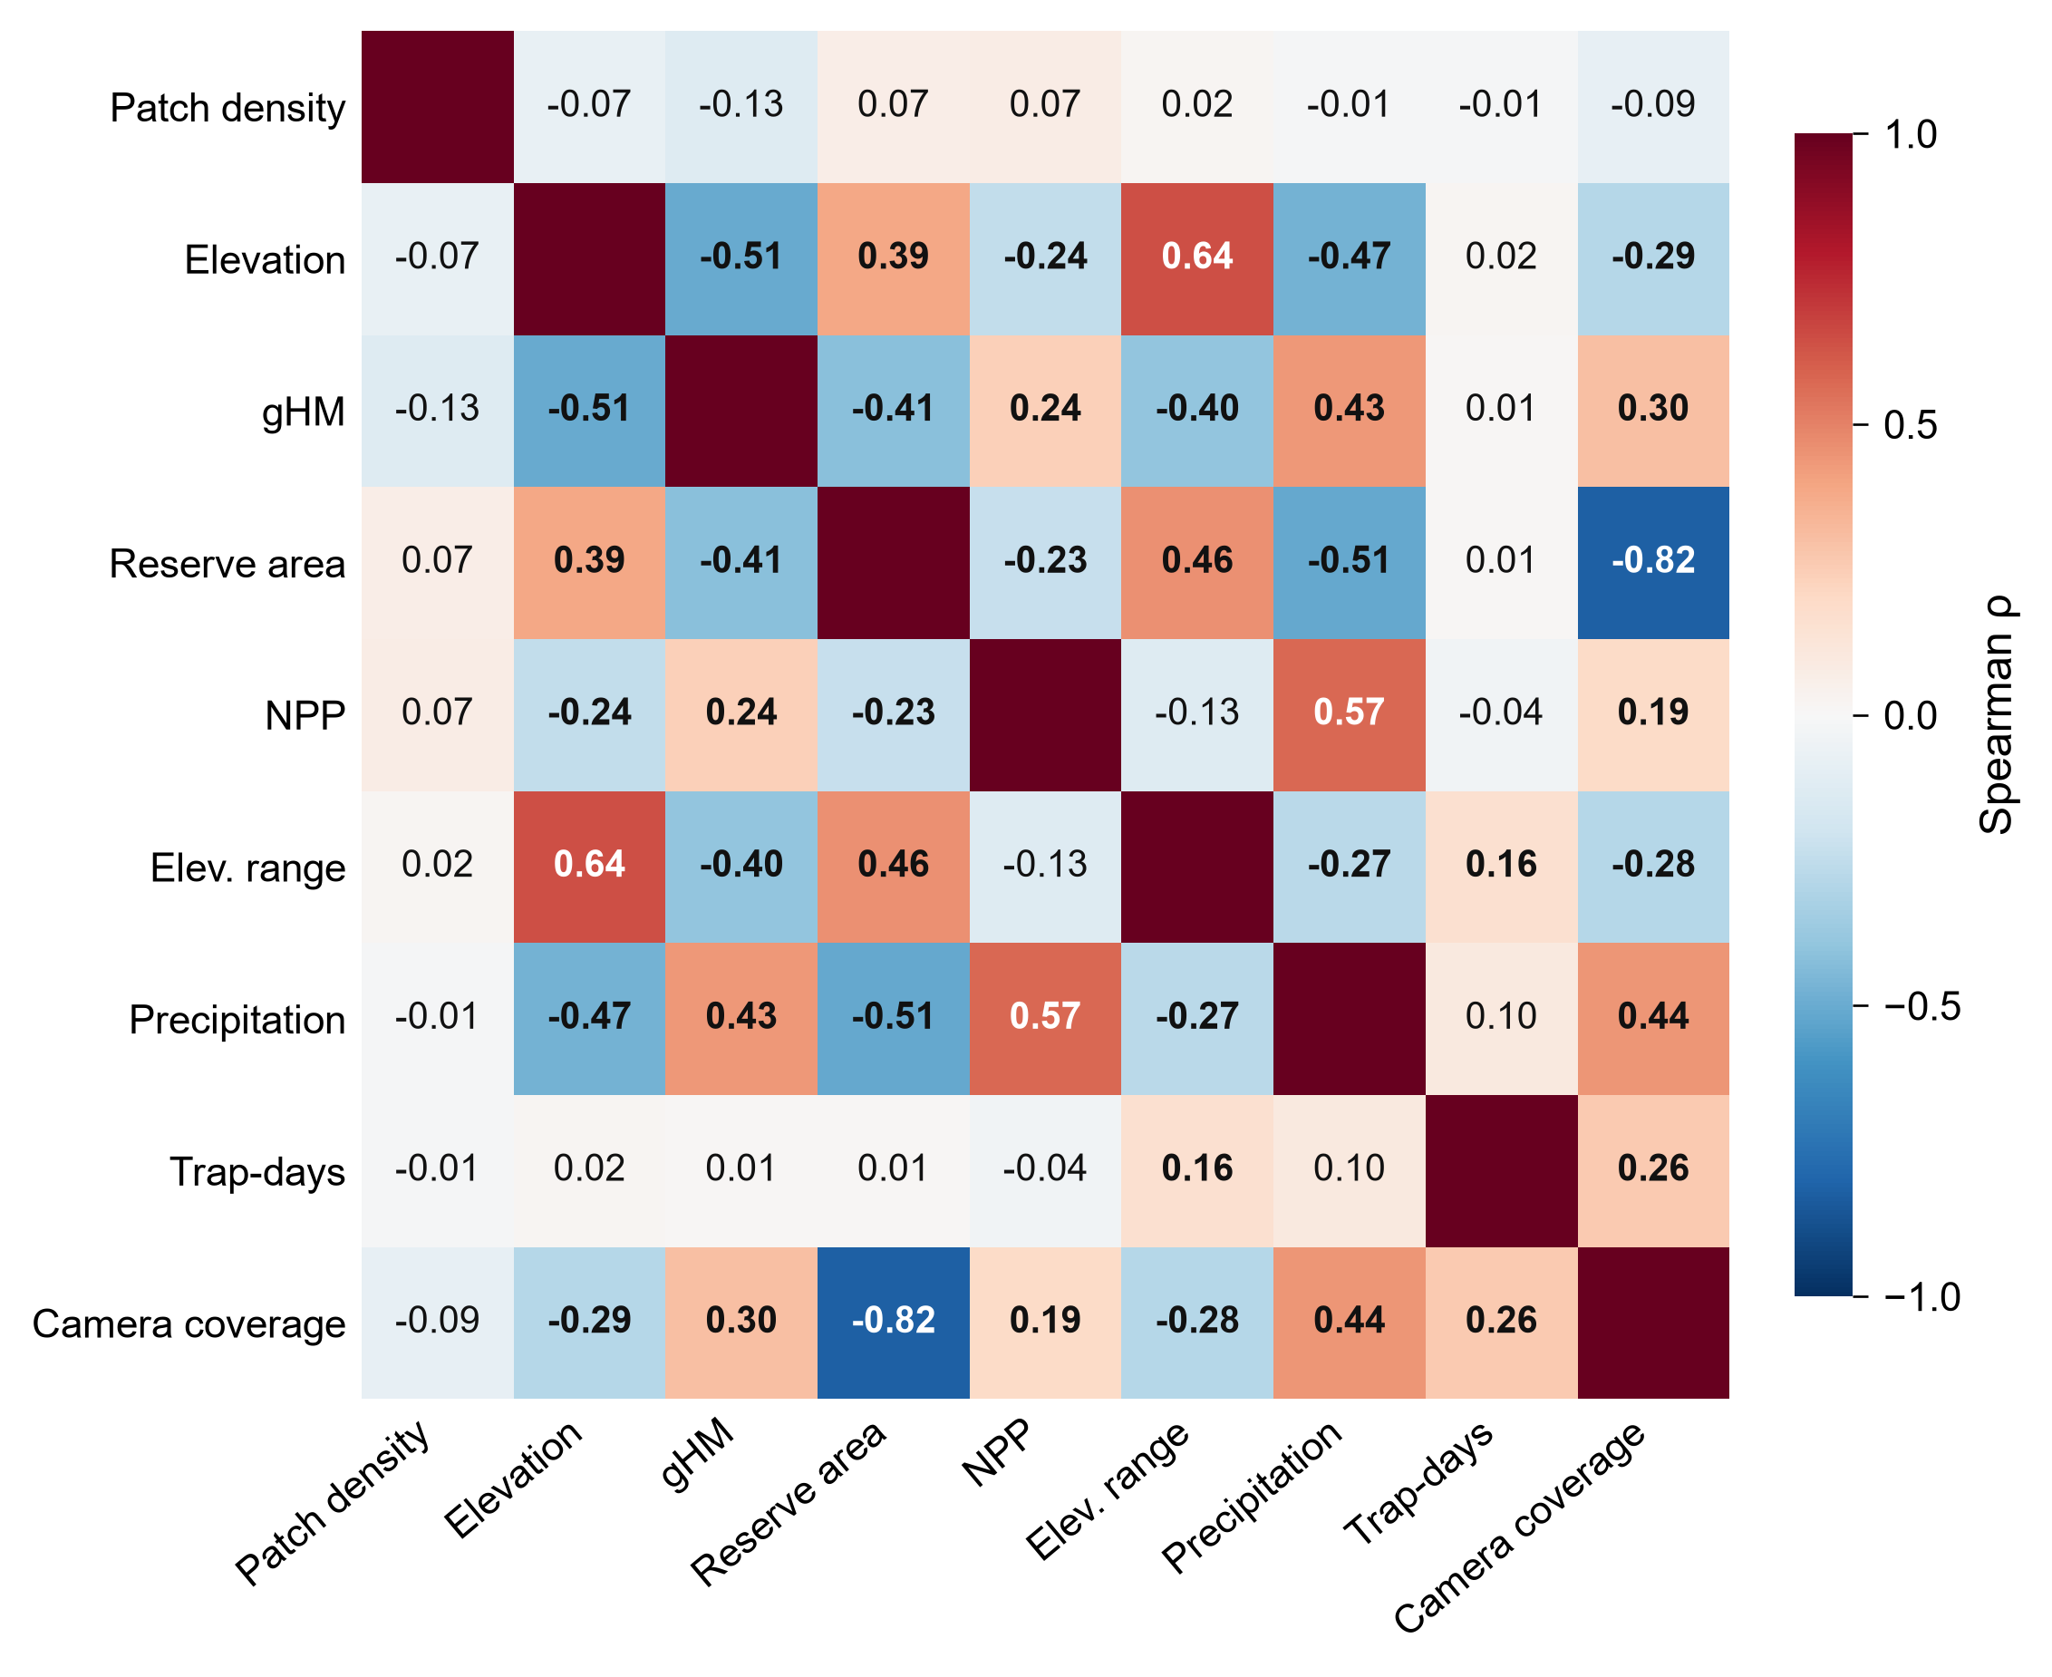
Figure S2 | Pairwise Spearman correlation among the nine candidate environmental / sampling covariates. Each cell shows the Spearman rank correlation between two candidate predictors across the 199 reserves; colour scale from −1 (blue) to +1 (red). Reserve area and trap-days were log-transformed prior to correlation. Bold values indicate correlations that are statistically significant (P < 0.05). The matrix guided the correlation-collinearity screen (|ρ| < 0.65) that determined which covariates entered the GAMs; only the reserve-area × camera-coverage pair (ρ = −0.82) is near-collinear and was therefore never entered simultaneously into the same model.
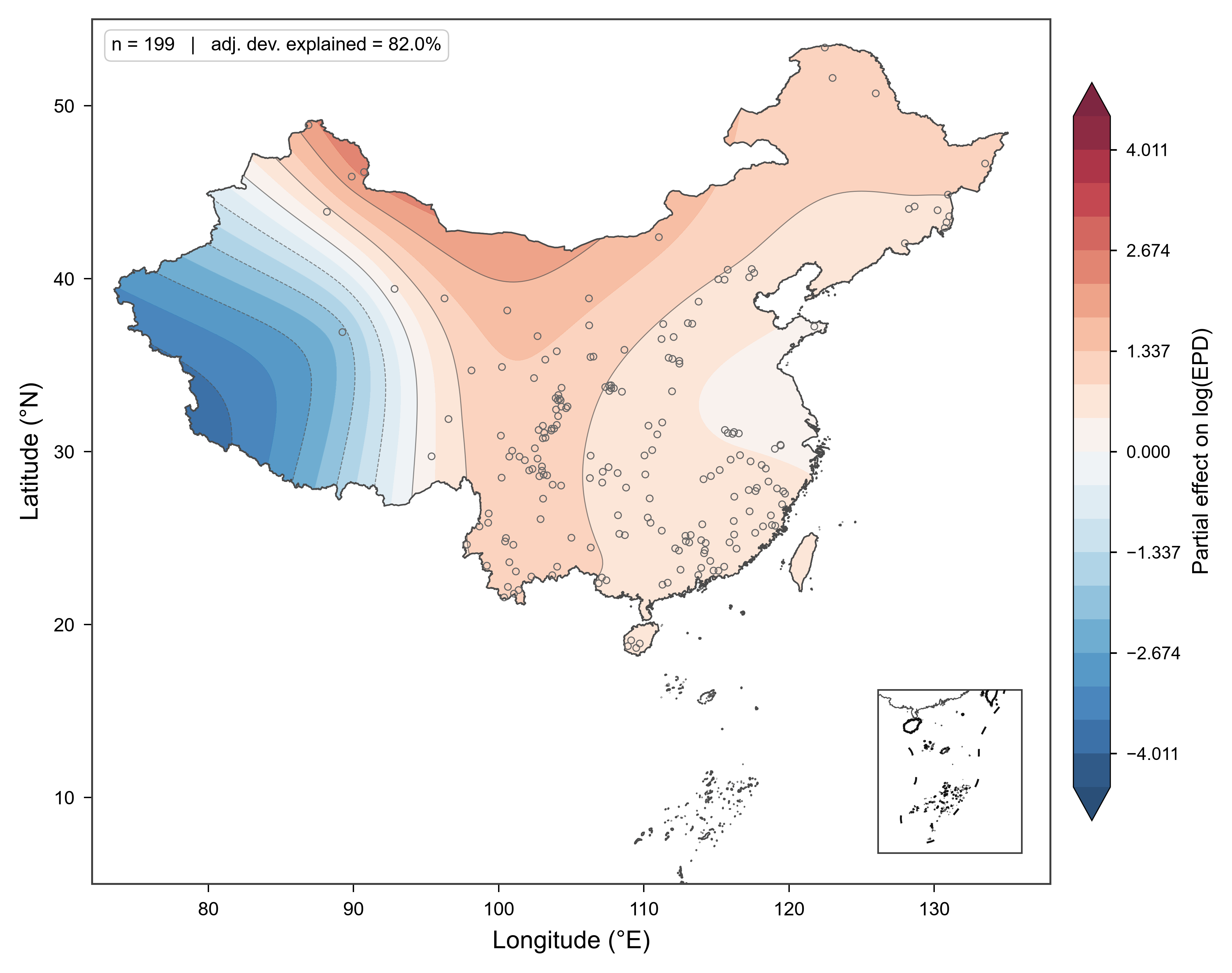
Figure S3 | Residual spatial smoother from the log(EPD) GAM. Filled contours show the tensor-product smoother s(longitude, latitude, k = 20) fitted alongside — and net of — five environmental / sampling covariates (elevation, elevational range, annual precipitation, NPP, log(trap-days)). Warm and cool tones indicate reserves with log(EPD) higher or lower than expected from those covariates alone. The smoother is highly significant (P < 0.001) and absorbs a large amount of the remaining variation (full-model adj. deviance explained ≈ 82 %). Small hollow circles mark the 199 reserves; the inset shows the South China Sea nine-dash line for reference. Contours are derived by evaluating the fitted smoother at each reserve location and interpolating with a thin-plate-spline RBF, then clipped to the China polygon.
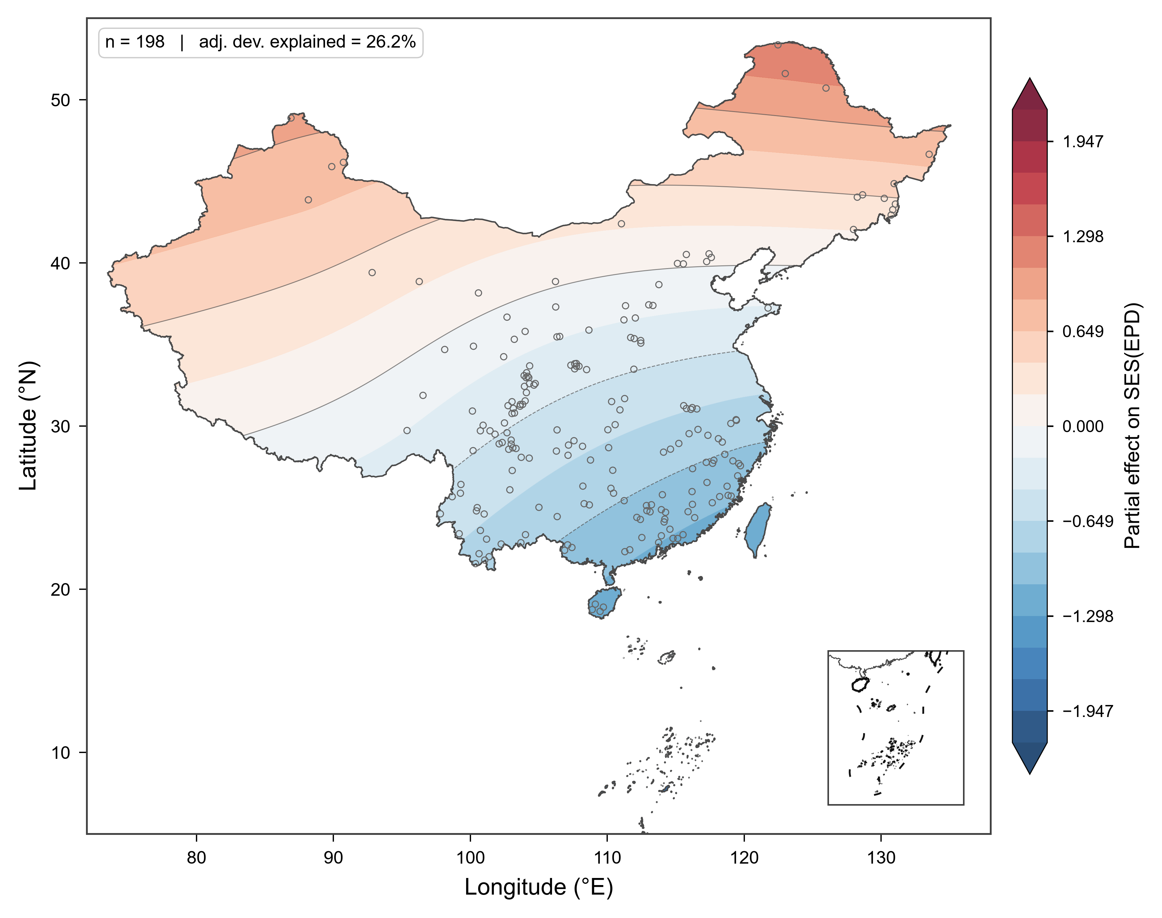
Figure S4 | Residual spatial smoother from the SES(EPD) GAM. As Figure S3, but for the richness-standardised phylogenetic dark diversity SES(EPD). The spatial term remains significant (P ≈ 2 × 10⁻⁶) after removing environmental / sampling effects: SES(EPD) is systematically higher (warmer than expected) north of ~35° N and lower (cooler than expected) across sub-tropical South China, indicating a north–south residual gradient that environmental covariates alone do not explain.
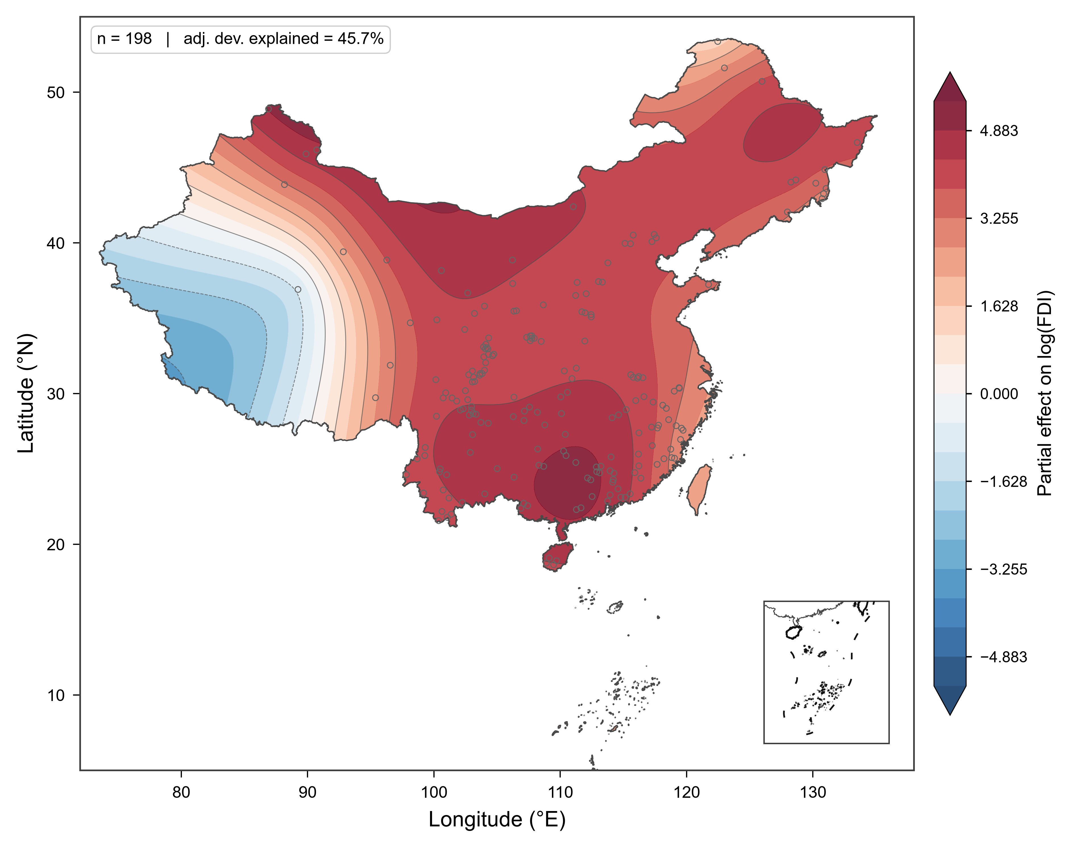
Figure S5 | Residual spatial smoother from the log(FDI) GAM. Filled contours show the tensor smoother s(longitude, latitude, k = 20) fitted with sampling effort (log(trap-days)) as the only fixed effect (n = 198). The smoother is highly significant (P < 10⁻¹²) and reveals a broad zone of elevated functional deficit across eastern and central China, opposite the Xinjiang / western-plateau pattern of Figures S3 – S4. Small hollow circles mark reserves; inset and clipping conventions are identical to Figure S3.

Supplementary Tables
Table S1 — Regional null-model statistics for taxonomic dark diversity (DD_adj). Generated by 9999-permutation regional null model (Methods §2.7). Columns: region, number of reserves (n_site), observed regional mean, observed regional median, null mean, null standard deviation, standardized effect size (SES), two-tailed P, and Benjamini–Hochberg adjusted P (p_fdr). Provided as table_S_null_DDadj.csv.
Table S2 — Regional null-model statistics for phylogenetic dark diversity (EPD). Format as in Table S1. Provided as table_S_null_EPD.csv.
Table S3 — Regional null-model statistics for functional dark diversity (FDI). Format as in Table S1. Provided as table_S_null_FDI.csv.

Supplementary References
Benjamini, Y. & Hochberg, Y. (1995). Controlling the false discovery rate: a practical and powerful approach to multiple testing. Journal of the Royal Statistical Society, Series B, 57(1), 289–300.
Carmona, C. P. & Pärtel, M. (2021). Estimating probabilistic site-specific species pools and dark diversity from co-occurrence data. Global Ecology and Biogeography, 30(1), 316–326.
Fujinuma, J. & Pärtel, M. (2023). Decomposing dark diversity affinities of species and sites using Bayesian method: what accounts for absences of species at suitable sites? Methods in Ecology and Evolution, 14(7), 1796–1807.
Liu, J., Kang, Y., Kays, R., Jensen, A. J. & Jiang, A. (2025). Apex predator loss drives trophic downgrading in China’s protected areas. Current Biology, 35(13), 2989–2997.e3.
Servén, D. & Brummitt, C. (2018). pyGAM: Generalized Additive Models in Python. Zenodo. https://doi.org/10.5281/zenodo.1208723
Tobler, M. W., Carrillo-Percastegui, S. E., Leite Pitman, R., et al. (2008). An evaluation of camera traps for inventorying large- and medium-sized terrestrial mammals. Animal Conservation, 11(3), 169–178.
Upham, N. S., Esselstyn, J. A. & Jetz, W. (2019). Inferring the mammal tree: Species-level sets of phylogenies for questions in ecology, evolution, and conservation. PLOS Biology, 17(12), e3000494.
Wood, S. N. (2017). Generalized additive models: An introduction with R (2nd ed.). Chapman and Hall/CRC.

